Images related to Peripheral Blood Pathology Smear Review Criteria

**Anaplasma** is an organism spread by ticks that causes Lyme disease.

​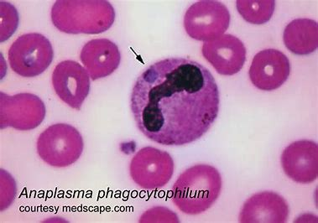​​

**APL Morphology**

|  |  |
| --- | --- |
| Sliding plate and dumb-bell shaped nuclei | Auer Rods |
| **​​** | **​​​**  **​​​** |

**Atypical CLL Morphology**

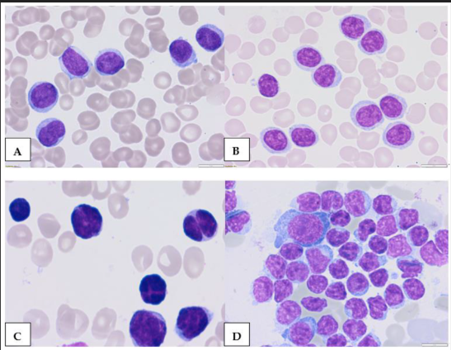

Morphologic features of atypical CLL cells. Prolymphocytes in peripheral blood (A,B) and cleaved cells (C)—in peripheral blood, (D)—bone marrow (magnification 63×).

Source: Robak, Tadeusz; Krawczyńska, Anna; Cebula-Obrzut, Barbara; Urbaniak, Marta; Iskierka-Jażdżewska, Elżbieta; Robak, Pawel; Atypical Chronic Lymphocytic Leukemia—The Current Status; 4427; Volume-15; Cancers; 2023/09/05

**Hairy cells**

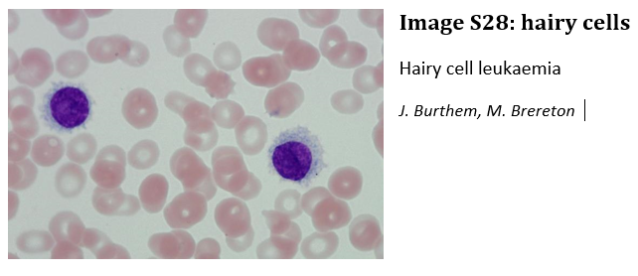

**Lymphoma cells**

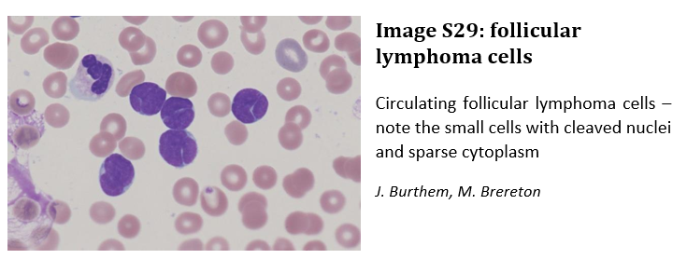

**Plasma Cells**

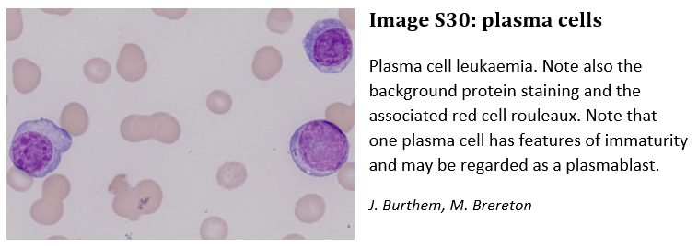

**Prolymphocytes**

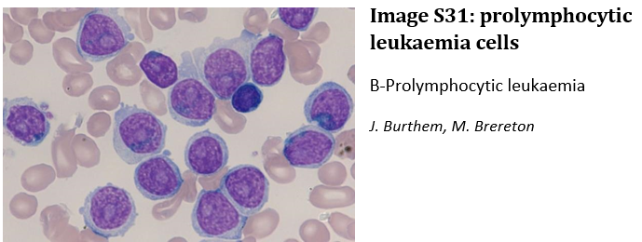

**Promonocytes/Mono Blasts**

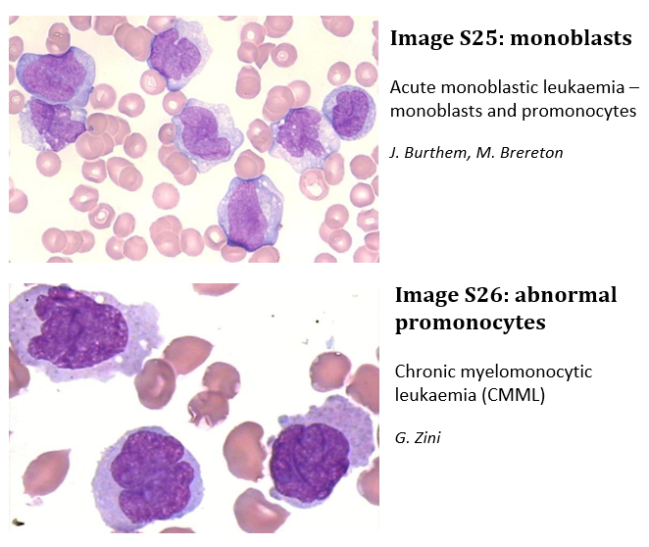

**Promyelocytes**

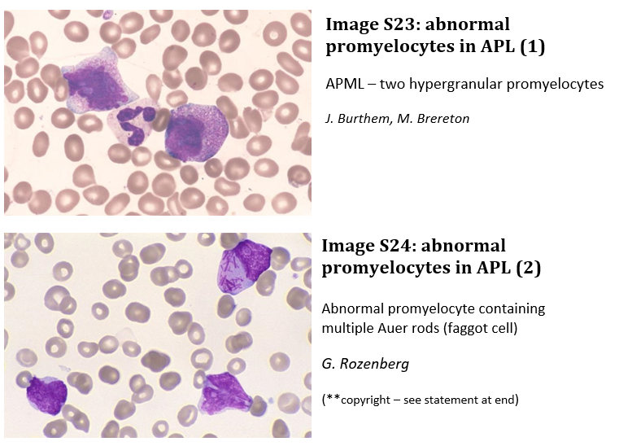

**Sezary Cells**

|  |  |
| --- | --- |
| Sezary cell  From ImageBank.Hematology.Org  [Sezary cell](https://imagebank.hematology.org/image/61378/sezary-cell) | Sezary syndrome - peripheral smear - 4.  From ImageBank.Hematology.Org  [Sezary syndrome - peripheral smear - 4.](https://imagebank.hematology.org/image/1105/sezary-syndrome--peripheral-smear--4?type=upload) |

Images S23-S26, S28-S30 are from *Microscopic haematology: a practical guide for the laboratory 3e (c) 2011, Sydney, Elsevier Australia*