**How to access Lab Policies/Procedures via CHRISTUS Connect**

**Purpose:** All Laboratory Associates must be knowledgeable of policies and procedures relevant to their job description. Access to LAB policies/procedures/guidelines are within **CHRISTUS Connect** on the CHRISTUS Spohn Intranet.

**Accountability:** All Lab associates must be knowledgeable of policies and procedures relevant to Lab General and their respective section(s) and thus must know how to access such content.

**Procedure for accessing content:**

1. From the main desktop double click on the **Spohn Intranet** icon

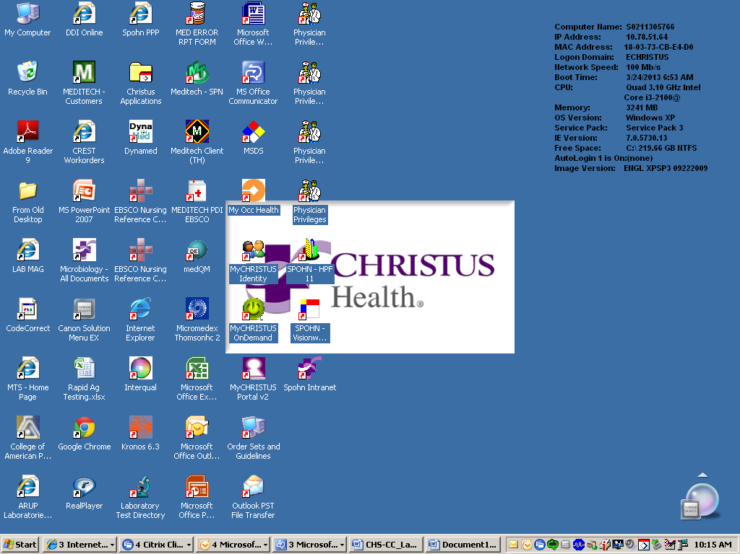

1. Under **SPN Links:** choose **Dept. Sharepoint Sites** and choose **Laboratory**

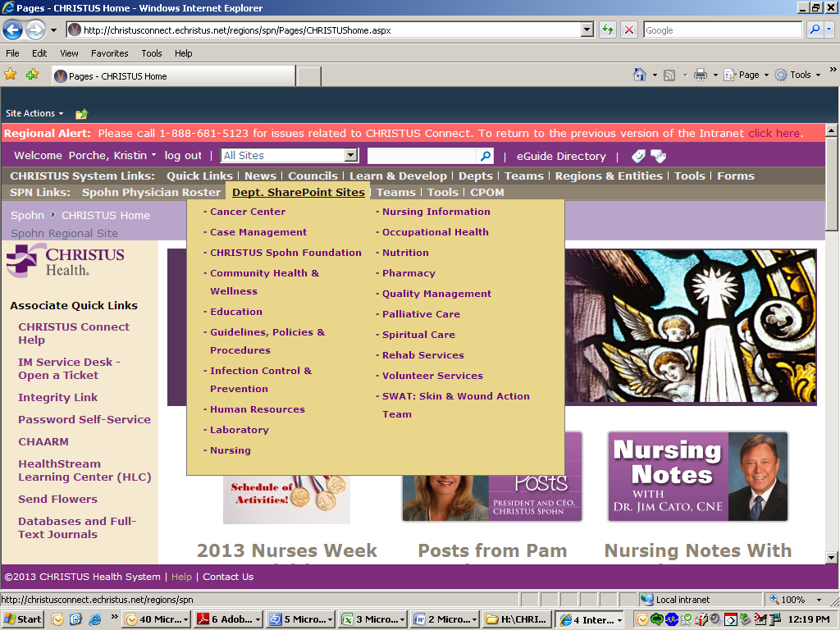

You are now in the **CHRISTUS Spohn Laboratory CHRISTUS Connect Site.**

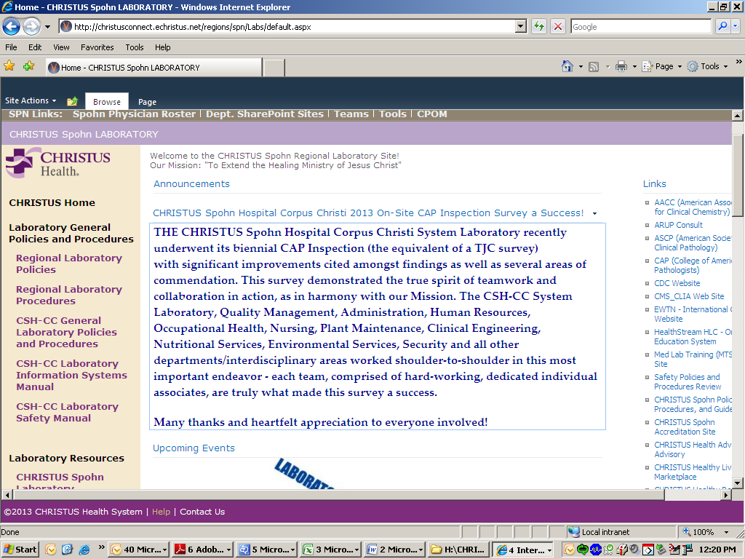

1. **Navigate through this page to see available content.**
   1. Lab General Policies / Procedures including the Safety Manual
   2. Departmental Specific Policies/ Procedures
   3. Links to frequently accessed websites (internal and external) such as CAP, MTS Lab Training and Competency, Healthstream, etc.
   4. Lab Resources including Commonly Used Forms, Online Lab Test Menu , Specimen Collection Manual, etc.
   5. Announcements, Lab Newsletters, etc.
2. **To access CC and Regional General Lab Policies and Procedures** including the *Lab Critical Value Policy* and the *Packing and Shipping P&P* click on the appropriate link as shown below. Familiarize yourself with each so you are aware which policies and procedures are housed within each.

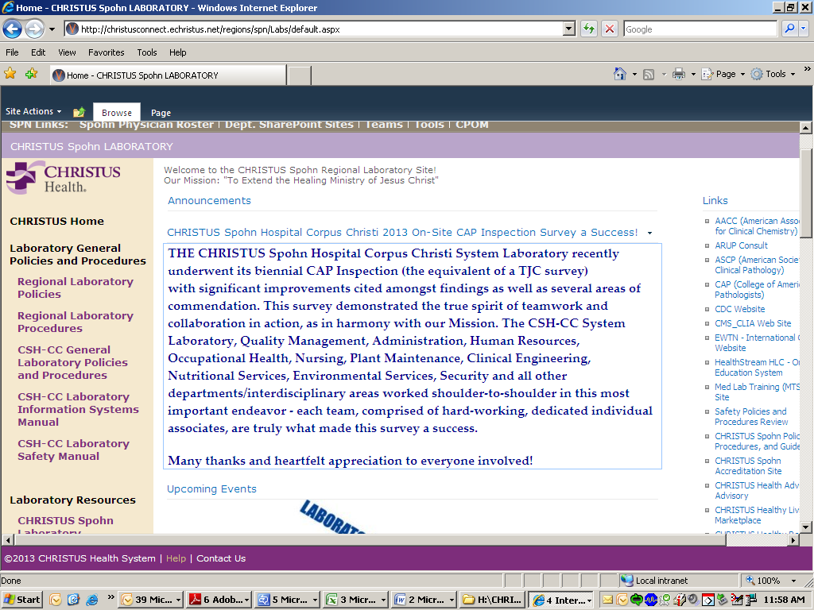

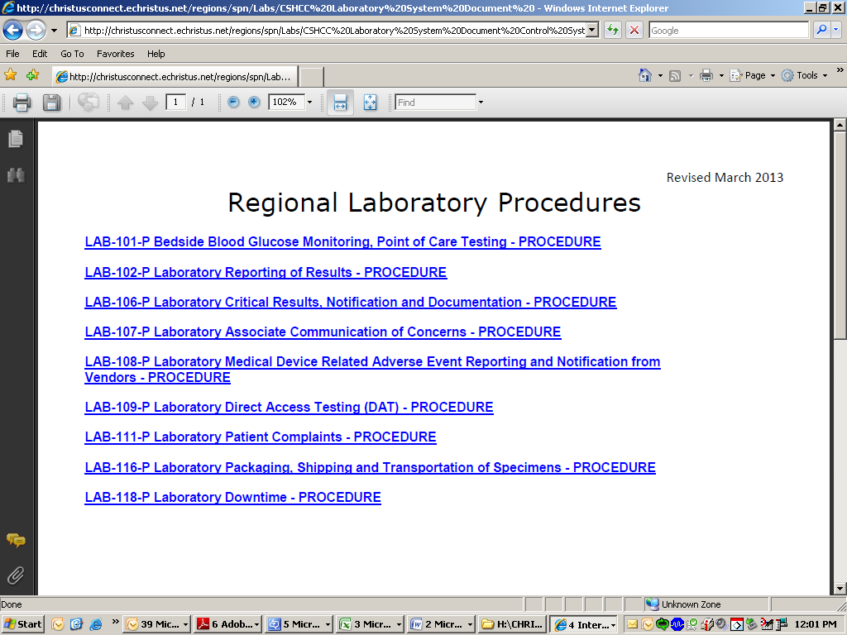

These links will link you directly to the policy or procedure which is stored on the Spohn Health System P&P site.

From this section, **Laboratory General Policies and Procedures**, you can also quickly obtain the **CSH-CC** **Laboratory Safety Manual**

1. **To access Departmental Specific Procedures and Documents** choose the appropriate library as shown below within **Department Sections**.

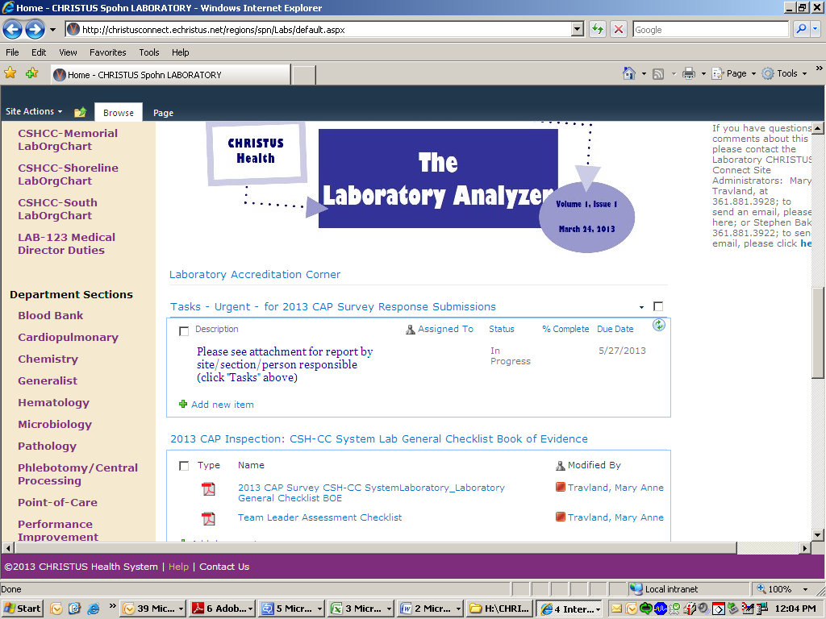

Upon choosing the appropriate section library (i.e. Microbiology) click on the policy/procedure or find the pertinent folder within (i.e. Microbiology – Specimen collection and Setup) to find the desired material.

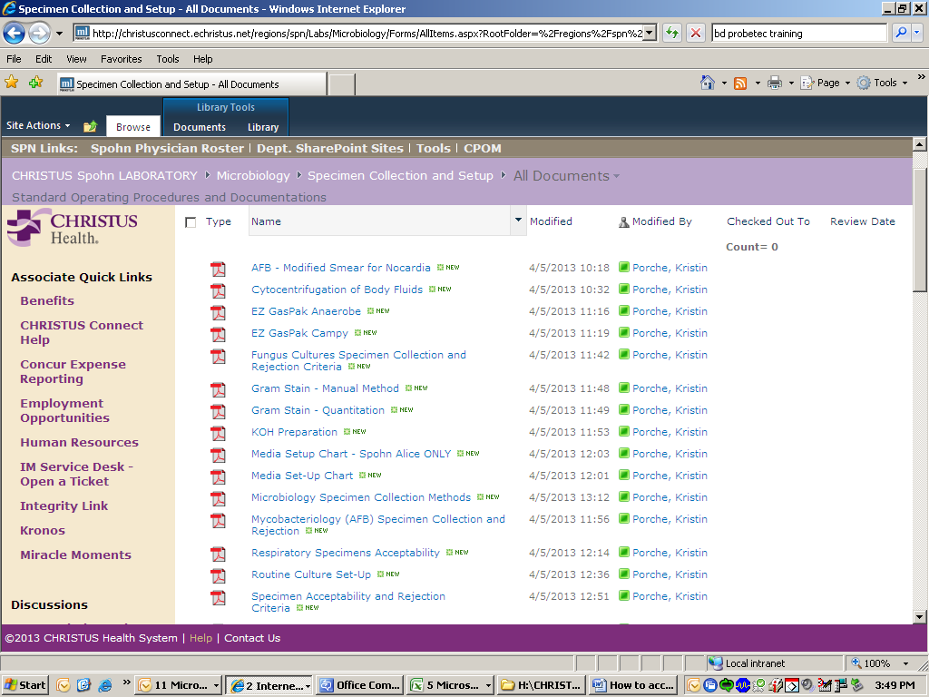

1. **To access Links to Commonly Used Websites (internal and external)** – Links are located along the right side of the home page.

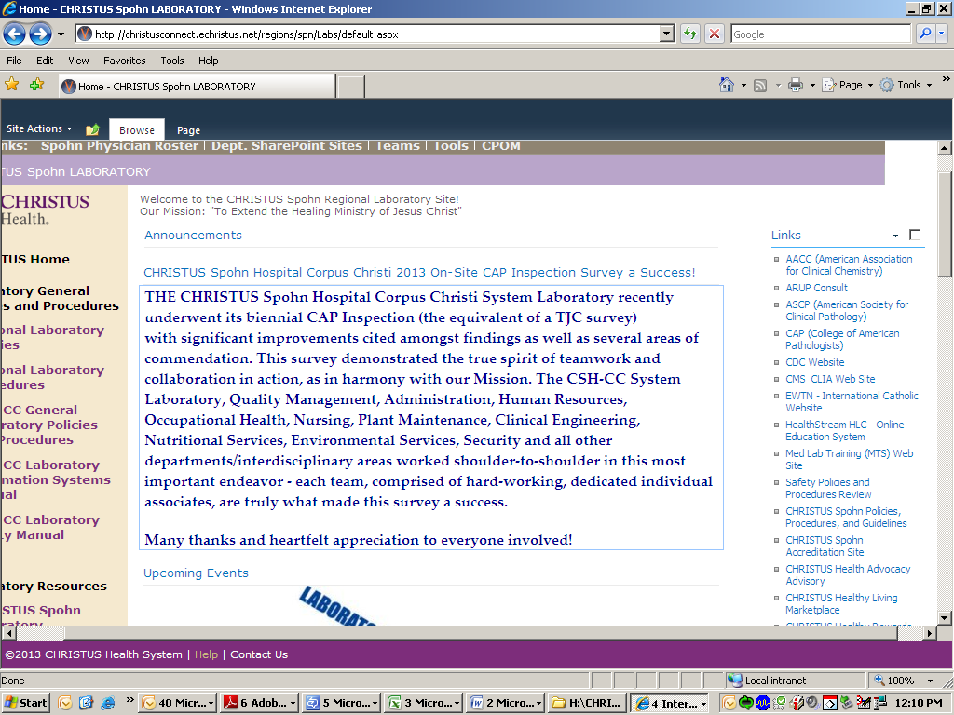

1. **To access Commonly Used Forms and other Lab resource material** click on the **Forms** link under **Laboratory Resources** and see the forms available which include **PTO request form** and **KRONOS Time adjustment form**s. From here you can also access Antibiogram Data, the Specimen Collection Manual & the Lab Online Test Menu.

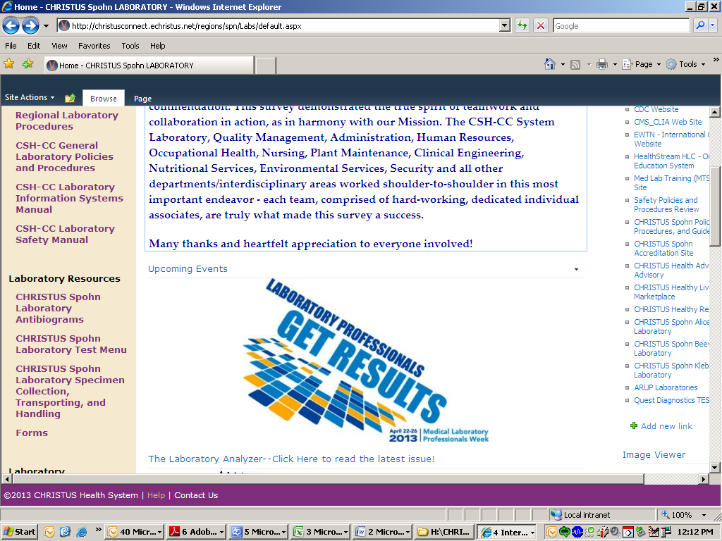

1. Within the middle section are Announcements and access to the Lab Analyzer Newsletter

**If unsure where to find something within all of the available folders,** click on the **Search**   C:\Documents and Settings\KBP8078\Local Settings\Temporary Internet Files\Content.IE5\Q2NX11MX\MC900442167[1].pngfield located near the top, as shown below, and choose the appropriate drop-down to limit the search. In the box to the right enter the term/word to be searched**. Note:** Limiting the search to a specific folder, i.e., to **“This Site: CHRISTUS Spohn Laboratory”** will make the search more applicable and pertinent to Spohn Lab material.

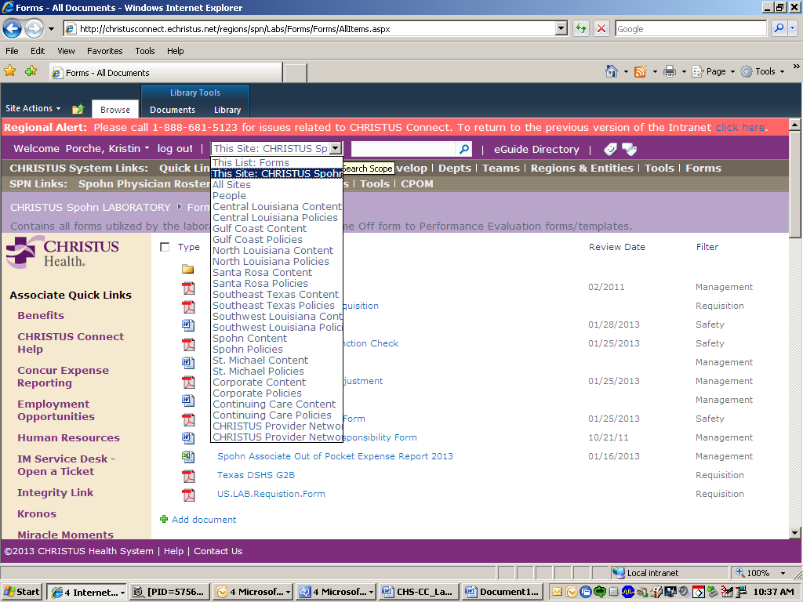

Example: Searching for **Bioterrorism** within Spohn Lab CHRISTUS Connect pulled the following:

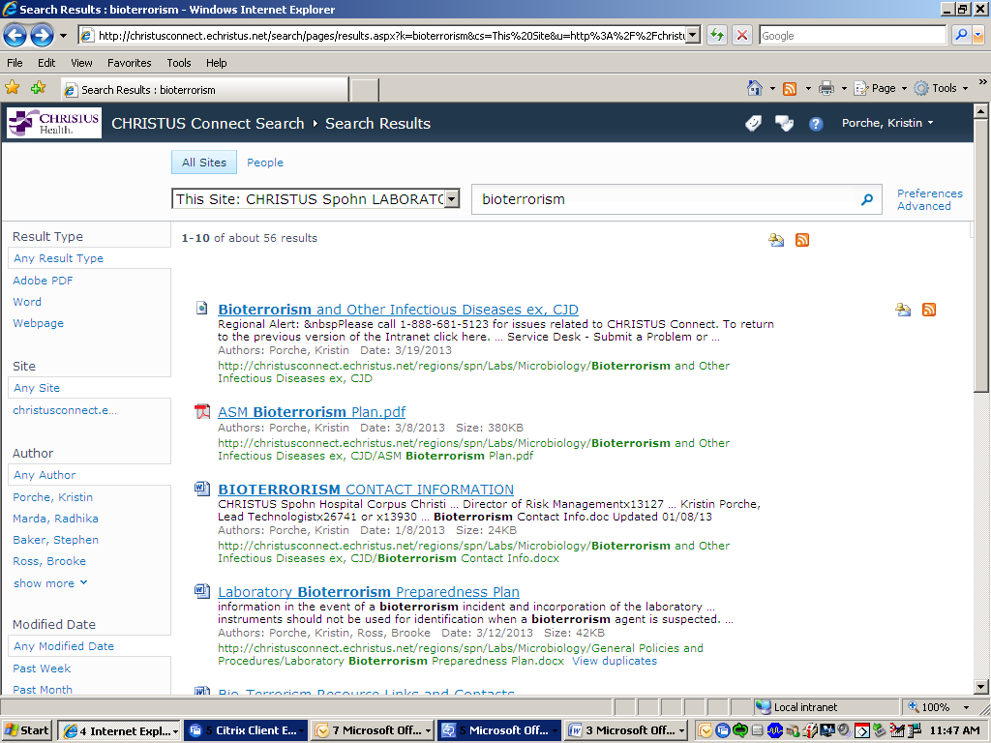

The most applicable and most recent hits are usually at the top of the search list.

**Familiarize yourself with the Search button to quickly and easily access content.**

**For further instruction on utilizing the Laboratory CHRISTUS connect site please ask your Lead Tech and/or Lab Manager.**