SOP Number: | CCP140 | Creation Date: | April 23, 2012
Department: | Central Processing/Phlebotomy | Effective Date: | January 29, 2013
Author: | N. Lozano | Version: | 02

Applicable Standards |  |  |  |  | Version History
Standard |  | Organization |  |  | Version | Effective Date |  | Deactivation Date
 |  |  |  |  | 01 | April 23, 2012 |  | January 29, 2013
 |  |  |  |  | 02 | January 29, 2013
Related Documents
Review History (Up to the Last 15 Occurrences)
Date | Version |  | Revision Type |  |  |  | Review By
4/2012 | 01 |  | Supervisor Review |  |  |  | N. Lozano
10/2012 | 01 |  | Pathologist Review |  |  |  | Dr. James Scherer
1/2013 | 02 |  | Major Revision-Lab Med Dir |  |  |  | Dr. Joe Lewis
4/2014 | 02 |  | Supervisor Review |  |  |  | N. Lozano
11/2014 | 02 |  | Revision-4.0 snap shots |  |  |  | N. Lozano

Distribution
CP SOP Volume 1

To define a standardized procedure for testing associates who experience an exposure to blood-borne pathogens via needle stick or splash.

1.0 Exposure to Blood-Borne Pathogens
(Expo Panel Source/ Expo Panel Associate)

1.1 The Texas Occupational Injury Assistance Plan (TOIAP) must be filled out immediately after notification of injury. The packet provides the Requisition for the Ordering of Laboratory Exposure Tests required by the laboratory. This packet is necessary to provide the details information which will allow the Occupational Health nurse to coordinate testing results of source and associate.

1.2 Associate must notify Supervisor immediate: Director/Charge Nurse/Shift Coordinator. Associate will receive CHRISTUS Spohn Health System TOIAP Injury Reports packet which must be filled out and submitted to Occupational Health Representative.

1.3 Following notification to Supervisor, Occupational Health RN should be paged using the following numbers:

Alice: Pager 361.224.3176 / Fax 361.6618369
Shoreline: Pager 361.224.1212 / Fax 361.881.3205
Memorial/Beeville: Pager 361.224.2185 / Fax 361.902.4396
South/Kleberg: Pager 361.224.1210 / Fax 361.985.5156

1.4 After Hours, Week-ends, and Holidays site Shift Coordinator must be contacted.

2.0 LABORATORY ORDER REGISTRATION

2.1 The laboratory must be provided with completed requisition form signed by the Occupational Health Nurse or the nursing supervisor before both exposure and source specimens are collected or testing is initiated. See Diagram 4.0 at the end of this document for examples of the Occupational Medicine Lab Authorization registration form.

2.2 Registration account is site specific:
AR/SML - AS/SHL - AV/SSL - AQ/SKL - AW/SBL - AY/SAL
Registration Client: Site.EMPHES (i.e. AR.EMPHES)
Location: OCC (i.e. AR.OCC)
Attending: OCCHEA

2.3 Reason for Visit window can display type of exposure, needle stick, blood borne pathogen or 6 month follow up.

2.4 Associate/exposure must have Hospital badge, which will provide a picture with ID number for EXPO PANEL ASSOCIATE registration protocol. Associate must also provide DOB, SS# and Assoc# as requested on Registration Form for Laboratory.

2.5 Patient/source for EXPO PANEL SOURCE will be provided in the TOIAP packet, which will provide the patient’s hospital account number, and follow ordering protocol. (Generate LIS order if patient’s unit did not). Notification of exposure to the Chemistry Department will allow staff to check for blood in lab. Blood in lab will be used if available and or patient/source will be collected as ordered “U” Urgent.

2.6 Non-Associate for Exposure will follow the initial Expo Panel Associate registration protocol and must also provide the DOB and SS#. Students, Physicians, Contractors and Visitors are classified as non-associates.

2.7 EMPEXP order set will be ordered for Associate/exposure and Non-Associate/exposure. EMPEXPSRC order set will be ordered for Patient/source. Comment order box will be used to link both accounts for Occupational Health Department management.

2.8 On EMPEXPSRC order comment box enter associate’s account number. On EMPEXP order comment box enter patient’s hospital account number.

2.9 Meditech aliquot label for both patient/source and associate/exposure will be adhered to requisition form. Requisition form will be file by Chemistry department.

2.10 Associate may have HIVCombo ABS and HCV orders for the 6 month follow up. Use previous created Medical Record number for follow up registration to avoid creating multiple medical record numbers. See Diagrams 4.1 – 4.7 at the end of this document for examples of the registration protocol.

3.0 LABORATORY TESTING PROTOCOL

3.1 EMPEXPSRC order group tests are HBSAG, HCVAB, and HIV1RAPID.
EMPEXP order group tests are HCVAB, and HIV1RAPID. HBSAB can/will be added as requested by Occupational Health RN if needed.

3.2 All patient/source HIV1RAPID specimens will be processed as ordered “U” and called immediately to site Occupational Health RN or site Shift Coordinator. Documentation of name, date, and time result called must be done for future reference.

3.3 SHL process all HBSAG, HCVAB, and HBSABPN daily before 1400 cut off time. Specimens are held in laboratory for at least 7 days.

4.0 DIAGRAMS

Diagram 4.0
Laboratory Order Registration

CHRISIUS SPOHN CHRISTUS SPOHN HEALTH SYSTEM
Health System OCCUPATIONAL MEDICINE LAB AUTHORIZATION FORM
Expo Associate Name Assoc#
Last First
Dept DOB SS#
Name
- Expo Panel - Assoc
Diagnosis (ICD-9/10 Code)
Authorization by Date
Medical Director:. Earl Matthew, MD
- Charge to OHO
CHRISIUS SPOHN CHRISTUS SPOHN HEALTH SYSTEM
Health System OCCUPATIONAL MEDICINE LAB AUTHORIZATION FORM
Expo Source Name Acct #
Last First
Dept Loc Occurred Medical #
- Expo Panel - Source
Diagnosis (ICD-9/10 Code)
Authorization by Date
Medical Director: Earl Matthew, MD
Charge to OHO
Place Patient Label HERE

Diagram 4.1
Laboratory Order Registration

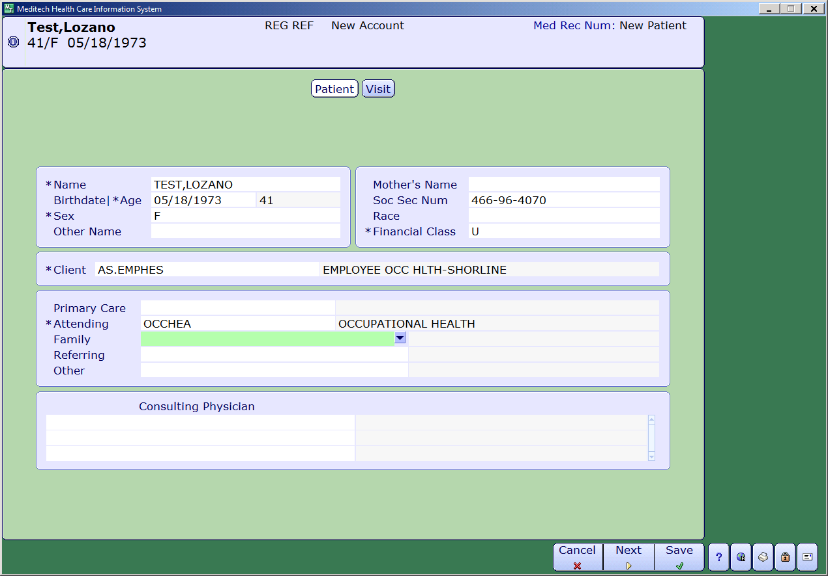

Diagram 4.2
Laboratory Order Registration

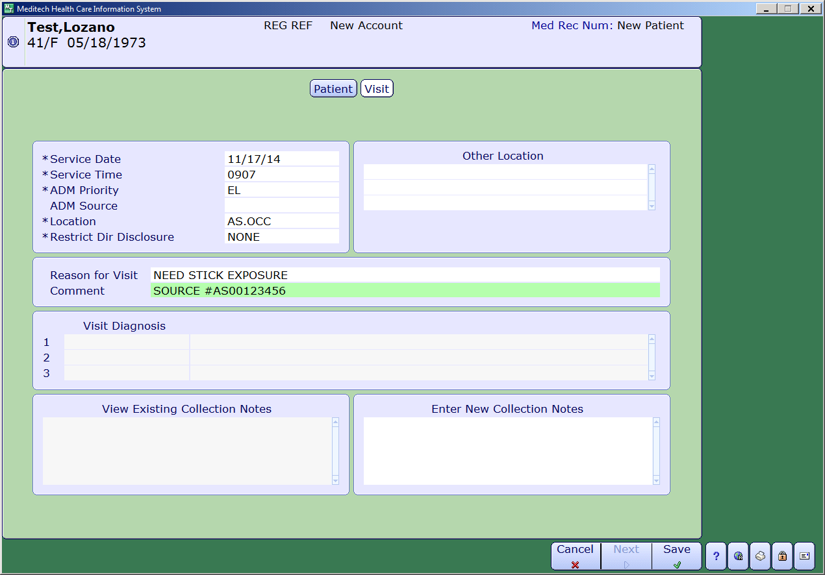

Diagram 4.3
Laboratory Order Registration

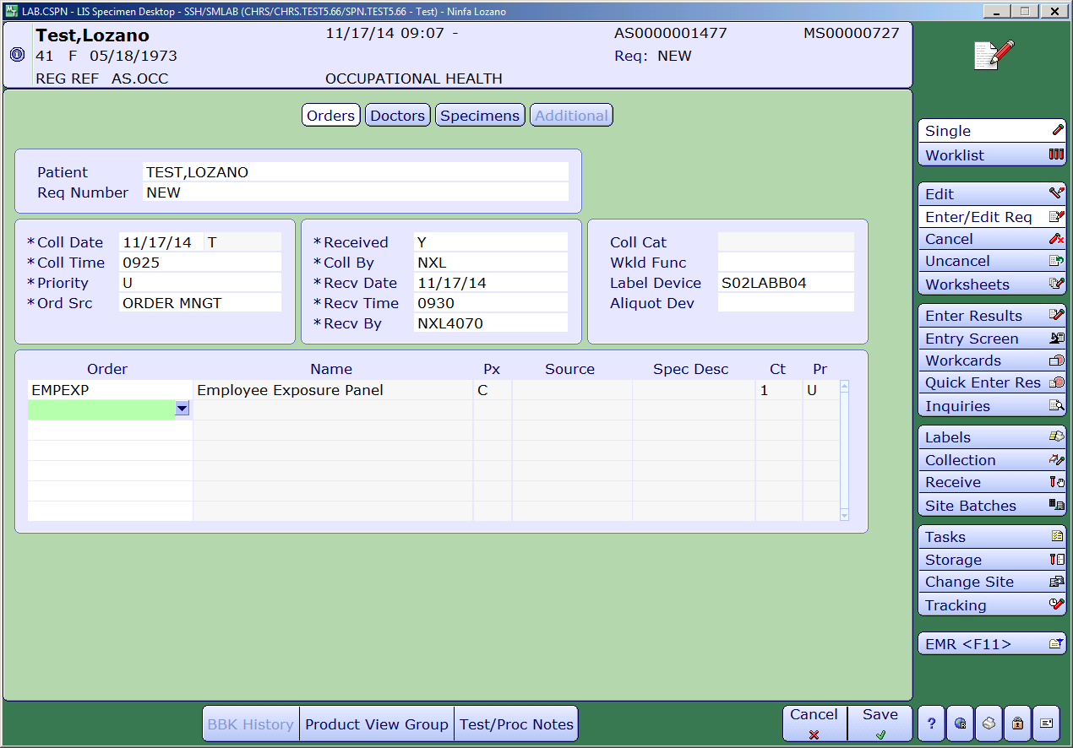

Diagram 4.4
Laboratory Order Registration

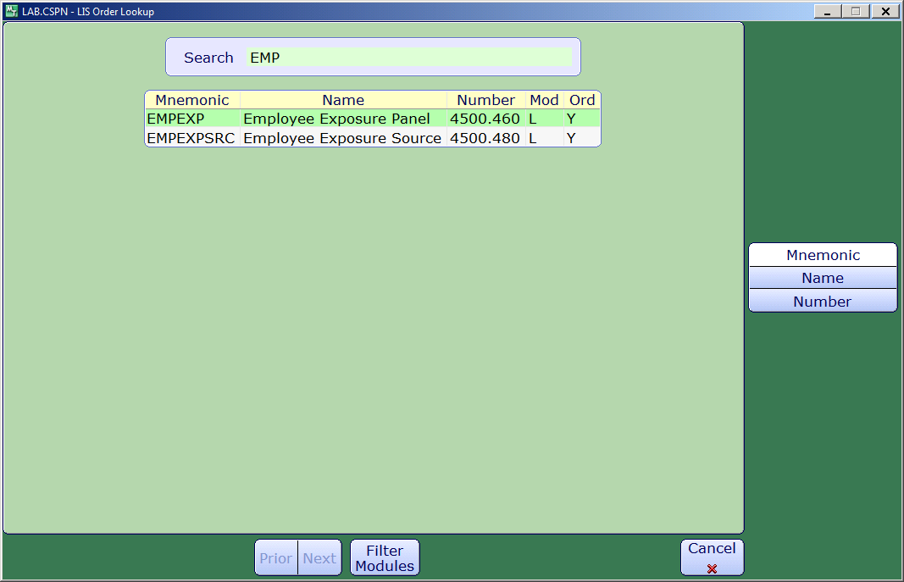

Diagram 4.5
Laboratory Order Registration

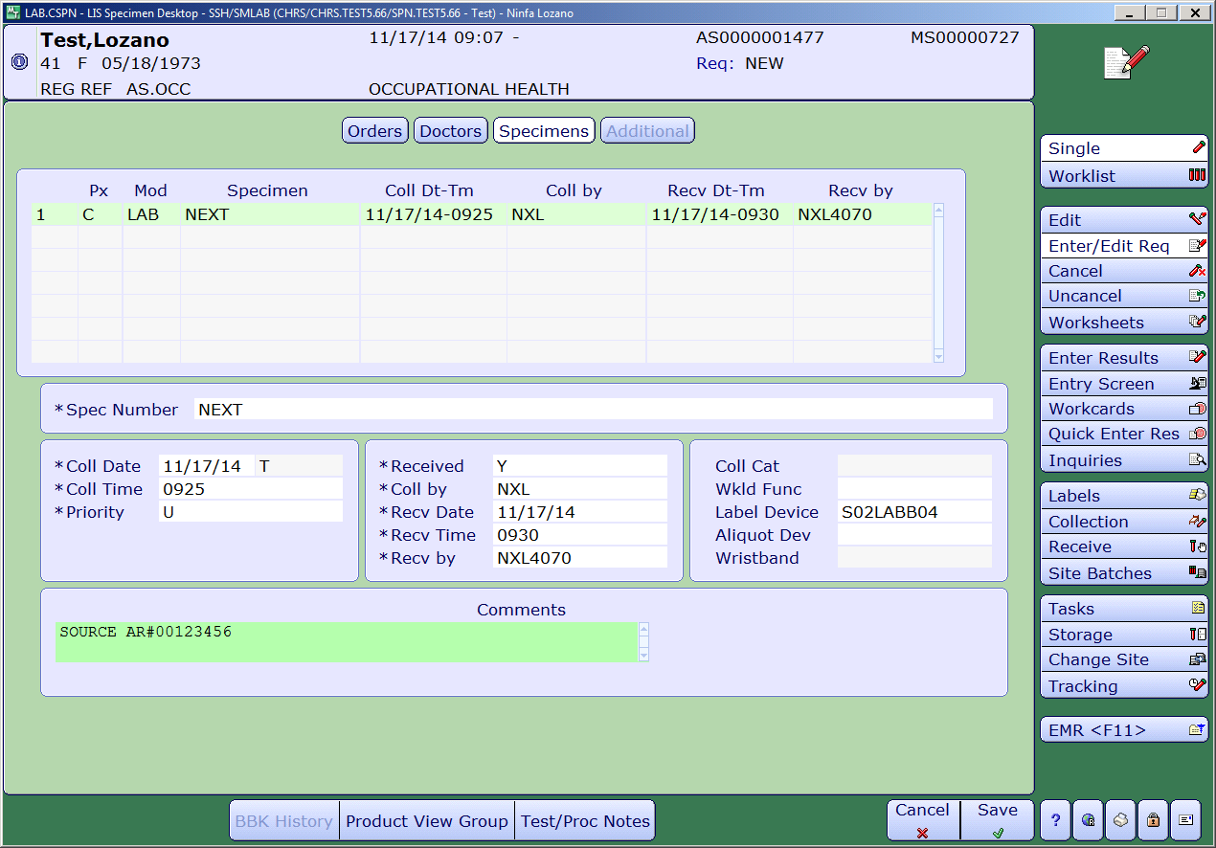

Diagram 4.6
Laboratory Exposure Follow Up Order Registration

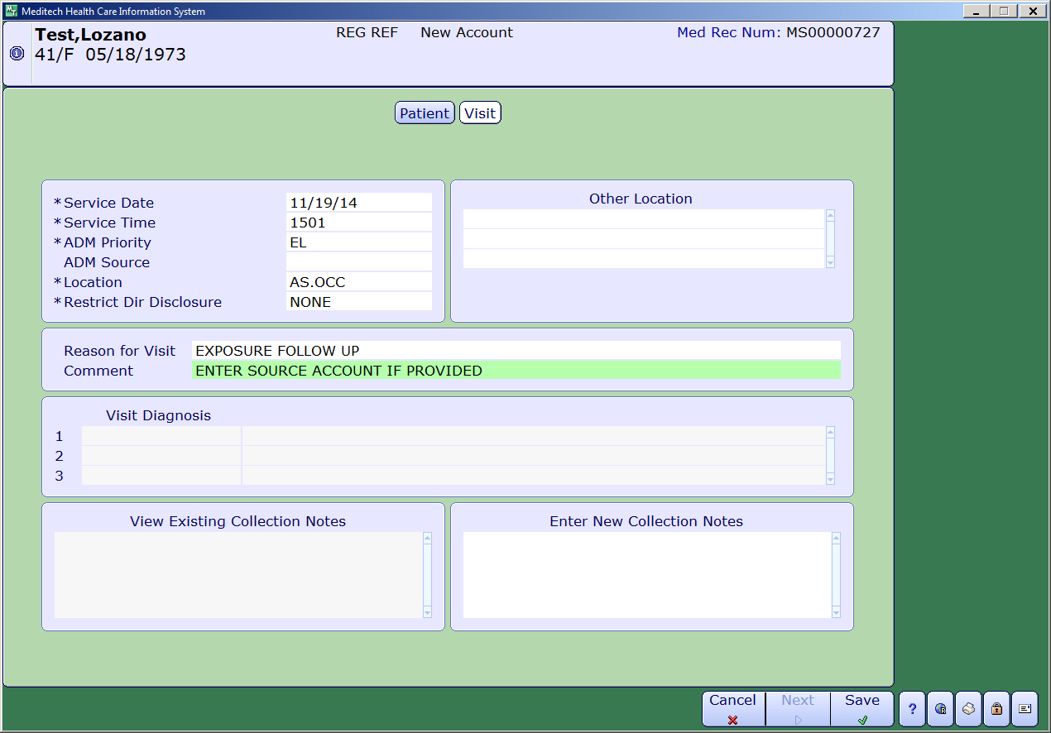

Diagram 4.7
Laboratory Exposure Follow Up Order Registration

