**Cord Blood Testing in GEL**

When we initially implemented Gel testing, interference with Wharton’s Jelly in cord blood specimens caused discrepant results. At the time the decision was made to continue performing tube testing on cord blood specimens.

L&D’s transition from collecting cord blood specimens in red top tubes to lavender top (EDTA) tubes has caused us to reevaluate our cord blood testing policy.

Our goal has always been to simplify and streamline our policies. Having as many tests as possible using the Gel technology is consistent with that goal. Therefore we will be switching to cord blood Gel testing starting on Monday July 20, 2015.

Read the Newborn Testing SOP starting on the next page.

Clinical Laboratory – Policy and Procedure

# Newborn Testing

## Principle:

Testing of newborns (patients less than 4 months of age) is primarily used to determine Rh immune globulin (RhIG) candidacy of the newborn's mother. Results can also identify and/or aid the newborn's clinician in resolving clinical problems with the newborn.

## Preparation:

Refer to the following SOPs for materials list, specimen requirements, reading and grading test results, and other test considerations:

* Test Standards
* Patient Specimens
* Gel Testing
* Tube Testing
* ABO Testing
* Rh Testing
* Direct Antiglobulin Test (DAT)
* Indirect Antiglobulin Test (IAT)
* Antibody Screen

## Specimen:

* Cord blood: Specimen must be labeled with the mother's name and hospital number since the newborn is not registered at the time of delivery. The specimen must also have the word CORD written on the label before the specimen can be accepted for testing.
* Venous blood: Specimen must be labeled with newborn’s name and hospital number.

## Procedure:

1. Review mother's current ABO/Rh and antibody screen results. Complete the RhIG Decision Log (refer to Appendix 1). A specimen obtained from the mother during her current admission is preferable. If a current specimen is not available, the ABO/Rh may be performed on any acceptable specimen submitted for lab testing. Perform the mother's antibody screen if the results are needed to resolve problems with the newborn's testing. Order and result the test(s) in the LIS.
2. For ABO/Rh and DAT, proceed as in SOPs listed above.
3. Perform weak D testing using the tube method when the gel anti-D well is negative.
4. When the newborn testing results in an AB Pos interpretation or when there are questionable reactions, i.e. mixed field reactions, repeat the ABO/Rh and DAT testing using the tube method.
5. Cord specimens must be washed 4 times to reduce false positive reactions due to Wharton's jelly which is a high molecular weight protein found in the cord.
6. Label tubes for the ABO/Rh, DAT. Label two extra tubes for repeat or additional testing if needed.
7. Add 1 drop of a 5% cell suspension of the newborn’s cells to each tube.
8. For ABO/Rh proceed as in SOPs listed above.

## Newborn DAT:

1. When the DAT tube method is performed, add two drops of Anti-IgG to the tube labeled DAT. Mix well and centrifuge.
2. Resuspend the red cells, read and record results.
3. Add one drop of check cells to each negative test, centrifuge, resuspend the red cells, read and record results. If this test is negative, results are invalid and DAT must be repeated. Document the repeat test as a comment in LIS.

## Negative DAT (Eluate Request):

Refer to ABO Antibodies (Newborn/Maternal) SOP.

## Positive DAT:

1. Report the positive DAT interpretation and grade reactions (+w, 1+, 2+, 3+ or 4+).
2. If mother's blood type and antibody screen have not been done, obtain a mother's blood specimen and perform these tests.
3. If mother's test results indicate that the positive DAT is due to immune ABO antibodies, no further testing is indicated.

ABO incompatibility is indicated when:

* Mother's antibody screen is negative

and

* Mother's blood is of a type that contains immune anti-A and /or anti-B

and

* Baby is group A,B, or AB and corresponds with the mother’s antibody. i.e. the baby is group A and the mother has anti-A

Note: Add the "ABO" comment to the "Positive" interpretation in LIS.

1. If the mother's plasma/serum is positive due to the presence of antenatal RhIG and/or a cold agglutinin, no further testing is indicated.

Note: Add the "RHIG" comment to the "Positive" interpretation in LIS. If both immune ABO antibodies and ARhIG may be present, add the "ABORHIG" comment.

1. Perform elution studies on all other examples of positive DAT.
2. A positive DAT is considered a critical test result. Call the patient care unit for all positive DAT tests. Add the “CALL” comment to the result in LIS.

## Weak D Invalid:

An Rh-negative mother must be considered an RhIG candidate if the D or Weak D testing is invalid for any reason.

## References:

* AABB Technical Manual

RB1410 v.1 Revised: 29Jun15

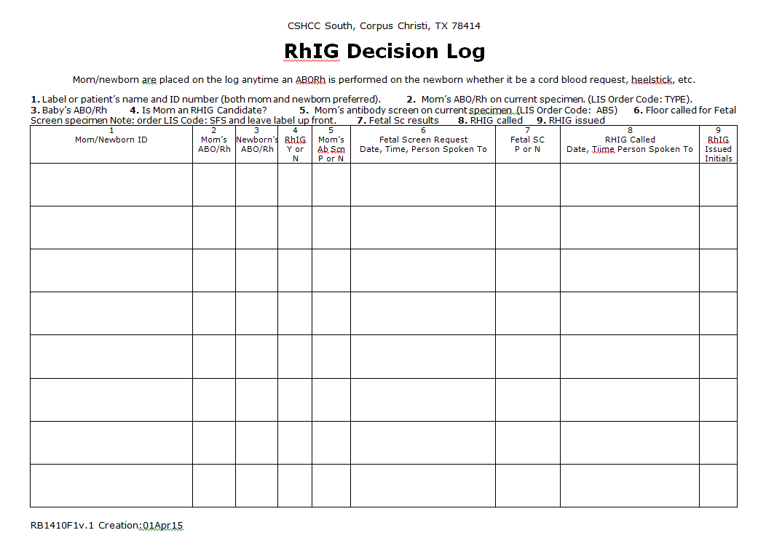

Appendix 1