**HemaTrax Unity Standalone User Guide**

**Introduction**

HemaTrax Unity is an application used to print Full Face and Product/Expiration Date Labels when Meditech is not available. The application is available on the PC that is serially connected to the ISBT 128 (Zebra) Label Printer(s).

**Getting Started**

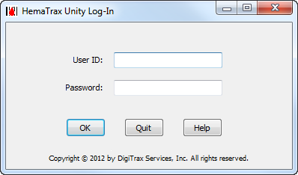

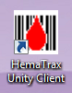

1. To login, click on the **HemaTrax Unity Client** desktop icon and enter your **User ID** (same as your Network ID). **Tab** advance to the **Password** dialog box. Scan your ID badge which is your password. Click **OK.**

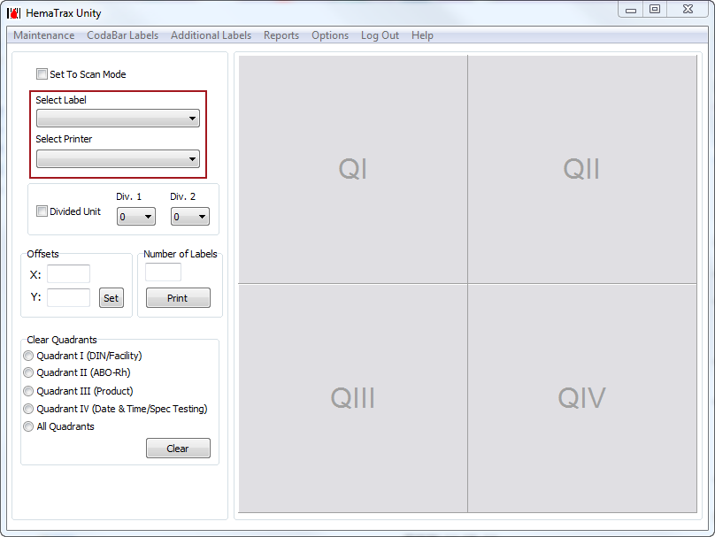

**Product/Date & Time Label – 4 x 2 (Thawed Products, Irradiated)**

Note: Only Quadrants QIII and QIV are entered for 4 x 2 labels.

1. Click on the **Select Label** dropdown menu and select **Product Date/Time.**
2. Click on the **Select Printer** dropdown menu to select your **4x2 printer**.
3. To fill in Quadrant III of the label, click on the grey square labeled QIII. The **Find Product** box will display.

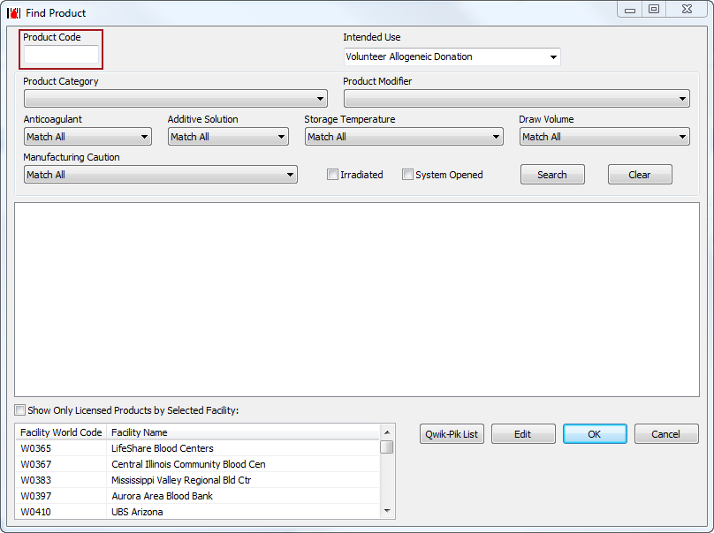

1. In the **Product Code** text field, type in the **Thawed** product code associated with the frozen product listed on the **Meditech Downtime Conversion Chart.** The product data will automatically populate in the remainder of the fields. Click **OK** and QIII will display product information.
2. To fill in Quadrant IV of the label, click on the grey square labeled QIV. The **Expiration Date and Time** box will display.

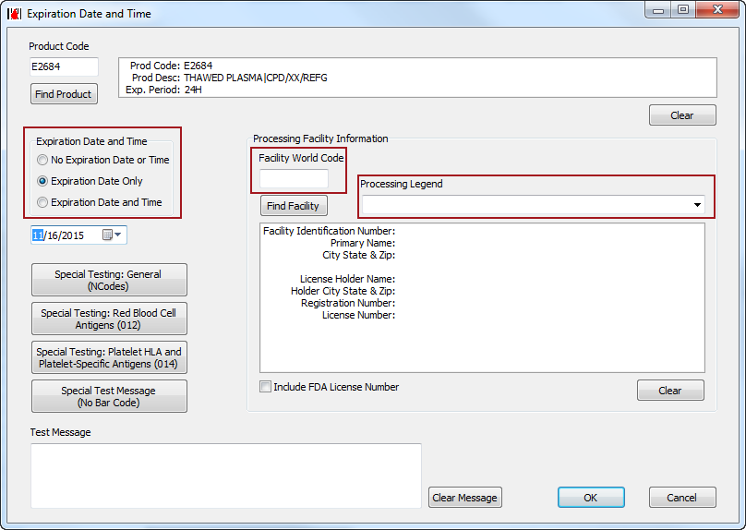

1. Under the Expiration Date and Time header, you can select the appropriate option by clicking the radio button next to the desired choice. Select **Expiration Date Only** or **Expiration Date and Time** as described in the **Transfusion Service SOP**.
2. Under the **Processing Facility Information enter:**
   1. Facility World Code
      * SALAB: W3098
      * SBLAB: W3097
      * SHLAB: W2287
      * SKLAB: W3096
      * SMLAB: W3095
      * SSLAB: W3094
   2. Processing Legend
      * Further Processed by
3. If CMV antibody negative (N0008) information is included on the original unit, enter the information under the **Special Testing General (NCodes)** button.
4. Select **OK.**

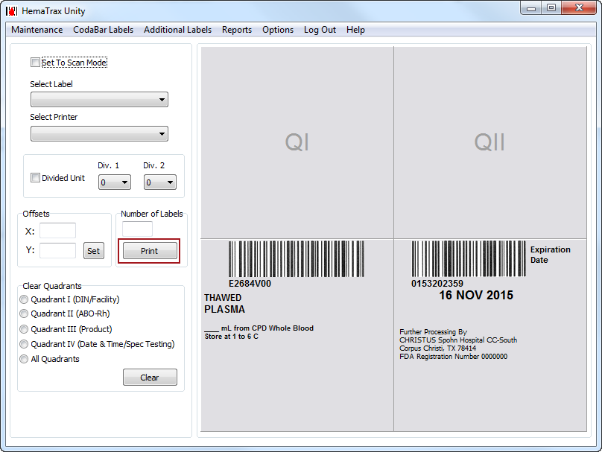

1. Click on the **Print** button to send your label to the printer.
2. When printing is complete, click **Log Out** in the horizontal menu to logout of the application.

**Full Face Label – 4 x 4 (Aliquot)**

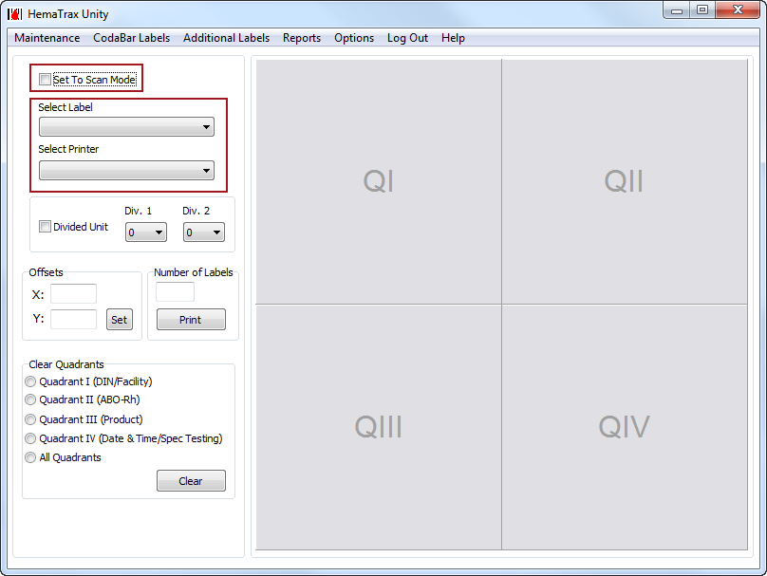

1. Select the checkbox next to **Set To Scan Mode.**
2. Click on the **Select Label** dropdown menu and select **Full Face**.
3. Click on the **Select Printer** dropdown menu to select your **4x4 printer**.
4. Scan the **Unit ID, Blood Type and the Product** barcodes from the original unit. QI, QII and QIII will automatically populate.

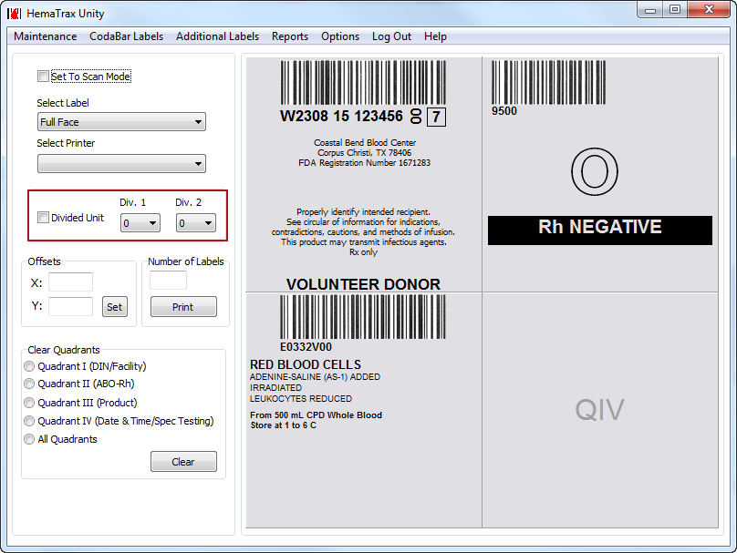

1. Select the checkbox next to **Divided Unit.**
2. Select the aliquot division From the **Div. 1** drop down. Leave **Div. 2** at **0** since it is not currently used.
3. Continue with steps 5 through 10 as described above for the 4x2 label.

**Clear Quadrant Data**

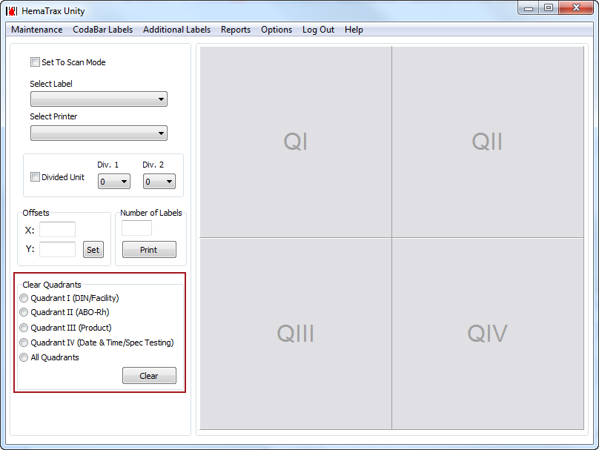

If you make a mistake entering information in any of the quadrants or a label for another unit is needed, you can select the radio button next to the relevant quadrant in the **Clear** Quadrants area of the screen, and then click the **Clear** button to clear out that quadrant. All Quadrants can be selected as well.