SOP Number: | CCP010 | Creation Date: | June 8, 2005
Department: | Central Processing/Phlebotomy | Effective Date: | January 29, 2013
Author: | N. Lozano | Version: | 02

Applicable Standards |  |  |  |  | Version History
Standard |  | Organization |  |  | Version | Effective Date |  | Deactivation Date
 |  |  |  |  | 01 | June 8, 2005
 |  |  |  |  | 01 | April 20, 2012 |  | January 29, 2013
 |  |  |  |  | 02 | January 29, 2013
Related Documents
Review History (Up to the Last 15 Occurrences)
Date | Version |  | Revision Type |  |  |  | Review By
4/2012 | 01 |  | Supervisor Review |  |  |  | N. Lozano
10/12 | 01 |  | Pathologist Review |  |  |  | Dr. James Scherer
1/13 | 02 |  | Major Revision-Lab Med Dir |  |  |  | Dr. Joe Lewis
4/14 | 02 |  | Supervisor Review |  |  |  | N. Lozano
11/2014 | 02 |  | Revision-Updated 6.7 |  |  |  | N. Lozano
2/2015 | 02 |  | Supervisor Review |  |  |  | N. Lozano
3/2015 | 02 |  | Revision- 5.6, 5.7, 11.1 |  |  |  | N. Lozano
4/2015 | 02 |  | Revision-Updated 10.7.2 |  |  |  | N. Lozano
6/2016 | 02 |  | Revision-Updated 5.5,7.2,10.6 |  |  |  | N. Lozano

Distribution
CP SOP Volume 1

It is the policy of the Central Processing and Phlebotomy Department to accuratelly provide the bolk of the pre-analytical processing of laboratory specimens.

1.0 LABORATORY COMMUNICATION BOARD

  - This board provides employees with written documentation of
Information pertinent to the operations of the CP department. Use this
board to enter comments regarding:

Absences – inform the Lab Manager or Lead Technologist when an
Employee calls in sick, to make arrangements for adequate staffing. Document call ins and tardiness data in Communication Book. Call in policy must be followed.
Meetings-date and time of meetings will be documented on board as well.
Central Processing and Phlebotomy procedure, policy changes
and clarifications are communicated through hospital email, department meetings, and one on one interaction with supervisor. A notice will be sent out via email explaining any procedural changes or revisions informing associates of these changes. Department meeting minutes will be saved on SharePoint and distributed via hospital email. Coaching tools, annual, mid-year evaluations and performance feedback will be communicated in private, one on one communication with supervisor and associate(s).

  - Any other information that assists in the smooth operation between shifts
is handed off verbally, OSR, or specimen tracker. Department equipment and or LIS software malfunctions are reported to appropriate personal or documented in CP/Phlebotomy Dep. Concern Log Book for future reference.

1.3 No badge –assocites are accountable for wearing their work badge. If work badge is damaged or lost, the associte will report to HR for immidiate replacement.
A KRONOS Time Adjustment form must be filled out for time correction(s) due to mis-punches.

2.0 PATHOLOGIST / ADMINISTRATION MAGNETIC BOARD

2..1 The magnetic board provides and updates location of the Pathologist and Laboratory Administrative personnel. A magnetic button designates the pathologist on call after 5 p.m., weekends, and
holidays which will be paged using number posted.
*In case of an Autopsy is needed by one of the Facilities do the following:

Day Time
2.11 Document name of the Facility or Funeral Home where the
Autopsy is needed.
2.12 Get the patient’s chart from Medical Records or the floor
and deliver to Pathologist’s Conference room table.
Content form must be sign by next of kin and doctor. Place content form in front of chart.

After 5 pm or Saturdays
2.13 Page and inform On Call Pathologist of Autopsy. Repeat
page if no respond after 5-10 minutes and or call back
from Pathologits.
2.14 After confirmation from Pathologist, notify requesting
Facility confirmation was made and the estimated time of
arrival.

2.2 Department will make the following documentation of phone call and Pathologist paged for FS;

2.21 Name of caller and their phone number
2.22 Specific site i.e SMH or SSH or SS
2.23 OR room and direct OR contact number
2.24 Physician or Surgeon’s name
2.25 Any information about the case i.e. Frozen section
will be made on CP Daily Activity Log for future reference and follow up.

2.3 To page Patholgist use icon Mobility Pager on computor desk top to access pager. Enter the following information when paging the On Call Pathologist SMH FS Rm “___” and Phone # “___” (please include area code and phone # ) ie. SMH FS RM5 316-902-4280. Verify direct OR contact number is on the specimen requisition.

2.4 Documentation for dispatching and or delivery of FS specimen from Memorial Lab to Shorleine Histology Frozen Room (Mon-Fri 0700 – 0500) will be made on CP Activity Log for futrue reference.

3.0 CENTRAL PROCESSING SPECIMEN COLLECTION LOG

3.1 Logbook #1, located in the CP area is the department daily activity log and contains specimen collection and updates concerning Hospital collections. (i.e.-unable, refused, phlebotomist dispatched). This logged information can be used to locate phlebotomist when paging for a STAT order or which person collected blood sample for compatiblity testing. Documentation of possible stroke patient specimens from ED are logged in Logbook #1 as per policy. See section Z :Laboratory Stroke Specimen Collection Policy.

3.2 Logbook #2, located in the OP area computer, contains specimen collection information. i.e Pathway for accessing log from Desk Top is as follow:
- My Computer
- S:
- LAB_SSH
- Memorial
- Phlebotomy
- Main Lab Out Patient Log
Select month in use, open file, use lower tab to open correct day. File/Save entered data before exciting.

3.3 CAP Specimen Recollection/Rejection Data Log is located in the CP area. Collected information is forward to the Laboratory Performance Improvement Coordinator and posted in QA board.

4.0 SPECIMEN COLLECTION, LOGGING, LABELING

4.1 Identification of the patient is crucial to ensure that the blood
specimen is being drawn from the individual designated on the lab
request form. Two positive identifiers will be used (i.e. name, acc#, DOB) as stated in NPSG #1 Improve the Accuracy of Patient ID.

4.2 To minimize unnecesarliy large blood draw volumes, patient’s lab orders are reviewed to avoid unnecessary repetition of tests, minimize the use of standing orders, and reduce adverse consequences of excess venipuntures.
Orders are combined or added to prevent unnecessary multiple collections and collection tubes.

4.3 Each specimen to be collected by phlebotomist must be labeled with a
pre-printed label created by the LIS. This label contains the patient
name,hospital number, room number or assigned clinic and the
specific test ordered. Each specimen must be inverted after collection
and labeled at bedside and in presence of the patient. DO NOT
LEAVE THE PATIENT OR THE PATIENT’S ROOM UNTIL THE
TUBES ARE COMPLETELY LABELED CORRECTLY.

4.4 To alert the technologist of a STAT, a CODE, or Special Handeling of
the specimen, color dots, insturction stickers, and or color border
labels will be used on specimen vials. (i.e. Blue/Green Dots,
Red/Yellow borders, “DoNot Centrifuge” stickers)

4.5 The pathway for printing specimen labels (i.e. indicating to the LIS that
The specimen is to be collected) is as follows:

- CHRISTUS Spohn Health LAB **LIVE**
- FACILITY
- CHRISTUS Spohn Hosp Memorial and or Hosp Shoreline
- LAB ASSITANT
- Phlebotomist Desk Top

4.6 The use of COLLECTION BATCHS PREVIEW AND CREATE provides the phlebotomist with a LIS test requistion label that contains a unique specimen number which is used for specimen. The first 4 digits are the date (i.e. 0513 for May 13) followed by a colon and a letter for department identifier (U for urinalysis), 5 numerical digits and a priorty code (S for Stat, U for Urgent, R for Routine, T for Timed, and Z for ABG/VBG). This label also contains patient name, hospital identification number, and nursing unit location. This requisition label contains aliquot labels used for containers associate with that specimen. The aliquot label contains the patient name, account number, and the LIS specimen number.

4.61 Pathway to Print a Collection Batch
      - Phlebotomist Desk Top
- Preview/Create.
- From and Thru Category.
Accept defaults or change range as specified per site location.
- Select F12/OK.
- Select Category(ies).
Use Create key to build the batch.
Message window will appear displaying Batch # if reprinting of batch is required.
- Accept defaut printer or change location.
See Diagram 22.0 at the end of this document for an
example of Preview/Create sequence.

4.62 Pathway to Reprint a Collection Batch
- Phlebotomist Desk Top
- Coll Batch.
- Reprint
- Enter Category Batch ID, Date, and Batch # to reprint.
If batch # is unknown, use F9 key to lookup list. At *Print window enter N and verify start location. Once correct batch # is located return to *Print window and enter Y.
See Diagram 22.1 at the end of this document for an
example of Batch Reprint sequence.

4.7 The CP daily activity log book is used by phlebotomist to provide a way to monitor patients collected, location of dispatched phlebotomists, FHC specimen arrival, and documentation of nursing home calls. A aliquot label or manual entry is used.

4.8 Specimens received in the Laboratoy must meet the specimen requirements and special instructions outlined for each Laboratory test in the Laboratory Service Directory Manual. All specimens will meet the integrity and quality Speciment Collection and Preparation Guide Lines.

4.9 Specimens arrive to CP by several methods. Pneumatic Tube System and or Hand delivered from nursing units, nursing homes, and or via couier. Specimens that are labeled with an addressograph or handwritten should be query in Meditech. The pre-printed label created by the LIS is printed and used to re-label specimen for processing after
verification of the two positive identifiers and collection informatiion. (refer CP Meditech Manual).

4.10 Re-labeling a specimen with the pre-printed LIS label must be applied without covering the patient’s name on the original label.

4.11 When handling specimens use Standard Precautions as outlined in the
Central Processing personal protective equipment table (i.e. – gloves and lab coat).

5.0 ADD-ONS, EXTRA SPECIMENS, HOLD ORDERS, BODY FLUIDS

5.1 Single container submitted specimens requiring more than one department are delivered to the first appropriate depatment with all submitted LIS order labels. (i.e. BFCNT,BFGLU, UA, UDS,URCUL etc).

5.2 Add-ons or additional testing requested by nursing units on specimen
that are already in the laboratory are order by the nursing units. If a
nursing unit calls and informs lab perssonel that an add-on is needed, the specimen integrety is verified. If specimen is acceptable, the nursing unit will order test with “specimen in lab” in comment box, or lab personnel will edit comment box using canned message (i.e. CPL/CPLP)which includes the name of nursing staff who requestd to use specimen in lab. Enter the accession number of specimen in lab on add on order/label which will help the technologist locate and process the specimen faster. The label should be distrubuted to the appropriate department and the personnel of that department should be informed of the additional test.

5.3 Laboratory samples submitted as extra specimens (i.e physician
anticipating additional orders) may be distributed to the respective
departments for storage. These specimens must be properly labeled with a patients name, hospital account number/DOB, time collected and initials of collector. Three XXX may be used to indicate the specimen is an extra collection. If the specimen is not labeled it is to be disposed of in a biohazardous container.

5.4 Extra body fluids that do not require cytology testing should be stored in a refrigerator. Each extra specimen must be labeled with the date and the words “EXTRA FLUID”. This will help indicate when the specimen can be disposed of.

5.5 “HOLD” order is enter by lab personnel on a Care Area collected
specimen or a CBN (Collected by Nurse) specimen with no LIS order.
The HOLD order will have documentation of specimen collection date,
time, collector, source, and name of nursing staff notified.

Specimen will be disposed as per set guidelines. Ref. section 11.1 for cancellation of “HOLD” order.

Discard specimen post stability range;

Specimen type Storage Stability Range
Urine Refrigerated 48 hours
Respiratory Refrigerated 48 hours
Swab Refrigerated 48 hours
Stool Refrigerated 48 hours
Body Fluid Refrigerated 7 days
BC Room Temp 24 hours

NOTE: CSF and or CODE BLUE specimen(s) are to be delivered to appropriate department.
5.6 CSF, unless otherwise specified the tubes will be processed as follows:
Tube#1 Chemistry
Tube #2 Microbiology
Tube #3 Hematology (deliver 1st) and Cytology (after Hematology**)
Tube #4 Hold tube for additional orders- Deliver to Chemistry
Receive all test orders, separate CSF vial with their corresponding orders and deliver to the apprpriate department(s). If only a small amount of CSF is obtained and/or less than 3 tubes are submitted to the laboratory, receive and deliver all CSF tube(s) to Microbiology.

**CP would only deliver specimens directly to Pathology if there were not corresponding Hematology orders or if a tube was specifically designated for Cytology/Pathology.

5.7 When CP department receives notification of a suspected case of Highly Infectious Pathogens (i.e., CJD, Mad Cow Disease, 14-3-3 prion/protein test) the associate taking the call is to Notify All laboratory sections by providing patient’s information, location, and specimen ETA. All suspected cases of Highly Infectious Pathogens, the specimens (CSF tubes) are to be delivered to Chemistry department.

While prior to specimen submission was intended for the collectors we would want any notification, even after the fact, communicated to all.

6.0 SPECIMEN RECEIVING, BATCHING

6.1 Each specimen received in Central Processing Department must be labeled with a pre-printed label created by the LIS. This label contains the patient name, hospital number, room number or assigned clinic and the specific test ordered. Specimens “CBN” are submitted with the Order Detail Form. Both specimen and form identifications are verified. (See section 6.3 if data does not match)

6.2 This Meditech barcode label also contain a specimen number that is unique for that specimen. The specimen number is utilized in the receiving process. The first 4 digits are the date (i.e. 0513 for May 13) followed by colon and a priority code (S for Stat, U for Urgent, R for Routine and T for timed).

6.3 The label contains a barcode and barcode number. The barcode number can be used for specimen identification on any hand-held barcode reader. The barcode number is translated by the LIS into the specimen number found on the label.

6.4 The pathway for receiving a specimen (i.e. indicating to the LIS that the
specimen is in the laboratory and ready to be tested) is as follows:

- CHRISTUS Spohn Health LAB **LIVE**
- FACILITY
- CHRISTUS Spohn Hosp Memorial or Hosp Shoreline
- LAB ASSITANT
- Specimen Desk Top
(Single and Receive are automatically selected)

6.5 Press the Enter key or the Tab key to get to Specimen window. Enter the specimen number and press the Enter key or the Tab key. The LIS will bring up the associated patient name and information. Verify that the information is correct.

6.6 Enter the collection time and the identifier/initials of the person
Collecting the specimen.

6.7 Use comment box to identify a recollected specimen. The use of canned messages (i.e CPRS or 1RC) may be used in comment box for Nursing Staff, Doctor, and Laboratory staff. All updated comments must be enter before any other comment in box. (i.e. to be recollected-specimen hemolyzed-specimen clotted) This will eliminate any confusion/questions.

6.8 When all information has been entered, use the mouse to click on the
Save button (green check mark) at the bottom right hand side or press F12 key. This files the information and makes the specimen available for further processing. See Diagram 22.2 at the end of this document for an example of the receiving screen. Also, refer to the Client/Server
Laboratory Module User Manual, Released 5.1 for more detailed information.

6.9 When all information has been entered, if an asterisk (*) appears on the Ed CD column Collected window between Time and By this indicates a discrepancy between order date and collection date or the specimen has been marked to edit the collection date. After information has been verified and the F12/OK key has been press, a window will appear to FILE, EDIT, or CANCEL specimen. Select FILE if order and collection information is correct, select EDIT if order date needs to be corrected (new specimen number will be assigned) or CANCEL if not sure and futher information is needed.

6.10 The pathway for batching a specimen (i.e. indicating to the LIS that the
specimen is in the laboratory, ready to be batched, and to be sent out to be tested) is as follow:

- Specimen Desk Top (change task by selecting from right hand side)
- Site Batches
- Enter/Edit

6.11 At the Batch Date window enter T (today’s date), use tab key/enter key to advance to Batch Number window. Enter N (New). Use tab/enter key tto advance to Send From Site window. Enter SMLAB, use tab/enter key to advance to Send to Site window. Enter SHLAB. Tab/enter key to advance to Include Specimen Form Pool window. Very important to enter “N”. Advance to Specimen window. Scan label or enter specimen number. Advance to Batch Status and enter Send. F12 to file.

6.12 The Print Destination window appears. Increase the Copies to be printed to 2. Select OK to print.

6.13 Submit one batch sheet with specimen and give second sheet to
Chemistry department.

7.0 VERIFICATION AND REJECTION OF SPECIMEN

7.1 The meditech bar-code label should be placed on the specimen or if
the label is not available, an addressograph label should be placed on
each tube. All specimens submitted to lab must have two positive identifiers. The specimen must include the time of collection and the identifier/intials of the person collecting the specimen. Specimens must be collected in the appropriate tube for the test that is ordered. This information can be found on the right side of the specimen label. (i.e. Lav5 for H&H/EDTA 5ml, Blue5 for PTT/SODIUM CITRATE 5ml, SST10 for K/SERUM SEPERATOR TUBE 10ml). The specimen will be visually acceptable draw. Short draws will be Rejected.

7.2 Any unlabeled specimen or discrepancies with submitted specimen and order requistion are to be discarded and the nursing station notified
that the specimen has been rejected and a new specimen must be collected. (Refer to Laboratory Specimen Rejection Policy.) File a Risk Management “Risk Event Notification” using CHRISTUS Connect and document in the Central Processing Specimen Logbook. The reason for rejection and action taken with specimen must be part of the LIS specimen comment process for future referral.

7.3 If a specical means collecion specimen is received into the laboratory with any of the aforementined labeling or identification problems the unit manger/shift coordinator is notified. The responsible collector will come to the laboratory and sign a “Specimen Acceptance of Responsibility” form followed by documentation of the “Risk Event Notification” and Central Processing Specimen Logbook. (Refer to Laboratory Specimen Rejection Policy)

8.0 RECOLLECTED SPECIMENS, EDITING

8.1 When “received” specimen are found to be unacceptable by department technologist, (i.e. hemolyzed, clotted), CP/phlebotomist
will be requested to recollect specimen(s). The reason for recollection of specimen will be documented in the CAP Specimen Rejection Collection Data Log. The specimen will be unreceived in the LIS. The reason for unreceiving must be noted for future referral. (i.e. Time/reason for rejection- recollection/name of nurse notified followed by initals of documenter. Use F5 to access CP canned messages)

8.2 When a specimen is “not collected”, enter reason in comment box found on ther bottom left hand side of the screen. See Diagram 22.3 at the end of this document for an example. (i.e. Time/reson specimen was not obtained/name of nursing staff notified/intials of editor. Use F5 to access CP canned messages )

8.3 The pathway for unreceiving or editing a specimen (i.e. indicating to
the LIS that the specimen is to be colleted) is as follows:

- Specimen Desk Top
- Edit
- Specimen Data
- Unrecieve

8.4 Enter the patient’s account, select test from list and press the Enter
key. The LIS will bring up the associated patient name and
information. Verify that the information is correct.

8.5 Enter new collection catogory and time. Advance to append to
comment box and enter Time/reason for rejection- recollection/name of nurse notified followed by initals of documenter. Advance to specimen box, verify specimen number to recollect. Remove other specimen numbers which maybe in same requisition or they too will be unreceive.

8.6 When all information has been entered, use the mouse to click on the
Save button (green check mark) at the bottom right hand side or press F12 key. Unreceive order is now “ORD” status and can be pulled from Preview and Create menu.

9.0 DISTRIBUTION OF SPECIMENS TO RESPECTIVE DEPARTMENTS

9.1 Acceptable specimens that have been received into LIS are available
for distribution to the Laboratory departments. Specimen are delivered to their respective departments promptly, notifying Technologists of special priorities (i.e. STAT or CODE BLUE). See Section 17.0 Delivery of Specimen from Central Processing which list the departments and vials.

9.2 STAT and or CODE specimens should NOT be batched for delivery while
receiving and should be delivered to their respective departments
immediately. See section Z :Laboratory Stroke Specimen Collection Policy for the essential step of the placement of a BLUE DOT on each tube with subsequent placement of speciment(s) in a BLUE BIO-BAG.

10.0 UNCOLLECTED SPECIMEN

10.1 The use of LAB PATIENT MASTER LOG and THE SPECIMEN
TRACKING provides the phlebotomist with a LIS list of past and future
patient lab orders which have not been collected. This information
contains patients account number, patient’s name, location, and time for collection. This helps phlebotomist monitor uncollected specimens in modules L (Lab), M (Micro), and B (Blood Bank).

10.2 The use of L modules provides the phlebotomists with a list of patient orders from the following departments;Hematology, Coagulation, Chemistry, Serology, and Urinalysis.

10.3 The use of M modules provides the phlebotomists with a LIS list of patients which have not been collected for Microbiology and pending PPD. See Diagram 22.4 at the end of this document for an example. Labels can also be reprinted using specimen number available from list. Internal inquiry of order can be viewed by clicking on lefts side window which selects patient and order to view comments and or ordering detail questions.

10.4 The pathway for LIS Patient Master Log (i.e. indicating to the LIS that
the specimen is to be collected ) is as follow:

- LAB ASSITANT
- Mangement Reports Desktop
- LIS Patient Master Log

10.5 The pathway for LIS Specimen Tracking is as follow:

- Specimen DeskTop
- Tracking (Right Hand side)
-Laboratory
-Microbiology
-Blood Bank

10.6 For daily monitoring and editing of uncollected specimens, ACCEPT all set defaults for profile. i.e. SMCP, SHLPET, SHLCPPAV. Press F12 key. This files information and allows LIS to print to screen or printer of choice. Use mouse and click on Preview to print to screen or Print to print to paper printer.

10.7 For Morning Collection Stacks monitoring and editing of uncollected
specimens, the same pathway is used but, before accepting set defaults for profile SMCP or SHCP, change COLB value to ORD.

Click Save or press F12 key. This files information and allows LIS to print to screen or printer of choice. Use mouse and click on Preview or Print.

10.7.1 To minimize blood collection volumes, deletions of duplicate orders, combining of orders, and line draw patients, orders are edited using the above printed information from the Print Master Log. Date/time stamp “Line Draw” sheets sent to floors and date/time stamp sheets as they are retuned to lab.
See Diagram 22.5 at the end of this document for an example.

10.7.2 Line Draw order labels are edited using canned message CPTS. Order collection label(s), vial(s) are packaged in bio-bag and send to the unit for nurse to collect.

10.7.3 From the Preview and Create screen, select and create batches
0000-0600.

10.7.4 Separate labels instacks, grouped by floors. Separate individually by patient, keeping each patient’s labels attached. Pull out labels for the LINE DRAWS and place on line draw rack.

10.7.5 Calculate the total number of patient draws and divide among the Graveyard and AM phlebs.

10.7.6 Vial and LIS order label is bagged for each patient listed and send to appropriate floor for RN to collect.

11.0 SPECIMEN CANCEL/UNCANCEL

11.1 Test ordered on a patient will be CANCELLED if specimen was
unobtainable, patient refused, Nursing unit requested cancellation, duplicate order, LIS order for “HOLD” specimen entered/recieved, and test was on wrong account number or wrong test. Nursing unit will be notified and reason for cancellation must be part of
the cancellation process for future referral. See Diagram 22.7 at the end of this document for an example.

11.2 The pathway for cancelling a specimen to be cancelled (i.e. indicating
to the LIS that the specimen is to be cancelled) is as follows:

- LAB ASSITANT
- Specimen Desktop
- Cancel

11.3 Enter specimen number and press the Enter key, press F12 key, or use
the OK button (green check mark). The LIS will bring up the associated patient name and information. Verify that the information is correct. Enter the reason for cancellation in the Cancellation Comments Box. (i.e. Time/Reason for cancellation/Name of staff requesting cancellation or the use of canned message 1SR)

11.4 When all information has been entered, use the mouse to click on the OK button (green check mark) or press F12 key. This files information and allows LIS to cancel specimen.

11.5 The pathway for uncancelling single or multiple specimens/requistion to be uncancelled is as follows:

- LAB ASSITANT
- Requisition Desktop
- Uncancel Req

11.6 Test ordered on a patient will be UNCANCELLED if cancellation was
done in error, or if patient allowed specimen to be collected with in four hours of cancellation. Reason for uncancelling must be part of the
uncancelling process for future referral. See Diagram 22.7 at the end of this document for an example.

11.7 Enter patient’s name or account number and press the Enter key, press F12, or use the OK button (green check mark). The LIS will bring up the associated patient name and information. Verify that the information is correct.

11.8 Enter the F9 key (i.e. indicating to the LIS to do a Lookup of requisition status). Use arrow key to select test to be uncancelled. Press the Enter key, press F12 key, or use OK button (green check mark). Verify that correct test was selected to uncancel.

11.9 The test selected will be indicated with an arrow on the far right side.
Press the letter Y for the box under Uncancel? and press the Enter key. Enter reason for uncancelling specimen in Append to specimen comments found on the bottom left hand side of the screen. (note that LIS
automaticly list time and date user cancelled and uncancelled specimen) The reason for uncancelling specimen must be noted as
part of the uncancelling process for future referral. Press the F12/OK key to file.

12.0 ORDER ENTRY CANCELLATION REQUEST

12.1 Test ordered are not elligable for cancellation by nursing staff if order status is COLB. Nursing staff request OE cancellation if test is a duplicate order, no written order, Doctor’s request, orders are
discontinued, and wrong test. OE cancellation request form will print in CP printer. Request Form will have all information needed for lab to cancel test. Reason for cancellation must be part of the cancellation process for future referral. Refer to 10.2 for cancellation pathway.

12.2 OE cancellation request form will have date, time, test to cancel, Req#, and reason for cancellation request. Use arrow key or mouse to select test to be canceled. (Note: Test should be in COLB status, but occasionally test may be in COMP status)

12.3 The LIS will bring up the associated patient name and information. Verify that the information is correct. Use Req # from OE Cancellation form to verify selection is correct. (Note: Req # is found on left top corner following three asteriks.) Enter the reason for cancellation in the Cancellation Comments Box.

12.4 When all information has been entered, use the mouse to click on the OK button (green check mark) or press F12 key. This files information and allows LIS to cancel test.

12.5 Remove collection label from collection rack, found in Phlebotomy area.

13.0 EDIT SPECIMEN DATA/COLLECTION DATA

13.1 Test ordered on a patient will be elligable for EDIT SPECIMEN
DATA/COLLECTION DATA if specimen was unobtainable and Nursing
unit requested date change or patient was recollected and time is
essential to patient treatment. See Diagram 22.9 at the end of this document for an example. (note:order date and service date must match for insurance purpose.)

13.2 Specimen collection dates will need to be changed if a specimen was ordered prior to midnight but collected shortly after midnight. This will ensure collection times do not conflict with order times. Specimen collection times will need to be changed if patient is receiving blood or therapeutic drugs and timing is curcial for obtaining the specimen at the correct time. Also, if patients leave for procedures and the nursing staff will ask to collect once they return at a later time.

13.3 The pathway for EDIT SPECIMEN DATA of a specimen to be change
(i.e.indicating to the LIS that the specimen’s date is to be changed and a new specimen number will be assinged) is as follows:

- Specimen Desk Top
- Edit

13.4 Select Specimen Data, enter specimen number which will bring up
associated patient's name and information. Verify all information is correct.
Edit the specimen’s Coll time, Status, Received status, the Recv date and time, Rec’v by, or add individual specimen comments.

13.5 To edit collection date, same pathway is used, but select Collection Data See Diagram 22.10 at the end of this document for an example.)

13.6 Enter the new collection date or use T+1 (Today plus # of future dates).
Use Enter key to advance to specimen window and scan barcode. Verify the information is correct. Press F12/Save key to file. Specimen order status is “ORDER” and will returns to Preview and Create.

14.0 NON HOSPITAL/REFERED SPECIMENS

14.1 Specimens received in the Laboratory must meet the specimen
requirements and special instructions outlined for each Laboratory test in the Specimen Collection Manual.

14.2 Non Hospital/Refered patients are regristered in the LIS by Admitting
staff or occationally by Laboratory staff. Refered specimens are hand
delivered or arrive via courier. Specimens are delivered to CP and follow CP SOP policy. Refer to Section S-Out Patient Specimen Collection for stepwise instuctions.

15.0 REFERENCE LABORATORY SPECIMEN HANDLING

15.1 Specimens received in the Laboratory must meet the specimen
requirements and special instructions outlined for each Laboratory test in the Specimen Collection Manual. Specimen unacceptability can be discovered during any stage of specimen processing – pre-analytic, analytic, post-analytic – and thus rejected in any of these stages.

15.2 If online instructions are unavailable (computer system down) this information is obtained by calling the laboratory number. Telephones are answered 24 hr/day 7 days/wk. to provide collection instructions.

16.0 ADD- ONS AND EXTRA SPECIMENS ON NON
HOSPITAL/REFERED CLIENT

16.1 Add-ons or additional testing requested by Non Hospital/Refered Clients
on specimens that are already in the Laboratory are ordered by Admitting
or Laboratory Staff. Admitting staff must verify order date, received date
and service date, as well as the ICD9 code. Verbal phone orders are unacceptable.

16.2 Laboratory samples collected as extra specimens may be distributed to the
respective departments for storage. These specimens must be properly labeled with a patient’s name, time collected and initials of collector.
Three XXX are used to indicate the specimen is an extra collected sample for an anticipating order which may follow. If the specimen is not labeled, it is to be disposed of in a biohazardous container.

17.0 DELIVERY OF SPECIMEN FROM CENTRAL PROCESSING

17.1 Laboratory blood samples are received by phlebotomist and
delivered to their appropriate department.

Tube Color/Additive Department
Lavender (4.0) EDTA “H” Hematology
Lavender/Pink (10.0/7.0) EDTA “BB” Blood Bank
Lavender (4.0) EDTA “LR” Chemistry/SSH STAT LAB
Blue NaCitrate “CG” Coagulation/SSH STAT LAB
Yellow (6.0)SST/Clotting “C” Chemistry
(4.0) SST/Clotting “S” Chemistry
Red (6.0) Clotting “C” Chemistry
Grey NaFluoride “C” Chemistry
Green Lith Heparin “C” Chemistry/SSH STAT LAB
Na Heparin “LR” Speical Chemistry
Green(Aero) BacT/ALERT FA “BC” Bacteriology
Purple(Ana) BacT/ALERT SN “BC” Bacteriology

When the specimen is found to be unacceptable, (i.e. hemolyzed,
clotted, questionable) Techs or CP/Phlebotomist will unreceive, make
comment, and request recollection(Ref:8.0). Collect data on CAP
Specimen Data Log which is submitted to Laboratory Performance
Improvement Coordinator.

17.2 Laboratory urine specimens are received by phlebotomists and or CP.
When multipe urine orders are submitted, all labels will remain with
urine sample for technologists to aliquot and deliver to next
appropriate department.
Urine specimens are delivered to the following department;

Routine “U” Urinalysis
Cultures “M” Bacteriology
UDS “C” Chemistry
HCG “S” Chemistry/Hematology

18.0 PHLEBOTOMY SUPPLY STORAGE

18.1 Due to the importance of specimen integrity and accuracy of patient
results phlebotomy collection tubes are monitored closely. Expired
tubes will not be used and will be discarded. Vacutainer tubes must be
stored at a temperature range of 4˚ C – 25˚ C as suggested by the
manufacture.

18.2 Storage room temperture must be monitor and recorded daily by
Designee who will document reading and initial temperature log post in
storage room.

18. The digital thermomerter has a built in alarm that will alert when the
temperature falls above or below the acceptable storage temperature.
The corrective action log on the temperature log must be documented
with corrective action taken to address the temperature change.

18.4 The monthly temperature log sheet will be picked up to be reviewed by
department Lead Tech and filed in appropriate binder.

19.0 EVALUATION OF PHLEBOTOMY PRODUCT

19.1 The quality of test results reported by any laboratory are directly
dependent upon the proper collection and handling of the specimen
submitted. The products used for phlebotomy must meet Federal
Register Standards. Products are introduced by Vendors, Internet,
and Sales Representatives.

19.2 Evaluation information has been obtain, the results are submitted to
Manager.

20.0 PHLEBOTOMY TRAY MAINTENANCE

20.1 Each phlebotomist involved in performing veni-punctures should become familiar with procedure and supplies available in phlebotomy
tray and at any location where veni-punctures are performed routinely. The described supplies are as follow:

- Blood collection tray
- Gloves
- Plastic bio-hazard bags
- Needles (protecive device sterile, 21 and 23 gauge, butterfly)
- Sterile syringes
- Single use vacutainer holder
- Vacutainer tubes
- Blood Transfer device
- Tourniquets
- Antiseptic
- Sterile gauze pads
- Adhesive tape or bandage
- Equipment for special handling of collectd specimen
is available in CP.

20.2 DAILY-A visual inspection of supplies should be done daily, and the
phlebotomy tray is restocked at the end of the shift.

20.3 WEEKLY-A detail examination of supplies is done weekly. Verify all expiration dates and remove supplies which may expire within the month.

20.4 MONTHLY-The tray is properly disinfected. The tray is emptied out and cleaned with 10 % bleach. The phlebotomy tray is restocked and ready to be used.

20.6 Each phlebotomist is responsible for maintaining their collection tray.

21.0 BONE MARROW, SLIDES FOR PATHOLOGISTS /
HISTOLOGY

21.1 Slide(s)s to be reviewed by a specific Pathologist may arrive to CP. Verify slides are properly labeled and appropriate paperwork was submitted. Deliver slide tray and papaerwork to the Histology department immediately.

21.2 Bone marrow specimen(s) (i.e. clot, core) and slides may arrive to CP. Verify BM specimens, and slides are properly labeled with the appropriate paperwork submitted.

21.3 A bone marrow specimen collected in a Sodium Heparin tube (green top) for Flow or Cytogen must be received in LIS, tagged with Bone Marrow Label and Do Not Centerfuge Label when appropriate. delivered to the appropriate department immdeiately.

22.0 DIAGRAMS AND EXAMPLES

See pages 19 through the end of the document.

Diagram 22.0
Preview/Create
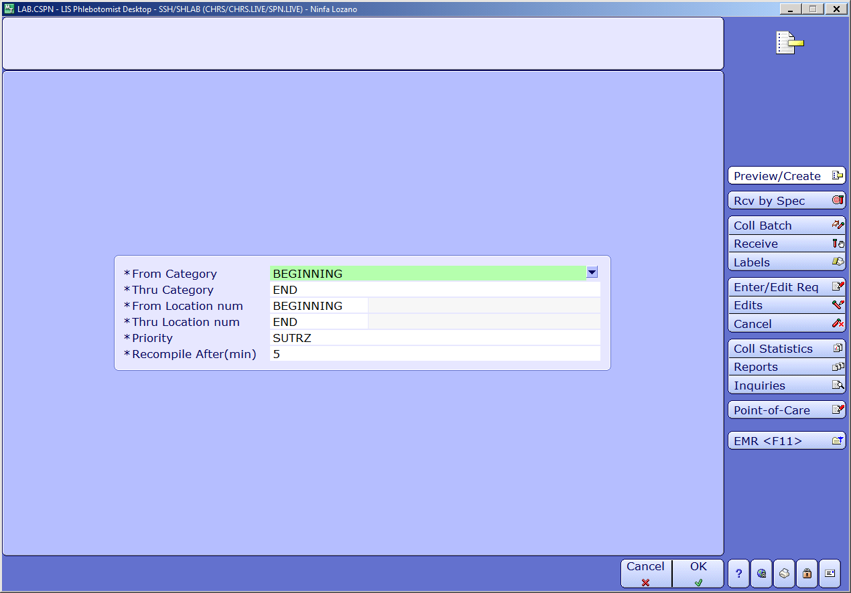
Diagram 22.0
Preview/Create
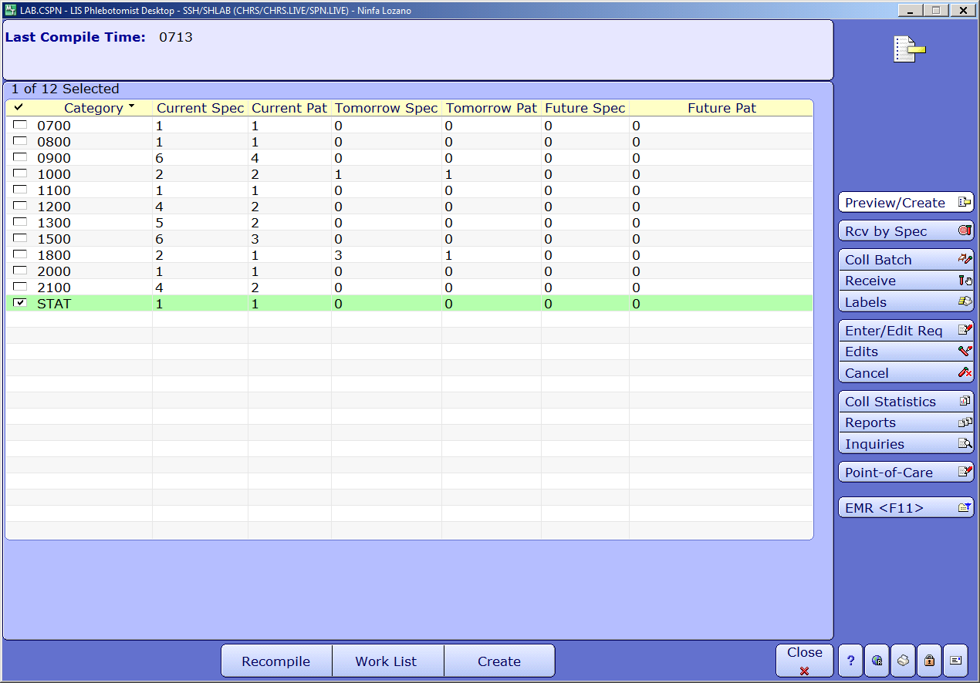

Diagram 22.0
Preview/Create
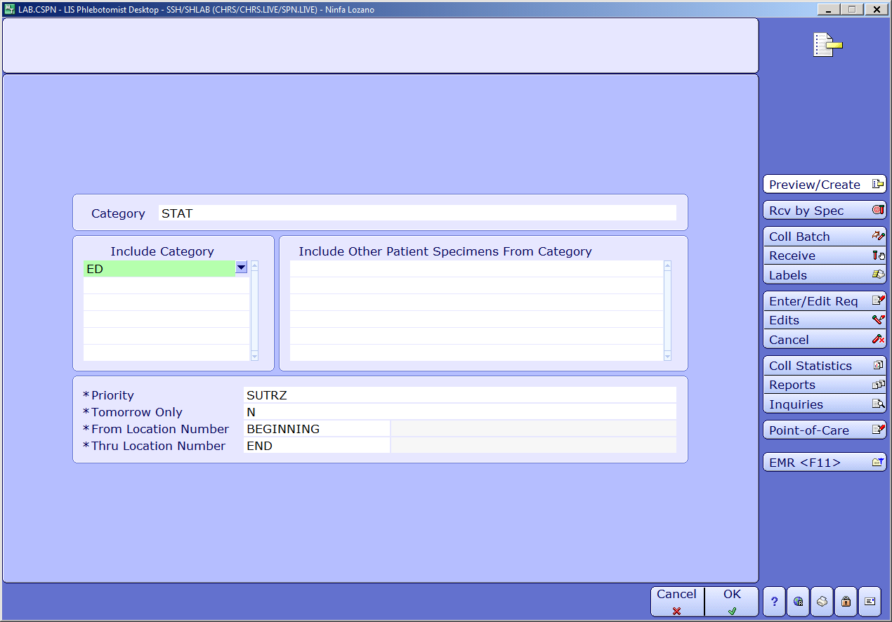
Diagram 22.0
Preview/Create
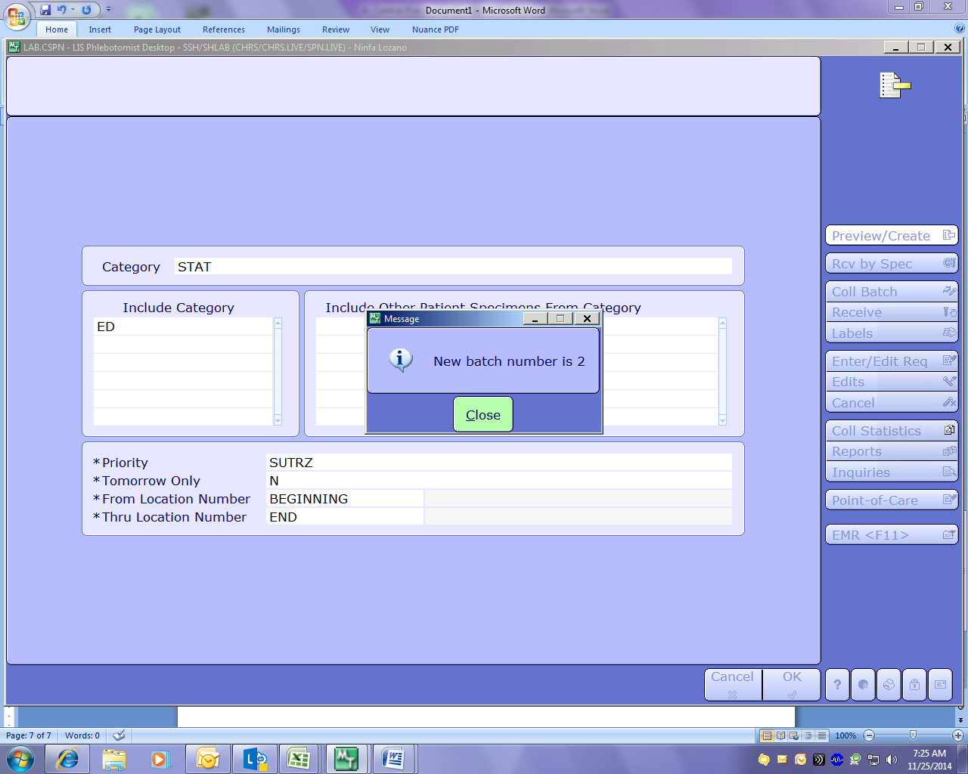

Diagram 22.0
Preview/Create
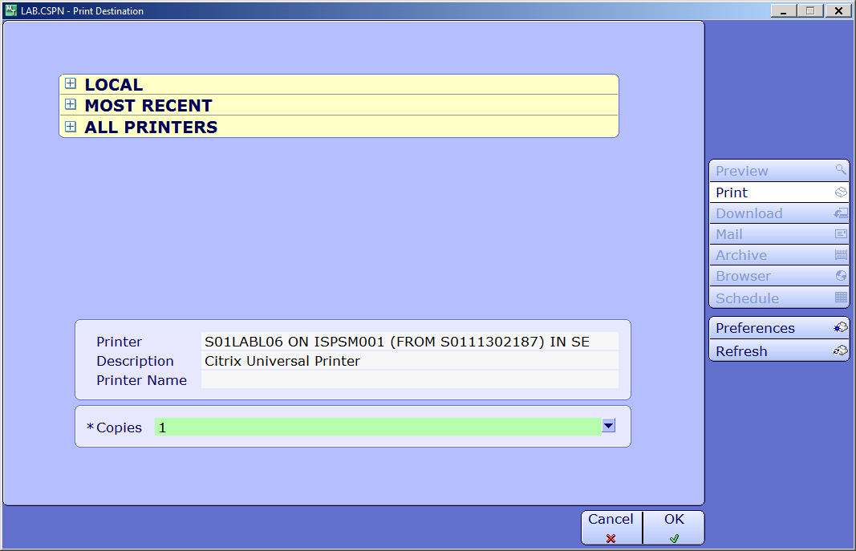
Diagram 22.1
Reprint Batch
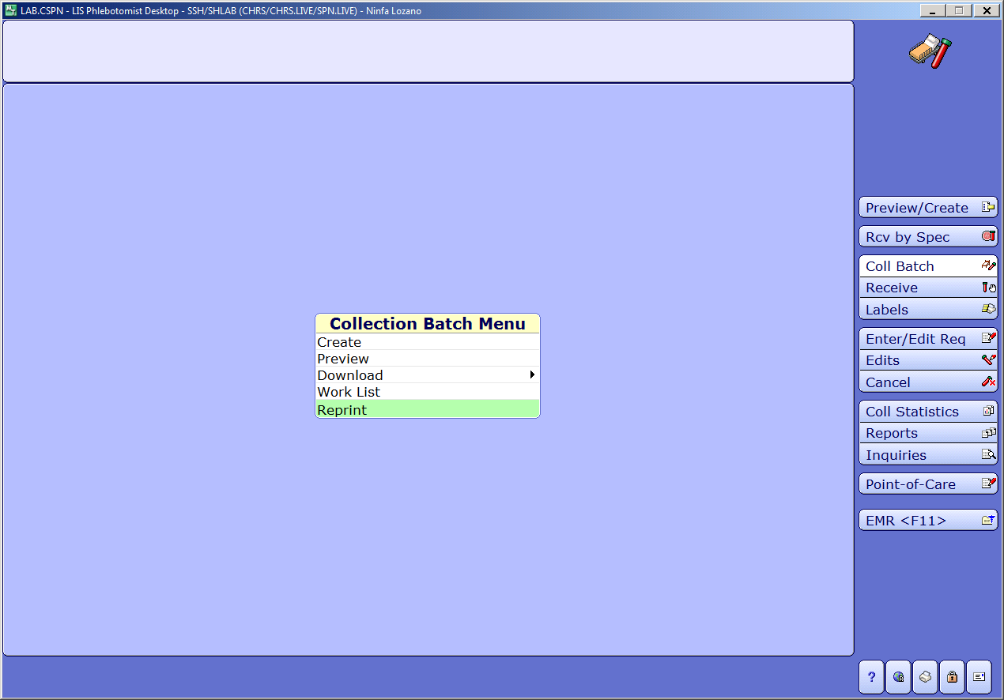

Diagram 22.1
Reprint Batch
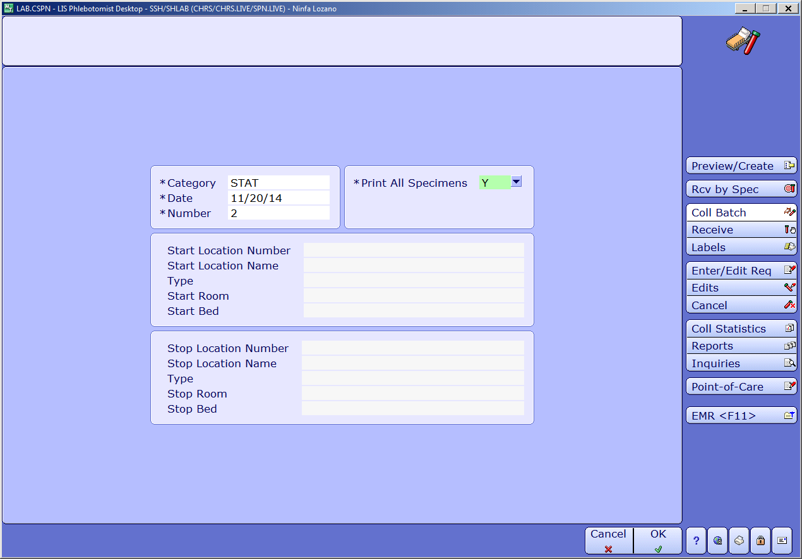

Diagram 22.2
Specimen Receiving
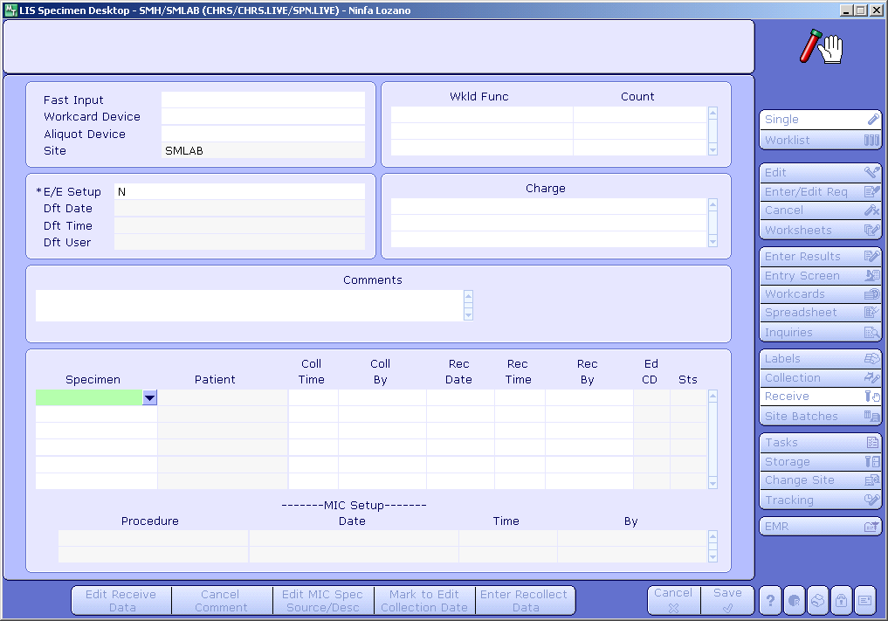

Diagram 22.3
Specimen Unreceiving, Editing
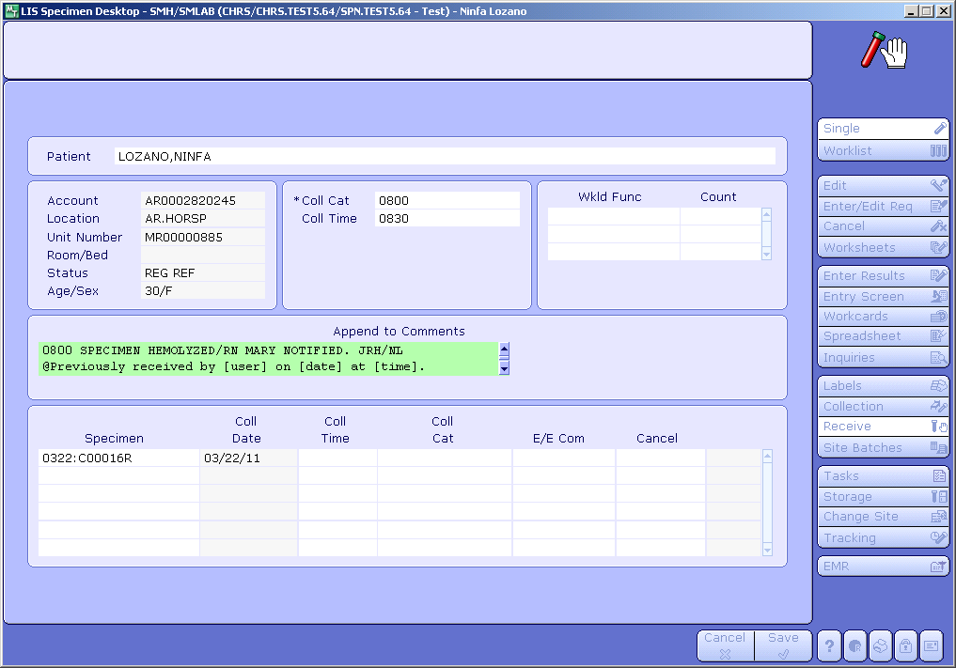

Diagram 22.4
Lab Patient Master Log Uncollected Specimen-LAB, MIC
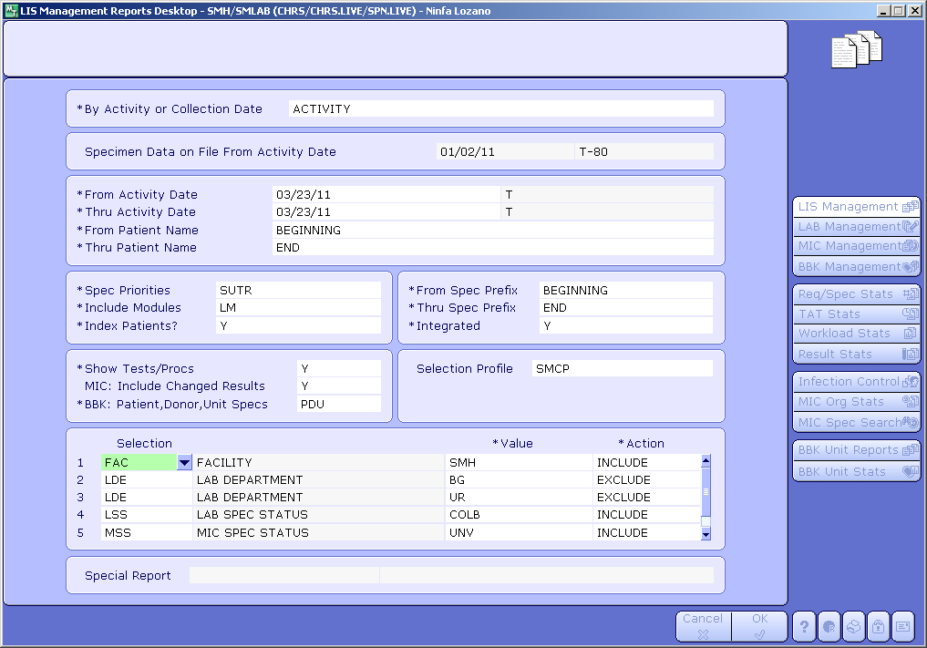

Diagram 22.5
Specimen Tracking Uncollected Specimen
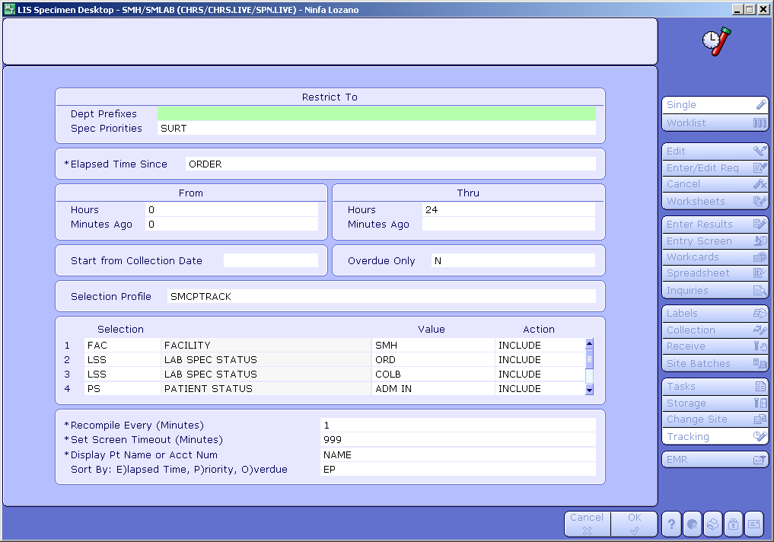

Diagram 22.6
Uncollected Specimen/Line Draw Sheet

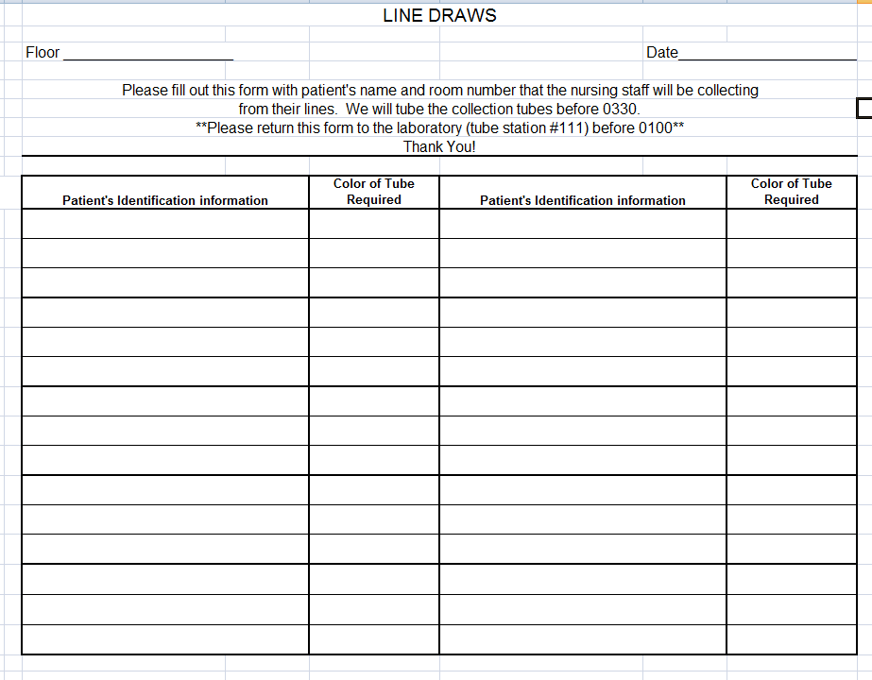

Diagram 22.7
Specimen Cancel/Uncancel

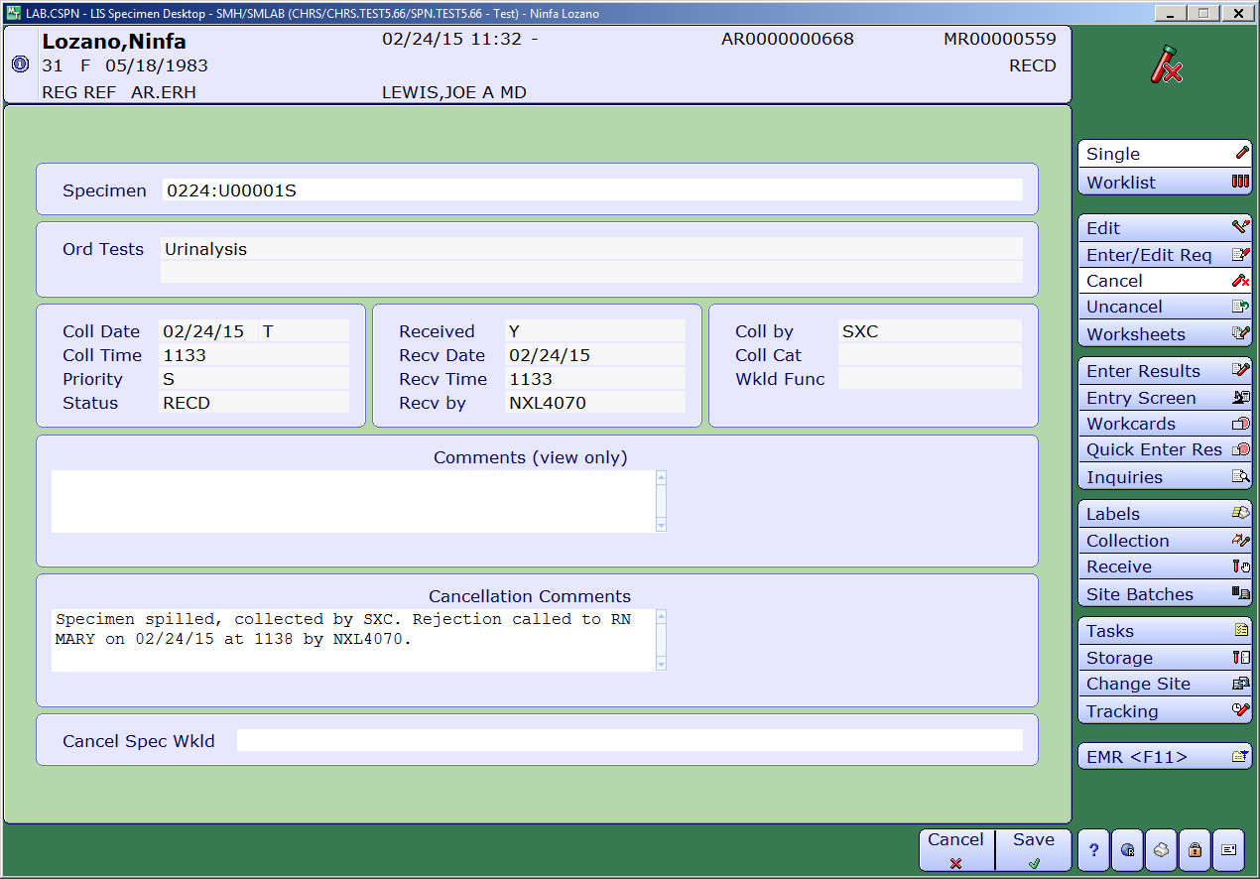
Diagram 22.8
Specimen Cancel/Uncancel
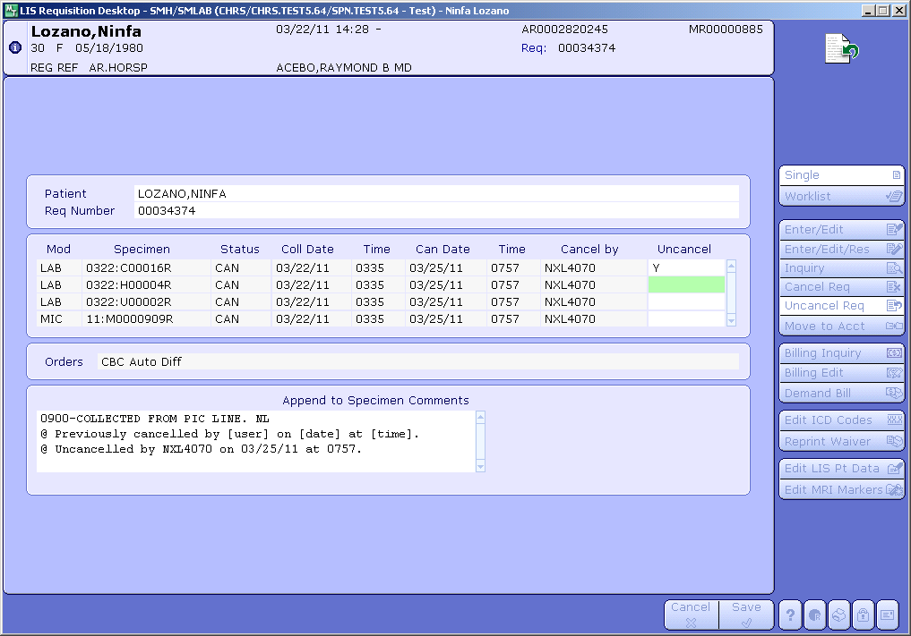

Diagram 22.9
Edit Specimen Data/Collection Data
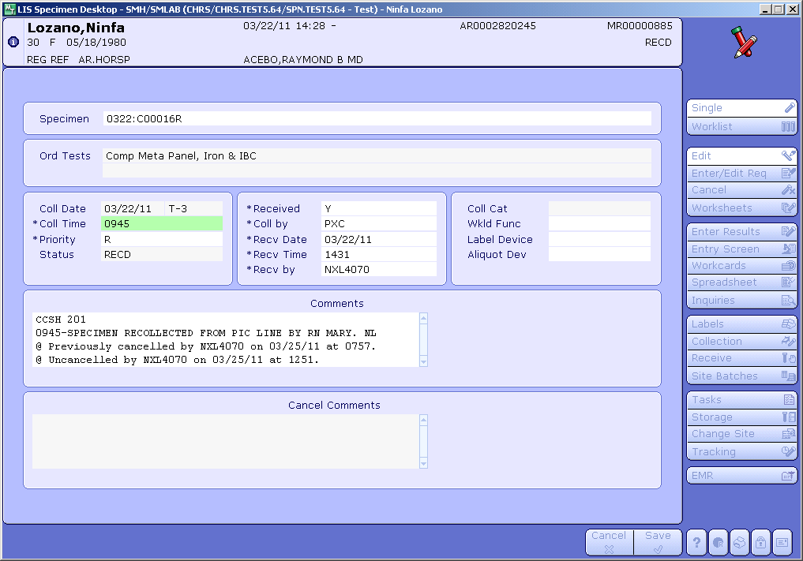

Diagram 22.10
Edit Specimen Data/Collection Data

