SOP Number: | CCP120 | Creation Date: | May 1, 2004
Department: | Central Processing/Phlebotomy | Effective Date: | January 29, 2013
Author: | N. Lozano | Version: | 02

Applicable Standards |  |  |  |  | Version History
Standard |  | Organization |  |  | Version | Effective Date |  | Deactivation Date
 |  |  |  |  | 01 | April 20, 2012 |  | January 29, 2013
 |  |  |  |  | 02 | January 29, 2013
Related Documents
Review History (Up to the Last 15 Occurrences)
Date | Version |  | Revision Type |  |  |  | Review By
4/2012 | 01 |  | Supervisor Review |  |  |  | N. Lozano
10/2012 | 01 |  | Pathologist Review |  |  |  | Dr. James Scherer
1/2013 | 02 |  | Major Revision-Lab Med Dir |  |  |  | Dr. Joe Lewis
4/2014 | 02 |  | Supervisor Review |  |  |  | N. Lozano
1/2015 | 02 |  | Revision-Updated 3.5, 5.13 |  |  |  | N. Lozano
2/2015 | 02 |  | Supervisor Review |  |  |  | N. Lozano
6/2016 | 02 |  | Supervisor Review |  |  |  | N. Lozano

Distribution
CP SOP Volume 1

Administering antigen to a patient to aid with the diagnosis of the possilbity of exposure to Tuberculosis is called a PPD Skin Test. It is a procedure which requires both knowledge and skills and should be performed in manner to reduce patient anxiety and provide acuate resutls for proper diagnosis and proper patient treatment.

Administering PPD Antigen

(MANTOUX METHOD SKIN TESTING)

1.1 Antigen Storage and stability

- The PPD solution is stored between 2-8 C. A new vial must be dated when opened. The solution expires after 30 days.

1.2 Follow the CDC recommended hand hygiene technique

- Handwashing – wet hands with water, apply soap, rub hands together for at least 15 seconds.
- Handrubs – apply to palm of one hand, rub hands together covering all surfaces until dry
- Standard precautions must be followed and gloves must be worn

1.3 Verify patient’s identification. Two positive identifiers must be used, and patient must be wearing a hospital identification wristband. An out patient in addition must be verified by stating their Name and DOB.

1.4 Ask patient if they have ever had a positive TB skin test. If the answer is “YES”, do not give skin test. Out Patient Associates; Refer to Employee Health Nurse. Out Patient with physician; physician will be notified and patient will follow physician’s instruction. Out Patient without physician; Refer to Nueces County Tuberculosis Clinic.

1.5 Out Patient/Associate who answered “NO” to ever having a positive TB skin test, verify if patient/associate can return for PPD reading 48 Hours (max 72 hours). If answer is “NO” do not administer antigen and reschedule for a later date. If answer is “YES” select site. Left forearm is the preferred site if available.

1.6 Gloves must be worn. Prepare 1cc tuberculin syringe with 0.1 ml of test antigen. Because of absorption onto plastic, the antigen should be drawn into the syringe and immediately used. The vial of Tuberculin PPD must be dated with open date and the vial which has been entered or in use must be discarded at the 30 day post opened date as it is the expiration date.

1.7 Clean selected site, and allow drying. The left forearm is the standard site, if another site must be used, the specific site must be documented in the record. If left or right forearm is unavailable, back shoulder area may be used.

1.8 Stretch the skin taut using thumb. Face bevel upward and hold needle and syringe almost parallel to insure proper intradermal puncture.

1.9 Carefully insert needle just below skin surface. The tip of the needle should be seen through the skin.

1.10 Slowly inject the antigen. Firm resistance is felt as the antigen enters the skin. Inject the entire antigen.

1.11 A tense white wheal 5-10 mm in diameter appears over the point of the needle. It is important that the needle is positioned properly. If a wheal does not appear, repeat PPD at least 2” from the original site or opposite arm.

1.12 Wipe away any blood that appears. A small amount of bleeding is normal. Too much bleeding indicates improper administration.

1.13 If skin marker available mark outside injection site using 4 dots, and remind patient/associate to return 48-72 hours for reading of test.

1.14 Dispose of needle according to protocol and document accordingly.

2.0 Receiving PPD

2.1 The pathway for the PPD to be received (i.e. indicating to LIS that the specimen is to be received) is as follows:

2.11 Specimen Desktop - Enter Result
2.12 Enter patient’s account number/specimen number
(i.e.:M1267).
2.13 Type “E” at the result window-line #1. See Diagram 7.0
2.14 Enter Antigen Lot #-box line #2 .
and enter Exp date –box line #3. See Diagram 7.1
2.15 Enter site of injection if different than Left Upper Arm-
box line #4
2.16 Enter date in DATE GIVEN- box line#5.
See Diagram 7.1
2.17 F12/Save, and F12 again.
2.18 Mark Preliminary/Unverified file status.
See Diagram 7.2
2.19 Select OK,F12/Green Check mark, and F12 again.
2.20 Check Broadcast Results, and release by entering F12.
See Diagram 7.6

3.0 Reading the PPD

Read the skin test at 48-72 hours.

  - A reaction consists of induration, a firm nodule under and around the site of injection. This induration is measured transverse to the long axis of the arm with a flexible ruler divided into millimeter (mm).

  - Redness (erythema) at the site is ignored. Any question regarding reading, ask for a consultation.

  - No reaction is reported as “0 mm” – not as negative.

  - Record result in Meditech.

  - A Positive Out Patient, without a physician, will be given an information sheet about the Nueces County Tuberculosis Clinic to follow up with.

- Resulting the PPD

  - The pathway for the PPD to be resulted (i.e. indicating to LIS that the specimen is to be resulted) is as follows:

4.11 Specimen Desktop - Enter Result
4.12 Enter patient’s account number/specimen number
(i.e. :M1267).
4.13 Enter initials under READ BY-box line #1
4.14 Enter date at DATE READ-box line #6.
4.15 Enter reading at INDURATION box in mm-box line #7
See Diagram 7.3
4.16 Use Enter key to include interpretation of result.
See Diagram 7.4
4.17 F12/Save, and F12 again
4.18 Mark Final/Verified file status. See Diagram 7.5
4.19 Check Broadcast Result, Print External Inquiry and
release by entering F12. Provide the printed external
copy of PPD result to the associate where fitting.
See Diagram 7.6

5.0 Resulting Discharged/No Return PPD

5.1 If the patient is discharged or does not return after 72 hours, the pending PPD must be resulted with a message. The pathway for the PPD to be resulted with a message (i.e. indicating to LIS that the patient was discharged/did not return for reading) is as follows:

  - Follow 4.11 and 4.12 Resulting PPD.
  - Return to line 7 Induration window. (F9 to view Code)
Type PAT to attach message which reads Patient did not
return for skin test reading
Or
Type DIS to attach message which reads Patient
discharged prior to skin test reading.
Or
Type NO to attach message which reads Associate did
not return for skin test reading. See Diagram 7.5

  - Check Broadcast Result, and release by entering F12.

6.0 Repeating PPD (if patient does return to have read)

  - In general, there is no risk associated with repeated tuberculin skin test placements. If a person does not return within 48 -72 hours for a tuberculin skin test reading, a second test can be placed as soon as possible. There is no contraindication to repeating the PPD (TST), unless a previous PPD was associated with a severe reaction.

  - If a patient is determined to have an “indeterminate result” and is confirmed by the Occupational Medicine nurse or other trained personnel, the PPD test should be repeated immediately or as recommended by Occupational Medicine or supervisor.

7.0 Diagrams and Examples
See pages 6 through the end of the document.

Diagram 7.0
PPD Receiving

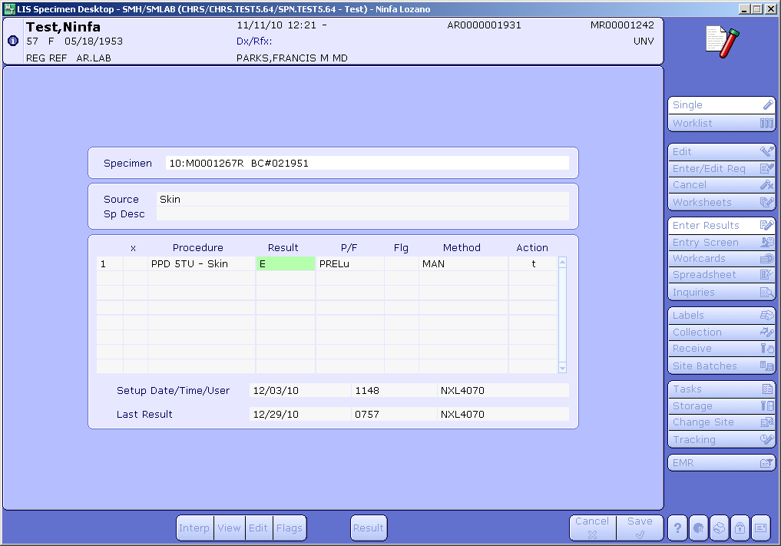

Diagram 7.1
PPD Receiving

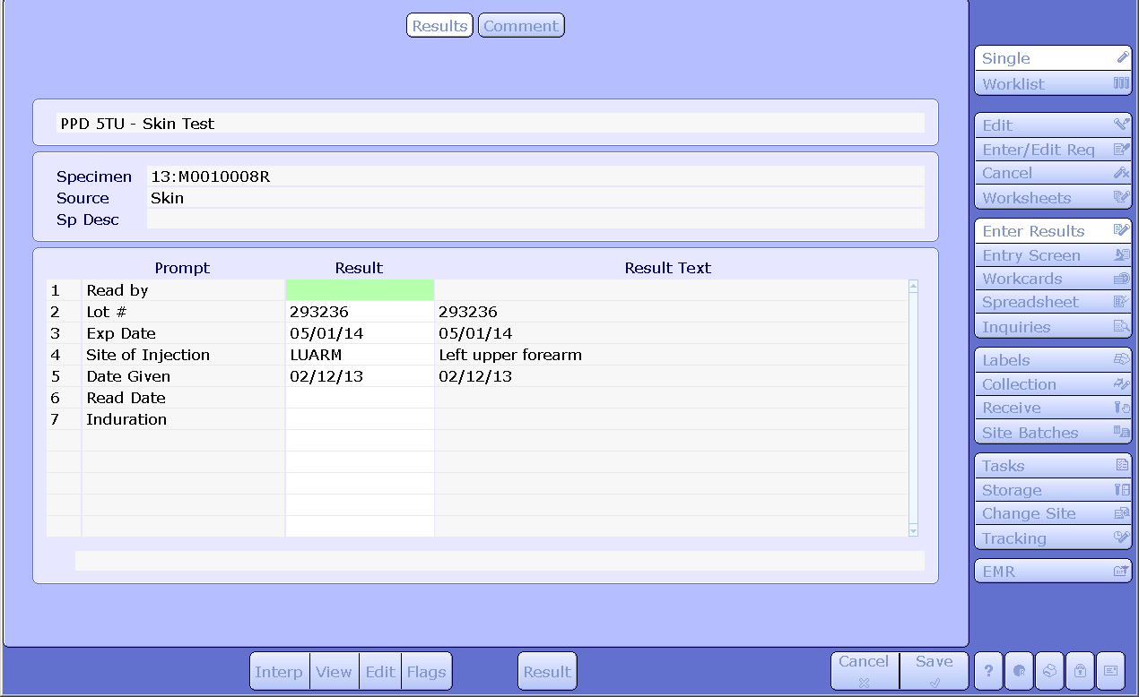

Diagram 7.2
File Status (Receiving)

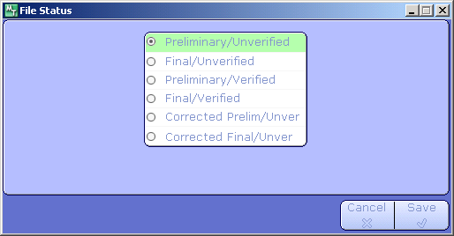

Diagram 7.3
PPD Resulting

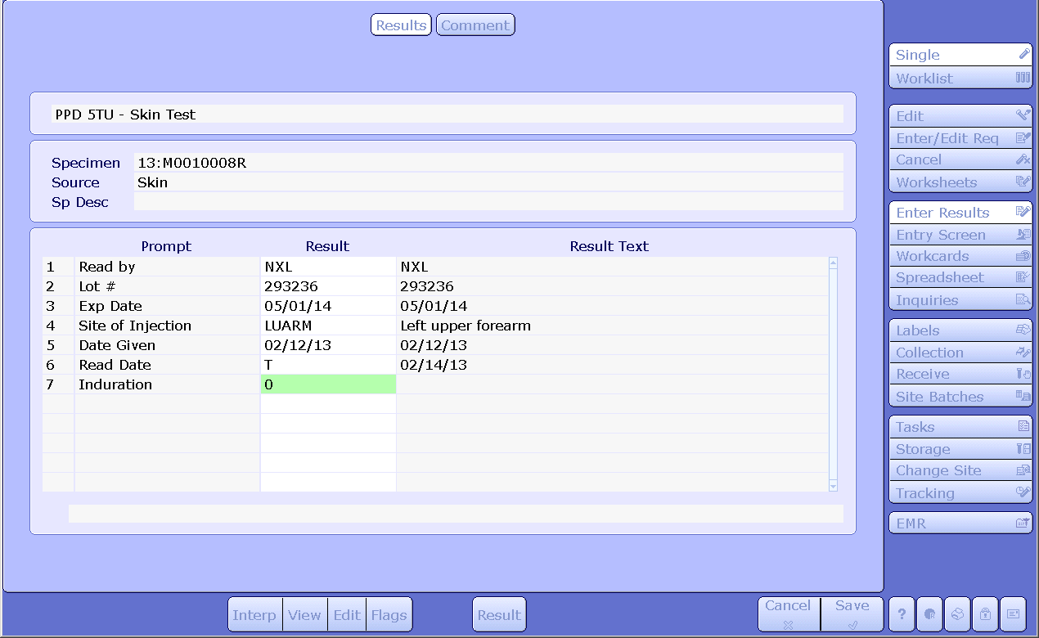

Diagram 7.4
File Guideline (Resulting)

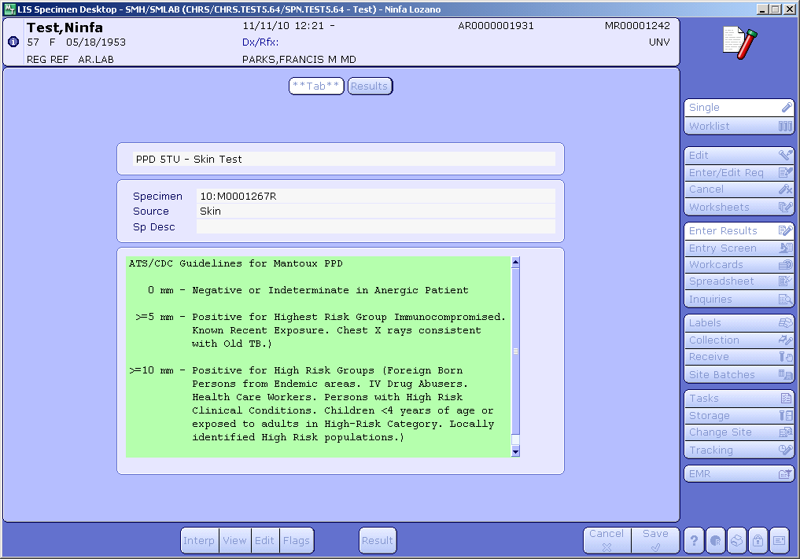

Diagram 7.5
File Status (Resulting)

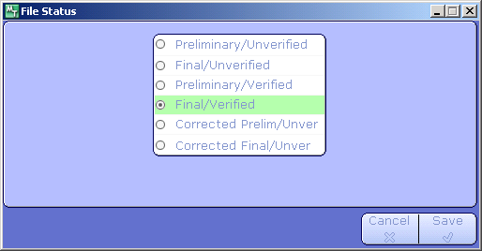

Diagram 7.6
File Results (Receiving & Resulting)

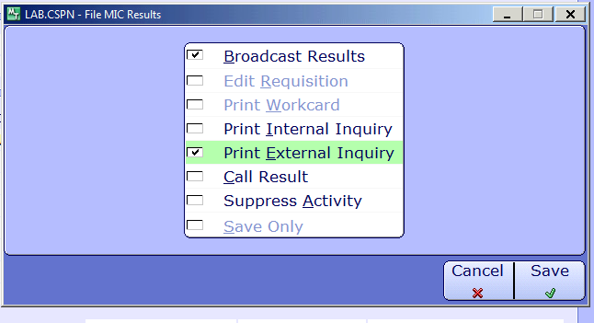

Diagram 7.7
Resulting Discharged/No Return

