SOP Number: | CCP150 | Creation Date: | January 29, 2013
Department: | Central Processing/Phlebotomy | Effective Date: | January 29, 2013
Author: | N. Lozano | Version: | 01

Applicable Standards |  |  |  |  | Version History
Standard |  | Organization |  |  | Version | Effective Date |  | Deactivation Date
 |  |  |  |  | 01 | January 29, 2013
Related Documents
Review History (Up to the Last 15 Occurrences)
Date | Version |  | Revision Type |  |  |  | Review By
1/2013 | 01 |  | New Form |  |  |  | Dr. Joe Lewis
4/2014 | 01 |  | Supervisor Review |  |  |  | N. Lozano
2/2015 | 01 |  | Supervisor Review |  |  |  | N. Lozano
6/2016 | 01 |  | Supervisor Review |  |  |  | N. Lozano

Distribution
CP SOP Volume 1

To define a standardized procedure for ordering a PPD Skin Test which will provide guidelines and responsibilities in regards OCC Health Associates PPD Skin Test orders.

- Compliance Expectation

  - New associates must have an initial Two-step PPD testing. Occupational Health will register associate, enter the LIS order and administer first PPD which can be read and resulted at any of CHRISTUS Spohn Health System facilities.

  - Reaction of first PPD must be read 48-72 hours after administration and administration of second PPD must be 2-3 weeks following the first PPD.

  - Associates will report to lab for annual, biannual, and exposure to MTB PPD skin testing. If associate does not provide the PPD order from OCC Health, associate must fill out the Associate Surveillance Form which provides information needed for registration. Full name, SS#, DOB, Associate #, Department name, Department #, and reason for PPD.

- Registration

  - Select Enter/Edit from Specimen or Registration Desk Top. Use associate’s last and first name but its best to use SS# if provided. Use enter key. Enter SS# to start look up.

  - Enter Sex and DOB on pop up window which will narrow search. F12 and use enter key to start search.
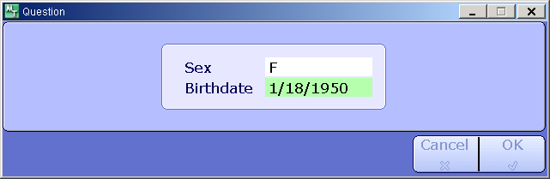
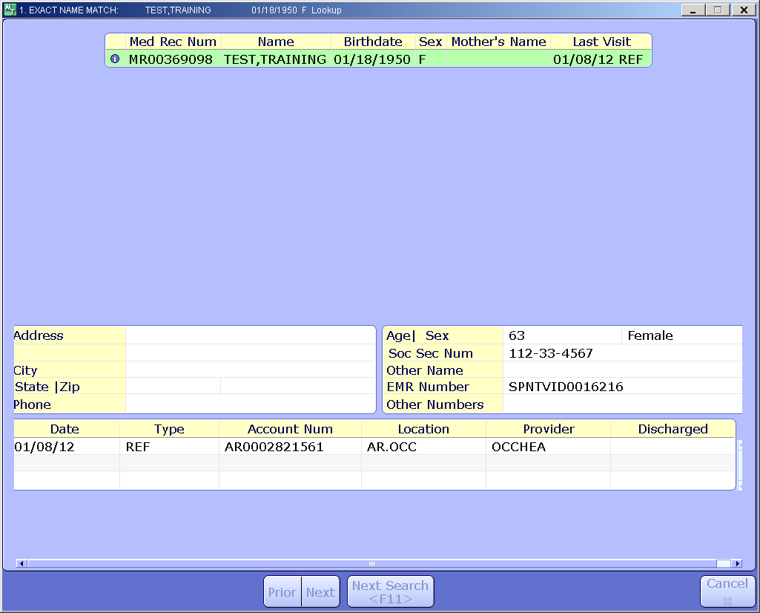

2.3 LIS will provide a list of
accounts. Review list (Medical Record # to avoid duplication) and verify previous visit. Note left top corner which reads “Exact Name Match” use enter key. If it reads “Account look up” use Esc key to avoid selecting old account and entering new order. (BAR will reject due to Registration date and Order date did not match)

  - Accept ordering site default “*Enter into Facility” and “*Registration Screen”.

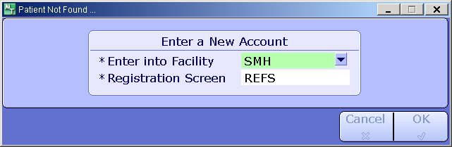
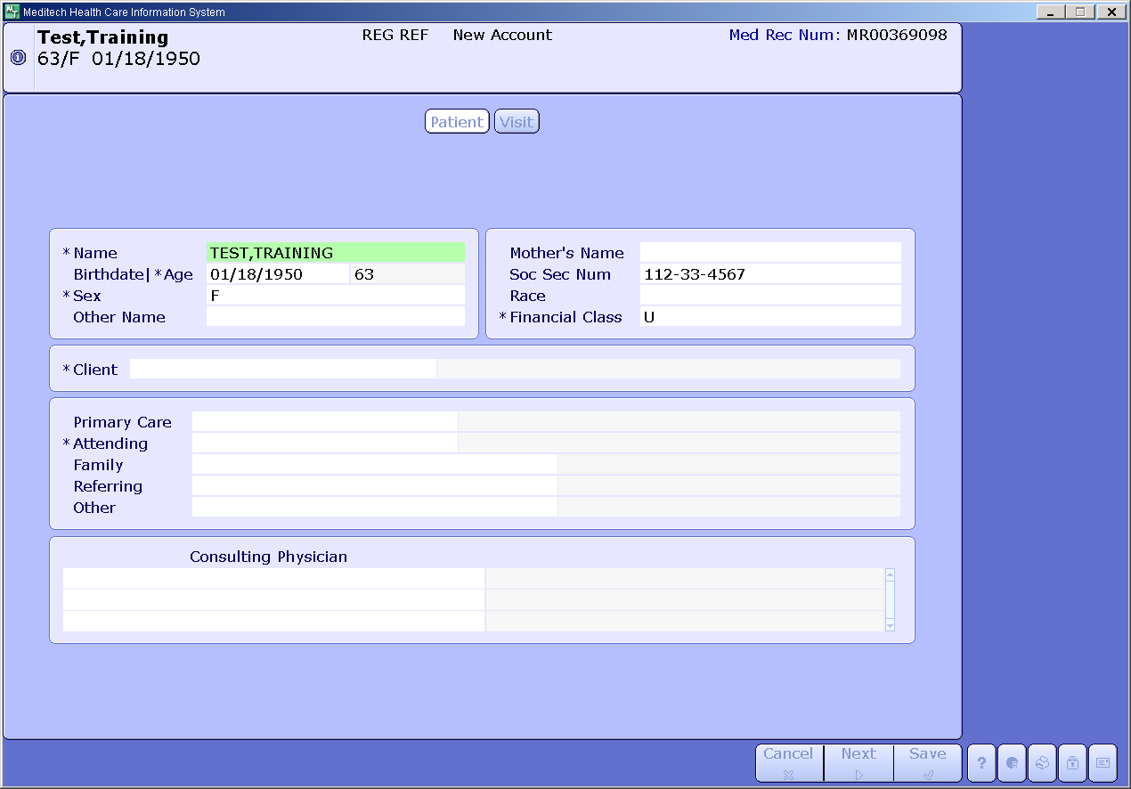
  - Verify Registration Screen has same Medical Record number from pervious lookup, Registration date is current if not use Esc key and start over. (an old account will have date stamp on top center screen)

  - Associates not found will have new Account number and New Medical Record number.

  - Verify full name, DOB, and SS#. (Enter DOB and SS# if new patient/associate not found.)

  - Registration account is site specific:
AR/SML - AS/SHL - AV/SSL - AQ/SKL - AW/SBL - AY/SAL
Registration Client: Site.EMPHES (i.e. AR.EMPHES)
Location: OCC (i.e. AR.OCC)
Attending: OCCHEA

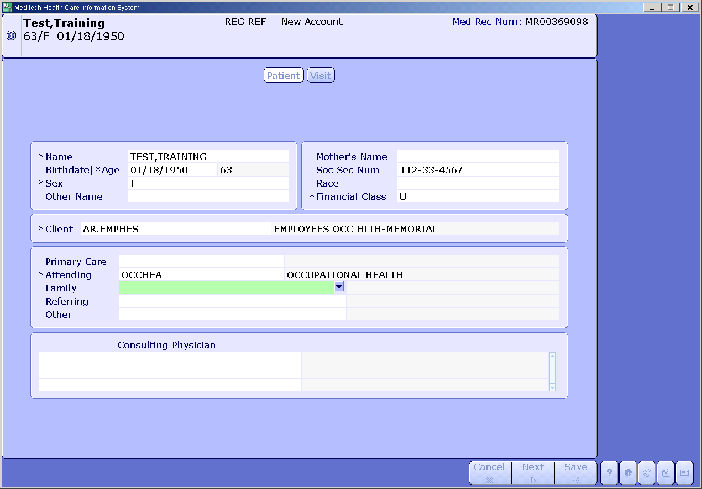

  - Reason for Visit window can display annual, biannual, and or exposure to MTB. Use f12 or enter key to file. Use ESC key or enter “N” at Print Admission Forms. Message window pop up will display Account number and MR number.
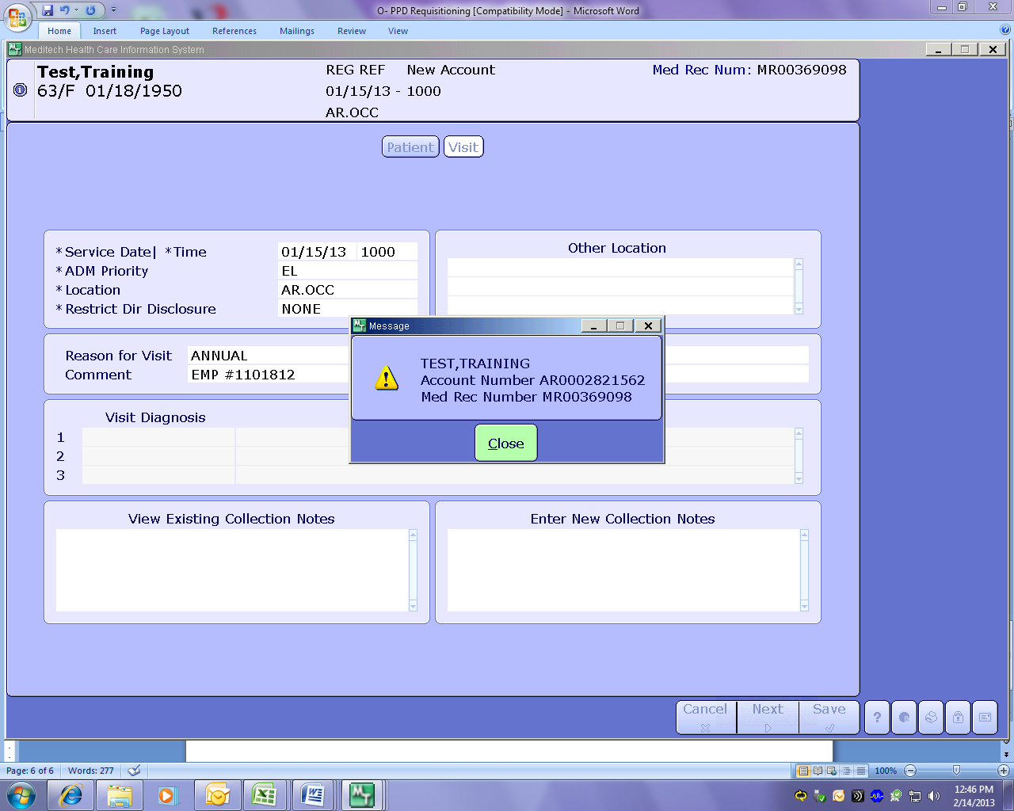

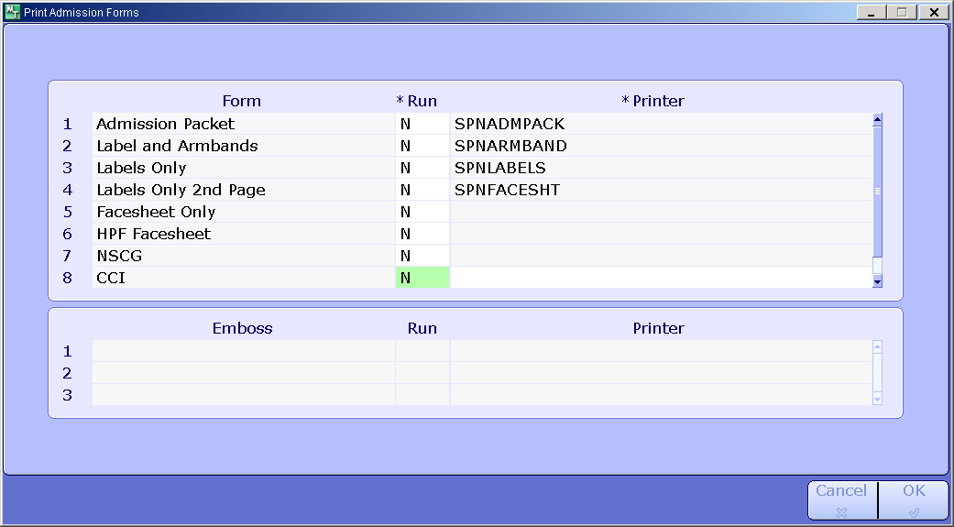

  - At Req Number window enter “N” for New Requisition Order. Continue to enter information all * required windows. Verify Label printer Device. Advance to Order window and type PPD use enter key which will fill in additional information. Specimen Tab key can be use to access comment box to enter associate information if not enter during registration phase.
Use F12 key to file and LIS will print order label to be used for reading, resulting, and tracking of pending PPD order.

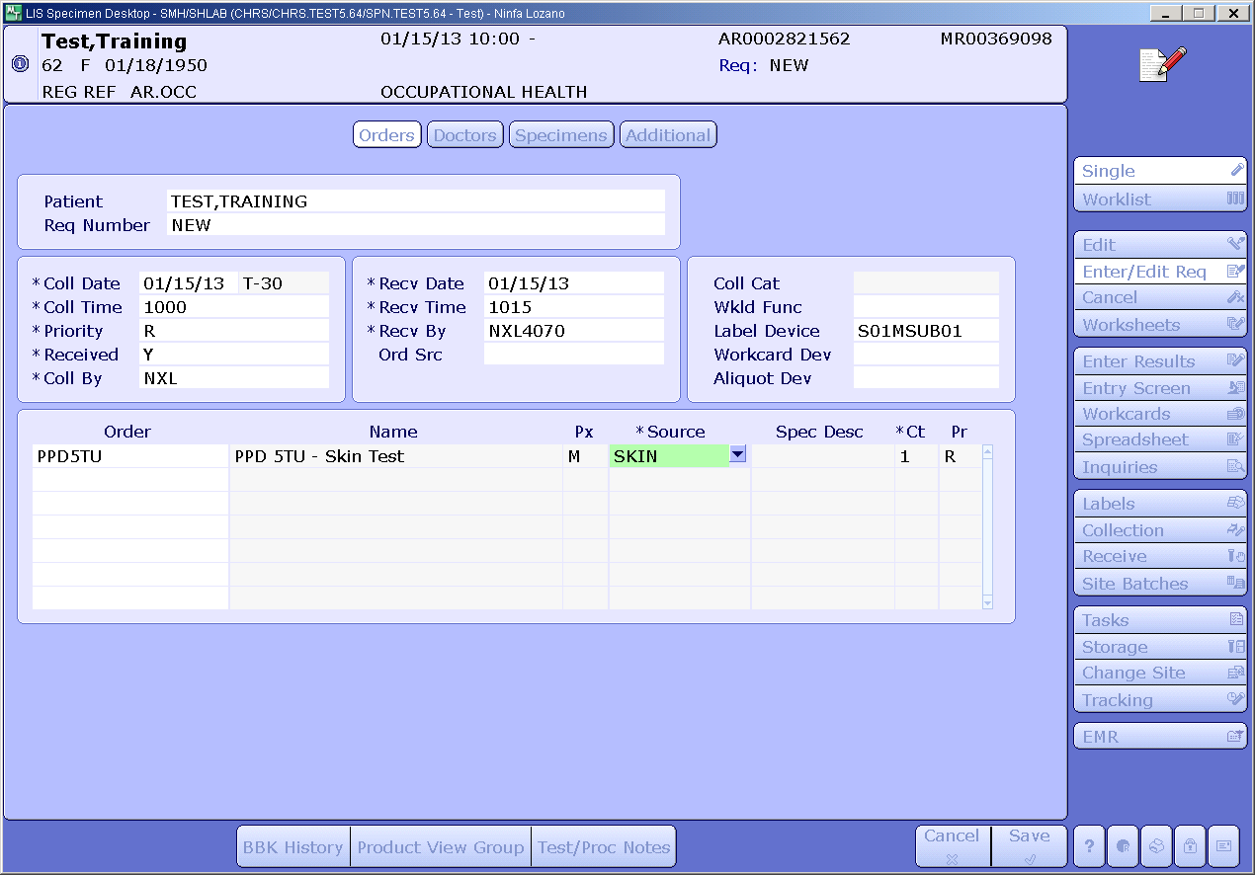

  - Procedural notes.

    - Look up associate by name if #SS# does not pull a previous
registration before prcoessing with regestration.
    - Avoid duplication of Medical Record number.
    - Follow PPD protocol…registration, reading, and resulting to
meet compliance expectations due to suspension if not done
correctly.

