**Sofia RSV FIA**

**For use with the Sofia and Sofia 2 only**

**CLIA Complexity: WAIVED for children less than 7 years of age**

**CLIA Complexity: Moderate for pediatric patients 7 to less than 19 years of age**

For *in vitro* use only, Rx only

**INTENDED USE**

The Sofia RSV FIA employs immunofluorescence for detection of respiratory syncytial virus (RSV) nucleoprotein antigen in nasopharyngeal swab and nasopharyngeal aspirate/wash specimens taken directly from symptomatic patients. This qualitative test is intended for use as an aid in the rapid diagnosis of acute RSV infections in pediatric patients. Negative results do not preclude RSV infection and should not be used as the sole basis for treatment or for other management decisions. A negative result is presumptive, and it is recommended these results be confirmed by viral culture or an FDA-cleared RSV molecular assay.

The Sofia RSV FIA may be used with Sofia or Sofia 2.

**SUMMARY AND EXPLANATION**

RSV is a causative agent of highly contagious, acute, viral infection of the respiratory tract in pediatric and elderly populations. Respiratory syncytial virus is a single-stranded RNA virus.1 Nearly half of all children become infected with RSV in their first year of life. It is also the major viral cause of nosocomial illness in children already hospitalized for other reasons.2 In the United States, RSV is estimated to be responsible for 73,400 to 126,300 hospitalizations annually for bronchiolitis and pneumonia alone among children younger than 1 year.3 In an analysis of U.S. viral surveillance and mortality data, respiratory syncytial virus (RSV) was reported as the most common viral cause of death in children younger than 5 years when compared to influenza A H1N1, influenza A H3N2, and influenza B.4 Among children hospitalized with RSV infection, the mortality rate is estimated to be as low as 0.3% to 1.0%3, 5 and in the range of 2.5% to 4.0% for children with underlying cardiac or pulmonary disease.3, 5, 6

**PRINCIPLE OF THE TEST**

The Sofia RSV FIA test employs immunofluorescence technology that is used with Sofia and Sofia 2 to achieve the rapid detection of RSV antigens. The Sofia RSV FIA test involves the disruption of virus and detection of nucleoproteins inside the virus. The patient specimen is placed in the Reagent Tube, during which time the virus particles in the specimen are disrupted, exposing internal viral nucleoproteins. After disruption, the specimen is dispensed into the Test Cassette sample well. From the sample well, the specimen migrates through a test strip containing various unique chemical environments. If RSV viral antigens are present, they will be trapped in a specific location.

Depending upon the user’s choice, the Test Cassette is either placed inside of Sofia or Sofia 2 for automatically timed development (WALK AWAY Mode) or placed on the counter or bench top for a manually timed development and then placed in Sofia or Sofia 2 to be scanned (READ NOW Mode).

Sofia and Sofia 2 will scan the test strip and measure the fluorescent signal by processing the results using method-specific algorithms. Sofia and Sofia 2 will display the test results (positive, negative, or invalid) on the screen.

**REAGENTS AND MATERIALS SUPPLIED   
*25-Test Kit:***

* Individually Packaged Test Cassettes (25): Mouse monoclonal anti-RSV antibodies
* Reagent Tubes (25): Lyophilized buffer with detergents and reducing agents
* Reagent Solution (25): Ampoules with salt solution
* Sterile Nasopharyngeal Swabs (25)
* Small, Clear 120 µL Fixed Volume Pipettes (25)
* Large, Pink 250 µL Fixed Volume Pipettes (25)
* RSV Positive Control Swab (1): Swab is coated with non-infectious RSV antigen
* Negative Control Swab (1): Swab is coated with heat-inactivated, non-infectious Streptococcus C antigen
* Package Insert (1)
* Quick Reference Instructions (1)
* QC Card (located on kit box)
* Printer Paper (1)

**MATERIALS NOT SUPPLIED IN KIT**

* Sofia or Sofia 2
* Calibration Cassette (supplied with the Sofia Installation Pack or Sofia 2)
* Timer or watch for use in READ NOW Mode
* Sample/Specimen container
* Sterile saline for sample collection
* Equipment used for collection of nasopharyngeal aspirate or wash specimens

**WARNINGS AND PRECAUTIONS**

* Do not use the kit contents beyond the expiration date printed on the outside of the box.
* Use appropriate precautions in the collection, handling, storage, and disposal of patient samples and used kit contents.'
* Use of Nitrile or Latex (or equivalent) gloves is recommended when handling patient samples.'
* Do not reuse the used Test Cassette, Fixed Volume Pipettes, Reagent Tubes, solutions, or Control Swabs.
* The user should never open the foil pouch of the Test Cassette exposing it to the ambient environment until the Test Cassette is ready for immediate use.
* Discard and do not use any damaged or dropped Test Cassette or material.
* The Reagent Solution contains a salt solution (saline). If the solution contacts the skin or eye, flush with copious amounts of water.
* To obtain accurate results, the Package Insert instructions must be followed.
* The Calibration Cassette must be kept in the provided storage pouch between uses.
* Inadequate or inappropriate sample collection, storage, and transport may yield false test results.
* Sample collection and handling procedures require specific training and guidance.
* To obtain accurate results, use the viral transport media (VTM) recommended in this Package Insert.
* When collecting a nasopharyngeal swab sample, use the Nasopharyngeal Swab supplied in the kit.
* Use the appropriate Fixed Volume Pipette in accordance with test procedures:

 **Only the Small, Clear 120 µL Fixed Volume Pipette** is to be used for adding patient sample to the Test Cassette.

 **Only the Large, Pink 250 µL Fixed Volume Pipette** is to be used with the aspirate/wash or viral transport media test procedure when transferring the patient sample from the collection cup into the Reagent Tube.

* Do not pour samples from the Reagent Tube into the Test Cassette sample well. Use the provided **Small, Clear 120 µL Fixed Volume Pipette** when adding the sample to the Test Cassette.
* Do not write on the barcode of the Test Cassette. This is used by Sofia and Sofia 2 to identify the type of test being run and to identify the individual Test Cassette so as to prevent a second read of the Test Cassette by the same Sofia or Sofia 2.
* Do not attempt to scan a Test Cassette more than one time. The barcode on the Test Cassette contains a unique identifier that will prevent Sofia and Sofia 2 from performing a second read on a previously scanned Test Cassette. An error message will be displayed if a Test Cassette is scanned more than once.
* As the detection reagent is a fluorescent compound, no visible results will form on the test strip. Sofia or Sofia 2 must be used for result interpretation.
* Testing should be performed in an area with adequate ventilation.
* Dispose of containers and unused contents in accordance with Federal, State and Local regulatory requirements.
* Wear suitable protective clothing, gloves, and eye/face protection when handling the contents of this kit.
* Wash hands thoroughly after handling.
* For additional information on hazard symbols, safety, handling and disposal of the components within this kit, please refer to the Safety Data Sheet (SDS) located at [quidel.com](http://quidel.com).

**KIT STORAGE AND STABILITY**

Store the kit at room temperature, 59°F to 86°F (15°C to 30°C), out of direct sunlight. Kit contents are stable

until the expiration date printed on the outer box. Do not freeze.

**QUALITY CONTROL**

***There are three types of Quality Control for Sofia or Sofia 2 and the Test Cassette: Calibration Check***

***procedure, Built-in Procedural Control features, and External Controls.***

***Sofia Calibration Check Procedure***

**Note:** This is a “Calibration Check” procedure.

The Calibration Check Procedure should be performed every 30 days. Sofia can be set to remind the user to complete the Calibration Check Procedure.

The Calibration Check is a required function that checks Sofia optics and calculation systems using a specific Calibration Cassette. This Calibration Cassette is supplied with the Sofia Installation Pack. Refer to the Sofia User Manual for details regarding the Calibration Check Procedure.

**Important:** Ensure that the Calibration Cassette is stored in the provided storage pouch between uses to protect from exposure to light.

|  |  |
| --- | --- |
| 1. To check the calibration of Sofia, select “Calibration” from the Main Menu. 2. Following the prompts, insert the Calibration Cassette into Sofia and close the drawer. Sofia performs the Calibration Check automatically within two minutes with no user input required. |  |

Sofia indicates when the Calibration Check is completed. Select **OK** to return to the Main Menu.

**NOTE:** If the Calibration Check does not pass, notify the on-site Supervisor or contact Quidel Technical Support for assistance Monday through Friday from 7:00 a.m. to 5:00 p.m. Pacific Time at 800.874.1517 (in the U.S.); 858.552.1100 (outside the U.S.); Fax: 858.455.4960; [customerservice@quidel.com](mailto:customerservice@quidel.com) (Customer Service); [technicalsupport@quidel.com](mailto:technicalsupport@quidel.com) (Technical Support); or contact your local distributor.

***Sofia 2 Calibration Check Procedure***

The Calibration Check Procedure should be performed every 30 days. Sofia 2 can be set to remind the user to complete the Calibration Check Procedure.

The Calibration Check is a required function that checks Sofia 2 optics and calculation systems using a specific Calibration Cassette. This Calibration Cassette is supplied with Sofia 2. Refer to the Sofia 2 User Manual for details regarding the Calibration Check Procedure.

**Important:** Ensure that the Calibration Cassette is stored in the provided storage pouch between uses to protect from exposure to light.

|  |  |  |
| --- | --- | --- |
| 1. To check the calibration of Sofia 2, select “Run Calibration” from the Main Menu. |  |  |

|  |  |
| --- | --- |
| 2. Following the prompts, insert the Calibration Cassette into Sofia 2 and close the drawer. Sofia 2 performs the Calibration Check automatically within one minute with no user input required.  Sofia 2 indicates when the Calibration Check is  completed. Select to return to the Run Test screen. |  |

**NOTE:** If the Calibration Check does not pass, notify the on-site Supervisor or contact Quidel Technical Support for assistance Monday through Friday from 7:00 a.m. to 5:00 p.m. Pacific Time at 800.874.1517 (in the U.S.); 858.552.1100 (outside the U.S.); Fax: 858.455.4960; [customerservice@quidel.com](mailto:customerservice@quidel.com) (Customer Service); [technicalsupport@quidel.com](mailto:technicalsupport@quidel.com) (Technical Support); or contact your local distributor.

***Built-in Procedural Controls***

The Sofia RSV FIA contains built-in procedural control features. Each time a test is run in Sofia or Sofia 2, the

procedural control zone is scanned by Sofia or Sofia 2 and the result is displayed on the Sofia or Sofia 2 screen.

The manufacturer's recommendation for daily control is to document the results of these built-in procedural controls for the first sample tested each day. This documentation is automatically logged into Sofia or Sofia 2 with each test result.

A valid result obtained from the procedural controls demonstrates that the test flowed correctly and the functional integrity of the Test Cassette was maintained. **The procedural controls are interpreted by Sofia or Sofia 2 after the Test Cassette has developed for 15 minutes. If the test does not flow correctly, Sofia or Sofia 2 will indicate that the result is invalid.** Should this occur, review the procedure and repeat the test with a new patient sample and a new Test Cassette.

|  |  |
| --- | --- |
|  | ***For example: This display shows an invalid result on Sofia.***  ***For example: This display shows an invalid result on Sofia 2.*** |

***External Quality Control***

External Controls may also be used to demonstrate that the reagents and assay procedure perform properly.

Quidel recommends that Positive and Negative Controls be run:

* once for each untrained operator
* once for each new shipment of kits – provided that each different lot received in the shipment is tested
* as deemed additionally necessary by your internal quality control procedures, and in accordance with Local, State and Federal regulations or accreditation requirements.

To test External Controls, the user must first select Run QC on the Main Menu of Sofia or Sofia 2. Then, when prompted, scan the QC Card (located on the kit box). This card provides information specific to the kit lot, including lot number and expiration date.

The user will select the desired mode (WALK AWAY or READ NOW) then run the External Control Swabs.

External Positive and Negative Control Swabs are supplied in the kit and should be tested using the Swab Test Procedure provided in this Package Insert or in the Quick Reference Instructions. **The Positive Control test must be run prior to the Negative Control test.**

When the QC run is complete, each result will be displayed as “Passed” or “Failed” on Sofia or or on Sofia

2 for the Positive Control and the Negative Control.

Do not perform patient tests or report patient test results if either of the QC test results fail. Repeat the test or contact Quidel Technical Support before testing patient samples.

On Sofia, if both the Positive and Negative Controls fail, repeat testing with new Positive and Negative Controls a second time. If only a single Control fails, the user has the option of repeating both the Positive and Negative Controls OR to repeat only the Control that failed. The user may select “Skip” on the Sofia display in order to skip the Control test that previously passed. The QC Results will show a skipped Control test as “unknown.”

On Sofia 2, if either or both of the Positive and Negative Controls fail, repeat testing with new Positive and Negative Controls a second time.

Additional External Control swabs may be obtained separately by contacting Quidel Customer Support Services at 800.874.1517 (in the U.S.) or 858.552.1100.

**SAMPLE COLLECTION AND HANDLING**

**SAMPLE COLLECTION**

***Nasopharyngeal Swab Sample***

***Use the Nasopharyngeal Swab supplied in the kit.***

To collect a Nasopharyngeal Swab sample, carefully insert the Swab into the nostril that presents the most

secretion under visual inspection. Keep the Swab near the septum floor of the nose while gently pushing the

Swab into the posterior nasopharynx. Rotate the Swab several times then remove it from the nasopharynx.

***Nasopharyngeal Aspirate/Wash Sample***

Follow your institution’s protocol for obtaining nasopharyngeal aspirate/wash specimens. **Use the minimal amount of saline that your procedure allows.** Alternatively, if your institution does not provide a protocol, then consider the following procedures that are used by clinicians.

**To collect a nasopharyngeal aspirate sample:** instill a few drops of sterile saline into the nostril to be suctioned. Insert the flexible plastic tubing along the nostril floor, parallel to the palate. After entering the nasopharynx, aspirate the secretions while removing the tubing. The procedure should be repeated for the other nostril if inadequate secretions were obtained from the first nostril.

**To collect a nasopharyngeal wash sample:** the child should sit in the parent’s lap facing forward, with the child’s head against the parent’s chest. Fill the syringe or aspiration bulb with the minimal volume of saline required per the subject’s size and age. Instill the saline into one nostril while the head is tilted back. Aspirate the wash specimen back into the syringe or bulb. The aspirated wash sample will likely be approximately 1 cc in volume.

**Alternatively, following instillation of the saline, tilt the head forward and let the saline drain out into a clean collection cup.**

**SAMPLE TRANSPORT AND STORAGE**

Samples should be tested as soon as possible after collection. However, if transport of samples is required, minimal dilution of the sample is recommended, as dilution may result in decreased test sensitivity. Whenever possible, 1 milliliter or less is best to avoid excessive dilution of the patient sample. The following viral transport media listed in Table 1 were tested with Sofia RSV FIA and Sofia and found to be compatible:.

**Table 1**

**Recommended Viral Transport Media**

|  |  |  |
| --- | --- | --- |
| **Viral Transport Media (VTM)** | **Recommended Storage Condition** | |
| **2°C to 8°C** | **25°C** |
| Copan Universal Transport Medium | 24 hours | 24 hours |
| Hank’s Balanced Salt Solution | 24 hours | 24 hours |
| Liquid Amies Media | 24 hours | 24 hours |
| M4 | 24 hours | 24 hours |
| M4-RT | 24 hours | 24 hours |
| M6 | 24 hours | 24 hours |
| Modified Liquid Stuarts Media | 24 hours | 24 hours |
| Saline | 24 hours | 24 hours |
| Starplex Multitrans | 24 hours | 24 hours |
| Phosphate Buffered Saline | 24 hours | 24 hours |

**Note:** When using viral transport media (VTM), it is important to ensure that the VTM containing the sample is warmed to room temperature. **Cold samples will not flow correctly and can lead to erroneous or invalid results. Several minutes will be required to bring a cold sample to room temperature.** The time required is dependent on the pre-existing room temperature, the sample volume, the type of container holding the sample, and other factors. The operator is encouraged to determine the time required experimentally using cold VTM that is most commonly used in the particular laboratory. Cold samples should be avoided.

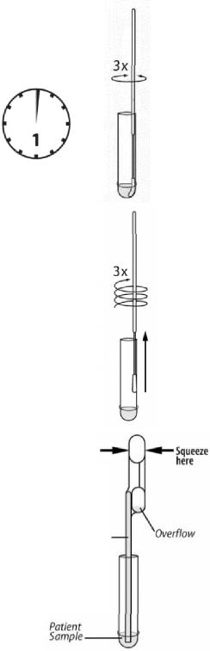**TEST PROCEDURE**

**All samples, including samples in VTM, must be at room temperature before beginning the assay.**

**Expiration date:** Check expiration date on each individual test package or outer box before using. *Do not use any test past the expiration date on the label.*

|  |  |
| --- | --- |
| ***Nasopharyngeal Swab Test Procedure***   1. Verify that Sofia or Sofia 2 is set to the desired Mode: **WALK AWAY** or **READ NOW**. See the “Using Sofia and Sofia 2” section for more information. 2. **Prepare Reagent:** 3. Flick or shake the Reagent Solution vial down so that all fluid is in the bulb. 4. Twist off the tab. 5. Slowly dispense all of the Reagent Solution into the Reagent Tube. 6. Gently swirl the Reagent Tube to dissolve its contents. |  |

1. Place the patient Swab sample into the Reagent Tube. Roll the Swab at least 3 times while pressing the head against the bottom and side of the Reagent Tube.

**Leave the Swab in the Reagent Tube for 1 minute.**

1. Roll the Swab head against the inside of the Reagent Tube as you remove it. Dispose of the used Swab in your biohazard waste.
2. Fill the provided **Small, Clear 120 µL Fixed Volume Pipette** with the patient sample from the Reagent Tube.

**To fill the Fixed Volume Pipette with the patient sample: *120 µL Pipette***

1. FIRMLY squeeze the top bulb.
2. Still squeezing, place the Pipette tip into the patient sample.
3. With the Pipette tip still in the patient sample, slowly release pressure on bulb to fill the Pipette.

**Note:** MUST use the provided pipette to transfer the patient sample to the Test   
Cassette.

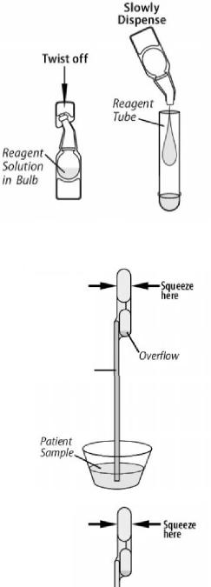

|  |  |
| --- | --- |
| 1. Firmly squeeze the top bulb to empty the contents of the **Small, Clear**   **120 µL Fixed Volume Pipette** into the Test Cassette sample well. Extra liquid left  over in the overflow bulb should be left behind.  **NOTE**: The Fixed Volume Pipette is designed to collect and dispense the correct amount of patient sample. Discard the Pipette in your biohazard waste.   1. Promptly proceed to the next section, “Using Sofia and Sofia 2,” to complete the test. |  |

***Nasopharyngeal Aspirate/Wash or Samples in Viral Transport Media Test Procedure***

**1.** Verify that Sofia or Sofia 2 is set to the desired Mode: **WALK AWAY** or **READ NOW**. See the “Using Sofia and Sofia 2” section for more information.

**2. Prepare Reagent:**

1. Flick or shake the Reagent Solution vial down so that all fluid is in the bulb.
2. Twist off the tab.
3. Slowly dispense all of the Reagent Solution into the Reagent Tube.
4. Gently swirl the Reagent Tube to dissolve its contents.

**3.** Fill the provided **Large, Pink 250 µL Fixed Volume Pipette** with patient sample from the collection cup.

**To fill the Fixed Volume Pipette with the sample:**

1. FIRMLY squeeze the top bulb.

***250 µL Pipette***

1. Still squeezing, place the Pipette tip into the patient sample.
2. With the Pipette tip still in the patient sample, slowly release pressure on bulb to fill the Pipette.

**4.** Firmly squeeze the top bulb to empty the contents of the **Large, Pink 250 µL Fixed**

**Volume Pipette** into the Reagent Tube. Extra liquid left over in the overflow bulb should be left behind. **Gently swirl the Reagent Tube to mix.**

**NOTE:** The Fixed Volume Pipette is designed to collect and dispense the correct

amount of patient sample. Discard the Pipette in your biohazard waste.

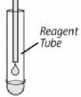

1. Fill the provided **Small, Clear 120 µL Fixed Volume Pipette** with patient sample from the Reagent Tube, by slowly releasing pressure on the bulb.

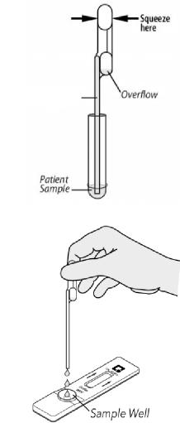

***120 µL Pipette***

**NOTE:** MUST use the provided pipette to transfer the patient sample to the Test Cassette.

1. Firmly squeeze the top bulb to empty the contents of the **Small, Clear**

**120 µL Fixed Volume Pipette** into the Test Cassette sample well. Extra liquid left over in the overflow bulb should be left behind. Discard the Pipette in your biohazard waste.

**NOTE**: The Fixed Volume Pipette is designed to collect and dispense the correct amount of patient sample. Discard the Pipette in your biohazard waste.

**7.** Promptly proceed to the next section, “Using Sofia and Sofia 2,” to complete the test.

**USING SOFIA AND SOFIA 2**

***WALK AWAY/READ NOW Modes***

**Refer to the appropriate User Manual (Sofia or Sofia 2) for operating instructions.**

Sofia and Sofia 2 may be set to two different modes (WALK AWAY and READ NOW). The procedures for each

mode are described below.

**WALK AWAY Mode**

In WALK AWAY Mode, the user **immediately** inserts the Test Cassette into Sofia or Sofia 2. The development

time may differ between Sofia and Sofia 2.

* Sofia – Sofia will automatically time the test development, and the results will be displayed in 15 minutes.
* Sofia 2 – Sofia 2 scans the Test Cassette periodically during the test development time. Positive test results will be displayed between 3 and 15 minutes. Negative test results will be displayed at 15 minutes.

**READ NOW Mode**

**Critically important: Allow the test to develop for the FULL 15 minutes BEFORE placing it into Sofia or Sofia 2.**

Following transfer of the patient sample to the sample port, the user must first place the Test Cassette onto the counter or bench top for 15 minutes (outside of Sofia or Sofia 2) and manually time this development step. The Test Cassette MUST stand 15 minutes to get an accurate result. Then, the user inserts the Test Cassette into Sofia or Sofia 2. In READ NOW Mode, Sofia and Sofia 2 will scan and display the test result within 1 minute. **Note:** Results will remain stable for an additional 15 minutes after the recommended development time of 15 minutes.

**Tips for Batch Testing**

Depending on the workload, several options exist to make batch testing easier. The user can add the Reagent Solution to one or more Reagent Tubes, recap them, and store them on the bench at room temperature (RT) for up to 4 hours without loss of activity before adding the sample(s). Alternatively, after addition of the Reagent

Solution, the user can process Swab or liquid specimens in the Reagent Tube. Then after removing the Swab (if applicable), recap the tube and let them stand at room temperature for up to 4 hours without loss of activity before testing.

**Critically important:** The user should never open the foil pouch exposing the Test Cassette to ambient environment until ready for immediate use.

**RUN TEST WITH SOFIA**

1. Input the User ID using the barcode scanner or manually enter the data using the key pad.

***NOTE:*** *If you mistakenly scan the incorrect barcode, use the Arrow Buttons on the Sofia key pad to*

*re-highlight the field. Then simply rescan using the correct barcode, and the previous one will be overwritten with the correct barcode.*

2. Input the Patient ID or Order # using the barcode scanner or manually enter the data using the key pad.

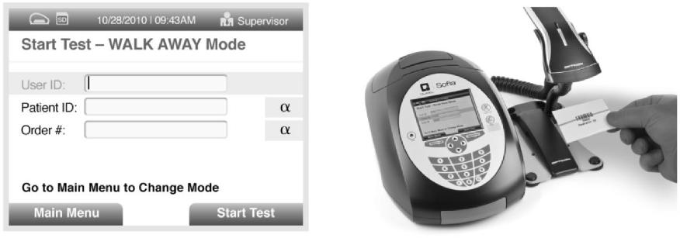

**Sofia V FIA** Page **11** of **28**

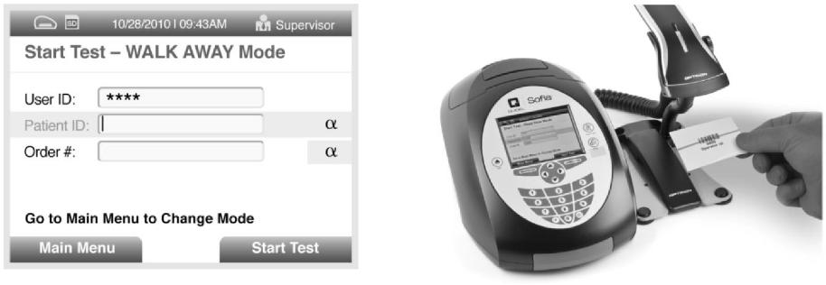

3. Press Start Test and the Sofia drawer will automatically open.

|  |  |
| --- | --- |
|  |  |
| 1. Verify that the correct development mode, WALK AWAY or READ NOW, has been selected. Insert the prepared patient Test Cassette into the drawer of Sofia and close the drawer. 2. Sofia will start automatically and display the progress, as shown in the example below. In WALK AWAY Mode, the test results will be displayed on the screen in approximately 15 minutes. In READ NOW Mode, the test results will be displayed on the screen within 1 minute. See Interpretation of Results section. |  |

|  |  |
| --- | --- |
|  | ***For example: This display shows that the test in WALK AWAY Mode has 12 minutes, 13 seconds remaining. Sofia will read and display the results after 15 minutes.*** |

**INTERPRETATION OF RESULTS USING SOFIA**

When the test is complete, the results will be displayed on the Sofia screen. The results can be automatically printed on the integrated printer if this option is selected. Test Lines, which are fluorescent, cannot be seen with the naked eye.

The Sofia screen will display results for the procedural control as being “valid” or “invalid,” and will provide a positive or negative result for RSV. If the procedural control is “invalid,” retest with a new patient sample and a new Test Cassette.

**Positive Results:**

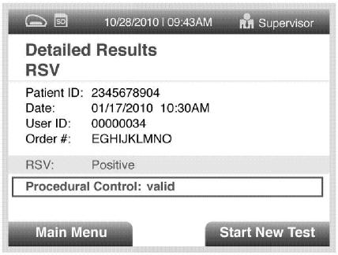

**Negative Results:**

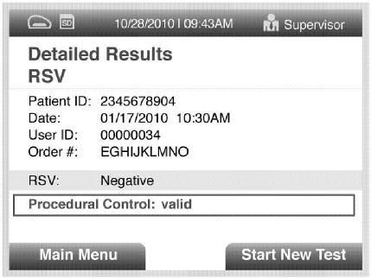

**Invalid Results:**

|  |  |
| --- | --- |
|  | ***For example: This display shows an invalid result.***  **Invalid Result:** If the test is invalid, a new test should be performed with a new patient sample and a new Test Cassette. |

***For example: This display shows a valid positive result for RSV.***

**NOTE:** A positive result does not rule out co-infections with other pathogens.

***For example: This display shows a valid negative result for RSV.***

**NOTE:** A negative result does not exclude RSV viral infection. It is recommended that negative results be confirmed by viral culture or an FDA-cleared RSV molecular assay.

**RUN TEST WITH SOFIA 2**

1. Input the User ID using the integrated barcode scanner or manually enter the data using the on-screen key   
   pad.

***NOTE:*** *If you mistakenly scan the incorrect barcode, select the field again to re-highlight it. Then simply rescan using the correct barcode, and the previous one will be overwritten with the correct barcode.*

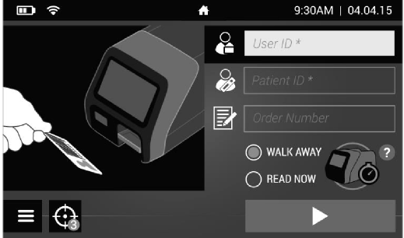

1. Input the Patient ID and Order #, if applicable, using the barcode scanner or manually enter the data using the on-screen key pad.

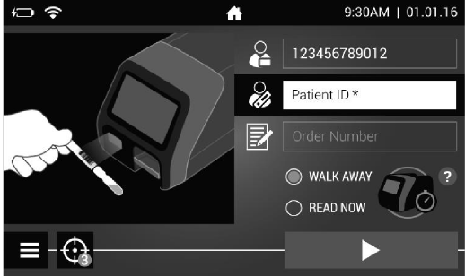

1. Verify that the correct development mode, WALK AWAY or READ NOW, has been selected. Press and open the the Sofia 2 drawer.

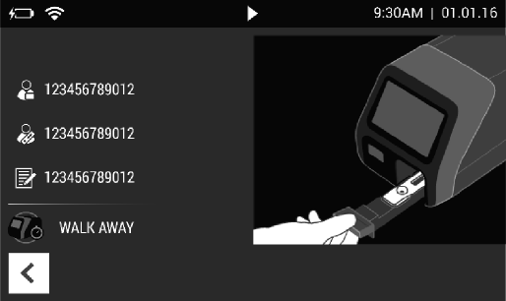

1. Insert the prepared patient Test Cassette into the drawer of Sofia 2 and close the drawer.

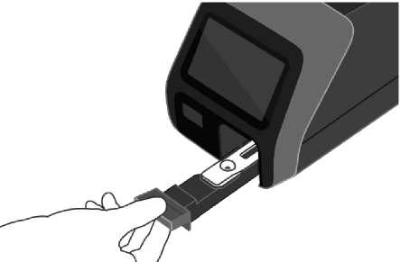

1. Sofia 2 will start automatically and display the progress, as shown in the example below. In WALK AWAY Mode, the test results will be displayed on the screen between 3 and 15 minutes. In READ NOW Mode, the test results will be displayed on the screen within 1 minute. See Sofia 2 Interpretation of Results section.

|  |  |
| --- | --- |
|  | ***For example: This display shows that the test in WALK AWAY Mode has 12 minutes, 34 seconds remaining. Sofia 2 will read and display the results between 3 and 15 minutes.*** |

**INTERPRETATION OF RESULTS USING SOFIA 2**

When the test is complete, the results will be displayed on the Sofia 2 screen. Test Lines, which are

fluorescent, cannot be seen with the naked eye.

The Sofia 2 screen will display results for the procedural control as being or , and will provide a positive or

negative result for RSV. If the procedural control is retest with a new patient sample and a new Test Cassette. If a printer is connected, the results can be printed manually by selecting the print icon while the test results are displayed on the screen.

**Positive Results:**

|  |  |
| --- | --- |
|  | ***For example: This display shows a valid positive result for RSV.***  **NOTE:** A positive result does not rule out  co-infections with other pathogens. |

|  |  |
| --- | --- |
| **Negative Results:** |  |
|  | ***For example: This display shows a valid negative result for RSV.***  **NOTE:** A negative result does not exclude RSV viral infection. It is recommended that negative results be confirmed by viral culture or an FDA-cleared RSV molecular assay. |
| **Invalid Results:** |  |

|  |  |
| --- | --- |
|  | ***For example: This display shows an invalid result.***  **Invalid Result:** If the test is invalid, a new test  should be performed with a new patient sample and a new Test Cassette. |

**LIMITATIONS**

* This test is suitable for the pediatric population (less than 19 years of age) only. Performance characteristics have not been established for use with patients older than 19 years of age and for immunocompromised patients.
* The contents of this kit are to be used for the qualitative detection of RSV antigen from nasopharyngeal swab and nasopharyngeal aspirate/wash samples.
* This test detects both viable (live) and non-viable RSV. Test performance depends on the amount of virus (antigen) in the sample and may or may not correlate with viral culture results performed on the same sample.
* A negative test result may occur if the level of antigen in a sample is below the detection limit of the test or if the sample was collected or transported improperly.
* Failure to follow the Test Procedure may adversely affect test performance and/or invalidate the test result.
* Test results must be evaluated in conjunction with other clinical data available to the physician.
* Positive test results do not rule out co-infections with other pathogens.
* Negative test results are not intended to rule in other non-RSV viral or bacterial infections.
* Positive and negative predictive values are highly dependent on prevalence. False negative test results are more likely during peak activity when prevalence of disease is high. False positive test results are more likely during periods of low RSV activity when prevalence is moderate to low.
* Monoclonal antibodies may fail to detect, or detect with less sensitivity, RSV viruses that have undergone minor amino acid changes in the target epitope region.
* Samples contaminated with whole blood >1% may interfere in the interpretation of the test. Visually bloody samples should not be used.
* Mycoplasma pneumoniae at levels greater than 1x105 cfu/mL may cross-react or interfere with the performance of the test.
* The performance of this test has not been evaluated for use in patients without signs and symptoms of respiratory infection.

**EXPECTED VALUES**

The rate of positivity observed in RSV testing will vary depending on the method of specimen collection, handling/transport system employed, detection method utilized, time of year, age of the patient, and disease prevalence.

**PERFORMANCE CHARACTERISTICS**

**The following studies were performed using Sofia.**

***Sofia RSV FIA Performance vs. Cell Culture***

The performance of the Sofia RSV FIA with Sofia was compared to viral cell culture methods followed by DFA in a multi-center clinical field study during February through April of 2012 and October through December of 2012 in the United States. This study was conducted by health care personnel at 17 distinct sites in various geographical regions within the United States. In this multi-center, point-of-care (POC) field trial, two (2) nasopharyngeal swabs or nasopharyngeal aspirate/wash specimens were collected from each of 1,736 patients. A pair of nasopharyngeal swab specimens was provided by 972 patients and a nasopharyngeal aspirate/wash specimen was provided by 764 patients. All clinical samples were collected from symptomatic patients (less than 19 years of age): 55% were male and 45% were female.

On-site testing of one nasopharyngeal swab specimen or a portion of nasopharyngeal aspirate/wash sample was performed by medical personnel in the physician’s office or hospital facility with the Sofia RSV FIA. The samples were freshly collected and tested. The remaining sample was placed in viral transport media for culturing. The paired swab samples were randomized with respect to the order of testing in the Sofia RSV FIA versus culture. Viral cell culture was performed either at a local clinical laboratory at the test site, or the samples were transported cold on ice packs, not frozen, overnight to a central laboratory for culture within 48 hours. Results are presented in Tables 2 and 3.

**Table 2**

**Sofia RSV FIA Nasopharyngeal Swab Results Versus Culture**

**(Ages 0-<19 Years)**

**Culture**

|  |  |  |  |
| --- | --- | --- | --- |
|  | Pos | Neg | **Sens. =** 126/146 = 86% |
| Sofia Pos | 126 | 25 | (95% C.I. 80-91%) |
| Sofia Neg | 20 | 801 | **Spec. =** 801/826 = 97% |
| Total | 146 | 826 | (95% C.I. 96-98%) |

**Table 3**

**Sofia RSV FIA Nasopharyngeal Aspirate/Wash Results Versus Culture**

**(Ages 0-<19 Years)**

**Culture**

|  |  |  |  |
| --- | --- | --- | --- |
|  | Pos | Neg | **Sens. =** 57/64 = 89% |
| Sofia Pos | 57 | 12 | (95% C.I. 79-95%) |
| Sofia Neg | 7 | 688 | **Spec. =** 688/700 = 98% |
| Total | 64 | 700 | (95% C.I. 97-99%) |

***Sofia RSV FIA Performance vs. Cell Culture When Testing Specimens Placed into Viral Transport Media*** The performance of the Sofia RSV FIA with Sofia, when testing specimens placed into VTM was compared to viral cell culture methods followed by DFA in the same multi‐center clinical field study during February through April of 2012 and October through December of 2012 in the United States. This portion of the study was conducted by laboratory personnel at two (2) distinct laboratory sites within the United States. A nasopharyngeal swab or nasopharyngeal aspirate/wash specimen collected from each of 1,749 patients was placed in viral transport media and then transported cold on ice packs, not frozen, overnight to the laboratory. The Sofia RSV FIA test was performed on a portion of each specimen, and the culture was performed using the remainder of the same specimen in VTM. Nasopharyngeal swab specimens were provided by 968 patients and nasopharyngeal aspirate/wash specimens were provided by 781 patients. Results are presented in Tables 4 and 5.

**Table 4**

**Sofia RSV FIA Nasopharyngeal Swab in VTM Results Versus Culture**

**(Ages 0-<19 Years)**

**Culture**

|  |  |  |  |
| --- | --- | --- | --- |
|  | Pos | Neg | **Sens. =** 125/143 = 87% |
| Sofia Pos | 125 | 26 | (95% C.I. 81-92%) |
| Sofia Neg | 18 | 799 | **Spec. =** 799/825 = 97% |
| Total | 143 | 825 | (95% C.I. 95-98%) |

**Table 5**

**Sofia RSV FIA Nasopharyngeal Aspirate/Wash in VTM Results Versus Culture**

**(Ages 0-<19 Years)**

**Culture**

|  |  |  |  |
| --- | --- | --- | --- |
|  | Pos | Neg | **Sens. =** 59/67 = 88% |
| Sofia Pos | 59 | 12 | (95% C.I. 78-94%) |
| Sofia Neg | 8 | 702 | **Spec. =** 702/714 = 98% |
| Total | 67 | 714 | (95% C.I. 97-99%) |

***Reproducibility Studies***

The reproducibility of the Sofia RSV FIA with Sofia was evaluated at three (3) different laboratories. Two (2) different operators at each site tested a series of coded, contrived samples, prepared in negative clinical matrix, ranging from low negative to moderate positive RSV. The inter-laboratory agreement (Table 6) for negative samples was 98%-100% and 98%-100% for positive samples.

**Table 6**

**Sofia RSV FIA Reproducibility Study Inter‐laboratory Agreement**

|  |  |  |  |  |
| --- | --- | --- | --- | --- |
| **Site** | **Low Neg  (no virus)** | **High Negative  (C5)** | **Low Positive  (C95)** | **Mod. Positive  (C3X LoD)** |
| 1 | 30/30 | 28/30 | 30/30 | 30/30 |
| 2 | 30/30 | 30/30 | 28/30 | 30/30 |
| 3 | 30/30 | 30/30 | 30/30 | 30/30 |
| Total | 90/90 | 88/90 | 88/90 | 90/90 |
| **% Overall  Agreement  (95% CI)** | **100%**  **(95%-100%)** | **98%**  **(92%-100%)** | **98%**  **(92%-100%)** | **100%**  **(95%-100%)** |

***Limit of Detection and Analytical Reactivity***

The limit of detection (LOD) for the Sofia RSV FIA using Sofia was determined using a total of four (4) strains

of RSV, two (2) isolates of RSV A and two (2) isolates of RSV B (Table 7).

**Table 7**

**Limit of Detection with Human Isolates of RSV A and B**

|  |  |
| --- | --- |
| **Viral Strain** | **Minimum  Detectable Level  (TCID50/mL)** |
| RSV A-2 | 3153 |
| RSV A Long | 372 |
| RSV B CH93-18(18) | 476 |
| RSV B Washington/18537/62 | 32.3 |

TCID50/mL=50% tissue culture infectious dose. TCID50 levels   
were determined by the Reed-Muench method.

Analytical reactivity was demonstrated using two (2) additional strains of RSV B: West Virginia Strain/14617/85 at 163 TCID50/mL and RSV 9320 at 8.7 TCID50/mL.

***Analytical Specificity***

***Cross Reactivity***

The cross reactivity of the Sofia RSV FIA with Sofia was evaluated with a total of 32 bacterial and fungal microorganisms and 42 non-RSV viral isolates. None of the organisms or viruses listed below in Table 8 showed any sign of cross reactivity in the assay. When the same organisms in Table 8 were pre-mixed with RSV and tested in the Sofia RSV FIA, all results were positive indicating that the potential cross-reactants did not interfere with the detection of RSV.

**Table 8**

**Analytical Specificity and Cross Reactivity**

|  |  |
| --- | --- |
| **Organism/Non‐RSV Virus** | **Concentration\*** |
| *Acinetobacter baumannii* | 2.32x106 cfu/mL |
| *Bacteroides fragilis* | 2.32x106 cfu/mL |
| *Bordetella pertussis* | 2.32x106 cfu/mL |
| *Candida albicans (yeast)* | 2.32x106 cfu/mL |
| *Corynebacterium diptheriae* | 2.32x106 cfu/mL |
| *Escherichia coli* | 2.32x106 cfu/mL |
| *Haemophilus influenzae* | 2.32x106 cfu/mL |
| *Klebsiella pneumoniae* | 2.32x106 cfu/mL |
| *Lactobacillus plantarum* | 2.32x106 cfu/mL |
| *Legionella pneumophila* | 2.32x106 cfu/mL |
| *Moraxella catarrhalis* | 2.32x106 cfu/mL |
| *Mycobacterium avium* | 2.32x106 cfu/mL |
| *Mycobacterium intracellulare* | 2.32x106 cfu/mL |
| *Mycobacterium tuberculosis* | 2.32x106 cfu/mL |
| *Mycoplasma pneumoniae* | 1x105 cfu/mL |
| *Neisseria meningitides* | 2.32x106 cfu/mL |
| *Neisseria mucosa* | 2.32x106 cfu/mL |
| *Neisseria sicca* | 2.32x106 cfu/mL |
| *Neisseria subflava* | 2.32x106 cfu/mL |
| *Pseudomanas aeruginosa* | 2.32x106 cfu/mL |
| *Serratia marcescens* | 2.32x106 cfu/mL |
| *Staphylococcus aureus* | 2.32x106 cfu/mL |
| *Staphylococcus aureus* (Cowen 1) | 2.32x106 cfu/mL |
| *Staphylococcus epidermidis* | 2.32x106 cfu/mL |
| *Streptococcus mutans* | 2.32x106 cfu/mL |
| *Streptococcus pneumoniae* | 2.32x106 cfu/mL |
| *Streptococcus pyogenes* Group A | 2.32x106 cfu/mL |
| *Streptococcus sanguis* | 2.32x106 cfu/mL |
| Streptococcus sp. Group B | 2.32x106 cfu/mL |
| Streptococcus sp. Group C | 2.32x106 cfu/mL |
| Streptococcus sp. Group F | 2.32x106 cfu/mL |
| Streptococcus sp. Group G | 2.32x106 cfu/mL |
| Adenovirus 3 | 2.32x105 TCID50/mL |
| Adenovirus 4 | 2.64x104 TCID50/mL |
| Adenovirus 5 | 8.98x105 TCID50/mL |
| Adenovirus 7A | 2.32x105 TCID50/mL |
| Adenovirus 11 | 2.32x105 TCID50/mL |

|  |  |
| --- | --- |
| **Organism/Non‐RSV Virus** | **Concentration\*** |
| Coronavirus OC43 | 2.32x105 TCID50/mL |
| Coronavirus 229E | 2.32x105 TCID50/mL |
| Coxsackievirus B5 (Faulkner) | 2.32x105 TCID50/mL |
| Cytomegalovirus AD-169 | 2.32x105 TCID50/mL |
| Cytomegalovirus Towne | 2.32x105 TCID50/mL |
| Echovirus Type 3 | 2.32x105 TCID50/mL |
| Herpes Simplex virus 1 | 2.32x105 TCID50/mL |
| Herpes Simplex virus 2 | 2.32x105 TCID50/mL |
| Human Metapneumovirus A1 | 2.32x105 TCID50/mL |
| Human Metapneumovirus A2 | 2.32x105 TCID50/mL |
| Human Metapneumovirus B1 | 2.32x105 TCID50/mL |
| Human Metapneumovirus B2 | 2.32x105 TCID50/mL |
| Influenza A H1N1 (Mexico/4108/2009) | 2.32x105 TCID50/mL |
| Influenza A H1N1 (Denver/1/57) | 2.32x105 TCID50/mL |
| Influenza A H1N1 (FM/1/47) | 2.32x105 TCID50/mL |
| Influenza A H1N1 (New Jersey/8/76) | 2.32x105 TCID50/mL |
| Influenza A H1N1 (PR/8/34) | 2.32x105 TCID50/mL |
| Influenza A H3N2 | 2.32x105 TCID50/mL |
| Influenza B Hong Kong | 2.32x105 TCID50/mL |
| Influenza B Panama | 2.32x107 TCID50/mL |
| Influenza C/Taylor/1233/47 | 2.32x105 TCID50/mL |
| Measles (Edmonston) | 2.32x105 TCID50/mL |
| Metapneumovirus VR-03-00181 UIHC | 2.32x105 TCID50/mL |
| Mumps (Enders) | 2.32x105 TCID50/mL |
| Parainfluenza virus 1 | 2.32x105 TCID50/mL |
| Parainfluenza virus 2 | 2.32x105 TCID50/mL |
| Parainfluenza virus 3 | 2.32x105 TCID50/mL |
| Parainfluenza virus 4A | 2.32x105 TCID50/mL |
| Parainfluenza virus 4B | 2.32x105 TCID50/mL |
| Rhinovirus Type 1B | 2.32x105 TCID50/mL |
| Rhinovirus Type 2 | 2.32x105 TCID50/mL |
| Rhinovirus Type 3 | 2.32x105 TCID50/mL |
| Rhinovirus Type 7 | 2.32x105 TCID50/mL |
| Rhinovirus Type 15 | 2.32x105 TCID50/mL |
| Rhinovirus Type 18 | 2.32x105 TCID50mL |
| Rhinovirus Type 37 | 2.32x105 TCID50/mL |
| Varicella Zoster Virus | 3.55x104 TCID50/mL |

*The levels of bacteria were determined by limiting dilution, bacterial culture, and colony counting to give cfu/mL (cfu=colony forming unit). Virus

concentrations were determined by standard virology methods, Reed-   
Muench.

***Interfering Substances***

Whole blood, mucin, and several over-the-counter (OTC) products and common chemicals were evaluated

with the Sofia RSV FIA using Sofia. No interference was observed at the levels indicated below (Table 9).

**Table 9**

**Non‐interfering Substances**

|  |  |
| --- | --- |
| **Substance** | **Concentration** |
| Acetamidophenol | 23 mg/mL |
| Acetylsalicylic acid | 23 mg/mL |
| Albuterol | 26 mg/mL |
| Chlorpheniramine | 4 mg/mL |
| Dextromethorphan | 4 mg/mL |
| Diphenhydramine | 3 mg/mL |
| Guaiacol | 46 mg/mL |
| Mucin | 9 mg/mL |
| Nasal Spray #1 (Vick's) | 23% |
| Nasal Spray #2 (4-Way) | 23% |
| Nasal Spray #3 (Equate) | 23% |
| OTC Mouthwash #1 (Listerine) | 58% |
| OTC Mouthwash #2 (Crest Pro-Health) | 58% |
| OTC Mouthwash #3 (Scope) | 58% |
| OTC Cough Drop #1 (CVS) | 19% |
| OTC Cough Drop #2 (Ricola) | 15% |
| OTC Cough Drop #3 (Halls) | 34% |
| Phenylephrine | 11 mg/mL |
| Rimantadine | 116 µg/mL |
| Whole Blood | 1% |

***CLIA Waiver Studies***

As part of the prospective study described in the Performance Characteristics section above, the accuracy of the Sofia RSV FIA with Sofia, was evaluated at CLIA waived sites when used by untrained operators, with specimens from pediatric patients ages 0-<7 years. The test results obtained with the Sofia RSV FIA were compared to the results obtained by viral cell culture. This study was conducted at sixteen (16) CLIA-waived sites with thirty-seven (37) untrained operators representative of CLIA-waived settings.

The study included 2193 subjects: one thousand fifty-seven (1,057) subjects provided a pair of nasopharyngeal swabs and one thousand one hundred thirty-six (1,136) provided a nasopharyngeal aspirate/wash specimen.

The clinical sensitivity and specificity of the Sofia RSV FIA with ages 0-<7 years, as compared to viral culture (the comparator method), are presented below in Tables 10 and 11.

**Table 10**

**Sofia RSV FIA Versus Culture (Nasopharyngeal Swabs)**

**(Ages 0-<7 Years)**

**Culture**

|  |  |  |  |
| --- | --- | --- | --- |
|  | Pos | Neg | **Sens. =** 134/154= 87% |
| Sofia Pos | 134 | 34 | (95% C.I. 81-92%) |
| Sofia Neg | 20 | 869 | **Spec. =** 869/903= 96% |
| Total | 154 | 903 | (95% C.I. 95-97%) |

**Table 11**

**Sofia RSV FIA Versus Culture (Nasopharyngeal Aspirate/Wash)**

**(Ages 0-<7 Years)**

**Culture**

|  |  |  |  |
| --- | --- | --- | --- |
|  | Pos | Neg | **Sens. =** 141/154= 92% |
| Sofia Pos | 141 | 22 | (95% C.I. 86-95%) |
| Sofia Neg | 13 | 960 | **Spec. =** 960/982= 98% |
| Total | 154 | 982 | (95% C.I. 97-99%) |

A second study was conducted to demonstrate that untrained intended users could perform the test consistently and accurately using weakly reactive samples. The study consisted of three (3) distin**ct CLIA‐** waived sites where the Sofia RSV FIA used with Sofia was evaluated using coded, randomized panels of simulated samples, including one (1) weak positive (C95 **–** a concentration at the assay cutoff) and one

1. weak negative (C5 **‐** a concentration just below the assay cutoff ). Two (2) or more operators at each site (8 operators total) tested the panel on each of ten (10) days, spanning a period of approximately two
2. weeks. The performance of the Sofia RSV FIA with samples near the assay cutoff was acceptable when used by untrained intended users. The percent agreement with expected results for each sample is shown in Table 12.

**Table 12**

**Sofia RSV FIA Performance Near the Cutoff (All Sites)**

|  |  |  |
| --- | --- | --- |
| **Sample Level** | **Untrained Intended Users** | |
| **Percent Agreement with Expected Results\*** | **95% Confidence Interval** |
| Weak RSV Positive  (C95) | 85% (51/60) | 74-92% |
| Weak RSV Negative  (C5) | 93% (56/60) | 84-98% |

*The expected results for **“Weak Posit**i**ve”** samples are **“Positive,”** while the expected results for **“**Weak Neg**ative” samp**l**es are “N**egati**ve.”**

**Sofia RSV FIA Performance with Sofia 2**

**The following studies were performed to demonstrate equivalency between Sofia and Sofia 2 when**

**testing the Sofia RSV FIA.**

***Method Comparison***

The performance of the Sofia RSV FIA when tested on Sofia vs. Sofia 2 was compared using a panel of 200 clinical samples. This field study was performed at 3 intended user laboratory sites using identical panels of known positive and negative clinical and contrived samples prepared in viral transport media (VTM). Each site used 4 Sofias and 4 Sofia 2s for a total of 12 instruments of each type in the study. One hundred (100) positive and one hundred (100) negative samples were incorporated into the panels. Panel members were prepared so that a broad range of negative and positive samples were evenly distributed across the range of the assay. All samples were coded and used to prepare the randomized panels. A total of 200 samples per site were tested resulting in a total of 600 results.

Sofia versus Sofia 2 comparison results are shown below in Table 13. RSV positive agreement was 97%; negative agreement was 96%.

**Table 13**

**Sofia vs. Sofia 2 Method Comparison**

Sofia

|  |  |  |
| --- | --- | --- |
|  | Pos | Neg |
| Sofia 2 Pos | 314 | 10 |
| Sofia 2 Neg | 9 | 267 |
| Total: | 323 | 277 |

|  |  |
| --- | --- |
| Positive % | 97% (314/323) |
| Agreement = | (95%CI=94.7%-98.6%) |
| Negative % | 96% (267/277) |
| Agreement = | (95% CI=93.4%-98.1%) |

There was a total of 19 discordant results between Sofia and Sofia 2, all of which were determined to contain analyte concentrations near or below the cutoff at the time the method comparison study was conducted.

***Reproducibility***

A reproducibility study was performed with the Sofia RSV FIA using Sofia 2 at three different laboratories, one of which was Quidel. Two different operators at each site tested a nine-member panel of contrived samples, prepared in negative clinical matrix, ranging from negative to moderate positive RSV concentrations. Each operator tested one panel on 5 different days spanning over approximately 1 week. A total of 10 Sofias and 10 Sofia 2s were used. The inter-laboratory agreement (Table 14) for the Sofia RSV FIA was identical for all samples with 100% agreement.

**Table 14**

**Sofia RSV FIA Reproducibility Study Inter‐laboratory Agreement**

|  |  |  |  |
| --- | --- | --- | --- |
| **Site** | **RSV Negative** | **RSV Weak  Positive (1X**  **LOD)** | **RSV Moderate  Positive  (2-3X LOD)** |
| 1 | 30/30 | 30/30 | 30/30 |
| 2 | 30/30 | 30/30 | 30/30 |
| 3 | 30/30 | 30/30 | 30/30 |
| **Total** | **90/90** | **90/90** | **90/90** |
| **% Overall  Agreement  (95% CI)** | **100%**  **(95-100%)** | **100%**  **(95-100%)** | **100%**  **(95-100%)** |

***Limit of Detection***

A limit of detection (LOD) study was performed with the Sofia RSV FIA on Sofia and Sofia 2 using a total of

four (4) strains of RSV, two (2) isolates of RSV A and two (2) isolates of RSV B (Table 15).

**Table 15**

**Limit of Detection with Human Isolates of RSV A and B**

|  |  |  |
| --- | --- | --- |
| **Viral Strain** | **Platform** | **Minimum  Detectable Level  (TCID50/mL)** |
| RSV A Long | Sofia | 471 |
| Sofia 2 | 467 |
| RSV A-2 | Sofia | 5511 |
| Sofia 2 | 5950 |
| RSV B CH93-18(18) | Sofia | 585 |
| Sofia 2 | 620 |
| RSV B Washington/18537/62 | Sofia | 78.6 |
| Sofia 2 | 91.1 |

TCID50/mL=50% tissue culture infectious dose. TCID50 levels were   
determined by the Reed‐Muench method.

***CLIA Waiver Near the Cutoff Study***

A study was conducted to demonstrate that untrained intended users could perform the test consistently and accurately using weakly reactive samples with the Sofia RSV FIA and Sofia 2. The study consisted of three (3) distinct CLIA-waived sites where the Sofia RSV FIA was evaluated using coded randomized panels of simulated samples, including one (1) weak positive (C95—a concentration at the assay cutoff) and one negative for RSV. Three (3) operators at each site (9 operators total) tested the panel on each of 10 days, spanning a period of approximately 2 weeks. The percent agreement with expected results for each sample is shown in Table 16.

**Table 16**

**Sofia RSV FIA Performance Near the Cutoff (All Sites)**

|  |  |  |
| --- | --- | --- |
| **Sample Level** | **Untrained Intended Users** | |
| **Percent Agreement with Expected Results\*** | **95% Confidence Interval** |
| Weak RSV Positive  (C95) | 97% (70/72) | 90-100% |
| RSV Negative (C0) | 100% (72/72) | 94-100% |

*The expected results for “Weak Positive” samples are “Positive,” while the expected results for “Negative” samples are “Negative.”

Using the risk analysis as a guide, analytical flex studies were conducted. The studies demonstrated that the test is insensitive to each of the stresses of environmental conditions and potential user errors that were investigated in these studies.

**ASSISTANCE**

If you have any questions regarding the use of this product or if you want to report a test system problem,

please call Quidel Technical Support at 800.874.1517 (in the U.S.) or 858.552.1100 (outside the U.S.), Monday

through Friday, from 7:00 a.m. to 5:00 p.m., Pacific Time. If outside the U.S. contact your local distributor or [technicalsupport@quidel.com](mailto:technicalsupport@quidel.com). Test system problems may also be reported to the FDA through the MedWatch medical products reporting program (phone: 800.FDA.1088; fax: 800.FDA.0178; <http://www.fda.gov/medwatch).>

**REFERENCES**

1. Red Book, American Academy of Pediatrics, 28th edition (2009) pp. 560–569.
2. Macartney K. et al. Nosocomial Respiratory Syncytial Virus Infections: The Cost-Effectiveness and Cost-Benefit of Infection Control. Pediatrics, 2000 Sep; 106(3):520–526. <http://pediatrics.aappublications.org/cgi/content/full/106/3/520.>
3. Collins P., Chanock R., Murphy B. Fields Virology. Fourth Edition. Volume 1. Chapter 45 –Respiratory Syncytial Virus. Lippincot Williams and Wilkins (2001).
4. Thompson W. et al. Mortality Associated With Influenza and Respiratory Syncytial Virus in the United States. JAMA, 2003 Jan; 289(2):184.
5. Navas L., Wang E. et al. Improved outcome of respiratory syncytial virus infection in a high risk hospitalized population of Canadian children. Pediatric Investigators Collaborative Network on Infections in Canada. J Pediatr. 1992 Sep; 121(3):348–54.
6. Moler F.W. et al. Respiratory syncytial virus morbidity and mortality estimates in congenital heart disease patients: a recent experience. Crit Care Med. 1992 Oct; 20(10):1406–13.
7. Biosafety in Microbiological and Biomedical Laboratories, 5th Edition. U.S. Department of Health