Body Fluid Lining Cells clarification
- Part of CAP requirement regarding reporting out Body fluid differentials is to report out lining cells if we are reporting Total Nucleated Cells instead of WBC. Starting today, you must report out lining cells along with the WBCs (e.g. Mesothelial cells, synovial lining cells, ventricular lining cells, bronchial lining cells, epithelial cells) under [Linning Cells, BF] or [Linning Cells, SF] (refer to the images below). There are resource books and Atlas in the Hematology resulting bench if you need reference of what these lining cells look like, and you can also let us know if you need a show and tell.
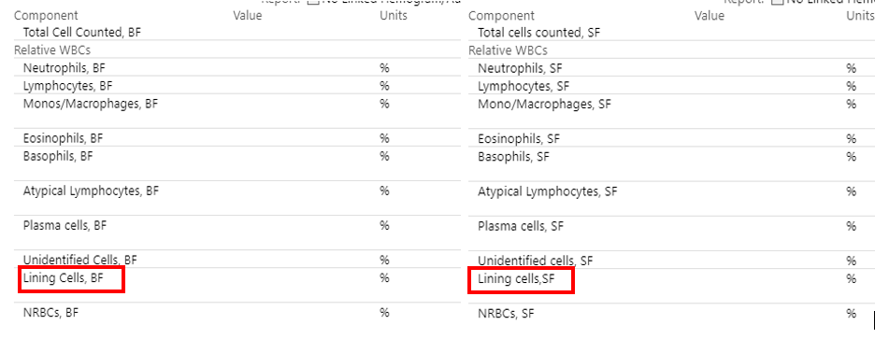
- Lining cells and NRBC are added to the CSF Diff and Fluid keyboards.
- The table below shows the cells included or not included in the 100-cell differential for each body fluid type. Please note that when it says “do not include” -the cells will be counted and noted on the diff but will not contribute towards the 100-cell differential.
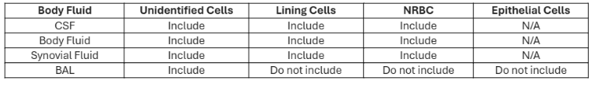
- BAL Diff keyboard in Beaker now has Linning cells, Epithelial cells, and NRBC built. These are not included in the calculation for the 100-cell differential. These will be classified as “Other Calculated Values” and will have an attached comment as an observation each time these are noted. Make sure the Manual and Slide Review box are checked so the results can cross to the patient’s chart.
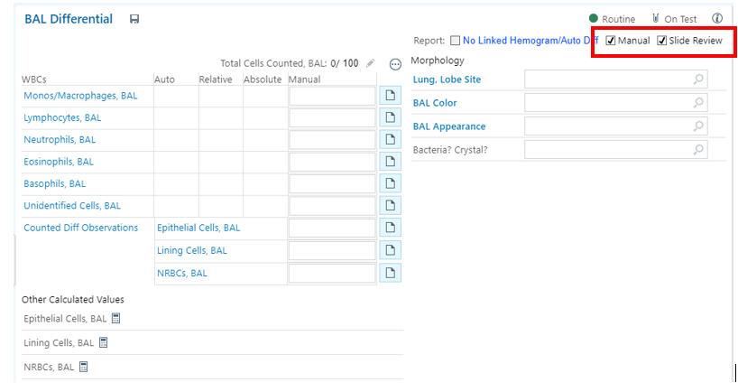
Lining cells Overview
Lining cells are specialized epithelial cells that form protective barriers and line various structures in the body, including organs, cavities, and blood vessels. Examples include squamous epithelium, endothelial cells, and mesothelial cells.
Detailed Examples:
- Epithelial Cells: These cells line the internal surfaces of the body and form the outer layer of the skin. They can be classified by their shape (squamous, cuboidal, columnar), the number of layers (simple or stratified), and specialized functions like secretion or absorption.
  - Simple Squamous Epithelium: Forms a single layer of thin, flat cells, found in the lungs, blood vessels (endothelium), and body cavities (mesothelium).
  - Stratified Squamous Epithelium: Consists of multiple layers of cells, including keratinized and non-keratinized forms, lining the skin and oral cavity, respectively.
  - Columnar Epithelium: Column-shaped cells, lining the stomach, colon, and rectum.
- Endothelial Cells: Specialized epithelial cells forming the inner lining of blood vessels, heart, and lymphatic vessels.
- Mesothelial Cells: Found in the pleural, pericardial, and peritoneal cavities.
- Transitional Epithelium: Found in the urinary system, specifically the ureters and urinary bladder, with cells that can change shape as the bladder fills with urine.
- Synovial Lining Cells: Found in the lining of joint spaces, producing synovial fluid.
- Bone Lining Cells: Present on bone surfaces, involved in bone remodeling.

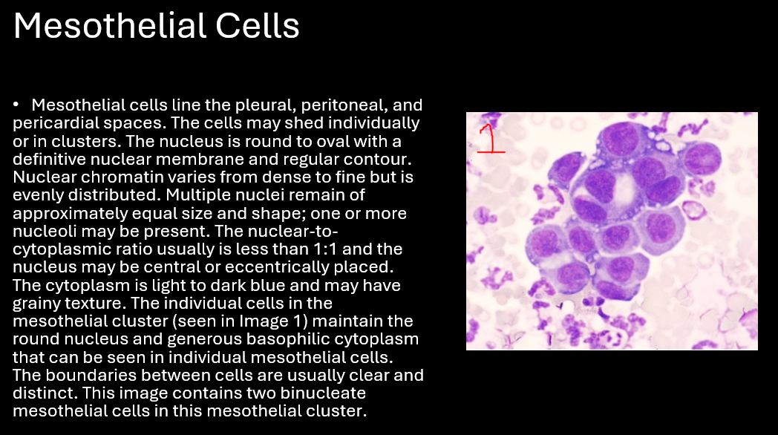
Created by: Victoria Jones MLS(ASCP)
Lead Hematology Paulding Hospital Lab
09/12/2024

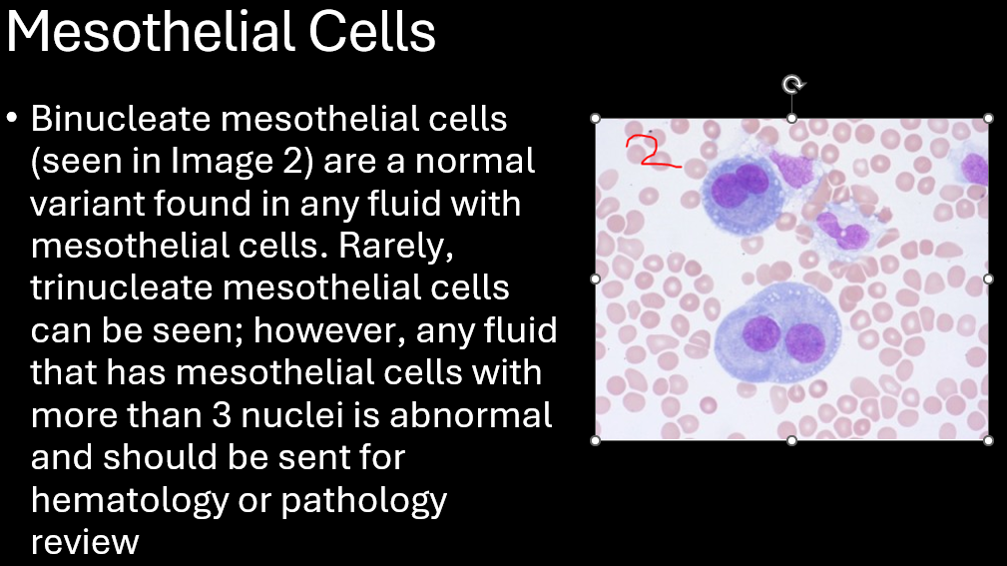
Created by: Victoria Jones MLS(ASCP)
Lead Hematology Paulding Hospital Lab
09/12/2024

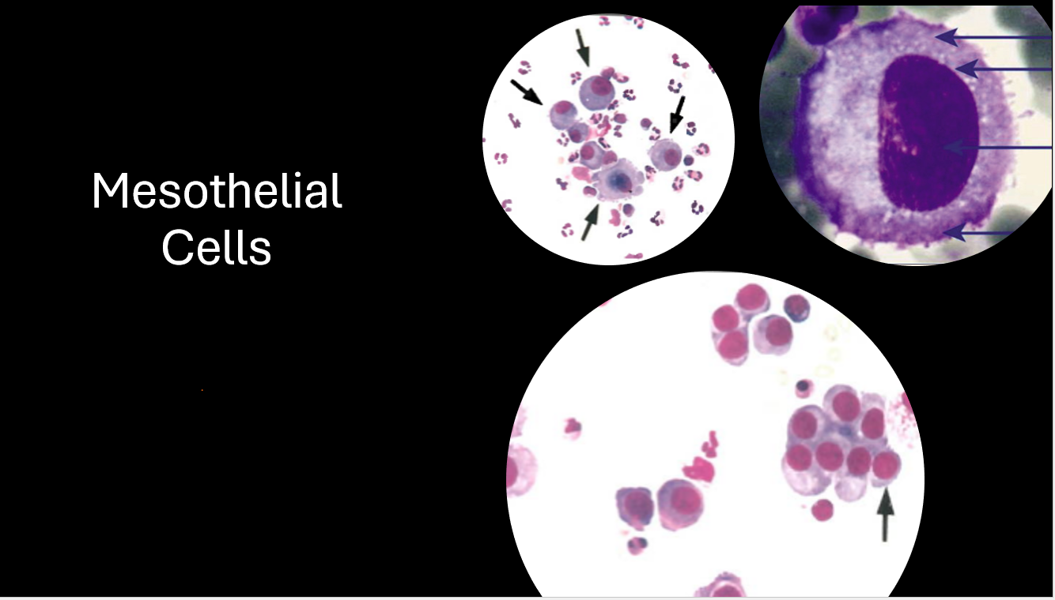
Created by: Victoria Jones MLS(ASCP)
Lead Hematology Paulding Hospital Lab
09/12/2024
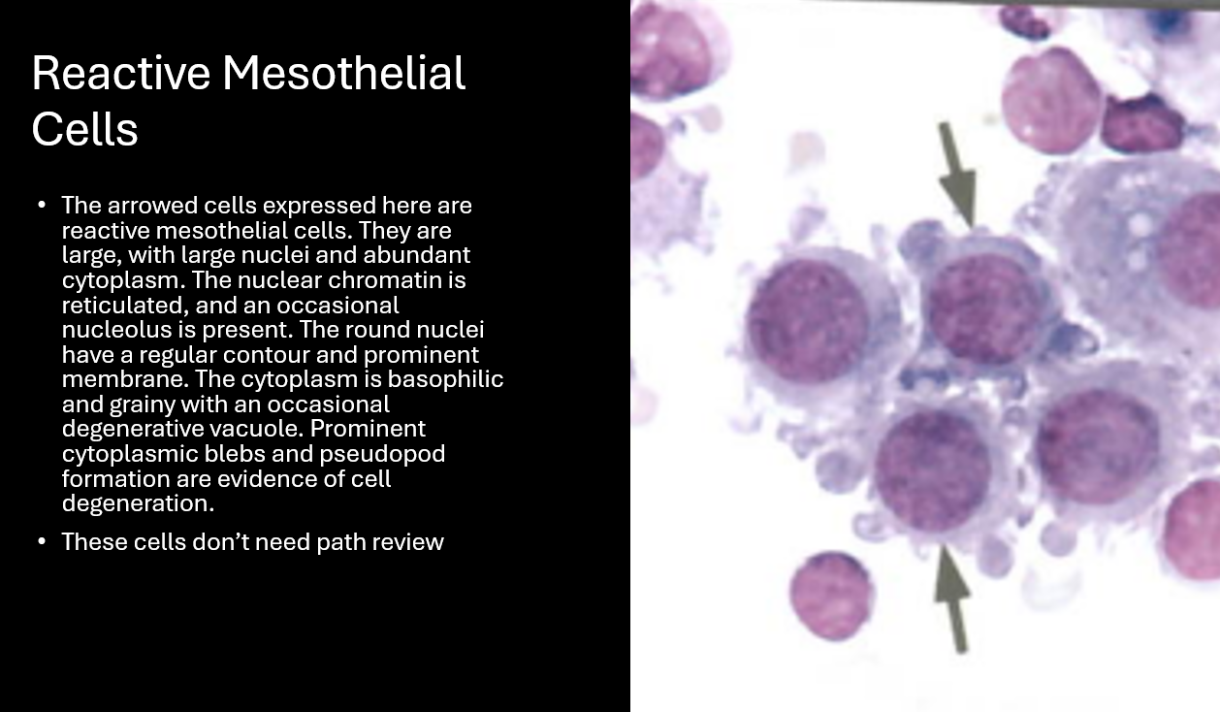
Created by: Victoria Jones MLS(ASCP)
Lead Hematology Paulding Hospital Lab
09/12/2024

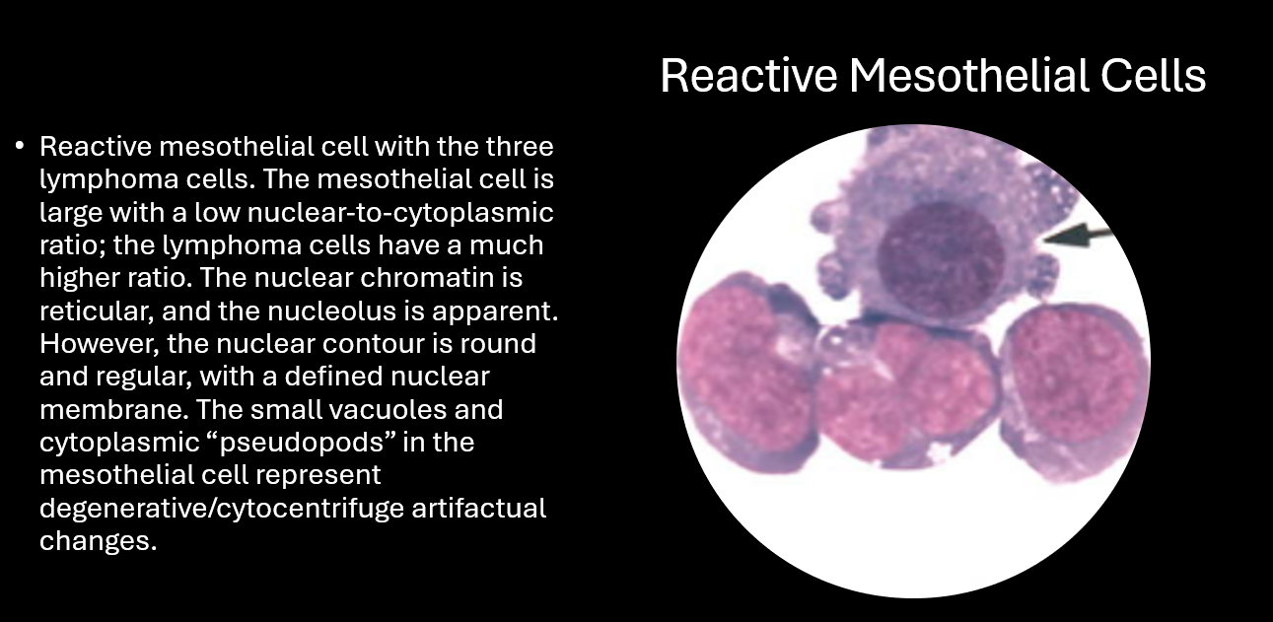
Created by: Victoria Jones MLS(ASCP)
Lead Hematology Paulding Hospital Lab
09/12/2024

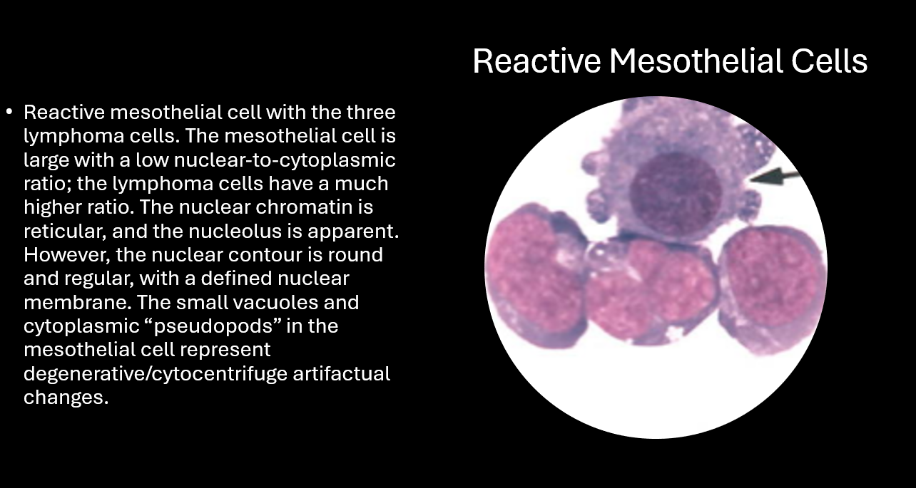
Created by: Victoria Jones MLS(ASCP)
Lead Hematology Paulding Hospital Lab
09/12/2024

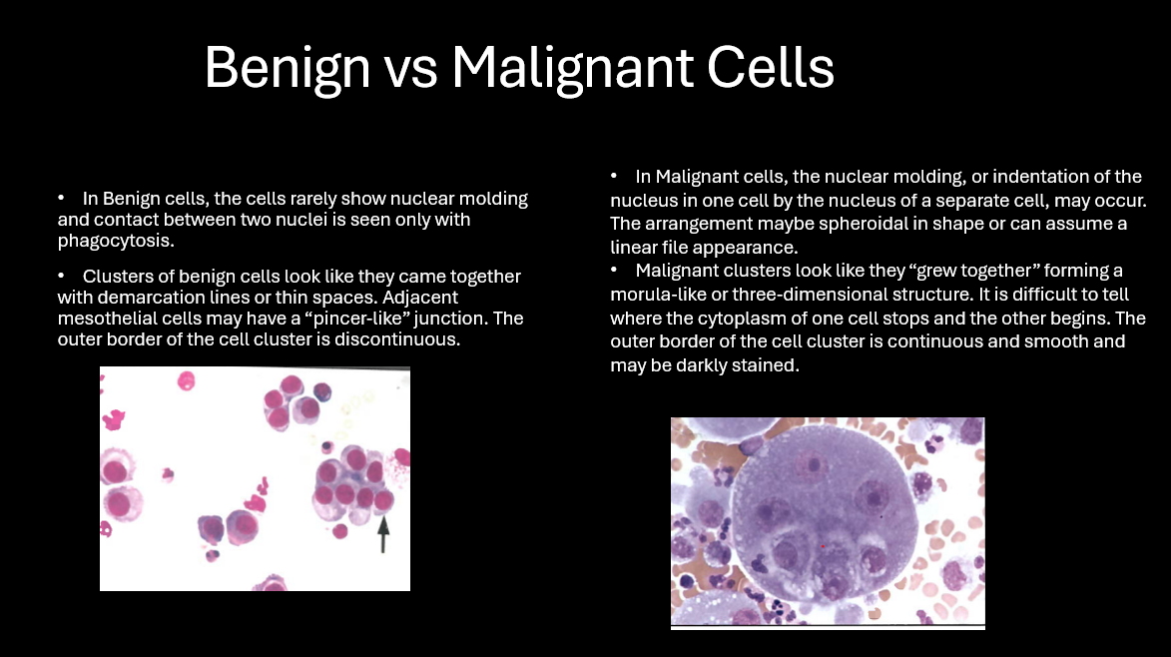
Created by: Victoria Jones MLS(ASCP)
Lead Hematology Paulding Hospital Lab
09/12/2024

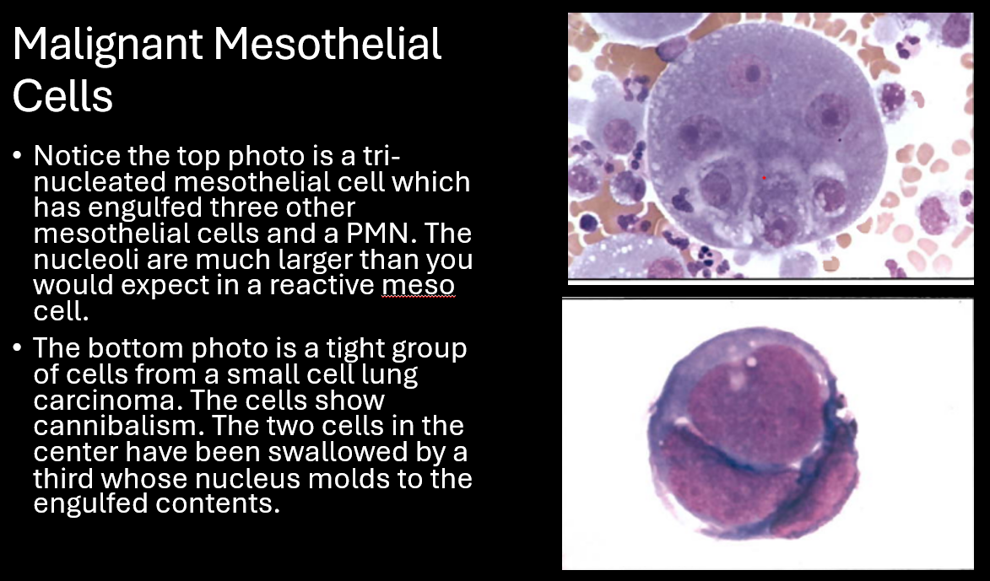
Created by: Victoria Jones MLS(ASCP)
Lead Hematology Paulding Hospital Lab
09/12/2024
Created by: Victoria Jones MLS(ASCP)
Lead Hematology Paulding Hospital Lab
09/12/2024
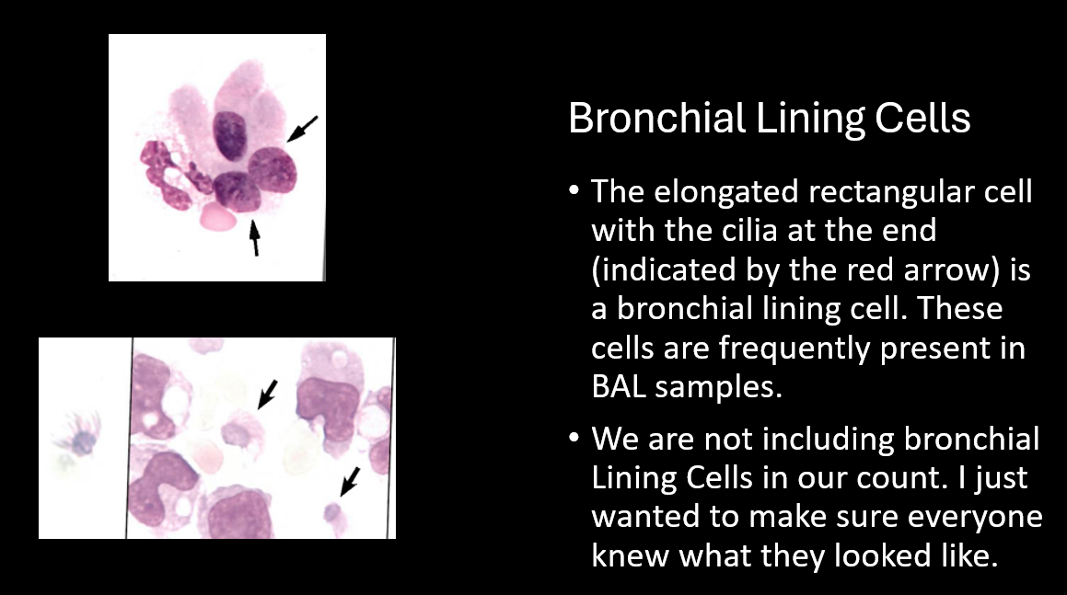

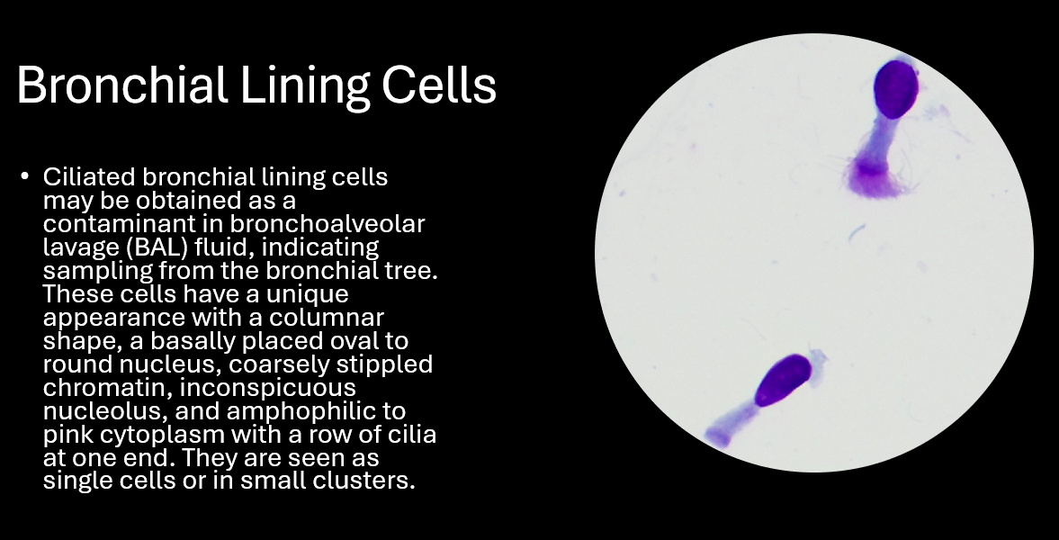
Created by: Victoria Jones MLS(ASCP)
Lead Hematology Paulding Hospital Lab
09/12/2024

