Case #2 Sezary Syndrome
- CAP case grading criteria
- Identify malignant lymphoid cells (other than blast) 50
- Lymphocytes count ≥ 20% (sum of lymphocyte count and WBC, Other count) 20
- Refer case to pathologist for review 20
- Decreased platelet estimate 10

- Patient history
A 61-year-old woman with a history of cutaneous lymphoma developed redness and scaling over the majority of her skin. Concerned, she went to her hematology specialist who ordered a complete blood count. The test included the following results:
Indices | Patient Results | Reference Values
WBC | 12.47 x 10⁹/L | 3.70 -11.00 x 10⁹/L
RBC | 3.00 x 10¹²/L | 3.9 - 5.2 x 10¹²/L
HBG | 9.0 g/dL | 11.5 - 15.5 g/dL
MCV | 95.7 fL | 80.0 - 100.0 fL
RDW-CV | 16.1 % | 11.0 - 15.0%
PLT | 120 x 10⁹/L | 150 - 40

- Sezary Syndrome Overview
Peripheral blood smear findings in cutaneous lymphoma (CTCL) may include the presence of abnormal, malignant lymphoid cells called Sézary cells, which are often large, have irregular or "cerebriform" (serpentine) nuclei, and can be found in varying percentages depending on the stage of the disease. In Sézary syndrome, an advanced form of CTCL, these cells can be abundant in the blood. Other findings may include an overall increase in lymphocytes, a decreased number of normal CD4+, CD8+, and NK cells, and sometimes an elevated erythrocyte sedimentation rate (ESR) or lactate dehydrogenase (LDH) level.
The smear may also reveal a decrease in normal lymphocytes (dilution of healthy cells) and can show abnormalities in a complete blood count (CBC), such as anemia or leukocytosis.
Morphological findings on the peripheral blood smear:
- Sézary cells: These are the most characteristic findings, though they are not always present.
  - Nuclear shape: Often have a convoluted, cerebriform, or serpentine-like nucleus.
  - Size: Can be larger than normal lymphocytes and may vary in size.

- Lymphocyte population changes:
  - Dilution: A decrease in the number of normal CD4+, CD8+, and NK cells can be seen due to the presence of malignant cells.
  - Other abnormal cells: In some cases, especially with other types of lymphoma, abnormal lymphocytes with more uniformly condensed chromatin and deep nuclear clefts may be seen, such as in follicular lymphoma.
Other related findings:
- Complete blood count (CBC):
  - Can show abnormalities like anemia (low red blood cell count), leukocytosis (high white blood cell count), or thrombocytopenia (low platelet count).
- Flow cytometry: While not a smear finding, it's a crucial test that complements the smear by confirming the presence of a clonal population of malignant T-cells, often with abnormal surface markers (e.g., loss of CD7).
- Case Cell Images
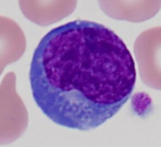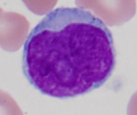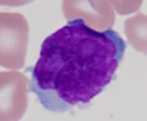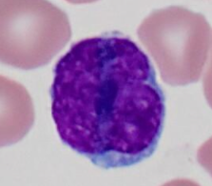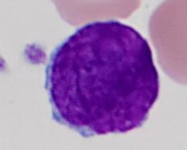

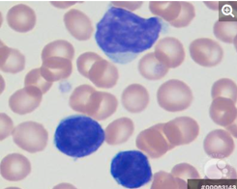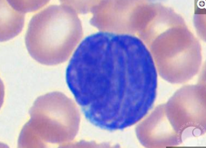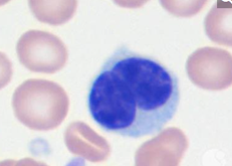

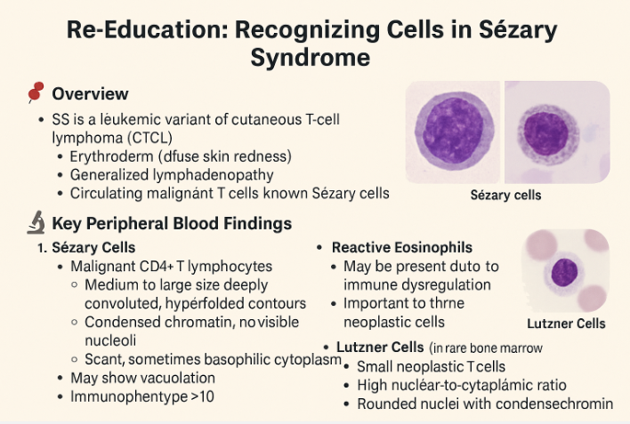

Case #4 Essential Thrombocythemia
- CAP Case Grading Criteria
- Increased platelets estimate 60
- Report platelet, large or platelet, giant 20
- Identify neutrophil with hypersegmented nucleus 10
- Identify macrocyte oval or round (excluding polychromatophilic red cells) 10

- Patient history
An 84-year-old woman with essential thrombocythemia being treated with hydroxyurea presents for disease monitoring. The complete blood count included the following results:
Indices | Patient Results | Reference Values
WBC | 8.30 × 10⁹/L | 3.70 - 11.00 x 10⁹/L
RBC | 3.01 × 10¹²/L | 3.9 - 5.2 x 10¹²/L
HBG | 11.0 g/dL | 11.5 - 15.5 g/dL
MCV | 111.3 fL | 80.0 - 100.0 fL
RDW-CV | 14.7 % | 11.0 - 15.0%
PLT | 741 x 10⁹/L | 150 - 400 x 10⁹/L

- Essential thrombocythemia (ET) Overview
Essential thrombocythemia is a myeloproliferative neoplasm causing high platelet counts, while hypersegmented neutrophils are a separate condition where neutrophils have an unusually segmented nucleus. These two conditions are not directly linked, though some treatments for ET, like hydroxyurea, can cause the appearance of hypersegmented neutrophils alongside other red blood cell changes. Hypersegmented neutrophils are typically a sign of vitamin B12 or folate deficiency or can be an artifact of delayed blood smear preparation.

Hypersegmented Neutrophils Overview
Hypersegmented neutrophils are mature neutrophils with six or more nuclear lobes, or when >3–5% of neutrophils have ≥5 lobes.
Morphology
- Nucleus: 6+ lobes (normal: 3–5)
- Cytoplasm: Normal appearance with fine granules
- Size: Slightly larger than typical neutrophils
- Seen in: Peripheral blood smear under microscope
Clinical Significance
Hypersegmentation is a sensitive and early marker for:
- Megaloblastic anemia (due to vitamin B12 or folate deficiency)
- Myelodysplastic syndromes (MDS)
- Iron deficiency anemia
- Drug effects (e.g., hydroxyurea, methotrexate)
- Chronic infections
- Following G-CSF therapy
Associated Conditions
- Pernicious anemia
- Myeloproliferative neoplasms
- Chemotherapy effects
- Autoimmune gastritis

Comparison with Normal and Dysplastic Neutrophils
Feature | Normal Neutrophils | Hypersegmented Neutrophils | Dysplastic Neutrophils
Nuclear Lobes | 3–5 lobes | 6 or more lobes or when >3–5% of neutrophils have ≥5 lobes. | Irregular nuclear shape
Cytoplasmic Appearance | Normal | Normal | Abnormal (hypogranular, vacuolated)
Associated Condition | Normal immune function | Megaloblastic anemia, B12/Folate deficiency | Myelodysplastic syndromes (MDS), leukemia

Hypersegmented neutrophils are an early and sensitive marker for certain vitamin deficiencies and hematological disorders. Their detection in a blood smear can provide valuable insights into a patient’s nutritional and hematological health, making them a critical focus in diagnostic hematology.
Key Takeaways
- Vitamin B12 and folate deficiencies are the most common causes.
- Megaloblastic anemia and myelodysplastic syndromes frequently show hypersegmented neutrophils.
- Medications and chemotherapy can induce similar neutrophil abnormalities.
- Identifying the underlying cause is crucial for proper diagnosis and treatment.

Hypersegmented neutrophils are not just a laboratory finding—they serve as an important early warning sign for serious hematological and nutritional disorders.

- Macrocytosis Overview
A macrocyte is an abnormally large red blood cell found in peripheral blood, often detected by a high mean corpuscular volume (MCV) on a complete blood count (CBC). See HEM3.1, chapter XI Grading Morphology for more details . It is not a disease itself but a sign of an underlying condition, such as vitamin B12 or folate deficiency, liver disease, or alcoholism. Further investigation, including a peripheral blood smear, is needed to determine the specific cause and whether it has led to macrocytic anemia.
Causes of macrocytes
- Nutritional deficiencies: Lack of vitamin B12 and/or folate is a common cause, especially when the peripheral blood smear shows megaloblastic changes like macro-ovalocytes and hypersegmented neutrophils.
- Liver disease: Conditions like hepatitis, obstructive jaundice, and chronic alcoholism can lead to macrocytosis, often characterized by round macrocytes in the peripheral smear.
- Medications: Certain drugs that interfere with DNA synthesis, such as some immunosuppressants, can cause macrocytes.
- Other conditions:
  - Chronic alcoholism
  - Hypothyroidism
  - Myelodysplastic syndromes (MDS) or other bone marrow disorders
  - Pregnancy
  - Autoimmune or endocrine conditions
How macrocytes are detected and diagnosed
- Complete Blood Count (CBC): A standard blood test that includes a measurement of the mean corpuscular volume (MCV). An MCV above the normal range (typically >100 fL) indicates macrocytosis.
- Peripheral Blood Smear: A microscopic examination of the blood that allows a doctor to visualize the red blood cells and other cells. This helps determine the specific morphology of the macrocytes (e.g., oval-shaped vs. round) and look for signs like hypersegmented neutrophils, which points to a megaloblastic cause.
- Additional Tests: Depending on the initial findings, doctors may order more tests to pinpoint the underlying cause. These can include checking vitamin B12 and folate levels, reticulocyte count, liver function tests, and thyroid function tests.
Macrocytic anemia
- When enlarged red blood cells don't have enough hemoglobin, they can't transport oxygen efficiently, leading to a condition called macrocytic anemia.
- Symptoms can be similar to other types of anemia and may include fatigue, shortness of breath, and pale skin.
- In some cases, especially with megaloblastic anemia, other symptoms may be present, such as diarrhea, a sore tongue, or neurological changes.
- Case cell images
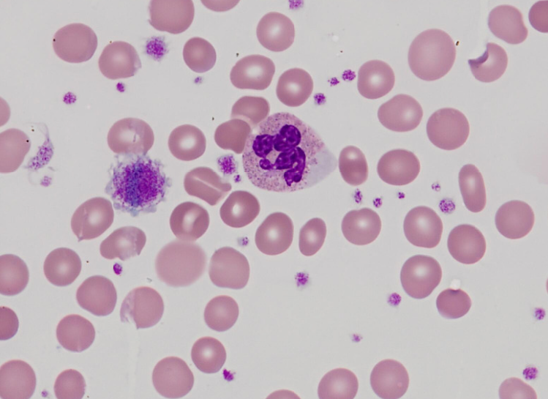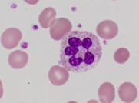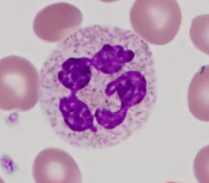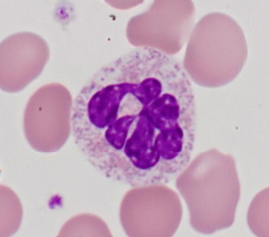
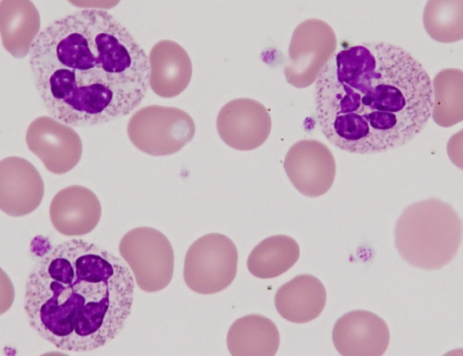

Case #5 Chediak-Higashi Syndrome
- CAP Case Grading Criteria
  - Identify leukocyte containing Chediak-Higashi anomaly inclusion(s) 70
  - Refer case to pathologist for review 20
  - Decreased platelet estimate 10

- Patient history
A sixteen-year-old male was referred to out-patient hematology for evaluation of mild cytopenias and unexplained fevers. Physical exam notable for fair complexion and partial ocular albinism. The complete blood count included the following results:
Indices | Patient Results | Reference Values
WBC | 3.3 × 10⁹/L | 3.7 - 11.0 x 10⁹/L
RBC | 4.87 × 10¹²/L | 4.2 – 6.0 x 10¹²/L
HBG | 13.0 g/dL | 13.0 - 17.0 g/dL
MCV | 78 fL | 80.0 - 100.0 fL
RDW-CV | 16 % | 11.5 - 15.0%
PLT | 130 x 10⁹/L | 150 - 400 x 10⁹/L

- Albinism and Chediak-Higashi Syndrome Overview
Chediak-Higashi syndrome (CHS) is a rare genetic disorder characterized by, among other things, a form of albinism known as oculocutaneous albinism (OCA).
Albinism in CHS:
- OCA in CHS is caused by an abnormal accumulation of large, rod-shaped granules called melanosomes in the cells that produce melanin, the pigment responsible for skin, hair, and eye color.
- This accumulation prevents the normal distribution of melanin, resulting in:
  - Light skin and hair
  - Pale blue or green eyes
  - Increased sensitivity to sunlight
The peripheral blood smear finding most characteristic of Chediak-Higashi syndrome is the presence of abnormally large, dysfunctional lysosomal granules within white blood cells.

Abnormal granule characteristics
- Appearance: These giant granules are a result of inappropriate fusion of lysosomes and can appear as large, dense inclusions in the cytoplasm of various blood cells. The abnormal granules can be so large and prominent that they resemble large, rounded lysosomes.
- Cell types affected: The giant granules can be found in neutrophils, eosinophils, basophils, and lymphocytes.
- Function: The fused granules impair the cells' normal functions. For example, in neutrophils, the inability of these granules to fuse properly with phagosomes leads to defective killing of ingested bacteria. In platelets, the absence of normal-sized dense granules can lead to a bleeding tendency.

Other blood smear findings
In addition to the giant granules, a peripheral blood smear from a patient with Chediak-Higashi syndrome may show other findings, particularly in the later, accelerated phase of the disease:
- Neutropenia: This is a low count of neutrophils, caused by the destruction of these cells within the bone marrow.
- Thrombocytopenia: A low platelet count, which contributes to the bleeding issues.
- Hemophagocytosis: In the accelerated phase, macrophages may be seen phagocytizing other blood cells.

- CAP cell images
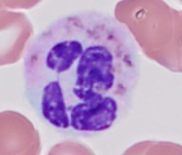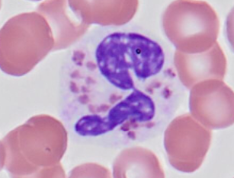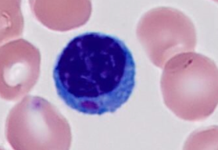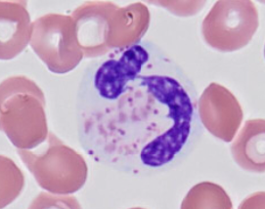
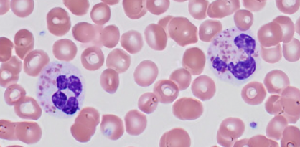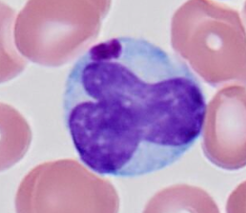
Reference
- https://imagebank.hematology.org/
- https://cancerbiologyresearch.com
- https://medlineplus.gov/genetics/condition/chediak-higashi-syndrome
- College of American Pathologist – Assessment of Consistency of Peripheral Blood Morphologic Observations (QPC 2025)

Survey recommendations
When reviewing the slides, click the white bubble to check the patient’s history. It will give you an idea of what to look and to answer questions such as Platelet estimate, MVC, etc. Follow Cobb’s HEM 3.1 chapter XI. Grading Morphology.
