- Doctor codes - Do not assume you know the code; pick from list every time. LIS Admin has found a lot of errors that take considerable time to fix
- Attending Doctor - Never change this code. It should always remain the same
  - The ordering doctor can be changed
  - When doctors order from communities
    - Attending = NIC
    - Ordering = ordering physician at their specific clinic

- Medipatient
  - System was upgraded last night
    - Passwords needed to be changed; if yours does not work contact TSC (not April)
    - All workstations should have Medipatient; if not contact TSC
  - Creating encounter
    - Choose “regular” and “Community name” if community is in site list
    - Choose “referred in” and “Stanton” if community is not on list
    - Write encounter number on requisition so you can match it to the proper encounter when accessioning in LIS.
  - If PHN expired you should delete it; bill to self if required

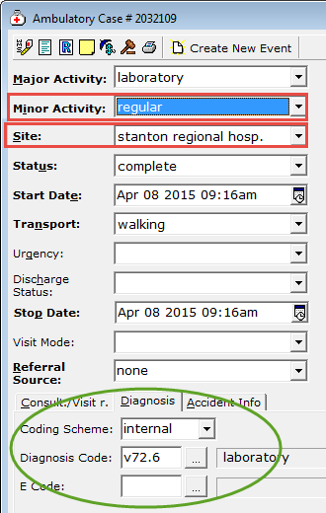

- All ER / ICU sample should be accessioned as STAT
  - Please do not change status even if requisition marked as routine (except micro)
  - This will increase our TAT and make samples more visible in LIS/labels
- MLA Competitions - Congrats to Chade Leopoldo and Holly Menton
- Call Log - Please document all calls to nurses or physicians
    - Critical values automatically pop-up
    - You can create a manual call log. Talk to your colleagues if you do not know how
    - This will capture workload numbers and create a record of your concerns
- Please date all QC/reagents when opened. If there is no date on an open vial it must be discarded
- Manager Competition – No update at this time
- Learning Management System
  - Fire Training and WHMIS have been updated and must be repeated
  - PDI may be denied if you are not up to date on your mandatory training
- Receiving Blood Cultures
  - Accession immediately and add to Bactec or give to micro staff immediately
  - There are time constraints on samples; especially referrals

MWA 08APR15

