- Extra NBIL Label
  - April has a long outstanding task in SharePoint requesting that an extra NBIL aliquot label print off with all NBIL requests. Do we still need this extra label or have we implemented a suitable work around all ready? Yes.
  - April will set the LIS to generate two NBIL collection labels. On label will be sent for sample collection, the second label will be separated by the person entering the order and will be brought to the chemistry bench for the aliquot.

- Discarding of extra patient samples
  - If extra patient samples are received for a patient order (this usually occurs from the communities) do NOT throw away the extra samples.
  - Accession the extra samples using the appropriate EXT… code and hold the extra samples in the correct sample rack. This way if add-on testing is ordered we can perform the testing.

- CBS Perinatal
  - Doctor codes are not being filled in on the yellow copies of the AHS Pre-natal Requisition that is sent to CBS. If this information is not correctly completed we may not receive a copy of the report in a timely manner.
  - Specimen collector is responsible to ensure that the Doctor codes are correctly filled out on the requisitions.
  - This is also an issue for PKU’s

- Alberta Provincial Laboratory; Guide To Services
  - There is an update to the Alberta Provincial Laboratory Guide to Services.
  - Carolyn has printed off a single hard copy of this document and put it in the binder at the front of the lab for use during down time.
  - An electronic version is routinely available on the DynaLIFE website.
  - http://www.provlab.ab.ca/guide-to-services.pdf

- New Vitros 5600 tests requested by sites outside of Yellowknife
  - The “new” tests offered on the Vitros 5600 are only available for Yellowknife patients at this time as we do not have an arrangement with the other health authorities to pay for the testing.
  - FT3 will be processed for all samples received here in Yellowknife for which we would ordinarily perform the TSH and FT4 testing.

- Vitros 5600 – Waste Container A
  - If you change the cardboard waste liner for the Waste Container A on the Vitros 5600, please remember to tape the corners to the rigid plastic of the waste container.
  - The cardboard does band and block sample tips from dropping correctly into the waste and can cause jams in the instrument.
  - Jen has mentioned this issue to Sheldon

- Vitros 5600 – Loadlist
  - The Vitros 5600 is different from other analyzers currently interfaced with the LIS.
  - If the instrument is taken off-line for any reason the loadlist will need to be rebuilt.
  - To rebuild the loadlist:
    - In Instrument Menu click on the ‘Loadlist’ tab.
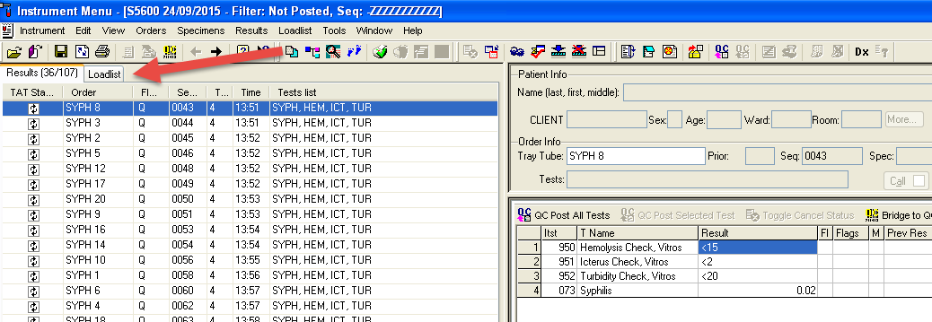

    - Click on the “Build a Loadlist” key
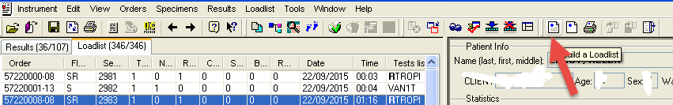

    - The following pop-up box will open. Click on the “More” button:
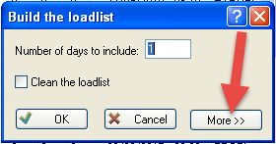

    - Make changes to the check boxes in this pop-up box to ensure that only “Workstation” and “Not Downloaded” are checked.
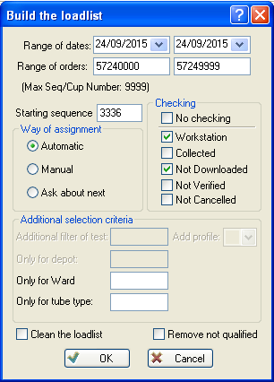

    - Click “OK”
    - You should then receive the following message:
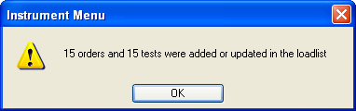

    - Click “OK”

- Vitros 5600 – Loading of ADD
  - There is a new Assay Data Disk (ADD) that has been uploaded to the Vitros 5600 via e-connectivity. Please do not download this ADD. There is a protocol change for the HBsAg assay on this ADD that will not take effect until we receive a new lot number of HBsAg reagent, which will not begin to ship until October.
  - If you load the ADD by mistake please tell Jen immediately so that appropriate intervention can be taken.
  - This does not affect loading the ADD disks on the Vitros Fusion 5,1.

- New Reject Codes
  - We have three new extra reject codes to accommodate multiple sample rejections on a single order.
  - These codes are now LIVE.

- YKHSSA Annual General Meeting
  - Tonight the YKHSSA Annual General Meeting will be taking place at 19:00 at the Tree of Peace.
  - See the flyer here.
- Harmony
  - April has created a code for the collection of the Harmony test kits
  - The code is: HARM
  - This code will auto verify and will auto result: you will just need to “Collect and Receive” the order
  - Dr. Kotaska is lobbying the DHSS to fund this test: At this time however, patients are still required to pay for their tests if the request is not supported by the DHSS.
- Roundtable:
  - Sally – phone calls to Microbiology when there are no staff in the area: Do unanswered phone calls get re-routed to the core lab? No, this functionality is not available in the laboratory.

  - April – New interfaces have been added to the Interface Maintenance menu. The HIS interface has been added and will restart automatically if it goes down. This will help to ensure that the HIS interface will continue to run as soon as possible following any issues.

  - Jen – This Clinitek Advantus went LIVE yesterday, 23 September, 2015. Draft procedures are available on the bench. If you have any comments, questions, concerns or other feedback on these procedures please write directly on them. Veronica will be the alternate Key Operator for this instrument. One-on-one training will commence shortly: training will be provided my Veronica or Jen.

  - Sarah – there is new dissemination of information/privacy legislation coming into effect October 01, 2015. Information will be shared with staff as it becomes available.

    - Please see highlighted information below, provided by Sarah.
The Government Health Information Act (HIA) has been approved and will be active as of 1st October 2015. This item further expands on the patient privacy concepts and scope of ATIP legislation. The introduction of the new HIA provides all Health Authority programs with the opportunity to align privacy processes in NWT with current best practice. Additionally as we are all residents and health care consumers the legislation ensures protection of our and our families privacy rights going forwards.

From a Diagnostics perspective the evaluation of current practices against scope of required operational changes has not yet been determined. At this stage and until further notice there is NO change to laboratory privacy based actions. As and when more information is received from the GNWT on specific applications and requirements for compliance we will bring to the group and discuss before implementation. Staff specific information and training resources are currently being generated as are those items required for patient information.

If there are any questions or concerns in relation to this please speak to Sarah or alternatively see the government privacy website :

    - http://www.hss.gov.nt.ca/health/slides/health-privacy-protecting-your-health-information

