- Maintenance Documentation
  - TQC has the ability to document maintenance activities; Do we want to try documenting the daily maintenance for the Clinitek Advantus?
  - Discussion determined that we can give it a try.

- Saccomono’s Fixative
  - Saccomono’s Fixative is a fixative that is often required for cytology samples. Please consult the DynaLIFE website to determine which samples require the addition of this fixative.
  - This fixative has been ordered and has arrived
  - This fixative is stored in the fire cabinet in the storage room
  - If you get a request for a fixative that we do not stock please let Mike know

- Blood Bank Collections & Identifying patients
  - There were some questions about when we need two signatures in blood bank
    - Two signatures are required whenever there is the potential for a patient product.
  - Two signatures are required for plasma, blood and platelets
  - Please do not forget to initial the patient collection tube

- Meal Allowance
  - Claim through PeopleSoft
  - Select the Meal Allowance code in PeopleSoft and enter the actual dollar amount to be claimed as determined by the collective agreement:
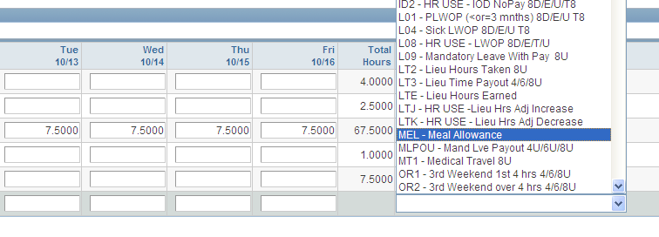
- Air Canada Blood Shipments
  - We had a problem with a shipment received from CBS that was sent via Air Canada and we were not informed that the shipment was being sent this way. No lab staff were dispatched to pick up the blood from the airport
  - We have asked CBS to notify us when samples are being sent via an air carrier other than Canadian North and to fax us copies of the waybills
  - If OT needs to be approved for someone to go pick up the shipment the lab staff will need to contact Carolyn: Mike and Carolyn will work on instructions for staff.
  - The shipments of blood products and lab supplies are a big problem for all of the Northwest Territories.
  - How will people be paid for this work is to be decided by Carolyn; however, this will not be considered a call back if staff are not on-call.

- Power
  - We have a number of different types and colours of plugs in the lab
    - The red plugs are for the normal back-up power supply
    - The orange plugs connect to the hospital UPS
  - Please do not plug items into the orange UPS plugs – these are for essential hospital equipment only.
  - There was a recent issue with the hospital UPS being overloaded. This was determined to not have been caused by laboratory equipment.

- HbA1c
  - Just a reminder that we are not currently running HbA1c testing on Wednesdays. This is to conserve on quality control reagent as there is only enough reagent to run the QC twice and the open expiration date is only three days.
  - The cost of the QC reagent is just over $55 a piece. When we run two levels of QC the cost of the wasted QC adds up to about $2500 per year.
  - If the holding of samples proves to be a major issue we can revisit this decision in the future.
  - UPDATE: Theresa and Erin discovered that the HbA1c controls actually have a 14 day open expiration. Please run the HbA1c test Monday to Friday.

- Documenting Lot Changes
  - A reminder to all staff that lot changes of all reagents must be adequately documented in TQC and in the manual log books where provided.
  - This is essential to maintain adequate traceability for our patient results in accordance with ISO standards.
  - Properly documenting lot changes also allows for swift response to recall notifications.

- Roundtable
  - Erin – We had a patient today that came to the lab with a routine outpatient requisition indicating a type & screen and crossmatch for a patient. The patient was accessioned using the outpatient clinic; however, transfusions should only occur in inpatient clinics. For this patient the order should have been held until the patient was admitted to medical daycare and the sample should be collected and banded in Medical Day Care.
    - Carolyn and Mike will need to follow up with the Manager of the clinic to clarify the laboratories expectations for the ordering of blood products and transfusion testing
    - The use of appropriate blood bank requisitions
  - Jen – Reminder that the new Stanton Hospital groundbreaking ceremony is on Thursday from 12:00 to 13:00.

