PURPOSE:

The IAT is used to demonstrate in vitro coating of red cells with antibody achieved by incubating reagent red cells (screening cells) with patient plasma at 37°C. Red cell antibodies may cause direct agglutination or lysis of red cells, or may coat the red cells with IgG.

Clinically significant antibodies detected by the AHG phase are usually from the Rh, Kell, Duffy, Kidd, and MNS systems.

The IAT saline method shall be a secondary method available to staff during IAT gel equipment downtime or for results inconsistent with the IAT gel method.

POLICY:

- A minimum of two reagent red cells that express a wide variety of blood group antigens shall be used for antibody screening. Reagent red cells with a double expression of antigens (homozygous) should be used to detect unexpected antibodies to red cell antigens. Reagent red cells for antibody screening shall not be pooled.
- Antibody screening shall include a 37°C incubation followed by an indirect antiglobulin procedure that has been shown to have sufficient sensitivity for the detection of clinically significant red cell antibodies. Alternative test methods may be used provided there is appropriate documentation of sensitivity and the manufacturer’s instructions are followed. The use of a monospecific antiglobulin reagent is acceptable if it contains anti-IgG.
- Upon discovery of a positive IAT Saline antibody screen or a history of antibodies an IAT Saline Crossmatch must be performed.
- When a patient has clinically significant antibodies identified, the donor units must lack the corresponding antigen (phenotypically compatible) and be cross matched by an indirect antiglobulin test.

REAGENTS and/or SUPPLIES:

- Centrifuge (Serofuge)
- 37°C Incubator
- Work Rack
- Tubes
- Transfer Pipettes
- 3% Red Cell Suspension
- Anti-IgG Anti-Human Globulin
- IgG-coated Control Cells
- 0.9% Saline

EQUIPMENT CALIBRATION AND MAINTENANCE:

- See BLB70200 Temperature Monitoring for Blood Bank
- See BLB70400 Equipment Maintenance for Blood Bank
- See BLB70700 Calibration of Incubators, Pipettes and Thermometers

QUALITY CONTROL:

- See BLB71000 Reagent QC
- All negative antiglobulin tests shall be positively controlled (for the addition of reagent anti-IgG human globulin) using IgG sensitized red cells (Coombs Control Cells) and the results shall be documented.

PROCEDURE INSTRUCTIONS:

Step | Action
Performing the Indirect Antiglobulin Test by Saline Method
1 | Appropriately label the test tubes. Refer to BLB20400 Labelling tubes, Gel Cards & Block Set-up.
2 | Add 4 drops of patient plasma to each labeled tube.
3 | Add 1 drop of the appropriate 3% red cell suspension to each labeled tube.
4 | Mix the contents of each tube.
5 | Examine the tubes for appropriate volume and appearance. If the volume and/or appearance is not consistent, discard the tubes and repeat set-up of all tests.
6 | Incubate the tubes at 37°C for 30 minutes.  - The incubation time may be extended to 60 minutes, if necessary.
7 | Wash the tubes 4 times with saline.  CAUTION: Avoid contamination from one tube to the next while dispensing saline into several tubes.  - Fill the tube with saline. Direct the saline into the bottom of the tube so that the red cells are mixed homogeneously. Leave approximately 1cm from the top of the tube empty.  - Centrifuge the tubes 45 to 60 seconds at 3,400 ± 200 RPM (high setting on serologic centrifuge).  - After centrifugation, check that the red cells are packed at the bottom of the tube. If a line of red cells has formed along the side of the tube, the centrifugation time should be extended until all the red cells are packed at the bottom of the tube.  - Decant the saline from the tubes by quick inversion. Leave the red cell button as intact as possible.  - Turn the tubes upright. Mix the tubes gently to dislodge the red cell button.  - Repeat the bulleted items in this step for a total of 4 washes as required.  - After the last wash, check that there is minimal residual saline remaining and that the size of the cell button is consistent.
8 | Add 2 drops of anti-IgG anti-human globulin reagent to each tube.  Note: After the wash cycle is complete, anti-IgG should be added to the dry cell button as soon as possible. If a delay of more than 5 minutes occurs, the tests must be repeated.
9 | Thoroughly re-suspend the contents of each tube.
10 | Centrifuge the tubes 15 seconds at 3,400 ± 200 RPM (high setting on serologic centrifuge).
11 | Gently re-suspend the cells immediately after centrifugation. If a delay of more than 2 minutes occurs, the tests must be repeated.
12 | Read the tubes macroscopically for agglutination. Record the test results in SoftBank or on the downtime form.  NOTE: The LIS default method for performing the IAT is the Gel method. To change the method in SoftBank to Saline select Patient > Orders > Cancel and cancel the A/B Screen Gel. Then go to Patient > Orders > Modify and add the ABSCS to the Tests.  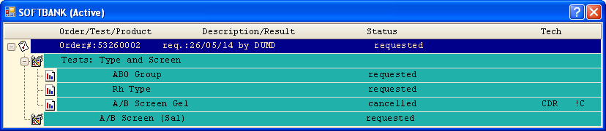  Record the agglutination in the fields shown.  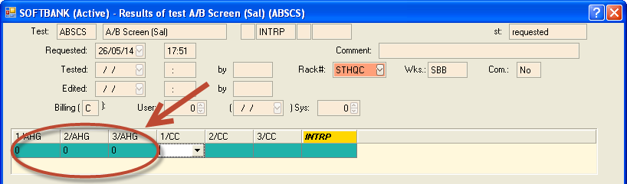
13 | Add 1 drop of IgG-coated control cells to the tube(s) with negative test results.
14 | Mix the contents of each tube.
15 | Centrifuge the tubes 15 seconds at 3,400 ± 200 RPM (high setting on serologic centrifuge).
16 | Gently re-suspend the cells.
17 | Read the tubes macroscopically.
18 | Record the test results in SoftBank:  - Agglutination 2+ or greater must be present, otherwise repeat.  - Positive results that do not require Coombs Control must be entered at “NT”. For example “3+” for 2/AHG will also have “NT” resulted for 2/CC.  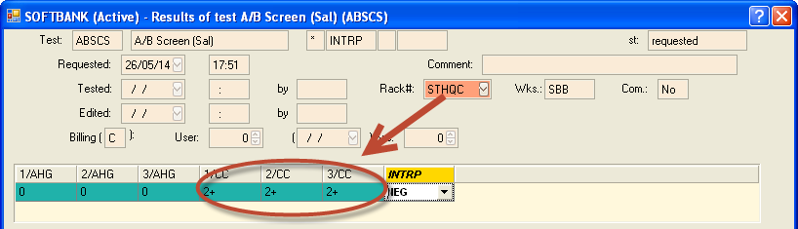

METHOD PERFORMANCE EXPECTATIONS:

- The cell washing process must remove unbound human plasma globulin from the test system before the addition of antihuman globulin (AHG) reagents. If there is inadequate washing of red cells, the residual unbound globulin may neutralize the antihuman globulin. Neutralization will be detected by the failure of IgG coated red cells (Coombs Control Cells) to agglutinate the red cells of a negative test, thus resulting in an invalid test result.
- When performing an antiglobulin test, the red cells shall be washed 4 times after the incubation phase, before the addition of AHG.
- When performing an antiglobulin test, once the wash phase has initiated, the washing and testing shall be carried through to the reading phase without interruption (within 5 minutes).

RELATED DOCUMENTS:

- BLB25700 Reading Hemagglutination Reactions: Tube and Gel
- BLB30600 Saline Addition & Replacement Technique
- BLB30700 Routine Antibody Investigation
- BLB70200 Temperature Monitoring for Blood, Blood Components & Derivatives
- BLB70400 Equipment Maintenance for Blood Bank
- BLB70700 Calibration of Incubators, Pipettes and Thermometers
- BLB71000 Reagent QC

REFERENCES:

- RT.005 Antibody Screen. In Technical Resource Manual for Hospital Transfusion Services. British Columbia Provincial Blood Coordinating Office. British Columbia Provincial Blood Coordinating Office. 2005.
- Pretransfusion Testing. Downes, K. A. In AABB, Technical Manual, 17th Edition (pp. 437-462). Bethesda, Maryland: AABB. 2011.
- Manitoba Transfusion Quality Manual for Blood Banks. Diagnostic Services of Manitoba. Office of Provincial Director of Quality. Winnipeg, MB, Canada. 2007

- Blood & Blood Components. CAN/CSA-Z902-10. Canadian Standards Association. February 2010.

- Standards for Hospital Transfusion Services, Version 3. Canadian Society of Transfusion Medicine. February 2011.

- Blood Regulations. Health Canada. May 2014

REVISION HISTORY:

REVISION | DATE | Description of Change | REQUESTED BY
1.0 | 20Oct15 | Initial Release | C. Russell

