PURPOSE:

This procedure establishes criteria for the correct collection of blood specimens by venipuncture.

POLICY:
Pre-examination errors can be numerous (eg, incorrect patient identification, incorrect order of draw, incorrect use of additive tubes, labeling errors, incorrect timing of collection, clerical errors). Standard procedures and protocols are intended to prevent these problems and protect against complications and patient mismanagement that can otherwise arise when specimens are improperly collected.

SUPPLIES:
- Alcohol Prep Pads
- Tourniquet
- Sterile Syringes or Vacuum Blood Sample Devices
- Gauze Pads
- Needle
- Blood Collection Tubes and Labels
- Gloves
- Bandages and/or Tape
- Sharps Container
- Pen
- Safety Transfer Device
SPECIAL SAFETY PRECAUTIONS:

Because it is often impossible to know what isolates or specimens might be infectious, all patient and laboratory specimens are treated as infectious and handled according to standard precautions. Standard precautions are guidelines that combine the major features of universal precautions and body substance isolation practices.

QUALITY CONTROL:

Major causes of laboratory error can be related to non-analytical factors, such as specimen collection, handling, and transport. Non- biological factors, such as patient misidentification, and biological factors, such as patient posture and the time the specimen is drawn all contribute to the total laboratory error.

PROCEDURE INSTRUCTIONS:

Step | Action
Performing a Venipuncture
1 | Prepare the accession order.  - See SCM40300 Specimen Accessioning
2 |   Approach and identify the patient. Sanitize hands.  - The phlebotomist should identify himself or herself, establish a rapport, and gain the patient’s confidence.  - The phlebotomist must NOT perform blood collection against the patient’s or guardian’s consent. Instead report the patient’s objections to the physician or nursing station.  - See Hospital Wide Policy I-0500 Identifiers – The Use of 2 Patient Identifiers.  - See Hospital Wide Policy I-0691 Infection Control – Hand Hygiene.
3 | Verify the patient’s fasting status or medication history as appropriate.
4 | Assemble necessary supplies and select appropriate tubes according to test requests.  - Inspect all supplies for possible defects and applicable expiration dates.  - Thread the appropriate needle into the holder until it is secure.  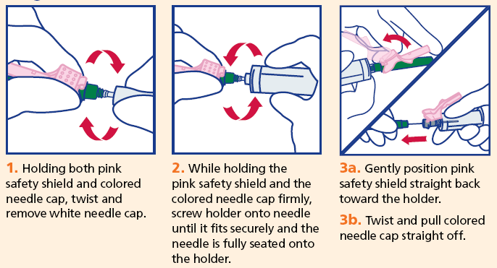
5 | Position the patient.  - The arm should be supported firmly and should not be significantly bent at the elbow. A slight bend may be necessary to avoid hyperextension.  - No food or liquid, chewing gum, or other objects should be in the patient’s mouth at the time of collection.
6 | Apply the tourniquet and select the venipuncture site and vein.  - If a tourniquet has been in place for longer than one minute, it should be released and reapplied after two minutes.  - If the patient has a skin lesion at the intended tourniquet location, consider an alternate draw site or apply the tourniquet over the patient’s clothing.  - Apply the tourniquet 7.5 to 10.0 cm above the venipuncture site.  - Patients should form a fist, but they should NOT pump their hands vigorously.
6 | Selecting a Vein:  - See SCM20700 Best and Inappropriate Sites for Venipuncture.  - The preferred venipuncture site is the antecubital fossa.  - When antecubital veins are not acceptable or unavailable, veins on the back of the hand are also acceptable for venipuncture.  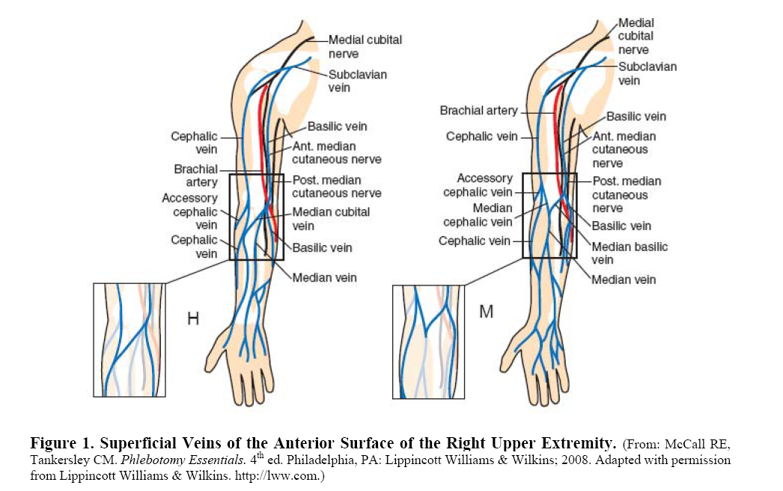  - Veins on the underside of the wrist must NOT be used, as nerves and tendons are close to the surface of the skin in this area.  - Alternative sites, such as ankles or lower extremities, must NOT be used without the permission of the physician because of the potential for medical complications (eg. Phlebitis, thrombosis, tissue necrosis).  - Avoid healed burn areas.  - A physician MUST be consulted before drawing blood from the side on which a mastectomy was performed because of the potential for lymphostasis.  - Phlebotomy must NOT be performed on any size hematoma. If another vein site is not available, the specimen is collected distal to the hematoma.  - Preferably, specimens should NOT be collected from an arm with an IV site. Drawing blood from an IV arm has the potential risk for erroneous and misleading test results. Blood should not be drawn from that limb unless there is no alternative and the tests are critical to the care of the patient, as determined by the physician or nurse.  - For distal collection:  - Ask the responsible caregiver to turn off the IV infusion for at least TWO minutes before venipuncture. Care should be taken to ensure that the flow has been completely discontinued.  - Apply the tourniquet. When drawing distal to the IV infusion site, apply the tourniquet between the IV and the intended venipuncture site.  - Perform the venipuncture.  - Add the following order comment “This sample was collected below an IV site after it was stopped for two minutes. There is a possibility of dilutional/contamination effect on these results.”  - For proximal collection:  - Ask the responsible caregiver to turn off the IV infusion for at least TWO minutes before venipuncture. Care should be taken to ensure that the flow has been completely discontinued.  - Apply the tourniquet 7.5 to 10.0 cm above the intended venipuncture site.  - Perform the venipuncture.  - Add the following order comment “This sample was collected above an IV site after it was stopped for two minutes. There is a possibility of dilutional/contamination effect on these results.”  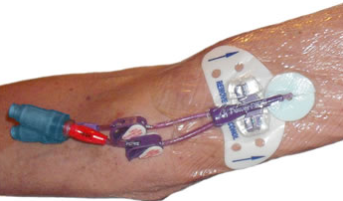  - Phlebotomists should NOT draw blood from indwelling lines, heparin or saline locks or vascular access devices.  - A fistula is an artificial shunt connection done by a surgical procedure to fuse the vein and artery together. It is used for dialysis only. An arm with a fistula should NOT be used for drawing blood without physician permission. The use of a tourniquet may lead to complications.  - If during the procedure, accidental puncture is suspected (eg, rapidly forming hematoma, rapid filling of tube), discontinue the venipuncture immediately. 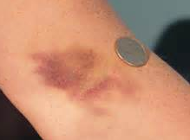  Remove the needle, and apply direct forceful pressure to the puncture site for a minimum of five minutes until active bleeding has ceased. The nursing staff/physician MUST be notified and the incident documented in RiskPro.  - If the patient feels a shooting, electric-like pain, or tingling or numbness proximal or distal to the puncture site, terminate the venipuncture and remove the needle immediately. Repeat the venipuncture in another site if needed. Document the incident in RiskPro and direct the patient to medical evaluation, if indicated.  - Palpation is usually performed using the index finger. The collector’s thumb should NOT be used to palpate because it has a pulse beat. In addition to locating veins, the palpation pressure helps to differentiate veins from arteries, which pulsate, are more elastic, and have a thick wall.
7 | Put on gloves.  - The phlebotomist MUST put new gloves on before the venipuncture is performed.  - See page 30 of the Infection Control Practices Module.
8 | Cleanse the venipuncture site and allow to dry. Allow the area to air dry to prevent hemolysis of the specimen, to prevent the patient from experiencing a burning sensation when the venipuncture is performed, and to allow optimal antisepticeffect of alcohol.  - See SCM20800 Blood Culture Collection for alternate cleansing instructions in the event blood cultures are ordered.  - Use a commercially prepared alcohol pad.  - Cleanse the site with a circular motion from the centre to the periphery.  - Allow the area to dry.  - If the venipuncture proves difficult and the site must be touched again to draw blood, it should be cleansed again.
9 | Perform venipuncture; once flow begins, request the patient to open his/her hand.  - Hold the patient’s arm firmly distal to the intended puncture site. The phlebotomist’s thumb should be used to draw the skin taut to anchor the vein. The thumb should be 2.5 to 5.0 cm below the venipuncture site.  NOTE: Anchoring the vein from above is NOT recommended due to the risk of an accidental needlestick.  - To prepare the patient, inform him/her that the venipuncture is about to occur.  NOTE: From this point on, be prepared to react to a sudden and unexpected loss of consciousness.  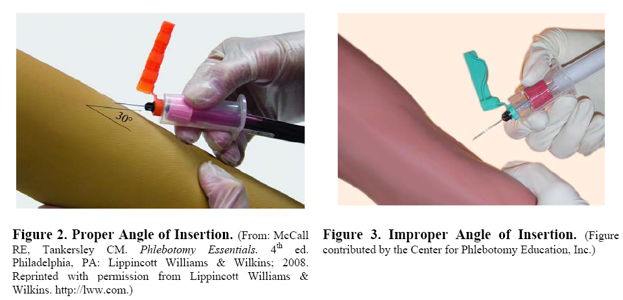  - With the bevel up, puncture the vein with the needle at an angle of insertion of 30 degrees or less. Keeping the needle as stable as possible in the vein, push/connect the first tube onto the needle using the holder flanges to prevent/restrict needle movement. Maintain the tube below the site when the needle is in the vein so there is an air space between the incoming blood and the patient whenever possible.  Correct  Incorrect
10 | Fill tubes using the correct order of draw.  - See SCM20600 Order of Draw.  - Allow the tube to fill until the vacuum is exhausted and blood flow ceases. For tubes that contain additives, this will ensure there is correct ratio of blood to additive.  - When the blood ceases to flow, remove/disconnect the tube from the needle/holder. The sleeve recovers the needlepoint that pierces the tube closure, stopping blood flow until the next tube is inserted/connected to the needle/holder. To obtain additional specimens, insert/connect the next tube into the needle/holder and repeat the collection procedure. Remove the last tube collected from the needle/holder before withdrawing the needle from the vein.  - Immediately after drawing each tube that contains additive, mix the blood gently and thoroughly by inverting the tube for the required amount of inversions. To avoid hemolysis, do not mix vigorously.
11 | Release and remove tourniquet.
12 | Place the gauze pad over the puncture site.  - A clean gauze pad should be placed lightly over the venipuncture site.
13 | 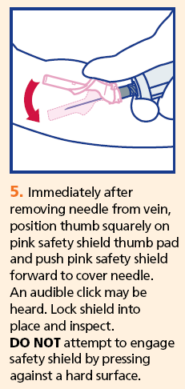  Remove the needle, activate any safety feature, and dispose of the device.
14 | Apply pressure to the site, making sure the bleeding has stopped, and then bandage the arm.  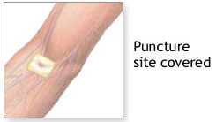  - Do NOT allow patients to bend their arm up as a substitute for pressure, as this technique is not adequate to prevent hematoma formation in all circumstances.  - Patients may apply direct pressure as long as the collector constantly monitors the site to ensure pressure is adequate.  - Check that bleeding has ceased, observe for hematoma, and apply an adhesive or gauze bandage over the venipuncture site.  - Tell the patient to leave the bandage on for at least 15 minutes.  - The phlebotomist should watch for excessive bleeding. If a hematoma develops or bleeding persists longer than 5 minutes, the patient’s physician should be notified. Pressure, applied with a gauze pad, MUST continue at the site as long as necessary to stop the bleeding. Wrap tape tightly over the gauze to keep the pad in place and tell the patient to leave the bandage on the site for at least 15 minutes.
15 | Label (See I-0500 – The Use of 2 Patient Identifiers) and initial the tubes and record the time of collection and phlebotomists initials on the requisition.  - The tube must be labeled before leaving the side of the patient. This may be done with a computer generated label or by handwriting the information on the tube.
16 | Observe special handling requirements (if any required).
17 | Send appropriately labeled tubes to the specimen processing area.

Step | Action
Performing a Venipuncture Using Needle and Syringe (Abbreviated)
1 | 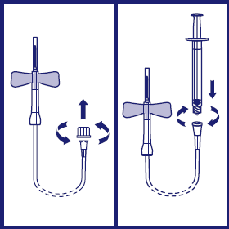  Assemble the needle and syringe. Break the seal of the plunger and advance it fully forward, expelling all air from the barrel of the syringe before use.
2 | Hold the patient’s arm firmly distal to the intended puncture site. The phlebotomist’s thumb should be used to draw the skin taut to anchor the vein. The thumb should be 2.5 to 5.0 cm below the venipuncture site.  NOTE: Anchoring the vein from above is NOT recommended due to the risk of an accidental needlestick.
3 | Prepare the patient by informing them that the venipuncture is about to occur.
4 | 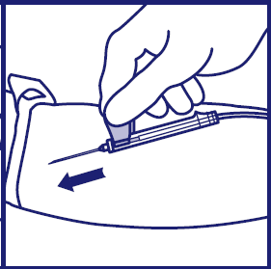  With the bevel up, puncture the vein with the needle at an angle of insertion of 30 degrees or less.
5 | Keeping the needle as stable as possible in the vein, slowly withdraw the desired amount of blood into the syringe.
6 | Release the tourniquet as soon as possible, after the blood begins to flow.
7 | Follow the other steps not related to safe blood transfer from the complete venipuncture procedure above.

NOTE:
A venous blood collection tube system is the recommended method for blood collection, as it is a closed system and is much safer than the syringe draw method. If it is necessary to use a syringe, proceed with the following recommendations to transfer the blood from a syringe to a blood collection tube.
1 | Use the same order of draw as for a venous blood collection tube system.
2 | 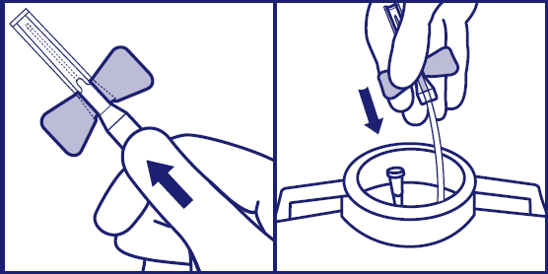  To transfer the blood from the syringe to a venous blood collection tube, activate the safety feature of the needle or winged blood collection set used to withdraw the specimen, remove and discard.
3 | 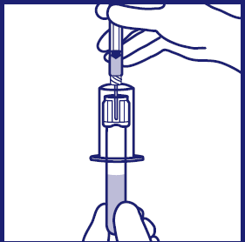  Apply the safety transfer device. Insert the tube in the safety transfer device, and pierce the stopper with the needle. Allow the tube to fill without applying any pressure to the plunger until the flow ceases. This technique helps to maintain the correct ratio of blood to additive if an additive tube is being used.
4 | Mix additive tubes by inversion.
5 | Rubber stoppers should NOT be removed from venous blood collection tubes to transfer blood to multiple tubes.
6 | Discard sharps in appropriate sharps container.

BLOOD SPECIMENS THAT CANNOT BE OBTAINED:

When a blood specimen cannot be obtained, it may be necessary to:

- Change the position of the needle. If the needle has penetrated too far into the vein, pull it back a bit. If it has not penetrated far enough, advance it farther into the vein. Rotate the needle half a turn.
- Lateral needle relocation should NEVER be attempted in an effort to locate the basilica vein, since nerves and the brachial artery are in close proximity.
- Try another tube to ensure the tube selected is not defective (ie, lacks vacuum).
- Unless the exact location of the vein is determined, manipulation other than that recommended above may be considered probing. Probing is not recommended. Probing can be painful and may produce arterial perforations, resulting in a hematoma and nerve compression or direct nerve injury.
- It is not advisable to attempt a venipuncture more than twice. If possible, have another person attempt to draw the specimen, or notify the physician.

RELATED DOCUMENTS:

- I-0500 Identifiers – The Use of 2 Patient Identifiers
- I-0691 Infection Control – Hand Hygiene
- SCM20600 Order of Draw
- SCM20800 Blood Culture Collection
- Infection Control Practices Module
- SCM20700 Best and Inappropriate Sites for Venipuncture
- SCM40300 Specimen Accessioning

REFERENCES:

- Clinical and Laboratory Standards Institute. (2012). Procedures for the Collection of Diagnostic Blood Specimnes by Venipuncture; Approved Standard. Wayne, Pennsylvania: Clinical and Laboratory Standards Institute.
- BD. (n.d.). BD Vacutainer Blood Transfer Device. Retrieved June 30, 2014, from Blood Transfer Device Connect and Protect Wall Chart: http://www.bd.com/vacutainer/products/accessories/#blood_transfer_device
- BD. (n.d.). BD Vacutainer Eclipse Blood Collection Needle. Retrieved June 30, 2014, from Eclipse Wall Chart: http://www.bd.com/vacutainer/pdfs/eclipse_wall_chart.pdf

REVISION HISTORY:

REVISION | DATE | Description of Change | REQUESTED BY
1.0 | 25Jun08 | Initial Release | C. Russell
1.1 | 15Nov10 | Update to New Format | C. Russell
2.0 | 31Jul13 | Complete re-write to reflect CLSI Standards | B. Hussey
2.1 | 30Jun14 | Reviewed – verified with current references | C. Russell

