  Document Name:  Genital Culture – Bacterial Vaginosis | Document Number: | MIC30300
 | Version No: 5.0 |  | Page: 1 of 7
Distribution:
Microbiology Culture Manual
 | Effective: 30 January, 2017
 | Date Reviewed: 30 January, 2017
 | Next Review: 30 January, 2019
Approved By:  Jennifer G. Daley Bernier, A/manager, Laboratory Services | Status: APPROVED

PURPOSE:
To determine the presence or absence of Bacterial Vaginosis, Trichomonas vaginalis and Candida spp. in vaginal specimens.

SAMPLE INFORMATION:
Type | Swab  - Amie’s with or without charcoal
Source | - Posterior vaginal vault or vaginal orifice  - Only performed on patients ≥ 13yrs of age  - If specimen received on patient <13yrs of age, process as Genital Culture
Stability | - Viability of Trichomonas vaginalis is significantly diminished if wet preps are not examined within 1h of collection.  - If the sample is received in the laboratory greater than 24h from collection:  - Add specimen quality comment: “Delayed transport may adversely affect pathogen recovery”  - If the sample is received in the laboratory and processed greater than 5 days from collection:  - Add order comment: “Smear for Bacterial Vaginosis made at time of receipt not time of collection. This delay may alter the specimen results. Please interpret results with caution.”
Storage Requirements | Room temperature
Criteria for rejection and follow up action | - Unlabeled/mislabeled swabs  - Dry swabs

REAGENTS and/or MEDIA:
- Sabouraud dextrose agar (SAB)

SUPPLIES:
- Microscope slides and coverslips
- Test tube
- Sterile saline
- Gram stain reagents
- Immersion oil
- 35° ambient air incubator

SPECIAL SAFETY PRECAUTIONS:
Containment Level 2 facilities, equipment and operational practices for work involving infectious or potentially infectious materials or cultures.
- Lab gown must be worn when performing activities with potential pathogens.
- Gloves must be worn when direct skin contact with infected materials is unavoidable.
- Eye protection must be used where there is a known or potential risk of exposure of splashes.
- All procedures that may produce aerosols, or involve high concentrations or large volumes should be conducted in a biological safety cabinet (BSC).
- The use of needles, syringes and other sharp objects should be strictly limited.

QUALITY CONTROL:
Refer to Quality Control manual for reagent quality control procedures

PROCEDURE INSTRUCTIONS:
Step | Action
Processing Vaginal specimens
1 | Double check patient age  - If patient is <13yrs of age, specimen should be processed as a genital culture. See MIC20875  - If patient ≥13yrs of age proceed to step 2.
2 | - If Trichomonas is requested, perform microscopic examination for Trichomonas vaginalis.  - If Genital culture is requested AND relevant clinical information is provided, perform direct smear and vaginal culture. Relevant clinical information/diagnosis includes:  - Post-surgical, Toxic shock syndrome, pregnant, intrapartum, postpartum, post hysterectomy, pessary in place, D&C.  - If Genital culture is requested and NO relevant clinical information is provided, process as BV only and add order comment:  - Routine genital cultures will not be performed unless testing is requested AND relevant clinical history is provided.  - If Yeast culture is requested AND relevant clinical information is provided, perform yeast culture. Relevant clinical information/diagnosis includes:  - Chronic or recurrent vaginal candidiasis, treatment failure or immunosuppression  - If Yeast culture is requested and NO relevant clinical information is provided, process as BV only and add order comment:  - Routine yeast cultures will no longer be performed unless there is a clinical history of recurrent vaginal candidiasis, treatment failure and/or immunosuppression, particularly HIV infection. Microscopic examinations will continue for the detection of yeast and, if seen, will be reported.
3 | If Trichomonas is requested, label test tube with wet prep label. In the biosafety cabinet add approximately 0.5 mL saline. Label slide with patient’s last name, accession number and BV to identify test required. Inoculate slide with swab, ensuring all surfaces of the swab make contact with the slide. Place on hotplate to allow slide to dry. If yeast is requested, inoculate SAB, streak for isolation and incubate at room temperature on the urine bench for 48h. Place swab into wet prep tube and mix by flicking the tube. Incubate at 35° for 20 minutes.
4 | If Trichomonas is not requested, wet prep does not need to be performed. Label slide with patient’s last name, accession number and BV to identify test required. Inoculate slide with swab, ensuring all surfaces of the swab make contact with the slide. Place on hotplate to allow slide to dry. If yeast is requested, inoculate SAB, streak for isolation and incubate at room temperature on the urine bench for 48h.
5 | Gram stain the slide as per MIC20115 Stains – Gram Stain.
6 | If applicable, examine wet prep under 40x magnification as per MIC52700 – Wet Preparation using Saline.

If: | Then:
Trichomonas seen  (parasite must be motile) | - In SCWPT select “Trich – Seen”  - Finalize SCWPT
Trichomonas not seen | - If sample is < 24 hours old, at SCWPT select: “Trichomonas – Not seen.”  - If sample >24h and ≤ 72h old select: “Trichomonas - Not Seen  NOTE: The presence of Trichomonas cannot be ruled out since there was a delay >24hrs in transport and/or processing of this specimen.”  - If sample >72h old, specimen is unsuitable for Trichomonas analysis and the test needs to be cancelled. Click on Cancel Test and insert cancelation comment TRICH:  “Specimen in transit greater than 72h. Vaginal swabs should be submitted to the laboratory optimally within 24 hours for Trichomonas examination. Unsuitable for Trichomonas analysis.”

7 | Examine the gram stain under 10X magnification scan 5-10 fields and quantitate the number of epithelial cells, white blood cells and clue cells seen. Add one drop of immersion oil to the slide and under 100X magnification scan 5-10 fields and quantitate the number of Lactobacilli, Gram variable bacilli and pleomorphic bacilli (Mobilluncus). Record numbers of Yeast and Trichomonas, if present.
8 | Calculate the N-Score as in the table below  Gram stain examples of relevant bacterial pathogens  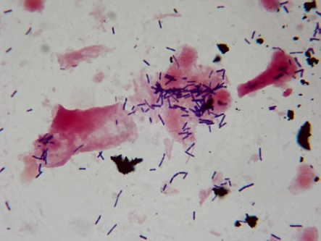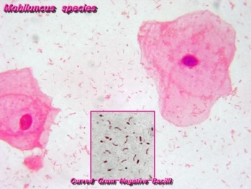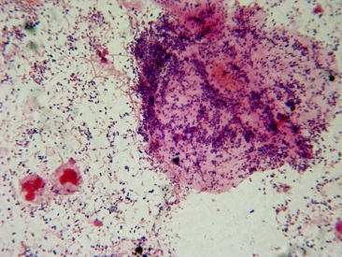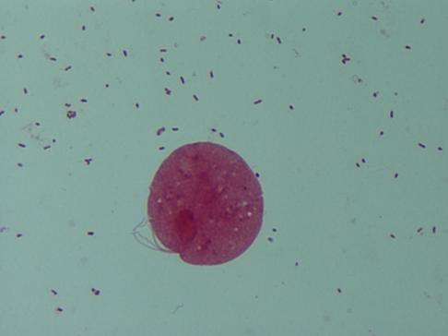  Lactobacillus sp. Mobiluncus sp. Gardnerella vaginalis Trichomonas vaginalis
  Quantitation of bacterial morphotype | Points scored per morphotype
  Quantitation of bacterial morphotype | None | 1+ | 2+ | 3+ | 4+
  Lactobacillus sp: med/large Gram positive rods | 4 | 3 | 2 | 1 | 0
  Gardnerella vaginalis: Small Gram-negative or variable rods  Bacteroides: Gram-negative rods | 0 | 1 | 2 | 3 | 4
  Mobiluncus sp: Curved gram neg or –variable rods | 0 | 1 | 1 | 2 | 2
9 | Interpreting and Reporting BV Smear results by N-Score
  N-SCORE | REPORT
  0 – 3 | Smear NEGATIVE for Bacterial Vaginosis
  4 - 6 | Gram stain shows altered vaginal flora. Results are indeterminate for Bacterial Vaginosis.  - If clue cells are present, report:  Presence of Clue cells suggests transition of vaginal flora towards Bacterial Vaginosis. Repeat testing of another vaginal smear is recommended.
  7 – 10 | Smear consistent with BACTERIAL VAGINOSIS

10 | Add comments if appropriate:
  IF | ADD COMMENT
  Patient is >55 yrs. | “Results may not be reliable in post-menopausal women. Correlate with the clinical picture”.
  Yeast cells/pseudo hyphae seen. | “Yeast Seen. Candida species are normal flora in the genital area of 30-40% of women. The presence of yeast must be correlated with clinical picture”
  3+ or 4+ WBC’s | “Purulence suggests the presence of another infection and/or inflammatory condition. Correlate with the clinical picture. Testing for N. gonorrhoeae and C. trachomatis may be indicated”.
  Multiple anaerobic organisms seen | “The presence of mixed anaerobes seen intracellularly may be more compatible with cervicitis or pelvic inflammatory disease than bacterial vaginosis. Clinical correlation required.”
  Scant or no cells, or excess amorphous material | “Insufficient sample to assess for vaginitis. Recollection required”.
  Trichomonas seen in smear | “Trichomonas seen in smear.”
12 | Interpreting and Reporting Yeast Culture Results
  IF | THEN
  SAB plate - yeast isolated | Confirm with wet prep if unsure of morphology  - Order ^WP  - If positive: reflex using keypad to add a Yeast isolate and quantify as scant, light, moderate or heavy.  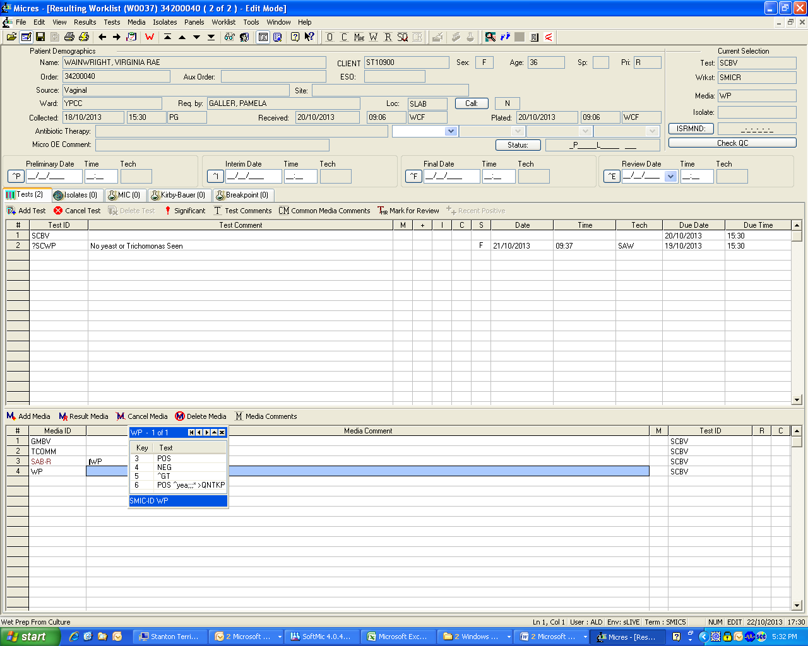  - Verify the isolate.  Note: It is not necessary to perform a Vitek 2 Yeast ID. The designation of “Yeast” is sufficient in the diagnosis of candidiasis.
  SAB plate - no yeast isolated | Add Test comment “No Yeast Isolated”.

REFERENCES:

- Clinical Microbiology Procedures Handbook, 4th edition, ASM Press, 2016
- Jorgensen J.H., Pfaller M.A., Carroll K.C., Funke G., Landry M.L., Richter S.S., Warnock D.W. 2015. Manual of Clinical Microbiology, 11th edition, ASM Press, Washington, D.C.

REVISION HISTORY:

VERSION | DATE | Description of Change | REQUESTED BY
1.0 | 03-Dec-2010 | Initial Release | M-L Dufresne
2.0 | 30-Apr-2012 | Update and Review | C.Russell
3.0 | 01-Mar-2013 | Revision | S.Webber
4.0 | 21-Oct-2013 | LIS updates/document number change | A.Darrach
5.0 | 06-Dec-2016 | Update to reflect pre-analytical and analytical requirements | L.Steven

