PURPOSE:
Intended for use with the Vitek 2 Compact system for the automated identification of most clinically significant yeasts and yeast–like organisms.

SAMPLE INFORMATION:

Type | Yeast and yeast-like organisms
Source | 18-24h culture

REAGENTS and/or MEDIA:

Type | Vitek 2 YST Identification card
Source | Biomerieux
Volume | 1 card
Stability | Stable until date of expiration indicated on the container
Storage Requirements | Store at 2-8°C
Criteria for rejection and follow up action | Do not use if:  - The expiration date has passed  - There are other signs of deterioration

SUPPLIES:
- Vitek 2 Compact YST cards, stored in reagent refrigerator
- Densichek
- Sterile saline (0.45% NaCl) with dispensette
- Sterile swabs or sticks
- Vortex

SPECIAL SAFETY PRECAUTIONS:
Containment Level 2 facilities, equipment, and operational practices for work involving infectious or potential infectious materials or cultures.
- Lab gown must be worn when performing activities with potential pathogens.
- Gloves must be worn when direct skin contact with infected materials is unavoidable.
- Eye protection must be used when there is a known or potential risk of exposure of splashes.
- All procedures that may produce aerosols, or involve high concentrations or large volumes should be conducted in a biological safety cabinet (BSC).
- The use of needles, syringes and other sharp objects should be strictly limited.

QUALITY CONTROL:
Quality control is set up once per new shipment using the following control organisms:
- Candida albicans ATCC 14053
- Candida glabrata ATCC MYA-2950

PROCEDURE:
Step | Action
Setting up YST identification card on Vitek 2 Compact
1 | Allow cards to come to room temperature before opening the package liner.
2 | Use fresh 18-72h cultures.
3 | Fill out Vitek Worksheet for your assigned bench.
4 | Select isolated colonies from a primary isolation plate and inoculate a tube containing  3.0 mL sterile saline to obtain a 1.80 – 2.20 McFarland concentration.
5 | Cap tube and vortex. If suspension is too heavy, dispense saline into an extra tube to use as diluent. Do NOT dilute bacterial suspensions directly from the dispensette. If suspension is too light, add more colonies from the plate.
6 | Remove cap and place tube with McFarland suspension into first slot on cassette.
7 | Open YST ID card and place stick into suspension tube.
8 | After loading cards and inoculum into the cassette, place the cassette in the Filler Station. When you press the Start Fill key, a vacuum pump evacuates the air from the chamber. When the instrument releases the vacuum, the pressure of the air replacing  the vacuum forces the samples to flow into and inoculate the test card.
9 | To load a cassette into the Filler Station:  - Open the Fill door and place the cassette into the chamber.  - Close the Fill door.  - Press the Start Fill button to being the filling process.  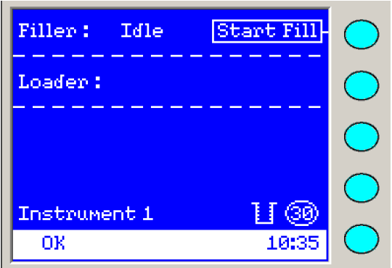  - After completion of the Fill cycle (the Fill blue indicator LED blinks), remove the cassette from the Filler Station and close the Fill door.
10 | To load a cassette into the Load station:  - Open the Load door and place the cassette into the Cassette Load/Unload station.  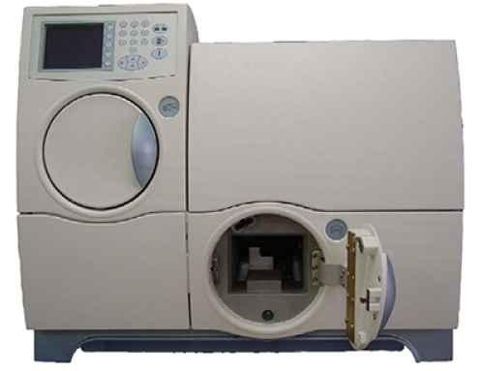  - Close the Load door. The cassette icon appears on the Status screen.  - After completion of the Load station (the Load station blue indicator LED blinks), remove the empty cassette from the instrument and close the Load door.  - Make purity plates using the blue stick from the ID tube. Incubate the purity plates in the air incubator.
11 | To enter the information from the bench worksheet into the Setup Tests Post Entry:  - During the first minute after you load a cassette, the instrument reads the bar code on each test card. From this bar code reading, the instrument knows the number of tests cards in the cassette, the type of test cards, and the position of each test card. The instrument sends this information, along with the cassette number read during the bar code reading process, to the workstation. You can view this information in the Enter Manage Cassette View from the main menu:    - Cassettes appear in the navigation tree. When a cassette is selected, the following cassette specific information appears in the cassette workspace:  - Cassette ID  - Instrument Name  - Load Time and Date  - Setup Technologist Name  - Bench Name  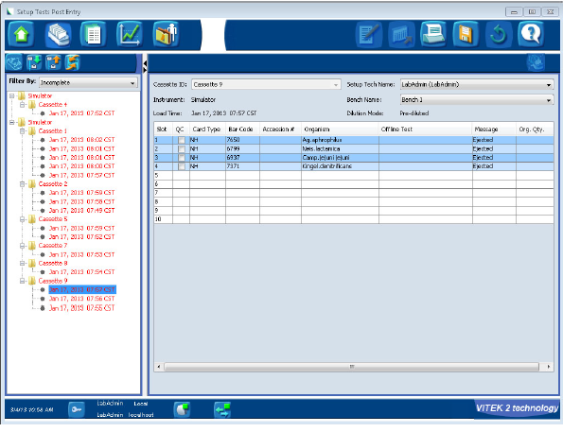  - Select the loaded cassette from the displayed list in the navigation tree. Each cassette contains card information for the cards in each slot. The cassette will appear in red in the navigation tree as additional information is needed to completely define the selected cassette.  - Enter the accession ID: To enter the accession ID, select the Accession # cell and scan in the specimen barcode and isolate number from the worksheet.  - After all necessary information is entered, save cassette information by clicking on the Save icon:  
12 | To enter the information using Virtual Cassette:  - To enter information before loading the cassette into the instrument, you can create a Virtual Cassette. Creating a Virtual Cassette allows you to enter all the necessary isolate information into the system software before loading the cassettes into the instrument. The instrument then reads the cards. You can view this information in the Enter Manage Cassette View from the main menu:  - Click the Maintain Virtual Cassette icon located in the left view bar:    - Click the Create New Virtual Cassette icon:    This will open up the Virtual Cassette workspace.  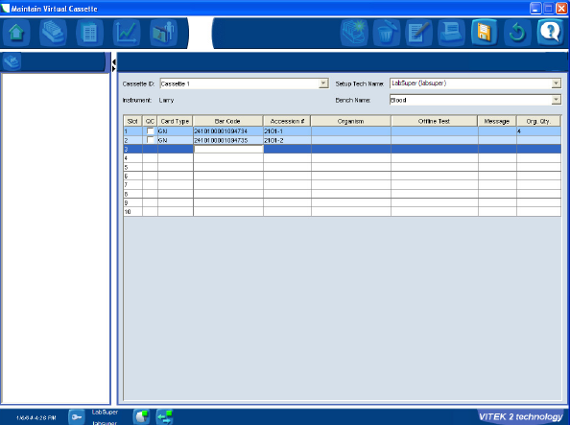  - Select cassette ID from the list of available Cassette ID’s.  - Select a Bench Name from the list where the cassette will be introduced.  - Enter the card ID: To enter the card ID, select the Bar Code cell and scan in the card bar code.  - Enter the accession ID: To enter the accession ID, select the Accession # cell and scan in the specimen barcode and isolate number from the worksheet.  - After all necessary information is entered, save cassette information by clicking on the Save icon:

REFERENCES:

- Vitek 2 Compact Online Software User Manual, Biomerieux, 2013
- Vitek 2 Compact Instrument User Manual, Biomeriux, 2004

REVISION HISTORY:

REVISION | DATE | Description of Change | REQUESTED BY
1.0 | 22-Dec-16 | Initial Release | L. Steven

