SCC-LIS_TIP OF THE WEEK

|  |  |
| --- | --- |
| MODULE: SoftLab | SOFTWARE VERSION: 4.0.8 |
| TOPIC: CBSRO | ISSUE DATE: 28April2017 |
| DISTRIBUTION: End Users_All | PAGE: 1 of 1 |
| ISSUED BY:April Darrach, Territorial LIS Administrator | |

**TOPIC/QUESTION:**

How do I add my CBSRO to a tasklist? Will I get a manifest? How do I result it back?

**ANSWER/TIP:**

CBSRO is set to auto-report/auto-verify out of SoftLab with a result of “See Bloodbank”. To add it to a REF tasklist, the STATUS on the tasklist must be set to ALL.

When sending to REFLAB for manifest generation, you will not get a manifest because the original requisition should always accompany the sample. The Tasklist number for the test is recorded under Order Entry🡪Specimen🡪Specimen Tracking History, if needed later

As of 28 April, 2017🡪CBSRO are now resulted back in SoftBank only – which should eliminate the unnecessary step of resulting in both SoftLab and SoftBank

**EXAMPLE:**

TASKLIST template

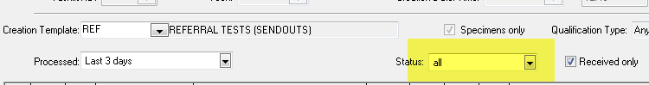

CBSRO resulting

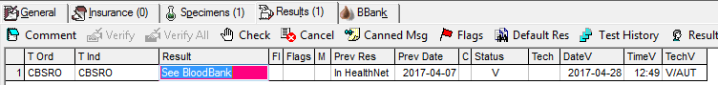  
CBSRO RESULTING INSTRUCTIONS: 