Red Blood Cell Label  Example:  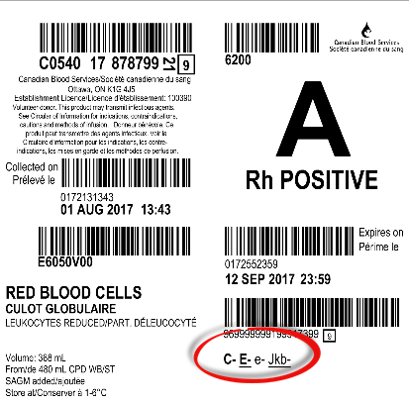  RBC Phenotype Printed on Bag Label:  - Antigens testing positive will NOT be printed on the label  - All antigens testing negative will print on the label in the following format:  - Regular font: Donor has been tested once  - Bold Font: Donor has been tested twice  - Underlined: Tested on current donation | Phenotype Tag  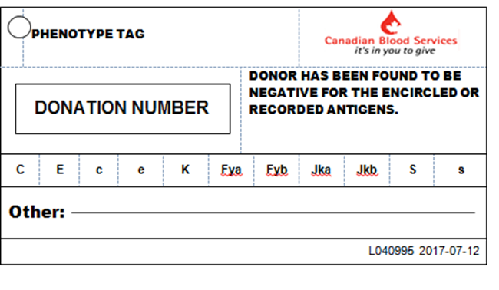  The PHENOTYPE TAG – will be attached to red cells in some circumstances, such as testing being completed after final labeling of the unit has occurred.

