 SCC-LIS_**WARNING**

|  |  |
| --- | --- |
| MODULE: SoftBank | SOFTWARE VERSION: 4.0.8 |
| TOPIC: SoftBank Actions Cannot Be Duplicated Within the Same Order Number | ISSUE DATE: 16Aug2018 |
| DISTRIBUTION: End Users_All | PAGE: 1 of 1 |
| ISSUED BY:M-L Dufresne_Territorial LIS Administrator | |

**ISSUE/RISK:**

Ordering the same action multiple times in Blood Bank will result in incorrect reporting to Wolf and Healthnet Viewer.

**DETAILS:**

When the same blood bank product (action) is ordered multiple times in blood bank due to varying lot numbers etc, each new action overwrites the previous result in Wolf and Healthnet Viewer

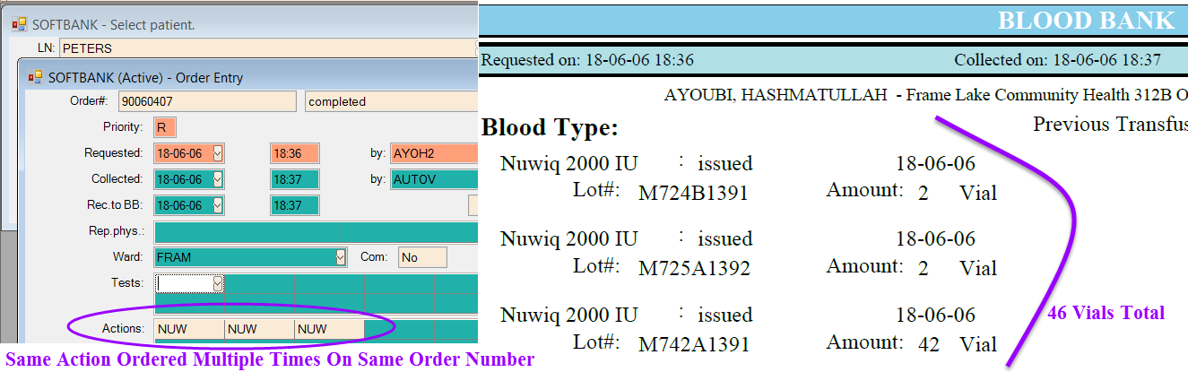**EXAMPLE:**

**__________________________________________________________________**

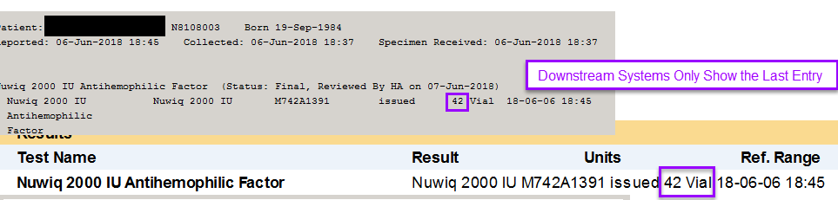

**RESOLUTION:**

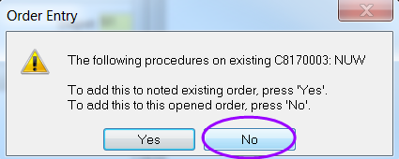Create a separate order number for each lot number change using the “Add Next Order” Function in OE. If pop-up displays stating that procedure already exists on previous order number🡪Click NO to keep new action on separate order number.