PURPOSE:
The purpose of this procedure is to instruct on how to ad-hoc print or fax reports. Reports can be ad-hoc printed in most areas of the LIS where the Printer icon is available 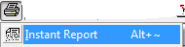. Order Entry, Result Entry, Micro Query, Lab Query, Instrument Menu are all areas in the LIS where Instant reports can be generated for ad-hoc printing and faxing

PROCEDURE INSTRUCTIONS: Ad-hoc Report Printing and Faxing
Follow the steps in the table below to ad-hoc print or fax a report
Step | Action
 | Ensure you are on the correct order number
Hit the Printer icon
- Select the Instant Report option

Instant Report Dialog box will display
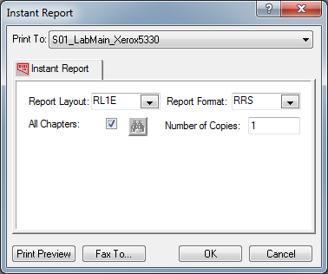

- Use “Print To:” drop down arrow to view available network printers
 | IF | THEN
 | Destination has a networked printer listed | Select the correct printer and hit OK to send the report. You are done. A report with your initials in the footer should be visible in Softmedia confirming that you have sent an adhoc report.
 | Destination does not have a networked printer listed | Hit the “Fax To…” button to send via fax  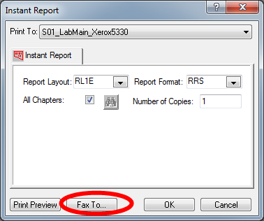  - Go to step 5
When the fax browser dialog box displays – ensure the “Display Warning” checkbox is checked
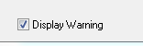
Using the column labelled “Location” - find the correct ward/location
- To sort that column alphabetically – click on the header “Location”
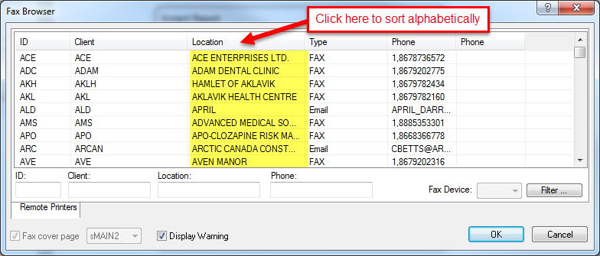
 | Verify the fax number is correct (if available)
 | IF |  | THEN
 | You have a fax number but don’t know the location |  | Sort the display by Phone number and numerically find the number  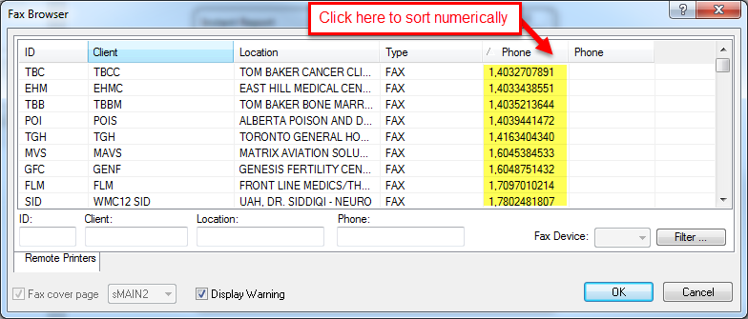
 | Highlight correct location and hit OK
The Fax Warning box will display so users can double check the location is correct before the fax is sent
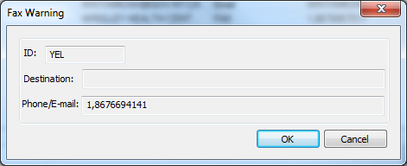
 | IF |  |  | THEN
 | The Fax Warning box does not display |  |  | The display warning box was not checked – the fax was sent without verification
 | The fax number/destination is incorrect |  |  | Hit Cancel and repeat steps 6-10
 | The fax number/destination is CORRECT |  |  | Hit OK  You are done. A report with your initials in the footer should be visible in Softmedia confirming that you have sent an adhoc report.

REFERENCES:

SCC SoftComputer. (2016, April). SoftLab Laboratory Information System Version 4.0.8 User Manual(1st edition).

REVISION HISTORY:

REVISION | DATE | Description of Change | REQUESTED BY
1.0 | 31AUG11 | Initial Release | Darrach (A)  Dufresne (M-L)
2.0 | 11JUL2018 | Updated screenshots, more general procedure, new document number | LISADMIN

