PURPOSE:
The purpose of this procedure is to instruct users on how to enter Glucometer Glucose screening results before administering the TruTol glucose drink for Gestational Glucose Tolerance Testing (GGTT) or Glucose Tolerance Testing (GTT). The glucometer glucose test (GLUGL) is a non-reportable test code used for internal laboratory purposes only.

PROCEDURE INSTRUCTIONS:
Follow the steps in the table below to
Step | Action
 | Order Gestational Glucose Tolerance Test (GGTT) or the Glucose Tolerance Test (GTT) as indicated on the requisition
 | Save order
RBS rule will fire to add on the GLUGL test code
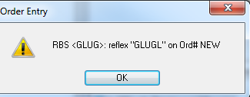
 | Perform the glucometer test for glucose as indicated by the laboratory standard operating procedure
Under Specimen tab – Click on Specimen Type: GLG
Workstation will depend on the site: FS=FCHMM, HR=HCHMM, IN=ICHMM, ST=SCHMM
Hit Coll/Rec
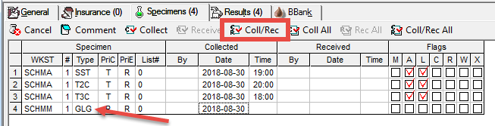
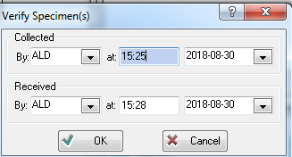
Enter Collector Initials, time and date
- Hit OK
- Save Order or hit Edit button to prompt
save order

Enter glucometer glucose result in box
- result is set to auto-verify
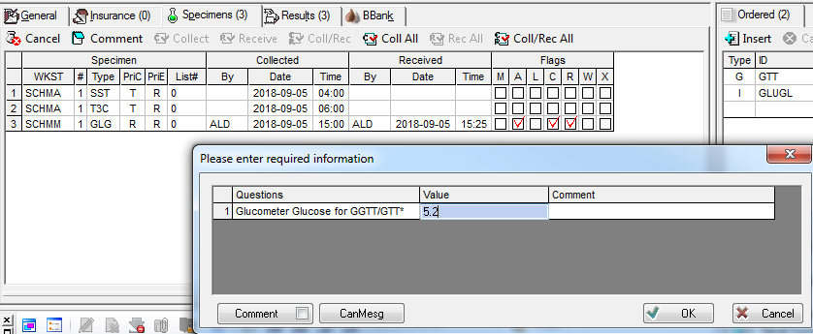
 | IF | THEN
 | Glucometer glucose result is less than or equal to 7.8 | Proceed with the glucose tolerance testing
 | Glucometer glucose result is greater than 7.8 | RBS rule GLUG1 will reflex to cancel the GGTT or RBS rule GLUG2 will reflex to cancel the GTT test code  - The rules will order the GLUF test code  - No new label will print – use the original SST label for the GGTT or GTT test code  - On the SST label - cross out the GGTT or GTT test and handwrite GLUF
 | Glucometer glucose screening is not performed because samples were collected outside the laboratory | Enter dot “.” in the result box or select the canned message box and result with canned message
 | Save Order when complete

REFERENCES:

SCC SoftComputer. (2016, April). SoftLab Laboratory Information System Version 4.0.8 User Manual(1st edition).

REVISION HISTORY:

REVISION | DATE | Description of Change | REQUESTED BY
1.0 | 21NOV2018 | Initial Release | LISADMIN

