PURPOSE:

This document is a standard operating procedure for understanding the presence of XN-1000 generated flags.

QUALITY CONTROL:
Quality control must be performed and within the acceptable limits before sample analysis can be performed. Refer to procedure  Running Quality Control on the XN-1000.

XN FLAG IDENTIFICATION:

XN Flag | LIS Error Message | Meaning | Action Required
- | L | Indicates the value is less than the reference interval. | NO
+ | H | Indicates the value is higher than the reference interval. | NO
@ | > | Out of assured linearity | YES  - Repeat sample  - Dilute
---- | A | Indicates an analysis or hardware error and the value cannot be produced. Value is automatically cancelled in instrument menu. A ‘C’ will appear in the status column. | YES  - Check analyzer status  - Repeat sample
++++ | A | Indicates value cannot be displayed because the value exceeds the display limit. Value is automatically cancelled in instrument menu. A ‘C’ will appear in the Status column. | YES  - Repeat sample  - Dilute
IP Message | A | All IP message result records will have an ‘A’. | YES  Go to:  - WBC IP Message, procedure   - RBC IP Message, procedure   - PLT IP Message, procedure 
* | W | Low reliability | YES  Scan peripheral smear
! | Y – High  Z – Low | Indicates that the value is higher than or less than the clinical panic value. Also indicates that the value is higher than the allowed value for a background check. | YES  - Repeat sample  - Follow critical result protocol.

INTERPRETATION OF ANALYZER FLAGS:
INTERPRETATION
If: | Then:
Specimen is judged NEGATIVE  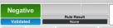 | There are no IP messages generated and results can be released.
Specimen is judged POSITIVE | An IP Message has been generated and further action is required. Positive judgments indicate a data value has some type of flag related to differential, morphology or count.
Specimen is judged ERROR | An analysis error has occurred. Check analyzer status as well as sample quality assurance.
An asterisk (*) appears next to a parameter. | Indicates these results have low reliability and a scanning of the peripheral blood smear must be performed to confirm results. If there is no IP Message attached to the ( * ) there will not be an automatic report print out from the instrument.
Dashes ( - - - - ) are in place of numeric data. | The analyzer cannot produce a numeric value.

ACTION STEPS

Step | Action
1 | If an XN flag is generated there will be an automatic print out of the sample run.
2 | Use the following table below to identify which action is needed.
3 | If: | Then:
 | WBC IP Message | - Refer to LIS ACTION steps in the next chart.  - Go to procedure  WBC IP Message
 | RBC IP Message | - Refer to LIS ACTION steps in the next chart.  - Go to procedure  RBC IP Message
 | PLT IP Message | - Refer to LIS ACTION steps in the next chart.  - Go to procedure  PLT IP Message
 | Dashes ( - - - - ) | - [Post All] results in Instrument Menu.  - When prompted by the Instrument Menu verification dialog box select [No].  - In Resulting Menu put a [.] value in the resulting parameter field.  - When the cancellation dialog box appears add a comment as to why a value cannot be obtained.  - Request a recollection.
 | Asterisk (*) | - Refer to LIS ACTION steps in the next chart.  - Make a peripheral blood smear.  - Refer to procedure  Peripheral Smear Review.
4 | Do not release specimen results until all sample related problems have been resolved and correct results are obtained, as well as all morphological findings documented.

If ACTION is required, follow the LIS steps below:

Step | Prompt
1 | Instrument menu
2 | Select XN analyzer that the specimen was processed on.  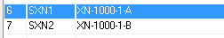
3 | Select specimen number.
4 | Scroll down to bottom of CBC parameters. The IP messages will appear at the end. An ‘A’ will appear in the Error column.  (i.e.)
5 | Select [Post All] on the toolbar.
6 | When the Instrument Menu pop up box appears.  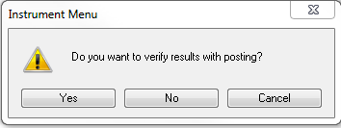  Select [ NO ]
A reflex box will appear in the bottom of the screen.
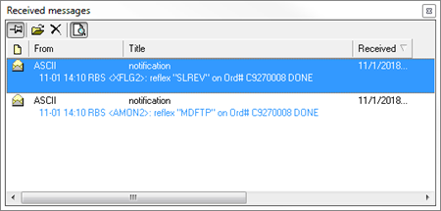
 | XFLAG | ACTION
 | SMREV | Smear Review required
 | MDFTP | Manual Differential required
 | MORTP | Morphology required
7 | Specimen will disappear and be posted in the [Resulting Worklist] folder under the template [DIFFX].

RELATED DOCUMENTS:

Procedure  Running Quality Control on the XN-1000

Procedure  WBC IP Message

Procedure  RBC IP Message

Procedure  PLT IP Message

REFERENCES:

Sysmex, XN series (XN-1000) Instructions for Use, Sysmex Corporation (North American Edition, XN-11/XN-21

Sysmex XN-Series Automated Hematology Systems;
Flagging Interpretation Guide; Document Number:1166-LSS, Rev.3
January 2017

APPENDIX (APPENDICIES):

REVISION HISTORY:

REVISION | DATE | Description of Change | REQUESTED BY
 |  | Initial Release

