Attendees: Jocelyn, Bayo, Theresa, Erin, Holly, Kayla, Connie, David, Cole, Amy, Laura S, Laurie, April

1. Ketones
   1. They are back and validated
   2. New QC also so you will see a new lot
2. Sweater left in old hospital
   1. Size small, pink sweatshirt in the lab if it is yours
3. Printer paper
   1. New paper kept below the Xerox
   2. No longer need to use coloured paper
4. Lab Recycling
   1. Laurie is giving it up as she will be on maternity leave
   2. Somebody needs to take it over or Dexterra has recycling bins in the break room
   3. Using our existing recycling money to send to Mike Arbuckle
5. Renal Panel
   1. Laurie created a keypad tab for just the renal panel tests
   2. In Order Entry keypad, there is a tab called Renal
   3. All in-house orders should be placed on Order 1
   4. Send-outs are placed on order 2

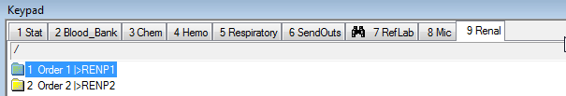

1. New water contract for Dialysis water
   1. Effective today – dialysis water testing is being referred to Chief Medical Labs in Alberta
   2. Dialysis waters do not go back to Microbiology – they are to be ordered and processed by the lab assistants
   3. There is a Stanton Dialysis patient that is to be used for accessioning

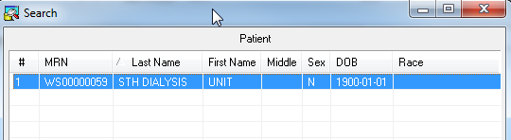

* 1. Waters are setup as standing orders so you need to cycle the MRDIA test

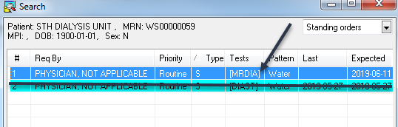

* 1. LIS info sent to SoftComm and email
  2. Shipping information is pending

1. TPSA
   1. Testing can resume at Stanton
2. Stanton Ambulatory Care Centre
   1. Requisitions will start to filter through with the new SACC codes on them
   2. If you find a physician who does not have an SACC code but needs one – please enter them as an Auxiliary Doctor
3. Printer updates
   1. Just go the go-ahead from Kim Riles/Jen to set up the sites to revert the in-house fax locations to network printing
   2. The issue is that some wards did not keep their old HP printer (TSC supported) and only have a Multi-function Xerox (NOT TSC supported)
   3. There is no longer a backup for network printing or fax as their used to be
   4. The onus is on the wards to troubleshoot their own faxes/printers and call Xerox for service
4. Plasma ISBT codes
   1. ISBT codes for thawed products are different
   2. See Blood Bank procedure for instruction
5. Mail issues
   1. Email sent out June 3rd, 2019 regarding mail issues – please read
   2. Chantelle will clarify what goes into the tube regarding internal mail/reports, etc

**Round Table:**

Chantelle: just a reminder to update the test list on the side of the fridge when a test comes back validated from Dynalife.

Chantelle: ABL is still just the ABL90 that is validated

Erin: CO2🡪any feedback on this from Dynalife?

* Dynalife is requesting that we run a previous CAP survey and compare it to the original results
* Chantelle to check EQAS

Erin: Need to send out a notification regarding not sending routines sample in the tube until 9am

Theresa: follow up with wards regarding the time the requisitions should be sent down from wards. They have received conflicting information.

Laurie: Sign card for Mike and get it back to me by end of next week. Want to send the card and the basket for his surgery next week.

Amy: April and Chade are leaving us. Come celebrate at Fred Henne on July 6th. Details will follow.

Amy: CBS reports need to be entered into the RL6 system when they have the wrong location indicated on them.

Amy: Alarm checks will start taking place daily – 1 fridge/day

Minutes by: April Darrach