**DEPARTMENT OF HEALTH AND SOCIAL SERVICES TRAINING**

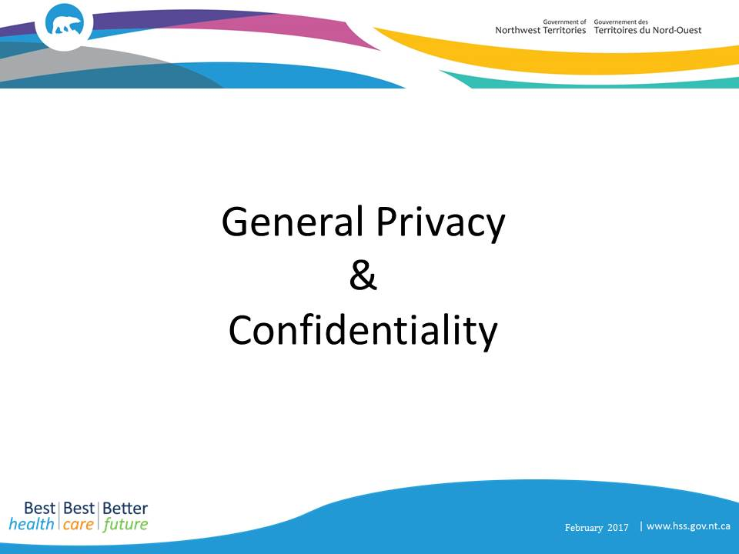

***Participant’s Guide***

# General Privacy and Confidentiality

**Privacy means:**

* A legislated right
* About protecting clients
* About the client’s information

Privacy is the right to be free from unwanted or unnecessary intrusion/nosiness/snooping/interference in one’s life or personal matters.

**Privacy applies to:**

* Personal Information; and
* Personal Health Information

**Confidentiality means:**

* A job requirement
* About protecting the organization
* About any type of information (client, government, sensitive)

Confidentiality is about keeping someone’s trust and confidence, and is usually only used when talking about keeping the organization’s trust.

**Confidentiality applies to:**

* Classified Information;
* Personal Information; and
* Personal Health Information

# Types of Information

# Classified Information, Personal Information, Personal Health Information

**Classified information**

* Non-public information that is shared with limited number of employees for a specific purpose
* Organizational information such financial, employee, technical
* Plans, proposals, legal advice
* Cabinet papers, briefing notes, contract negotiations

Classified information includes any information that if disclosed may result in harm to the organization.

**Personal Information**

* Any piece of information that relates to a specific person who can be identified by the information
* Any identifiable information which will or may reasonably lead to the identification of one or more specific individuals
* Names, contact details, social insurance numbers, purchase records, vehicle registration information
* Child and family services information, adoption information, professional licensing and human resources information

**Personal Health Information**

PHI is defined by the NWT *Health Information Act*, as information in any form that identifies an individual or in respect of which it is reasonably foreseeable in the circumstances that the information could be used, either alone or with other information to identify an individual, including:

* Information about the health and health care history of an individual
* Information respecting health services provided to an individual
* Information about eligibility or registration of an individual for a health service or related product or benefit
* Information about the payment for a health service for an individual
* Information collected in the course of providing a health service to an individual or information that is collected incidentally to the provision of a health service to an individual, including the individual’s name and contact information
* A personal health number, other identifying number, symbol, or other particular assigned to an individual in respect of health services or health information
* Prescribed information about a health service provider that provides a health service to an individual
* Information respecting the donation by an individual of a body part or bodily substance, organ and tissue transplantation
* Information about health services that relate to mental health and addiction services including addiction treatment, counselling and detoxification and mental health counselling.

# Responsibility

When it comes to information we handle on daily basis, no matter whose information or what type (classified, personal information or personal health information), we have a responsibility to:

* Respect the information
* Protect the information
* Keep the information confidential and private

# Privacy Principles

**The privacy principles are:**

* + Gather, use and share only the **least amount of information needed** to do your job,
  + Gather, use and share **identifiable information only when non-identifiable won’t do**
  + Know **why this information is needed now** to do your job.

These principles apply when you handle information for example collecting, using, *and* sharing information.

**Least Amount of Information**

Always handle the **least** amount of information necessary to do your job.

* + Example: A patient intake/new patient form does not require you to collect a SIN number, so don’t ask the patient for their SIN number
  + Be careful when asking the patient lots of questions – be sure they are relevant and necessary in order for you to do your job
  + Do not collect information just in case it “might be useful” in the future or because you think it may be “good to know”
* Helps to preserve privacy when sharing information.
* Information needs change depending on the job at hand, and who is doing what job.
* Example: Clinic assistant vs. Physician
* Clinic assistant scheduling a patient appointment: will collect and use the patient’s demographic information and maybe the reason for the patient’s visit
* Physician consulting with a patient: will see the patient’s demographic information; may also access the patient’s medication history, recent lab test results, and collect additional information about the patient’s health status
* They each collect and use the least amount of information they *need to know to do their OWN job*

**REMEMBER: Just because you *can* view more information on a patient’s chart doesn’t mean that you *should.***

**Non-identifiable versus identifiable information**

Sometimes non-identifiable information is enough. For example when reporting attendance at a clinic, only report the number of people who visited the clinic. Do not say the names of the people.

**Know Why the Information is Needed**

When you **know what** information you **need** or is necessary, you are able to:

* make decisions about collecting, using, and sharing information
* explain why information is being collected and how it will be used
* share only information needed for you or someone else to do their job which also helps to protect patients’ privacy.

# Simple Privacy Safeguards

Privacy safeguards are found in any environment in any form.

Privacy safeguards are important as they create a safety barrier to protect client privacy.

What you can do:

* Don’t store documents on your C:Drive or desktop
* Don’t share passwords
* Don’t throw private and confidential notes in the garbage
* Don’t open attachments or click on links sent from unrecognized email addresses
* Don’t chat about clients in the halls
* Don’t use your personal email for work
* Do keep your desk clean
* Do think before you hare information
* Do keep records safe
* Do lock up before you go
* Do use VPN

# Training

**Why is Training needed and important?**

Whenever you come across classified information, personal information or personal health information, you are **involved**.

You are **responsible** to take the privacy and confidentiality of information you come across seriously, which means you respect the privacy of clients and protect the organization.

You **may be required to take additional privacy training**, depending on your role.

Various training modules are available, both mandatory and optional.

