PROGRAM Standard Operating Procedure – Laboratory Services
Title: URN60100 Semen Analysis-Post Vasectomy | Policy Number:
Program Name: Laboratory Services
Applicable Domain: Lab, DI and Pharmacy Services
Additional Domain(s):
Effective Date: | Effective Date:
Issuing Authority: | Issuing Authority:
Director, Health Services | Director, Health Services
Accreditation Canada Applicable Standard: N/A

GUIDING PRINCIPLE:
Semen analysis from a post vasectomy patient should be submitted 12 weeks after the date of the procedure. Semen analysis allows for the microscopic examination of a semen sample to determine the efficiency of the procedure and confirmation of sterility.

PURPOSE/RATIONALE:
Post Vasectomy examination of seminal fluid is performed by laboratory staff to determine the presence or absence of spermatozoa and if present to grade the motility.

SCOPE/APPLICABILITY:
This procedure applies to Medical Laboratory Technologists (MLT’s) who will be performing this procedure.

SAMPLE INFORMATION:
Type | Seminal Fluid
Source | Collected by masturbation following a 48 to 72 hour period of abstinence from sexual activity.
Collection Container | Samples should be collected directly into orange topped sterile containers, prophylactics should not be used.
Volume | Entire ejaculate must be collected in the sample collection container.
Stability | 30 minutes at body temperature.
Patient Preparation | Patient must abstain from sexual activity for at least 48-72 hours up to a max of 7 days.
Storage Requirements | For best results, sample should be kept at body temperature and submitted to the laboratory for testing within 30 minutes of collection.  Samples from Community Health Centers can be accepted up to 48 hours post collection, however, this is not a preferable sample. Attempt to keep the specimen at 37˚C during shipping, or at minimum, room temperature.
Criteria for rejection and follow up action | - Improperly labelled samples  - Samples not delivered within 48 hours of collection from Community Health Center’s.  - Samples collected in unsuitable sample containers  - Samples not accompanied with a requisition

SUPPLIES:
- Glass slides
- Coverslips
- Transfer pipettes
- 5cc syringe
- 18G syringe needle
- Conical urine tube and cap
- Centrifuge

EQUIPMENT:
- 37˚C Water Bath or Incubator
- Microscope

EQUIPMENT CALIBRATION AND MAINTENANCE:
Kohler Illumination should be performed at the beginning of each shift for the microscope being used. See MIC61120 Kohler Illumination Job Aid.

SPECIAL SAFETY PRECAUTIONS:
- Ensure proper PPE is used such as gloves, lab gowns and eye protection when possible exposure to splashes
- Ensure all samples are treated following universal precautions and assume all products as potentially infectious.

QUALITY CONTROL:
There is no routine quality control procedure to perform this test. External proficiency testing is performed on a bi-annual basis.

PROCEDURE INSTRUCTIONS:
Follow the steps in the table below.
 | Action
1 | Samples should be placed into a biohazard bag and then placed into the 37˚C water bath or incubator for up to 30 minutes to allow complete liquefaction of the sample. Be sure to orientate the specimen with the lid up so that the sample does not become “stuck” to the lid.
2 | If the semen sample fails to liquefy after 30 minutes, the sample can be mechanically liquified by forcefully expelling the semen from a 5cc syringe fitted with an 18G needle.
3 | Mix the sample well.
4 | Using a transfer pipette place a drop of liquified sample onto a glass slide and coverslip.
5 | Using the high-dry 40x objective, examine the slide under the microscope for the presence of spermatozoa.
6 | In the LIS open the Semen Worklist: Resulting Worklist >Template > SEMEN(Semen Analysis/Post Vas)
7 | Select the correct result from the keypad.  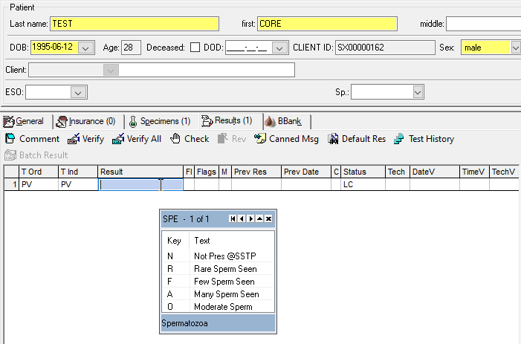
8 | If: | Then:
 | Spermatozoa are not seen | - Select “Not Pres” from keypad and verify. This will generate a reflex OSEA order for referral to DynaLIFE.  - Using a transfer pipette, transfer the entire seminal fluid specimen into a labeled conical urinalysis tube.  - Cap the tube and centrifuge at 1500 RPM for 5 minutes.  - Prepare 2 smears from the sediment and label the slides with the patient’s name, healthcare number and “CONC. Semen”.  - Allow smears to airdry.  - Print off the patient results using Lab Results Query.  - Place the slides into a slide holder and label the slide holder with the OSEA barcode.  - Place slide holder, along with results, into a small biohazard bag and place in the DynaLIFE referral bucket for tracking and shipment.
 | Spermatozoa are seen | - Select the appropriate result from the keypad; Rare, Few, Many or Moderate Sperm present and verify. This will reflex an order for MO(Motility) and MOT(Motility Grade).  - In the LIS open the Semen Worklist: Resulting Worklist >Template > SEMEN(Semen Analysis/Post Vas)  - Report MO(Motility) based on the percentage of motile sperm seen.  - Report MOT(Motility Grade) based on the interpretations below.
9 | The motility of sperm is reported in percent, however, the Motility Grade will be reported based on the speed and path of forward progression and graded on a scale of 0-4 as follows:  0 No Motion  1 Sperm Moving, but no forward motion visible  1+ Sperm Moving, but with only slight forward motion  2 Sperm moving with slow, meandering forward progression  2+ Sperm moving in a more direct, slow forward course  3 Sperm moving in an almost straight line with moderate speed  3+ Sperm moving in a straight line with good speed  4 Sperm moving in a straight line with high speed  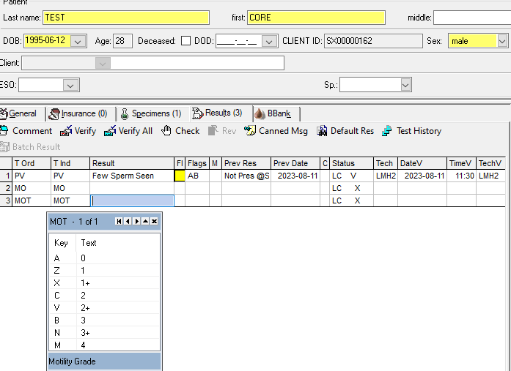
10 | Verify results in LIS.
11 | NOTE: Quantitative counts should be completed upon the request of a doctor. To perform a count refer to procedure URN60200 Semen Analysis(Fertility).

METHOD PERFORMANCE EXPECTATIONS:
To reliably conclude that the procedure was successful an initial assessment should be completed at 12 weeks post procedure and CLSI guidelines states testing should be repeated to confirm azoospermia on a subsequent specimen.

MEASUREMENT UNCERTAINTY/LIMITATIONS:
When less than 1 mL is provided, add the following canned comment “Less than 1 mL of sample received, results may not be representative. Please recollect if necessary.”

Samples should be processed within 4 hours of collection. If this is not possible add the following canned comment “Specimen >4hrs old, sample integrity may be affected.” All attempts should be made to receive samples from Community Health Centers on same day of collection.

EXPECTED RESULTS:
Not present.

CROSS-REFERENCES:

MIC61120 Kohler Illumination Job Aid
Semen Collection Aid
URN60200 Semen Analysis(Fertility)

REFERENCES:

Canadian Society for Medical Laboratory Science, Body Fluids: Seminal Fluid Course Number 9847, April 2005

Stanton Territorial Health Authority, Hematology Manual – Semen Analysis (Post Vasectomy), 2008

Stanton Territorial Health Authority, Hematology Manual – Semen Analysis (Post Vasectomy), 2013

DynaLIFE Medical Laboratory

CLSI POCT10-A2:2011 Physician and Nonphysician Provider-Performed Microscopy Testing, 2nd edition

RELATED DOCUMENTS:
Add as needed here.

APPROVAL:

__________________________
Date

__________________________
Choose:
Facilities: Name of each COO this policy applies to.
And/Or:
Executive Director, Corporate and Support Services
Or:
Executive Director, Clinical Integration

REVISION HISTORY:

REVISION | DATE | Description of Change | REQUESTED BY
 |  | Initial Release | L. Howlett

