Questions for Laura S:

1. ANO2 in vaginal culture specimens?

* **Anaerobes are listed as commensal flora in the SOP for vaginal specimens**
* **For commensal flora in vaginal specimens, SOP says to do min ID and list as commensal flora**
* **Minimal ID for ANO2 is to do a gram and aerotolerance test to prove it is an anaerobe. Don’t need to do ANC card as ID isn’t relevant just need to prove it is an anaerobe**

1. Reporting for *S.aureus* in sputum sample?

* **The SOP says only report *S.aureus* in sputum sample if pure and predominant and that it is a potential pathogen**
* **SOP says under the reporting section:**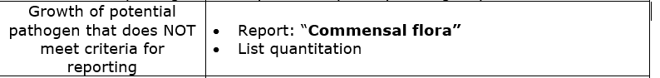

1. Reporting *G.vaginalis* in vaginal swabs?

* **SOP says if pure, report full ID and maybe sens. To do full ID, need to use NH card**
* **SOP says if multiple morphotypes growing, do full ID if heavy and predominant growth. I changed the SOP to say if not these things, do minimal ID and report as commensal flora**
* **Minimal ID would just be a gram. Don’t need to do NH card**

1. Reporting *S.lug* if potential pathogen that needs to be listed?

* **If SOP says to do min ID and list *S.lug*, list as CNST. Same as any CNS**
* **Minimal ID for *S.lug* is do RS (can be pos or negative). If RS is positive but it doesn’t look like SA do PYR. *S.aureus* is PYR negative and *S.lug* is PYR positive so that will diff them and is a rapid test to quickly ID. Don’t need to do GPI, not necessary**

1. DT for SPN:

* **Laura S didn’t think about the TXP keypad, and it wasn’t changed when the card was introduced**
* **On the ALPHA keypad the line for OTH has been changed to order TXP. This is because for OTH don’t need to do GPI, just TXP**
* **On the TXP keypad there is**
* **>14 mm - S eye that adds ID as SPN and adds EYE comment**
* **>14 mm - OTH that will add ID as SPN, order ST03 card, order DT and add sens. to follow comment**
* **<14 mm - OTH-Full ID-Sens will order GPI and ST03 if need to do full ID on Streptococcus viridans group**
* **<14 mm - OTH-Min ID-No Sens will call organism Streptococcus viridans group**
* **ALPHA keypad is for invasive specimens and TXP keypad is for other specimens**