Specimen Control Staff Meeting
Wednesday, June 26, 2024 (14:00-14:30)

Attendees:
Pearl Martin, Ryan Alexander, Vanessa Jaramillo, Jaime Kennedy, Robyn Villeneuve
Carolyn Russell

Discussion Items:
- Staff was questioning if infectious chemistry specimens are Category B. Yes. Infectious chemistry specimens must be sent as Category B. In fact, Transport Canada has changed the definition of exempt human specimens to: 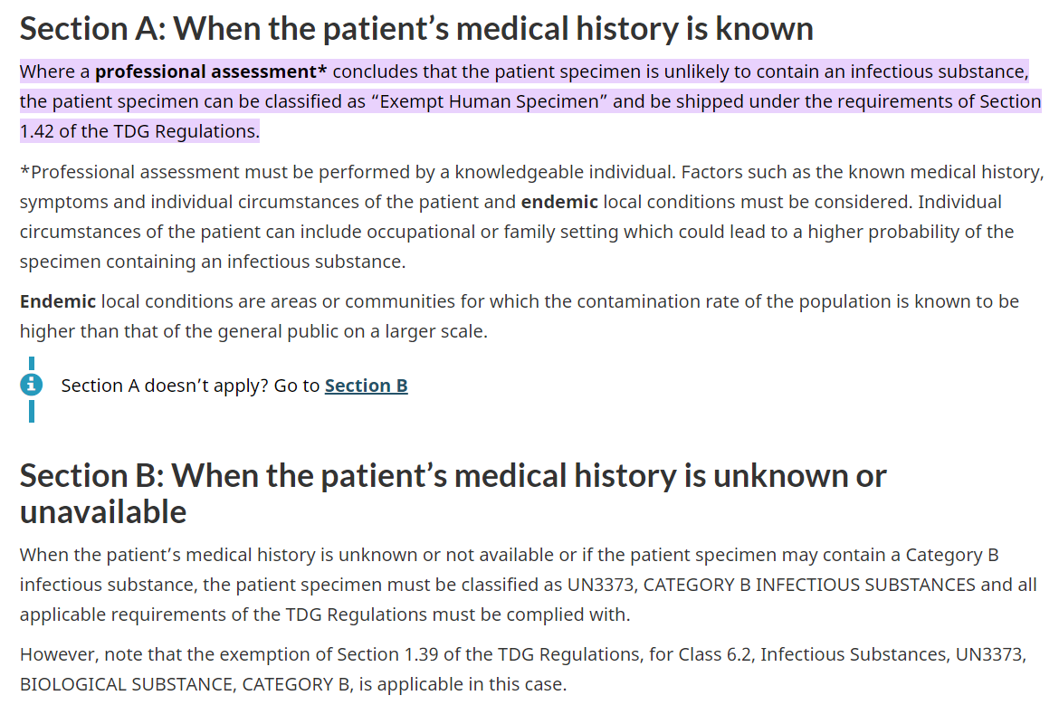
This means that most specimens are now Category B as we do not have access to this information.
- Core Lab has asked that we stop entering referral specimens into Soft at 21:00 Monday through Thursday. You can continue to Medipatient, but only enter time sensitive or STAT specimens after 21:00 unless the Core Lab Tech asks you to continue. Continue to enter as much as you can on Friday night as weekend staff may not be able to process them all before they time out.
- Please ensure that you put a copy to stamp on the PREN requisitions (even the ones from the communities). The CBS report only gets faxed to the Blood Bank printer if the stamp is present.
- Please remember to add a SLAB cc on all orders. This is so we no longer need to use the stamp on the manifests. There should be a reminder to enter it, but staff indicated that the reminder is not currently working – Carolyn to follow up with LIS.
- There was direction provided earlier that all morning ward collectors were to go up to wards together and come down from wards together. A Core Lab staff member brought forward that this was not occurring. In follow-up discussions with both Core and Specimen Control staff, feedback indicates that this process does not work well. This is no longer required, but the key point is that no one should be left behind or forgotten on the units.
- I have been reviewing the temperature charts and have noted that they are not being consistently completed. Please ensure that they are filled in every day (including weekends).
- Physicians can call in to have certain patients prioritized for outpatient appointments or walk-in slots. Wanda and Carolyn are working with the practitioners to formalize this process.
- On the weekend, there are only 07:00 rounds. Please ensure that priority specimens are collected as ordered, and that you collect routine orders as soon as you have time. Please do not leave the routine orders until the end of the day as this creates a backlog that prevents the Core Lab staff from being able to leave on time.
- Monday through Friday, ward rounds are to be completed at 07:00. 13:00, 15:00, and 19:00. The last 2 each day are performed by the evening shift.
- Remember to enter your pay as it is early cut off this week.
- ER collections (if any) should be done prior to going up for morning wards. Wanda is going to have a meeting discussing in-house collections with the other teams. I will keep you posted.
- I have been asked to post the meeting minutes in both the shared drive and on MTS.

