Attendee | Present? | Attendee | Present? | Attendee | Present?
Carolyn (Recorder) |  | Pearl |  | Myles
Jaime |  | Aldie |  | Miranda
Vanessa |  | Kaitlyn |  | Alix
Ryan |  | Janina

- All pathology send-outs need to be accessioned and the reports for these need to be prioritized. New/updated SOPs and processes will be developed over the next few months.
- Ordering for YPCC – Please ensure you place orders in SAM for YPCC. Do not just send a list to the main Lab (unless it is for products from APL). When you place the order in SAM, make sure you change the delivery location to YPCC.
  - In the Header section click on Requisition Defaults.
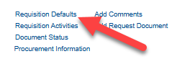
  - In the Distributions section, find the Location field.
  - Change to the YPCC location.
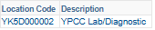
- Annual leave schedule has been posted.
- A Job Aid/Cheat Sheet is being developed to assist with entering Dr. Osman patients.
- Do not allow any public use of the YPCC washrooms. Clients may use the washrooms, but there are several safety and privacy concerns with allowing non-clients into the secured area. Signage is being developed and posted to re-enforce this message. If you run into issues, please call Northview Security or the RCMP.
- In response to your feedback, I have reached out to Avens and Extended Care to have them update their requisitions and to provide information on properly completing requisitions. Please let me know if there are ongoing issues but remain patient as they transition to the correct process.
- Debrief on Peds Cardio – Over 20 spots wasted for Outpatient Collections. Kim Elkin has provided the list so we can add the patients into the scheduler. Hopefully we can get it in advance for next time.
- PPIRF Response – In response to the PPIRFs submitted, there are two process flows posted on the Specimen Control Board.
  - AM Process
    - 06:30 – Come in and take temperature checks and BSC Maintenance. Proceed with entering requisitions for morning wards.
    - 07:00 – Restock collection carts, assist with entering requisitions (if required), then proceed to rounds.
    - Core Lab will look after the samples from the pneumatic tube until rounds are complete. (If you are able to, you can assist)
  - Evening Shift Process – A process map has been posted on the board. This process MUST be followed. You can provide suggestions on future improvements, but for at least the next 90 days, this is the process we will be using. Anticipate that as we become more familiar with it, we will become more efficient. A larger version of the process map is posted on the Specimen Control board.
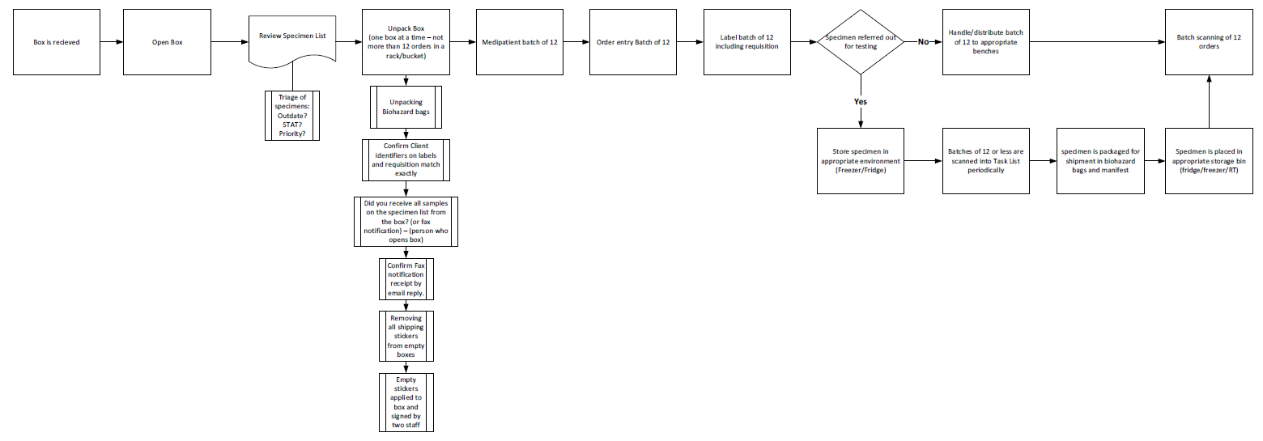
- YPCC Waste – If you have sharps waste at YPCC, you can call KBL (867) 873-5263 and they will pick it up. This is a collection location written in their contract.
- Holes in the Glass barrier – All actions that can be done from our end are complete. Project has been deferred until next fiscal year.

