Attendee | Present? | Attendee | Present? | Attendee | Present?
Carolyn (Recorder) |  | Pearl |  | Myles
Jaime |  | Aldie |  | Miranda
Vanessa |  | Kaitlyn |  | Alix
Ryan |  | Janina

- Ensure all specimen drop-offs are processed. There was a report of a urine specimen left at the drop-off window, and someone “from the back” was notified. By the time the specimen was accessioned, the sample had timed out.
- Book patients – do not just tell them to drop in. If you are calling a patient back for a recollection, please ensure you book them a time to have the bloodwork drawn.
- Send extra ECG with patients from Peds Cardio. Peds Cardio patients need a copy of the ECG for their appointment. One still needs to be sent to APL and one needs to be scanned to our system and sent to the ordering practitioner.
- Send back incomplete blood spot cards. If the information on the PKU blood spot cards is incomplete (including codes) or the mother’s sticker is not on the back, do not collect. Return the card to the nursing station for them to complete the information.
- When you place a LIS label on a requisition, please ensure it does not cover any of the demographic information. This information is required to remain visible.
- Mail is to be taken to be taken to the mail room daily. The Booking Clerk will collect the mail at 15:00 and take it to the mail room daily.
- If copies are requested for out of territory providers, please ensure that you are entering the “CC not processed” comment with the name and number for the copy we did not process. If you are unsure if the provider is one that is already set up in the LIS:
  - Click on the Instant Report Icon.
  - Click on Fax To.
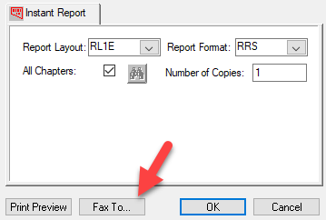
  - Enter the number provided into the phone field. If it is on the list, enter the client number into the cc field in order entry. This will send the cc to the requested location.
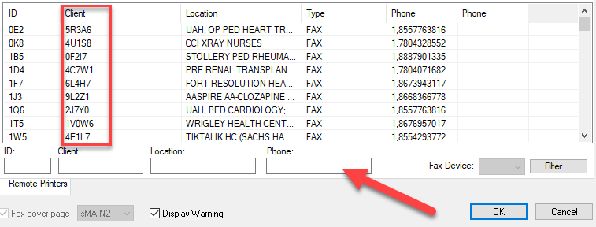
- Please ensure you are following the new processes indicated on the Specimen Control Board. Please contact me if you have any questions.
- Punctuality – Please ensure you show up on time for your shift and stay until it is over. Each one of the shifts has duties/handovers that need to occur on time. You must let your Supervisor know if you are going to be late or absent, before the beginning of your shift AND call in to the Lab.
- Please ensure you are completing your Mandatory Certifications. I have noticed a large drop in training rates since I last checked in early January. If you have certificates, please upload them.
- Fire Extinguisher Training Session held during the meeting.
- I will be away next week. Kaitlyn will be the Responsible Person while I am away.

Questions asked:
- Printing Requisitions – This is a function that has been assigned to Diagnostic Services Clerks. Questions about the process they use to print requisitions from the EMR need to be directed to their Supervisor/Manager.
- Expired Requisition Stamp – staff would like to purchase a stamp for marking requisitions as expired. Carolyn will investigate.

