**PROCEDURE: ALERETM PBP2A SA CULTURE COLONY TEST**

1. **PRINCIPLE**

Early detection of methicillin-resistant Staphylococcal infections is known to reduce health care costs, critical in efforts to decrease patient morbidity and mortality, reduce empiric use of vancomycin and permits cost-effective decisions for optimal patient management.1 There are three mechanisms that contribute to the resistance of oxacillin in *S. aureus*: Production of a supplemental penicillin-binding protein (PBP) that is encoded by the *mecA* gene; hyper β-lactamase production; and production of modified PBPs that lowers the affinity of organisms for β-lactam antibiotics.2 Conventional methods of antimicrobial susceptibility testing can take over 24 hours, and *mecA* gene identification is expensive and time-consuming to perform. Penicillin-binding protein 2a (PBP2a) detection has an advantage over *mecA* in that it identifies strains that not only harbor the *mecA* gene, but also produce the protein that confers resistance to methicillin.

The AlereTM PBP2a SA Culture Colony Test is a qualitative, *in vitro*, immunochomatographic assay for the rapid detection of penicillin-binding protein 2a (PBP2a) in isolates identified as *Staphylococcus aureus* as an aid in identifying methicillin-resistant *Staphylococcus aureus* (MRSA). It utilizes highly sensitive recombinant monoclonal antibody fragments (rFabs) to detect the PBP2a protein directly from bacterial isolates. The rFab and a control protein are immobilized onto a nitrocellulose membrane as two distinct lines and combined with a sample pad, a pink/purple conjugate pad, and an absorption pad to form a test strip.

1. **AVAILABILITY**
   1. This test is performed as needed to confirm or determine Methicillin resistance through presence of PBP2a protein in a given isolate of *Staphylococcus aureus*.
2. **TEST CODE**
   1. $PBP2
3. **SPECIMEN**
   1. Bacterial isolates <24 hours that have been identified as *Staphylococcus aureus* isolated on TSA w/ 5% sheep blood or Columbia Agar w/ 5% sheep blood.
4. **MATERIALS AND EQUIPMENT**
   1. AlereTM PBP2a SA Culture Colony Test Kit
      1. Test Strips
      2. Reagent 1
      3. Reagent 2
      4. Assay Tubes
      5. Test Racks
   2. Bacteriological loops
   3. Vortex Mixer
   4. Clock, timer or stopwatch
   5. External positive and negative control strains
5. **STORAGE AND HANDLING**
   1. Store kit components at room temperature or under refrigeration (2-30°C).
   2. The AlereTM PBP2A SA Culture Colony Test Kit and reagents are stable until the expiration dates marked on their outer packaging.
6. **QUALITY CONTROL**
   1. Internal Quality Control
      1. AlereTM PBP2A SA Culture Colony Test has built-in positive and negative procedural controls.
      2. The appearance of a pink/purple line at the “control line” position can be observed if capillary flow has occurred.
   2. External positive and negative controls should be tested with each new lot and/or shipment.

|  |  |
| --- | --- |
| Recommended Control Strains | |
| Positive control: | *Staphylococcus aureus* ATCC #43300 |
| Negative control: | *Staphylococcus aureus* ATCC #25923 |

1. **TEST PROCEDURE** 
   1. Holding the dropper bottle vertically, add two drops of Reagent 1 to an assay tube.
   2. Take one heaped 1 µl bacteriological (a heavy inoculum) of sample from well-isolated colonies on the culture plate, place into the tube and thoroughly mix.
   3. Holding the dropper bottle vertically, add two drops of Reagent 2 to the tube.
   4. Vortex briefly. The blue solution must turn a clear color (if the color does not change, add one more drop of Reagent 2 and mix until the sample turns clear).
   5. Insert the test strip into the assay with arrows pointed downward.
   6. At five (5) minutes, withdraw the test strip from the tube and read the assay result.
2. **INTERPRETATION** *– Refer to* *Figure 1*
   1. Negative
      1. A Pink/Purple Control Line appears in the top half of the test strip. No other line appears.
      2. Isolate is negative for PBP2a.
   2. POSITIVE
      1. A Pink/Purple Control line appears, AND a second PINK/PURPLE Sample Line appears below it in the bottom half of the test strip.
      2. Any faint line, even when very faint, is POSITIVE.
      3. Isolate is positive for PBP2a.
   3. Invalid
      1. If the PINK/PURPLE Control line does not appear, whether a Sample Line is present or not, the test is Invalid.
      2. Repeat invalid tests with a new test strip.
      3. If repeat Invalid, report as Indeterminate. The presence or absence of PBP2a is unable to be determined. Methicillin resistance must be determined by an alternative method.
      4. Call AlereTM Technical Support if the problem persists.

Figure 1.

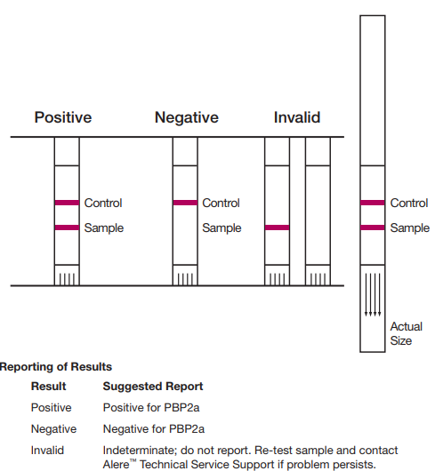

1. **REPORTING**
   1. PBP2a results are routinely used for confirmation of Vitek 2 and/or MIC/KB susceptibility results.
   2. Document all PBP2a testing in the worksheet by adding media **$PBP2** and resulting using the provided keypad.
   3. Preliminary organism identifications of MSSA and MRSA using PBP2a is performed upon physician request only.
   4. If requested, perform PBP2a colony test on appropriate isolates only.
      1. Negative PBP2a
         1. Report the following:
            1. **Organism ID:** MSSA
            2. **Isolate comments:** “Susceptibilities to follow.”
      2. Positive PBP2a
         1. Report the following:
            1. **Organism ID:** MRSA
            2. **Isolate comments:** “Susceptibilities to follow.”
   5. If unable to report full susceptibility panel due to termination or no growth, include the following isolate comment: **&MRSU**

“Unable to perform full susceptibility testing due to atmospheric growth requirements of this organism. Methicillin susceptibility determined by alternative method.”

* 1. **The use of PBP2a in identification of MSSA/MRSA isolates other than what is stated or any variation from the reporting protocol is to be brought up on Rounds.**

1. **LIMITATIONS OF TEST**
   1. False negatives may occur if inadequate inoculum is used.
   2. The AlereTM PBP2a SA Culture Colony Test should be performed only on isolates of *Staphylococcus aureus.*
   3. Performance verification has not been established for small-colony variants of

*Staphylococcus aureus*.

1. **NOTES**
   1. For *in vitro* diagnostic use only.
   2. If refrigerated, allow all kit components to equilibrate to room temperature

(15-30°C) before testing.

* 1. Leave test strip sealed in its foil pouch until just before use.
  2. Avoid skin and eye contact with reagents and test strip.
  3. Do not interchange or mix components from different kit lots.
  4. Reagent 1 contains sodium hydroxide.

DANGER: Causes sever skin burns and eye damage.

* 1. Reagent 2 contains sodium azide.

1. **TECHNICAL SUPPORT**

1-877-866-9341

TS.SCR@alere.com

1. **REFERENCES**
   1. Lodise TP, McKinnon PS. Clinical and economic impact of methicillin resistance in patients with *Staphylococcus aureus* bacteremia. Diagn Microbiol Infect Dis. 2005 Jun; 52(2):113-22.
   2. Swenson, J.M., J.F. Hindler, and J.H. Jorgensen. 2003. Special phenotypic methods for detecting antibacterial resistance, p. 1178-1195. *In* P.R. Murray,E.J. Baron, J.H. Jorgensen, M.A. Pfaller and R.H. Yolken (ed.). Manual of clinical microbiology, 8th ed. American Society for Microbiology, Washington,
   3. AlereTM PBP2A SA Culture Colony Test Package Insert

**Alere PBP2a SA Culture Colony Test Procedure Card**

