**PROCEDURE: GENMARK EPLEX RESPIRATORY PATHOGEN PANEL (RPP)**

1. **PRINCIPLE**

The GenMark ePlex Respiratory Pathogen Panel is a qualitative nucleic acid multiplex in vitro diagnostic test intended for use on the ePlex System for the simultaneous detection and identification of multiple respiratory viral and bacterial nucleic acids in nasopharyngeal swabs (NP swabs).

The ePlex system automates all aspects of nucleic acid testing including extraction, amplification, and detection, combining electrowetting and GenMark’s eSensor technology in a single use cartridge.

Electrowetting, or digital microfluidics, uses electrical fields to directly manipulate discrete droplets on the surface of a hydrophobically coated printed circuit board. Sample and reagents are moved in a programmable fashion in the ePlex cartridge to complete all portions of the sample processing from nucleic acid extraction to detection.

A sample is loaded onto the ePlex cartridge, and nucleic acids are extracted and purified from the sample via magnetic solid phase extraction. For RNA targets, a reverse transcription step is performed to generate complimentary DNA from the RNA, followed by PCR to amplify the targets. Exonuclease digestion creates single-stranded DNA in preparation for eSensor detection.

The target DNA is mixed with ferrocene-labeled signal probes that are complementary to the specific targets on the panel. Target DNA hybridizes to its complementary signal probe and capture probes, which are bound to gold-plated electrodes, as shown below in **Figure 1**. The presence of each target is determined by voltammetry which generates specific electrical signals from the ferrocene-labeled signal probe.

**Figure 1**: Hybridization complex. Target specific capture probes are bound to the gold electrodes in the eSensor microarray on the ePlex cartridge. The amplified target DNA hybridizes to the capture probe and to a complimentary ferrocene-labeled signal probe. Electrochemical analysis determines the presence or absence of targets using voltammetry.



The test is able to detect 18 respiratory viral targets and three (3) bacterial targets as summarized in the table below:

|  |  |  |  |
| --- | --- | --- | --- |
| **TARGET** | **CLASSIFICATION** | **SEASONAL PREVALENCE\*** | **MOST COMMONLY INFECTED DEMOGRAPHIC** |
| Adenovirus | Adenovirus (DNA) | Late winter to early summer | All ages, immunocompromised |
| Coronavirus 229E | Coronavirus (RNA) | Winter, spring | All ages |
| Coronavirus HKU1 |
| Coronavirus NL64 |
| Coronavirus OC43 |
| Human Metapneumovirus | Paramyxovirus (RNA) | Winter, spring | Children, elderly, immunocompromised |
| Human Rhinovirus/Enterovirus | Picornavirus (RNA) | Fall, spring, summer | All ages, immunocompromised |
| Influenza A | Orthomyxovirus (RNA) | Winter | All ages |
| Influenza A H1 |
| Influenza A 2009 H1N1 |
| Influenza A H3 |
| Influenza B |
| Parainfluenza Virus 1 | Paramyxovirus (RNA) | Fall | All ages |
| Parainfluenza Virus 2 | Fall, early winter |
| Parainfluenza Virus 3 | Spring, summer |
| Parainfluenza Virus 4 | Fall, early winter |
| Respiratory Syncytial Virus A | Paramyxovirus (RNA) | Winter | Infants, children, older adults |
| Respiratory Syncytial Virus B |
| *Bordatella Pertussis* | Bacterium (DNA) | No peak season | All ages |
| *Chlamydia pneumoniae* | Bacterium (DNA) | No peak season |  |
| *Mycoplasma pneumoniae* | Bacterium (DNA) | Late summer, Fall | Children, young adults |
| *Based on northern hemisphere seasons | |  |  |

1. **AVAILABILITY**

Specimens will be run on all 3 shifts, 7 days a week

1. **TEST CODE**

RPP

1. **SPECIMEN**
   1. The appropriate specimen for the ePlex RPP is a nasopharyngeal swab collected and transported in a 1ml UTM using the Flu collection kit (must be an NP swab)
   2. Alternatively, a bronchial wash can be used only if an np cannot be collected. Bring any Bronchs or BAL requests for RPP up on rounds. This test MUST have director approval to be run on this specimen type.
      1. **No BAL or Bronchs are to be run on second or third shift. Hold the specimen for first shift. If a Bronch Wash or BAL is received during these shifts a call must be made to the floor to request an np.**
2. **MATERIALS AND EQUIPMENT**
   1. Materials
      1. ePlex Respiratory Pathogen Panel kits (EA001212). Containing 1 RPP Cartridge and 1 Sample Delivery Device
      2. MMQCI ePlex RP Control M306
      3. Sterile, nuclease free disposable extended pipette tips with filters (Art XL P-200)
   2. Equipment
      1. GenMark ePlex System and Software
      2. 200uL Sartorius pipette earmarked for RPP specimen delivery only
      3. Vortex mixer for specimen set up
      4. Freezer (manual defrost) at -10 to -30 oC
      5. Refrigerator at 2 to 8 oC
3. **STORAGE AND HANDLING**
   1. ePlex RPP cartridges are shipped at room temperature. Once in the lab, they should be stored at 2 to 8 oC
      1. Cartridges can be used immediately from refrigerator storage
      2. Cartridges and Sample Delivery Devices are 1 time use and should be discarded in biohazard receptacles after use
      3. Once the foil packaging of the cartridge is opened, the cartridge must be used within 2 hours
   2. MMQCI RP Control M306 control panels should be stored frozen at -20 oC until needed
      1. Control tube must reach room temperature (18-25 oC) before use.
      2. Control tube must be flicked several times then vortexed for 3-5 seconds
      3. Tap on bench to force fluid from the cap
      4. Controls are one time use and any remaining fluid should be discarded in biohazard trash.
   3. Patient specimen should be run immediately after receipt in the lab. If the specimen cannot be run immediately, it should be stored in the refrigerator at 2 to 8 oC. Once run, the specimen should be stored in the refrigerator.
      1. Specimens can be held at Room Temperature (15 to 30 oC) for up to 12 hours or at 2 to 8 oC for 10 days after collection in UTM
      2. Any specimen requiring storage for >10 days must be placed in -70 oC. Specimens stored in -70 oC are acceptable for testing for up to 6 months with up to 2 freeze/thaw cycles
4. **QUALITY CONTROL**
   1. Commercial external controls are purchased from MMQCI (Maine Molecular Quality Controls, Inc.)
      1. This control panel encompasses every target detected in the ePlex Respiratory Panel in addition to a *No Target Control* to be used as an external negative control.
         1. Alternatively, sterile transport media can be used
      2. The entire panel will be run every 30 days and/or with every new shipment of ePlex RPP Cartridges or after a major system maintenance (software upgrade, annual PM, or replacement of multiple modules.
      3. No patient results will be released until monthly controls are resulted and confirmed correct. Bring any discrepant control results to the attention of the Senior Medical Tech, Lead Medical Tech, or Manager.
      4. Refer to **Appendix AP53**, *Expected Results for ePlex RP Control M306* for expected results.
   2. Internal Control- Each Cartridge includes internal controls that monitor performance of each step of the testing process.
      1. A DNA control verifies extraction, amplification, and detection of DNA targets and RNA controls verify amplification and detection of RNA targets.
      2. Either the internal control or the target must generate a signal above the threshold for a valid test result.
   3. Environmental wipe testing is performed monthly. All test areas are swabbed and run as test patients. Refer to **Appendix F –** In the STAT Binder for environmental instructions
   4. Positivity rate monitored monthly.
   5. Refer to IQCP for complete Quality Control procedures.
5. **EQUIPMENT MAINTENANCE**
   1. On a monthly basis, the exterior (front, sides, and top) of the ePlex unit must be cleaned with 10% bleach- let sit for 5 minutes, water, then 70% alcohol using lint-free wipes.
      1. Avoid getting any liquid in the area of the bays
   2. On a weekly basis, the exterior (front, sides, and top) of the ePlex unit must be cleaned with 70% alcohol using a lint-free wipe
   3. The screen should be cleaned when needed with DI water and a WipeAll
6. **TEST PROCEDURE**

**PATIENT SAMPLES SHOULD BE SET UP IN THE HOOD ONE AT A TIME.**

* 1. Thoroughly decontaminate the molecular hood, pipette, bench area, and corresponding tip box with bleach, followed by DI water, then 70% alcohol. Change your gloves.
     1. Place a WipeAll on the working surface of the hood. The cartridge must be set up on a dry surface.
  2. Place one cartridge, one Sample Delivery Device, and patient specimen in the hood.
     1. Open the foil packaging of the cartridge and place label within the rectangular space on top of the cartridge. The standard label must be trimmed to fit within the borders of the label area on the cartridge
  3. Vortex the patient sample for 3-5 seconds.
  4. Gently tap the Sample Delivery Device on the work surface to force any fluid toward the bottom of the tube. Ensure there is fluid in the Delivery Device.
  5. Unscrew the **purple** cap from the Delivery Device.
  6. Pipette **200uL** of patient sample into the Delivery Device and replace the **purple** cap.
  7. Recap patient specimen
  8. Vortex the Sample Delivery Device for 10 seconds
     1. Delivery of the specimen into the cartridge must be completed immediately after vortex of Sample Delivery Device
  9. Remove the white cap from the tip of the Sample Delivery Device and invert the Delivery Device above the specimen port of the cartridge.
  10. Dispense the entire volume of the Delivery Device.
      1. Avoid dispensing foam that will form once the bottle has emptied
      2. A random bubble or two can be present when closing the cap
  11. Slide the cap over the port and push cap into place. There should be a click.
  12. Bring the cartridge to the ePlex and place on a dry surface or WipeAll
      1. Log into ePlex if necessary
  13. Scan the patient barcode label and cartridge barcode using the scanner adhered to the ePlex.
      1. The barcode reader will beep once to indicate it has read both barcodes
      2. The identifier can be manually put into the ePlex by selecting the keyboard at the bottom of the ePlex screen. Enter the identifier into the window and select enter.
  14. Gently insert the cartridge into any available slot on the ePlex indicated by **white** flashing lights.
      1. Once the pre-flight checks have been made, the white light will turn **blue.**
      2. If pre-flight fails, remove the cartridge and place into another available slot. After three attempts GenMark Technical Services must be called
  15. At this time, another patient can be set up. Change gloves, place a new WipeAll under the hood, repeat starting with step B above
      1. Alternatively, up to 3 specimens can be set up one-at-a-time in the hood before walking over to the e-Plex. Cartridges **cannot** be stacked, but must be placed on a sterile surface to be carried over to the equipment
  16. Once the test is complete, the ePlex with eject the cartridge. At this time it should be removed from the ePlex and placed in biohazard waste
  17. A full report will automatically print when the test is complete
  18. Refer to **Appendix AP50- RPP Soft resulting: Non-interfaced results** for resulting instructions

1. **INTERPRETATION**
   1. Internal Control (IC) – The internal control will result 1 of 4 ways
      1. **PASS** – Test is valid and all results will generate and can be reported
      2. **FAIL** – Test is not valid because neither the IC nor any target generated a signal above the threshold. Repeat the specimen using a new cartridge and Delivery Device.
      3. **N/A** – Test is valid and results will generate and can be reported. An N/A result for IC indicates the internal control is not valid but detection of signal above threshold for a target in every amplification reaction indicates valid results were generated.
      4. **INVALID** – Test is not valid due to an error during processing on the instrument or a software error. The specimen should be repeated with a new cartridge and Delivery Device. A specimen that results as INVALID twice will require specimen recollection for further testing.
         1. A notification call to the provider will also need to be made if the delay will push the resulting of the test beyond our set turn around time.
         2. To perform this notification, follow the following steps (example below)
            1. In order entry, click the Call button.
            2. Under the Call comm section, enter in the following “Delay in testing due to an invalid result, test is being repeated”. This comment can be modified to fit each situation.
            3. Check off the Called box and hit OK

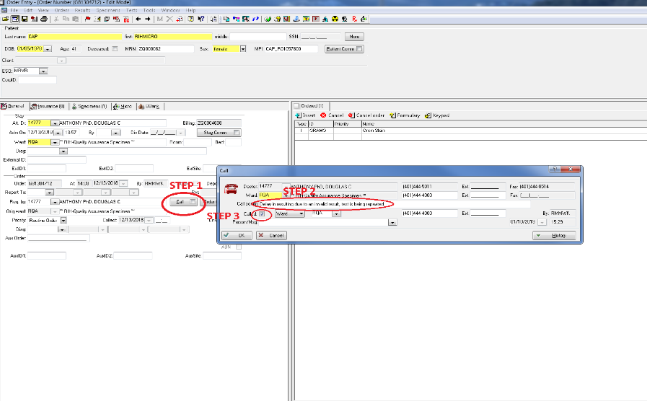

* 1. External Controls – See **Appendix AP53** for a list of expected external controls
  2. Patient Specimen
     1. **DETECTED** – The detected target has generated signal above the defined threshold. Report target as “Detected”.
     2. **NOT DETECTED** – The test was completed successfully and the target did not generate signal above the defined threshold. Report target as “Not Detected”.
     3. **INVALID** – The test did not complete successfully. Results are invalid and test should be repeated. Be sure to notify a nurse or clinician on ED or In-house specimens about the delay in resulting. Record invalid in ePlex QC Binder.
  3. Influenza A result interpretation
     1. If an RPP is positive for Influenza A, and more than one subtype (H1, 2009 H1N1, or H3) is reported as DETECTED, then this could indicate contamination. Thus, the test must be repeated for confirmation.
     2. On guidance on resulting, refer to *Appendix AP60* – Repeating Interfaced ePlex Results

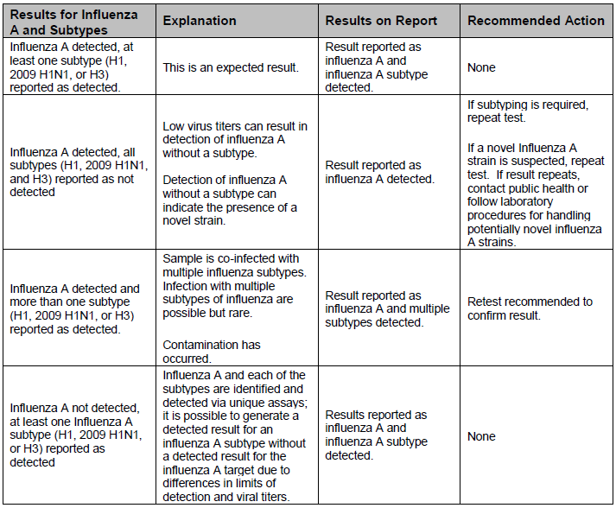

1. **LIMITATIONS OF TEST**
   1. Due to the genetic similarities between human rhinovirus and enterovirus, the ePlex RP Panel cannot reliably differentiate them
   2. **Minimum Sample Volume –** 200uL np swab in viral transport media is required for testing
   3. Improper and/or infrequent decontamination can lead to contamination of ePlex, cartridges, and/or other equipment leading to false positive results
   4. Use of RP Panel kits beyond their expiration date may result in erroneous results
   5. Failure to follow storage and handling requirements in the above **Storage and Handling** section can affect final results
   6. Reuse of any kit component is not allowed and can result in lab contamination and/or incorrect results
   7. Gloves should be changed frequently to avoid contamination between test cartridges
   8. This test was validated using nasopharyngeal swab specimens in 1mL UTM. Any other transport method or specimen type should be approved by the Medical Director before running
   9. Analyte targets may exist *in vivo* independent of their viability. Detection of targets does not imply active infection
   10. Improper collection, transport, storage and/or preparation of samples may lead to incorrect results
   11. There is a risk of false negative values due to the presence of sequence variants for any of the targets in this test
   12. Not Detected results may occur due to presence of inhibitors, technical error, sample mix-up or an infection caused by a target not on this panel
   13. The performance of this test has not been validated for immunocompromised individuals or for patients without signs and symptoms of respiratory infections
2. **NOTES**
   1. Wet cartridges should never be used. Wipe any moisture with a kimwipe before inserting into ePlex
   2. Specimens must be processed in a biosafety hood. Technologist must be wearing protective gear such as sterile gloves and disposable lab coats
   3. A trained healthcare professional should interpret assay results in conjunction with the patient’s medical history, clinical signs and symptoms, and the results of other diagnostic tests.
   4. Reagents within the RPP cartridge may cause irritation to skin, eyes, and respiratory tract and are harmful if swallowed. Do not pierce reagent blisters on the ePlex cartridge
   5. Once the sample is loaded into the ePlex RP Panel cartridge, the sample should be tested within 2 hours
3. **TECHNICAL SUPPORT**

Ph: 1-800-373-6767, option 2

Email: technicalsupport@genmarkdx.com

1. **REFERENCES**
   1. ePlex Respiratory Pathogen Panel Package Insert (RUO) PI1059-A
   2. ePlex Respiratory Pathogen Panel Package Insert (EU) PI1056-C
   3. MMQCI ePlex RP Control M306 Package Insert (M306 12142016.00)
   4. GenMark ePlex Validation (09/14/2017)
   5. A Comparison of Multiplex Respiratory Panels: A Workflow Analysis; Lisa Tingley, Lori Daigneault, Dr. Kimberle Chapin (2017)

**RPP Soft Resulting: Non-interfaced results**

1. Negative for ALL TARGETS
   * 1. Go to Result Entry, enter Order Number where appropriate
     2. Select **Not Detected** at the RVPR line
        1. This should auto-populate a **Not Detected** result for all targets and any appropriate comments
     3. If the specimen is a bronch wash or BAL the source must be changed from NP swab at the RPPNS line
        1. Choose **Bronchial** from the keypad
        2. The comment to reflect this source will auto-populate
     4. Click **Verify All**
     5. Print Instant Report and compare it to the printed report from ePlex
     6. Staple the instant report to the instrument’s printout and place in the folder for specialist review
2. Resulting with positives
   * 1. Go to Result Entry, enter Order Number where appropriate
     2. Select **Enter Result** at the RVPR line
     3. If the specimen is a bronch wash or BAL the source must be changed from NP swab at the RPPNS line
        1. Choose **Bronchial** from the keypad
        2. The comment to reflect this source will auto-populate
     4. One by one enter the result mirroring to the printout from the ePlex
        1. When entering a positive Flu A, remember Flu A and its subtypes are entered in 2 places in **Result Entry**
     5. *Whenever possible have another tech check the results on the computer screen before verifying.*
     6. Click **Verify All**
     7. Print Instant Report and compare it to the printed report from ePlex
     8. Staple the instant report to the instrument’s printout and place in the folder for specialist review
3. Resulting Invalids
   * 1. Go to Result Entry, enter Order Number where appropriate
     2. Select **Invalid** at the RVPR line
        1. This should auto-populate an **Invalid** result for all targets and any appropriate comments
     3. If the specimen is a Bronch Wash or BAL the source must be changed from NP swab at the RPPNS line
        1. Choose **Bronchial** from the keypad
        2. The comment to reflect this source will auto-populate
     4. Click **Verify All**
     5. Print Instant Report and compare it to the printed report from ePlex
     6. Staple the instant report to the instrument’s printout and place in the folder for specialist review

**RPP Soft Resulting: Interfaced results**

1. **Negative Results** 
   1. Negative results uploaded from the ePlex to Soft will post to patient order number and autoverify automatically. Check the posted result to ensure that the interface worked.
2. **Positive Results**
   1. From SoftLab, go to “Interfaces”, and select “Instrument Menu”
   2. RIH: Select “RPLEX - GenMark eplex” from Instrument Menu
      * TMH: Select “MPLEX - GenMark eplex” from Instrument Menu
   3. Select “Loadlist and Today’s Results”, “Not Posted”, “By Sequence”
   4. Each order will be highlighted individually. Verify the result against the instrument printout.
   5. To Add Result Comments, i.e. Phone reports:
      * Highlight the Order number on Left of Screen
      * At bottom of screen click on *Lab Results* tab
      * Open “Comment” box and add comment/phone report using canned comment @CALM.
      * Click Back to *Instrument* Tab and Save when asked
      * Click **Post All** to verify the report
      * Order number should disappear from list on Left
   6. Check Pending Log again to confirm that all results have been verified:
      * Go to “Resulting Worklist”
      * Sort by Test: RPP
      * Status: Pending and Non-Verified
      * OK
      * Check for pending specimens and unresolved issues
3. **Resulting RPP for Director approved Bronch specimens**
   1. Prior to running specimen, open Result Entry in Softlab and replace NP swab in RPPNS field with Bronch@SRCB located in the keypad. Hit **save** and proceed to run specimen.
   2. Results from instrument should cross over automatically. Follow standard protocol with resulting.

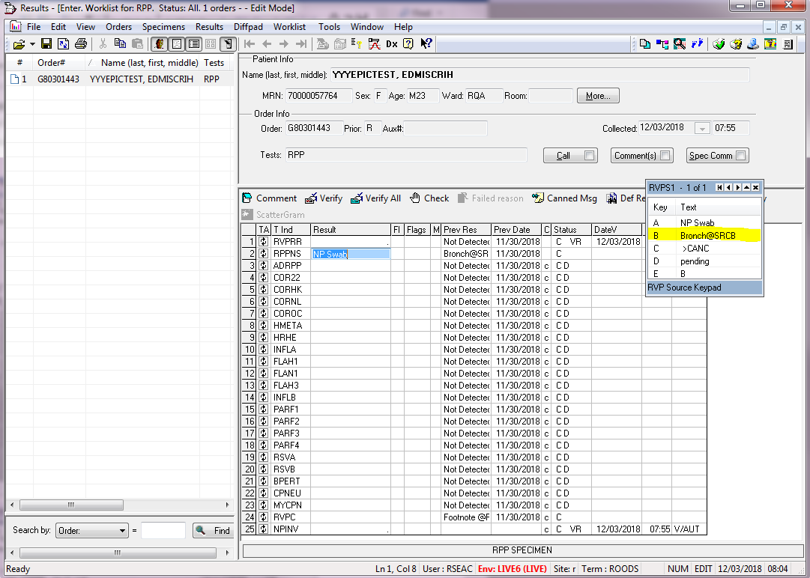 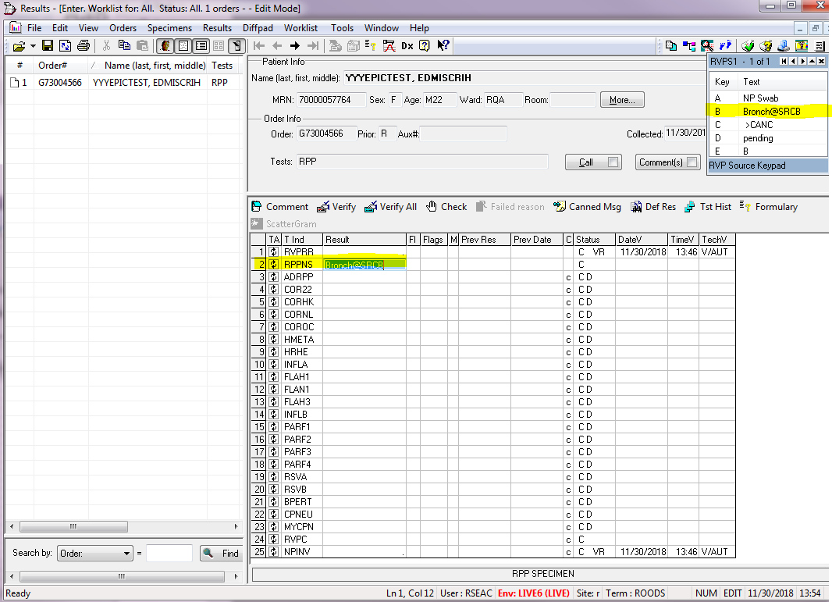

**RPP PANEL: SOFT CODES**

|  |  |
| --- | --- |
| **RVPR** | Select “Not Detected”, “Invalid”, or “Enter Result” |
| **ADRVP** | Adenovirus |
| **COR22** | Coronavirus 229E |
| **CORHK** | Coronavirus HKU1 |
| **CORNL** | Coronavirus NL63 |
| **COROC** | Coronavirus OC43 |
| **HMETA** | Human Metapneumovirus |
| **HRHE** | Human Rhinovirus/Enterovirus |
| **INFLA** | Influenza A |
| **FLAH1** | Influenza A H1 |
| **FLAN1** | Influenza A 2009 H1N1 |
| **FLAH3** | Influenza A H3 |
| **INFLB** | Influenza B |
| **PARF1** | Parainfluenza 1 |
| **PARF2** | Parainfluenza 2 |
| **PARF3** | Parainfluenza 3 |
| **PARF4** | Parainfluenza 4 |
| **RSVA** | Respiratory Syncytial Virus A |
| **RSVB** | Respiratory Syncytial Virus B |
| **BPERT** | *Bordetella pertussis* |
| **CPNEU** | *Chlamydia pneumoniae* |
| **MYCPN** | *Mycoplasma pneumoniae* |
| **RVPC** | Footnote will auto-populate |
| **NPINV** | Invalid footnote |

**RP PANEL: Expected External Control results**

|  |  |  |  |  |  |
| --- | --- | --- | --- | --- | --- |
| **ePlex RP Control M306** | | | | | |
|
| Control Name | Positive A | Positive B | Positive C | Positive D | Negative |
| Adenovirus | ***Detected*** | ***Detected*** | ***Detected*** | Not Detected | Not Detected |
| Coronavirus 229E | Not Detected | Not Detected | ***Detected*** | Not Detected | Not Detected |
| Coronavirus HKU1 | Not Detected | ***Detected*** | Not Detected | Not Detected | Not Detected |
| Coronavirus NL63 | ***Detected*** | Not Detected | Not Detected | Not Detected | Not Detected |
| Coronavirus OC43 | Not Detected | Not Detected | Not Detected | ***Detected*** | Not Detected |
| Human Metapneumovirus | Not Detected | ***Detected*** | Not Detected | Not Detected | Not Detected |
| Human Rhinovirus/Enterovirus | Not Detected | Not Detected | Not Detected | ***Detected*** | Not Detected |
| Influenza A | ***Detected*** | ***Detected*** | ***Detected*** | Not Detected | Not Detected |
| Influenza A H1 | Not Detected | Not Detected | ***Detected*** | Not Detected | Not Detected |
| Influenza A 2009 H1N1 | Not Detected | ***Detected*** | Not Detected | Not Detected | Not Detected |
| Influenza A H3 | ***Detected*** | Not Detected | Not Detected | Not Detected | Not Detected |
| Influenza B | Not Detected | Not Detected | Not Detected | ***Detected*** | Not Detected |
| Parainfluenza Virus 1 | Not Detected | Not Detected | ***Detected*** | Not Detected | Not Detected |
| Parainfluenza Virus 2 | Not Detected | ***Detected*** | Not Detected | Not Detected | Not Detected |
| Parainfluenza Virus 3 | Not Detected | Not Detected | ***Detected*** | Not Detected | Not Detected |
| Parainfluenza Virus 4 | ***Detected*** | Not Detected | Not Detected | Not Detected | Not Detected |
| Respiratory Syncytial Virus A | ***Detected*** | Not Detected | Not Detected | Not Detected | Not Detected |
| Respiratory Syncytial Virus B | Not Detected | ***Detected*** | Not Detected | Not Detected | Not Detected |
| *Bordatella Pertussis* | Not Detected | Not Detected | ***Detected*** | Not Detected | Not Detected |
| *Chlamydia pneumoniae* | ***Detected*** | Not Detected | Not Detected | Not Detected | Not Detected |
| *Mycoplasma pneumoniae* | Not Detected | Not Detected | Not Detected | ***Detected*** | Not Detected |

1. The ePlex instrument is connected by an interface which allows results to cross over into an Instrument Menu. This limits the need for technologist intervention in posting results, except for detected results.
2. If there is a need in repeating a questionable DETECTED result on the EPLEX, follow the steps below to remove initial interfaced result:
   * 1. Open Instrument Menu. The Order should be populated on the list to the left
     2. Highlight the appropriate Order
     3. At the top of the window, select Orders
     4. Then select Cancel Order
     5. Hit Save
     6. The Order should disappear from the list
3. If this is done correctly, there will only be a single result per order number on the Instrument Menu. This process prevents a corrective report.