**Sending Results to LIS (Cepheid Interface)**

Results on the Cepheid GeneXpert will auto-upload from the instrument and cross into the Instrument Menu in Soft. This will not only include Positive and Negative results, but also Errors, Invalids and No Results. The technologist is required to cancel all Errors, Invalids and No Results on each hospital’s respective Instrument Menu. Refer to “How to Cancel a Test from Instrument Menu”.

When a test is complete, the status of the test should change from *Upload-Pending* to *Uploaded* on the GeneXpert.

1. Negative Results
   1. Negative results will upload from the instrument and auto-verify into the patient’s order number in Soft.
2. Positive Results
   1. Positives do not auto-verify, and thus requires intervention when resulting.
   2. In SoftLab, go to *Interfaces* then *Instrument Menu.*
   3. Select the intended instrument menu. (GENEX, NGENE, MGENE)

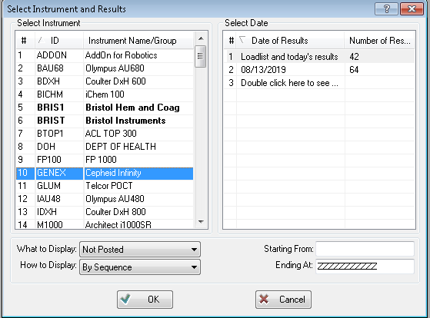

* 1. Select *Loadlist* and Today’s Results, *Not Posted,* *By Sequence.*
  2. Each order will be highlighted individually. Verify the result against the GeneXpert printout. **For any result that is being repeated do not post result.**
  3. For results that require a phone call per Critical Call Policy, follow these steps:
     1. Highlight the Order number.

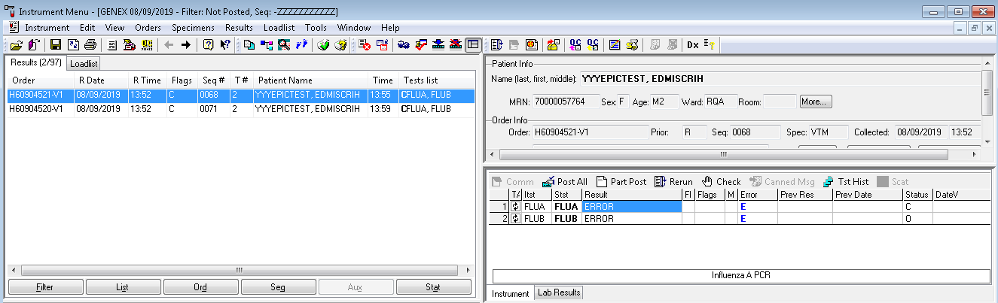

* + 1. Select *Lab Results* at the bottom.

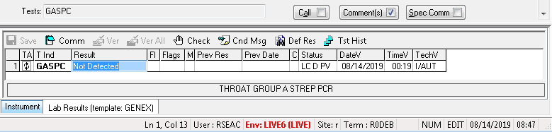

* + 1. Open *Comment* box at the top and record the phone report. Hit ok, then hit yes to save.

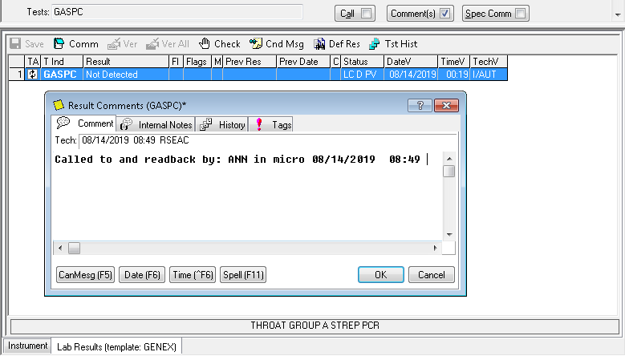

* + 1. Return to the *Instrument* tab and select *Post All* at the top.

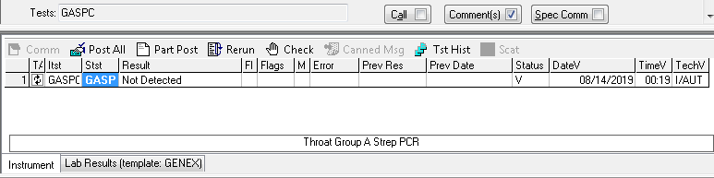

* 1. If a Positive result does not require a call or comment, proceed to select *Post All*.

1. Verify that results have been uploaded into each test order. Confirm this by going to *Lab Results Query* in Softlab.
   1. Type or scan in the accession number into the order field.

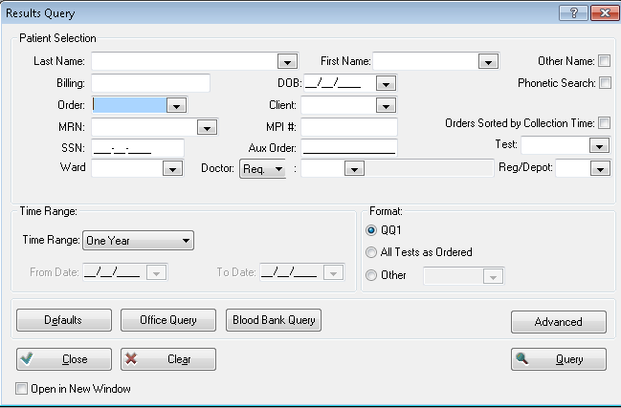

* 1. Verify that the report to the right has the expected result.

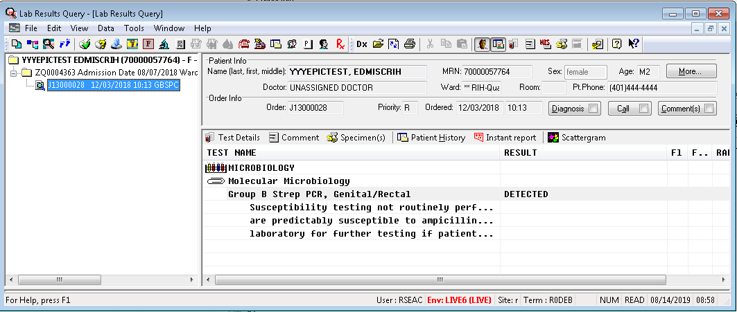

1. How to Cancel/Remove a Test from Instrument Menu
   1. If re-testing is required due to an ERROR, INVALID or NO RESULT then that result must be removed from the instrument menu to avoid potential posting into the test order. This can be done with the following steps:
      1. Select the intended instrument menu. (GENEX, NGENE, MGENE)



* + 1. Highlight the intended order to remove.



* + 1. At the top, select *Results* then select *Cancel*. Alternatively, you may hit F4 to cancel.
       1. If a test has more than one result (ex. FLUA, FLUB & RSVP) cancel each field or line. There will be a **C** (highlighted) in front of each result to confirm a cancellation.

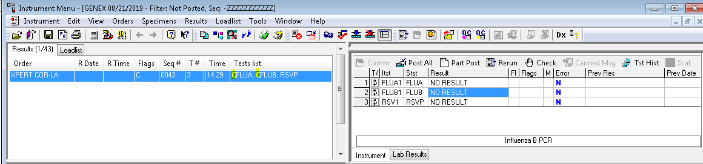

* + 1. Select SAVE.
    2. Select YES for changes to be made.

**Interface Troubleshooting Tips**

1. If results do not upload to Soft, please verify the following circumstances on the GeneXpert:
2. Make sure correct accession number was scanned with correct extension (ex. X2).
3. Review that Upload screen and be sure order numbers UPLOAD, if so then attempt to upload again by checking off the test and hitting UPLOAD.
4. If *Upload-Pending* does not change to *Uploaded*, then the Interface may need to be restarted.
5. To restart Cepheid Interface:
6. MAKE SURE THERE ARE NO TESTS RUNNING!!!
7. Shut down the Cepheid Software.
8. Restart the Cepheid Software – this restarts and launches the interface.

**Resulting a test (without Cepheid Interface)**

1. Under SoftLab, Click on *Result Entry.*
2. Go to *Select test by* and pick *Test* from the drop-down menu.
3. Under *Test* type in the test code.
4. Under *Order Number* type in the order number you need to result.
5. Select the result from the keypad. Verify the result against the instrument printout.
   1. If a sample tests Invalid, Error, and No Result after the second attempt or if it is QNS for the retest result as INDETERMINATE and call floor/ER documenting it in the comment box.
6. Positives that require a phone call per Critical Policy Procedure must be recorded into the comment box.
7. VERIFY then SAVE.
8. If you verify the result and go back in at a later time to add the comment you MUST verify the result line and save again or the test will change to a pending status.