**PROCEDURE: XPERT MTB PCR ASSAY**

1. **PRINCIPLE**
   1. *Mycobacterium tuberculosis* polymerase chain reaction (MTB-PCR) is performed using the Xpert® MTB/RIF Assay, which is a qualitative in vitro diagnostic test for the detection of *Mycobacterium tuberculosis* complex DNA. This test is intended for use with respiratory specimens from patients suspected of tuberculosis, and who have had less than 3 days of anti-TB therapy. A risk assessment is performed on the patient before performing the assay. In specimens where MTB complex is detected, the assay detects mutations associated with rifampin resistance in the *rpoB* gene. Used in combination with routine mycobacterial culture and smear, rapid detection of MTB complex can be determined within two hours.
2. **AVAILABILITY**
   1. This assay is available 7 days a week on first and second shift.
   2. The test is orderable as a laboratory order only.
   3. The physician will be contacted to complete a risk assessment before the assay is performed.
   4. The MTBPCR will not be repeated on a patient who is previously positive for TB without director approval.
3. **TEST CODE**
   1. The Test Code is MTBPC.
   2. A routine CXAFB must be ordered at the same time when MTBPC is requested.
   3. Refer to *Appendix AP1* – *Microbiology Order Entry* for additional ordering instructions.
4. **SPECIMEN**
   1. Expectorated or induced sputum (2-4mL of direct sputum are required for testing. At least 1 mL for the TBPCR plus some volume for the AFB culture.)
   2. Concentrated sediment on expectorated or induced sputum
   3. Bronchial specimens – Bronchial wash, BAL or Bronchial brush (performance has been validated by this laboratory)
   4. Concentrated sediment on bronchial specimens (performance has been validated by this laboratory)
   5. Maximum of two MTB-PCR tests per inpatient encounter. Eight hours between sputum specimens collected. At least one test should be performed on direct specimen.
   6. Maximum of one MTBPCR test per outpatient
5. **MATERIALS AND EQUIPMENT**
   1. MATERIALS

GeneXpert MTB/RIF Assay kit contains the following:

* + - * 1. Xpert MTB/RIF Cartridges with Integrated Reaction Tubes

Bead 1 (freeze-dried) 2 of each per cartridge

Polymerase

dNTPs (deoxynucleoside triphosphates)

Probe

BSA (Bovine serium albumin)

Bead 2 (freeze-dried) 2 of each per cartridge

Primers

Probes

BSA (Bovine serum albumin)

Bead 3 (freeze-dried) 1 per cartridge

Sample Processing Control (SPC) ~6,000 non-infectious *B.globigii* spores

Reagent 1 4 mL per cartridge

Tris Buffer

Surfactants

EDTA (ethylenediaminetetraacetic acid)

Reagent 2 4 mL per cartridge

Tris Buffer

Surfactants

EDTA (ethylenediaminetetraacetic acid)

* + - * 1. Cepheid Xpert Sample Reagent 8 mL per bottle

Sodium hydroxide

Isopropanol

* + - * 1. Materials to properly clean the hood at the beginning of each shift, between testing or any time it is needed. To be used in this order:

10% bleach

DI H2O

70% Ethanol

* 1. EQUIPMENT
     1. GeneXpert Instrument System
     2. 2D barcode scanner
     3. Sterile transfer pipette
     4. Sterile container
     5. Vortex

1. **STORAGE AND HANDLING**
   1. Store the Xpert MTB/RIF Assay Cartridges and reagents at 2-28°C.
   2. Do not use reagents or cartridges that have passed the expiration date.
   3. The cartridge is stable up to 6 weeks at 2-45°C after opening the pouch.
   4. Do not open a cartridge until ready to test.
   5. Start the test within four hours of adding the Sample Reagent-treated sample to the cartridge.
   6. Preparation of digested, decontaminated, and concentrated sputum sediments, and Xpert MTB/RIF procedures should be done using Biosafety Level 2 practices.
   7. Use only for the detection of members of *M.tuberculosis* complex using sediments prepared following the NALC-NaOH or NaOH procedures recommended by the Centers for Disease Control and Prevention(CDC). This test may only be used with sputum specimens or bronchial specimens.
   8. When processing more than one sample at a time, open only one cartridge; add the Sample Reagent-treated sample and close the cartridge before processing the next sample. Change gloves in between samples.
   9. Do not open the Xpert MTB/RIF Assay cartridge lid except when adding the Sample Reagent-treated sample.
   10. Do not use a cartridge if it appears wet or if the lid seal appears to have been broken.
   11. Do not use a cartridge that has been broken or shaken.
   12. Do not use a cartridge that has a damaged reaction tube.
   13. Do not use reagents that are cloudy or discolored. Sample reagent can be colorless or yellow to amber.
   14. Do no reuse spent cartridges.
2. **QUALITY CONTROL**
   1. Maintenance
      1. Cleaning and maintenance of the instrument will be performed in accordance with the vendors Operator’s Manual. For further information, refer to the Infinity System’s Operator’s Manual.
   2. Each test includes a Sample Processing Control (SPC) and Probe Check Control (PCC).
      1. Sample Processing Control (SPC) – Ensures the sample was correctly processed. The SPC contains non-infectious spores in the form of a dry spore cake that is included in each cartridge to verify adequate processing of MTB. The SPC verifies the conditions for lysis of MTB have occurred if the organisms are present and verifies that the specimen processing is adequate. Additionally, this control detects specimen-associated inhibition of the real-time PCR reactions and acts as an internal positive control. The SPC should be positive in a MTB-negative sample and can be negative or positive in a positive sample. The SPC passes if it meets the validated acceptance criteria. The test result will be Invalid if the SPC is not detected in an MTB-negative sample.
      2. Probe Check Control (PCC, QC1, QC2) – Before the start of the first and second reactions of the nested PCR assay, the GeneXpert Instrument System measures the fluorescence signal from the QC1 and QC2 probes (reaction 1) and the rpoB and SPC probes (reaction 2) to monitor bead rehydration, reaction-tube filling, probe integrity and dye stability. The PCC passes if it meets the assigned acceptance criteria.
      3. External Controls –external controls run each lot/shipment and/or every 30 days (whichever if more frequent).
         1. Main Molecular Quality Controls, Inc. (MMQCI) INTROL Extern Run Control (catalog # TBNEG-04) as a negative control
         2. MMQCI INTROL External Run controls (catalog # TBWT-04) as a RIF susceptible positive control
         3. MMQCI INTROL External Run controls (catalog # TBMDR1-04) as RIF resistant positive control
3. **PROCEDURE ( DIRECT (RAW) SPECIMEN):**
   1. Before processing the specimen, check to see if there is adequate specimen volume to perform the test. 1-4mL is required for the MTBPCR test.) Set up the Molecular hood in the back room labeled for MTBPCR processing. Bring all supplies that are required to process the specimen to avoid having to enter and leave the hood during processing (sample reagent, pipets, sterile container, labels, lophene).
   2. NOTE: Since we are working with a specimen with high suspicion of MTB, we will follow the same biosafety hood rules as the AFB laboratory when processing the specimens. Anything removed from the hood (including gloved hands) must be wiped down with lophene first.
      1. **Pre-analytical**
         1. **Clean designated molecular hood by spraying with 10% bleach; rinse with deionized water; clean with 70% ethanol. This cleaning procedure must be performed before and after each specimen.**
         2. **If multiple tests are ordered, split for molecular testing BEFORE it is processed for routine testing.**
      2. Put on clean, powderless gloves.
      3. Vortex specimen, thoroughly.
      4. Split approximately equal amounts of specimen for routine CXAFB and MTB/RIF Assay to sterile containers.
      5. A minimum of 1mL (4mL maximum) of specimen is needed for the MTB PCR assay. If specimen is QNS, refer to Section IX, and use concentrated method. The physician must be notified of the delay of MTB PCR result. The physician may opt to send a new specimen for direct processing at this time.
      6. Process only one sample at a time in the biosafety hood.
      7. Add approximately 2 times the volume of the Sample Reagent into the sputum 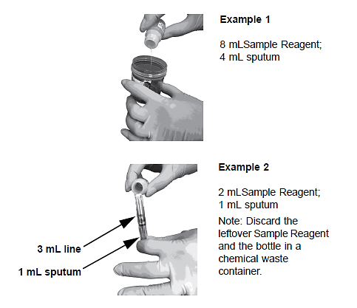
      8. Replace and secure lid on sample tube.
      9. Vortex for 10 seconds.
      10. Wipe gloved hands and any materials with lophene before removing from hood.
      11. Incubate for 15 minutes at room temperature (20-30°C).
      12. Discard remaining Sample Reagent in waste container located in the hood. Use only one sample reagent per specimen.
      13. Halfway through the incubation, vortex specimen for 10 seconds.
      14. Label the Xpert cartridge with reprinted specimen label.
      15. Open the cartridge lid and then open the sample container.
      16. Using the provided sample pipette, aspirate the liquefied sample close to the line on the pipette. Do not proceed with testing if there is insufficient volume.

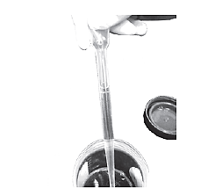

* + 1. Dispense the sample slowly to minimize the risk of aerosol formation. Transfer the Sample reagent-treated sample into the sample chamber of the Xpert cartridge.
       1. Save any leftover Sample Reagent-treated sample and label as “Sample Reagent-treated” and place in AFB refrigerator. Sample may be discarded once results are uploaded.

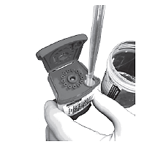

* + 1. Close lid firmly.
    2. Change gloves.
    3. Wipe everything coming out of the biosafety cabinet with Lophene.
    4. Transfer cartridge to the GeneXpert System.
    5. Scan cartridge, enter sample ID and start the run.
    6. Take specimen for CXAFB out of the hood and place in AFB bucket in fridge.
    7. Return to the hood and clean with bleach, DI water and then 70% ethanol.
    8. Change gloves.
    9. You may begin to process the next sample.
    10. Clean with bleach, DI water and 70% ethanol between each sample.
    11. Refer to **Section X – Starting Test**.
    12. When testing is complete, verify the results and place the printed result in the binder located in AFB lab.
    13. Discard trash from in the hood appropriately.

1. **PROCEDURE (Concentrated Sediment Specimens):**
   1. Before processing the specimen, check to see if there is adequate specimen volume to perform the test. 0.5mL of concentrated specimen is required to perform the MTBPCR test.) Set up the Molecular hood in the back room labeled for MTBPCR processing. Bring all supplies that are required to process the specimen to avoid having to enter and leave the hood during processing (sample reagent, pipets, sterile container, labels, lophene).
   2. NOTE: Since we are working with a specimen with high suspicion of MTB, we will follow the same biosafety hood rules as the AFB laboratory when processing the specimens. Anything removed from the hood (including gloved hands) must be wiped down with lophene first.
      1. Put on clean, powderless gloves.
      2. Clean hood with bleach followed by DI water and then 70% ethanol.
      3. Put on clean, powderless gloves.
      4. Refer to AFB processing and concentration procedure for CXAFB.
      5. Resuspended sediments can be stored at 2-8°C for up to seven days
      6. A minimum of 0.5mL is needed for one test.
      7. If sediment is QNS,add no more than 1ml of resuspension buffer(used in the sedimentation procedure ) to the sample and vortex for 10 seconds.
      8. Transfer at least 0.5mL of the total resuspended sediment to a sterile container using a transfer pipette.
      9. Using a transfer pipette, transfer 1.5mL of Sample Reagent to 0.5mL of resuspended sediment. If the volume is larger, add Sample Reagent equal to 3 times the volume of resuspended sediment. Replace and secure lid on specimen container.
      10. Discard any unused sample reagent buffer in the trash located in the hood.
      11. Vortex for 10 seconds.
      12. Wipe gloved hands and any materials with lophene before removing from hood.
      13. Incubate for 15 minutes at room temperature (20-30°C).
      14. Discard remaining Sample reagent in waste container. Use only one Sample reagent per specimen.
      15. Halfway through the incubation, vortex specimen for 10 seconds.
      16. Label the Xpert cartridge.
      17. Open the cartridge lid and then open the sample container.
      18. Using the provided sample pipette, aspirate the liquefied sample close to the line on the pipette. Do not proceed with testing if there is insufficient volume.
      19. Dispense the sample slowly to minimize the risk of aerosol formation.
      20. Transfer the Sample reagent-treated sample into the sample chamber of the Xpert cartridge.
      21. Save any leftover Sample Reagent-treated sample and refrigerate in AFB refrigerator
      22. Close lid firmly.
      23. Change gloves.
      24. Wipe everything coming out of the biosafety cabinet with Lophene.
      25. Transfer cartridge to the GeneXpert System.
      26. Scan cartridge, enter sample ID and start the run.
      27. Return to the hood and clean with bleach, DI water and then 70% ethanol.
      28. Put on clean, powderless gloves.
      29. You may begin to process the next sample.
      30. When testing is complete, verify the results and place the printed result in the binder.
      31. Discard trash from in the hood appropriately.
2. **STARTING THE TEST**
   1. The GeneXpert computer should be running. Go to the upper right and log into Windows using your user name and password.
   2. Click on the ***Order*** icon on the right hand side of home screen.
   3. Click on ***Order test***.
   4. Scan the appropriate Soft label under ***Patient id***. Scan the same label for the ***Sample id*** prompt. Scan the cartridge label.
   5. Click ***Submit***.
   6. Instrument will prompt you to load cartridge onto the belt.
   7. Click on ***End order test.***
   8. ***Logout***.
   9. Test will be completed in 2 hours.
3. **TEST INTERPRETATION –** 
   1. **MTB DETECTED; Rif Resistance DETECTED** – The MTB target is detected within the sample. **Do not report Rif Resistance.**
      * 1. A mutation in the rpoB gene has been detected.
        2. SPC: NA (not applicable). An SPC signal is not required because MTB amplification can compete with this control.
        3. Probe Check (QC1 and QC2): PASS. All probe check results pass.

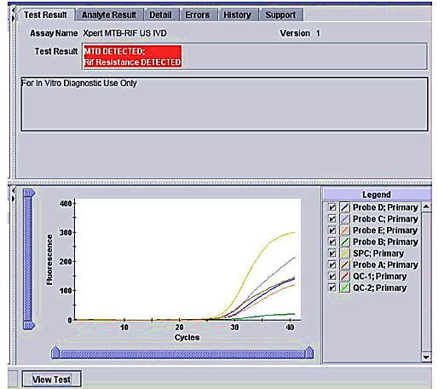

Example of MTB DETECTED; Rif Resistance DETECTED Result

* 1. **MTB DETECTED; Rif Resistance NOT DETECTED** – The MTB target is detected within the sample. **Do not report Rif Resistance.**
     1. A mutation has not been detected.
     2. SPC: NA (not applicable). An SPC signal is not required because MTB amplification can compete with this control.
     3. Probe Check (QC1 and QC2: PASS. All probe check results pass.

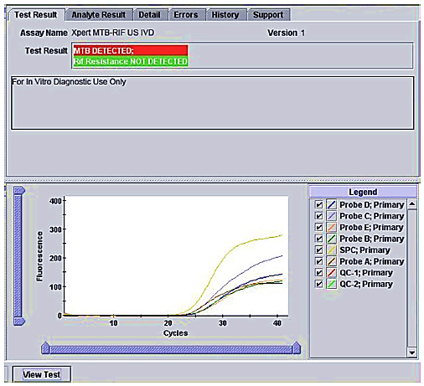

Example of a MTB DETECTED; Rif Resistance NOT DETECTED Result

* 1. **MTB DETECTED; Rif Resistance INDETERMINATE** – The MTB target is detected within the sample. Do not report Rif Resistance.
     1. A mutation in the rpoB gene could not be determined due to insufficient signal detection.
     2. SPC: NA (not applicable). An SPC signal is not required because MTB amplification can compete with this control.
     3. Probe check (QC1 and QC2): PASS. All probe check results pass.

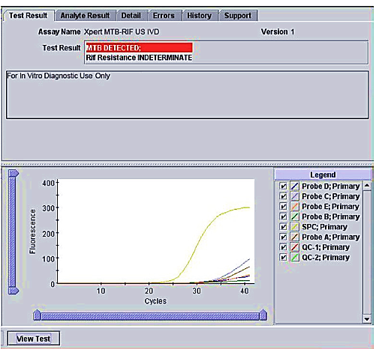

Example of a MTB DETECTED; Rif Resistance INDETERMINATE Result

* 1. **MTB Not Detected** – The MTB target is not detected within the sample.
     1. SPC: PASS. The SPC met the acceptance criteria.
     2. Probe check (QC1 and QC2): PASS. All probe check results pass.

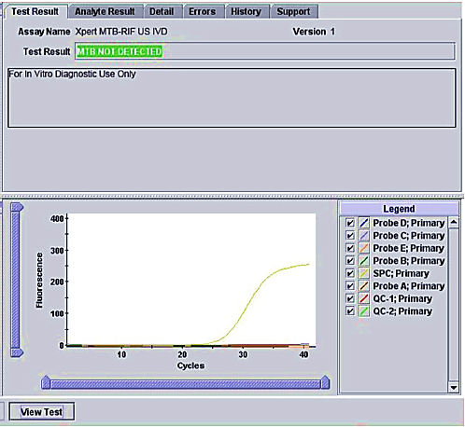

Example of a MTB NOT DETECTED Result

* 1. **INVALID** – The presence or absence of MTB cannot be determined. The SPC does not meet the acceptance criteria, the sample was not properly processed, or PCR was inhibited. **DO NOT REPEAT TEST .**
     1. MTB INVALID: the presence or absence of MTB DNA cannot be determined.
     2. SPC: FAIL. The MTB target result is negative, and the SPC Ct is not within the valid range.
     3. Probe Check (QC1 and QC2): PASS. All probe check results pass.

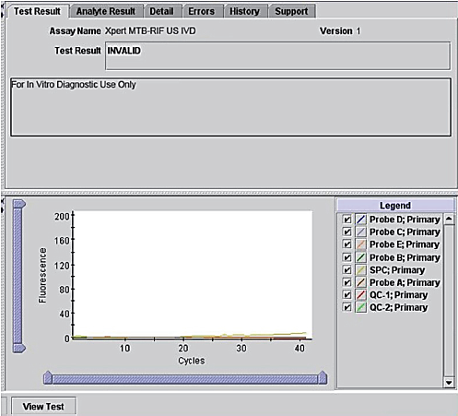

Example of an INVALID Result

* 1. **ERROR** – The presence or absence of MTB cannot be determined. Repeat the test. See section XIII.b, Retest Procedure.
     1. MTB: NO RESULT
     2. SPC: NO RESULT
     3. Probe Check (QC1 and QC2): PASS/FAIL. Probe check failure can be the source of error but other errors, such as system component failure, can occur even if probe check passes.
  2. **NO RESULT** – The presence or absence of MTB cannot be determined. Repeat the test. See Section Section XIII.b, Retest Procedure. A NO RESULT indicates that insufficient data were collected. For example, the operator stopped a test that was in progress.
     1. MTB: NO RESULT
     2. SPC: NO RESULT
     3. Probe Check (QC1 and QC2): NA (not applicable).

1. **REPORTING RESULTS-** For additional resulting instructions refer to *Appendix AP64 – Soft Instructions for Cepheid GeneXpert* 
   1. Report positive patients as: **“MYCOBACTERIUM TUBERCULOSIS COMPLEX DETECTED.”**
2. Refer to Critical Call policy for positive results. Use @CALM comment.
3. RIF Resistance is only reported to Infectious Disease upon Director Review. No Rifampin result should be released without first speaking to the laboratory medical director.
4. If Rifampin resistance is detected, notify Dr. Chapin and Dr. Bobenchik immediately by email. A phone call should be made during the next day shift in order to discuss this result.
   1. Report negative patients as: **“Mycobacterium tuberculosis complex NOT detected.”** If itis unknown whether a second PCR has been requested, call the physician listed on the risk assessment form to find out if they will be sending a second specimen. If the answer is yes, we will wait 24h to receive it. If the first PCR was not done on raw specimen indicate that we will need at least 2mls of specimen to perform the second one directly. It is an Infection Control policy requiring at least one TBPCR to be run on direct specimen. If it does not arrive in 24h, recall the physician to let them know the specimen never arrived.This should be documented in the negative MTBPCR log located inMycobacteriolgy**. Bring up on rounds any instance where we are unable to perform at least one PCR on direct specimen.**
   2. If testing is performed on a bronchial washing or lavage,free text the comment **Testing performed on a (source).**and then add ***The performance characteristics of this test were determined and validated by the Clinical Microbiology Laboratory at Lifespan Academic Medical Center. @rvpc***
   3. Report patients with **invalid** and **indeterminate** results as: **“Unable to analyze due to sampling issues caused by specimen integrity. Please resubmit if clinically warranted.”**
5. A patient’s sample is considered “Indeterminate” when the curve associated with that sample fails to cross the cycle threshold and the specimen’s internal control fails.
6. **REASONS TO REPEAT THE TEST**
   1. Repeat the test only once using new a cartridge if one of the following test results occurs:
7. An **ERROR** result indicates that the PCC (QC1 or QC2) failed or a system failure occurred, and the assay was aborted. The causes of the errors are possibly due to the reaction tube being filled improperly, a reagent probe integrity problem was detected, the maximum pressure limits were exceeded, or a GeneXpert module failed.
8. A **NO RESULT** indicates that indicates that insufficient data were collected. For example, the operator stopped a test that was in progress.
   1. **RETEST PROCEDURE**
9. If there is sufficient leftover Sample Reagent- treated sample within the four-hour window of sample preparation, the sample can be used to prepare and process a new cartridge immediately on the GeneXpert instrument.
10. **LIMITATIONS**
    1. The performance of the Xpert MTB/RIF assay was evaluated by the factory for the use with induced or expectorated sputa only. Bronchial specimen types have been validated in this laboratory. No other sample types are acceptable for testing.
    2. The performance of the assay during the FDA trial was not evaluated for pediatric patients. Pediatric patients will be performed by this laboratory. The results of the pediatric samples will be monitored, recorded and added to the data compiled for the verification.
    3. A positive test does not necessarily indicate viable organism present in the sample.
    4. A single negative result does not exclude the possibility of isolating MTB-complex from the sputum sample. The assay must be used in conjunction with mycobacterial culture to address the risk of false negative results and to recover organisms for further identification and susceptibility testing.
    5. Due to the low prevalence of rifampin resistant TB in the United States, rifampin resistance must be confirmed by a reference laboratory.
    6. This test is not indicated for use with samples from patients on anti-TB therapy for more than 3 days.
    7. This test is not to be used to monitor therapy.
    8. Test does not differentiate between species of MTB Complex (*M. tuberculosis, M. bovis, M. africanum, M. canettii, M. microti, M. caprae, M. pinnipedi, M. mungi* and *M. orygis*).
    9. The organism *M.scrofulaceum* may produce false positive results.
    10. Detection of MTB-complex is dependent on the number of organisms present in the sample. Accurate results are dependent on Proper collection, handling and storage.
11. **TECHNICAL SUPPORT**
    1. For Technical Support contact:

Cepheid Technical Support at 888-838-3222 or [techsupport@cepheid.com](mailto:techsupport@cepheid.com)

* 1. Restarting the System:
  2. Refer to Operator’s Manual.

1. **REFERENCES**

### Della-Latta, P. “Mycobacteriology and Antimycobacterial Susceptibility Testing”. In Clinical Microbiology Procedures Handbook, 3rd Edition. Vol 2. Editor: Garcia, L. 2007, pp. 7.0.1 – 7..8.8.3.

* 1. Pfyffer, G., “Mycobacterium: General Characteristics, Laboratory Detection, and Staining Procedures.” In: Manual of Clinical Microbiology, 11th Edition. Editors: Jorgensen, J., 2015, pp. 536-539.
  2. Cepheid Xpert MTB/RIF Package Insert Rev. H, February 2015

1. **ATTACHMENTS**
   1. Appendix 1 – Microbiology Order Entry
   2. Appendix AP31 – SOFT Instructions for Cepheid Xpert MTBPCR Tests
   3. Appendix AP64 – SOFT Instructions for Cepheid GeneXpert
2. **REVISIONS**
   1. December 30, 2019
      1. Updated attachments for ordering instructions
      2. Updated specimen testing requirements to include direct specimen testing frequency and resulting guidelines to include bronch wash comments
3. **Print Pending Log**
   1. **Under SoftLab**, Click on “Resulting Worklist”
   2. Go to “Select test by” and pick “Tests” from the drop down menu.
   3. Under “Tests”, type “MTBPC”.
   4. DO NOT use default date go back at least 2 weeks.
   5. Leave “Status” as “Pend + Nonver”
   6. Uncheck the “Received only” box
   7. Click “OK”. Any pending MTBPC orders will appear on the left hand side of the screen.
   8. To print the pending worklist, click the printer icon and scroll to “Worklist”.
   9. Click “OK”.
   10. All pending MTBPC orders whether or not they have been collected or received should be accounted for during the shift.
   11. File a copy of the pending worklist in the appropriate location.
4. **To Add Specimen Type Comments**
   1. Go to Soft Lab.
   2. Go to ***Result entry***
   3. Select test.
   4. Enter test code (MTBPC) and order number.
   5. Click on ***Comment box.***
   6. Click on ***Canned messages*** box.
   7. Select appropriate canned comment:
   8. ***Testing performed on concentrated specimen. @conc***

**or**

* 1. ***Testing performed on direct specimen. @dir***
  2. ***If testing is performed on a bronchial washing or lavage, free text the comment “Testing performed on a [source].” And “The performance characteristics of this test were determined and validated by the Clinical Microbiology Laboratory at Lifespan Academic Medical Center. @rvpc***
  3. Click ***ok***.
  4. Click ***verify.***
  5. Check instant report once results have been uploaded