**PROCEDURE: CORRECTED AND SUPPLEMENTAL REPORTS**

1. **OVERVIEW**

Supplemental and/or corrected final reports on any patient record must be indicated as such. Original final reports must never be deleted regardless of how minute the addition and/or correction is to the report. Additions to final patient reports should ultimately generate a supplemental report. Edits to incorrectly reported information should ultimately generate a corrected report.

There are four areas in a patient report that may be altered to trigger either a supplemental or corrected report. These areas include edits to test comments, isolate comments, isolate identifications, and/or drug alterations. The following procedure outlines the correct way to update and/or correct a report based on the portion of the report being altered.

1. **TEST COMMENTS**

Edits to test comments will result in either a supplemental or corrected report ONLY if made after a report has a Final status applied. Edits made to test comments set with a Final status will trigger an edit warning box, as well as a List of Corrections with a checkbox. This box may be left checked, which will then prompt a correction reason box and corrected report banner, or it may be unchecked, generating a supplemental report instead.

Edits to test comments in Preliminary or Interim status may trigger an edit warning box, depending on whether information is added or removed. This warning box will inform the technologist that a change is being made, but no further action must be taken.

* 1. **Example of Gram Stain (Test Comment) Corrected Report**
     + 1. Insert canned message }PREC above the original smear result.
       2. Insert correct gram stain result directly beneath header THIS IS A CORRECTED REPORT.
       3. Add/Remove a period at the end of the original gram stain result, this will generate a corrected report.
       4. Notify appropriate personnel regarding the corrected report and document phone report.
       5. Set final status and save**.**
       6. Edit warning box will appear, Click OK.
       7. List of corrections with check box will appear, leave the box CHECKED.

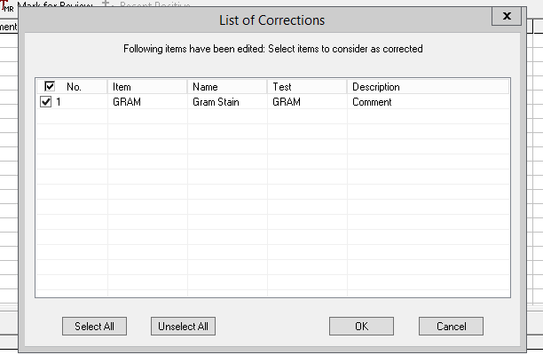

* + - 1. Correction reason box will appear, enter reason for change and click OK.

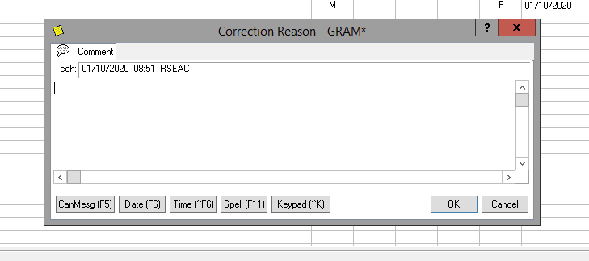

* + - 1. The report format should resemble the example below:

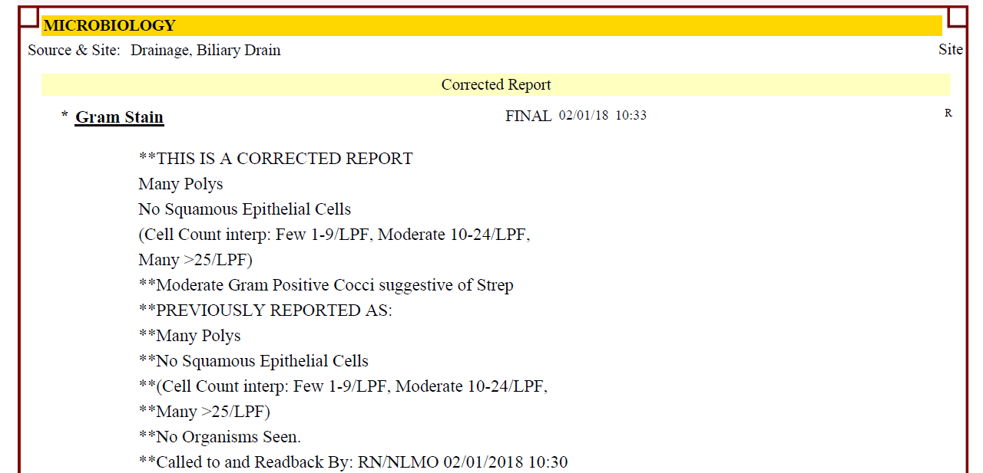

* 1. **Example of Blood Culture Gram Stain (Test Comment) Supplemental Report**
     + 1. Adding additional gram stain morphologies to existing blood culture reports in Final status will generate a Supplemental report.
       2. Add additional organisms below the original gram stain report and document notification of appropriate personnel. Since there is no change to the original report, only an addition, this will generate a supplemental report.
       3. Set Interim status and save.
       4. The report format should resemble the example below:

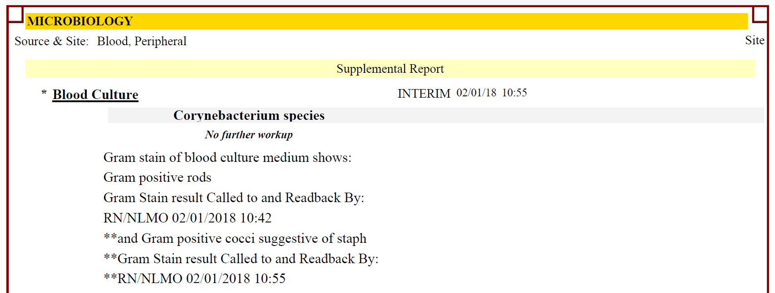

1. **ISOLATE COMMENTS**

Edits to isolate comments will result in either a supplemental or corrected report ONLY if made after a report has a Final status applied. Edits made to isolate comments set with a Final status will trigger an edit warning box, as well as a List of Corrections with a checkbox. This box may be left checked, which will then prompt a correction reason box and corrected report banner, or it may be unchecked, generating a supplemental report instead.

Edits to isolate comments in Preliminary or Interim status may trigger an edit warning box, depending on whether information is added or removed. This warning box will inform the technologist that a change is being made, but no further action must be taken.

* 1. **Example of an isolate comment edit creating a Corrected report**
     + 1. In this example an isolate comment was incorrectly used for the organism identified:

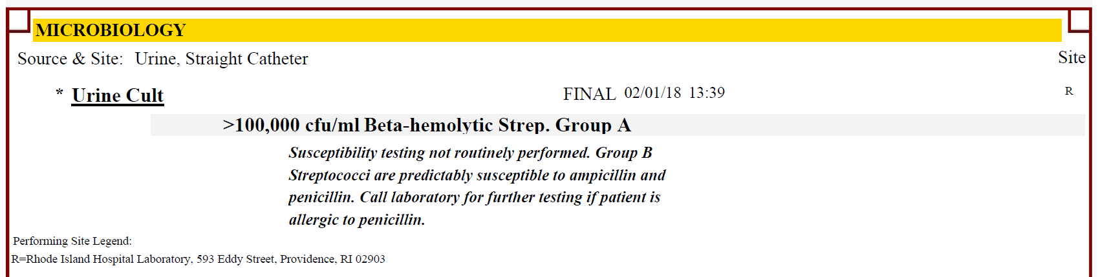

* + - 1. Free text ***Previously reported as:*** above the original isolate comment.
      2. If necessary, add additional isolate comments below header THIS IS A CORRECTED REPORT
      3. Add/Remove a period at the end of the original isolate comment, this will generate a corrected report.
      4. Notify appropriate personnel regarding the corrected report and document phone report.
      5. Set appropriate status for progress of culture and save**.**
      6. Edit warning box will appear, Click OK.
      7. List of corrections with check box will appear, leave the box CHECKED.

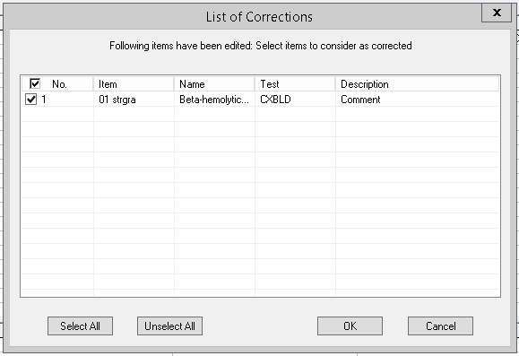

* + - 1. Correction reason box will appear, enter reason for change and click OK.

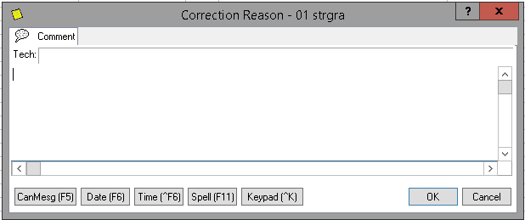

* + - 1. The report format should resemble the example below:

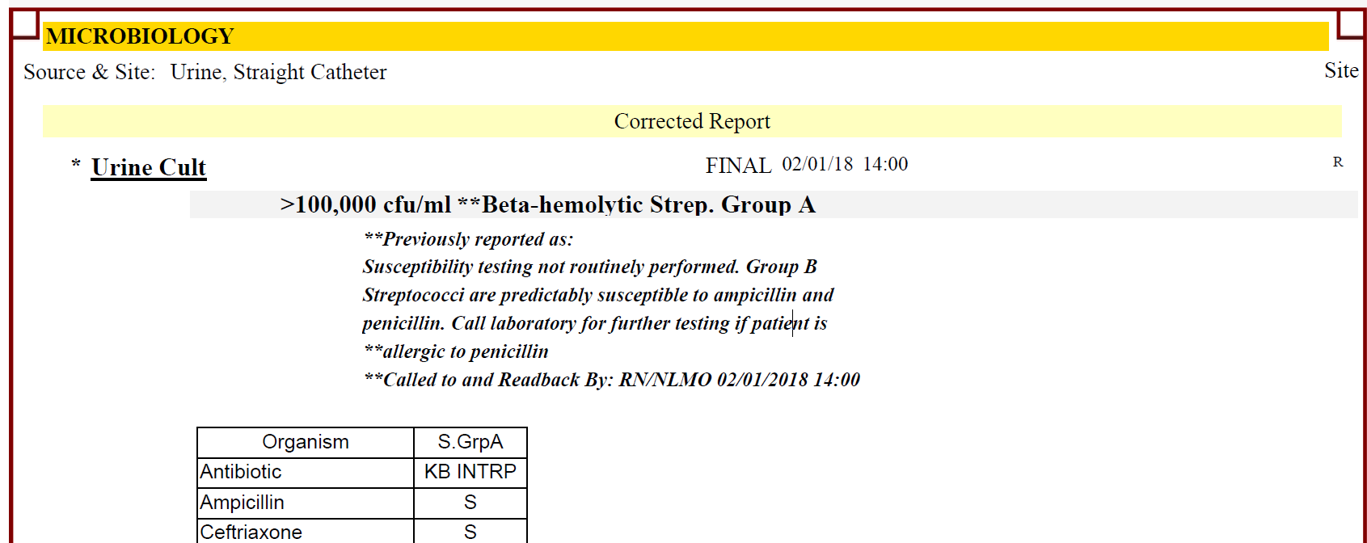

* 1. **Example of an isolate comment edit creating a Supplemental report**
     + 1. In this example, an isolate comment was forgotten for the organism identified:

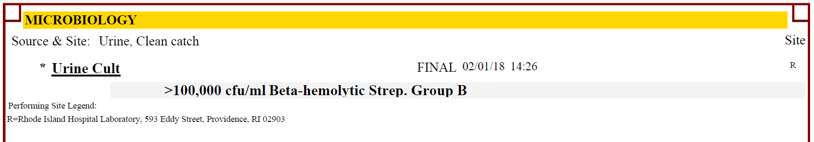

* + - 1. Add isolate comments and document notification of additional information to the appropriate personnel, if necessary. Since there is no change to the original report, only an addition, this will generate a supplemental report.
      2. Set appropriate status for progress of culture and save.
      3. The report format should resemble the example below:

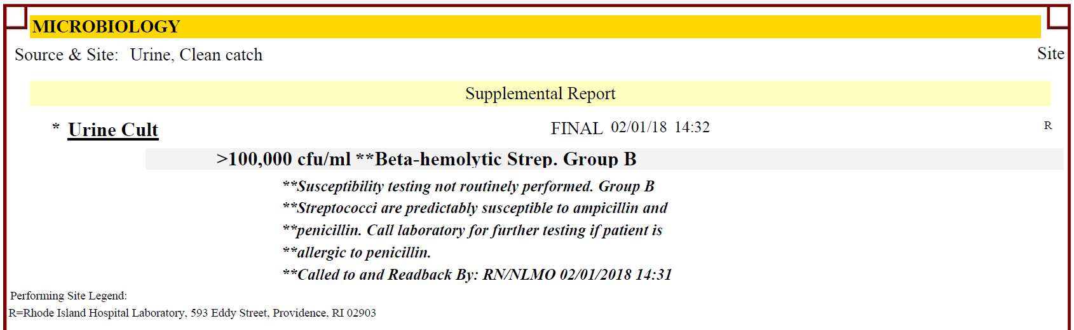

1. **ISOLATE IDENTIFICATIONS**

Edits to isolate identifications will result in a corrected report if made after the report has a Final status applied. There will not be an option to unselect the change as a correction and a correction reason will always be required. A corrected report banner will also be generated.

Edits to isolate identifications in Preliminary or Interim status will trigger an edit warning box as well as a correction reason box. There will not be an option to unselect the change as a correction and a correction reason will always be required, however, a corrected report will not be generated, and no corrected report banner will be generated.

* 1. **Example of an isolate identification edit created after Final status set**
     + 1. In this example an isolate comment was incorrectly identified, and the culture had a Final status applied:

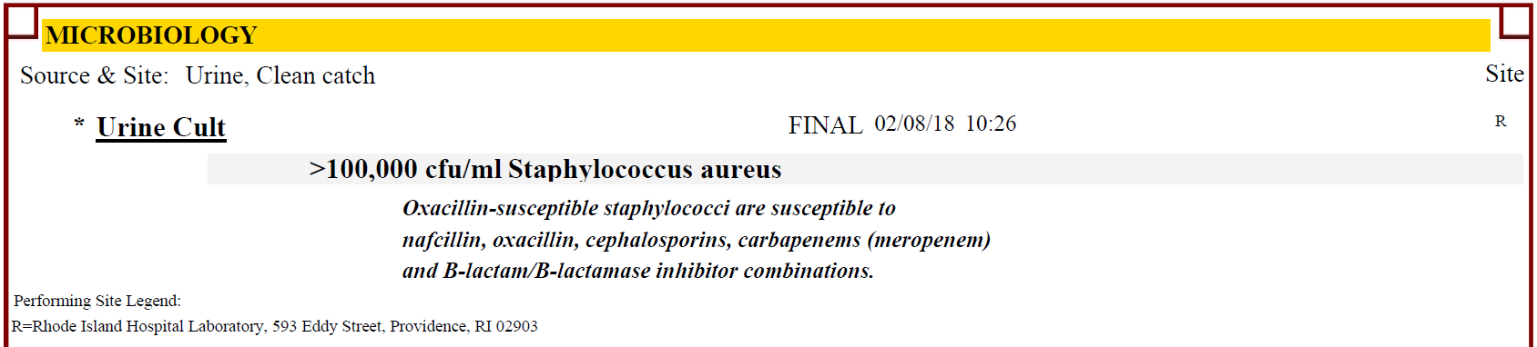

* + - 1. Insert correct identification in place of the incorrect identification.
      2. Notify appropriate personnel regarding the corrected report and document phone report.
      3. Set new status (Interim/Final) and save**.**
      4. An edit warning box will appear. There will not be an option to uncheck this as a correction.

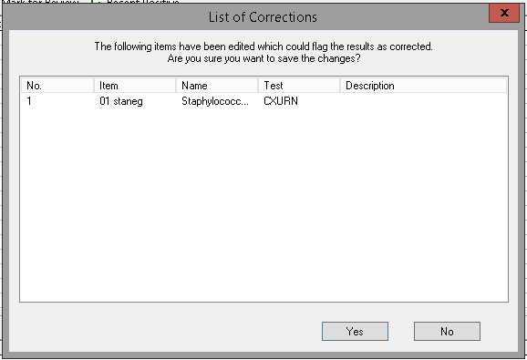

* + - 1. A correction reason box will appear, enter reason for change and click OK.

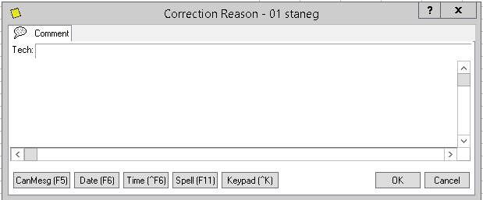

* + - 1. A corrected report with a corrected report banner will be generated.
      2. The report format should resemble the example below:

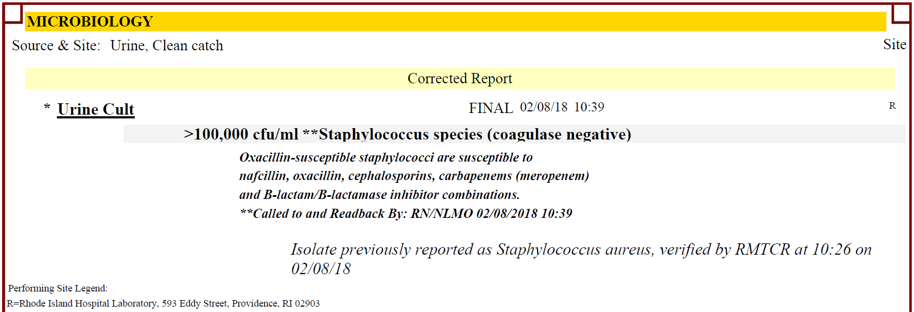

* 1. **Example of an isolate identification edit created after Prelim status set**
     + 1. In this example an isolate comment was incorrectly identified, and the culture had a Prelim status applied:

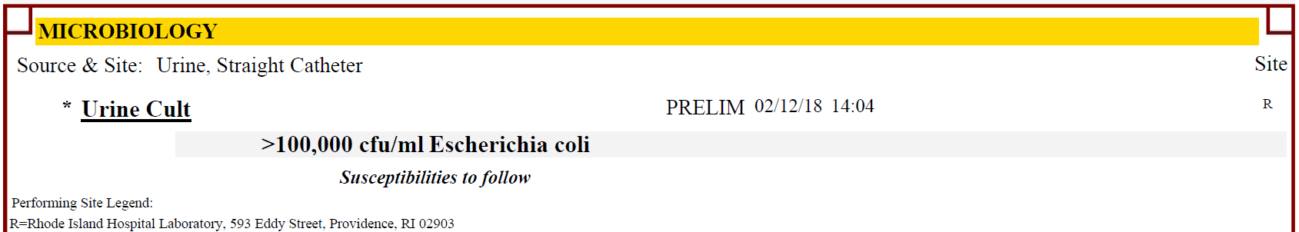

* + - 1. Insert correct identification in place of the incorrect identification.
      2. Notify appropriate personnel regarding the corrected report and document phone report.
      3. Set new status (Interim/Final) and save**.**
      4. An edit warning box will appear. There will not be an option to uncheck this as a correction.

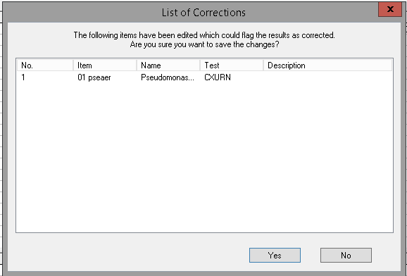

* + - 1. A correction reason box will appear, enter reason for change and click OK.

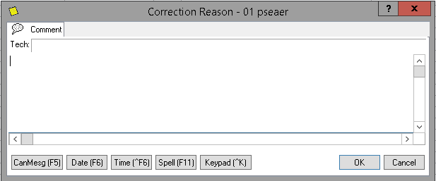

* + - 1. Because the incorrect identification result was saved in Prelim/Interim status, these changes will not flag this report as corrected and there will be no corrected report banner generated.
      2. In the Test Comment region, you will need to add a Canned Comment: **}CORR** which states:

**THIS IS A CORRECTED REPORT**

* + - 1. The report format should resemble the example below:

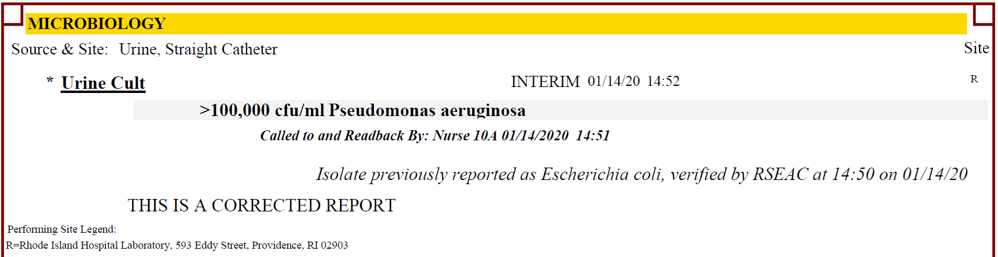

1. **DRUG SUSCEPTIBILITIES**

Edits to drug susceptibilities will result in a corrected report if made after the report has a Final status applied. There will not be an option to unselect the change as a correction and a correction reason will always be required. A corrected report banner will also be generated.

Edits to isolate identifications in Preliminary or Interim status will trigger an edit warning box as well as a correction reason box. There will not be an option to unselect the change as a correction and a correction reason will always be required, however, a corrected report will not be generated, and no corrected report banner will be generated.

* 1. **Example of a drug susceptibility edit created after Final status set**
     + 1. In this example a susceptibility result was incorrectly entered, and the culture had a Final status applied:

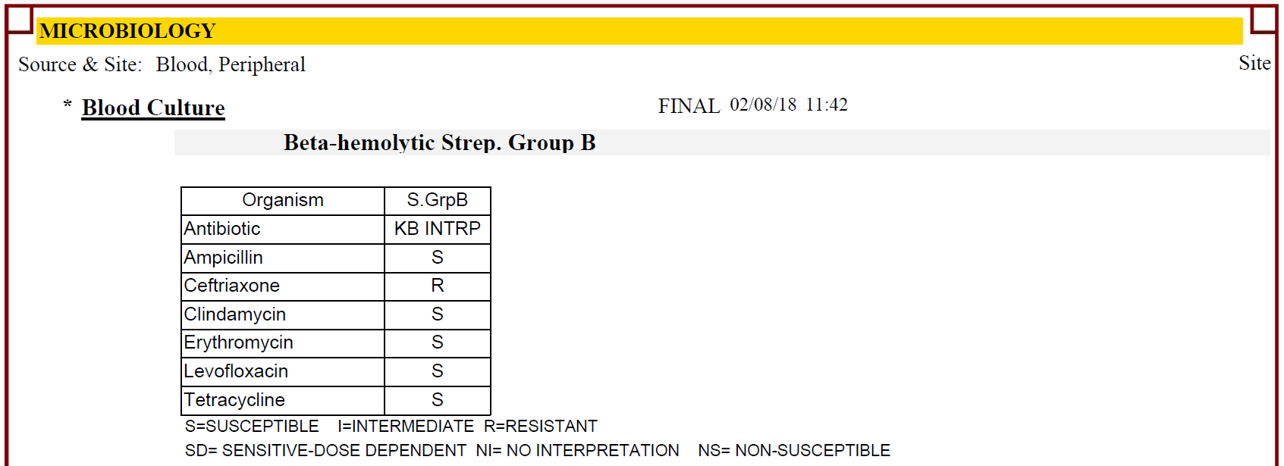

* + - 1. Insert correct susceptibility result in place of the incorrect result.
      2. Notify appropriate personnel regarding the corrected report and document phone report.
      3. Set new status (Interim/Final) and save**.**
      4. An edit warning box will appear. There will not be an option to uncheck this as a correction.

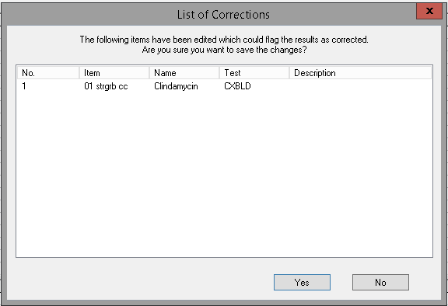

* + - 1. A correction reason box will appear, enter reason for change and click OK.

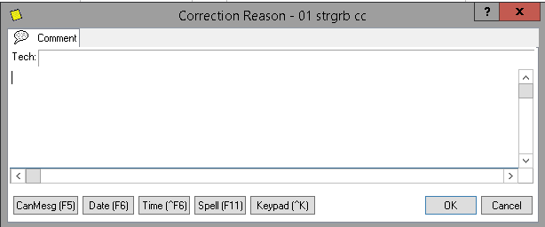

* + - 1. A corrected report with a corrected report banner will be generated.
      2. The report format should resemble the example below:

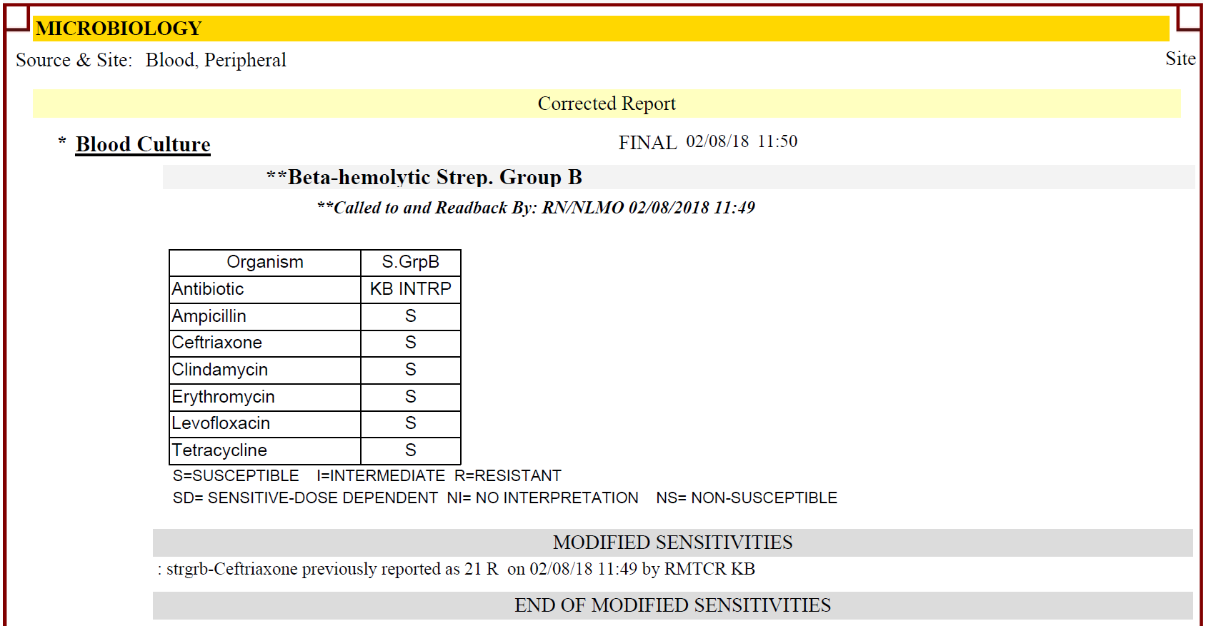

* 1. **Example of a drug susceptibility edit created after Interim status set**
     + 1. In this example a susceptibility result was incorrectly entered, and the culture had an Interim status applied:

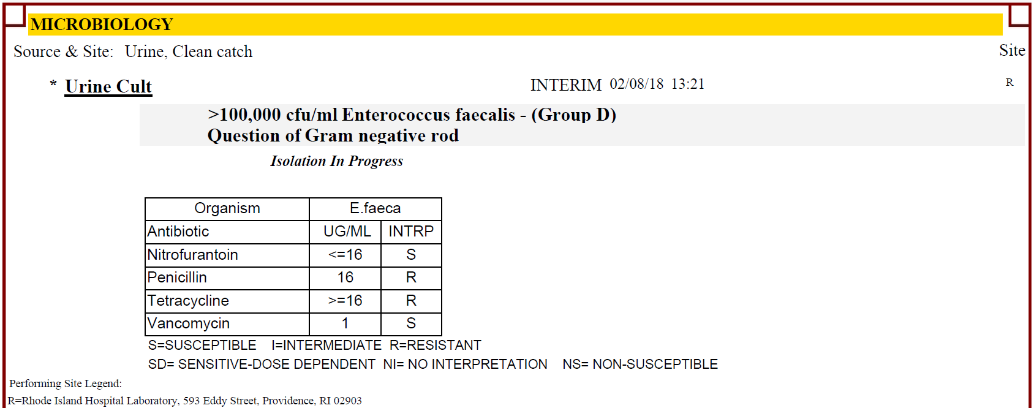

* + - 1. Insert correct susceptibility result in place of the incorrect result.
      2. Notify appropriate personnel regarding the corrected report and document phone report.
      3. In the Test Comment region, you will need to add a Canned Comment: **}CORD** which states:

**THIS IS A CORRECTED REPORT.**

**DRUG SUSCEPTIBILITES HAVE BEEN AMENDED.**

**SEE DRUG COMMENTS BELOW.**

* + - 1. Set new status (Interim/Final) and save**.**
      2. An edit warning box will appear. There will not be an option to uncheck this as a correction.

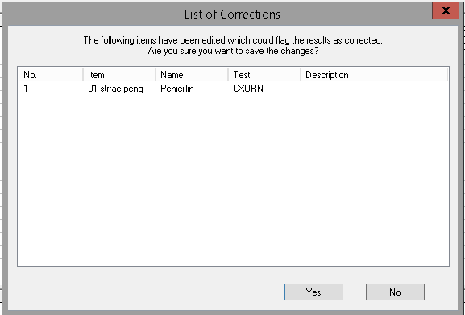

* + - 1. A correction reason box will appear, enter reason for change and click OK.

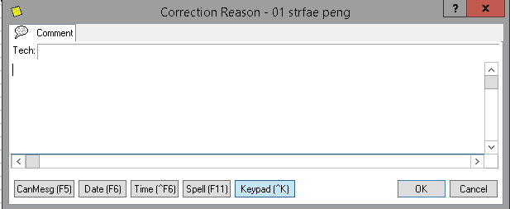

* + - 1. Because the incorrect susceptibility result was saved in Prelim/Interim status, these changes will not flag this report as corrected and there will be no corrected report banner generated.
      2. The report format should resemble the example below:

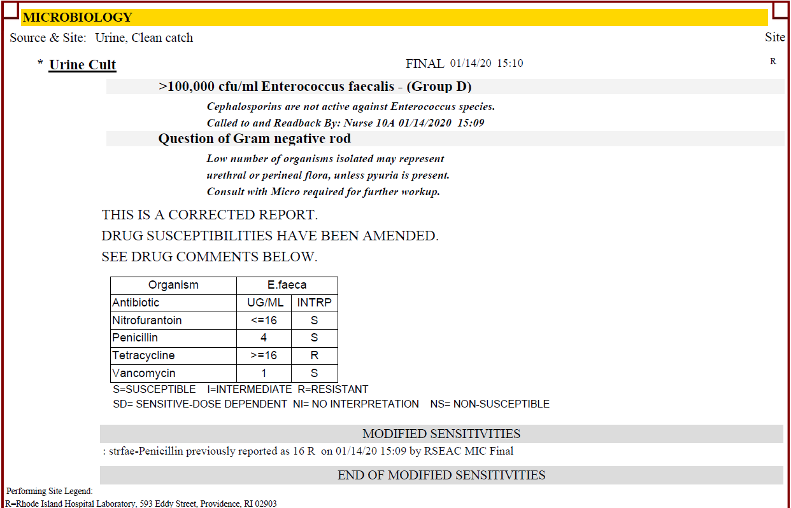

1. **CORRECTED RESULTS WITH RESULT ENTRY (SOFTLAB)**
   1. A result that needs correction and has been verified, will autogenerate a “previously reported…” comment. Simply delete what currently resides in the result field, fill in with new result, add call comment, and verify.

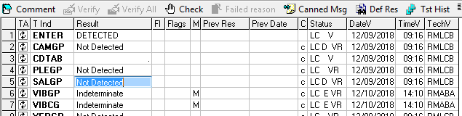 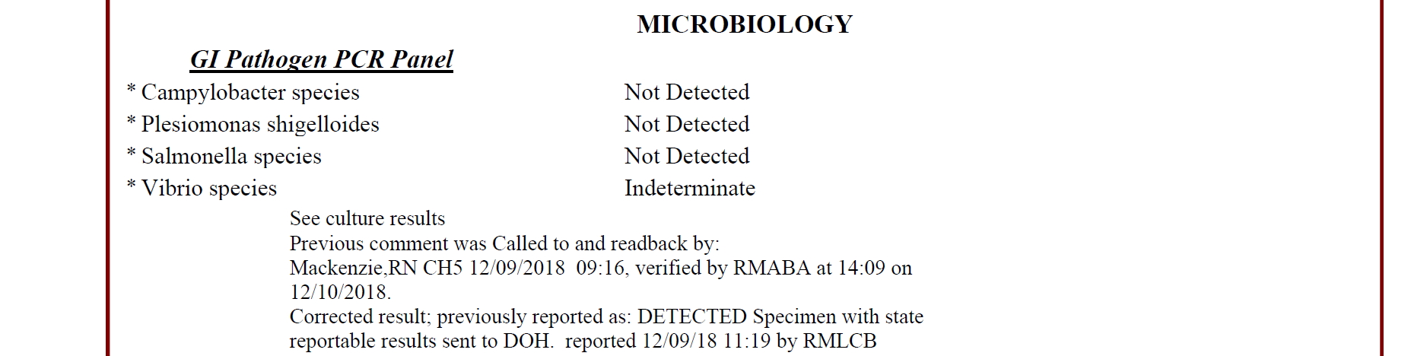

1. **REPORTING CORRECTED RESULTS AND NOTIFICATION** –*Refer to**Procedure: Critical Results Notification*
   1. Corrected gram stains must be called unless it is the result of a gram stain review and previously reported culture results match the reviewed gram stain.
   2. Blood culture results must be called for all changes if the physician is not aware of all of the organisms growing. If physician has been notified of all organisms in updated culture report, no need to call gram stain if it is reviewed and corrected after the fact.
   3. All corrections to isolate identifications must be called.
   4. All corrections to drug susceptibilities must be called.
   5. Any corrections on specimens that are associated with any ELR must be called to the DOH.