**PROCEDURE: GENMARK EPLEX SAR-CoV-2**

1. **PRINCIPLE**

The GenMark ePlex SARS-CoV-2 is a qualitative nucleic acid multiplex *in vitro* diagnostic test intended for use on the ePlex System for the simultaneous detection and identification of SARS-CoV-2 nucleic acid in nasopharyngeal swabs (NP swabs).

The ePlex system automates all aspects of nucleic acid testing including extraction, amplification, and detection, combining electrowetting and GenMark’s eSensor technology in a single use cartridge.

Electrowetting, or digital microfluidics, uses electrical fields to directly manipulate discrete droplets on the surface of a hydrophobically coated printed circuit board. Sample and reagents are moved in a programmable fashion in the ePlex cartridge to complete all portions of the sample processing from nucleic acid extraction to detection.

A sample is loaded onto the ePlex cartridge, and nucleic acids are extracted and purified from the sample via magnetic solid phase extraction. A reverse transcription step is performed to generate complimentary DNA from the viral RNA, followed by PCR to amplify the target. Exonuclease digestion creates single-stranded DNA in preparation for eSensor detection.

The target DNA is mixed with ferrocene-labeled signal probes that are complementary to the specific targets on the panel. Target DNA hybridizes to its complementary signal probe and capture probes, which are bound to gold-plated electrodes, as shown below in **Figure 1**. The presence of each target is determined by voltammetry which generates specific electrical signals from the ferrocene-labeled signal probe.



**Figure 1**: Hybridization complex. Target specific capture probes are bound to the gold electrodes in the eSensor microarray on the ePlex cartridge. The amplified target DNA hybridizes to the capture probe and to a complimentary ferrocene-labeled signal probe. Electrochemical analysis determines the presence or absence of targets using voltammetry.

1. **AVAILABILITY**

Specimens will be run on all 3 shifts, 7 days a week

1. **TEST CODE**

COV19

1. **SPECIMEN**
   1. The appropriate specimen for the ePlex SARS-COV-2 is a nasopharyngeal swab collected and transported in a 1ml UTM using the Flu collection kit (must be an NP swab).
   2. Only specimens received from current inpatients, ED patients, and either symptomatic healthcare workers, or healthcare workers with exposure to positive COVID19 patients are acceptable for testing.
   3. All specimens submitted for testing must include a corresponding RPP order.
      1. For ED patients, SARS-CoV-2 testing will be performed after RPP has been resulted.
      2. If ED patient is admitted, SARS-CoV-2 testing will be performed in-house.
      3. Discharged ED patients will have specimens sent to RIDOH for SARS-CoV-2 testing.
   4. Test requests for specimens received outside of the previously defined acceptance criteria will be performed upon Director approval.
2. **MATERIALS AND EQUIPMENT**
   1. Materials
      1. ePlex SARS-CoV-2 Test Kits (EA001212). Containing 12 SARS-CoV-2 Test Cartridge and 12 Sample Delivery Device
      2. Genmark ePlex SARS-CoV-2 Controls
      3. Sterile, nuclease free disposable extended pipette tips with filters (Art XL P-200)
   2. Equipment
      1. GenMark ePlex System and Software
      2. 200uL Sartorius pipette
      3. Vortex mixer for specimen set up
      4. Freezer (manual defrost) at -20 to -80 oC
      5. Refrigerator at 2 to 8 oC
3. **STORAGE AND HANDLING**
   1. ePlex SARS-CoV-2 cartridges are shipped at room temperature. Once in the lab, they should be stored at 2 to 8 oC
      1. Cartridges can be used immediately from refrigerator storage
      2. Cartridges and Sample Delivery Devices are 1 time use and should be discarded in biohazard receptacles after use
      3. Once the foil packaging of the cartridge is opened, the cartridge must be used within 2 hours
   2. ePlex SARS-CoV-2 Positive Controls should be stored frozen at -20 oC to -80 oC until needed
      1. Control tube must reach room temperature (18-25 oC) before use.
      2. Control tube must be flicked several times then vortexed for 3-5 seconds
      3. Tap on bench to force fluid from the cap
      4. Controls are one time use and any remaining fluid should be discarded in biohazard trash.
   3. Patient specimen should be run immediately after receipt in the lab. If the specimen cannot be run immediately, it should be stored in the refrigerator at 2 to 8 oC. Once run, the specimen should be stored in the refrigerator.
      1. Specimens can be held at Room Temperature (15 to 30 oC) for up to 12 hours or at 2 to 8 oC for 10 days after collection in UTM
      2. Any specimen requiring storage for >10 days must be placed in -70 oC. Specimens stored in -70 oC are acceptable for testing for up to 6 months with up to 2 freeze/thaw cycles
4. **QUALITY CONTROL**
   1. External control - Commercial external controls are purchased from Genmark directly.
      1. Previously characterized positive samples or viral transport medium spiked with well characterized organism can be used as an external positive control.
      2. Sterile, viral transport media can be used as a negative control
      3. Controls are run daily and with every new shipment of ePlex SARS-COV-2 Cartridges or after a major system maintenance (software upgrade, annual PM, or replacement of multiple modules)l
      4. No patient results will be released until required controls are resulted and confirmed correct. Bring any discrepant control results to the attention of the Senior Medical Tech, Lead Medical Tech, or Manager.
   2. Internal Control- Each Cartridge includes internal controls that monitor performance of each step of the testing process.
      1. A DNA control verifies extraction, amplification, and detection of DNA targets and RNA controls verify amplification and detection of RNA targets.
      2. Either the internal control or the target must generate a signal above the threshold for a valid test result.
   3. Environmental wipe testing is performed monthly. All test areas are swabbed and run as test patients. Refer to ***Appendix AP25 – CORE Environmental QC*** in the STAT Binder for environmental instructions
   4. Positivity rate monitored monthly.
   5. All QC failures are documented in the QC Failures Binder.
5. **EQUIPMENT MAINTENANCE**
   1. On a monthly basis, the exterior (front, sides, and top) of the ePlex unit must be cleaned with 10% bleach- let sit for 5 minutes, water, then 70% alcohol using lint-free wipes.
      1. Avoid getting any liquid in the area of the bays
   2. On a weekly basis, the exterior (front, sides, and top) of the ePlex unit must be cleaned with 70% alcohol using a lint-free wipe
   3. The screen should be cleaned when needed with DI water and a WipeAll
6. **TEST PROCEDURE**

**PATIENT SAMPLES SHOULD BE SET UP IN THE HOOD ONE AT A TIME.**

* 1. Thoroughly decontaminate the molecular hood, pipette, bench area, and corresponding tip box with bleach, followed by DI water, then 70% alcohol. Change your gloves.
     1. Place a WipeAll on the working surface of the hood. The cartridge must be set up on a dry surface.
  2. Place one cartridge, one Sample Delivery Device, and patient specimen in the hood.
     1. Open the foil packaging of the cartridge and place label within the rectangular space on top of the cartridge. The standard label must be trimmed to fit within the borders of the label area on the cartridge
  3. Vortex the patient sample for 3-5 seconds.
  4. Gently tap the Sample Delivery Device on the work surface to force any fluid toward the bottom of the tube. Ensure there is fluid in the Delivery Device.
  5. Unscrew the **purple** cap from the Delivery Device.
  6. Pipette **200uL** of patient sample into the Delivery Device and replace the **purple** cap.
  7. Recap patient specimen
  8. Vortex the Sample Delivery Device for 10 seconds
     1. Delivery of the specimen into the cartridge must be completed immediately after vortex of Sample Delivery Device
  9. Remove the white cap from the tip of the Sample Delivery Device and invert the Delivery Device above the specimen port of the cartridge.
  10. Dispense the entire volume of the Delivery Device.
      1. Avoid dispensing foam that will form once the bottle has emptied
      2. A random bubble or two can be present when closing the cap
  11. Slide the cap over the port and push cap into place. There should be a click.
  12. Change gloves.
  13. Bring the cartridge to the ePlex and place on a dry surface or WipeAll
      1. Log into ePlex if necessary
  14. Scan the patient barcode label and cartridge barcode using the scanner adhered to the ePlex.
      1. The barcode reader will beep once to indicate it has read both barcodes
      2. The identifier can be manually put into the ePlex by selecting the keyboard at the bottom of the ePlex screen. Enter the identifier into the window and select enter.
  15. Gently insert the cartridge into any available slot on the ePlex indicated by **white** flashing lights.
      1. Once the pre-flight checks have been made, the white light will turn **blue.**
      2. If pre-flight fails, remove the cartridge and place into another available slot. After three attempts GenMark Technical Services must be called
  16. At this time, another patient can be set up. Change gloves, place a new WipeAll under the hood, repeat starting with step B above
      1. Alternatively, up to 3 specimens can be set up one-at-a-time in the hood before walking over to the e-Plex. Cartridges **cannot** be stacked, but must be placed on a sterile surface to be carried over to the equipment
  17. Once the test is complete, the ePlex will eject the cartridge. At this time, it should be removed from the ePlex and placed in biohazard waste
  18. A full report will automatically print when the test is complete

1. **INTERPRETATION**
   1. Internal Control (IC) – The internal control will result 1 of 4 ways
      1. **PASS** – Test is valid and all results will generate and can be reported
      2. **FAIL** – Test is not valid because neither the IC nor any target generated a signal above the threshold. **The specimen should not be repeated.**
      3. **N/A** – Test is valid and results will generate and can be reported. An N/A result for IC indicates the internal control is not valid but detection of signal above threshold for a target in every amplification reaction indicates valid results were generated.
      4. **INVALID** – Test is not valid due to an error during processing on the instrument or a software error. **The specimen should not be repeated.**
   2. Patient Specimen
      1. **DETECTED** – The detected target has generated signal above the defined threshold. Report target as “Detected”.
      2. **NOT DETECTED** – The test was completed successfully, and the target did not generate signal above the defined threshold. Report target as “Not Detected”.
      3. **INVALID** – The test did not complete successfully. Results are invalid and test **will not** be repeated. Specimen will be sent to RIDOH for further testing. Notify a nurse or clinician about the delay in resulting for any inpatient specimens. Record invalid in ePlex Invalid/Error log.
         1. **Follow the steps below to document notification of Invalid results**:
            1. In order entry, click the Call button.
            2. Under the Call comm section, enter in the following “Delay in testing due to an invalid result, test is being repeated”. This comment can be modified to fit each situation.
            3. Check off the Called box and hit OK.

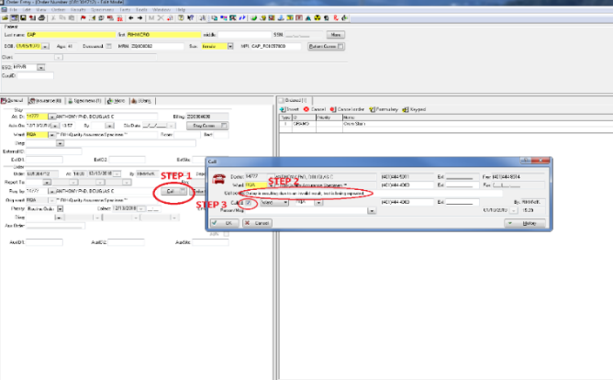

* + - 1. **Prepare specimen to be sent to RIDOH:**
         1. Add-on order **DHCOR** if not already ordered.
         2. Add 1mL UTM to specimen.
         3. Parafilm specimen and put specimen and appropriate forms in biohazard specimen bag.
         4. Send specimen on next courier run to RIDOH.

1. **RESULTING**
   1. Refer to ***Appendix AP#79 - SARS-COV-2 Soft resulting: Non-interfaced resulting*** for further instructions.
2. **LIMITATIONS OF TEST**
   1. For Research Use Only. Not for use in diagnostic procedures.
   2. **Minimum Sample Volume –** 200uL np swab in viral transport media is required for testing
   3. Improper and/or infrequent decontamination can lead to contamination of ePlex, cartridges, and/or other equipment leading to false positive results
   4. Use of SARS-CoV-2 test kits beyond their expiration date may result in erroneous results
   5. Failure to follow storage and handling requirements in the above **Storage and Handling** section can affect final results
   6. Reuse of any kit component is not allowed and can result in lab contamination and/or incorrect results
   7. Gloves should be changed frequently to avoid contamination between test cartridges
   8. Analytical specifications were validated using nasopharyngeal swab specimens in 1mL UTM. Any other transport method or specimen type should be approved by the Medical Director before running
   9. Improper collection, transport, storage and/or preparation of samples may lead to incorrect results
   10. Not Detected results may occur due to presence of inhibitors, technical error, sample mix-up or an infection caused by a target not on this panel
3. **NOTES**
   1. Wet cartridges should never be used.
   2. Specimens must be processed in a biosafety hood. Technologist must be wearing protective gear such as sterile gloves and disposable lab coats
   3. A trained healthcare professional should interpret assay results in conjunction with the patient’s medical history, clinical signs and symptoms, and the results of other diagnostic tests.
   4. Reagents within the SARS-CoV-2 cartridge may cause irritation to skin, eyes, and respiratory tract and are harmful if swallowed. Do not pierce reagent blisters on the ePlex cartridge
   5. Once the sample is loaded into the ePlex SARS-CoV-2 test cartridge, the sample should be tested within 2 hours
4. **TECHNICAL SUPPORT**

Ph: 1-800-373-6767, option 2

Email: technicalsupport@genmarkdx.com

1. **REFERENCES**
   1. ePlex SARS-CoV-2 Assay Manual (RUO) PI1108-A
2. **ATTACHMENTS**
   1. Appendix AP79 - SARS-COV-2 Soft resulting: Non-interfaced resulting
3. Under **SoftLab**, Click on **Result Entry***.*
4. Go to **Select test****by** and pick **Test** from the drop-down menu.
5. Under**Test**type in the test code.
6. Under **Order Number** type in the order number you need to result.
7. On the first line **[CV19]**, select the appropriate result from the keypad. Verify the result against the instrument printout. Any applicable canned messages will apply automatically.
8. Open the **Comment** box to document notifications to providers/patient care team.
9. Do not enter/edit results on the 2nd, 3rd, or 4th lines. These are placeholders for future comments and electronic transmittal of results to Theradoc.
10. Once result is entered, **Verify All**.

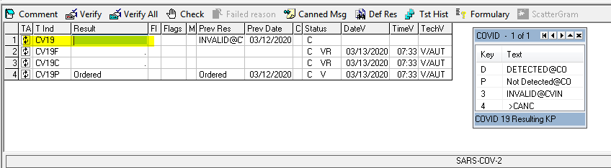

**Example: SARS-CoV-2 DETECTED**

Result Entry:

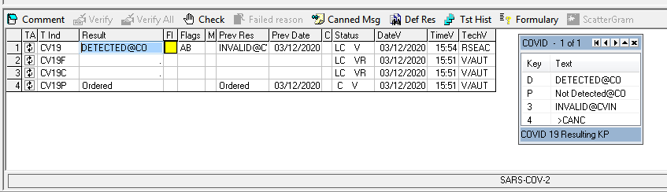

Instant Report:

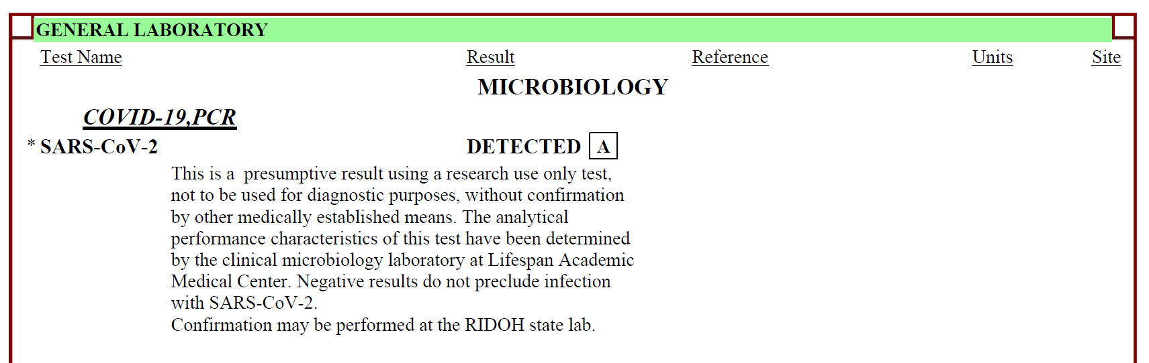

**Example: SARS-CoV-2 Not Detected**

Result Entry:

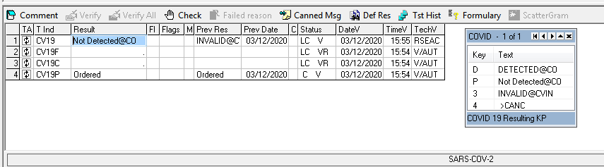

Instant Report:

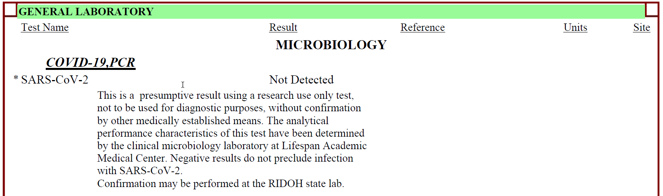

**Example: SARS-CoV-2 Invalid**

Result Entry:

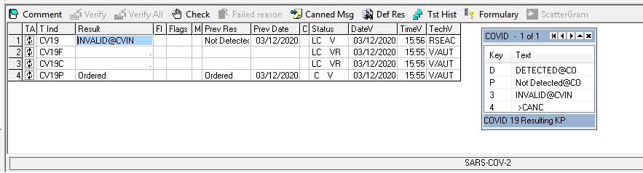

Instant Report:

