|  |  |  |  |
| --- | --- | --- | --- |
| **Molecular Tests Performed at Coro Molecular Micro** | | | |
| **Test Name** | **Specimen** | **Test Code** | **Comments** |
| HIV Viral Load | Plasma EDTA | HIVL2 | Centrifuge at 3000 for 20 minutes within 6 hrs. Separate/aliquot plasma into new labeled tube. Process on all shifts. Freeze plasma and send to Coro Molecular Micro.   TMH- Refrigerate plasma and send to RIH Micro to be frozen and sent to Coro Molecular Micro.  An empty tube may be received for HCVCK and HIVLX orders when an extra tube has not been drawn. Investigation of all other empty tubes is required at time of receipt in lab. |
| HIVLX- extra tube for Pedi | Plasma EDTA  An empty tube may be received for HIVLX orders when an extra tube has not been drawn | HIVLX  (extra 3ml tube for Pedi patients <=16) |
| HCV Viral Load | Plasma EDTA or PPT Pearl top and gel separator | HCVL1 |
| HCVCK-order only "Dummy Order" for HCV Reflex | Plasma EDTA or PPT Pearl top and gel separator  An empty tube may be received for HIVLX orders when an extra tube has not been drawn | HCVCK  (tube drawn on all HCV ab orders for reflex testing) |
| HBV Viral Load | Plasma EDTA | HBVL1 |
| HCV Genotype | Plasma EDTA or PPT Pearl top and gel separator | HCVG1 |
|  |  |  |  |
| HPV | Thin Prep | HPV1 | Ordered and aliquotted by Molecular Techs |
| HPV Genotype 16,18/45 | Thin Prep | HPVG1 |
|  |  |  |  |
| Urine Aptima Specimens | Urine collected in Aptima Urine collection kit | URIC1 URIG1 URNTV | Tube must be filled within the lines marked. Overfills/underfills are cancelled and called. |
| Swab Aptima Specimens | Swab specimen (blue swab) submitted in Aptima collection kit. | CERC1 CERG1 CERTV VAGC1 VAGG1 VAGTV UREC1 UREG1 URETV RECC1 RECG1 RECT1 THRC1 THRG1 THRT1  EYEC1 EYEG1  NASC1 NASG1 | **BLUE SWABS ONLY**! Cancel and call if white swab or no swab instead of blue swab is in collection tube.  **Reject if foil cap is punctured** |
|  |  |  |  |
| **Performed at RIH Molecular- Do Not Confuse with Coro Testing** | | | |
| HSV PCR | Plasma EDTA Plasma only for infants ≤8 weeks | PHSV | Centrifuge specimen and refrigerate TMH-Refrigerate and send to RIH Micro. Specimen must be in lab by 11AM for same day resulting. Performed Mon-Fri. |

1. **Plasma Samples**
2. Check orders on blood samples prior to processing. The following orders are the ONLY orders processed in Micro. Any other orders should be returned to Central Collections or check with a specialist.
   1. HIVL2
   2. HIVLX
   3. HCVL1 Testing performed at Coro Molecular Micro
   4. HCVCK
   5. HBVL1
   6. HCVG1
   7. PHSV - Testing performed at RIH Molecular
3. **Aptima Samples for GC/CT and Trich**
4. It is the responsibility of the desk tech or tech receiving specimens to check for proper specimen collection and ordering.
5. **All issues** including cancelling and reordering tests should be addressed at the Desk ASAP. Call in-house patients and the ER so specimens can get recollected before discharge. Call outreach at 34242 to inform them if a specimen has been canceled.
6. Reasons for cancelling Unisex Swab Collection Kits- These should have **Blue Swab Only**
   1. White swab, wooden swab, calgi swab, or no swab submitted
   2. The swab is not broken off at the score mark and is folded over in the tube.
   3. Urine is submitted in a swab collection kit.
   4. The foil cap is punctured- this could contaminate other specimens during transport.
   5. Incorrect order. Double check the order to make sure it is correct; male vs female specimen type (check gender). Incorrect specimen types will need to be cancelled and reordered with the correct source. Remember to put the correct label on the tube
   6. More than 1 order is received on the same tube. Only 1 order number/ label per specimen is acceptable. Multiple orders can be combined and the extra orders canceled as order error.
7. Reasons for cancelling Urine collection kits
   1. Overfilled or Underfilled collection tubes. It may be necessary to peel back the label.
   2. Urine received in a urine cup instead of Aptima collection tube.
   3. Urine collection tube contains any swabs
   4. The foil cap is punctured- this could contaminate other specimens during transport.
   5. Incorrect order. Double check the order to make sure it is correct.
   6. More than 1 order is received on the same tube. Only 1 order number/ label per specimen is acceptable. Multiple orders can be combined and the extra orders canceled as order error.
8. Cancelling Specimens in Result Entry Using the Cancel Keypad
   1. From Result Entry Select tests by “Tests”
   2. Enter the Test ID in the Test box
   3. Enter the order number in the order number box.

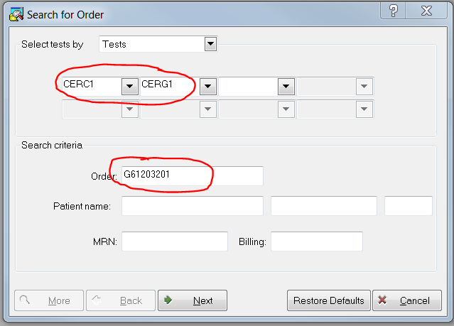

* 1. Hit “Next”
  2. Click on the Result box for the test to be canceled
  3. Choose >CANC from the resulting keypad box.

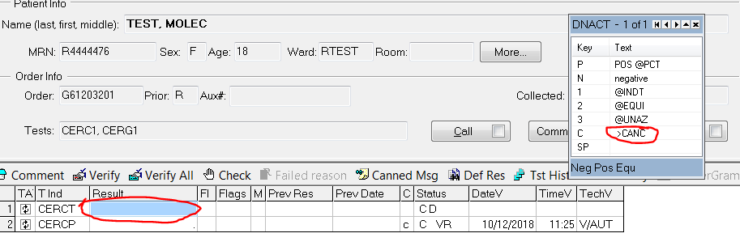

* 1. Click the ↓ to open the Cancel keypad

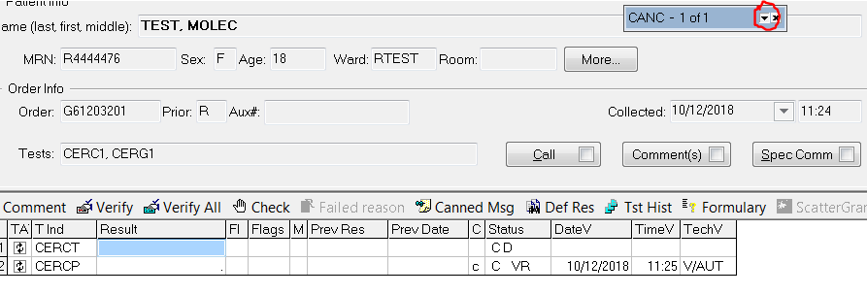

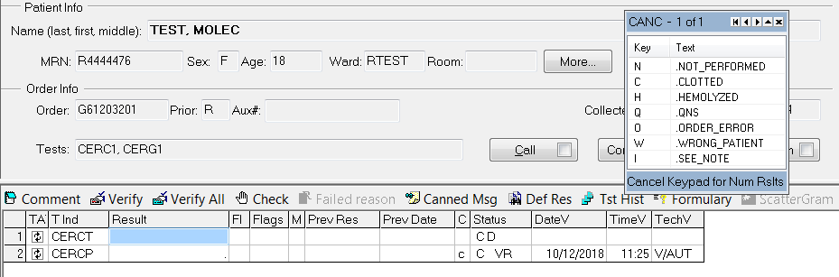

* 1. Choose the reason for canceling from the choices, ie. Not Performed, Order Error, QNS, etc.

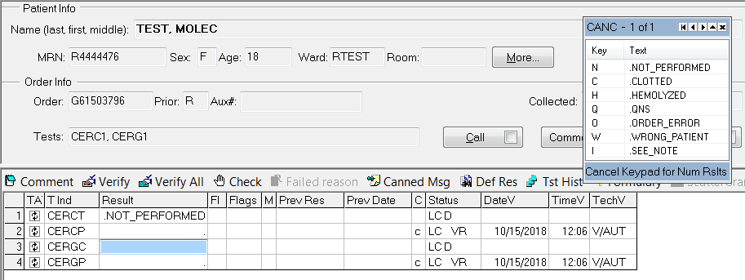

* 1. Repeat for additional orders if there are more than 1, ie. CERC1 and CERG1.

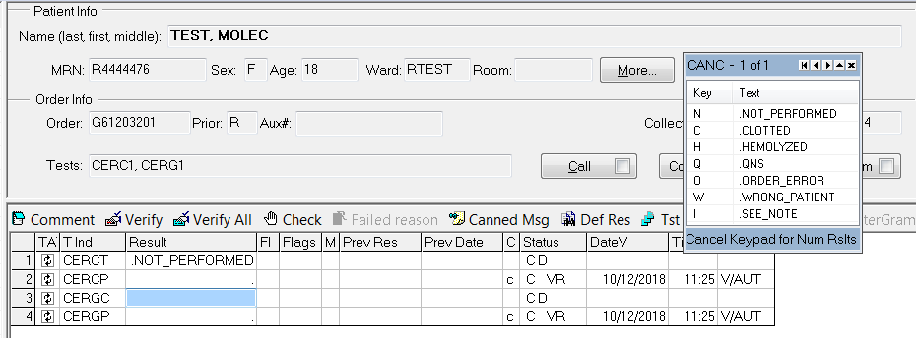

* 1. To add additional comments, open the comment box and add a canned comment or free text a comment, ie. Phone report.

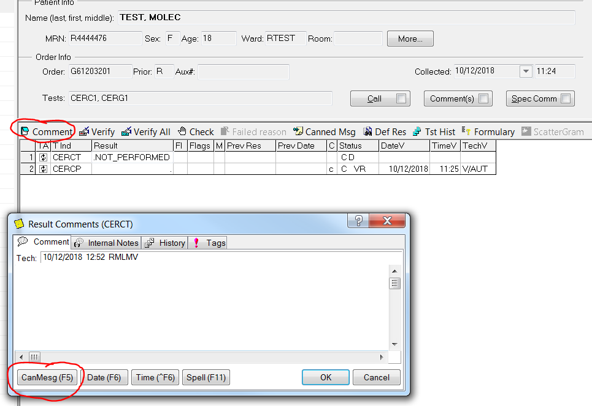

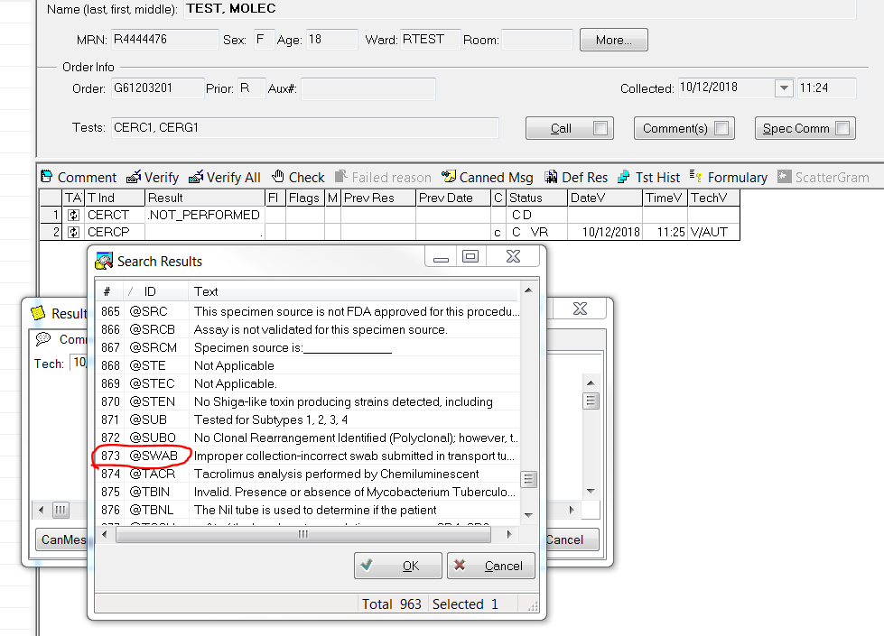

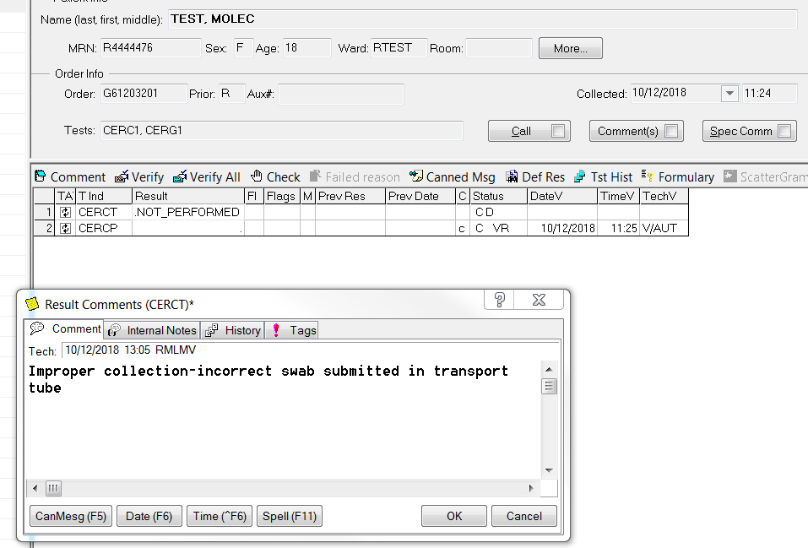

* 1. Frequently used cancellation codes.

Note: These codes can be typed in the comment box and hit Enter or look them up alphabetically in the canned messages.

* + 1. @CONT- Received in wrong container
    2. @OVER- Urine transport tube overfilled
    3. @UNDER- Urine transport tube underfilled
    4. @SWAB- Incorrect swab received in transport tube
  1. Free text as much information as available and add phone report when required.

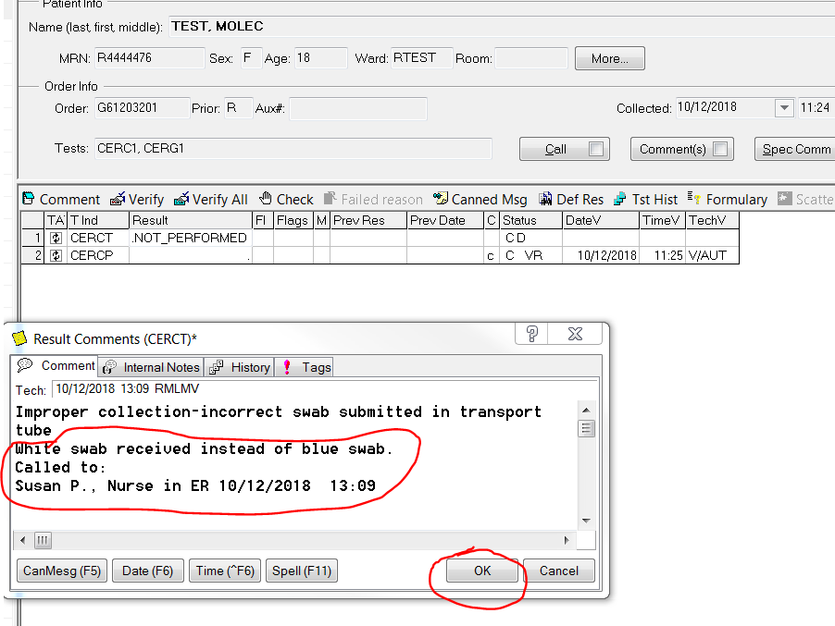

* 1. Click OK
  2. Repeat for additional tests.
  3. Cancel all additional lines corresponding to the test, ie. “Performed by” footnote or “Bill Only” lines, by choosing Cancel and Not Performed.

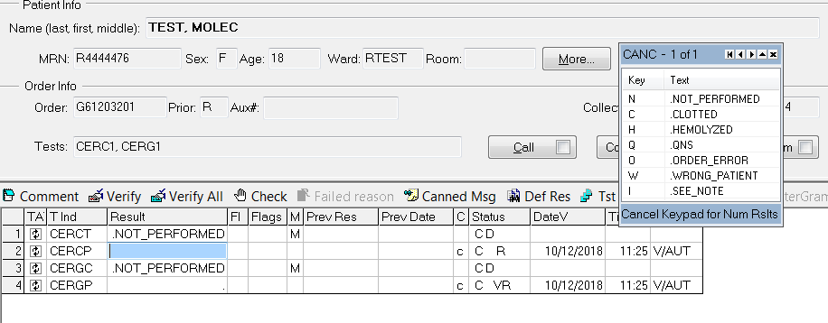

* 1. Verify All and Save

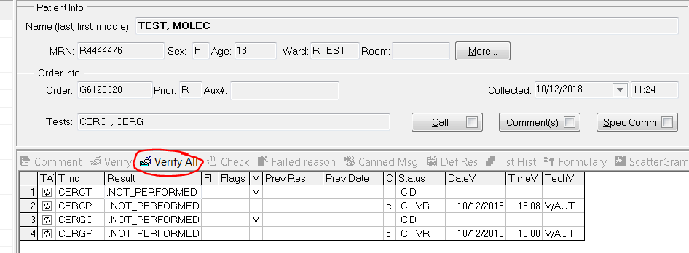

* 1. Check the Instant Report

