High-Sensitivity Troponin I (TNIH)

ADVIA Centaur® XP and ADVIA Centaur® XPT Systems
Prepared by Debra Napert MT (ASCP) |  |  |  | Adopted Date: 6/9/21
Approved by |  |  |  | Date:
The medical director or the director’s designee should review all copies of this procedure.
Reviewer |  | Date | Comments

Revisions

Lifespan AMC – Department of Pathology

The Miriam Hospital ___ ___ Rhode Island Hospital
164 Summit Avenue 593 Eddy Street
Providence, Rhode Island 02906 Providence, Rhode Island 02903

High-Sensitivity Troponin I (TNIH)
Attributes for: | Cardiac troponin I | Analyzer: | ADVIA Centaur® XP  ADVIA Centaur® XPT

Principles of the Procedure
The ADVIA Centaur TNIH is a 3-site sandwich immunoassay using direct chemiluminescent technology. The Solid Phase reagent consists of magnetic latex particles conjugated with streptavidin with two bound biotinylated capture monoclonal antibodies each recognizing a unique cTnI epitope.
The Lite Reagent comprises a conjugate with an architecture consisting of a proprietary acridinium ester and a recombinant anti-human cTnI sheep Fab covalently attached to bovine serum albumin (BSA) for chemiluminescent detection. The accumulated light signal is directly related to the sample cTnI concentration.

Intended Use
The ADVIA Centaur® High-Sensitivity Troponin I (TNIH) assay is for in vitro diagnostic use in the quantitative measurement of cardiac troponin I in human serum or plasma (lithium heparin) using the ADVIA Centaur XP and ADVIA Centaur XPT systems. The assay can be used to aid in the diagnosis of acute myocardial infarction (AMI).

Specimen Types
Plasma (Lithium Heparin)
Serum – refer to Limitations – not validated by Lifespan Labs

Specimen Stability
- The use of a single sample type (either lithium-heparin plasma or serum) is recommended for troponin analysis when collecting serial samples from the same patient.
- Allow blood specimens to clot completely before centrifugation.
- Keep tubes always stoppered and upright.
- Samples must be free of fibrin or other particulate matter. The presence of fibrin, red blood cells, or suspended particles may lead to inaccurate results. Serum samples that contain suspended fibrin particles or erythrocyte stroma must be re-centrifuged before testing.
- If clotting time is increased due to thrombolytic or anticoagulant therapy, the use of plasma specimens will allow for faster sample processing and reduce the risk of micro-clots, fibrin or particulate matter.
- For plasma specimens, avoid transferring white blood cells or platelets from the layer located just above the red blood cells.
- If a fixed angle rotor is used for centrifugation, care should be taken to avoid re-suspending cellular material (platelets) upon removal from the centrifuge.
- Samples are stable up to 8 hours when tightly capped and stored at room temperature.
- Samples are stable up to 7 days when tightly capped and stored at 2–8°C.
- Samples can be frozen at or below -20°C for up to 40 days in non-frost-free freezer.
- Samples can be frozen at or below -70°C for up to 1 year.
- Freeze samples only once and mix thoroughly after thawing. Frozen samples must be centrifuged at 2200 x g for 10 minutes after thawing, before analysis.
- Before placing samples on the system, ensure that samples have the following characteristics:
  - Samples must be free of fibrin or other particulate matter.
  - Samples should be free of bubbles.

Minimum Sample Volume
100 μL

Preparing the Reagents
All ADVIA Centaur TNIH ReadyPack reagents are liquid and ready to use. Remove all of the reagents from the refrigerator and mix all primary reagent packs by hand. Visually inspect the bottom of the reagent pack to ensure that all particles are dispersed and resuspended before loading it onto the system.

Storage and Stability
Store the reagents upright at 2–8°C. Protect reagent packs from heat and light sources. Reagent packs loaded on the system are protected from light.
Reagents are stable at 2–8°C until the expiration date on the product.
The ADVIA Centaur TNIH assay reagents are stable onboard the system for 28 days and are stable unopened until the expiration date on the product. Discard reagent packs at the end of the 28-day onboard stability interval. Do not use reagents beyond the expiration date.
ADVIA Centaur TNIH Calibrators are stable on the system for 4 hours. Dispose of any calibrator that remains in the sample cups after 4 hours.

TNIH CALIBRATOR
Master Curve
The ADVIA Centaur TNIH assay requires a Master Curve calibration when using a new lot number of Lite Reagent and Solid Phase. Use the barcode reader to scan the QR codes from the Master Curve card so the values will automatically be entered onto the system. The system must be in a “Ready” state to scan a new reagent lot Master Curve. The Master Curve can be scanned in any screen on the workstation.
Once all QR codes are scanned, select Save.
Defining Calibrator Values
Use the barcode reader to enter the values from the Calibrator Assigned Value card onto the system. This can be done at any time, a “Ready” state is not necessary.
- At the workspace, select Calibration.
- Select Calibrator Definition.
- Select Add Calibrator Definition.
- Use the handheld barcode reader to scan the barcodes, from top to bottom, on the Calibrator Assigned Value card.
- Select Save.
Two-Point Calibration Interval
Use the TNIH Calibrators provided in the ADVIA Centaur TNIH reagent kit to perform two-point calibrations.
Note: The TNIH calibrators provided in this kit are matched to the Solid Phase, Lite Reagent, and Ancillary Reagent. Do not mix TNIH calibrator lots with different lots of reagents.
Prepare the TNIH Calibrators as described below:
- The low-level calibrator is ready to use.
- The high-level calibrator comes lyophilized and must be reconstituted.
- Add 1mL of reagent water into the high-level calibrator vial using a volumetric or precision pipet.
- Allow the calibrator to sit 15-20 minutes at room temperature to allow the lyophilized material to dissolve.
- Gently swirl and invert the vial until homogeneous.
Calibration Interval
Use Calibrator TNIH to perform two-point calibrations.
Perform two-point calibration every 28 days and:
- When changing lot numbers of primary reagent packs
- When replacing system components
- When quality control results are repeatedly out of range

Quality Control Material
Use BioRad Cardiac Markers Level 1B, 2 and 3 quality control materials to monitor assay performance.
Analyze at least two levels of quality control material on each day that samples are analyzed.
Analyze all levels of quality control materials each time a two-point calibration is performed.
For detailed QC procedural information refer to the operator’s manual or on-board help.
Troubleshooting Out-of-Range QC Values
If the quality control results do not fall within the Expected Values or within the laboratory’s established values, do not report results. Take the following actions:
- Verify that the materials are not expired.
- Verify that required maintenance was performed.
- Verify that the assay was performed according to the instructions for use.
- Rerun the assay with fresh quality control samples.
- Recalibrate the assay if indicated.
- If necessary, contact your local technical support provider or distributor for assistance.
Corrective Action
Patient test results must be repeated, and corrective action taken when QC results fall outside of acceptable limits as determined by red range/backtrack range.

Interferences
Potential interference in the ADVIA Centaur TNIH assay from the compounds listed below is designed to
be ≤ 10%. Interfering substances at the levels indicated were tested as described in CLSI Document
EP07-A2 using the ADVIA Centaur TNIH assay.
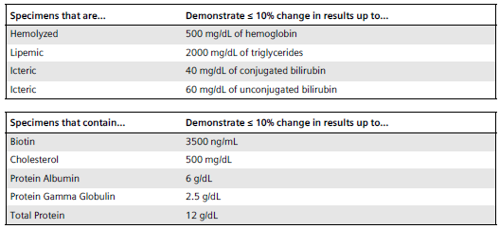
Testing was performed with both human serum and lithium-heparin plasma samples, with troponin concentrations in the ranges of 20–60 pg/mL (ng/L) and 1000–2000 pg/mL (ng/L). The following drugs were added to the samples at the concentrations indicated and were evaluated for potential interference in the ADVIA Centaur TNIH assay. The results demonstrated a ≤ 10% interference from each drug.
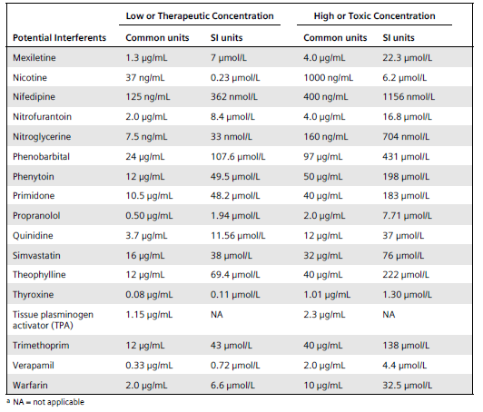
Specificity
The ADVIA Centaur TNIH assay shows high specificity for cTnI. The following compounds were added at the concentrations indicated to a serum or lithium heparin sample with a known cTnI concentration. ADVIA Centaur TNIH assay results from the spiked samples were compared with those of unspiked control samples. Percent cross-reactivity was determined in accordance with CLSI Document EP07-A2 and is calculated as:
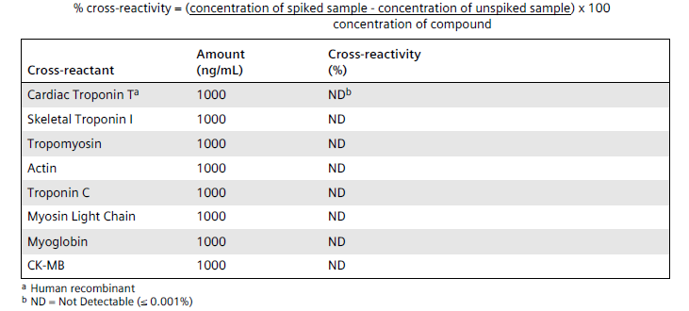

High-Dose Hook Effect
No hook effect has been observed in patient samples with cTnI levels as high as 500,000 pg/mL (ng/L).

Other- Limitations
- The use of a single sample type (either lithium heparin or serum) is recommended for troponin analysis when collecting serial samples from the same patient.
- Serum is acceptable per Siemens, but has not been validated by Lifespan Labs.
- If clotting time is increased due to thrombolytic or anticoagulant therapy, using serum samples may increase the risk of micro-clots, fibrin, or particulate matter. Lithium heparin plasma is the preferred sample type for patients undergoing anticoagulant therapy.
- Specimens from some individuals with pathologically high gamma globulin levels may demonstrate depressed troponin values. Additional information may be required for diagnosis.
- Heterophilic antibodies and rheumatoid factor in human serum can react with reagent immunoglobulins, interfering with in vitro immunoassays. Patients routinely exposed to animals or to animal serum products can be prone to this interference and anomalous values may be observed. Additional information may be required for diagnosis.
- Samples from patients receiving preparations of mouse monoclonal antibodies for therapy or diagnosis may contain human anti-mouse antibodies (HAMA). Such samples may show either falsely elevated or falsely depressed values when tested with this method.
- An unknown interference was observed in analytical spiking and dilution studies causing negative bias that may affect interpretation of patient results. The unknown interference may be due to the presence of troponin autoantibodies, which have been reported in up to 10% of patients with or without AMI and up to 20% of patients positive for rheumatoid factor. If the cTnI result is below the 99th percentile value at the first blood draw, at least two additional blood samples should be drawn before results are interpreted as negative for AMI.

Calculation of Results
The instrument reports troponin I results in pg/mL (common units) or ng/L (SI units), depending on the units defined when setting up the assay.
Lifespan Labs will report in ng/L

Analytical Measuring Range
2.50–25,000.00 pg/mL (ng/L)

Dilutions
The sample volume required to perform onboard dilution differs from the sample volume required to perform a single determination. Refer to the following information for the sample volume required to perform onboard dilutions:
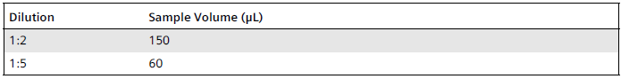
Patient samples with cTnI levels > 25,000 pg/mL (ng/L) can be diluted and retested to obtain quantitative results. Patient samples with cTnI levels ≤ 25,000 pg/mL (ng/L) should not be diluted.
- Patient samples can be automatically diluted by the system.

- For automatic dilutions, ensure that ADVIA Centaur Multi-Diluent 11 is loaded and set the system parameters as follows:
Dilution point: 25,000 pg/mL (ng/L)
Dilution factor: Max dilution = x5

Sensitivity
The limit of blank (LoB), limit of detection (LoD), and the limit of quantitation (LoQ) were determined as described in CLSI Document EP17-A2. The assay is designed to have an LoD of ≤ 1.6 pg/mL (ng/L), and an LoQ of ≤ 3.0 pg/mL (ng/L).
The LoB is defined as the highest measurement result that is likely to be observed for a blank sample. The ADVIA Centaur TNIH assay has an LoB of 0.50 pg/mL (ng/L).
The LoD is defined as the lowest concentration of cTnI that can be detected with 95% probability. The ADVIA Centaur TNIH assay has an LoD of 1.60 pg/mL (ng/L).
The LoQ is defined as the lowest concentration of cTnI that can be detected at a total CV of 20%. The ADVIA Centaur TNIH assay has an LoQ of 2.50 pg/mL (ng/L).
Report results below the LoQ as < 2.50 pg/mL (ng/L).

Expected Values
Female reference range | 3 – 37 ng/L
Male reference range | 3 – 57 ng/L

Values above the 99th percentile upper reference limits for male or female will be flagged as high.
Reportable Range <3 – >125,000 ng/L

Critical Values
There is no critical value defined. Refer to Reporting section.

Reporting- Courtesy Calls

Call to Emergency Dept every time | ≥120 ng/L
First subsequent level >120ng/L following an ED stay (patient admitted to inpatient unit) must be called to the non-ED clinical unit.

Clinical Interpretations

This assay measures cTnI in nearly 100% of healthy people which enables the establishment of a reference range. Therefore, hs-cTnI levels must be interpreted in the clinical context.
- The Emergency Department workflow will by using the new 4th Universal Definitions of Myocardial Injury and Myocardial Infarction which is the 0h/2h rule-out myocardial infarction strategy. Troponin levels will be collected at the two intervals and results will be reported to Lifechart. This strategy enables the definition and presentation of delta values which are related to the assay and inter-/intra-individual variation. The calculated delta values will be available for the healthcare team to assess and determine treatment or next steps. Evaluation involves some combination of a 0 and a 2-hour troponin along with clinical suspicion and agreed upon disposition decision making.
- The troponin order will default to a 0, 2-hour order for the ED patients.
- 0/2h delta: Absolute difference in hs-cTnI values between a baseline and “two-hour” lithium heparin plasma specimen.
- Treatment for Inpatients will be based on the 0h/3h/6h rule-out MI strategy on the clinical units. Any troponin orders will default to the 0, 3, 6-hour orders for inpatients.

Note Appendices L1 and L3 of CLSI QMS02-A6, published 2/28/2013, guided the creation of this document.
Siemens document number: 11200077D_TNIH_EN_US

