**PROCEDURE: C. DIFFICILE GENEXPERT DX SYSTEM**

# PRINCIPLE

* 1. The Cepheid Xpert® *C. difficile* Assay, performed on the Cepheid GeneXpert® Dx System, is a qualitative *in vitro* diagnostic test for rapid detection of toxin B gene sequences from stool specimens collected from patients suspected of having *Clostridioides difficile* infection (CDI).  The test utilizes automated real-time polymerase chain reaction (PCR) to detect toxin gene sequences associated with toxin producing *C. difficile*.  The Xpert *C. difficile* Assay is intended as an aid in the diagnosis of CDI.  The GeneXpert Dx System automates and integrates sample purification, nucleic acid amplification, and detection of the target sequence in simple or complex samples using real-time PCR and RT-PCR assays. The system consists of an instrument, personal computer, and preloaded software for running tests and viewing the results. The system requires the use of single-use disposable cartridges that hold the PCR reagents and hosts the PCR process. Because the cartridges are self-contained, cross-contamination between samples is eliminated. The Xpert *C. difficile* Assay includes reagents for the detection of toxigenic *C. difficile*, as well as a Sample Processing Control (SPC). The SPC is present to control for adequate processing of the target bacteria and to monitor the presence of inhibitors in the PCR reaction. The Probe Check Control (PCC) verifies reagent rehydration, PCR tube filling in the cartridge, probe integrity, and dye stability.

1. **AVAILABILITY**

Specimens will be run on all 3 shifts, 7 days a week

1. **TEST CODE**
   1. CDPCR
2. **SPECIMEN**
   1. A minimum of 10 mL of liquid or soft stool specimens collected from patients suspected of having *Clostridioides difficile* infection (CDI). *C. difficile* orders are allowed throughout a hospital stay for patients with suspected CDI. Positive patients will not be retested for 7 days. **Formed Stools and stools less than 10ml in volume are not accepted.** Stools that do not move in the cup when tipped will have to pass the stick test.
      1. **STICK TEST-** Place a stick approximately 1 inch into the stool. If the stick remains upright, the stool should be cancelled as formed.Save cancelled stools in 7-day bucket.
         1. Canceled stools need to be called.
      2. Stools less than 10 mL will be canceled as QNS
      3. Inpatient specimens: receipt within 24 hours
      4. Outpatient specimens: refrigerated specimens up to 5 days
      5. Collected specimens should be kept between 2°C and 25°C during transport. Protect against freezing and exposure to heat.
      6. Any stool can be cancelled as a duplicate if previously negative within 3 days.
      7. **ANY** doctor wishing the *C. difficile* to be run after it has been cancelled will need Director approval.
3. **MATERIALS AND EQUIPMENT**
   1. MATERIALS
      1. The Xpert *C. difficile* Assay cartridge contains the following:
         1. Bead 1 (freeze-dried) 1 per cartridge
            1. Polymerase
            2. dNTPs
            3. BSA (bovine serum albumin)
            4. Probe
         2. Bead 2 (freeze-dried) 1 per cartridge
            1. Primers
            2. Probes
            3. BSA
         3. Bead 3 (freeze-dried) 1 per cartridge
            1. Sample Processing Control (SPC) noninfectious sample preparation control spores
         4. Reagent 1 (Sodium Hydroxide) 1 x 3.0 ml
         5. Reagent 2 (Tris Buffer, EDTA, surfactants) 1 x 3.0 ml
      2. Sample Reagent (Guanidinium thiocyanate and surfactants) 1 x 2.0 ml
   2. Materials available but not provided
      1. Sterile cotton tipped swab
      2. Disposable, sterile transfer pipettes (for sterile transfer into cartridge)
      3. Microbiologics® KwikStik™ QC organisms
         1. Positive Control: *C. difficile* ATCC 9689
         2. Negative Control: *C. difficile* ATCC 700057
      4. Materials to properly clean the hood at the beginning of each shift, between testing or any time it is needed. To be used in this order:
         1. 10% bleach
         2. DI H2O
         3. 70% Ethanol
   3. EQUIPMENT
      1. Infinity System (RIH)
      2. GeneXpert Gx System (TMH & NH)
      3. Biosafety Cabinet
      4. Vortex
4. **STORAGE AND HANDLING**
   1. Store the Xpert C*. difficile* cartridges and reagents at 2-28º C
   2. Do not open a cartridge until you are ready to perform testing.
   3. Do not use any reagents that have become cloudy or discolored.
   4. Use the cartridge and reagents within 30 minutes after opening the package.
5. **QUALITY CONTROL**
   1. Maintenance
      1. Cleaning and maintenance of the instrument will be performed in accordance with the vendors Operator’s Manual. For further information, refer to the Infinity or GeneXpert System’s Operator’s Manual.
   2. Each test includes two internal controls to validate the assay:
      1. Sample processing control and probe check. External quality control is run on new shipments and/or monthly, whichever is more frequent, and after major system maintenance including: software upgrade, annual PM, and if 3 or more modules are replaced at the same time. They are also repeated if the controls are out of range or invalid. Positive and negative external controls purchased from Microbiologics®:

*C. difficile* ATCC 9689 and C. *difficile* ATCC 700057.

* 1. Each Test includes a Sample Processing Control (SPC) and a Probe Check Control (PCC) and a Sample processing control (SPC)
     1. The SPC is present to control for adequate processing of the target bacteria and to monitor the presence of inhibitors in the PCR reaction The SPC is considered to pass if it meets the validated acceptance criteria. If the SPC does not meet acceptance criteria, the sample was not properly processed or PCR is inhibited, the SPC will fail.
     2. Probe check –Before the start of the PCR reaction, the GeneXpert is programmedto perform a probe check to verify reagent bead rehydration and reaction tube filling. Probe check is considered to pass if it meets the validated acceptance criteria. If the reaction tube was filled improperly, a probe integrity problem was detected or the assay aborts, the probe check will fail.
     3. External Quality Control Preparation: 
        1. Allow the Kwik-Stik pouches containing the positive and neagative control to equilibrate to room temperature then remove the Kwik-Stik tube from the pouch.
        2. With a fresh pair of gloves, crack the ampule found in the cap of the Kwik-Stik tube to release the hydration fluid.
        3. Hold tube vertically and tap on a hard surface to allow the hydration fluid to reach the lyophilized pellet at the bottom of the tube.
        4. Pinch the bottom of the tube to break up the pellet and mix with the hydration fluid.
        5. Saturate the swab with the hydrated material and break the swab into the Xpert *C. difficile* assay sample reagent.
        6. Vortex for 10 seconds.
        7. Using a sterile transfer pipette, transfer all the contents of the sample reagent into a Xpert *C. difficile* cartridge.
  2. Environmental “wipe” testing is performed monthly. All testing areas are swabbed and run as test patients.

1. **TEST PROCEDURE** 
   1. Pre-analytical
      1. Clean designated molecular hood by spraying with 10% bleach; rinse with deionized water; clean with 70% ethanol. This cleaning procedure must be performed before and after each specimen.
         1. If multiple tests are ordered, split for molecular testing BEFORE it is processed for routine testing.
   2. Specimen
      1. Specimen should be collected in a clean container.
      2. Store specimen at 2-8° C. The specimen is stable for up to five days when stored at 2-8°
      3. Specimens will be accepted if left at room temperature (20-30° C) for up to 24 hrs in rare occasions.
      4. Positive patients will not be retested for 7 days.
   3. Preparing the Cartridge – Refer to Figure 1

**Note:** Be sure to load the cartridge into the Infinity or GeneXpert Dx instrument and start the test within 30 minutes of adding the sample to the cartridge:

**TEST WILL BE PERFORMED IN MOLECULAR HOOD FOUND IN MAIN LAB**

* + 1. Remove one cartridge and reagent from the packaging.
    2. Open container with clean gauze. Change gauze between samples. Change gloves between samples.
    3. Briefly place a swab in the stool sample. The swab does not need to be completely saturated. See figures 6, 7.
    4. Insert the swab into the vial containing the Sample Reagent. ***Note***: **Use sterile gauze to minimize risks of contamination when handling swab.**
    5. Hold the swab by the stem near the rim of the vial, lift the swab a few millimeters from the bottom of the tube and push the stem against the edge of the vial to break it. Make sure the swab is short enough to allow the cap to close tightly.
    6. Close the lid and vortex at high speed for 10 seconds
    7. Open the cartridge lid. Using a clean transfer pipette, transfer the entire contents of the Sample Reagent to the “S” chamber of the Xpert *C. difficile* Assay cartridge. Avoid bubbles when adding specimen to sample chamber.
    8. Close the cartridge lid.
    9. Do not use cartridge if it is tipped or dropped after specimen and reagents have been added.
    10. See Appendix AP77 for abbreviated procedure.

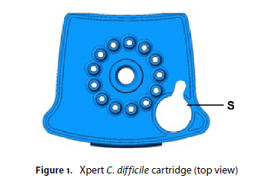

**S =Sample**

* 1. Starting the Test
     1. Infinity Systems
        1. Log on to the Cepheid Infinity System software using your username and password
        2. Click “Order” then “Order Test”
        3. Scan in the specimen barcode for Patient ID
        4. Scan in the specimen barcode for Specimen ID
        5. Scan in cartridge barcode
        6. Click “Submit.” In the dialog box that appears, type your password (if required)
        7. After clicking Submit, you will be asked to place the cartridge on the conveyor belt. After placing the cartridge, click OK to continue. The cartridge will be automatically loaded, the test will run and the used cartridge will be placed onto the waste shelf for disposal.
        8. When all samples are loaded, click “End Order Test”
     2. GeneXpert Dx Systems
        1. Log on to the Cepheid Dx System software using your username and password.
        2. In the Cepheid Dx System window, click “Create Test”.
        3. Scan patient barcode
        4. Scan cartridge barcode.
        5. Click “Start Test”.
        6. Open the instrument module door with the blinking green light and load the cartridge. Close the door. Check to ensure that the green light stops blinking.
        7. The test will be completed in approximately 45 minutes. The module door will unlock and open slightly. Remove the cartridge and discard in the biohazard bin.

1. **INTERPRETATION**

**NOTE**: the results are available in the Xpert System Software- View Results window. Sample processing control (SPC) is displayed as CIC (Cartridge internal control) in the View Results window

* 1. POSITIVE (Fig. 1) – Toxin producing *C. difficile* target DNA sequences are detected.

SPC (CIC) - PASS, FAIL or Non-applicable (N/A)*

Probe Check – PASS

*SPC is ignored since target amplification may compete with control.

* 1. NEGATIVE (Fig. 2) – Toxin producing *C. difficile* targets not detected.

SPC (CIC) – PASS

Probe Check – PASS

* 1. INVALID (Fig. 3) – Presence or absence of *C. difficile* target DNA cannot be determined. Repeat test according to the instructions in the Retest Procedure section below.

SPC (CIC) – FAIL

Probe Check – PASS

* 1. ERROR or NO RESULT – Presence or absence of *C. difficile* cannot be determined. Repeat test according to instructions in the Retest Procedure section below.

*C. difficile* – NO RESULT

SPC (CIC) – NO RESULT

Probe Check – FAIL or NO RESULT

1. **RETEST PROCEDURE for INVALID/ERROR or NO RESULT**

**NOTE:** For retest within 3 hours of an indeterminate result, use a new cartridge (do not re-use the cartridge) and new reagents. For retest after 3 hours of an indeterminate result, repeat the test with a new swab sample.

* 1. Open the cartridge that failed. Transfer remaining contents from Chamber S to a new Sample Reagent vial using a disposable transfer pipette. For retest after 3 hours of an indeterminate result, repeat the test with a new swab sample.
  2. Vortex for 10 seconds and add the entire contents of the Sample Reagent to Chamber S of the new Xpert *C. difficile* Assay cartridge.
  3. Close the lid and start new test.
  4. If result remains Invalid/ Error or No Result upon repeat send out as “Indeterminate”

1. **REPORTING RESULTS**
   1. Report positive patients as: *C.difficile* Toxin DETECTED
      1. Refer to Critical Call policy for positive results. If comment is needed use @CALM; called to ___ and read back by___, *date, time.*
      2. Positive results will be reflexed to TOX A/B QUIK CHEK to test for *C. difficile* free toxin. Refer to TECHLAB® *TOX A/B QUIK CHEK®*procedure and Appendix AP 77 *– C. difficile Assay Resulting*
   2. Report negative patients as: *C.difficile* Toxin Not Detected
   3. INDETERMINATE: RESULT: A patient’s sample is considered “indeterminate” when the curve associated with that sample fails to cross the user-defined cycle threshold and the specimen’s internal control fails to amplify.
   4. Children <3 yrs old: Soft will automatically add the comment: “Routine testing for *C. difficile* toxin in children <3 of age is not recommended unless other agents of gastroenteritis have been excluded (AAP, Pediatrics 2014, 131:196-200).”
   5. Positivity Rate is monitored monthly

Figure 1 - An example of a toxigenic *C. difficile* POSITIVE result. 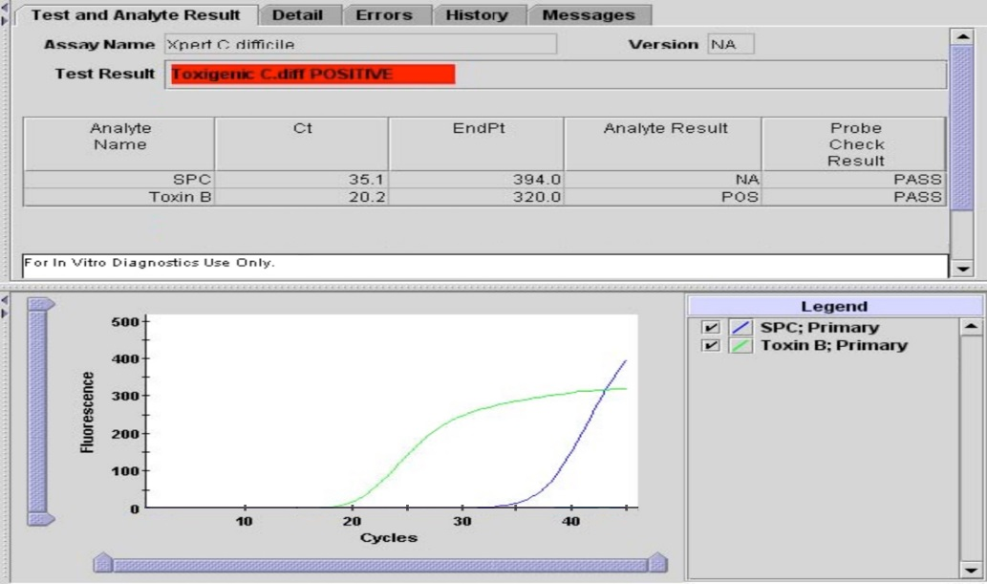

Figure 2 - An example of a toxigenic *C. difficile* NEGATIVE result.

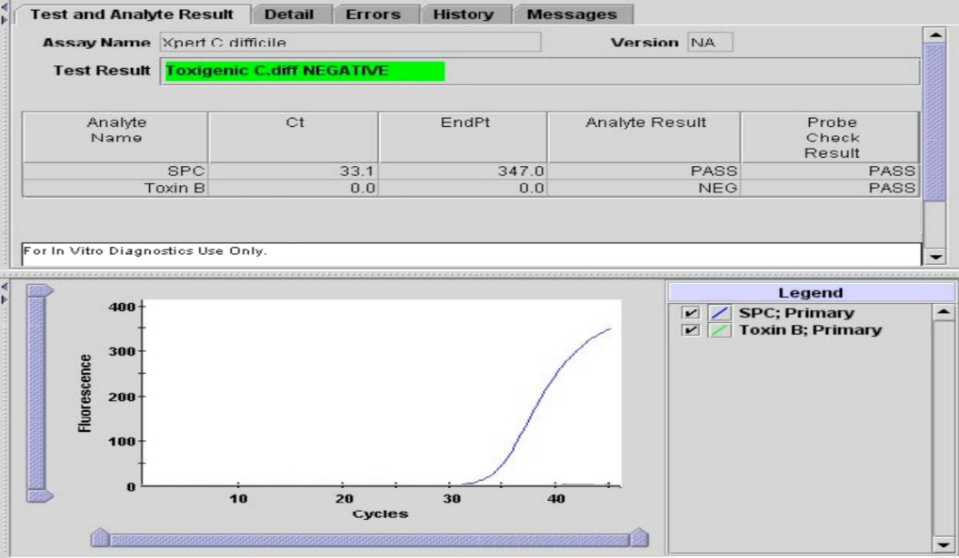

Figure 3. An example of an INVALID result.

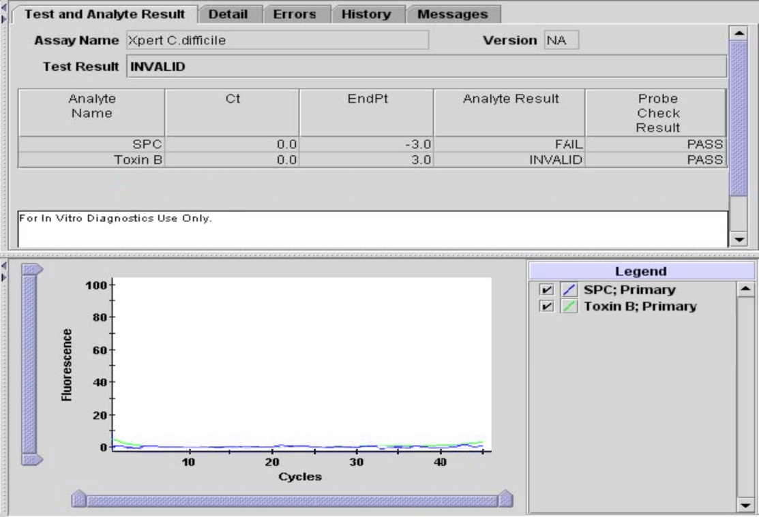

1. **LIMITATIONS**
   1. This test detects but does not differentiate the NAP1 (Ribotype 027) strain from other toxigenic strains of *C. difficile*.
   2. This test targets the *tcdB* gene for Toxin B production. This test will not detect strains of *C. difficile* that do not contain the *tcdB* gene.
   3. The performance of the Xpert *C. difficile* Assay was validated using the procedures provided in this package insert only. Modifications to these procedures may alter the performance of the test.
   4. Results from the Xpert *C. difficile* Assay should be interpreted in conjunction with other laboratory and clinical data available to the clinician.
   5. Erroneous test results might occur from improper specimen collection, failure to follow the recommended sample collection, handling and storage procedures, technical error, sample mix-up, or because the number of organisms in the specimen is too low to be detected by the test. Careful compliance with the instructions in this insert is necessary to avoid erroneous results.
   6. Because of the dilution factor associated with the retest procedure, it is possible that *C. difficile* positive specimens, very near or at the limit of detection (LoD) of the Xpert *C. difficile* Assay, may result in a false negative result upon retest
   7. Inhibition of the Xpert *C. difficile* Assay has been observed in the presence of the following substances: Zinc oxide paste and Vagisil® cream.
2. **TECHNICAL SUPPORT**
   1. For Technical Support contact Cepheid Technical Support at 888-838-3222 or [**techsupport@cepheid.com**](mailto:techsupport@cepheid.com)
   2. Before contacting Cepheid Technical Support, collect the following information:
3. Product name
4. Lot number
5. Serial number of the instrument
6. Error messages (if any)
7. Software version and, if applicable, Computer Service Tag number
8. **REFERENCES**
   1. Larson HE, Price AB, Honour P, Borriello SP. Clostridium difficile and the aetiology of pseudomembranous colitis, Lancet 1978; 1:1063-1066.
   2. Bartlett JG. Clinical practice. Antibiotic-associated diarrhea. N Engl J Med 2002; 31:334-339
   3. Borriello SP. The influence of the normal flora on Clostridium difficile colonization of the gut. Ann Med 1990;22-61-7
   4. Bignardi GE. Risk factors for Clostridium difficile infection. J Hosp Infect 1998; 40-1-15.
   5. Kelly CP, Pothoulakis C, Lamont JT. Clostridium difficile colitis. N Engl J Med 1994; 330:257-262.
   6. Braun VT, Hundsberger P, Leukel M, Sauerborn and C. von Eichel-Striber. Definition of the single integration site of the pathogenicity locus of Clostridium difficile. 1996; Gene 181:29-38.
   7. Hammond GA, Johnson JL. The toxigenic element of Clostridium difficile strain VPI 10463. Microb Pathog. 1995;19:203-213.
   8. Sambol SPMM, Merrigan D, Lyerly DN Gerding, Johnson S. Toxin gene analysis of a variant strain of Clostridium difficile that causes human clinical disease. Infect. Immun 2000;68:5480-5487.
   9. Goncalves C, Decre D, Barbut F, Burghoffer B, Petit JC. Prevalence and characterization of a binary toxin (actin-specific ADP-ribosyl-transferase) from Clostridium difficile. J Clin Microbiol 2004;42:1933-9
   10. Stubbs S, Rupnik M, Gibert M, Brazier J, Duerden B, Popoff M. Production of actin-specific ADP-ribosyltransferase (binary toxin) by strains of Clostridium difficile. FEMS Microbiol Lett 2000;186:307-12.
   11. Popoff MR, Rubin EJ, Gill DM, Boquet P. Action-specific ADP-ribotransferase produced by a Clostridium difficile strain. Infect Immun 1998;56:2299-306.
   12. Kuijper EJ, Coignard B, Tull P. ESCMID Study Group for Clostridium difficile; EU Member States; European Centre for Disease Prevention and Control.Emergence of Clostridium difficile-associated disease in North America and Europe. Clin Microbiol Infect. 2006; Oct;12 Suppl 6:2-18. Review.
   13. Curry SR, Marsh JW, Muto CA, O'Leary MM, Pasculle AW, Harrison LH. tcdC genotypes associated with severe TcdC truncation in an epidemic clone and other strains of Clostridium difficile, J Clin Microbiol. 2007 Jan;45(1):215-21. Epub 2006 Oct.
   14. Erratum in: J Clin Microbiol. 2007 Jun;45(6):2103.
   15. MacCannell DR, Louie TJ, Gregson DB, Laverdiere M, Labbe AC, Laing F, Henwick S. Molecular analysis of Clostridium difficile PCR ribotype 027 isolates from Eastern and Western Canada, J Clin Microbiol. 2006 Jun;44(6):2147-52.
   16. Wilkins TD, Lyerly DM. Clostridium difficile testing: after 20 years, still challenging. Clin Microbiol. 2003 Feb;41(2):531-4. Review.
   17. Delmee M. Laboratory diagnosis of Clostridium difficile disease. Clin Microbiol Infect. 2001 Aug;7(8):411-6. Review.
   18. Poutanen SM, Simor AE. Clostridium difficile-associated diarrhea in adults. CMAJ. 2004 Jul 6;171(1):51-8. Review.
   19. Centers for Disease Control and Prevention. Biosafety in microbiological and biomedical laboratories. Richmond JY and McKinney RW (eds) (1993). HHS Publication number (CDC) 93-8395.
   20. Clinical and Laboratory Standards Institute (formerly National Committee for Clinical Laboratory Standards). Protection of laboratory workers from occupationally acquired infections; Approved Guideline. Document M29 (refer to latest edition)
   21. Lawson, P. A., Citron, D. M., Tyrrell, K. L. & Finegold, S. M. (2016). Reclassification of Clostridium difficile as Clostridioides difficile (Hall and O’Toole 1935) Prevot 1938. Anaerobe 40, 95–99.
   22. Oren, A. & Garrity G.M. List of new names and new combinations previously effectively, but not validly, published. IJSEM. 2016; 66, 3761-3764
9. **ATTACHMENTS**
   1. Appendix AP77 – *C. difficile* Assay Resulting
10. **REVISIONS**
    1. 02/10/2020 Nomenclature change – updated *Clostridium* to *Clostridioides*
    2. 06/21/2021 Procedural change- TECHLAB® *TOX A/B QUIK CHEK®* Procedure referred