**Maxwell® RSC Instrument Procedure**

1. **PRINCIPLE:**
   1. The Maxwell® Rapid Sample Concentrator (RSC) Instrument performs automated nucleic acid purification using magnetic particle-handling. The Maxwell® RSC Instrument is designed for use on a range of sample types.
   2. The purification method uses sample lysis and binding to paramagnetic particles as the primary separation principle. The workflow of the automated purification includes:
      1. **Lysis** of the specimen in the presence of a specially formulated Lysis Buffer.
      2. **Binding** of nucleic acids to paramagnetic particles.
      3. **Washing** of the bound target molecules away from other cellular components.
      4. **Elution** of the product.
   3. The Maxwell® RSC System is comprised of the Maxwell® RSC Instrument, a Tablet PC with the Maxwell® RSC Application Software, the Quantus™ Fluorometer and the Maxwell® RSC Preprocessing Kit (RNA FFPE Kit and DNA FFPE Kit).
      1. **The Maxwell® RSC Instrument**:
         * 1. Performs automated nucleic acid purification for up to 16 samples simultaneously in less than an hour.
           2. Minimal risk of cross-contamination due to magnetic handling.
           3. UV lamp to aid in decontamination.
      2. **The Quantus™ Fluorometer**:
         * 1. Compact dual-channel fluorometer for quantitation.
           2. Provides highly sensitive fluorescent detection of purified nucleic acids.
      3. **The Maxwell® RSC Sample Preprocessing Kits**:
         * 1. Extract RNA and DNA from formalin-fixed, paraffin-embedded tissue samples.
           2. Pre-dispensed reagent cartridges for simplicity**.**
      4. **The Tablet PC**:
         * 1. User interface: touch screen with Microsoft Windows® operating system.
           2. Control of the Maxwell® RSC Application Software, which includes preprogrammed purification methods and the interactive Maxwell® RSC User Home Screen.
   4. The Home Screen of the Maxwell® RSC Application Software contains four tabs for instrument operation:
      * 1. **Start** – The Start tab begins the process of preparing a protocol run on the Maxwell® RSC Instrument.
        2. **Results** – The Results tab allows users to view the Reports Screen where it is possible to review, print, and export any of the run reports from previous purification runs and service processes. Here, users can also use the integrated Quantus™ Fluorometer when applicable.
        3. **Sanitize** – The Sanitize tab activates the UV light in the Maxwell® RSC Instrument to perform a sanitization.
        4. **Settings** – The Settings tab accesses the Settings window, where users can view Instrument Info, export log files, change instrument settings and perform QC (Self-Test) and Troubleshooting functions.
   5. See the Maxwell® RSC System components in Figure 1:

**Figure 1: The Maxwell® RSC System (RSC Instrument, Tablet PC, Quantus™ Fluorometer, and Sample Preprocessing Kit)**

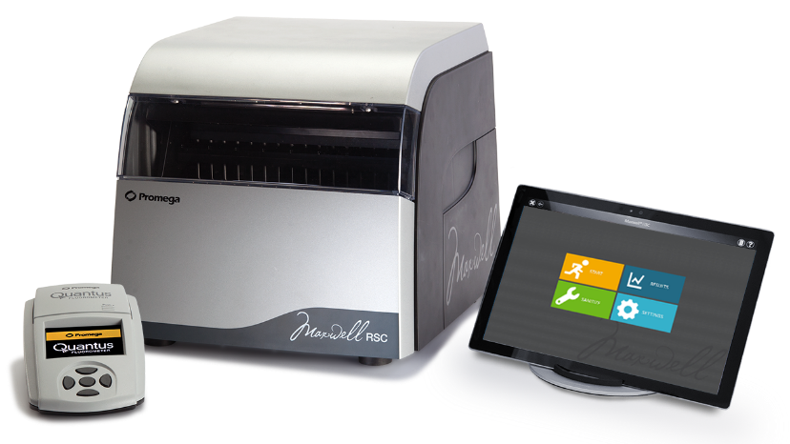

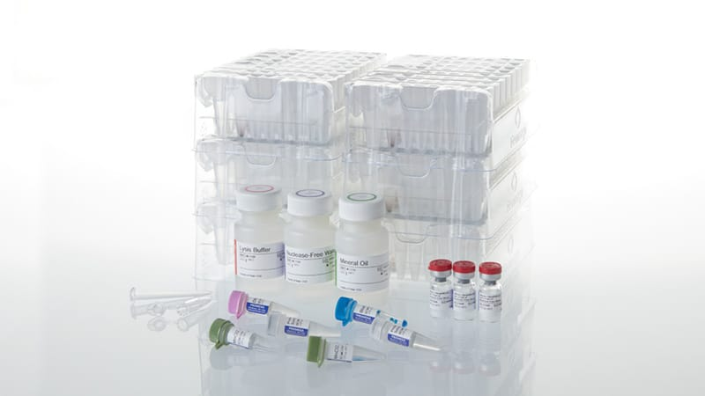

* 1. See the Maxwell® RSC Application Software Home Screen in Figure 2:

**Figure 2: The Maxwell® RSC Home screen**

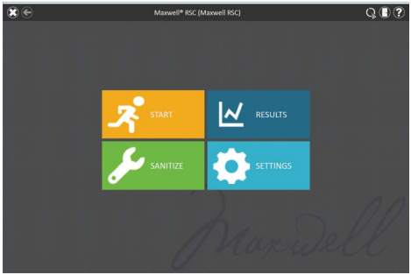

1. **PROCEDURE FOR OPERATION:**
   1. Purification by the Maxwell® RSC requires samples that have been preprocessed using the RSC RNA FFPE or RSC DNA FFPE Extraction Kits.
   2. **RSC Cut Block/RSC Scrape Slides**
      1. Log into Soft Molecular.
      2. Open Extractions by using the Extractions tile on the dashboard.
      3. Highlight RSC Cut Block or RSC Scrape Slides branch in the action tree.
      4. Highlight the Barcode# field. Scan the Soft Molecular specimen label and press **Enter** on the keyboard. Repeat this step for all applicable specimens.
      5. **If a sample is being re-extracted, expand the child level and change the Volume in the child level tube to 200. This is necessary to ensure adequate volume in the system for performing any testing.**
      6. Select **Save**.
         1. Two aliquot labels per sample will automatically print upon saving.
            1. If only one 1.5ml tube is being utilized, discard the second aliquot label in the appropriate receptacle.
      7. Label a 1.5ml tube with an aliquot label for each specimen.
   3. Preprocessing of FFPE Samples:
      1. For FFPE blocks
         * 1. Use a microtome set at 5 microns and cut 5 slices/scrolls per sample.
           2. Place the tissue sections into an appropriately labeled 1.5mL microcentrifuge tube.
           3. BRIEFLY, spin down the tube if needed.
      2. For macrodissection of tissue on unstained slides, use 5 slides per sample or number of slides otherwise noted.
         * 1. Line up the corresponding circled H&E slide and circle the tumor area of interest on the back of the unstained slides.
           2. Warm the unstained slides on the heat block just until the wax is melted.
           3. Using a scalpel, scrape off the area of interest and place the tissue sections into an appropriately labeled 1.5mL microcentrifuge tube.
           4. Spin down the tube for 5 seconds.
      3. Prepare a Blank reaction tube for each Maxwell® RSC run for quality control.
         * 1. Label a 1.5mL microcentrifuge tube as the “Blank”.
           2. Process the Blank reaction along with the samples.
      4. Add 300µL of Mineral Oil to each sample and Blank tubes.
      5. Vortex for 10 seconds.
      6. Ensure that the tissue section is completely immersed in the Mineral Oil.
      7. Heat the samples at 80°C for 2 minutes.
      8. After the 2 minutes of incubation, place the samples at room temperature while the master mix is prepared.
      9. **NOTE**: Use the master mix within 1 hour of preparation. The master mix cannot be stored for later use.
      10. Prepare a master mix of Lysis Buffer, Proteinase K Solution and Blue Dye as shown below.
      11. See Table 1 for Master Mix preparation

**Table 1: The RSC Master Mix Preparation**

|  |  |  |  |  |
| --- | --- | --- | --- | --- |
| **Number of Samples/**  **Reaction Tubes** | **Volume of Lysis Buffer**  **(µL)** | **Volume of Proteinase K (µL)** | **Volume of Blue Dye**  **(µL)** | **Total Volume**  **(µL)** |
| 1 | 448 | 50 | 2 | 500 |
| 2 | 672 | 75 | 3 | 750 |
| 3 | 896 | 100 | 4 | 1000 |
| 4 | 1120 | 125 | 5 | 1250 |
| 5 | 1344 | 150 | 6 | 1500 |
| 6 | 1792 | 200 | 8 | 2000 |
| 7 | 2016 | 225 | 9 | 2250 |
| 8 | 2240 | 250 | 10 | 2500 |
| 9 | 2464 | 275 | 11 | 2750 |
| 10 | 2688 | 300 | 12 | 3000 |
| 11 | 2912 | 325 | 13 | 3250 |
| 12 | 3136 | 350 | 14 | 3500 |
| 13 | 3360 | 375 | 15 | 3750 |
| 14 | 3584 | 400 | 16 | 4000 |
| 15 | 3808 | 425 | 17 | 4250 |
| 16 | 4032 | 450 | 18 | 4500 |

* + 1. Vortex the master mix for 5 seconds to mix.
    2. Add 250µL of master mix to each reaction tube.
    3. Vortex each tube for 5 seconds.
    4. Centrifuge the tubes at 10,000 x g for 30 seconds to separate the layers.
    5. **NOTE**: If a large pellet remains in the lower blue layer, mix the lower blue layer with a 1mL pipette tip to resuspend the pellet. Centrifuge the tube again at 10,000 x g for 30 seconds to separate the layers.
    6. **NOTE**: Ensure that the correct incubation time is used for the appropriate preprocessing kit.
    7. Transfer the tubes to a 56°C heat block.
    8. For **RNA FFPE** extraction, incubate the samples at 56°C for 15 minutes.
    9. After the 56°C incubation, immediately transfer the samples to an 80°C heat block.
    10. For **RNA FFPE** extraction, incubate the samples at 80°C for 1 hour.
    11. After the 80°C incubation, remove the samples from the heat block.
    12. Allow the samples to cool to room temperature for 8 minutes.
    13. After the samples reach room temperature, add 50µL of Nuclease-Free Water to the lower blue layer in each tube. Then, pipette 5 times to mix.
    14. Centrifuge the samples at full speed in a microcentrifuge for 2 minutes.
    15. The samples are now preprocessed and ready to be loaded onto the Maxwell® RSC for purification.
    16. Proceed to Section E below.
  1. **Record your extraction reagents: RSC Extraction Reagents**
     1. Log into Soft Molecular and open Extractions tile on the dashboard, if applicable.
     2. Highlight the RSC Extraction Reagents branch on the action tree.
     3. Highlight the Barcode# field. Scan the aliquot label or SoftLab specimen label and press **Enter** on the keyboard. Repeat this step for all applicable specimens.
     4. Enter the final elution volume in the Prod Vol column.
        + 1. FFPE Block/Unstained Slides: 35ul
     5. Select the Spec/Tube Reagents field and in the dropdown, scan the appropriate TQC reagent label to add the RSC Maxwell FFPE LEV kit lot number to each specimen.
     6. Select **OK** in the Spec/Tube Reagent window.
     7. Mark the **Completed** checkbox and select **Save**.
  2. Starting the Maxwell® RSC System:
     1. If the Maxwell® RSC Instrument and the Tablet PC are already powered on, proceed to Step 10 below; otherwise, continue to Step 2.
     2. Start the System by powering on the Maxwell® RSC and the Tablet PC.
     3. The RSC power switch is located next to the power cable connection on the back-left side of the instrument.
     4. Power on the instrument by switching the On/Off power switch to “On”.
     5. Press the power button located on the top of the Tablet PC to power on the Tablet.
     6. Launch the Maxwell® RSC Application Software by touching the software icon on the touchscreen.
     7. A Self-Test is performed automatically when the instrument is powered on and the software launched.
     8. The Self-Test checks the Maxwell® RSC’s initialization, motion, and heater functions.
     9. The Self-Test can also be manually initiated if the System is already on.
     10. From the Home Screen, select the Settings tab and then, select Self-Test to perform the Self-Test.
     11. NOTE: A Self-Test must be performed and passed before each use of the instrument.
  3. Starting a Run:
     + 1. From the Home Screen, select Start.
       2. Touch the text box at the top of the screen to enter the kit barcode ID.
       3. Using the keypad, enter the entire barcode ID, which can be found on the label of the kit or use a scanner to scan the barcode (e.g.; AS14401041092020-08).
       4. **NOTE**: The kit barcode ID is a combination of the catalog ID, lot number, and the expiration date of the kit and must be valid to run a Method.
       5. When the barcode ID is entered correctly, the corresponding extraction Method from the list of preprogrammed Methods will become highlighted.
       6. Confirm that the highlighted Method matches the extraction Kit being used.
       7. Touch the **Proceed** buttonnext to the highlighted Method, to move to the Cartridge Setup screen.
       8. The Cartridge Setup screen displays the layout of the Maxwell RSC Deck Tray with position numbers and the selected run Method.
       9. On the Cartridge Setup screen, the user can select which cartridge positions (based on the number of samples) will be processed by selecting or deselecting cartridge positions.
       10. Select a cartridge position by touching the black rectangle above the number of that position.
       11. A selected position can be deselected/deactivated by touching the black rectangle of that position again.
       12. See the Maxwell® RSC Cartridge Setup Screen in Figure 3:

**Figure 3: Cartridge Setup screen**

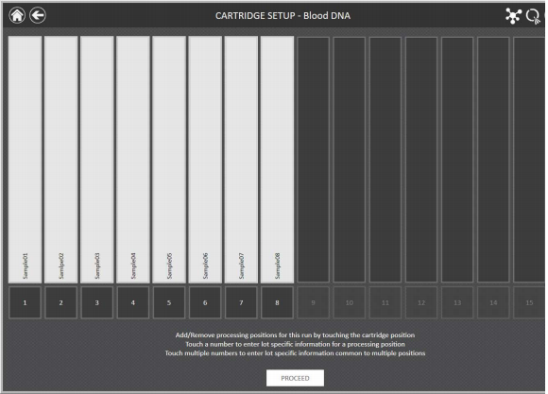

* + - 1. See the Maxwell® RSC Cartridge Setup Screen with Sample ID input in Figure 4:

**Figure 4: Sample ID input screen**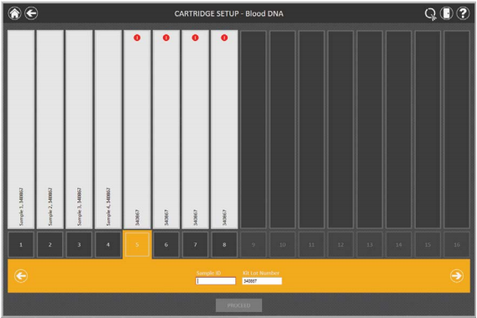

* + - 1. **NOTE**: Deselecting a cartridge position prevents the user from using that position for the run being processed. Therefore, ensure that no cartridges are loaded in positions that have been excluded from processing.
      2. **NOTE**: Conversely, positions that have been selected must be loaded with a cartridge containing the appropriate specimens.
      3. Next, enter the corresponding Sample ID and Elution Tube ID for all cartridge positions that are to be processed.
      4. To enter the Sample ID and Elution Tube ID for a position, touch the “active” position number (black square) on the Cartridge Setup screen.
      5. Touch the **Sample ID** text box and use the keypad to enter the Sample ID or use a scanner to scan the aliquot label (e.g., MOL-00-0000).
      6. Touch the **Elution Tube** **ID** text box and use the keypad to enter the corresponding Elution Tube position number.
      7. When all Sample IDs and Elution Tube IDs have been entered, the **Proceed** button on the bottom of the screen will become active.
      8. Touch the **Proceed** button to move to the Door screen and then press the OK button to open the Maxwell RSC Instrument door.
      9. When the Door opens, the Extraction Checklist screen is presented. The checklist indicates the steps that need to be performed prior to starting an extraction process.
      10. Follow the checklist and ensure that the Deck Tray and instrument are set up accordingly.
      11. **NOTE**: Use only the RSC Plungers, Elution Tubes and Nuclease-Free Water that are supplied with the specific Maxwell RSC Kit.
      12. First, remove the Deck Tray from the Deck for easy loading access. Lift the tray up from the front and pull out.
      13. **NOTE**: If processing fewer than 16 samples, center the cartridges on the Deck Tray as best as possible. If helpful, label the cartridges with the Sample IDs.
      14. Place the new cartridges to be used in the Maxwell RSC Deck Tray at the selected positions.
      15. Press down firmly to snap the cartridges in place at both ends. There should be an audible click.
      16. See the Maxwell® RSC Deck Tray with cartridges in Figure 5:

**Figure 5: Placing the Cartridges in the Deck Tray**

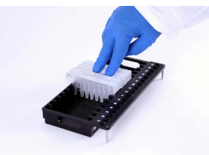****

* + - 1. Carefully remove the foil seals from all cartridges.
      2. Add each preprocessed Sample to well # 1 of the corresponding cartridge (well # 1 is the largest well in the cartridge).
      3. **NOTE**: For some difficult sample types (e.g., large pellet, abundant paraffin, etc.), the transfer process may require more than one attempt to completely transfer the blue, aqueous layer.
      4. **NOTE**: To prevent additional mineral oil and paraffin from getting into the Sample well, take care not to submerge the pipette tip below the surface of the buffer when transferring.
      5. Set a pipette to 350mL and carefully remove the entire blue, aqueous phase of the Sample.
      6. Transfer the Sample to well # 1 of the corresponding cartridge.
      7. Place one plunger into well # 8 of each cartridge (well # 8 is the closest well to the Deck Tray position numbers).
      8. Label the appropriate number of 0.2mL Elution Tubes with the corresponding Elution Tube position number found on the Tray.
      9. Add 50µL of Nuclease-Free Water to the bottom of each Elution Tube and place the Elution Tubes into the corresponding Elution Tube positions for each cartridge on the Deck Tray.
      10. Open the Elution Tubes so that the lids are oriented away from the cartridges.
      11. **NOTE**: The Elution Tubes must stay open during the purification Method.
      12. Place the prepared Tray back onto the RSC Deck by first sliding in the back end of the Tray and then pressing down on the front.
      13. When the Deck Tray has been properly seated, touch the **Start** button to begin the run or touch the **Cancel** button to return to the Cartridge Setup screen.
      14. During the run, the Protocol Selected screen is shown with run information like estimated time remaining, a description of the current step being performed, and a progress bar showing the percent completion of the current step.
      15. **NOTE**: If you wish to abort the run, touch the **Abort** button in the lower right corner of the screen. Any samples being processed will be lost if a run is aborted.
      16. See Figure 6 for Placing the Deck Tray in the instrument:

**Figure 6: Placing the Deck Tray in the instrument**



* 1. **Maxwell RSC TNA Extraction**
     1. Highlight the Maxwell TNA Extraction branch on the action tree.
     2. Highlight the Barcode# field. Scan the aliquot label and press **Enter** on the keyboard. Repeat this step for all applicable specimens.
     3. Navigate to the **Print** tab and click the **Print Product Labels** dropdown menu. Select the ‘**…**’ button that appears.
     4. Select **OK** when asked to save before print.
     5. In the Print Product Labels window, verify the correct printer and product label template is selected (PROD LBL V1). Click **Print**.
     6. Select **Back** in the Extractions window.
     7. Exit Soft Molecular application.
     8. Label a new clean 1.5ml tube with a product label for each specimen.
  2. Completing a run:
     1. **NOTE**: It is important to close the Sample Elution Tubes’ caps as soon as the run is finished.
     2. When the run is finished, the Protocol Selected screen will change to indicate that the protocol is 100% *Completed*.
     3. Touch the **Open-Door** button to open the door of the Maxwell® RSC Instrument.
     4. After the door is opened, the UV sanitization window will be presented.
     5. Do not perform the UV sanitization. Instead, proceed to Step 7 below.
     6. **NOTE**: UV sanitization and other clean-up steps can be performed after the eluates are quantified and stored accordingly.
     7. Immediately cap the Sample Elution Tubes to prevent evaporation and/or contamination of the eluates.
     8. Remove the Deck Tray from the instrument.
     9. Remove the Sample Elution Tubes from the Deck Tray.
     10. Centrifuge at 10,000 g for 30 seconds.
     11. Place the Samples on a magnetic rack for 1 minute to bring any residual magnetic particles toward the center of the magnetic rack.
     12. Aspirate each purified sample and place into a clean and appropriately labeled 1.5mL tube.
     13. Proceed to Nucleic Acid quantification.
     14. After quantification, place samples on ice for immediate use or at -80°C for storage.
     15. Perform the post-run clean up (see the QC and Maintenance section below).
  3. Shutting down the System:
     1. **NOTE**: Shut down the System as needed (e.g., Technical Support, or prolonged period without use).
     2. **NOTE:** If not in use for >1 month, the Maxwell® RSC Instrument and Tablet PC must be shut down and unplugged.
     3. Shut down the Maxwell RSC software by pressing the ‘x’ in the upper left corner of the Home screen.
     4. Switch the Maxwell RSC “OFF” using the On/Off power switch in the back of the instrument.
     5. To shut down the Tablet PC:
        + 1. Swipe inward from the right side of the Home screen.
          2. Select Settings.
          3. Select Power.
          4. Select Shut Down.
  4. **Refer to the Qubit 3.0 Fluorometer Instrument Procedure to measure the nucleic acid concentration of each sample.**
     1. Soft Molecular will automatically calculate dilutions to 100 ng/ul.
     2. If the sample has a concentration of greater than 150 ng/ul, then dilute the sample to 100 ng/ul.
     3. If the sample has a concentration of less than 150 ng/ul, proceed with the appropriate clinical assay.
     4. If a sample has a concentration that is too low to quantitate, in the Excel File, change “Out of range” to “0” (zero) and save as a new file with suffix “_edit”.
  5. **RNA Qubit Quantitation Action**
     1. Log into Soft Molecular.
     2. Open Extractions by using the Extraction tile on the dashboard.
     3. Highlight the RNA Qubit Quantitation branch on the action tree.
     4. Select **Tools** tab followed by **Import** to import Nanodrop results.
     5. Select **RNA QUBIT CONC** from the dropdown in the Template field.
     6. Choose file name using the ‘**…**’ button next to the File Name field and confirm by clicking **Open**.
     7. Select **Import**.
     8. In the Import Finished window, select **OK**.
     9. Close the Import from Excel window using the ‘**X**’.
     10. If a dilution is not required, highlight the Barcode# field, scan the product label, and select **Enter** on the keyboard. Repeat this step for all applicable specimens. Select **Save**.
     11. Select **Back** in the Extractions window.
     12. Exit Soft Molecular application.
  6. **Dilution**
     1. Mark the **Dilute(?)** checkbox for every patient sample that requires a dilution.
     2. Highlight the Barcode# field. Scan the product label and select **Enter** on the keyboard. Repeat this step for all samples pending RNA Qubit Quantitation. Select **Save**.
     3. Highlight the RNA Qubit Dilute and Repeat Quantitation branch on the action tree.
     4. Select **Tools** tab, followed by **Import** to import Qubit results.
     5. Choose file location using the ‘**…**’ button next to the Directory field and confirm by clicking **OK**.
     6. Select **FINAL RNA QUBIT CONC** from the dropdown in the Template field.
     7. Choose file name using the ‘**…**’ button next to the File Name field and confirm by clicking **Open**.
     8. Select **Import**.
     9. In the Import finished window, select **OK**.
     10. Close the Import from Excel window using the ‘**X**’.
     11. Highlight the Barcode# field, scan the product label, and select **Enter** on the keyboard. Repeat this step for all applicable specimens. Select **Save**.
     12. Select **Back** in the Extractions window.
     13. Exit Soft Molecular application.

1. **QC AND MAINTENANCE:**

The Maxwell® RSC Instrument has no user-serviceable parts and is designed to require minimal maintenance. However, the following procedure must be followed to ensure optimal performance:

* 1. Before each run:
     1. Open the door of the Maxwell RSC Instrument.
     2. Remove the Deck Tray.
     3. Use a soft cloth or a Kimwipe, dampened with 70% ethanol to wipe down the Deck, Deck Tray, Plunger Bars, and the inside of the door.
     4. Place the Deck Tray back in the instrument.
     5. Run the Self-Test.
  2. After each run:
     1. Verify that all the cartridges have a plunger in well # 8 (see the Troubleshooting section if otherwise).
     2. Remove the cartridges and plungers from the Deck Tray and discard accordingly.
     3. Use a soft cloth or a Kimwipe, dampened with 70% ethanol to wipe down the Deck, Deck Tray, Plunger Bars, and the inside of the instrument’s door.
     4. **NOTE**: Do not spray 70% ethanol directly on the instrument. Do not use bleach to clean the instrument.
     5. Reinsert the Deck Tray back in the instrument.
     6. Touch **Start** on the Clean Up Checklist screen to run the 15-minute UV sanitization.
     7. To manually initiate the UV sanitization wizard, select the Settings tab from the Home screen and then select **Sanitize**.
  3. Monthly:
     1. Use a soft cloth to clean the vents in the back of the instrument to remove dust.
     2. Remove magnetic particles from the magnetic rod assembly by wrapping a magnet in a Kimwipe and wiping the rods and assembly.
     3. Clean the Tablet PC touchscreen by gently wiping with a Glass/LCD anti-static wipe.
        + 1. Follow with a Kimwipe for a streak-free clean.
  4. Yearly:
     1. Preventative Maintenance of the Maxwell® RSC System is performed by Promega Technical Services.

1. **IMPORT EXTRACTION METHODS:**
   1. Insert an encrypted flash drive into a networked computer.
   2. Navigate to the Promega website (www.promega.com).
   3. Highlight the **Resources** tab at the top of the webpage. Then, under the Software & Firmware section, click **Downloads**.
   4. Locate the Maxwell Maxprep section, then click the **Maxwell RSC or FSC** button.
   5. Scroll to the Methods section, then click the applicable method. The method will download as a zipped file.
   6. A downloads window will appear. Click the downloaded file.
   7. In the File Explorer window that appears, **Cut** the PACKAGE file, then **Paste** it in the Secure Key drive (F:/) associated with the encrypted flash drive.
   8. Safely remove the flash drive from the networked computer.
   9. Verify the Maxwell RSC instrument is not currently in use.
   10. Insert the encrypted flash drive into one of the USB ports located on the back of the Maxwell RSC instrument.
   11. From the Maxwell RSC home screen, click **Settings**.
   12. In the Settings window, select the **Administrator** button.
   13. In the Administrator window, select the **Methods** button, followed by the **Select Import Package** button.
   14. In the window that appears, select the Secure Key drive (F:/), highlight the correct file, then click **OK**. The method file will download onto the Maxwell RSC instrument.
   15. Verify that the newly downloaded method now appears in the Method list.
2. **TROUBLESHOOTING:**
   1. Below is a list of guidelines for troubleshooting the Maxwell RSC System. Follow the recommended actions to address specific issues when applicable. Also, contact Promega Technical Services for further assistance if needed.
   2. See Table 2 for Troubleshooting:

**Table 2: Symptoms and Recommended Actions for Troubleshooting the Maxwell RSC System**

|  |  |
| --- | --- |
| **Symptom** | **Recommended Action** |
| Post-run cartridge is missing a plunger in well # 8; the plunger is still engaged on the plunger bar. | Perform the following plunger removal method:   * Remove the cartridges containing ejected plungers from the Deck Tray**.** * Reinsert the Deck Tray with the remaining cartridges (those with missing plungers). * Touch the Start Clean Up button to eject the remaining plungers. * After the Clean Up is successful, press the **Open-Door** button and proceed with the *After run cleanup*. * If the plunger removal fails, contact Promega Technical Services for further assistance. |
| Tablet PC touch screen does not appear to be working. | * Verify that the power supply is securely connected to the Tablet PC. * Verify that the instrument is plugged into the USB port on the Tablet PC. * Restart the Maxwell RSC Tablet PC and launch Maxwell RSC software. * If the issue is not resolved, contact Promega Technical Services. |
| Power failure during a run. | In the event of a power failure, turn OFF the instrument and the Tablet PC. When power has returned, turn the instrument and Tablet PC back ON. Check to see whether plungers are loaded on the plunger bar. If so, run the plunger removal method described above.  **An aborted run (due to power failure) will result in the loss of all the samples. Do not attempt to repurify samples from an aborted run.** |
| Initialization failure. | Contact Promega Technical Services. |
| **Symptoms** | **Recommended Action** |
| USB and connectivity issues. | * If the instrument and Tablet PC are powered on but the connectivity problem persists, perform a power cycle of the system by doing a System Start Up. * Contact Promega Technical Services if further assistance is needed. |
| The Open-door warning is detected during a run. | The run will be aborted.  Contact Promega Technical Services if needed. |
| During cartridge placement verification, the instrument detected cartridges not fully seated in the tray. | * Reseat the cartridges in the tray. * Contact Promega Technical Services if error persists. |
| Door sensor tripped.  Door failed to open successfully. | Contact Promega Technical Services. |
| Startup Diagnostics:  Self-Test failed  Firmware version change detected | Contact Promega Technical Services. |
| USB and connectivity issues. | * Ensure that the Instrument is connected to a power source and is powered on. * Ensure that the Tablet PC is connected to the instrument and is turned on. * Ensure that the USB cable is properly connected to the instrument. |

1. **CONTACT INFORMATION:**
   1. Promega Corporation

2800 Woods Hollow Road

Madison, WI 53711-5399

USA

Website: www.promega.com

E-mail: techserv@promega.com

Phone: 608-274-4330

Toll Free: 1-800-356-9526

Fax: 608-277-2516

1. **REFERENCES:**
   1. Maxwell® RSC Instrument Operating Manual (Revised 10/16).
   2. Maxwell® RSC RNA FFPE Kit Technical Manual (Revised 11/17).
   3. Maxwell RSC RNA FFPE Kit *Quick* Protocol with Archer Modifications.
2. **REVISIONS**:
   1. 12/14/2020: Steps for Soft Molecular added.
   2. 7/6/2021: Added a section for Import Extraction Methods