**PROCEDURE**: **VITEK MS**

1. **PRINCIPLE**

The VITEK MS is a matrix-assisted laser desorption ionization-time of flight mass spectrometer for rapid identification of microorganisms from culture.The sample is uniformly mixed with matrix. The sample crystalizes in the matrix and the matrix protects the sample from being completely destroyed by the 337nm ultraviolet nitrogen laser. The matrix also aids in desorption of the specimen when the laser is applied. It transfers positive charges to the sample after being in contact with the laser beam.

After contact with the laser, the sample is vaporized and because the sample is now positively charged, the sample along with a small portion of matrix is guided into the vacuum tube by the negatively charged field. The velocity of the particles in this vacuum tube depends on the mass/charge ration of the particles. The time that it takes for the particles to travel a known distance (“time of flight”) of the particles is measured. Heavier particles travel slower. This data is collected by the ion detector.

A spectrum is created in the computer of the masses that are detected. Each organism has a unique spectrum. The obtained spectrum is compared to the VITEK MS knowledge base and organism identification is applied.

1. **AVAILABILITY**

N/A

1. **TEST CODE**

In SOFT MIC: “maldi” on the ID section of the Isolate tab

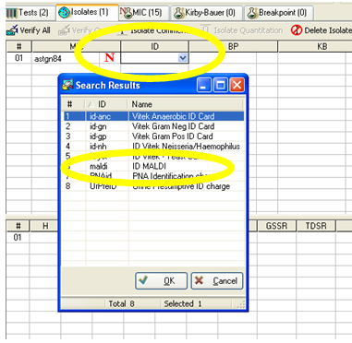

1. **SPECIMEN COLLECTION AND PROCESSING**
2. Select colonies from a primary or restreak plate on which the growth is 24-72 hours old.
3. 3mm colonies are preferred
4. Pure isolates must be used.
5. Only growth on validated media can be used.
   1. 5% Sheep Blood Agar
   2. CNA agar
   3. Trypticase Soy Agar
   4. Chocolate Agar
   5. MacConkey Agar
   6. Sabouraud Dextrose Agar
   7. Brucella Agar
   8. CIN Agar
   9. XLD Agar
   10. Leeds media * (validated)
6. **EQUIPMENT AND MATERIALS**

* VITEK MS-DS target slides –Room Temperature (15-25°C)

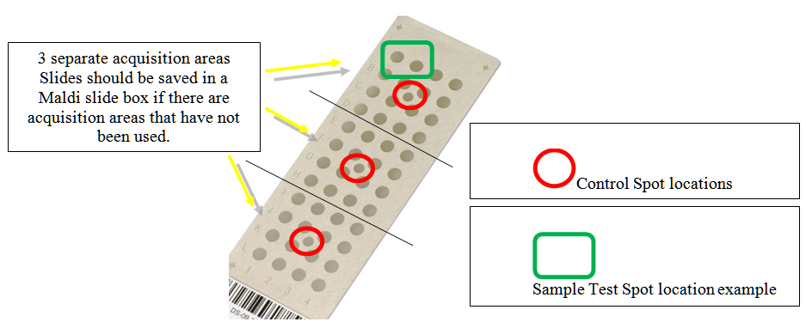

* VITEK MS-CHCA (matrix) – Refrigerated (2-8°C)

(Stabile for 7 days once opened)

* VITEK FA (formic acid) REAGENT – Refrigerated (2-8°C)

(Stabile for 14 days once opened)

* 1µl calibrated green plastic loops
* Vitek PICKME pen and nibs
* Precision pipette to deliver 1.0µl (for matrix)
* Precision pipette to deliver 0.5µl (for formic acid)
* Non-sterile colorless pipette tips without filter
* ATCC strain *E. coli* 8739 (18-24 hour growth on blood agar plate restreaked fresh from “Mother Plate” daily)
* ATCC strain *Klebsiella aerogenes* 13048
* ATCC strain *Candida glabrata* MYA-2950
* **Worksheet Template** showing the 3 Acquisition groups (each with 16 sample spots and one center calibration spot)

**(Example below)**

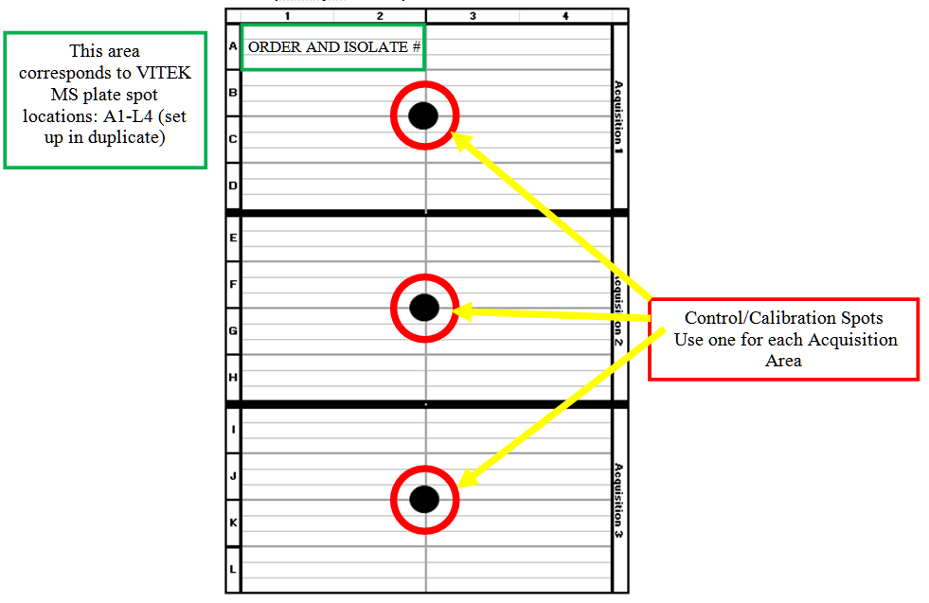

1. **SAMPLE/QC SLIDE PREPARATION PROCEDURE**
   1. Assemble the required materials.
   2. Put on gloves. Gloves must be worn throughout the slide preparation/handling.
   3. Place the VITEK MS-DS target slide on a flat surface.
   4. Use a 1µl green plastic loop or Vitek PICKME pen and nib to apply *E. coli* ATCC 8739 to the small control/calibration spot in the center of each acquisition group being used.
   5. Distribute that appropriate amount of organism into a thin film layer that covers the entire spot.
   6. Pipette 1.0µl of VITEK MS-CHCA matrix immediately onto the spot and allow to air dry.
   7. Begin to prepare your patient isolates starting with the first available spot of the Acquisition Area.
   8. To avoid sample drying, no more than two spots should be prepared at a time.
   9. Select a suitable colony from the culture to be tested. A suitable colony is a pure culture 24-72 hours old and about 3mm in size.
   10. Use a 1µl green plastic loop or Vitek PICKME pen and nib to pick up part of the colony.
   11. Inoculate the selected colony on the two designated isolate spots. Avoid excessive inoculation.
   12. Distribute organism into a thin film layer that covers the entire spot.
   13. ***IF YOU ARE PROCESSING A FUNGAL ISOLATE***:

Immediately, **pipette 0.5µl of VITEK MS-FA reagent** to the center of each yeast spot, and allow that to **dry completely**. Be sure to use a new pipette tip for each spot.

* 1. Pipette 1.0µl of VITEK MS-CHCA matrix on to the center of each prepared spot. Use a new pipette tip for each spot.
  2. Repeat steps H-L for all additional isolates that need to be run.
  3. Allow matrix/organism suspension to dry completely on all spots. This should take about 3-5 minutes. When dry, the spots will have visible crystal formation (a yellow film).
  4. The slide is now prepared and ready to run on the VITEK MS. Prepared slides may be stored in the plastic slide case for up to 72 hours.
  5. No patient isolate should be tested or resulted until the Quality Control slide is run successfully – EACH DAY THE INSTRUMENT IS USED FOR PATIENT TESTING (
  6. Proceed to the **VITEK MS Procedure** when QC slide is verified as acceptable.

1. **DAILY QC ORGANISMS**
   1. Daily QC slide: 1 spot each of *Klebsiella aerogenes* 13048, *Candida glabrata* MYA-2950, MATRIX ONLY and MATRIX/FORMIC ACID ONLY.
   2. When target slide run is complete, check to ensure the results are consistent with what is expected – log in to MYLA to check results. The QC organisms should have been identified with the correct identification and the MATRIX; MATRIX/FA ONLY can show with a red OR green circle.

|  |  |
| --- | --- |
| **QC SPOT PREPARATION** | **ACCEPTABLE RESULT** |
| *K. aerogenes* ATCC 13048 + Matrix (bacterial isolate) | Organism identified as  *K. aerogenes* |
| *C. glabrata* ATCC MYA-2950 + Formic acid + Matrix (fungal isolate) | Organism identified as  *C. glabrata* |
| Matrix (bacterial isolate) | No identification |
| Matrix + Formic acid (fungal isolate) | No identification |

* 1. A PDF will automatically generate at the end of each month and results will be available in the VMS Portal
  2. Indicate that daily QC is acceptable for the day by writing clearly on the dry erase board located at Acquisition Station Area.
  3. Any QC that is not acceptable it must be repeated. Notify the specialist if undesirable QC results persist as an unscheduled calibration may be necessary.

1. **CALIBRATION SLIDE PROCEDURE**
   1. Indication that a Fine Tune is needed: repeated failure of center calibration spots, daily QC organisms not producing acceptable results, the time to obtain the appropriate vacuum seems long (exceeds about two minutes).
   2. Call Technical Support to check if a Fine Tuning is needed. If indicated, prepare a calibration slide.
   3. Obtain a new target slide.
   4. Open a new matrix container
   5. Place 1µl of Matrix to spot A1 **only**
   6. Place the working QC strain of E. coli ATCC 8739 on the remaining spots of the target slide
   7. Program the slide in the Vitek FlexPrep using premade barcodes for Fine tuning.
   8. Scan and load the target slide in the holder in position 1 and load a blank slide in position 4 of the holder.
   9. CLOSE the door (DO NOT START) of the MS instrument.
   10. Call Technical Support to perform Fine Tuning.
   11. Records of previous Calibrations can be obtained through Customer Service.
2. **VITEK MS PROCEDURE** – **Refer to Vitek MS “The Basics” section 2 – Routine Workflow: Vitek FlexPrep – Sample Prep Screen**
   1. Use your unique Myla username to log in to the Vitek MS Portal. Once logged in, click on Vitek FlexPrep icon.
   2. Click the **Layout** icon until Vitek MS is displayed.
   3. Scan in the Vitek MS-DS target slide.
   4. Keep the default IVD preparation mode and legacy_1 method.
   5. Enter the matrix and formic acid lot numbers used.
   6. For each isolate, complete information in the VITEK MS workspace:
      1. Scan or type the specimen accession number.
      2. Verify the correct isolate number.
      3. Select bench.
      4. Verify that the appropriate bacteria/fungi setting is being used for that isolate.
      5. Select setup operator
      6. Click the validate button (the green check mark) to save all of the isolate information to the slide
      7. Repeat steps 1-4 until all the prepared spots are linked to a location on the slide.
      8. Verify data for each spot is correct by viewing the summary screen.
   7. Check that all spots used are validated and then click the **Close Slide** button in the Flex Prep software.
   8. At the **Acquisition Station**, log into the Acquisition Station software using your unique Myla username.
   9. Check that all target slides to be run are dry (have visible yellow crystal formation).
   10. Click the **Open** button on the Acquisition screen.
   11. Once the door opens, remove the adapter from the VITEK MS and remove any old slides. Discard any slide on which all three acquisition groups have been used.
   12. Load the target slides to be tested in the adapter. The top of the adapter has angled corners and is the closest to slide position 1 with barcodes facing out to the left.
   13. At the Acquisition Station, scan the target slide barcodes starting with the slide in position 1.
   14. Load the adapter into the VITEK MS with the angled corners into the machine and slide the adapter until it will go no further. The edge of the adapter should be flush to the machine when properly loaded.
   15. At the Acquisition Station, click the **Start** button to run the slides.
   16. Once the target slides have completed the run and QC has passed, the isolates can be reviewed in the MYLA software.

Guide for spots at acquisition station:

|  |  |  |
| --- | --- | --- |
| **SPOT** | **COLOR** | **DESCRIPTION** |
|  | Grey | No sample programmed |
|  | Dark grey | Previous aquisition |
|  | Dark blue | Waiting for aquisition |
|  | Light blue | Spectrum is being acquired |
|  | Green with green border | Spectrum acquired; quality checks passed; sent to Myla. |
|  | Green with red border | Spectrum acquired; quality checks passed; not sent to Myla |
|  | Red with green border | Spectrum acquired; quality checks failed; sent to Myla |
|  | Red with red border | Spectrum acquired; quality checks failed; not sent to Myla |
|  | Light yellow | Spot selected for re-aquisition |

An example of slide being acquired

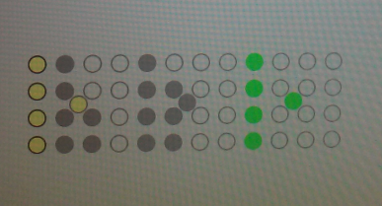

1. **REVIEWING RESULTS – Refer to VITEK MS “The Basics” Section 3: Vitek MS Results Management**
   1. Log-in to VITEK MS Portal homepage
   2. Click on Vitek MS Software icon
   3. Click the Results to Review icon to access the VITEK MS Review screen
      * 1. **Individual** High confidence isolates



* + - * 1. **Only identifications that match the colony morphology and preliminary tests should be reviewed and released.**
        2. **Additional testing may be required for isolates that have been flagged as highly pathogenic or critical pathogens.** **ALL spot tests and any additional testing must be recorded in the worksheet.**
      1. **Individual** Medium confidence results



* + - * 1. Slash-line/low discrimination results have occurred between the two spots for the isolate. Identification may be made by an alternate method or a spot test/additional testing can help to identify the organism. **ALL spot tests and any additional testing must be recorded in the worksheet.**
        2. Discrepant results have occurred on the two spots that were set up for the isolate.
* If the discrepancy is because of a poorly made spot and a Good identification on a spot of good quality, the good identification may be accepted if the results correlate with the colony morphology and spot tests. **ALL spot tests and any additional testing must be recorded in the worksheet.**
  + - * + If the discrepancy is because of contradicting identifications (example: gram negative rod and gram-positive rod), neither of the identifications should be reviewed or accepted. Vitek MS spots should be repeated, or identification should be made by an alternate method. **ALL spot tests and any additional testing must be recorded in the worksheet**. If the repeated VITEK MS is still discrepant, bring the culture up on “ROUNDS.”
  1. **DO NOT REVIEW (Accept)**:
     1. **Results that do not correlate with the organism growth and spot tests. Bring up on “ROUNDS”**
     2. **Low confidence results**



* 1. Delete these results and perform the identification by an alternate method.
     + - * Left click on the empty square at the far left in order to select it.
         * Choose the trash can icon at the top of the entire list to deleteall “Low confidence results”
     1. **Any identification that appears with the “non-FDA approved symbol** -blue stop sign with blue “N” must be retested by alternate method. **ALL spot tests and any additional testing must be recorded in the worksheet. Bring up on “ROUNDS” if NON-FDA approved identification needs to be used.**



The identification may be accepted under the review of the Medical Director/Associate Medical Director/designee if it correlates with culture growth or clinical picture. The comment below should be used:

*“Identification has been performed by a method that has not been cleared by the FDA. The result is consistent with culture growth and organism characteristics.”*

1. This laboratory has developed a database of identifications that are acceptable for use. A director approved current list can be found at the benches. These identifications MUST be used in conjunctin with the Isolate comment:



*“This organism has been identified using a FDA cleared MALDI-TOF MS using a laboratory-developed database determined by the Clinical Microbiology Laboratory at Lifespan Academic Medical Center.”*

1. **QUALITY CONTROL – Refer to Vitek MS “The Basics” Section 2: Routine Workflow: Vitek FlexPrep – Sample Prep Screen - QC**
2. QC to be run daily and programmed as follows **:**
   1. *Enterobacter aerogenes* ATCC 13048
   2. *Candida glabrata* ATCC MYA-2950
   3. Matrix only
   4. Matrix and Formic Acid only
3. Stock cultures
   1. ATCC Strain *E. coli* 8739
      1. A fresh working subculture from the “Mother Plate” is required for each day of testing using the VITEK MS. This is the same organism that will be used for fine-tuning.
      2. *E. coli* 8739 is required for every acquisition group on every target slide.
      3. Storage Conditions of ATCC strain *E. coli* 8739:

* Short Term Storage For **Daily** use:
  + Allow lyophilized organism come to room temperature.
  + Label two BAPs as “Mother Plates” with the organism name and “in-use” dates of two consecutive weeks (one week per plate).
  + Put lyophilized organism loop in a small amount of thioglycolate media and place inoculated thio and two BAPs in incubator to warm to 35°C.
  + After about 30 minutes of warming, inoculate the “Mother Plates” by placing two drops of the suspension onto Blood Agar Plates and streak for isolation.
  + Discard the used QC organism ampule in an appropriate biohazard receptacle.
  + Incubate these 2 plates for 24 hours at 37°C on the Blood Culture incubator shelf.
  + Store the 24hour old growth on the two plates at 2-8°C.
  + Daily, subculture the appropriate week’s “Mother Plate” for use as the working quality control organism for each acquisition group.
* Long Term Storage
  + *E.coli* ATCC 8739 purchased from an approved manufacturer and stroed per the package instructions.
  + *There are back-up quality control organisms in the -70 freezer. These are isolated colonies from a “Mother Plate” that were frozen in cryosavers.*

1. Additional QC organisms (*Klebsiella aerogenes* ATCC13048, *Candida glabrata* ATCC MYA-2950) are also available refrigerated or frozen. They are restreaked biweekly at the same time as the “mother plates” and stored in the tin in the refrigerator.
2. Quality Control of current lot of Matrix, Formic Acid and target slides are QC’d daily and recorded. Lots are recorded upon receipt to the laboratory.
3. Refer to the maintenance checklist for daily and other quality control responsibilities.
4. **TEST INTERPRETATION**
   1. The interpretation of VITEK MS results and the use of the instrumentation require a competently trained technologist. Judicious interpretation of results based on technologists’ experience, species information and other pertinent tests should be utilized when reporting the identification of tested organisms. Any additional information that is known to the technologist (gram stain reaction and morphology; colony morphology; atmospheric growth requirements; spot test results) should be considered before the results of the VITEK MS are accepted.
5. **PROCEDURE NOTES**
   1. Only pure bacterial isolates should be used.
   2. The samples on the target slides should be dry before placing into the instrument. Failure to dry the slide will cause the instrument to take an extended amount of time to pump down to the appropriate working pressure.
   3. Avoid direct sunlight on the VITEK MS instrument.
   4. Gloves should be worn at all times when handling the target slides.
   5. Ambient laboratory temperature above 26°C may affect test performance. The calibration may drift causing erroneous or undesirable results. The Inlet temperature is recorded daily to monitor this temperature.
   6. The quality of results produced is dependent on a good sample preparation step.

Example of “Good Quality” spots:

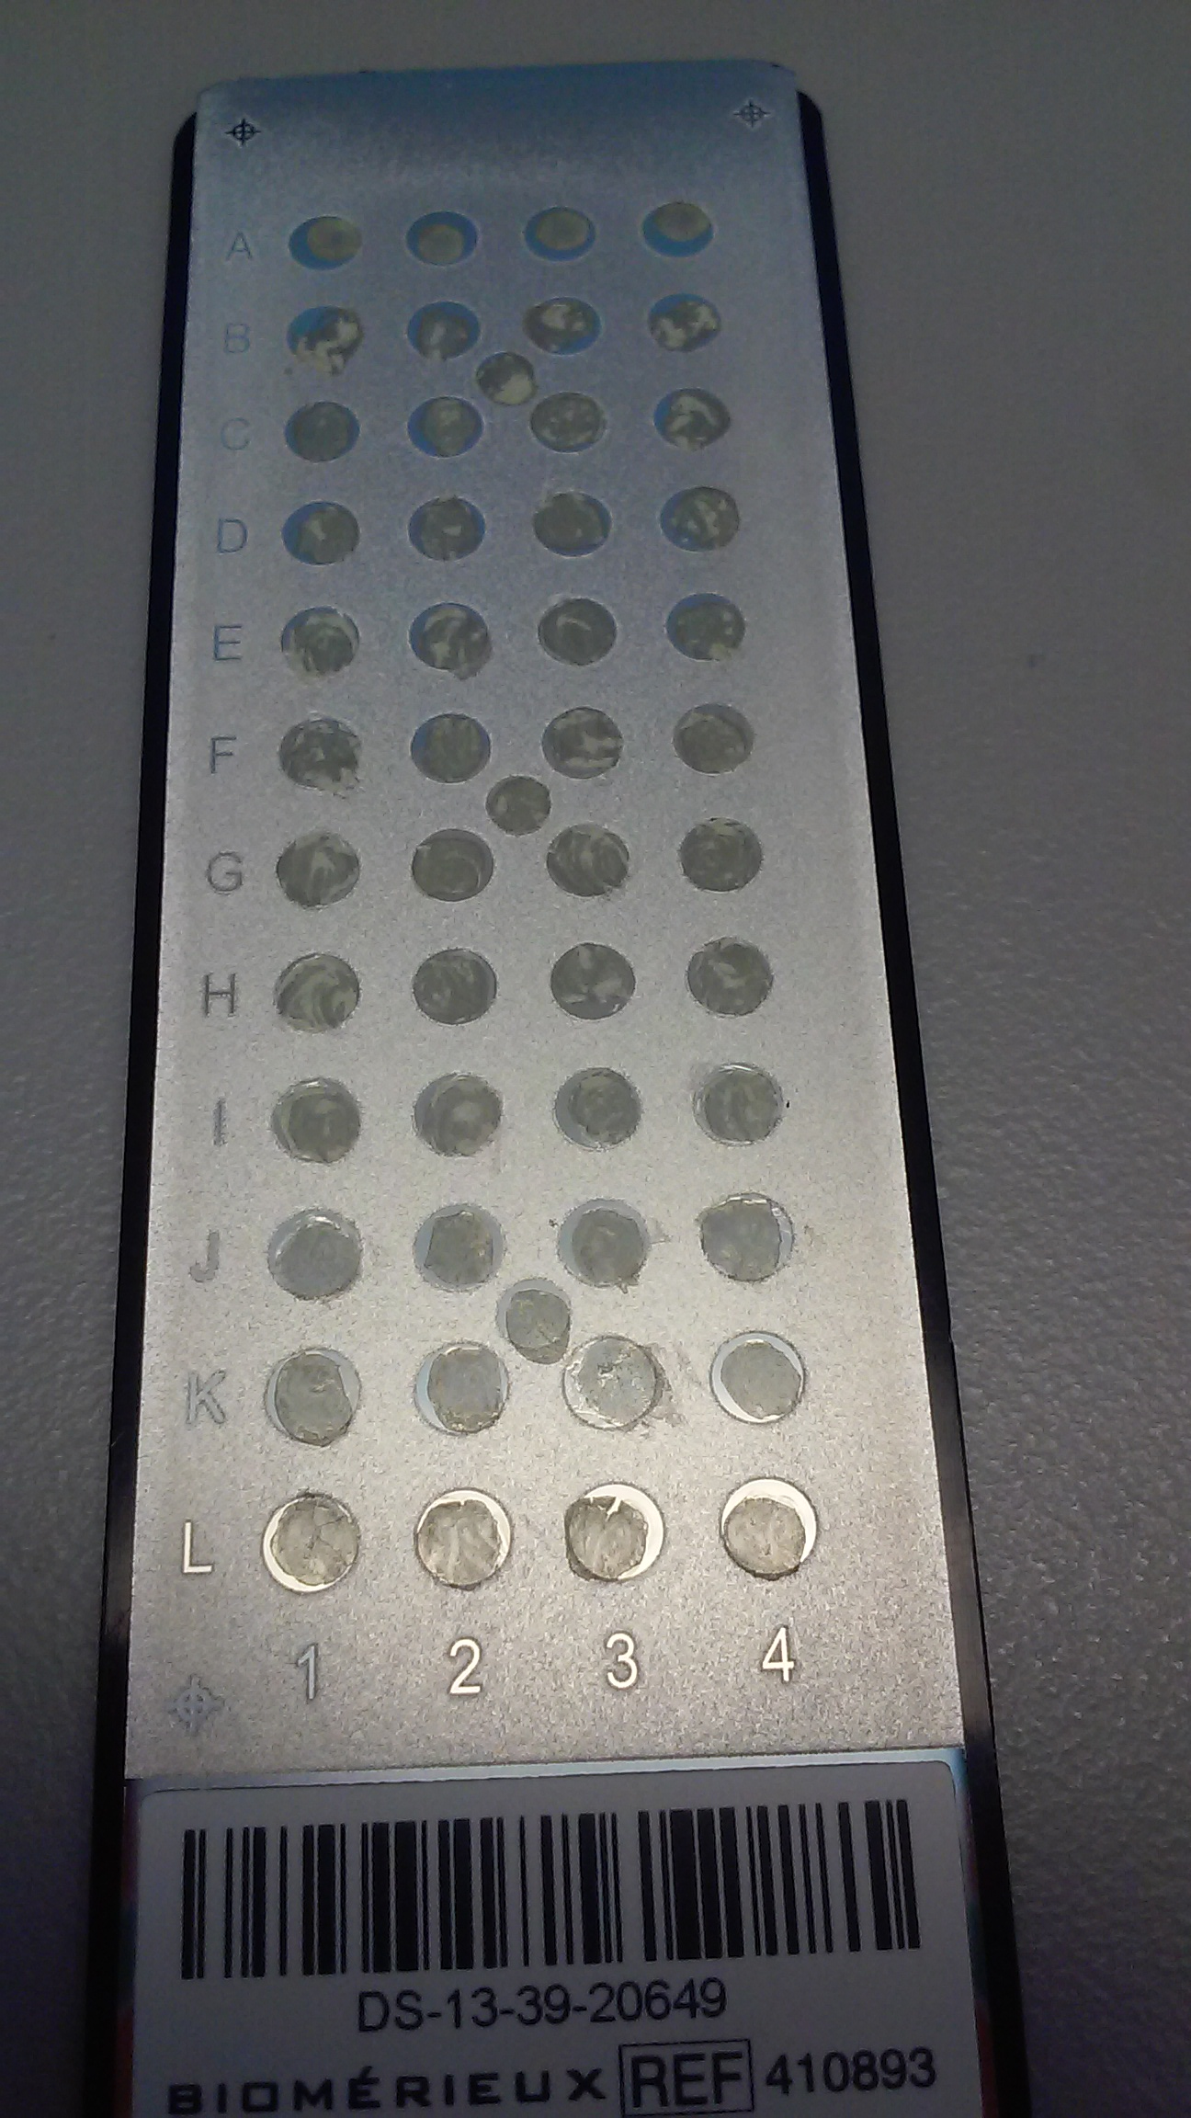

* 1. Fine tuning is required to avoid the calibration from drifting. The schedule for fine tuning can be found on the Maintenance Log. A field service engineer will perform this scheduled fine tuning. This tuning should take approximately 4 hours. If the instrument will be out of service for an extended amount of time, identification should be performed by Vitek 2.
  2. If the instrument starts to take an exceeding long amount of time to attain the correct pressure or acquire the 100 peaks needed to make identification, a fine tuning of the instrument may be needed. Notify the manager or a Technical Specialist.
     1. Call BioMerieux customer service (1-800-682-2666) for guidance and fine-tuning protocol. You cannot fine tune without calling BioMerieux. They will need to gain remote access and they will give instructions.
     2. They may need a calibration slide prepared. Refer to Section VIII – Calibration Slide Procedure
     3. The engineer will give instructions.
  3. When preparing your slide, picking up agar along with the colony may lead to poor identification results.
  4. If the quality control spot fails upon the second check during the assay, a fine tuning may be required.
  5. Spots may be re-fired no more than twice.

1. **LIMITATIONS**
   1. Only validated microbial Isolates can be identified. Refer to manufacturer list for specific organism.
   2. The system is not validated for use with direct patient samples or other sources containing mixed flora.
   3. Additional testing is required for low discrimination (Slash-line or Low confidence) or non-clinically validated organisms.
   4. *Shigella* species and *E. coli* 0157 are identified as “*Escherichia coli*”– testing is required to differentiate. Non-lactose fermenting colonies on Macconkey agar suggestive of E. coli should not be identified using the Vitek MS.
   5. Confirmation tests are recommended for *Neisseria gonorrhoeae*. Bring up on Rounds. The VITEK NH card can identify this organism.
   6. *Aeromonas hydrophila*, *Aeromonas caviae* and *Aeromonas sobria* should be considered as *Aeromonas* species group and further testing needs to be performed VITEK GN card can identify this organism.
   7. *Achromobacter dentrificans* and *Achromobacter xylosoxidans* should be considered a slash-line. Identification needs to be confirmed before reviewing results. The VITEK GN card may help identify these organisms.
   8. *Enterobacter cloacae* and *Enterobacter asburiae* should be considered slash-line identification. It is acceptable to identify these isolates as *Enterobacter cloacae complex*. Further identification may be performed by VITEK GN card.
   9. *Proteus penneri* and *Proteus vulgaris* results should be considered a slashline. A spot Indole needs to be performed to confirm identification before review.
   10. Organisms identified as *Citrobacter freundii, Citrobacter braakii* or *Citrobacter youngae* should be considered as *Citrobacter freundii complex*
2. **REFERENCES**

VITEK MS User Manual

[www.biomerieux-industry.com](http://www.biomerieux-industry.com)

VITEK ® MS V3.1 “The Basics…”

RPN 056470 – Rev. 01.A