PROCEDURE: BACT/ALERT® VIRTUO® PROCEDURE

PRINCIPLE

BACT/ALERT® VIRTUO® Microbial Detection System is an automated microbial test system capable of incubating, agitating, and continuously monitoring for the detection of aerobic, facultative, and anaerobic microorganism growth from blood and other normally sterile body fluids
The disposable Culture Bottles contain a liquid emulsion sensor that is monitored continuously using solid state photo detectors. The bottles contain media and atmosphere that promote the recovery of a wide variety of microorganisms.

The system supervises the reading of the Culture Bottles and contains decision-making algorithms to determine which samples are positive or negative. If no microbial growth is present after 5-day incubation time on the instrument, the sample is determined to be negative and unloads in the waste container. Positive bottles automatically unload to the bottle retrieval area.

If microorganisms are present in the test sample, carbon dioxide is produced as the microorganisms metabolize the substrates in the culture medium. When growth of the microorganisms produces CO₂, the color of the sensor in the bottle of each culture bottle changes from a dark to light color.
A light-emitting diode (LED) projects light onto the sensor. A photodetector measures the light reflected. As more CO₂ is generated, more light is reflected. This information is compared to the initial sensor reading. A high initial CO₂ content, an unusually high rate of CO₂ production, and/or a sustained product of CO₂, indicates the sample is positive. If the CO₂ level does not change significantly after a specified number of days at optimal conditions, the sample is negative.

- AVAILABILITY

24/7. All Blood Culture Bottles from affiliate hospitals are sent to Rhode Island Hospital for incubation.

- TEST CODE

  - CXBLD
  - CXBL2
  - CXBL3
  - CXANA
  - ABOT/NBOT

- MATERIALS AND SUPPLIES
- Materials
  - BACT/ALERT® VIRUTO® Microbial Detection System
  - BACT/ALERT blood Culture Bottles
- BACT/ALERT FA Plus Green Top
- BACT/ALERT FN Plus Orange Top
- BACT/ALERT PF Plus Yellow Top
  - Disposable gloves, laboratory coats
  - Biohazard waste bags
  - Silicone wipes

- Storage and Handling
BACT/ALERT Culture Bottles are ready for use. Store in an upright position protected from direct light at room temperature (15-30°C). An expiration date is printed on each bottle label. Do not inoculate the Culture Bottles beyond the expiration date indicated. If the bottles are exposed to temperatures less than 15°C, precipitates may form that will disappear when the bottles are warmed to room temperature. Bottles must be at room temperature before use.

- SPECIMEN COLLECTION AND PROCESSING

  - The blood culture bottles must be at room temperature. Remove the plastic flip top from the culture bottle. Prior to inoculation, disinfect the rubber septum on the top of the bottle or tube with 70% isopropanol.
  - Obtain blood samples prior to initiating antibiotic therapy. If this is not possible, draw blood immediately before administering the next antibiotic dose.
  - For Adult Patients:
    - Clean the patient’s skin with an antiseptic skin prep containing 2% Chlorhexidine Gluconated/70% isopropyl alcohol (ChloraPrep SEEP).
    - Pinch once to break the SEPP ampule. Saturate the tip with the antiseptic solution by gently pressing it against the treatment area. Using a back-and-forth motion, completely wet the treatment area for 30 seconds. Allow the prepped area to dry completely. Do not blot or wipe the solution away. Discard the applicator after single use into the nearest Sharps container.
    - Note: if further palpation of the vein is necessary, the finger must be disinfected with a second ChloraPrep SEPP or a sterile glove should be worn. If the arm is visibly soiled, it should be washed with soap before anything is done.
    - Note: if inoculating more than one type of blood culture bottle using a butterfly blood collection set, inoculate first the aerobic bottle and then the anaerobic bottle.
    - Note: if inoculating more than one type of blood culture bottle using a syringe, inoculate first the anaerobic bottle and then the aerobic bottle.
      - Draw approximately 20 ml of blood, per set, which is 10 ml per bottle. The target fill-to line on the bottle label may be used to assist in estimating a sample volume of approximately 10 ml. Alternatively, the 5 ml graduations on the bottle label may be used to assist in estimating sample volume.
    - While 10 ml is the optimal volume, smaller volumes are acceptable in patients where optimal volumes may be unobtainable.
    - Note: Isolator tubes must be filled (10 ml).
  - For Pediatric Patients:
    - Swab concentrically starting at the center with 70% alcohol then with 1-% PVP iodine solution then again with 70% alcohol. The disinfectant should be allowed to dry at least one minute before blood is drawn.
    - Note: if further palpation of the vein is necessary, the finer must be disinfected with 10% PVP iodine and alcohol or a sterile glove should be worn. If the arm is visibly soiled, it should be washed with soap before anything is done.
    - Draw approximately 4 ml of blood into the pediatric bottle.
    - Although lower sample volumes can be used, revery may be improved using a sample volume closer to the recommended 4 ml.
    - Note: Isolator tubes must be completely filled (1.5 ml).
    - Pediatric patients should have blood drawn based on weight:

Pediatrics
Weight (kg) Amount per Bottle | Amount of Blood required
<9 | 1 cc in 1 PF bottle (Pedi bottle)
9-13 | 3 cc in 1 PF bottle (Pedi bottle)
13-28 | 4 cc in 1 PF bottle (Pedi bottle)
28-40 | 5 cc (10 cc for 2 bottles; FA and FN) (Adult bottles)
40-55 | 7.5 cc (15 cc for 2 bottles; FA and FN) (Adult bottles)
>55 | >55 10 cc (20 cc for 2 bottles; FA and FN) (Adult bottles)

  - If using a syringe, use the Smith’s Female Adaptor / Luer. Preferably, blood should be drawn distal to (below) any intravenous line site.
  - A separate venipuncture must be performed for each blood culture ordered. If other specimens are being collected at the same time, the blood cultures are obtained first followed by the necessary tubes for the other testing.
  - Bandage the arm and label bottles according to standard operating procedure. In addition, label the site drawn (i.e. right arm, left hand, central line, arterial line etc.)
  - Transport the inoculated culture bottles promptly to the laboratory in biohazard labeled container. The pneumatic tube should be used if available in the area.
  - Take care to prevent contamination during both bottle preparation and inoculation of the patient sample. Proper skin disinfection is an essential requirement to reduce the incidence of contamination.
  - Although not recommended, blood may be drawn directly into collection tubes containing SPS. Tubes containing other anticoagulants should never be used for blood culture.
  - Inoculated bottles should be placed into the BACT/ALERT Microbial Detection System as soon as possible after collection. If there is an unavoidable delay, inoculated bottles may be maintained at room temperature up to 24 hours before loading into the instrument.

WARNINGS AND PRECAUTIONS
  - All in vitro diagnostic equipment, patient samples, and quality control (QC) assayed on this system, as well as all waste in the waste containers, should be treated as potentially bio- hazardous materials. All materials and mechanical components associated with the waste systems should be handled according to safe microbiological practices in compliance with the installation site’s biohazard procedures. Use the personal protective equipment recommended by the facility when handling any of these components, including gloves, safety goggles, and protective laboratory wear.
  - Do not try to access the interior of the laser case for any reason. Failure to comply may result in exposure to radiation and result in personal injury and damage to the instrument.
  - Bottles must be at room temperature before use. An erroneous test result (such as false positive or false negative) may occur if bottles are not at room temperature when loaded.
  - BACT/ALERT Culture Bottles should be examined for evidence of damage or deterioration (discoloration). Bottles exhibiting evidence of damage, leakage, or deterioration should be discarded.
  - Do not use a bottle which contains medium exhibiting turbidity, a yellow sensor, or excess gas pressure; these are signs of possible contamination.

  - General caution should be taken when sub-culturing positive culture bottles as they could have been overfilled or contain high gas-producing organisms. Positive culture bottle contents may be under increased internal pressure. Positive culture bottles should be transiently vented before staining or disposal to release any gas produced during microbial metabolism

  - Do not reuse BACT/ALERT® Culture Bottles.
  - A potential hazard of electrical shock exists during service and maintenance, electrical checks, or manual load mode.
  - A potential hazard (false negative test results) exists if non-bioMérieux and/or unsupported and/or substandard bottles are used with the instrument. Use only bottles manufactured by bioMérieux. The instrument can reject bottles that are not manufactured by bioMérieux (bottle authentication) and/or withhold test results.
  - A potential hazard (false negative test results) exists if the instrument is operated in an environment that is out of specification, or if proper electrical power is not maintained.
  - Consult with institution’s environmental waste personnel regarding proper disposal of used blood Culture Bottles. Check state and local regulations as they may differ from federal disposal regulations.

- BASIC FUNCTIONS

- Introduction
The basic functions are performed during your daily workflow by using the Large Display. These functions include:
  - Monitoring the system (viewing alarms and alerts, bottle capacity, temperature)
  - Managing bottle records
  - Configuring the system
  - Loading and unloading bottles
  - Resolving anonymous bottles
  - Searching for specific bottle data
  - Viewing, editing, and printing bottle data
- Monitoring the System
- Home Screen
The Home screen displays the system status for all instruments connected within the bank, including the number of cells available, number of positive and negative bottles, and active alarms or alerts. The Home screen also displays the buttons that navigate to other function screens, and a button to silence alarms and alerts for a defined period of time.

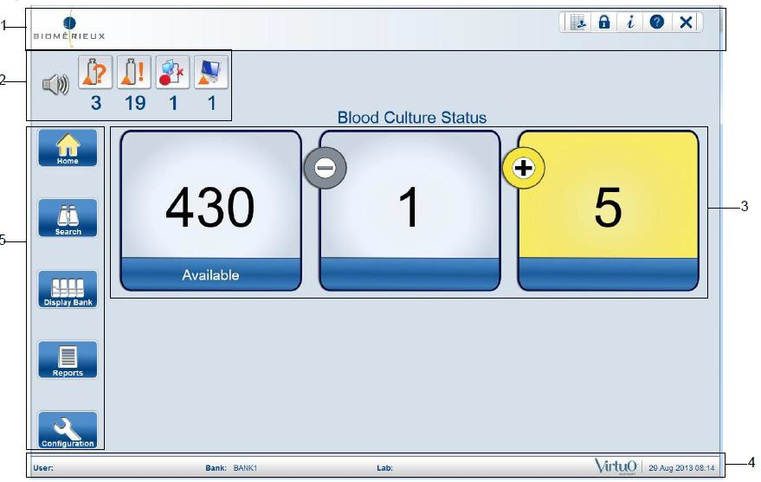
Home Screen (Refer to VIRTUO System User Manual for detailed description)

Zone 1 is at the top of the screen and includes the bioMérieux corporate logo and navigation buttons.
Zone 2 displays all active alarms and alerts that have not been resolved. Zone 2 also indicates when bottles are loading and unloading. Alarms and alerts are divided into five categories. A specific icon represents each category of alarm or alert. To view an alarm or an alert, select the icon.
Zone 3 displays the number of cells available and the total number of positive and negative bottles.
Zone 4 displays the user name, the bank name, the current date and time, and the lab name. Zone 5 displays the navigation buttons on the left side of the Home screen to access additional function screen

Display Bank Screen
To access detailed information for each instrument within a bank, select Display Bank on the left side of the Home screen. The Display Bank screen includes an Instrument Status icon for each instrument.

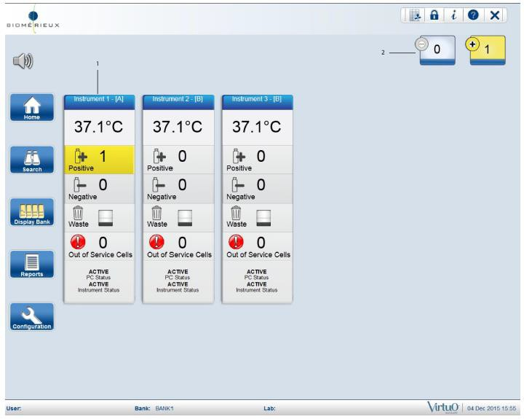

  - – Instrument status icon (Icon displays for each instrument in the bank)
  - – Number of negative and positive bottles in system (Includes all instruments that are part of the bank)

- TEST PROCEDURE

- Placement of User Applied Labels
  - Bottle ID barcode
  - Correct placement and orientation of user applied barcode label (vertical)
  - 2D barcode
  - Fill to line
  - Bottle lot number and expiration date
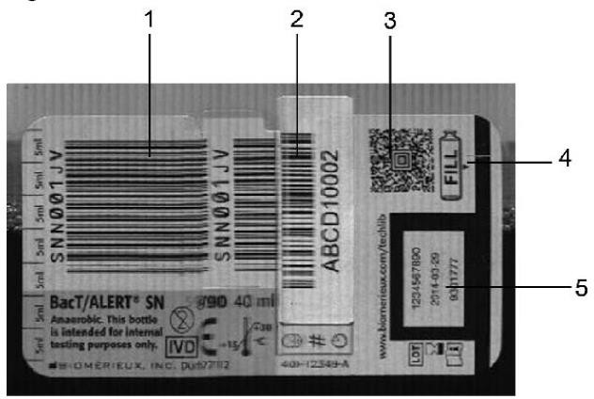
- Place barcode label vertically, so that the orientation is the same as the bottle barcode
- User applied labels should not be placed over the area of the 2D barcode or the Fill Line that are used for sample volume measurement
- Manual entry of the accession number will be required if the labels are not positioned correctly on the bottle and the scanner cannot read the barcode
- Loading Bottles Automatically
- Inspect each bottle and sensor before loading.
  - If the sensor is yellow, treat the bottle as positive.
  - If the bottle is creacked, do not load the bottle.
  - Remove and correctly reapply, if possible, any user applied barcode labels that are not placed correctly on the bottle.
- Place the bottles upright on the conveyor belt. The convey will begin moving and will feed the bottles into the bottle indexer, one at a time.

Batches of 20 bottles is optimal
- Avoid loading over 70 bottles within one hour
- Limit the number of bottles loaded in a single batch to no more than 40 bottles
- Allow the batch to completely load before adding more bottles to the conveyor

NOTE: If large numbers of bottles are loaded into the BACT/ALERT® VIRTUO® at the same time, there may be a very large heat transfer within the racks. This may trigger the detection algorithm to erroneously flag positive.
- Before leaving the instrument, verify that the instrument is operating properly and that the bottles remain upright and are being properly loaded into the bottle indexer.

- Unloading Bottles Automatically
The instrument automatically unloads all identified positive and negative bottles from any instrument in a bank after testing and a final test result is available.

NOTE: Anonymous bottles must be identified before they can be automatically unloaded.

WARNING: Automatic unloading stops and an alarm appears in the following situations. Resolve the alarm to continue automatic unloading.
- Waste container is full.
- Waste container is missing.
- Bottle retrieval area is full.
- Robot jam or other instrument malfunction occurs.

- Unloading Positive Bottles Automatically
  - Positive Bottles indicates the final result is positive. All identified positive bottles are automatically removed from the cells and transfer to the bottle retrieval area to stop incubation
  - Fully remove bottles from return chute
  - After the positive bottles are removed from the bottle retrieval area, the positive bottle counts update, and the unload events record in the audit log
  - The bottle status changes to Unloaded after the bottle is removed from the bottle retrieval area
Note: Up to three bottles can unload to each chute in the retrieval area at one time. No additional positive bottles can unload from the cells until the other bottles are removed from the retrieval area.
- Unloading Negative Bottles Automatically
  - Negative Bottles indicates the final result is negative.
  - All identified negative bottles automatically unload from the cells and transfer to the waste container.
  - The instrument capacity and the number of negative bottles update. The unload events are recorded in the audit log.
  - The bottle status changes to Unloaded after the bottles transfer to the waste container.
- Monitor Waste Capacity
- Capacity of the waste container
  - Negative bottles unload to the waste container.
  - Alerts display when the capacity of the waste container is full or almost full. Bottles stop unloading if the waste container is full or missing.

 Waste container is full  Waste container is missing
  - The waste bin is considered full if the bottle count reaches 50 or if the internal waste chute opening is blocked
- Emptying the Waste Container
- Pull the waste container door handle. The waste container door is located below the bottle loading area.
- Remove the yellow waste container from the compartment.
- Remove the liner bag from the waste container.
- Dispose of the bag in an approved biohazard container.
- Inspect the waste container and compartment for debris and sample spills.
- If required, clean with an approved cleaning agent. Refer to VIRTUO System User Manual for approved cleaning agents.
- Put a new liner bag in the waste container.
- Inspect the waste area for any bottles that may have fallen out of the waste container compartment.
- Return the waste container to the compartment and close the door.
- Resolve any alerts.
- Handling Unconfirmed Positive Bottles
- If a Gram stain of a positive bottle reveals no microorganisms, subculture the bottle and reload it to continue testing
- Place the bottles upright on the conveyor belt. The convey will begin moving and will feed the bottle into the bottle indexer
- When a bottle previously called positive is reloaded, a message states that the bottle result may reset to negative to date and may be flagged as unconfirmed positive. Select an option:
  - OK to continue
  - Cancel to cancel the action. The bottle result remains positive
- If growth appears on the subculture, access the Edit Bottle Record screen and change the bottle test result to Positive

NOTE: If a reloaded positive bottle signals positive a second time that bottle cannot be reloaded.
- Monitor Instrument Temperature
- If the internal instrument temperature varies by more than 1° for 20 minutes, bottles readings are halted
- An alarm notifies the user when this occurs
- Bottle readings resume when the instrument temperature is within ± 0.5° C of the set point for 30 minutes

- Resolve Alarms or Alerts
- Select the appropriate alarm or alert icon

NOTE: All alarms and alerts that are active for the specific alarm category appear in the Bottle Alerts List.
- View the Category:

Bottle Alarms and Alerts Instrument

Software and Communication

- View the Type for the specific alarm or alert and note the number in the brackets [ ].
- Select the Detail button for additional information.
- Refer to a list of Alarms and Alerts in the VIRTUO System User Manual
- Locate the message in the Alarm or Alert Column.

NOTE: Some of the Alarms and Alerts may display the same message. Use the number in the brackets to locate the correct message.
- Review the Cause and Impact and the action to take to resolve the issue.

- RESULTS

Positive or negative Culture Bottles are determined by decision making software contained in the BACT/ALERT® VIRTUO® Microbial Detection System. No action is required until BACT/ALERT VIRTUO instrument signals a culture bottle either positive or negative.

- INTREPETATION AND REPORTING

  - Positive Specimen
    - Alcohol bottle top and insert a sterile airway needle to sample bottle contents.
    - Prepare gram stain.
    - Hold bottle a room temperature until the culture is final.
    - Refer to Microbiology Blood Culture Procedure for workup protocol.

QUALITY CONTROL

- A Certificate of Conformance is available for each lot of Culture Bottles. If desired, individual laboratories can perform quality control testing of BACT/ALERT Culture Bottles. Refer to the appropriate BACT/ALERT User Manual and to CLSI® document M22-A3.6
- Instrument: Reflectance Calibration Standards are included with each BACT/ALERT VIRTUO instrument for the QC and Calibration procedures. All quality control should be part of normal system maintenance. The system has automatic, built-in quality control

- INSTRUMENT MAINTENANCE
- Automated Backups
Every day, the system software systematically backs up all the VIRTUO data
- Cleaning the Conveyor
Clean the loader conveyor belt surface when it is visibly dirty or when bottles start tipping over. Use silicone wipes (418007) to wipe the conveyor surface.
  - Wipe the conveyor surface that is visible with silicone wipes (418007) to lubricate.
  - Place a hand above the conveyor to activate the light curtain sensors.
  - The conveyor advances forward.
  - Wipe this section of the conveyor surface that is visible.
  - Continue in this manner until the entire conveyor is lubricated.

CAUTION: Do not get lubricant on the sensors.
- Clean any blood or test sample spills on the instrument or conveyor using the following:

  - Clean the spill with 10% sodium hypochlorite (13mL of 5.25% bleach to 1 liter of tap water) or wipes.
  - After decontamination, wipe with damp (water only) towel and thoroughly dry.

- WARNING: When performing maintenance on a BACT/ALERT® VIRTUO® system that is processing bottles in the racks, the door can be opened once for up to one hour while performing maintenance and/or to decontaminate the instrument if needed. The door cannot be opened again for a minimum of two hours to allow the system to get back to the proper temperature. Multiple openings of the door for short periods of time can cause issues with the temperature controls inside the incubator. Not following these instructions can lead to delayed results.
  - Wipe the conveyor surface with silicone wipes to lubricate.

LIMITATIONS
Many variables involved in blood culture testing cannot be practically controlled to provide total confidence that results obtained are due solely to proper or improper performance of any culture medium or detection system.
- Patient specimens determined positive by BACT/ALERT may contain organisms that are positive by smear that will not grow on routine subculturing media. When this is suspected, specimens should be subcultured on special media. Also, BACT/ALERT positive specimens may contain organisms that are not seen with routine smear staining methods and may require both specialized staining and subculturing media for detection and recovery.
- It is possible that certain rare, fastidious microorganisms will not grow or may grow slowly in the BACT/ALERT Culture Bottle growth medium. In addition, on rare occasions, organisms may be encountered that grow in the BACT/ALERT Culture Bottle growth medium but do not produce sufficient carbon dioxide to be determined positive. If rare, fastidious organisms requiring specialized media and culture conditions are suspected, alternative methods or extended incubation time should be considered for recovery.
- Certain strains of Haemophilus influenzae, Neisseria meningitidis, and Neisseria gonorrhoeae may be sensitive to the anticoagulant SPS, which may result in lack of growth or low production of CO₂ by these strains if an insufficient amount of sample is inoculated into the Culture Bottles.
- Infrequently, if there is a very high number of white blood cells present in the sample, the BACT/ALERT may indicate a culture bottle positive. In this case, the smear and subculture results may be negative.
- Organisms are often few in numbers and may appear intermittently in the blood stream; therefore, consecutive blood samples should be collected from each patient.
- Promptly remove positive Culture Bottles when they are signaled by BACT/ALERT to avoid possible non-viable cultures due to autolysis or other reasons. Certain strains of Streptococcus pneumoniae may be particularly prone to autolysis if they are not removed promptly after being signaled positive.
- A Gram-stained smear from a negative bottle may sometimes contain a small number of non- viable organisms that were derived from culture medium components, staining reagents,immersion oil, or glass slides, resulting in a false positive smear.
- bioMérieux recommends that inoculated Culture Bottles be placed into the BACT/ALERT Microbial Detection System as soon as possible after collection. But, in the unavoidable cases when there is a delay in bottle receipt by the laboratory, delayed entry information is provided from seeded studies in the “Performance Characteristics of the Test” section of the BACT/ALERT Culture Bottle package insert.
- Antimicrobial neutralization was not achieved for ceftazidime or cefepime.
- Extended times to detection or negative results may be observed for Stenotrophomonas maltophilia in cerebrospinal fluid for 12 month old bottles.
- BACT/ALERT bottles do not have appropriate levels of CO₂ in the headspace to reliably support growth of capnophiles such as Capnocytophaga spp.

REFERENCES
VIRTUO™ Microbial Detection System User Manual, Reference Number 514927, bioMerieux, Inc., Durham, North Carolina, May 2017.
BacT/ALERT® FA Plus Package Insert, Reference Number 410851, bioMerieux, Inc., Durham, North Carolina, April 2017.

