**PROCEDURE: Xpert® MRSA/SA Blood Culture**

# PRINCIPLE

* 1. The Cepheid® Xpert MRSA/SA is a qualitative *in vitro* diagnostic test capable of detecting SA and MRSA directly from positive blood culture specimens that are determined by gram stain as Gram-Positive Cocci in Clusters or Gram-Positive Cocci in singles. This assay utilizes automated real-time PCR for amplification of specific DNA targets including proprietary sequences for the Staphylococcal protein A (*spa*), the gene for methicillin resistance (*mec*A), and the Staphylococcal cassette chromosome *mec* (SCC*mec*). Real-time detection of amplified product is then performed using fluorogenic target-specific hybridization probes. The Cepheid GeneXpert® Dx system involves automation and integration of sample preparation, nucleic acid extraction, amplification, and detection. Single-use GeneXpert® cartridges allow PCR reactions to be self-contained, minimizing the chance of cross-contamination between samples.

# AVAILABILITY

* 1. The test will be available first and second shift, 7 days a week.

# TEST CODE

* 1. The Test Code is the billable media code: $PCR

# SPECIMEN

* 1. Positive aerobic (**BFA+**) blood culture bottles which gram stains show pure Gram-positive cocci in clusters or Gram-positive cocci in singles.
  2. The test will be performed on the first aerobic bottle that flags as positive per each admission (inpatient only) when gram stain requirements are met.
  3. The test will be performed on ALL aerobic bottles that flag as positive on specimens collected from patients <6 months old from Hasbro ED (including discharged patients) when gram stain requirements are met (RIH only). This assay should only be performed on pediatric patients **ONLY IF** specimen is collected in an aerobic (BFA+) bottle. Validation of Pediatric (PF+) blood culture bottle is currently in progress.

# MATERIALS AND EQUIPMENT

* 1. **Materials provided in the test kit**
     1. GeneXpert® MRSA/SA Assay kit which contains the following:
        1. GeneXpert® MRSA/SA cartridges
           1. Bead 1 (freeze dried) – 1 per cartridge
           2. Bead 2 (freeze dried) – 1 per cartridge
           3. Bead 3 (freeze dried) – 1 per cartridge
           4. Reagent 1 – 3 mL per cartridge
           5. Reagent 2 – 3 mL per cartridge

Sodium hydroxide

* + - 1. GeneXpert® MRSA/SA blood culture assay elution reagent – 2 mL
         1. Guanidinium Hydrochloride
         2. Surfactants
      2. Disposable sterile 50 uL aliquot pipette
  1. **Materials required but not provided in the test kit**
     + 1. Disposable, sterile transfer pipettes (for sample transfer to cartridge)
       2. Sterile plastic screw-capped tubes for specimen transfer
       3. External positive and negative controls: KwikStik™ MRSA/SA External Control from Microbiologics®. Catalog numbers: #0158 MRSA 23-004-808; #0360 MSSA 23-013-562; #0371 MSSE 23-004-810

# Equipment required

* + 1. GeneXpert® infinity Systems (-80 or-40 systems and software 6.4b or higher)
    2. Printer
    3. Vortex mixer

# STORAGE AND HANDLING

* 1. Store the GeneXpert® MRSA/SA cartridges and reagents at 2-28°C.
  2. Do not use reagents or cartridges that have passed the expiration date.
  3. Do not open the cartridge lid until you are ready to perform testing.
  4. If the specimen will be tested within 24 hours, refrigerate aliquot (2-8°C) or store blood culture bottle at room temperature. If the specimen will be tested after 24 hours, refrigerate the aliquot (2-8°C) for up to three days. DO NOT TEST SPECIMENS THAT HAVE BEEN HELD AT ROOM TEMPERATURE FOR MORE THAN 24 HOURS OR REFRIGERATED FOR MORE THAN THREE DAYS.

# QUALITY CONTROL

* 1. Maintenance
     1. Cleaning and maintenance of the instrument will be performed in

accordance with the vendors Operator’s Manual. For further information, refer to the Infinity System’s Operator’s Manual.

* 1. Each test includes two internal controls to validate the assay:
     1. **Sample Processing Control (SPC)**: The SPC contains spores of *Bacillus globigii* to verify adequate processing of Xpert MRSA/SA blood culture assay sample. The SPC verifies adequate specimen processing and that lysis of SA, if present, has occurred. The SPC serves as an internal positive control, as well as detects specimen-associated inhibition of the real-time PCR reactions.
     2. **Probe Check**:Before the start of the PCR reaction, the GeneXpert® measures the fluorescence signal from the probes to monitor bead rehydration, PCR tube filling in the cartridge, probe integrity, and dye stability.
  2. External quality control is run on new shipments and/or monthly, whichever is more frequent, and after major system maintenance including: software upgrade, annual PM, and if 3 or more modules are replaced at the same time. QC is also repeated if the controls are out of range or invalid. QC must be acceptable in order for the lot of reagent and instrument to be used for patient samples.

**INSTRUCTIONS FOR THE USE OF KwikStik™ EXTERNAL CONTROLS**

(Controls are located in the reagent refrigerator in the incubator/refrigerator room)

**Process only one external control at a time in the molecular hood.**

* + 1. Allow the Kwik-Stik pouch to equilibrate to room temperature then remove the Kwik-Stik tube from the pouch.
    2. With a fresh pair of gloves, crack the ampule found in the cap of the Kwik-Stik tube to release the hydration fluid.
    3. Hold tube vertically and tap on a hard surface to allow the hydration fluid to reach the lyophilized pellet at the bottom of the tube.
    4. Pinch the bottom of the tube to break up the pellet and mix with the hydration fluid.
    5. Saturate the swab with the hydrated material and break the swab into the GeneXpert® MRSA/SA blood culture assay elution reagent.
    6. Vortex for 10 seconds.
    7. Using a sterile transfer pipette, transfer all the contents of the elution reagent into a GeneXpert® MRSA/SA cartridge.

# TEST PROCEDURE

\***All preparation of the specimen and the cartridge is to be performed in the**

**Molecular hood**

* 1. Pre-analytical
     1. Clean designated hood with 10% bleach; rinse with deionized water; clean with 70% ethanol. This cleaning procedure must be performed before and after each specimen.
  2. Preparing the specimen
     1. Aliquot positive blood culture media to 1.5 mL screw cap tube labeled with full accession number.
     2. Specimen aliquots are stable for 24 hours at room temperature or for 3 days at 2-8°C.
     3. Using the 50 uL pipette provided in the kit, dispense 50 uL of the sample aliquot into the elution reagent vial.
     4. Close the elution reagent cap and vortex for 10 seconds.
  3. Preparing the cartridge – *Refer to Figure Below*
     1. Open the cartridge lid.
     2. Using a clean transfer pipette, transfer the entire contents of the elution reagent vial into the sample chamber of the cartridge. See Figure 1.
     3. Close the cartridge lid.

**Figure 1. MRSA/SA Blood Culture Assay Cartridge (Top View)**

* 1. Starting the test
     1. The test will be completed in approximately 62 minutes.
     2. For detailed instructions on how to view and print the results, see *APPENDIX AP81 - GeneXpert Instrument Navigation*. You may also refer to the *GeneXpert Dx System Operator Manual* or the *GeneXpert* *Infinity System Operator Manual*.
  2. Printing and Viewing Results
     1. For detailed instructions on how to view and print the results, see *APPENDIX AP81 - GeneXpert Instrument Navigation*. You may also refer to the *GeneXpert Dx System Operator Manual* or the *GeneXpert* *Infinity System Operator Manual*.

# INTERPRETATION

Note: The results are interpreted automatically by the GeneXpert System and are shown in the **View Results** window.

* 1. **MRSA POSITIVE/SA POSITIVE (FIGURE 2)**

The MRSA target DNA sequences are detected/SA target DNA sequence is detected within the sample:

1. MRSA POSITIVE – all MRSA targets (*spa*, *mec*A, SCC*mec*) have a cycle threshold (Ct) within the valid range and endpoint above the minimum setting.
2. SPC – NA (not applicable); the SPC signal is not part of the results interpretation in this case because MRSA amplification may compete with this control.
3. Probe Check – PASS; all probe check results pass.

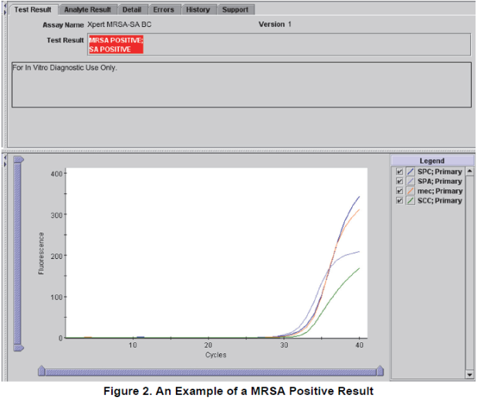

# MRSA NEGATIVE/SA POSITIVE (FIGURE 3)

MRSA target DNA sequences are not detected/SA target DNA sequence is detected within the sample

* + 1. SA POSTIVE – the SA target (*spa*) has a CT within the valid range and endpoint above the minimum setting. Target DNA for SCC*mec* is not detected; target DNA for *mec*A is not detected (“empty cassette”).
    2. SPC – NA (not applicable); the SPC signal is not part of the results interpretation in this case because SA amplification may compete with this control.
    3. Probe Check – PASS; all probe check results pass.

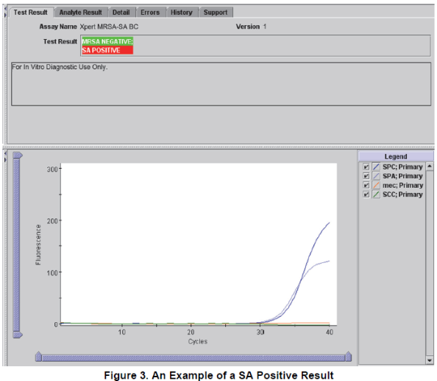

# MRSA NEGATIVE/SA NEGATIVE (FIGURE 4)

SA target DNA sequence is not detected. SPC meets acceptance criteria.

* + 1. NEGATIVE – the SA target (*spa*) DNA is not detected. Target DNA for *mec*A may or may not be detected, or target DNA for SCC*mec* may or may not be detected.
    2. SPC – PASS; SPC has a CT within the valid range and endpoint above the endpoint minimum setting.
    3. Probe Check – PASS; all probe check results pass

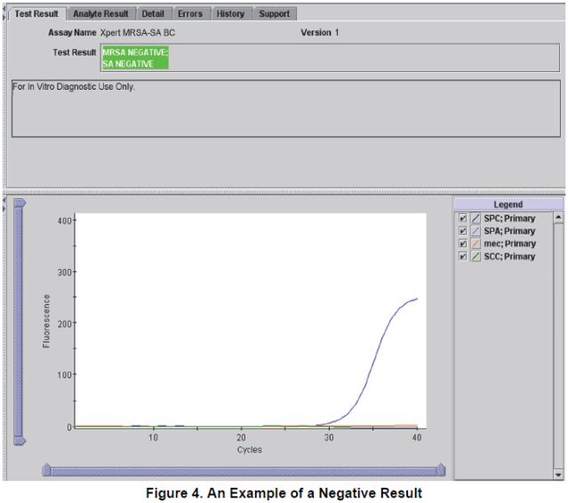

* 1. **INVALID (FIGURE 5)**

**Tests resulting in INVALID will NOT be repeated.**

Presence or absence of MRSA/SA target sequences cannot be determined. SPC does not meet acceptance criteria, the sample was not properly processed, or PCR was inhibited.

* + 1. INVALID – Presence or absence of SA DNA cannot be determined.
    2. SPC-FAIL – SPC Ct is not within valid range and endpoint below minimum setting.
    3. Probe Check – PASS; all probe check results pass.

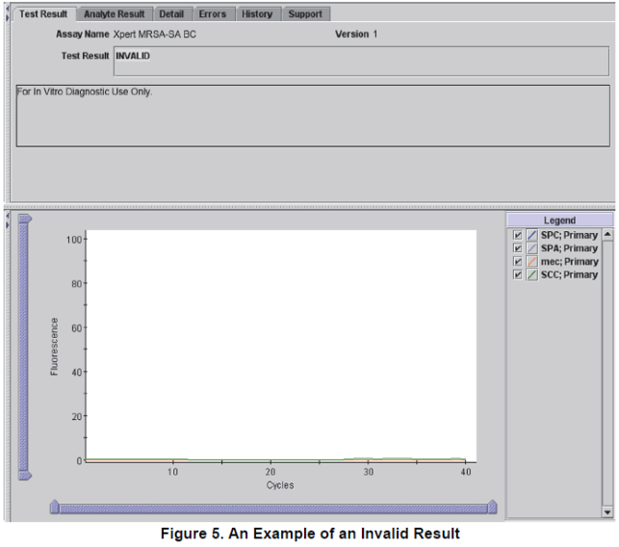

* 1. **ERROR**

**Do not repeat test more than one time.**

Presence or absence of MRSA/SA target sequences cannot be determined. Repeat using a new aliquot and a new cartridge. An error could be due to an improperly filled reaction tube, a probe integrity problem, a system component error, or because the maximum pressure limits were exceeded.

* + 1. MRSA – NO RESULT
    2. SA – NO RESULT
    3. SPC – NO RESULT
    4. Probe Check – FAIL/PASS
       1. If the probe checked passed, the error has been caused by a system component failure or the maximum pressure limit was exceeded.
  1. **NO RESULT**

**Do not repeat test more than one time.**

Presence or absence of MRSA/SA target sequences cannot be determined. Repeat using a new aliquot and a new cartridge. A “No Result” result can occur if the operator stopped a test that was in progress.

* + 1. MRSA – NO RESULT
    2. SA – NO RESULT
    3. SPC – NO RESULT
    4. Probe Check – NA (not applicable)

1. **REPORTING RESULTS**

**REFER TO APPENDIX AP26: SOFT Instructions for Cepheid® Xpert® MRSA/SA for detailed reporting instructions.**

* 1. **MRSA POSITIVE / SA POSITIVE**
     1. Probable METH/OXACILLIN *STAPH AUREUS* (by PCR)

*Confirmation of final identification and susceptibilities by culture are pending.*

* + 1. Follow critical call policy to report updated PCR results
    2. Wait for confirmation by susceptibility testing to change the ESO (Epidemiologic Significant Organism) in Order Entry to reflect the new MRSA result.

* 1. **MRSA NEGATIVE / SA POSITIVE**
     1. Probable *STAPHYLOCOCCUS AUREUS* (MSSA by PCR)

*Confirmation of final identification and susceptibilities by culture are pending.*

* + 1. Follow critical call policy to report updated PCR results
  1. **MRSA NEGATIVE / SA NEGATIVE**
     1. Positive for GRAM POSITIVE COCCI SUGGESTIVE OF STAPH

*PCR NEGATIVE for Staphylococcus aureus and MRSA. Final identification and additional testing by culture is pending.*

* + 1. No phone call is needed to report the PCR result.
  1. **INVALID / ERROR / NO RESULT**
     1. Positive for *GRAM POSITIVE COCCI SUGGESTIVE OF STAPH*

*PCR Indeterminate for Staphylococcus aureus and MRSA. Final identification and additional testing by culture is pending.*

1. **NOTES**

**Antibiotic Stewardship**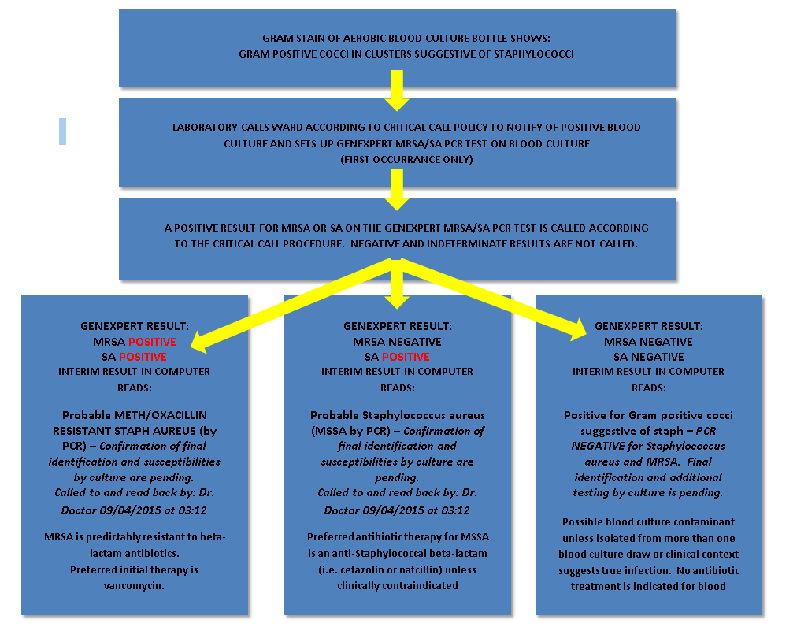

1. **LIMITATIONS**
   1. The performance of the Xpert MRSA/SA Blood Culture Assay was validated using the procedures provided in the package insert only. Modifications to the procedures provided may alter the performance of the test. Blood culture test should be interpreted in conjunction with other laboratory and clinical data available to the clinician.
   2. Results from the Xpert MRSA/SA Blood Culture Assay should be interpreted in conjunction with other laboratory and clinical data available to the clinician.
   3. The performance of the Xpert MRSA/SA Blood Culture Assay using blood culture bottle types other than the BACTEC Plus Aerobic/F, BacT/ALERT SA (Standard Aerobic), and VersaTrek Redox 1 Aerobic blood culture bottles has not been established.
   4. Blood culture media containing activated charcoal cannot be used with the Xpert MRSA/SA Blood Culture Assay (e.g., BacT/ALERT FAN aerobic).
   5. Testing with the Xpert MRSA/SA Blood Culture Assay should be used as an adjunct to other methods available.
   6. Mutation or polymorphisms in primer or probe binding regions may affect detection of new or unknown MRSA variants resulting in a false negative result.
   7. Erroneous test results might occur from improper specimen collection, failure to follow the recommended sample collection, handling and storage procedures, technical error, sample mix-up, or because the number of organisms in the specimen is too low to be detected by the test. Careful compliance with the instructions in the package insert is necessary to avoid erroneous results.
   8. Xpert MRSA/SA Blood Culture Assay results may sometimes be INVALID, ERROR, or NO RESULT, and require testing that can lead to a delay in obtaining final results.
   9. Target concentrations below the limit of detection of the assay may be detected, but results may not be reproducible.
   10. The Xpert MRSA/SA Blood Culture Assay may generate a false negative MRSA results when testing borderline oxacillin resistant SA (BORSA). The mechanism of oxacillin resistance in BORSA strains may be due to other factors (e.g., increased production of β-lactamase) rather than the presence of the *mec*A gene. BORSA with oxacillin MICs of 4-8 µg/mL are considered borderline resistant but may be reported as MRSA negative by the Xpert MRSA/SA Blood Culture Assay.
   11. The Xpert MRSA/SA Blood Culture Assay may generate a false negative MRSA result when testing modified SA (MOD-SA). The mechanism of oxacillin resistance in MOD-SA strains is due to other factors (e.g., changes in affinity of penicillin binding proteins for Oxacillin) rather than presence of the *mec*A gene. MOD-SA with oxacillin MICs of 4-8 µg/mL are considered borderline resistant but, would be reported as MRSA negative by the Xpert MRSA/SA Blood Culture Assay.
   12. The Xpert MRSA/SA Blood Culture Assay will generate a false negative MRSA result when testing a strain containing a *mec*A homologue known as *mec*C such as SA LGA251.
   13. The Xpert MRSA/SA Blood Culture Assay will generate a false positive MRSA result when testing a mixed infection blood culture specimen containing both Methicillin-resistant coagulase-negative *Staphylococcus* (MRCNS) and empty cassette Methicillin-susceptible SA
   14. A positive test result does not necessarily indicate the presence of viable organisms. It is, however, presumptive for the presence of MRSA or SA.
2. **TECHNICAL SUPPORT**
   1. For Technical Support contact Cepheid Technical support at888-838-3222 or [techsupport@cepheid.com](mailto:techsupport@cepheid.com)
3. **REFERENCES**
   1. Hidron AI, Edwards JR, Patel J, Horan TC, Sivert DM, Pollack DA, Fridkin SK. 2008. NHSN annual update: antimicrobial-resistant pathogens associated with healthcare-associated infections; annual summary of data reported to the National Healthcare Safety Network at the Centers for Disease Control and Prevention, 2006-2007. Infect Control Hosp Epidemiol. 2008 Nov;29(11):996-1011. doi: 10.1086/591861.Erratum in: Infect Control Hosp Epidemiol. 2009 Jan;30(1):107.
   2. Chaix C, Durand-Zileski I, Alberti C, Buisson B. 1999. Control of endemic methicillin-resistant *Staphylococcus aureus.* JAMA. 282(19):1745-51.
   3. Shopsin B, Kreiswirth BN. 2001. Molecular epidemiology of methicillin-resistant *Staphylococcus aureus.*  Emerging Infectious Diseases. 7(2):323-6.
   4. Padmanabhan RA< Fraser TG. 2005. The emergence of methicillin-resistant *Staphylococcus aureus* in the community. Cleveland Clinic J Med. 72(3):235-241.
   5. Das I, O’Connell N, Lambert P. 2007. Epidemiology, clinical and laboratory characteristics of *Staphylococcus aureus* bacteremia in a university hospital in UK. J Hosp Infect. 65(2):117-123.
   6. Anderson DJ *et al.* 2009. Clinical and Financial Outcomes Due to Methicillin Resistant *Staphylococcus aureus* Surgical Site Infection: A Multi-Center Matched Outcomes Study. PLoS ONE 4(12);e8305. doi:10.1371/journal.pone.0008305.
   7. Centers for Disease Control and Prevention. Biosafety in microbiological and biomedical laboratories (refer to latest edition). Clinical and Laboratory Standards Institute, Wayne, PA.
   8. Clinical and Laboratory Standards Institute (formerly National Committee for Clinical Laboratory Standards). Protection of laboratory workers from occupationally acquired infections; Approved Guideline. CLSI Document M29 (refer to latest edition). Clinical and Laboratory Standards Institute, Wayne, PA.
   9. CLSI M2-ALL. 2012. Performance Standards for Antimicrobial Disk Susceptibility Tests: Approved Standard. Eleventh Edition. CLSI, 940 West Valley Road, Suite 1400, Wayne, PA 19087-1898 USA.
   10. CLIS M100-S22. 2012. Performance Standards for Antimicrobial Susceptibility Testing. Twenty-second Informational Supplement, CLSI, 940 West Valley Road, Suite 1400, Wayne, PA 19087-1898 USA.
   11. Cooper, J E and Feil, E J. 2006. The phylogeny of *Staphylococcus aureus* – which genes make the best intra-species markers? Microbiology 152:1297-1305.
   12. Cepheid® GeneXpert® Xpert® MRSA/SA Blood Culture Product Insert reference: GXMRSA/SA-BC-10, Rev B: August 2013.