PROCEDURE: BLOOD CULTURES SCC SOFT RESULTING

- PRINCIPLE

All blood cultures will be an interfaced test with the automated blood culture instruments. During the 5-day incubation, the daily negative updated reporting will occur automatically with Soft Autoresulting worklists. The following procedure will encompass the different worklists that will be used to monitor the interfaced blood culture orders as well as define a bench workflow for working up positive cultures as well as monitoring Negative cultures.

A. Loading new Blood Cultures onto automated blood culture instruments

- “Plate” all blood cultures to be loaded onto the automated blood culture instrument. Media labels will not print but the process will generate a sequence number and qualify the order number to the blood culture autoresulting worklists.
- Load bloods onto the automated blood culture instrument according to manufacturer’s package insert.
- A report of the loaded specimens may be generated if needed. Refer to Operator’s manual for further guidance.

B. Bench Workflow

1. Negative Blood Cultures – Because of autoresulting worklists, pending negative blood cultures on the automated blood culture instrument will not require any tech intervention.

II. POSITIVE BLOOD CULTURES

- Unloading Positives & Setting the Significant Flag

- When a Blood culture is positive on the Instrument, remove the bottle from the Instrument.
- The blood culture instrument will automatically send a POSITIVE result from the instrument to Soft. The significant flag in Soft will be set and can be seen in the Status field as “+”. This will prevent the order from getting new Negative autoresults.
- Proceed with positive blood culture workup according to protocol.

B. If Gram Stain is NOS:

- Proceed with NOS workup, return bottle to instrument if within the allotted time frame, and unset the Significant button by clicking on it twice.
- The red √ in the “+ “column should appear and then disappear along with the “+” in the Status field. It will now qualify again for Negative Autoresulting Worklist.

C. Reporting Blood Culture Gram Stains

Some things to keep in mind when reporting blood culture gram stains:

Click on the Significant Flag:
A √ will appear in the “+” column across from the test being flagged (CXBLD). This will remove the Order number from the Negative Auto Resulting Worklist. It will qualify it to the Blood CX-Pos-RIH worklist.

- Positive blood culture gram stains will be reported as a Test Comment.
- A gram stain charge needs to be added at Media Level but only once per order number.
- When a gram stain is resulted as a Test Comment, set Status to INTERIM – This will prevent the order from qualifying to be autoresulted as a Negative via the autoresulting worklist

D. Resulting:
- Open Test Comment window
- Choose >BLGS- this will take you to the gram stain keypads for blood cultures
- Compose the gram stain so that it looks like this:

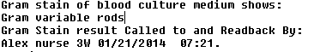

- Set the report status to INTERIM.
- Update the positive media at the Media Level-click on media
- Open Media Comment window
- Pick -One gs charge per set ^$GS. We can only charge for one gs per order number. If one has already been charged (generated as a media) then don’t do again.
- Choose appropriate subculture media and continue with workup.

E. Adding organisms to an existing Blood culture gram stain

1. Original Blood Culture Gram Stain (test comment)-INTERIM REPORT:

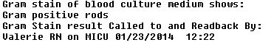

2. Corrected/updated gram stain (test comment)
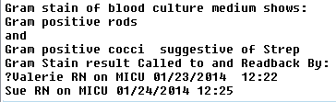

- Instant Report View
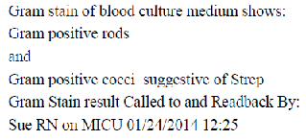

F. Changing a Blood Culture Gram Stain (updating Test Comment)

1. Original Gram stain report:- INTERIM REPORT

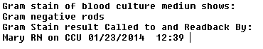

2. Insert the Canned Message }PREC above the gram stain report. Type in the correct report under ‘THIS IS A CORRECTED REPORT’. Then place a period (.) at the end of the original phone call line. This will flag this report as a Corrected Report. Answer Yes to all of the popup windows.
3. Corrected Worksheet Window view:
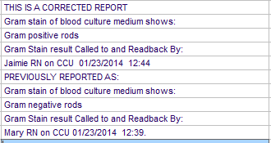

4. Instant Report View
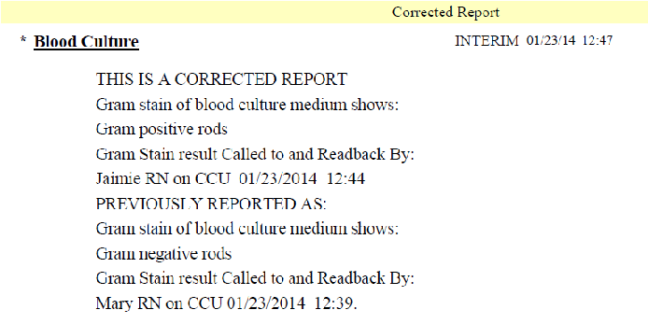

G. Resulting Transfusion Reaction gram stains:

If Prelim is already set by Autoresult:

-Add the gram stain result below the existing Test comment
-Set PRELIM status again

Do not set INTERIM!!!

Leaving the blood cultures as prelims with allow them to continue to get the negative autoresults every day.

If NO Prelim Set by Autoresult:

-Enter gram stain results in Test comment area
-SAVE
-Do not set PRELIM status!!

When prelim is set by Autoresult, the gram stain and prelim will be sent.

III. REVISIONS

A. 1/14/2022 – Removed TMH testing location to account for consolidation of blood cultures

Blood Culture Worklists
SCC Soft Resulting

Resulting Worklists

1) Pending Blds (W0020)

This list can be used just as an overview of all pending blood cultures. Both positive and negative cultures will qualify to this list.

2) Blood cx – POS (W0025)
This resulting worklist will display only positive blood cultures that are pending.
Qualifier: ! Significant ( ) or an Isolate filled in Isolate Column.
The Blood CX-Pos worklist has been defined to include any positive Blood cultures (with isolates) or Blood cultures that have been flagged as Significant. In most cases, the significant flag will be tripped before an Isolate is entered in the Isolate field

3) Extended Blds-Resulting Worklists
This worklist will only have blood culture orders that have the media $EXBL added to it. The Blood tech will have to monitor this list and update prelims every day until the bottles have been removed after 10 days – Refer to Procedure: Extended blood culture

Negative Autoresulting Worklists

These autoresulting worklists have the function of sending out updated prelim reports and final reports for all Negative blood cultures. Soft Print Scheduler will generate reports for all qualified order numbers based on the criteria set up in print scheduler.

QC- CAP Requirement- The autoresulting worklists should be QC’d once a year or after any Soft system change that could affect print scheduling. See Appendix AP13

1) Blds-1st Prelim-Autoresulting
This is an autoresulting worklist. Tech intervention is not need on this list at all. Qualified orders for this list will be:

Blood cultures that are 1 hour since “plated”.
and
Blood cultures that have a result posted from automated blood culture instrument
and
Blood cultures that don’t have an Isolate or Significant flag checked
and
Blood cultures that do not have a Preliminary report yet

If all of these parameters are met, then the Order number will sit on this worklist until the top of the next hour. Once each hour, the Orders on this list will be autoresulted with the Prelim: }BINC – “~Five day incubation in progress…”

2) Blds- UpPre/Final-Autoresulting
This is an autoresulting worklist that will hold all Blood cultures with a Prelim status that are Negative. There is no tech intervention needed with this worklist. It will update all negative prelim reports with a new date and time every 24 hours until 120hrs (5 days). Once the order number is 5 days old from “plated” and still Negative, a final report of “No growth at 5 days” will be resulted and status will be set to Final.

