Disclosure Procedure
- PRINCIPLE
  - Due to the HIPPA privacy regulation passed on April 14th, 2003, any Personal Health Information (PHI) given to someone other than the ordering physician is generally prohibited. If any PHI is given to someone other than ordering physician, the information that was disclosed must be recorded using the EPIC Release of Information program. The following is a guideline and instructions on how to record the disclosed information. For information that is automatically disclosed to the RIDOH through the ELR – The DOH needs to be notified by phone if a patient result is changed.

- DISCLOSURE REQUIRED
  - HIV Viral load results
  - HCV Viral Load results
  - HVB Viral Load results
  - HCV Genotype results
  - GC/CT positive results
  - Stool pathogens
  - Positive AFB cultures

- DISCLOSURE NOT REQUIRED
  - Related treatment, payment, or health care operations
  - HIPAA compliant inquiry
  - National Security
  - Regarding information prior to 4/14/03
  - Incident to a permissible use of PHI
  - Correctional institutions or law officials
  - Part of limited data set

- HOW TO FIND RESULTS THAT NEED TO BE DISCLOSED:
  - For HIV, HCV, HBV Viral load results and HCV Genotype results
    - Use the tasklist for that days run to enter your disclosures.
    - All results are disclosed to the DOH.
  - For GC/CT results
    - An instant report for each test will print in the laboratory.
    - Use these to enter your disclosures

- DISCLOSURE PROCEDURE:
  - Sign into Lifechart Production
  - Under the EPIC tab on the top tool bar, if you don’t have Batch Release listed, use the search box on the right and type in ‘batch release’
  - Select Batch release. The Batch records window opens.
  - Click the Create Batch button.
    - Ensure Quick Disclosure defaults in the Chart Type field.
  - In the Name field, name your batch starting with your initials, then the requester (RIDOH) and the date.
    - Separate each item with an underscore.
    - The date should be MMDDYEAR format.
    - Ex: MA_RIDOH_03022020
  - In the Template field, select the LAB DOH RELEASE template then Click Accept to close the record accept window.
  - Click Accept to close the Batch Records window.
  - In the Requester field, verify that RI DEPT OF HEALTH defaults in the Requester field.
  - Batch Info will auto populate (on the left) and verify the following information is defaulted in the various fields:
    - Release type: Regulatory
    - Purpose: Public Health Reporting
    - Type: Quick Disclosure
  - In the Authorization Needed? Field, click on the +Add Button
    - Click the magnifying glass
    - Choose No Authorization Needed
  - In the Request Field:
    - Choose All Records
    - Under Info Requested Choose All
  - Leave Output format field blank.
  - Click Add Patients
  - Search for your patients using their Medical Record number. Once patient has been located their information box will populate.
    - Click the Select button
    - Click the +Release button.
    - Add all patients for the batch release.
    - Continue to add each disclosure patient before continuing to next step
  - Click on the Worklist tab in the upper left section of the screen.
    - Double click on the patient’s name in the worklist
    - Click edit selection at the top of the Records section.
    - Choose the tab at the top of the records section that says All Records.
    - Click unselect all underneath the All Records tab.
    - Choose the tab at the top of the records section that says Labs.
    - Click unselect all underneath the Labs tab.
    - These selections can be filtered further by using the Filters tab on the left side of the Records sections.
    - Filter by Collection Date/Time
    - Check off the lab result by clicking the box next to the result based on your printout ensuring the correct collection date and time is chosen..
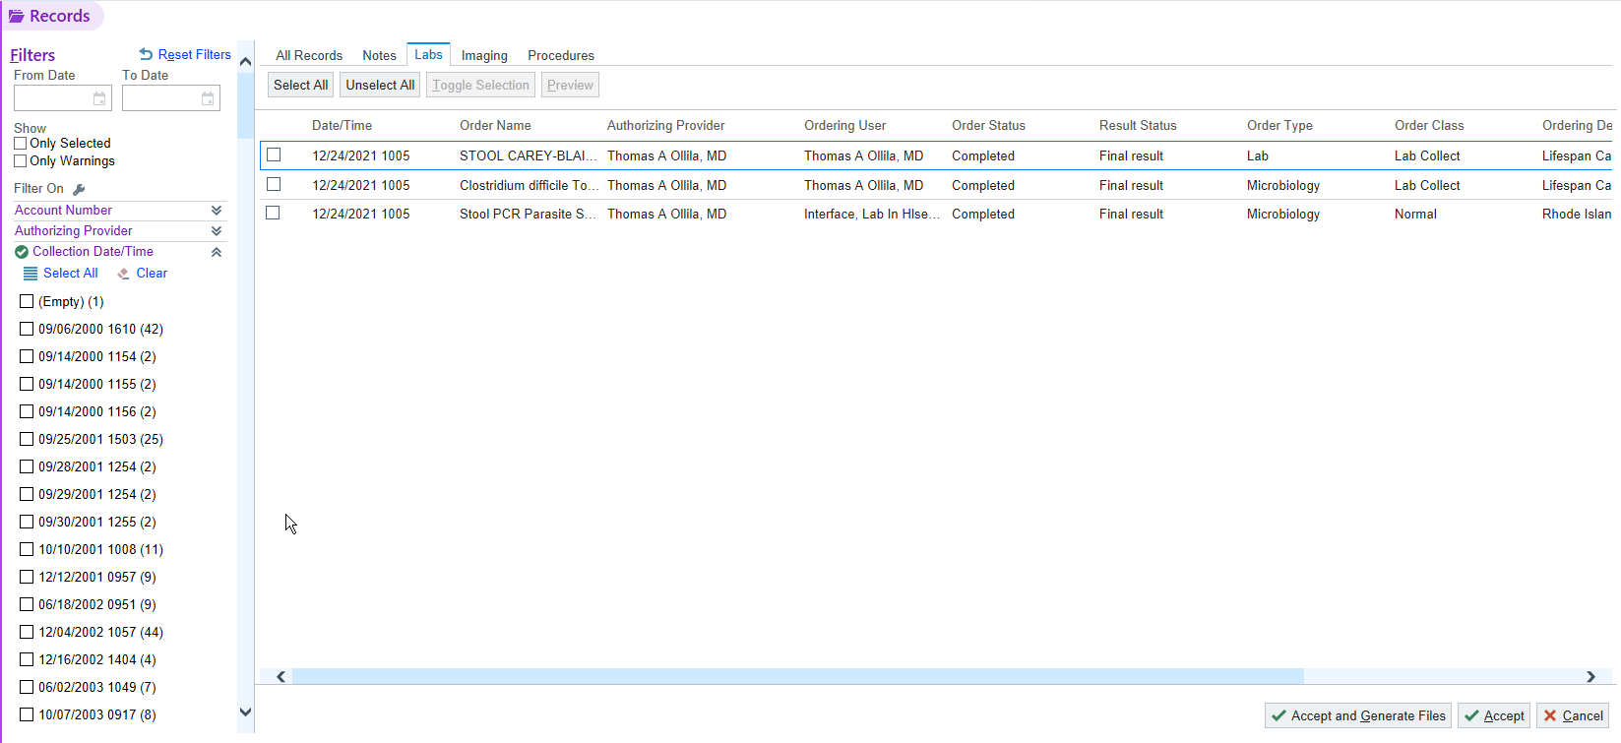
    - Click on the box in the lower right corner that says Accept and Generate Files.
    - Under Output, you will see the EMR Report being generated.
    - Be sure that the EMR Report has populated before finishing the Batch.
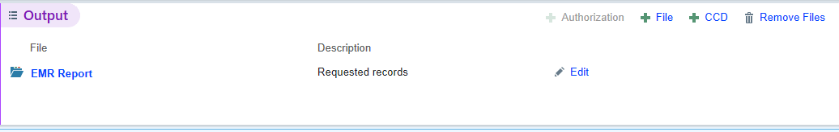
    - Click Ready for Delivery in bottom right corner and the current patient will automatically close.
    - Double click on the next patient and perform the same steps.
  - After all the patient information has been selected, click Batch Release (at the top).
  - Click on Complete Batch at the bottom right.
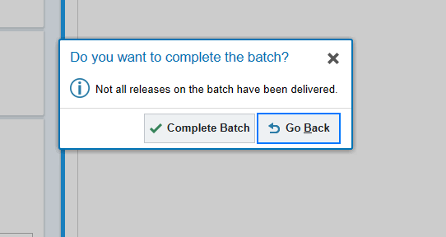
  - When the above field populates, choose “Complete Batch.”
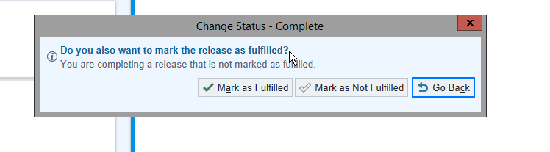
  - When the above field populates, choose “Mark as Fulfilled.”
  - The Release Status will be ‘Complete’.

- REVISIONS:
  - Changes were made to the EPIC batch release process.

