1. **PRINTING RESULTS**
   * 1. Under *Panel Results*, click on ^*Species* to minimize the identification results displayed:

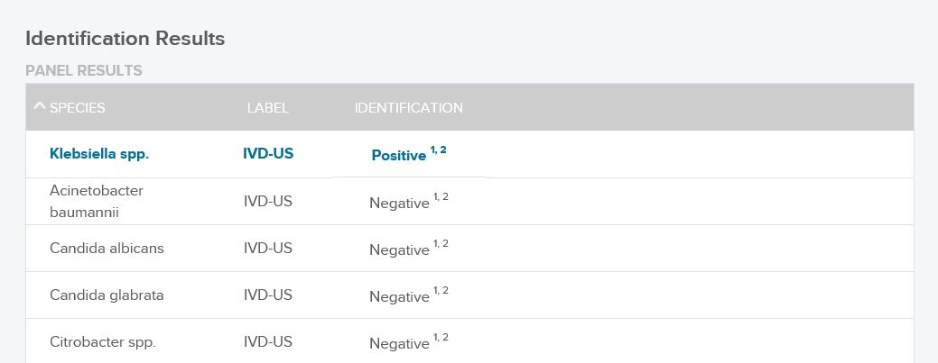

* + 1. *Summary Results* will now be displayed:

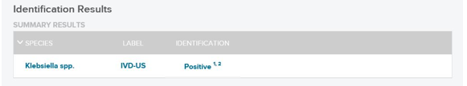

* + 1. Continue printing by using the printer icon at the far right of the *Footer**Bar*: 
    2. Attach standard label to patient report at the top left corner, directly under *Order Details/Order information.*

1. **SCANNING RESULTS**
2. All pages of the report must be scanned into the corresponding blood culture order in LifeChart by Central Collections between the hours of 7AM – 10PM.
3. Results obtained between 10PM-7AM are held to be scanned on the following day.
   * + 1. These can be found in the folders labeled **“Pheno Results – To be scanned”** located by the Pheno instruments.
       2. These folders should be checked first thing in the morning by assigned Pheno personnel.
4. **THE FOLLOWING REPORTS SHOULD NOT BE SCANNED – GIVE TO A SR. TECH ASAP:**
   * + - * **GRAM POSITIVE ORGANISMS**
         * **YEAST**
         * **POLYMICROBIAL RESULTS OTHER THAN GNRs**
5. **PAGING RESULTS**
6. The PharmD team must be paged any time a Pheno result is scanned into a patient’s chart. The PharmD pagers are:

**350-7193**

**350-6396**

**Add if NH patient: 350-8081**

1. Page both numbers for all Pheno results, include the 3rd number only if a Newport patient.
2. Enter the call back number corresponding from where you are calling.
3. The PharmD team may or may not call the lab back for additional information.
4. Follow-up pages **ARE NOT REQUIRED** if a call-back to the lab is not received.
5. The PharmD team will follow-up with the patient’s care team and make therapy suggestions as needed based on Pheno results.
6. **RESULTING IN SOFT**
7. Enter appropriate keypad choices in Soft under $PHEN media depending on patient results and steps taken:

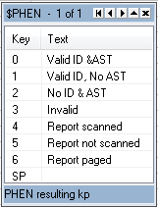

1. **FILING RESULTS**
2. Reports that have been scanned, paged, and resulted in SOFT are then reviewed by a Sr. Technologist.
3. Place report in the “**To Be Reviewed**” bin located outside Senior Tech office.
4. Results that are reviewed by a Senior tech are kept in the “Pheno Reports” binder located at the Blood bench.
5. All Pheno results should be brought up on Rounds.