**PROCEDURE: RAPID IDENTIFICATION AND SENSITIVITES DIRECTLY**

**FROM BLOOD CULTURE USING ACCELERATE PHENO™ SYSTEM**

1. **PRINCIPLE**

The Accelerate PhenoTest™ BC kit is a multiplexed *in vitro* diagnostic test utilizing both qualitative nucleic acid fluorescence *in situ* hybridization (FISH) identification and quantitative, antimicrobial susceptibility testing (AST) methods and is intended for use with the Accelerate Pheno™ system. It is performed directly on blood culture blood samples identified as positive by a continuous monitoring blood culture system. The Accelerate PhenoTM system is intended to measure signal intensity of fluorescent probes bound to nucleic acid in target and non-target organisms and to take time-lapse dark-field images of immobilized growing bacterial cells when used with Accelerate PhenoTest™ kits. Results are intended to be interpreted in conjunction with Gram stain results. The Accelerate PhenoTest™ BC kit is capable of simultaneous detection and identification of multiple microbial targets followed by susceptibility testing of the appropriate detected bacterial organisms within approximately 7 hours.

The Accelerate PhenoTest™ BC kit identifies the following Gram-positive and Gram-negative bacteria and yeast utilizing FISH probes targeting organism-specific ribosomal RNA sequences:

*Staphylococcus aureus*, *Staphylococcus lugdunensis*, Coagulase‐negative S*taphylococcus* species, *Enterococcus faecalis, Enterococcus faecium, Streptococcus* spp., *Pseudomonas aeruginosa*, *Acinetobacter baumannii, Klebsiella* spp., *Escherichia coli*, *Enterobacter* spp., *Proteus* spp.,*Citrobacter* spp., *Serratia marcescens, Candida albicans* and *Candida glabrata.*

The Accelerate PhenoTest™ BC kit tests the following antimicrobial agents with the specific target organisms identified below:

|  |  |
| --- | --- |
| **Organism** | **Antibiotics Tested** |
| *Acinetobacter baumannii* | Amikacin & Piperacillin/Tazobactam |
| *Citrobacter* spp. & *Enterobacter* spp. | Amikacin, Aztreonam, Ceftazidime, Cefepime, Ceftriaxone, Ciprofloxacin, Ertapenem, Gentamicin, Meropenem, Piperacillin/Tazobactam & Tobramycin |
| *Escherichia coli, Klebsiella* spp. & *Proteus* spp. | Amikacin, Ampicillin/Sulbactam, Aztreonam, Ceftazidime, Cefepime, Ceftriaxone, Ciprofloxacin, Ertapenem, Gentamicin, Meropenem, Piperacillin/Tazobactam & Tobramycin |
| *Pseudomonas aeruginosa* | Amikacin, Ceftazidime, Cefepime, Ciprofloxacin, Gentamicin, Meropenem, Piperacillin/Tazobactam & Tobramycin |
| *Serratia marcescens* | Amikacin, Aztreonam, Ceftazidime, Cefepime, Ceftriaxone, Ciprofloxacin, Ertapenem, Gentamicin, Meropenem, Piperacillin/Tazobactam & Tobramycin |
| *Enterococcus faecalis* & *faecium* | Ampicillin, Linezolid, Daptomycin & Vancomycin |
| *Staphylococcus aureus* | Ceftaroline, Erythromycin, Linezolid, Vancomycin & Daptomycin |
| Coagulase‐negative *Staphylococcus* | Daptomycin & Vancomycin |
| The following resistance phenotypes are reported based on qualitative tests: Methicillin-resistance (*S. aureus* *S. lugdunensis*, coagulase negative staphylococci) and macrolide-lincosamide-streptogramin B resistance (MLSb) (*S. lugdunensis* and coagulase negative staphylococci). | |

1. **AVAILABILITY**

24/7, performed on all shifts at RIH and TMH

1. **TEST CODE**

The Test Code is the billable media code: $PHEN

1. **SPECIMEN**
   1. Testing performed on positive aerobic, anaerobic, or pediatric blood culture bottles which gram-stain demonstrates **pure gram-negative rods**.
   2. The test will be performed on the first blood culture bottle that flags as positive per each admission and any patients discharged from the ED when gram stain requirements are met.
   3. Sample Volume
      1. 0.5-2 mL of blood.
   4. Sample Age
      1. Positive blood culture samples should be tested as soon as possible. If not tested right away, samples may be stored at room temperature before testing. Testing should not be performed more than 8 hours after positivity.
2. **MATERIALS AND EQUIPMENT**
   1. Materials
      1. Gram stain reagents
      2. BACT/Alert FA+ (aerobic), FN+ (anaerobic), or PF+ (pediatric) blood culture bottle
      3. Accelerate PhenoTest™ BC kit
      4. A syringe and needle (with at least 0.5 mL capacity) to transfer positive blood culture (0.5 mL sample volume) from blood culture bottle into sample vial.
      5. Alcohol wipes
      6. Gloves
   2. Equipment
      1. Vortex mixer
      2. Biosafety cabinet
      3. Printer
      4. The Accelerate Pheno™ system consists of the following hardware:
         1. Accelerate Pheno™ system ID/AST modules (Up to 4 or 8 depending on computing system architecture)
         2. Computing system, either:
            * Control PC/Analysis PC setup (supports up to 4 ID/AST modules):
            * Interface PC/Analysis module setup (supports up to 8 ID/AST modules):
            * Touchscreen monitor
            * Keyboard
         3. Mouse
         4. The major components of each ID/AST module are shown below:
3. **ID/AST Module Button**
4. **Cassette Nest**
5. **Reagent**

**Cartridge Nest**

1. **Door**

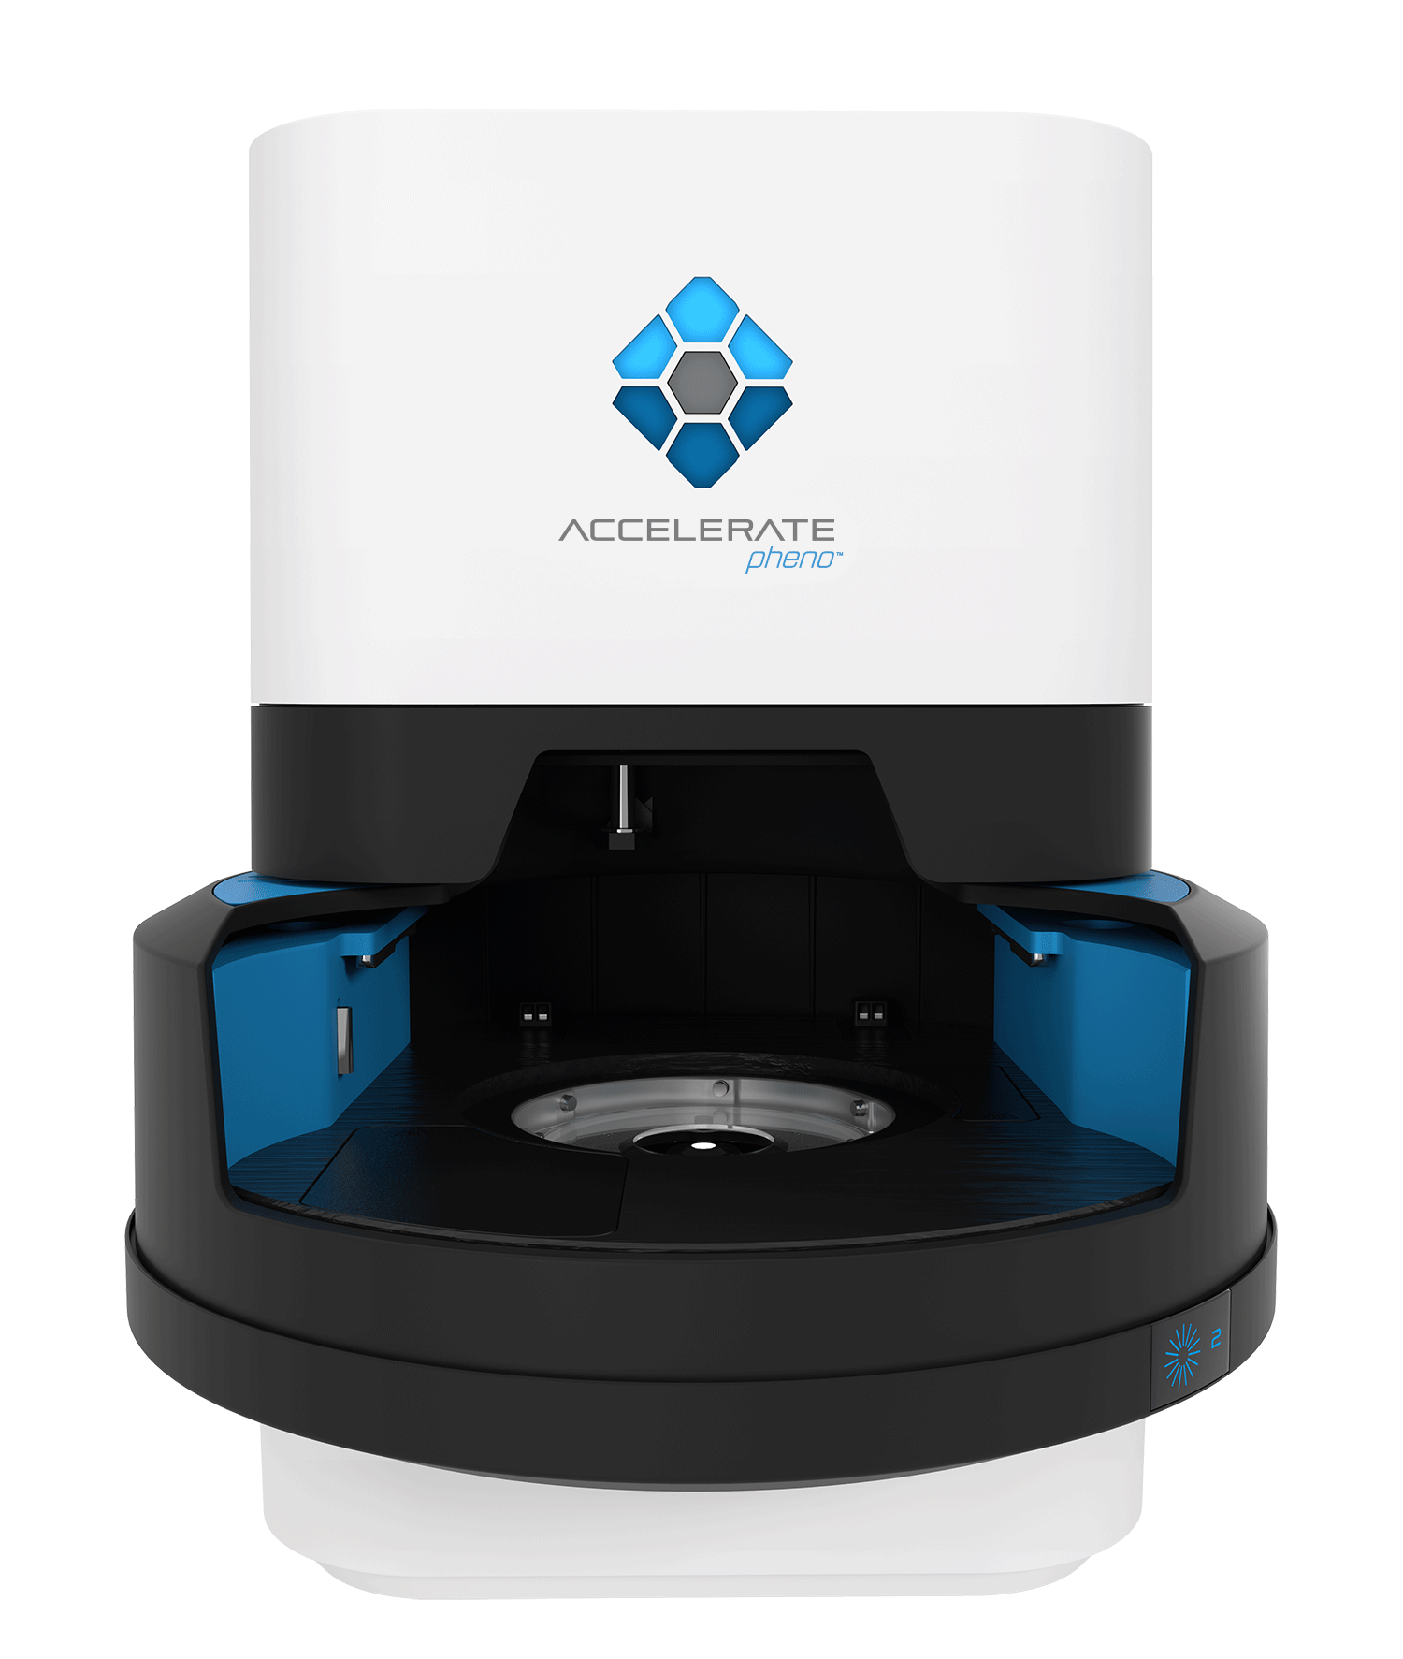

1. **STORAGE AND HANDLING**
   1. Store positive bottle at room temperature after flagging positive until it is ready to be run. The bottle is stable for up to 8 hours after positivity for testing.
   2. Be sure that a Accelerate Pheno™ system ID/AST module is available before opening a Accelerate PhenoTest™ BC kit.
   3. Handle only samples and cartridges one at a time.
   4. Test runs should be run within 1 hour after removing the assay kit from refrigerated storage to ensure accurate results. Cartridges may be returned to the refrigerator if not used within one hour.
   5. Change gloves and clean work area between each sample.
   6. Set-up of cartridges should be performed in the dedicated biosafety cabinet, located at the back of the lab.
   7. Routine cleaning only requires 70% ethanol of the hood.
   8. Accelerate PhenoTest™ BC kit storage upon arrival
      1. If the foil seals are pierced, do not use the reagent cartridge.
      2. Inspect the temperature monitor, Timestrip® PLUS™ indicator. This is used to monitor temperature excursion above the recommended upper threshold.
      3. ***Note:*** *Temperature indicators are intended to monitor temperature excursions during shipping only. The temperature indicators above should not be used to monitor temperature excursions once the assay kits are removed from the shipping box and placed in storage.*
      4. The Timestrip® PLUS™ blue indicator shows how much time the cartridge temperature was above 8°C. If the temperature monitor indicates the cartridge was above 8°C for ≥ 8 hours, do not use the reagent cartridge, and please notify Accelerate Diagnostics. See examples below:
         1. White space indicates cartridge is OK to use:



* + 1. The absence of white space in the indicator window means cartridge should not be used:



* + 1. Remove assay kit from shipping box and immediately place in storage at 2-8°C.
    2. Do not use the assay kit if desiccant indicator inside kit pouch shows exposure to humidity (by turning from blue to pink).
  1. Accelerate PhenoTest™ BC ID or AST QC storage upon arrival
     1. Remove Accelerate PhenoTest™ BC ID QC tests from shipping box and immediately place in storage at 2-8°C.
     2. Remove Accelerate PhenoTest™ BC AST QC tests from shipping box and immediately place in storage at -65°C to -86°C.
     3. QC should be run within 15 minutes after they are removed from refrigeration or freezer.
  2. Do not use the Accelerate PhenoTest™ BC kit, Accelerate PhenoTest™ BC ID QC tests, or Accelerate PhenoTest™ BC AST QC tests after the expiration date.
  3. Inspect package upon arrival.
     1. If the foil or laminate seals are pierced, do not use the Accelerate PhenoTest™ BC kit, Accelerate PhenoTest™ BC ID QC tests, or Accelerate PhenoTest™ BC AST QC tests.
     2. Inspect temperature monitors. Do not use Accelerate PhenoTest™ BC kit if temperate fell out of range. Contact Accelerate Customer Support Center.

1. **QUALITY CONTROL**
   1. Maintenance
      1. Cleaning and decontamination of instrument
         1. Cleaning and maintenance of the instrument will be performed in accordance with the vendors Operator’s Manual. General cleaning of internal ID/AST module surfaces is not recommended. External surfaces may be wiped down using a lint-free laboratory wipe that has been dampened by 70% isopropyl alcohol in water when the ID/AST module is not in use.
         2. **Do not spray cleaning solution directly on ID/AST module. Do not use excessive solution or allow any "puddling" or dripping.**
         3. DO NOT CLEAN INSIDE OF THE INSTRUMENT.
         4. For more details refer to *Accelerate PhenoTM System: Instrument and Software User Guide*
   2. QC is performed (ID & AST) at least weekly, or additionally as needed for new shipments or after major system maintenance including: software upgrade, annual PM, and if 3 or more modules are replaced at the same time. QC is also repeated if the controls are out of range or invalid. QC must be acceptable in order for the lot of reagent and instrument to be used for patient samples
   3. Accelerate PhenoTest™ BC AST QC
      1. Test contains assayed QC materials for monitoring quantitative AST assays found in the Accelerate PhenoTest™ BC kit. Analytes used to monitor AST performance include:

|  |
| --- |
| *Escherichia coli* ATCC® 25922™ |
| *Escherichia coli* ATCC® 35218™ |
| *Pseudomonas aeruginosa,* ATCC® 27853™ |
| *Enterococcus faecalis* ATCC® 29212™ |
| *Staphylococcus aureus* ATCC® 29213™ |
| *Staphylococcus aureus* ATCC® 43300™ |
| *Staphylococcus aureus* ATCC® BAA-977™ |
| *Candida albicans* ATCC® 96268™ |

* 1. Accelerate PhenoTest™ BC ID QC
     1. Test contains assayed QC materials for monitoring qualitative ID assays found in the Accelerate PhenoTest™ BC kit with the exception of the gel electrofiltration (GEF) step. Analytes used to monitor ID performance include:

|  |
| --- |
| Klebsiella spp. (KLE)/ |
| Coagulase-negative staphylococci (CNS) beads |
| *Enterococcus faecalis* (EFM) |
| *Candida glabrata* (CGL) beads |
| Streptococcus spp. (STR) |
| Enterobacter spp. (ENT) beads |
| *Staphylococcus lugdunensis* (SLU) beads |
| *Enterococcus faecalis* (EFS) beads |
| Proteus spp. (PRO) beads |
| *Escherichia coli* (ECO) beads |
| Citrobacter spp. (CIT) beads |
| *Serratia marcescens* (SMA) beads |
| *Pseudomonas aeruginosa* (PAE) beads |

* 1. Process Controls
     1. QC tests are used in place of a positive blood culture sample vial on the reagent cartridge of the Accelerate PhenoTest™ BC kit in the Accelerate Pheno™ system, and contain all components necessary to test all reagents for positive and negative reactivity.
     2. Three internal controls are included in each assay and require no action by the user: 1) Universal Bacterial Probe and Universal Eukaryotic Probe (for yeast), 2) General Nucleic Acid Stain, 3) Growth Control Channel.
  2. QC Workflow Procedure
     1. Remove Accelerate PhenoTest™ BC kit from refrigerator.
     2. Open Accelerate PhenoTest™ BC kit and remove contents from outer packaging. Remove and discard sample vial from the reagent cartridge (QC components will be used in place of the sample vial) and place cassette packaging to the side for later use.
     3. Remove the Accelerate PhenoTest™ BC AST QC test consumable (“π” configuration) from freezer.
     4. Use the top edge of the consumable and guide the post and top edge clips into the holes above the sample vial location as shown below.
     5. Next press the bottom edge so the respective clips snap into the semi-circle sample vial location. The AST QC test should be sitting level with the kit.
     6. Remove the clear adhesive from the AST QC test. Do not touch the open wells.
     7. Remove the ID QC test (“E” configuration) from refrigerator. The ID QC test will complement the previously loaded AST QC test when both are used together.
        1. **CAUTION:** *The ID QC test* ***CANNOT*** *be run alone. It must* ***ALWAYS*** *be run in parallel with an AST QC test*
     8. Press down on the center post and on edges of ID consumable to ensure security clips are engaged on the AST consumable.
        1. **Note**: The foil seal should not be removed. The instrument will automatically pierce the seal.
     9. Both the ID and AST QC tests should be flush with each other if seated correctly. The barcode labels from each consumable should be in line when on top of each other.
  3. QC Report
     1. When the assay is complete, the system displays the final results in Quality Control Report (example of a report page is below).

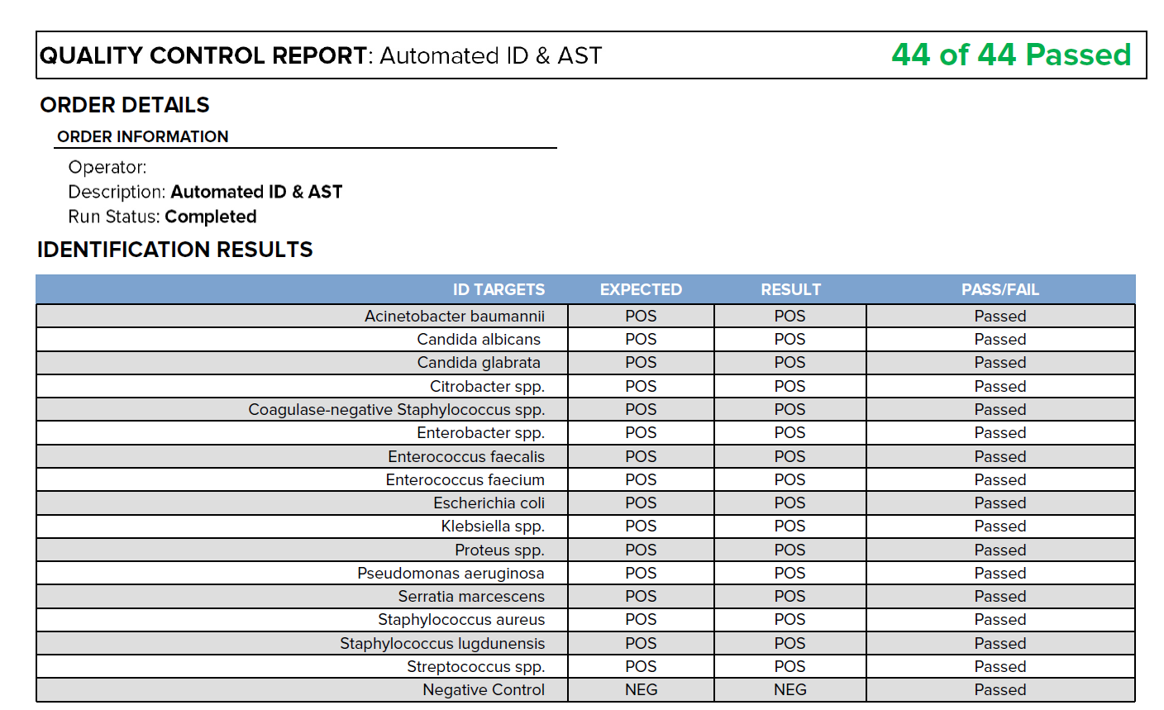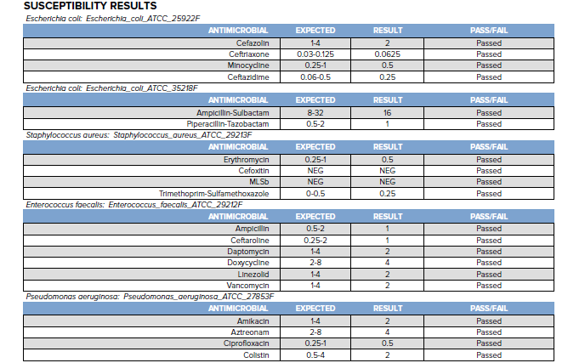

* + 1. The Accelerate PhenoTest™ BC ID QC test is run in conjunction with the Accelerate PhenoTest™ BC AST QC test and Accelerate PhenoTest™ BC kit. Therefore, ID and AST results will be displayed in a single report. Reports should be reviewed on a per result basis by evaluating whether a specific identification target or AST result passed or failed. The combined number of passing results out of the total number of possible results is provided at the top of the report in green.
    2. The identification results section lists the pass or fail status for each tested species. PASS/FAIL status is determined by whether the identification result (RESULT) matches the expected result (EXPECTED) for the assay (ID TARGETS).
    3. An ‘N/A’ result should be interpreted as an invalid run (neither pass, nor fail). Repeat the QC test again, and if the system again reports ‘N/A’ results, contact Accelerate Customer Support Center for assistance.
    4. The susceptibility results section lists the pass or fail status and MIC for each antimicrobial and resistance phenotype tested with the respective QC organism. PASS/FAIL status is determined by whether the MIC result (RESULT) falls within (Passed) or outside (Failed) of the QC range (EXPECTED) for the assay (ANTIMICROBIAL).
    5. An ‘N/A’ result should be interpreted as an invalid run (neither pass, nor fail). Repeat the QC test again, and if the system again reports ‘N/A’ results, contact Accelerate Customer Support Center for assistance.

1. **TEST PROCEDURE**
   1. Preparing cartridge
      1. Clean surface of biosafety cabinet with 70% ethanol before testing.
      2. Remove Accelerate PhenoTest™ BC kit from refrigerator.
         1. **CAUTION:** Test runs should be initiated as soon as possible after removing the assay kit from refrigerated storage (within ~1 hour) to ensure accurate results. Cartridges may be returned to the refrigerator if not used within one hour.
      3. Open kit and remove contents from outer packaging.
      4. Remove sample vial from the reagent cartridge and place cassette packaging to the side.
      5. Label sample vial with patient label.
      6. Remove venting needle from blood bottle after gram-stain and appropriate plates were inoculated.
      7. In a biosafety cabinet, grasp the blood bottle by the head with two fingers and swirl it counter-clockwise, to generate a vortex. Immediately set the bottom of the bottle firmly to the rubber platform of the vortexer. Once the vortex effect is achieved, begin a countdown of a minimum of 10 seconds.
      8. Disinfect the top of bottle with an alcohol wipe and allow to air dry.
      9. Use a 21G needle and syringe with at least 0.5 mL capacity to puncture top of bottle.
      10. Tip the blood culture bottle (with resin) horizontally until liquid fully fills the neck of the bottle.
      11. **Wait 10 seconds to allow resin beads to settle before aspirating the sample.**
      12. Remove a minimum of 2mL sample.
      13. Unscrew sample vial cap and fill the labeled sample vial to the fill line (0.5mL) as shown in figure 8-1 Screw on sample vial cap tightly.

Figure 8-1 Sample Vial Fill Volume

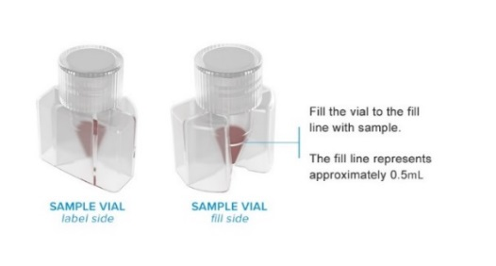

* + 1. Do NOT fill sample vial with more than 2 mL or it could affect the performance of the assay.
    2. DO NOT puncture the foil lid of the sample vial.
    3. Test must be initiated within 15 minutes of placing the blood content into sample vial. If not performed in this time, set bottle aside at room temperature until tested. Bottle can sit for 8 hours after positivity before running test.
    4. ***Do not vortex the sample in the sample vial.***
    5. Place sample vial into sample vial receptacle on the Accelerate PhenoTest™ BC Kit, making sure the vial label faces outward, and there is no empty space between the sample vial and vial receptacle as depicted below.
    6. An audible “click” occurs as the sample vial is inserted. Confirm sample vial is securely snapped into place and does not rotate by alternately pressing the edges of the seated vial with your thumbs.

Figure 8-2 Accelerate PhenoTest™ BC Kit

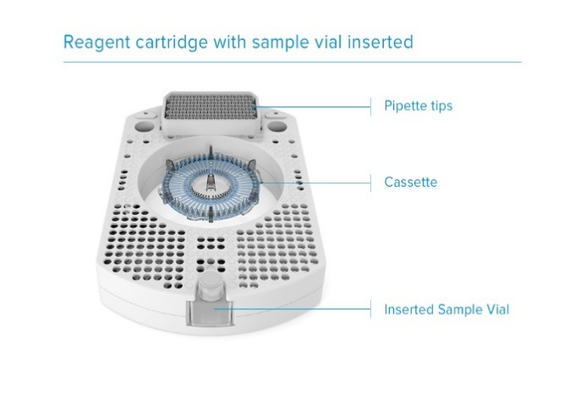

* + 1. Log into the instrument with user specific credentials.
    2. Press module button on front right side of Accelerate Pheno™ system module to open door.
    3. *Note: Try avoiding keeping the door open for too long. This will destabilize module temperature and will delay run time.*
    4. Remove cassette from packaging and place cassette into nest in center of instrument. Pick up cassette by central post and gently turn cassette clockwise until it clicks by using side tabs.
    5. Gloves must be worn when handling the cassette and should be transferred directly from packaging to the cassette nest into the module to prevent skin oils and debris from interfering with cassette imaging. Avoid touching top and bottom surfaces of cassette.

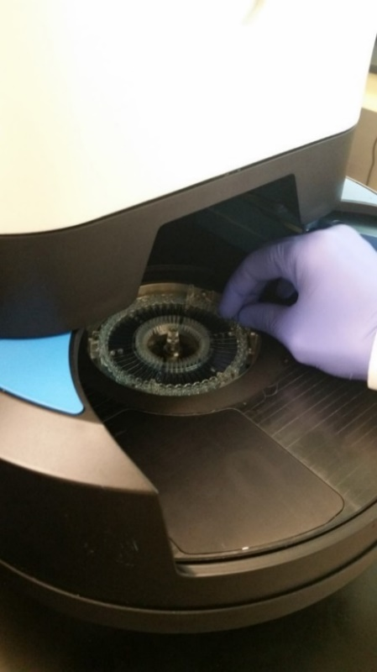

* + 1. Peel off protective cover from pipette tips on top portion of reagent cartridge.
    2. Be sure to inspect the perimeter of the tip tray for any residual adhesive left by the protective cover and that pipette tips are all nestled into the tray appropriately. Failure to remove all of the protective covering from the pipette tip rack may result in an instrument error.

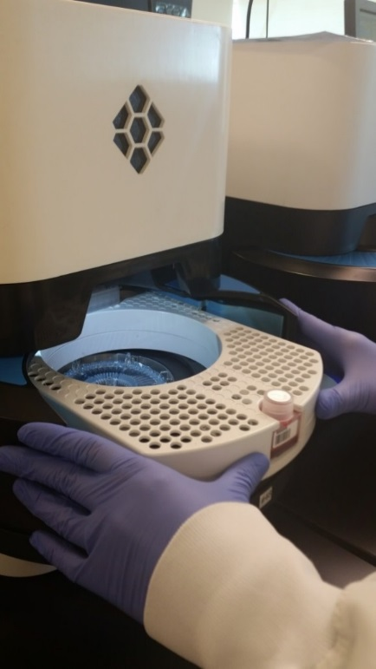

* + 1. With sample vial receptacle facing out, gently push reagent cartridge straight back into instrument until it stops. Cartridge will softly ‘click’ into place.
    2. Press module button to close door and begin run. The instrument will start automatically after closing the door.
    3. Be sure to remain by instrument to read RUNNING on screen. Before running, the instrument will take a few minutes to successfully engage a run, reading “starting run”. Observation is required in the event has any potential errors can be addressed. If an error is left unresolved then the run will subsequently fail.
    4. The module button will turn to blue when run is successfully engaged.
  1. Post-Run
     1. Upon completion the module button will change from blue to green or red and the user interface will display the message “run complete”.
        1. Red = failed run
        2. Green = successfully completed run
     2. Press the module button to open door.
     3. Remove sample vial, reagent cartridge and test cassette and discard into a sharps biohazard waste container. To remove test cassette, gently turn cassette counterclockwise using side tabs until it unclicks from nest. Hold reagent cartridge and test cassette level and gently place in suitable biohazard waste receptacle for disposal.
        1. *WARNING: Gloves should be worn when unloading sample vial, reagent cartridge and cassette. Use caution when removing the cassette from the module because the cassette center trough may contain liquid biohazardous waste*.
     4. Press module button to close door immediately following removal of all assay materials.
     5. Print report, and apply a standard label, and follow reporting steps.

1. **SYSTEM OPERATIO****N**
   1. For more information about operating the Accelerate PhenoTM instrument refer to *Appendix AP65- Accelerate Pheno System Operation*
2. **INTERPRETATIONS**
   1. **NO TESTING IS TO BE REPEATED.**
   2. The *Results* screen displays a list of reports for completed assay runs. To open the *Results* screen, select *Results* from the Workflow Menu. The user requires the ‘View Results’ permission to access this screen.

**Patient Results or QC Results**

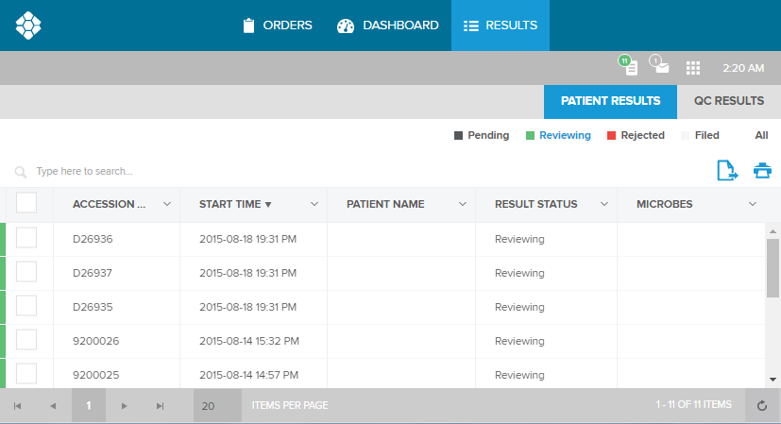

**Tab Bar**

**Filter Bar**

**Search Bar**

* 1. Use the *Tab Bar* to select from the following lists:
     1. Patient Results– Lists reports for patient sample runs
     2. QC Results – Lists reports for quality control runs.
  2. The *Filter Bar* has quick filter buttons on the right that filter reports by status. The *Search Bar* has a search field on the left.
  3. The *Patient Results* or *QC Results* screens contain tables of report records. Select a record to view the *Patient Report* or *Quality Control Report*, respectively. 
  4. Patient Results
     1. The *Patient Results* screen displays a list of reports with results from sample runs. To open the *Patient Results* screen, select *Results* from the Workflow Menu. *Patient Results* will be selected by default from the *Tab Bar*. Select *Patient**Results* from the *Tab Bar* at any time to return to *Patient Results* screen
     2. Patient Report
        1. The *Patient Report* screen allows the user to view, edit, accept/reject and print patient reports. To open the *Patient Report* screen, select a record from the Patient Results screen, or select the following icon from a module card on the Dashboardscreen for a patient sample run: 
        2. The patient report is displayed as follows:

**Footer Bar**

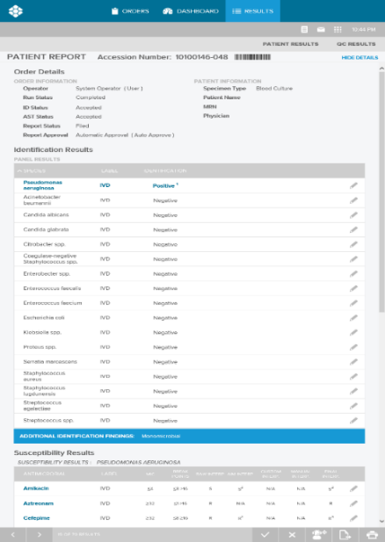

**EXAMPLE**

* + - 1. *View*- Use the left () and right () arrow buttons on the *Footer**Bar*to navigate sequentially between reports on the *Patient* *Results*list.
      2. *Export*- Use the export icon on the *Footer**Bar*to export the Patient Report in one of the following formats: MSExcel (.xlsx), MSWord (.docx), CSV Text (.csv), Plain Text (.txt), or Adobe PDF (.pdf).
      3. *Print***-** Use the printer icon at the far right of the *Footer**Bar* to create a printer friendly Patient Report: 
    1. Run Status
       1. A sample run may have one of the following statuses on the report:
          - *Completed* – Run complete. All results valid.
          - *Aborted* - Run did not complete due to user abort. Results obtained prior to abort are valid and should be reported.
          - *Failed* - Run did not complete due to a software/instrument failure. Results obtained prior to failure are valid and should be reported.
    2. Identification Results

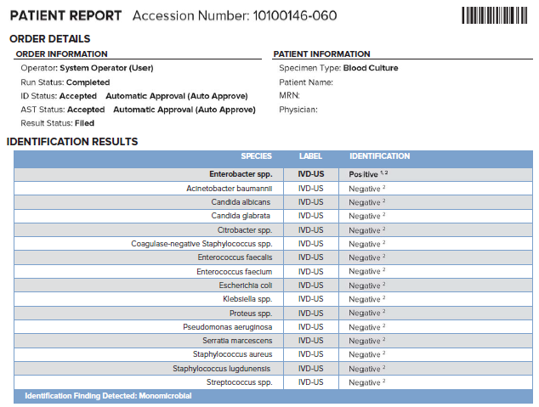

* + 1. The “Identification Results” section of the report lists all target groups tested and reports an identification result. Target group species are listed in Table 10-1, and identification result definitions are listed in Table 10-2.

Identification target groups are listed below

| **Target Group** | **Species** |
| --- | --- |
| **Gram-Positive Bacteria** | |
| *Staphylococcus aureus* | *Staphylococcus aureus* |
| Coagulase-negative *Staphylococcus* spp. | *Staphylococcus lugdunensis, Staphylococcus epidermidis*, *Staphylococcus haemolyticus*, *Staphylococcus hominis*, *Staphylococcus capitis*, *Staphylococcus warneri,* not differentiated |
| *Staphylococcus lugdunensis* | *Staphylococcus lugdunensis* |
| *Enterococcus faecalis* | *Enterococcus faecalis* |
| *Enterococcus faecium* | *Enterococcus faecium* |
| *Streptococcus* spp. | *Streptococcus mitis*, *Streptococcus oralis, Streptococcus gallolyticus, Streptococcus agalactiae, Streptococcus pneumoniae*, not differentiated |
| **Gram-Negative Bacteria** | |
| *Escherichia coli* | *Escherichia coli* |
| *Klebsiella* spp. | *Klebsiella pneumoniae, Klebsiella oxytoca*, not differentiated |
| *Enterobacter* spp. | *Enterobacter cloacae, Enterobacter aerogenes*, not differentiated |
| *Citrobacter* spp. | *Citrobacter freundii, Citrobacter koseri*, not differentiated |
| *Proteus* spp. | *Proteus mirabilis, Proteus vulgaris*, not differentiated |
| *Serratia marcescens* | *Serratia marcescens* |
| *Pseudomonas aeruginosa* | *Pseudomonas aeruginosa* |
| *Acinetobacter baumannii* | *Acinetobacter baumannii* |
| **Yeast** | |
| *Candida albicans* | *Candida albicans* |
| *Candida glabrata* | *Candida glabrata* |

Identification result definitions

|  |  |
| --- | --- |
| **Identification Result** | **Definition** |
| Positive | Target group detected |
| Negative | Target group not detected |
| Indeterminate | Result not defined – Target group may or may not be present |

* + 1. Target groups with positive and indeterminate results are printed at the top of the list in bold blue font. Off-panel or invalid results will trigger expert rules that state that alternate testing should be performed.
    2. Correlating positive blood culture Gram stain result with kit result.
       1. Perform standard positive blood culture sample Gram stain protocol.
       2. Any identification result(s) from Pheno that is inconsistent with Gram stain morphology should be confirmed with subculture of the blood culture bottle and identification by alternate methods.
       3. Any monomicrobial results from the assay kit that shows multiple Gram stain morphologies or if the observed Gram stain differs from the expected Gram stain morphology for the organism identified by the assay kit should be confirmed with alternate methods.
       4. Examples of Pheno results inconsistent with gram stain results include:

Correlation between Accelerate PhenoTest™ BC kit Result and Gram Stain triggering subculture and identification by alternate methods

|  |  |
| --- | --- |
| **Accelerate PhenoTest™ BC Kit Result** | **Inconsistent Positive Blood Culture Gram Staina** |
| Negative | Organisms visualized |
| *Staphylococcus spp.* | Gram-positive cocci in chains |
| Gram-negative rod |
| Gram-variable coccobacilli |
| Yeast |
| *Enterobacteriaceae Gram-negative rod* | Gram-positive cocci in chains |
| Gram-positive cocci in clusters |
| Yeast |
| Gram-variable coccobacilli |
| *Candida glabrata or Candida albicans* | Gram-positive cocci in chains |
| Gram-positive cocci in clusters |
| Gram-negative rods |
| Gram-variable coccobacilli |
| *Enterococcus spp.* | Gram-negative rods |
| Gram-variable coccobacilli |
| Gram-positive cocci in clusters |
| Yeast |

aAnalysis of Gram stain morphology should include Gram reaction (Gram-positive or Gram-negative, basic cellular morphology (cocci, rods, coccobacilli, yeast) and aggregate morphology (cocci in chains and clusters). Gram stain results showing gram-negative cocco-bacili may indicate the presence of *Acinetobacter baumannii*, however the cellular morphology may be inconsistent or difficult to interpret for members of this genus.

* + 1. Susceptibility Results

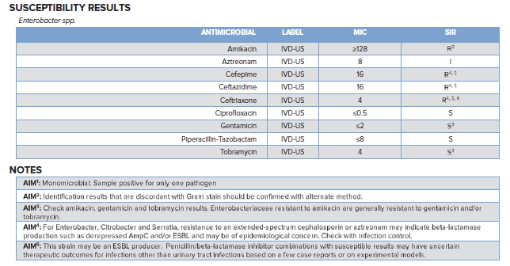

* + - 1. A separate “Susceptibility Results” section is displayed for each target species with a positive identification result, and lists label, minimum inhibitory concentration (MIC), breakpoints and SIR results for each tested antimicrobial.
      2. The Label column lists the regulatory labeling classification as follows:
         * IVD – For *in vitro* diagnostic use.
      3. The Breakpoints column lists the breakpoints for the current microbe/antimicrobial combination reported in one of 3 formats:
         * ≤ S ≥ R, where S is susceptible breakpoint and R is resistant breakpoint
         * ≤ S ≥ NS, where S is susceptible breakpoint and NS is nonsusceptible breakpoint
         * POS/NEG, where POS=positive, NEG=negative for phenotypic resistance mechanism assays
      4. The following SIR results are displayed:
         * Raw SIR – SIR interpretation based on MIC result and breakpoints
         * AIM SIR – SIR interpretation based on Accelerate Interpretation Manager (AIM) Expert Rules (Refer to Expert Rules Manual.)
         * Custom SIR – SIR interpretation based on customer-created Custom Rules (Refer to Instrument and Software User Guide.)
         * Manual SIR – SIR interpretation based on manual user edits (Refer to Instrument and Software User Guide.)
         * Final SIR – SIR interpretation based on priority: Manual SIR > Custom SIR > AIM SIR > Raw SIR (Refer to Instrument and Software User Guide.)
      5. SIR columns of the patient report can display the following interpretations:
         * S = susceptible
         * I = intermediate
         * R = resistant
         * NS = nonsusceptible (A category used for isolates for which only a susceptible interpretive criterion has been designated because of the absence or rare occurrence of resistant strains)
         * POS = positive (for resistance phenotype tests)
         * NEG = negative (for resistance phenotype tests)
         * N/A = not applicable
      6. If a particular resistance phenotype is detected, the expert rule system will display the name of the phenotype in a prominent blue bar below the list of antimicrobials. Notes associated with applicable expert rules will be displayed in the Notes section of the report.
    1. Monomicrobial Reporting
       1. The identification assay will also report when a sample is positive for only one target identification probe, and no other organisms are detected (i.e., monomicrobial call). End users have the ability to enable or disable reporting of monomicrobial samples. If enabled, detected monomicrobial samples are reported by the expert rules system that will print the ID Finding “Monomicrobial” and the following note on the report: “Sample positive for only one pathogen.” If disabled, the statement “Culture to agar media recommended to ensure the morphologic consistency of the ACCELERATE PHENO system identification” will be printed on the patient report for every valid ID result.

1. **REPORTING RESULTS**
   1. Refer to *APPENDIX AP67* – *Reporting of results for rapid identification and sensitivities directly from blood culture using Accelerate Pheno™ System*
2. **LIMITATIONS OF TEST**
   1. General Limitations
      1. This product can only be used with the Accelerate Pheno™ system.
      2. The Accelerate PhenoTest™ BC kit assay has not been evaluated for specimens other than blood (e.g. sterile body fluids inoculated into blood culture bottles)
      3. The performance of this test has only been evaluated using the following blood culture bottles:
         1. BD BACTEC™ Standard/10 Aerobic/F Medium,
         2. BD BACTEC™ Standard/10 Anaerobic/F Medium,
         3. BD BACTEC™ Lytic/10 Anaerobic/F Medium
         4. BD BACTEC™ PEDS PLUS™/F Medium
         5. BD BACTEC™ Plus Aerobic/F Medium
         6. BD BACTEC™ Plus Anaerobic/F Medium
         7. BioMérieux BacT/ALERT® SA Standard Aerobic
         8. BioMérieux BacT/ALERT® SN Standard Anaerobic
         9. BioMérieux BacT/ALERT® FA Plus Aerobic
         10. BioMérieux BacT/ALERT® FN Plus Anaerobic
         11. BioMérieux BacT/ALERT® PF Plus
         12. Versa TREK® REDOX 1 (Aerobic) Medium
         13. Versa TREK® REDOX 2 (Anaerobic) Medium
      4. This product should not be used with blood culture bottles containing charcoal.
      5. Positive blood culture samples must be run using the Accelerate PhenoTest™ BC kit on the Accelerate Pheno™ system within 8 hours of sample positivity.
      6. Positive blood culture sample must be loaded on the Accelerate Pheno™ system and the run must be initiated within 15 minutes of pipetting sample into sample vial and within 1 hour of removing the assay kit from refrigerated storage.  
         Failure to observe proper procedures for sample collection, preparation, storage, handling and/or transportation may cause incorrect results.
   2. Identification (ID) Limitations
      1. Due to the possibility of cross reactivity, all Accelerate PhenoTest™ BC kit results should be interpreted in conjunction with Gram stain.
      2. The ability of probes to detect all strains of a target species was not predicted by *in-silico* analysis.
      3. Additional subculture is required for the identification of *S. pneumoniae* in cases of a positive *Streptococcus* spp. call.
      4. Subculture of positive blood culture is required in the following situations:
         1. For the identification and susceptibility testing of off-panel organisms not identified by the Accelerate PhenoTest™ BC kit,
         2. For samples that give a polymicrobial result
         3. For organisms for which species identification is critical for patient care, (e.g. speciation of streptococci)
         4. For testing antimicrobial agents not included on the Accelerate panel
         5. For testing certain antimicrobial agents as discussed in AST limitations below
         6. For testing samples for which an “indeterminate” result for any probe was obtained
         7. To obtain isolates for epidemiologic testing.
      5. Accelerate PhenoTest™ BC kit identification results that are discordant with the result of the blood culture Gram stain (for example, no organism detection when the Gram stain is positive or detection of a Gram-positive cocci when Gram-positive cocci were not observed in the Gram stain) should be confirmed by an alternate technique prior to reporting the test result. For some polymicrobic calls, false positive results may not be mitigated by Gram stain analysis (for example, detection of 2 *Enterobacteriaceae* species with Gram-negative rods observed in the Gram stain). Results of such polymicrobic calls should be verified by subculture and/or an alternative identification method.
   3. Antimicrobial Susceptibility Testing (AST) Limitations
      1. Due to insufficient number of test isolates, the ability of the Accelerate PhenoTest™ BC kit to detect inducible MLSb resistance in coagulase-negative staphylococci is unknown when used with the following blood culture bottle types: BacT/Alert SN Standard Anaerobic, BACTEC Peds Plus/F, BACTEC Plus Anaerobic/F, BACTEC Standard Anaerobic, BACTEC Standard/10 Aerobic, VersaTrek Redox 1 Aerobic, VersaTrek Redox 2 Anaerobic. Use an alternative method for detection of inducible MLSb resistance when using these blood culture bottle types if critical to patient care.
      2. The Accelerate PhenoTest™ BC kit cannot differentiate multiple strains of the same species with different susceptibility profiles. In these cases, AST results may be inaccurate and confirmatory testing by an alternative method is recommended.
      3. Susceptibility testing of monomicrobial samples will only be performed when on-panel species eligible for susceptibility testing are detected. See intended use.
      4. Susceptibility testing of polymicrobial samples will only be performed on one organism out of a pair of species that meet all of the following criteria:
         1. One or both organisms must be on the Accelerate PhenoTest™ BC kit test panel and eligible for AST testing (except *Proteus* spp.)
         2. The two organisms must have distinct growth responses or morphological differences such that growing clones from each species can be differentiated by the software. These include the following pairs:

Table 11-1: Polymicrobial Testing Pairs that May Produce an AST Result

| **Organism 1** | **Organism 2** |
| --- | --- |
| * AST-eligible organism (except *Proteus* spp.) | * AST-ineligible organism: * *Streptococcus spp.* * *Candida albicans* * *Candida glabrata* |
| * *Escherichia coli* * *Klebsiella* spp. * *Enterobacter* spp. * *Citrobacter* spp.   or   * *Serratia marcescens* | * *Staphylococcus aureus* * Coagulase-negative *Staphylococcus* spp. * *Enterococcus* spp. *(E. faecalis, E. faecium )*   or   * *Pseudomonas aeruginosa* |
| * *Acinetobacter baumannii* | * *Enterococcus* spp. *(E.faecalis, E. faecium)* |

* + - 1. Only one organism when diluted for AST must be within the required concentration limits for AST testing (10-130 growing clones per field of view).
    1. If the concentration ratio between organisms is such that only one organism could be diluted to the concentration range required for AST testing, AST testing will only be performed on the higher concentration organism. If one of the organisms in the pair is eligible for AST testing and the other is not, AST testing will only be performed on the on-panel AST-eligible organism. If both organisms are eligible for AST testing and are within the required concentration limits for AST testing, AST results will not be reported.
    2. If an AST result is not provided by the Accelerate PhenoTest BC™ kit, susceptibility testing must be performed using an alternative method.
    3. Subculturing of positive blood culture is necessary for the identification and susceptibility testing of organisms not identified by the Accelerate PhenoTest™ BC kit and for antimicrobial agents not included on the Accelerate panel.
    4. Potential interference by antimicrobial agents that may be present in a patient blood specimen has not been established with the Accelerate PhenoTest™ BC kit.
    5. The ability of the Accelerate PhenoTest™ BC kit to detect resistance in the following combinations is unknown because an insufficient number of resistant isolates were encountered at the time of comparative testing:
       1. Amikacin: *Citrobacter* spp.*, Enterobacter* spp.*, E. coli, Proteus* spp.*, S. marcescens*
       2. Aztreonam: *Proteus* spp.*, S. marcescens*
       3. Cefepime: *Citrobacter* spp.*, Proteus* spp.*, S. marcescens*
       4. Ceftazidime: *Proteus* spp.*, S. marcescens*
       5. Ceftaroline: *S. aureus*
       6. Ceftriaxone: *Citrobacter* spp.*, E. cloacae, S. marcescens*
       7. Ciprofloxacin: *Citrobacter* spp.*, Proteus* spp.*, S. marcescens*
       8. Daptomycin: *S. aureus*
       9. Ertapenem: *Citrobacter* spp.*, Proteus* spp.*, and S. marcescens*
       10. Gentamycin: *Citrobacter* spp.*, Enterobacter* spp.*, Proteus* spp.*, S. marcescens*
       11. Meropenem:  *Citrobacter* spp.*, E. coli, Proteus* spp.*, and S. marcescens*
       12. Piperacillin/Tazobactam: *Proteus* spp.*, and S. marcescens*
       13. Tobramycin: *Citrobacter* spp.*, Proteus* spp.*, S. marcescens*
       14. Cefoxitin for Phenotypic Resistance: *S.lugdunensis*
       15. MLSb: S. *lugdunensis*
    6. The following antimicrobial/organism combinations may produce a resistant result that can be found susceptible by the reference method. If critical to patient care confirm these results with an alternate method:
       1. Meropenem: *Enterobacter*
       2. Ceftazidime: *Pseudomonas aeruginosa* (Any *P. aeruginosa* isolate that provides an MIC ≥16 μg/mL should be retested using an alternate method)
       3. Cefepime: *Pseudomonas aeruginosa*
       4. Ertapenem: *Enterobacter* spp.
       5. Piperacillin/Tazobactam: *Acinetobacter baumannii*, *Klebsiella* spp.
    7. The ability of the Accelerate PhenoTest™ BC kit to provide accurate MICs with amikacin resistant strains of *A. baumannii* has not been established; isolates of this species that provide resistant results should be confirmed by an alternative method.
    8. Due to a low essential agreement for *Serratia marcescens* with ceftriaxone, results should be confirmed with an alternate method if critical to patient care.
    9. The current absence of data on daptomycin-resistant isolates precludes defining any categories other than “susceptible”. Isolates yielding test results suggestive of a non-susceptible category should be retested and if the result is confirmed, the isolate should be retested using the reference method.
    10. The ability of the Accelerate PhenoTest™ BC kit to detect vancomycin-intermediate Staphylococcus aureus isolates (VISA) is unknown because insufficient numbers of VISA isolates were evaluated at the time of comparative testing.
    11. Any *S. aureus* isolate for which the vancomycin MIC is >= 8 ug/mL should be sent to a reference laboratory for reference method testing.
    12. Any coagulase negative Staphylococcus isolate for which the vancomycin MIC is >= 32 ug/mL should be sent to a reference laboratory for reference method testing.

1. **ERRORS AND TROUBLSHOOTING**
   1. NO TESTING IS TO BE REPEATED
   2. Loading Failure
      1. A loading failure can occur after all the components of an assay kit are loaded (cassette, sample vial and reagent cartridge), and the **ID/AST** **Module Button** is pressed to start a run if there is an obstruction preventing the door from closing. This could be a reagent cartridge that is not pushed far enough back into the instrument or some other object or appendage.
      2. When this error occurs, the door motors will release allowing the user to safely move the door manually. To recover from a loading failure, perform the following steps:
         1. Manually move the door as needed to remove the obstruction.
         2. Press the **ID/AST** **Module Button** to re-home the ID/AST module and start the run.

Table ‑1: Common loading failure related messages and appropriate troubleshooting steps.

| **Description** | **Error Message** | **Troubleshooting** |
| --- | --- | --- |
| Sample vial not detected/Sample barcode unreadable.  **Manual Entry** screen will open. | Failed to read Sample/QC barcode. | If barcode unreadable, manually enter sample information using Manual Entry screen to continue run.  -OR-  If sample vial missing or mislabeled, press and hold **ID/AST** **Module Button** until it flashes and turns red. Release and press the **ID/AST** **Module Button** to open the door. Remove reagent cartridge from ID/AST module. Place new labeled or relabeled sample vial in reagent cartridge, then place reagent cartridge back into ID/AST module. Press **ID/AST** **Module Button** to restart run.  -OR-  Ensure that the Accelerate Pheno™ system software is configured to the proper barcode symbology. |
| Sample order/identifier not listed in Laboratory Information System (LIS).  (Enable Local Order Accessioning feature is disabled.)  Manual Entry screen will open. | Accession Number "xxx" not found; please enter a valid Accession Number.  Unable to establish order:xxx (Error details) | Manually enter sample information that matches a valid entry in the LIS using Manual Entry screen to continue run.  -OR-  If removal of consumables is desired, press and hold ID/AST Module Button until it flashes and turns red. Release and press the ID/AST Module Button to open the door. “Run startup abandoned” message is displayed.  -OR-  Ensure the interface between the Control PC/Interface PC and the LIS is connected and operational.  -OR-  Check LIS configuration (Contact Technical Support). |
| Cassette not detected. | Cannot start assay without cassette present. | Press ID/AST Module Button to open door. Place test cassette in cassette nest and press ID/AST Module Button to restart run. |
| Used cassette detected. | Cannot start assay with dirty cassette present. | Remove used cassette and replace with new cassette. Press ID/AST Module Button to close door and restart the run. |
| Used reagent cartridge detected. | Kit Catalog "xxxxxxxx", Lot Number "xxxxx", Serial Number "xxxx" previously used. | Press ID/AST Module Button to open door. Remove reagent cartridge from ID/AST module. Remove sample vial from reagent cartridge and place vial in new cartridge. Place new cartridge in ID/AST module. Press ID/AST Module Button to restart the run. |
| Reagent cartridge barcode unreadable. | Failed to read Kit barcode. | Door will open automatically. Locate the 2D barcode on the left edge of the cartridge; ensure nothing is obstructing the reading of the barcode.  Contact Technical Support if barcode is missing, damaged, or if problem persists. |
| Kit cartridge is expired. | Kit Number “#”, Lot Number “#” expired on “MM/DD/YYYY”. | Press ID/AST Module Button to open door. Remove expired reagent cartridge from ID/AST module. Remove sample vial from expired reagent cartridge and place vial in new cartridge. Place new cartridge in ID/AST module. Press ID/AST Module Button to restart the run. |
| Unregistered kit. | Kit Number "xxx" is not a registered kit; please contact Accelerate Diagnostics. | Software upgrade required. Contact Technical Support.  Press ID/AST Module Button to open door. |
| Undefined run configuration. Sample and kit combination not defined in software. | Run Configuration for Kit Number: "xxxxxx", Specimen: "xxxxxxxx", Test Type: "xxxx" not defined. | Software upgrade required. Contact Technical Support.  Press ID/AST Module Button to open door. |
| Obstruction detected. | Unexpected item in bagging area! | Door will reopen automatically. Remove obstruction from center of reagent cartridge. Note: The packaging that protects the cassette during shipping should be discarded, not placed in the ID/AST module with the cartridge. |
| EKC circuit check failed. | EKC Failed - Insufficient Charge  EKC Failed - Open Circuit  EKC open circuit detected.  EKC terminated, failed to deliver sufficient charge | Contact Technical Support. |
| Heater errors | Heater Temperature exceeded the absolute maximum limit: “xxx” Heater Heater was below the control range longer than expected: “xxx” Heater  Heater was above the control range longer than expected: “xxx” Heater | Contact Technical Support. |
| Pipette tip foil not removed. | Pipette tip pickup failed all alternate tip positions. Unable to pick up pipette tips. Check to see if tip cover has been removed. | Press and hold ID/AST Module Button until it flashes and turns red. Release and press the ID/AST Module Button to open the door. Remove reagent cartridge and make sure all foil has been removed from pipette tips. Place cartridge back in ID/AST module and press ID/AST Module Button to restart the run. |
| The Analysis PC is not connected. | The Analysis PC is not connected. | See Chapter 4 for instructions for troubleshooting the Analysis PC. |
| Door will not close without removing cassette at end of run. | Cannot start assay with dirty cassette present. | Remove cassette. Press ID/AST Module Button to close door. |
| User aborted the run. | Assay was aborted by operator at the ID/AST module. | See **Error! Reference source not found.** **Error! Reference source not found.** Notification message. No action required. |

* 1. Run Failure
     1. A run failure can occur due to an ID/AST module malfunction. To recover from a run failure, perform the following steps:
        1. Press the **ID/AST** **Module Button** to open the door.
        2. Remove reagent cartridge and sample vial from ID/AST module and dispose in biohazard waste.
        3. Use kimwipes to soak up any waste material in the center of the cassette prior to removal from IDAST module to prevent a spill. Remove cassette and kimwipes from ID/AST module and dispose in biohazard waste.
        4. Follow action steps to resolve error in Table-2:

Table ‑2: Common malfunction messages and appropriate troubleshooting steps.

| **Description** | **Error Message(s)** | **Troubleshooting** |
| --- | --- | --- |
| Cassette fiducial marks not detected. Proper image capture requires optical sub-system alignment using these fiducials. | AST Imaging: Cassette Fiducial Discovery Failure.  Cassette Registration: Cassette Fiducial Based Registration Failure. | Contact Technical Support. |
| System illumination check failure. | Failed to discover focus.  Cassette Illumination System Check Failure. | Contact Technical Support. |
| Motor step loss detection. | Motor axis diagnostic for “xxx” motor, position analysis passed.  Assay failed to complete. Please run again. Call for assistance with motor axis: “xxx” Service visit required on motor axis: “xxx” Please do not run this Accelerate Pheno™ system module again.  Service visit required for tip eject solenoid. Please do not run this Accelerate Pheno™ system module again. | Contact Technical Support. |
| Camera software error | Capture Full Image failure | No action required. ID/AST module may be used again. |
| Fluidics imaging error | RC=-48 "S_HIGH_FG_BKG" | No action required. ID/AST module may be used again. |
| Run stopped suddenly | Assay was aborted due to an unexpected Accelerate Pheno™ system module mode change  tecMacroStopFailed | Contact Technical Support. |
| Imaging hardware failure | Cannot determine CassetteStage Ready status | Contact Technical Support. |
| Focus failure | Cassette Focus Based Registration Failure | Contact Technical Support. |
| EKC failed | EKC Failed - Open Circuit | Contact Technical Support. |
| Pipettor error | Macro "Assay FnCommon Tip Pick Up" failed  Macro "Assay FnCommon Tip Release" failed  Macro "Assay FnMix" failed  Macro "Assay FnTransfer" failed  Macro "Assay FnVacate GEF Volume" failed | Contact Technical Support. |
| GEF failure | GEF AST Failed - Short Circuit  GEF AST Failed - Voltage Output | Contact Technical Support. |
| Control PC communication error with Accelerate Pheno™ system ID/AST module. | Auto shutdown running module due to absent host  Timeout | Make sure the Control PC is powered on.  Ensure the serial cables between the Control PC and the ID/AST module are connected (Appendix B).  If problem persists contact Technical Support. |
| Connection between subsystems (peer-to-peer network computers) lost.  Connection automatically reset to try to reacquisition the peer. | Connection reset by peer  Connection Closed Gracefully | Ensure the network (cables & hubs) between the sub-systems are connected and operational (Appendix B).  Make sure all sub-system computers are powered on.  If problem persists contact Technical Support. |
| User permission required to download and update firmware in the connected Accelerate Pheno™ system ID/AST module. | Downloading firmware version: x.x.x  Build: xxx. | Click OK to authorize the firmware download and update, click Cancel to decline the firmware update. Contact Technical Support for questions. |
| Analysis software connection failure | tecAnalysisClientTimeout | Contact Technical Support |
| Analysis software processing failure | tecAnalysisFailure | Contact Technical Support. |

* 1. Other Errors
     1. Other common system errors are described in below.

Table ‑3: Common system errors and appropriate troubleshooting steps.

| **Description** | **Error Message** | **Troubleshooting** |
| --- | --- | --- |
| Frozen user interface  screen | N/A | Press the “F5” key on the keyboard to refresh the browser, log in when prompted.  If this does not correct the issue, shutdown and restart the Accelerate Pheno™ computing system. |
| Bluetooth mouse and/or  keyboard disconnected | N/A | See Appendix C. |

1. **TECHNICAL SUPPORT**

**Web:** [www.axdx.com](http://www.axdx.com)

**E-mail:** [support@axdx.com](mailto:support@axdx.com)

**Mail:** 3950 S. Country Club Road, Suite 470

* + 1. Tucson, AZ 85714 U.S.A.

**Telephone:** 1-888-586-2939 (U.S. only); 1-520-365-3100 (International)

**Fax:** 1-520-269-6580

**Labeling Documents:** [www.axdx.com/support](http://www.axdx.com/support)

**Support:** Use the support icon

For information for Run Support Request refer to *Appendix AP65- Accelerate Pheno System Operation*

1. **REFERENCES**
   1. Standard Operating Procedure Template - ETM000020_3.0
   2. Accelerate PhenoTest™ BC Kit Instructions for Use, LBL000171 Rev
   3. Accelerate PhenoTest™ BC ID and AST QC Test(s), LBL000176 Rev
   4. Accelerate PhenoTest™ System Instrument and Software User Guide, LBL000174 Rev
   5. Pheno User Guide - LBL000174_6.0
   6. Accelerate PhenoTest BC Kit Instructions for Use - IVD - LBL000171_P
   7. Accelerate PhenoTest BC ID and AST QC_IFU IVD - LBL000176_G
2. **APPENDICES**
   1. *Appendix AP65* – Accelerate Pheno System Operation
   2. *Appendix AP66* – How to run support request for Accelerate Pheno
   3. *Appendix AP67* – Reporting of results for Rapid identification and sensitivities directly from blood culture using Accelerate PhenoTM System
3. **REVISIONS**
   1. 1/21/2022 – Updated protocol to reflect new blood culture bottles with resin beads