**Clonality-*IGH* Assay (IgH) Invivoscribe Technologies**

1. **PRINCIPLE:**
   1. Polymerase chain reaction (PCR) assays are routinely used for the identification of clonal lymphocyte populations. During the maturation of B and T lymphocytes, antigen receptor genes undergo rearrangement. This includes the immunoglobulin heavy chain & light chains genes in B cells and the T cell receptor genes in T cells. Assays for B cell clonality amplify the *IGH* gene (immunoglobulin heavy locus), with primers that target the conserved framework (FR) and joining (J) regions (tubes A-C), and the diversity (D) and (J) regions (tube D) (see figure below). These conserved regions flank an area within the V-J region in which programmed genetic rearrangements occur. Each B cell has a single productive V-J rearrangement that is unique in both length and sequence. Therefore, when this region is amplified using DNA primers that flank this region, a clonal population of cells yields one or two prominent amplicons within the expected size range. Two products are produced in cases when the initial rearrangement was non-productive and was followed by rearrangement of the other homologous chromosome. In contrast, DNA from a normal or polyclonal population produces a smear, reflecting the heterogeneous population of V-J region rearrangements.
   2. This assay is performed using a kit provided by Invivoscribe Technologies. Detection of different size amplicon products can be resolved using gel electrophoresis and staining with DNA intercalating dyes.
   3. Immunoglobulin Heavy Chain Gene Rearrangement Assays are useful for identifying clonal B cell populations highly suggestive of B cell malignancies, lineage determination of leukemias and lymphomas, monitoring and evaluation of disease recurrence, and detection and assessment of residual disease.

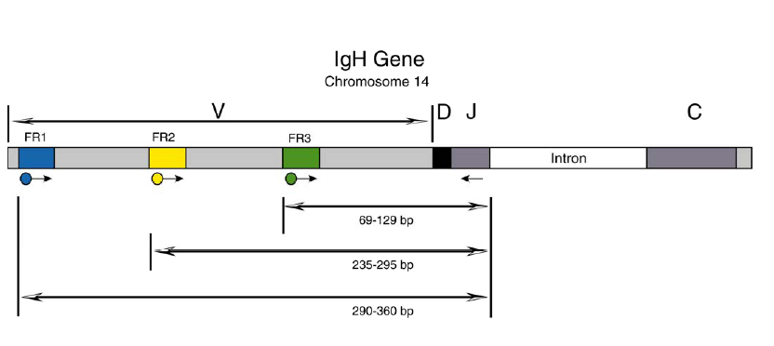

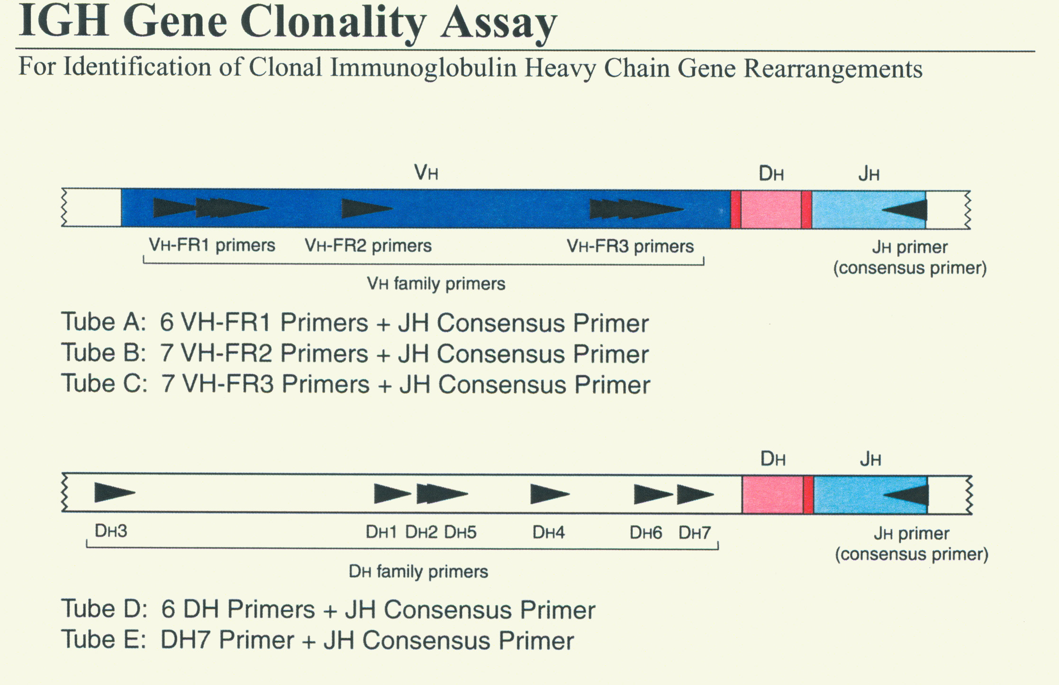

1. **SAMPLES:**
   1. DNA isolated from blood, body fluids, bone marrow aspirate, formalin-fixed paraffin-embedded (FFPE) tissue block, alcohol-fixed tissue, or fresh or frozen tissue.
   2. DNA is diluted to a concentration of 99 ng/ul (or less).
2. **REAGENTS:**
   1. IGH Tube A Framework 1+JH, store at -80°C.
   2. IGH Tube B Framework 2+JH, store at -80°C.
   3. IGH Tube C Framework 3+JH, store at -80°C.
   4. IGH Tube D DH1-6 + JH, store at -80°C.
   5. If Tube E is requested: IGH Tube E DH7+JH, store at -80°C.
   6. AmpliTaq Gold DNA polymerase, store at -20°C.
3. **CONTROLS:**
   1. Positive:
      1. IVS-0030 Clonal Control DNA
      2. IVS-0019 Clonal Control DNA
      3. IVS-0024 Clonal Control DNA
      4. If Tube E is requested: IVS-0008 Clonal Control DNA
   2. Sensitivity Controls:
      1. Dilutions derived from controls listed above.
   3. Negative:
      1. IVS-0000 Polyclonal Control DNA
      2. Master Mix Control
   4. Sample Quality:
      1. DNA ladder reaction
4. **PROCEDURE:**
   1. **Build your worksheet: IGH PCR – Test Worksheet Builder**
      1. Log into Soft Molecular.
      2. Open IGH PCR - Test Worksheet Builder by using the tile on the dashboard.
      3. Select **Find**.
      4. If applicable, on the Found Activities tab, click **OK** or double click any row.
         1. **Note**: All Test Codes are attached to the same worksheet.
      5. If applicable, double click **New** in the Pending Worksheets tab.
      6. Highlight the barcode scanning field. Scan the product label of the patient sample to be added to the worksheet. Select Enter on the keyboard. Repeat this step for all pending samples.
         1. **Note:** Comparison samples will need to be manually added to the worksheet.
      7. For each comparison and rerun sample, check the internal notes. Internal notes will contain master mix information for comparison samples.
      8. Select the Plate View tab. Delete comparison samples from Master Mixes where they are not needed.
      9. Switch to Worksheet View.
      10. Verify the control lot numbers by clicking on the Sample ID field.
          1. If the control needs to be changed, click on the dropdown arrow and select the correct control in the window that appears.
      11. Verify the reagent lot numbers by clicking on the vertical Settings tab on the left side of the screen.
          1. If the reagent lot needs to be changed, click on the dropdown arrow in the Stock # column and select the correct lot in the window that appears.
      12. Verify and confirm the control test code by clicking on the Test Code field.
          1. If the control test code needs to be changed, click on the dropdown arrow and select the correct one in the window that appears.
             1. **Note**: Do not select all. Only choose one test type, so the control Test Codes match the Test Code of one patient sample.
      13. Mark the Completed checkbox and select **Save**.
          1. **Note:** Q Numbers will generate for the controls upon saving.
      14. Click the **printer** icon, verify the correct printer is selected, and **Print**.
      15. Close the Print Preview window.
      16. Click Print Plate View to open plate preview.
      17. Click the **printer** icon, verify the correct printer is selected, and **Print**. Close the Print Preview window.
      18. Select **Settings** button and **Print** in the Select Printer window that appears.
          1. **Note**: Select **View** in the Select Printer window to open the Plate View Print Preview window.
      19. If applicable, close the preview window.
      20. Select **Back** in the IGH PCR – Test Worksheet Builder window.
      21. Exit Soft Molecular application.
   2. Turn on the DNA thermal cycler and laminar flow hood.
   3. Completely thaw all necessary reagents except AmpliTaq DNA polymerase.
   4. Briefly vortex reagents except Taq polymerase and flash spin.
   5. Assemble PCR reactions in a laminar flow hood using clean gloves, lab coat and barrier pipette tips as, appropriate.
   6. Prepare master mixes (tubes/reactions) A, B, C, and D in the appropriate size tubes. If requested by the Director, set up master mix E.
   7. Label the PCR tubes with the individual reaction #, master mix, and test.
   8. Mix by carefully pipetting up and down using a barrier pipette tip.
   9. Aliquot 45ul of the Master Mix A/B/C/D (+/- E) to the specified tubes, reusing a barrier pipette tip.
   10. Add 5ul of DNA samples to each reaction tube, as specified in the worksheet. If sample volume is insufficient to set up all the master mixes, reduce the volume of master mix to 22.5ul and add 2.5ul of DNA.
   11. Spin tubes for 30 sec. in PCR centrifuge.
   12. Initiate File jh+tcr on the thermal cycler.
       1. 95°C for 7 min.
       2. 35 amplification cycles as follows:
          1. 95°C for 45 sec. (denaturation)
          2. 60°C for 45 sec. (annealing)
          3. 72°C for 90 sec. (extension)
       3. Final extension reaction for 10 min. at 72°C to complete all products.
   13. **Processing your worksheet: IGH PCR**
       1. Log into Soft Molecular.
       2. Open IGH PCR – Test Worksheet Processing by using the tile on the dashboard.
       3. Scan the IGHPCR worksheet into the Worksheet# field and select **Find**.
       4. Use the dropdown under Thermocycler to select the correct instrument.
       5. Complete the IGH PCR activity by marking the Completed checkbox and selecting **Save**.
       6. Click Build Next Worksheet.
       7. Mark Select all tests. Verify that IGHGEL To build and Transfer Controls checkboxes are marked.
       8. Click **OK**.
       9. The system will ask the user if they want to open the new worksheet. Click **No**.
       10. Select **Back** in the IGH PCR – Test Worksheet Processing window.
   14. **Edit your gel worksheet: IGH Gel – Test Worksheet Builder**
       1. Open IGH GEL - Test Worksheet Builder by using the tile on the dashboard.
       2. Select **Find**.
       3. If applicable, select the correct IGH Gel worksheet in the Pending Worksheets tab.
       4. Go to the Plate View (vertical tab at the lower left side of the screen)
       5. Adjust patient samples and controls to reflect how the gel should be loaded.
          1. Adjust for the empty space by multi-selecting the samples/controls following the empty well and dragging them to the correct well.
       6. **Add 50_BP_Marker where appropriate.**
          1. Highlight the correct well and select 50_BP_marker from the dropdown next to 'Add Control' button.
          2. Click **Add Control** button.
          3. Repeat for all 50 BP markers.
       7. Go to Worksheet View (vertical tab at the lower left side of the screen)
       8. Select a lot number for the 50bp marker.
       9. Select IGH as the test code for all 50 BP markers.
       10. Select Tube from Tube dropdown for patient samples and 50bp markers.
       11. Click **Print Plate View**. Select **OK** to save before print.
           1. Q Numbers for the 50_BP_Marker will generate upon saving.
       12. Click on **Print** icon, verify the correct printer is selected, and **Print**.
       13. To print section labels, select the '**...**' icon next to Print Section Labels button on the bottom right of the screen. Select the correct printer, template (GEL LBL V1), then **Print**.
       14. Select **Back** in the IGH Gel – Test Worksheet Builder window.
       15. Exit Soft Molecular application.
   15. **Second Heteroduplex**
       1. Perform heteroduplex reaction:
          1. Incubate tubes at 95°C for 5 minutes.
          2. Incubate tubes at 4°C for 1 hour or until ready to analyze.
          3. If tubes are sitting longer than overnight, re-perform heteroduplex reaction by selecting “heteroduplex IVS” on the thermal cycler and incubate tubes at 4°C for 1 hour.
   16. **Process your worksheet**: **Second Heteroduplex**
       1. Log into Soft Molecular.
       2. Click on the IGH Gel - Test Worksheet Processing using the tile on the dashboard.
       3. Scan the IGHGEL Plate View into the Worksheet# field and select **Find**.
       4. Select Second Heteroduplexity Status, either Completed or Not Needed, from the dropdown.
       5. Print Section Labels if that has not been done already.
          1. To print section labels, select the '**...**' icon next to Print Section Labels button on the bottom right of the screen. Select the correct printer, template (GEL LBL V1), then select **Print**.
       6. Complete the Second Heteroduplex activity by marking the Completed checkbox and selecting **Save**.
       7. Select **Back** in IGH Gel – Test Worksheet Processing window.
       8. Exit Soft Molecular application.
   17. **Loading your gel**
       1. Add 4ul of loading dye to each tube and mix well.
       2. Load 20ul into gel. Store leftover PCR product at 4°C until gel has been analyzed.
       3. Analyze the PCR products by electrophoresis using 6% acrylamide gel at 2 watts per gel. (See Gel Electrophoresis Procedure.)
   18. **Process your Worksheet: Load Gel**
       1. Log into Soft Molecular.
       2. Open IGH GEL - Test Worksheet Processing by using the tile on the dashboard.
       3. Scan IGHGEL Plate View into the Worksheet# field and select **Find**.
       4. Complete the Load Gel activity by marking the Completed checkbox and selecting **Save**.
       5. Select **Back** in the IGH Gel – Test Worksheet Processing window.
       6. Exit Soft Molecular application.
   19. **Refer to Bio-Rad Gel Doc XR Instrument Procedure to capture and edit gel image.**
   20. **Process your worksheet: Acquire Image**
       1. Log into Soft Molecular.
       2. Open IGH GEL - Test Worksheet Processing by using the tile on the dashboard.
       3. Scan IGHGEL Plate View into the Worksheet# field and select **Find**.
       4. Verify Worksheet is selected in the Image Type field.
       5. Select Images. On the window that opens, select the Add File tab, then select the add file (folder) icon.
       6. Find and select the file to be added from the Windows Explorer window. Select **Open**.
       7. Choose Gel Image from Template dropdown.
       8. Select the green check icon to add file(s).
       9. Repeat steps 6-8 for all applicable gels.
       10. Close the window.
       11. Complete the Acquire Image action by marking the Completed checkbox and selecting **Save**.
       12. Select **Back** in the IGH Gel – Test Worksheet Processing window.
       13. Exit Soft Molecular application.
       14. Deliver worksheets to the Director/Pathologist assigned to Clonality Interpretation.
5. **INTERPRETATION:**
   1. Since immunoglobulin heavy chain J and V DNA sequences are widely separated in the germline, the amplification of PCR products in the appropriate base pair range from this reaction is evidence of gene rearrangement. The presence of a dominant band similar to that observed in the positive control reaction (B cell lymphoma) and different from the reaction observed with polyclonal samples is evidence that a clonal population of B cells is present. Since not all rearrangement events can be amplified with these primers, a negative result does not prove the absence of a clonal population. Greater than 90% of clonal rearrangements can be detected with this assay.
   2. A false positive result could be produced by contamination of the PCR reaction with exogenous DNA. The absence of a band in the negative control reaction largely excludes this possibility.
   3. A false negative result could be obtained if the DNA sample is too degraded or is otherwise unable to serve as an adequate PCR template. A separate quality control reaction is carried out to confirm the adequacy of the sample. The presence of characteristic bands in the control reaction generated from an unrelated genomic DNA segment (DNA size ladder 400bp for master mix A&D, 300bp for mmB, 200bp for mmC&E) is evidence against a false negative result(see the DNA Ladder QC PCR Procedure).
   4. A sensitivity control is run in each assay. If this reaction is negative, the assay does not meet the sensitivity specifications of the assay and should be repeated for all negative samples.
   5. Interpretation Guidelines: for each reaction, the bold product size range indicates the size range which should be evaluated for the presence of bands.

|  |  |  |  |
| --- | --- | --- | --- |
| **Master mix** | **Target** | **Control DNA** | **Product size** |
| IGH Tube A | FR1-JH | Valid size range  IVS-0000 poly  IVS-0030 clonal  IVS-0019 clonal  IVS-0024 clonal  IVS-0008 clonal | **310-360**  851, 310-360  2802, 325  345  342  no product |
| IGH Tube B | FR2-JH | Valid size range  IVS-0000  IVS-0030  IVS-0019  IVS-0024  IVS-0008 | **250-2956**  250-295  260  285  277  no product |
| IGH Tube C | FR3-JH | Valid size range  IVS-0000  IVS-0030  IVS-0019  IVS-0024  IVS-0008 | **100-170**  100-170  no product  145  140  no product |
| IGH Tube D | DH-JH | Valid size range  IVS-0000  IVS-0030  IVS-0019  IVS-0024  IVS-0008 | **110-2904, 390-420**  235-258, 3443  744, 944,1584,1764,1874,2004,3444  744, 944,1584,1764,1874,2004,3444  139  744, 944,1584,1764,1874,2004,3444 |
| IGH Tube E | DH7-JH | Valid size range  IVS-0000  IVS-0030  IVS-0019  IVS-0024  IVS-0008 | **100-130**  2095, 4165  794, 1234  794, 1234  794, 1234  109 |
| DNA ladder | Multiple genes | Any DNA | 84, 96, 200, 300, 400, 600 |

**Note**: The amplicon sizes listed above were determined using an ABI 3100 platform. Amplicon sizes seen on your specific CE instrument may differ 1-4bp from those listed above depending on the platform of detection and the version of the analysis software used. Once identified, the amplicon size is determined on your specific platform will be consistent from run to run.

**Note1**Under suboptimal conditions an aspecific product of 85bp can be detected in Tube A. To discriminate between specific and aspecific, negative control DNA should not show this band within the same experiment. If a band is present, we then consider the band specific.

**Note2**The 280bp band is a known amplicon that lies just outside of the valid size range for Tube A.

**Note3**An aspecific 344bp band is the result of cross-annealing of the DH2 primer to a sequence in the region upstream of the JH4.

**Note4**These bands are known amplicons that are seen with many different cell lines. These bands are absent in the presence of polyclonal backgrounds.

**Note5**A 209bp PCR product represents the smallest background band derived from the germline DH7-JH1 region. When the PCR amplification is very efficient, also longer products might be obtained because of primer annealing to downstream JH gene rearrangements; eg 416bp (DH7-JH2), 1028bp (DH7-JH3), etc.

**Note6**A non-specific peak may be seen at 227bp.

1. **RESULTS REVIEW**
   1. Log into Soft Molecular.
   2. Open IGH GEL - Test Worksheet Processing by using the tile on the dashboard.
   3. Enter previously built worksheet number into Worksheet# field and select **Find**.
   4. Select the 'Images' button on the upper right corner of the screen. This will open the Gel image window. The window can be floated.
   5. Leave this window open for input of the QC results as well as the patient results.
   6. For Controls: Use the dropdown menu to enter Pass/Fail results in the 'Control Result' column.
   7. For Patient samples: Use the dropdown menu to enter results in the 'IGH Tube A Gel Result' column.
   8. Using the 'Sub-template' dropdown, change sub-template from 'Tube A' to 'Tube B'.
   9. Repeat steps for all master mixes.
   10. Complete Result Review action by clicking the "Reviewed" checkbox. Select **Save**.
   11. Close the Test Worksheet Processing window.
   12. Open My Orders by using the icon on the dashboard.
   13. Click on Director Review tab.
   14. Click two times on order.
   15. Click **No** on the My Orders window that appears.
   16. Select IGH Result from dropdown in Test Result tab.
       1. **Note**: Images are available in vertical Analysis Images tab on right side of the screen.
   17. Mark 'Reviewed' checkbox which is at the bottom of the screen.
   18. Click **Save**.
   19. Click **OK**.
   20. Close the Test Review Entry.
2. **SIGN OUT ENTRY**
   1. Open My Orders by using the icon on the dashboard.
   2. Highlight the **Molecular Pathologist** tab.
   3. Click two times on order.
   4. Click **No** on the My Orders window that appears.
   5. Verify whether RBS rules are triggered correctly (Result, Interpretation, Methodology, Disclaimer sections are filled appropriately).
   6. If the specimen is a Body Fluid, the type of body fluid can be found in Sign Out Entry.
      1. Click the **Testing Info** tab, found in the middle of the Sign Out Entry window.
      2. The body fluid type will be in the field that appears.
      3. This information can be manually added to the Final Report as a Comment if needed.
   7. Enter Result for QC Ladder in QC ladder Result section. Click on the QC Result and a dropdown window will appear. Select the QC result and the choice will populate in the Sample QC window.
   8. If appropriate, focus cursor on Comment section and click on Canned Message button, which is on the toolbar.
      1. Select appropriate comment, mark the push pin and click OK.
   9. **Exception**:
      1. Changing result
         1. Click on little '+' sign button next to result field. Mark 'Use Man. Corr.' checkbox.
         2. Enter desired result into 'Manual Corr.' field. Select **OK**.
         3. If appropriate, click on little 'C' button next to result field and enter comment.
         4. Click on 'Accept' button.
      2. If you changed final result, click on 'Generate' button to fire reporting rules which populate interpretation sections with correct data.
      3. If individual Tubes (master mix reactions) were rerun, the individual Tube results can be changed.
         1. Click on little '+' sign button next to result field.
         2. Mark 'On Display' checkbox for run# 1,
         3. Mark 'Use Man. Corr.' checkbox and enter result in 'Manual Corr.' field.
         4. Click on OK button.
         5. Click on little 'C' button next to result field and enter comment that this tube came from rerun. Click on 'Accept' button."
   10. Mark Completed checkbox.
   11. Select **Sign Out** button.
   12. A window will appear. Press **Sign out** and the report will populate the screen.
   13. A result window appears. Select **OK** to save changes made in the Sign Out Entry window.
   14. Make sure that information on the report is correct or edit, as needed.
   15. Complete sign out by selecting **Complete Sign Out** button.
   16. Close Sign Out Entry.
3. **REPEAT TESTING**
   1. During the testing process, testing for some samples must be repeated for a variety of technical or analytical reasons. The specimen can be sent back to one of multiple prior steps in the workflow.
   2. In Soft Molecular, repeating a sample to a prior action can be accomplished from a variety of steps in the test workflow and places in the system. Please see the Soft Molecular Rerun Procedure for the specific steps to perform when requesting rerun testing.
4. **REFERENCES:**
   1. InVivoScribe Technologies IgH Gene Clonality Assay package insert
   2. van Dongen, JJM et al. Design and standardization of PCR primers and protocols for detection of clonal immunoglobulin and T-cell receptor gene recombinations in suspect lymphoproliferations: Report of the BIOMED-2 Concerted Action BMH4-CT98-3936. Leukemia. 2003, 17(12):2257-2317.
   3. van Krieken JH, Langerak AW, Macintyre EA, Kneba M, Hodges E, Sanz RG, Morgan GJ, Parreira A, Molina TJ, Cabeçadas J, Gaulard P, Jasani B, Garcia JF, Ott M, Hannsmann ML, Berger F, Hummel M, Davi F, Brüggemann M, Lavender FL, chuuring E, Evans PA, White H, Salles G, Groenen PJ, Gameiro P, Pott Ch, van Dongen JJM. Improved reliability of lymphoma diagnostics via PCR-based clonality testing: report of the BIOMED-2 Concerted Action BHM4-CT98-3936. Leukemia. 2007; 21(2):201-6.
5. **REVISIONS:**
   1. 3/14/2018: Removed reference to LDT test that has been retired. Updated format.
   2. 10/23/2018: Instructions were included for re-performing heteroduplex reaction if tubes sit for longer than overnight.
   3. 1/13/2020: Updated with steps for Soft Molecular and updated footer with new lab name.
   4. 3/6/2022: Updated several steps for Soft Molecular upgrade.