**Actionable Mutation Panel v2 (HS21) Procedure**

1. **PRINCIPLE:**
   1. The identification of molecular biomarkers in cancer has contributed to the rise of precision medicine and targeted therapeutics. Somatic alterations, such as single nucleotide variants, insertions, and deletions, can provide diagnostic, prognostic, or therapeutic guidance. However, in the clinical laboratory, the detection of these alterations can be difficult, due to the heterogeneous nature of most tumor tissue and the limited amount of clinical sample available for testing. As a result, sensitive methodologies (such as next-generation sequencing (NGS)) are required for the detection of variants at a low allele fraction within a sample.
   2. The QuantideX® NGS DNA Hotspot 21 Kit is intended for the quantification and enrichment of cancer-related variants in 46 regions of interest across 21 genes using purified DNA. The kit supports multiplex NGS analysis with an Illumina® MiSeq® Instrument. It also includes software (QuantideX® Reporter) that analyzes MiSeq® data files for the identification of base substitution mutations and small insertions/deletions using a locally integrated bioinformatics pipeline and companion data visualization tools. In addition, custom bioinformatics and pathology informatics tools have been implemented and clinically validated.
   3. The MiSeqDx Platform is an NGS instrument that measures fluorescence signals of labeled nucleotides using instrument specific reagents and flow cells, imaging hardware, and data analysis software. Illumina MiSeq® systems utilize sequencing by synthesis (SBS) technology, integrating cluster generation, sequencing, and data analysis on a single instrument.
      1. In contrast to standard MiSeq instruments, the MiSeqDx Platform has two modes of operation: Diagnostic Mode, which can be used with FDA-approved/cleared assays; and RUO/Research Mode, which can be used with laboratory-developed tests and research assays.
      2. This assay is performed using RUO/Research Mode. For the purposes of this Procedure, “MiSeqDx” and “MiSeq” shall be used interchangeably.
      3. This assay is performed using MiSeq Reagent Kits with V2 chemistry.
      4. The following Illumina software is used for this assay
         1. MiSeq Control Software (MCS; Instrument control and real-time analysis software) – version 2.6.2.1
         2. MiSeq Reporter – version 2.6.2
         3. Illumina Experiment Manager – version 1.11.0
         4. Sequencing Analysis Viewer (SAV) – version 1.10.2
   4. The Actionable Mutation Panel consists of five broad parts:
      1. Asuragen® QuantideX® NGS DNA Hotspot 21 Kit (HS21)
      2. Illumina MiSeq Sequencing Kit
      3. Asuragen® QuantideX® NGS Reporter (version 3.0.3) bioinformatics pipeline
      4. Custom Lifespan AMP Reporter Bioinformatics Pipeline (version 1.1)
      5. Custom Lifespan AMP variant reviewer software (SurascanReview version 3.0)
   5. Figure 1 below summarizes the steps and subcomponents of the assay.
      1. After DNA extraction from the specimen (see appropriate DNA Extraction Procedure), the wet-bench procedure is performed.
      2. Then, two bioinformatics pipelines are performed in parallel and results are cross-correlated for internal QC.
         1. The first pipeline is a custom pipeline developed according to guidelines from the National Cancer Institute. In addition, additional software has been added to optimize sensitivity and specificity of the assay.
         2. The second pipeline has been provided by the vendor of the reagents and has additional features, such as QC data relevant to the specific wet bench kit.
      3. Data from each pipeline are analyzed and cross-correlated.
         1. Analysis of the QuantideX NGS Reporter results is performed within the SurascanReview application – a custom software tool written in Perl for variant filtration and data review.
      4. If applicable, results are confirmed by alternative testing methods and then reported through the Laboratory Information System (LIS).
         1. The decision for whether confirmation testing should be performed is made at the discretion of the Pathologist/Lab Director.

**Figure 1.** Summary of AMP steps

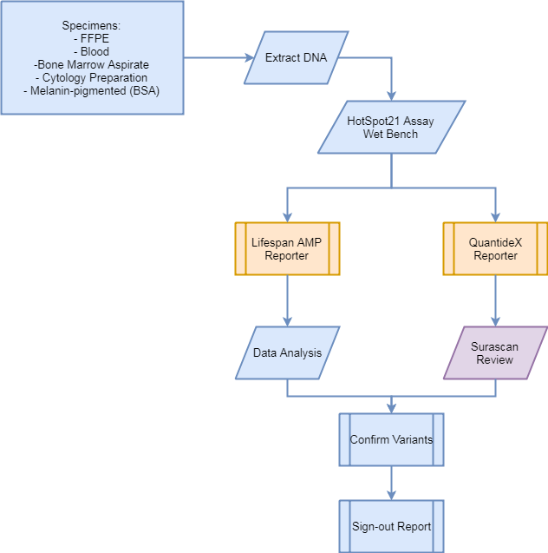

* 1. Table 1 below contains details on the genes and codons targeted by the HS21 Kit.

**Table 1.** Codon Regions Covered by the QuantideX® NGS DNA Hotspot 21 Panel

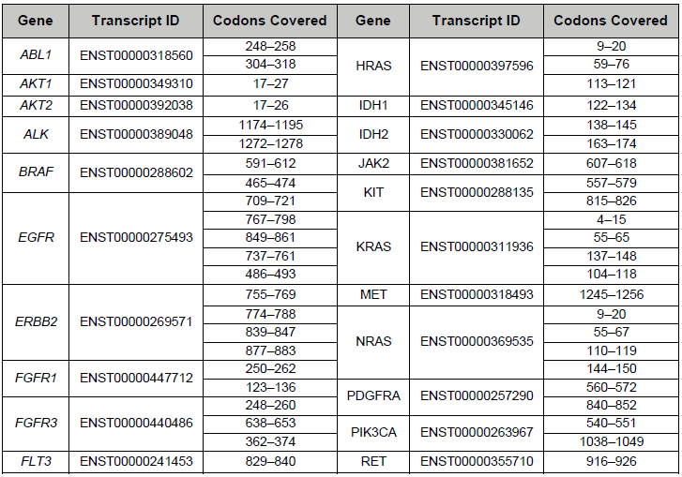

* 1. The assay was designed to target genes associated with clinical actionability in a variety of tumor types. Inclusion of these targets is based on NCCN guidelines for targets that should be tested in these tumor types. See Figures 2-3 below.

**Figure 2.** Summary of tumors and associated assay gene targets

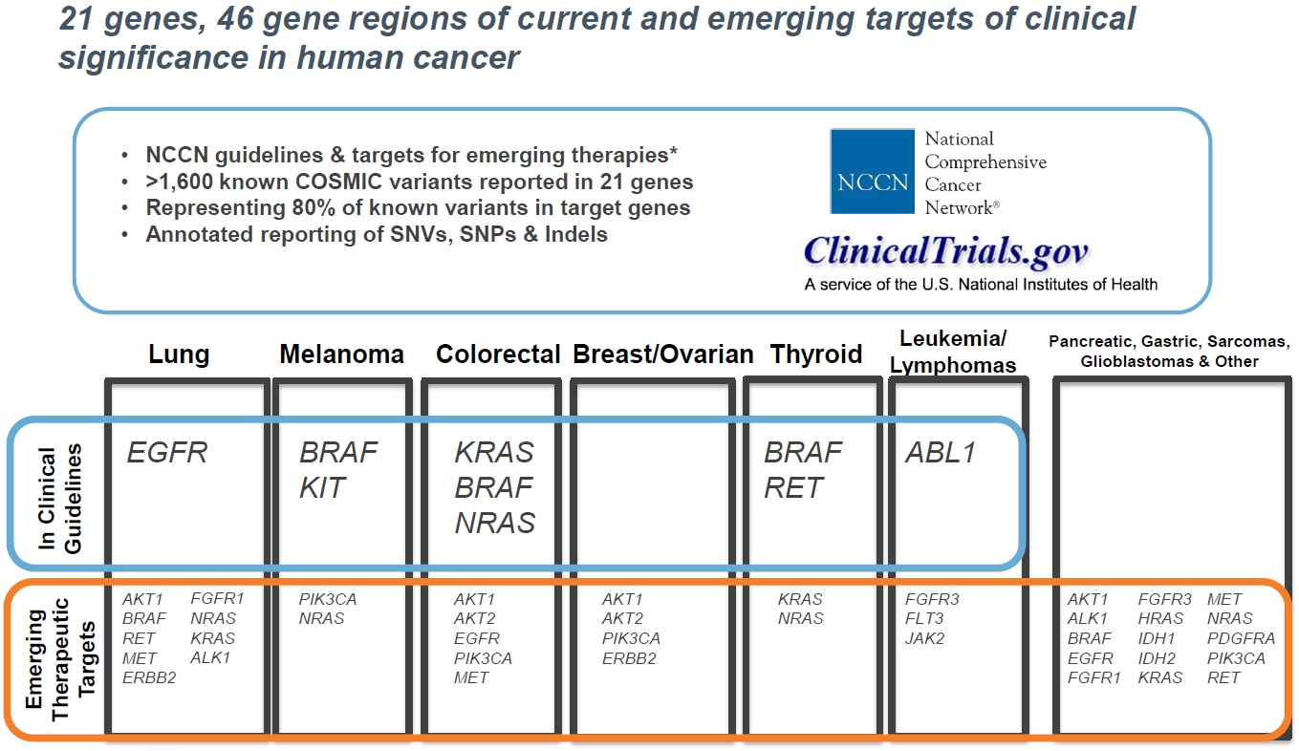

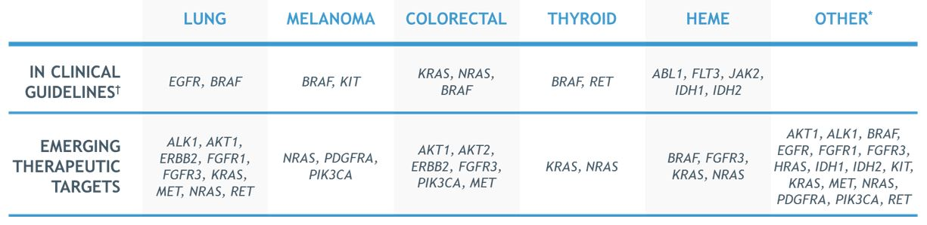

**Figure 3.** Summary of assay codon targets and associated tumors

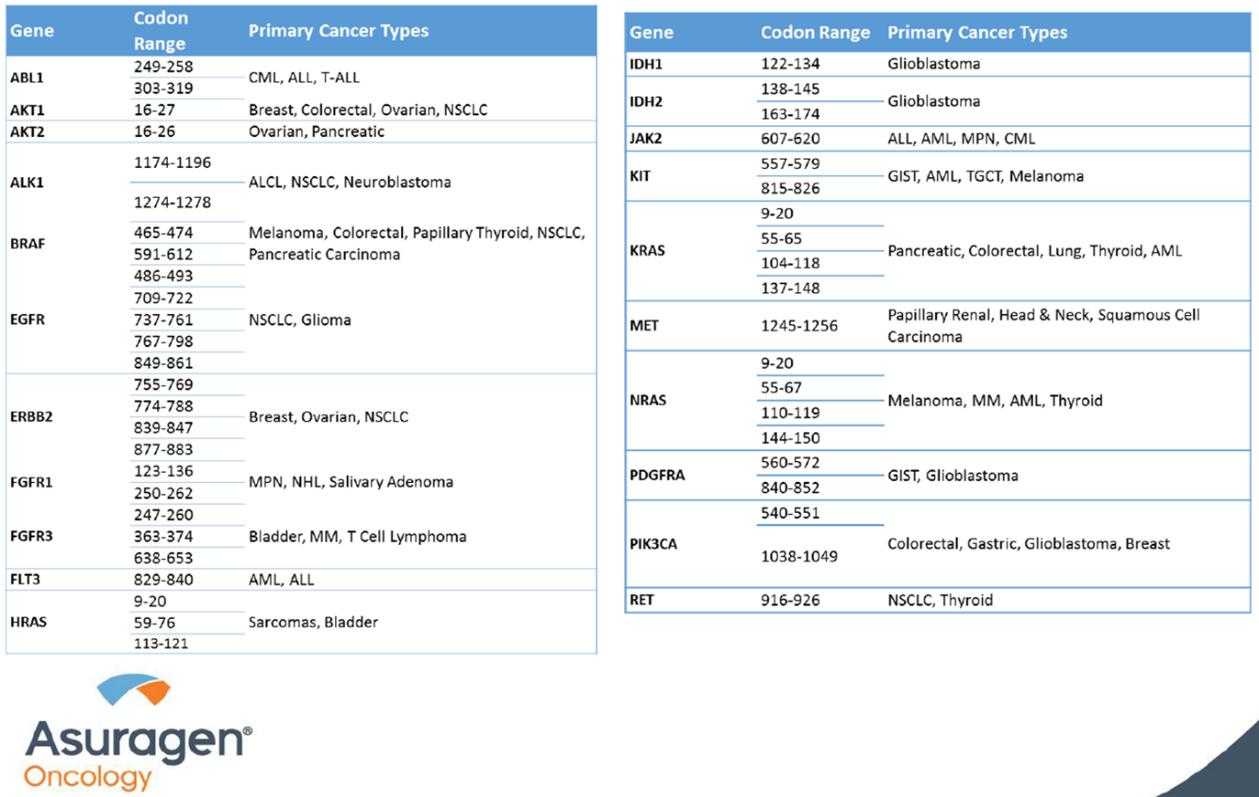

* 1. The HS21 kit includes reagents for DNA assessment, targeted enrichment, positive controls, index codes, and library purification and quantification. This assay is optimized to assess for mutations in a variety of clinical samples, including low-quality and low-quantity DNA samples isolated from FFPE (Formalin-Fixed, Paraffin-Embedded) or FNA (Fine Needle Aspiration) and other cytology tumor samples. Each HS21 kit component serves an essential role in the library prep workflow:
     1. Box 1: QuantideX® DNA Assay
        1. Reagents for functional DNA quantification and sample assessment.
     2. Box 2: QuantideX® NGS DNA Hotspot 21 Panel
        1. PCR primers and PCR reagents that support single-well multiplex PCR enrichment across hotspot regions.
        2. Additionally, the box contains the following control:
           1. NGS DNA Hotspot 21 Multi-Variant Ctrl – A pooled process control formulated from synthetic DNA in a background of cell line genomic DNA designed to detect the most common variants in the QuantideX® NGS DNA Hotspot 21 panel. See Figure 4.

**Figure 4.** Multi-Variant Control expected variant calls



* + 1. Box 3: QuantideX® Codes (ILM)
       1. Dual-Index-code oligonucleotide mixtures specific for the MiSeq and related Illumina sequencing platforms. These dual-index code primer mixes are formulated in racks of 48 codes with 4 uses per code.
    2. Box 4: QuantideX® Library Pure Prep
       1. A proprietary magnetic bead chemistry that provides size selection and purification of the amplified libraries.
    3. Box 5: QuantideX® Library Quant
       1. An assay that enables accurate assessment of purified libraries using a method based on relative competitive quantitative PCR.
    4. Box 6: QuantideX® Sequencing Reagents
       1. Custom sequencing primer mixtures for QuantideX NGS and standard Illumina library analysis.
    5. QuantideX® Reporter
       1. A push-button, integrated informatics processing and data reporting pipeline based on proprietary alignment and variant scoring algorithms.
  1. This assay is designed to target mutations associated with a variety of tumors (such as: non-small-cell lung cancer, colorectal adenocarcinoma, thyroid carcinoma, melanoma, and other tumors).
     1. Therefore, the assay can be performed on a variety of specimen types (see below for full list).
     2. Of note, various cytology preparations have been evaluated as a specimen type and require specific processing steps (see the TNA, Cytology Manual Extraction Procedure and QC/Evaluation documentation for more details).
     3. In addition, this assay is designed to target mutations in melanoma samples and melanin is a known inhibitor of PCR. Specimens with melanin pigmentation, hemoglobin, and other inhibitors may require specific processing steps (see the PCR Interfering Substances: BSA Method Procedure and QC/Evaluation documentation for more details).
     4. Refer to the AMP Validation Summary for additional details.

1. **SPECIMENS:**
   1. Sample types: FFPE unstained slides, FFPE scrolls, cytology cell block, cytology preparation (such as smear and liquid-based cytology slides), blood, bone marrow aspirate.
   2. Before proceeding with the assay, determine the DNA concentration in the specimen by Nanodrop (see NanoDrop Instrument Procedure).
   3. Specimen acceptability criteria:
      1. Perform the Box 1 procedure (See below).
         1. Samples should have a minimum Functional Copy (FC) score of 200.
         2. Samples with FC < 200 should be rejected unless approved by a Director/Pathologist. At the discretion of the Director/Pathologist, testing of the specimen may be attempted again on the next run. Such specimens may be added to the NGS Exception Log, if appropriate (see below).
      2. Before proceeding with sequencing on the MiSeq, the NGS library generated from each sample is quantified (see Box 5 procedure).
         1. Any samples that do not meet the LQ Analysis criteria outlined below should be rejected. At the discretion of the Director/Pathologist, testing of the specimen may be attempted again on the next run. Such specimens may be added to the NGS Exception Log, if appropriate (see below).
      3. If available, microscopic slides corresponding to the specimen should be reviewed by a pathologist.
         1. FFPE and cytology samples should have a tumor content of at least 10% within the material for extraction (i.e., entire tissue for scrolls or encircled area for macro-dissected slides). In a diploid genome, this corresponds to the limit of detection for heterozygous variants (variant allele fraction of 5%).
   4. See Director/Pathologist for any samples that do not meet these criteria to determine if they should be accepted. Such specimens may be added to the NGS Exception Log (see below).
2. **MATERIALS AND EQUIPMENT:**
   1. REAGENTS:
      1. 100% Ethanol. Store at room temperature in flammable cabinet.
      2. Illumina NextSeq PhiX Control Kit, store at -20°C.
         1. RBS Buffer
            1. Upon activation in TQC, aliquot 1 mL of stock into twenty 1.5 mL tubes. Store aliquots at -20°C.
      3. 1N Sodium Hydroxide. Store at room temperature. Make fresh one-time use aliquot with each run. If appropriate, document the pH on the MiSeq maintenance form.
         1. **NOTE**: If run quality looks poor (e.g., poor SAV metrics), check the pH of the Stock and one time use NaOH, and document prior to using the NaOH on the next run.
      4. PhiX Control v3. Store at -20°C.
      5. MiSeq Reagent Kit V2 Components:
         1. Box 1 – Store at -20°C.
            1. MiSeq V2 Cartridge.
            2. HyB Buffer.
         2. Box 2 – Store at 4°C.
            1. MiSeq V2 Flow Cell.
            2. Incorporation Buffer.
      6. The QuantideX® NGS DNA Hotspot 21 Kit Components, including any additional Storage and Handling information, are listed in **Table 2** below:

**Table 2.** Components of the QuantideX® NGS DNA Hotspot 21 Kit

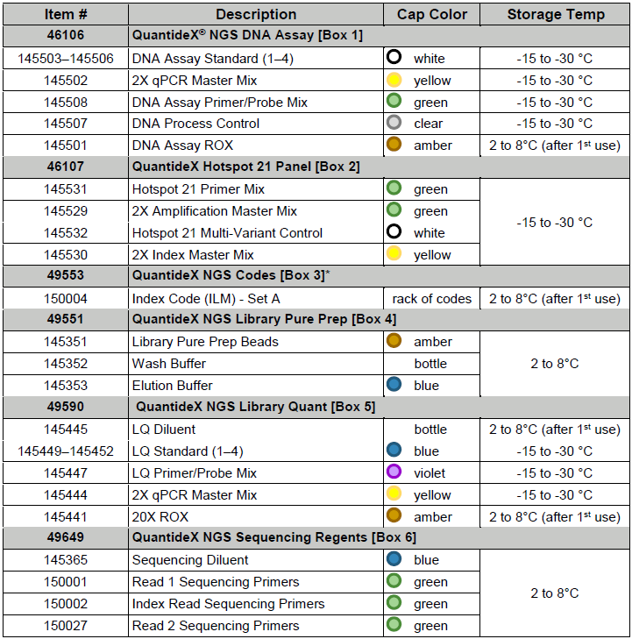

* 1. CONTROLS:
     1. Asuragen Hotspot 21 Multi-Variant Ctrl (synthetic, see above)
     2. Cell line control DNA (e.g., isolated from either H1650, H1975, RKO, SW480 or other cell line), diluted to a concentration of 25ng/ul.
     3. No Template Control (Negative Control)
     4. Functional Copy Sensitivity Control (SENSCT; DNA Process Control)
  2. MAJOR EQUIPMENT:
     1. Illumina MiSeqDx
     2. QuantStudio™ 7 Flex Real-Time PCR System (with Real-Time PCR Software v1.3)
     3. Applied Biosystems (Thermo Fisher) Veriti Thermal Cycler
     4. Standard Lifespan Desktop Computer
     5. Dell Server with Red Had Enterprise Linux 7
     6. Lifespan Desktop Computer with Windows 10 and QuantideX Reporter software

1. **QUALITY CONTROL:**
   1. See relevant sections in procedure below.
2. **TEST PROCEDURE – NGS DNA Hotspot 21 Kit**
   1. **NOTE**: These steps are performed by a molecular laboratory technologist, unless otherwise indicated.
   2. Preliminary processing
      1. DNA extraction from the sample should be performed according to the relevant Procedure for the sample type.
      2. If the sample contains potential PCR inhibitors or interfering substances (such as melanin or hemoglobin), discuss with Director and perform the following steps:
         1. If appropriate, the sample may be tested as per usual protocol and then discussed with a Director for further processing.
         2. Alternatively, the specimen may be diluted with water or BSA after extraction.
         3. Refer to the PCR Interfering Substances: BSA Method Procedure for more information.
   3. Box 1 – DNA QC:
      1. Remove Box 1 from the freezer.
         1. The reagents must thaw for a minimum of 30 minutes prior to setup.
         2. Once the reagents have thawed, mix by vortexing and pulse spin to collect contents.
         3. ROX is stored in the refrigerator after initial thaw.
      2. **Create your Box 1 worksheet: AMP Box 1 – Test Worksheet Builder**
         1. Open AMP Box 1 – Test Worksheet Builder by using the tile on the dashboard.
         2. Select **Find**.
         3. If applicable, on the Found Activities tab, click **OK** or double click any row.
         4. If applicable, select **New** in the Pending Worksheets window.
         5. Click the Barcode# field. Scan product label in the Barcode# field and select **Enter** on the keyboard to add the samples to the worksheet.
         6. Check for internal notes on each of the samples being run.
            1. Highlight the correct patient sample.
            2. Select **Tools** and click **Internal Notes**.
         7. If a sample requires modification, note the modification in the Comment field of the AMPBOX1 Test Worksheet Builder screen.
         8. Verify control lot number by clicking on the **Sample ID** field.
            1. If the control needs to be changed, click on the dropdown arrow and select the correct control in the window that appears.
         9. Verify that the Test Code for the controls matches the sample test code.
            1. **Note**: The control test code only needs to match one sample if there are multiple different sample types on the run.
         10. Verify the reagent lot numbers by clicking on the vertical **Settings** tab on the left side of the screen.
             1. If the reagent lot needs to be changed, click on the dropdown arrow in the **Stock#** field and select the correct lot in the window that appears.
         11. Mark the **Completed** checkbox and select **Save**. Worksheet Print Preview window will automatically open.
             1. **Note:** Q Numbers will not generate for the controls at this step.
         12. Select the **printer** icon, verify the correct printer is selected and click **Print**.
         13. Select the **Print Plate View** button.
         14. Select the **printer** icon, verify the correct printer is selected, and click **Print**.
         15. Click on the **Settings** button to open the Select Printer window. Verify the correct printer is selected in the dropdown field. Select **Print**.
             1. **Note**: Select **View** in the Select Printer window to preview the Section Settings.
         16. If applicable, close the preview window.
         17. Select **Back** in the AMP Box 1 – Test Worksheet Builder screen.
         18. Exit Soft Molecular application.
      3. Prepare the qPCR master mix in a clean microcentrifuge tube according to the Box1 Worksheet.
         1. Add the reagents to the tube in the order listed; volumes are shown per reaction.



* + 1. Mix the master mix with gentle vortexing, then pulse spin to collect contents.
    2. Aliquot 8ul of QC PCR master mix to separate wells in a 96-well optical PCR plate (USA Scientific 1402-9300).
    3. Add 2ul of each DNA Standard in duplicate to the appropriate wells of the 96-well plate (as indicated on the Box1 Worksheet).
    4. Add 2ul of dH2O to NTC well, as indicated on Worksheet.
    5. Add 2ul of the Functional Copy Sensitivity Control (SENSCT; DNA Process Control), as indicated on the Worksheet.
    6. Add 2ul of Cell Line Positive Control (POSCT), as indicated on the Worksheet.
    7. Add 2ul of each DNA sample to appropriate wells according to the Worksheet.
    8. Seal plate with optical seal (USA Scientific 2921-7800).
       1. Gently vortex the plate to mix.
       2. Finally, centrifuge 1 min at 1500g.
       3. Ensure there are no bubbles or debris visible on or around the plate.
    9. **Note: if you are proceeding immediately to Box 2 after the QuantStudio run is complete, the samples can be stored in the refrigerator to avoid another freeze/thaw cycle prior to Box 2 setup. However, if you are stopping after Box 1, please store samples in the freezer as per usual laboratory practice.**
    10. Ensure that the Applied Biosystems™ QuantStudio™ 7 Flex Real-Time PCR System (QuantStudio) is turned on.
    11. Load sample plate onto the QuantStudio using Real-Time PCR Software v1.3. To set-up the QuantStudio run:
        1. Click on the QuantStudio Real Time PCR Software icon located on the desktop of the connected computer.
        2. Under the **Set Up** panel, select **Template**.
        3. In the dialog box, open the RIH Templates folder.
        4. Select the AMP_Box1.edt file.
        5. In the **Experiment Name** field, scan the AMP Box 1 Worksheet.
        6. In the **Experiment Name** field, change any dash or period to an underscore. (Ex. Change 12.16.19-AMPBOX1-1 to 12_16_19_AMPBOX1_1)
           1. Parameters that should be selected:

QuantStudio 7 Flex System

96-well (0.2ml)

Standard Curve

TaqMan Reagents

Standard

* + - 1. Under the **Setup** panel on the far left of the screen, select **Define**.
      2. Make the sample list:
         1. Under the **Samples** section located on the right side of the screen, select **New**.
         2. For each sample, insert the Soft Molecular **Order#** as the Sample Name.
         3. Repeat for all samples included in the run.
      3. Under the **Setup** panel on the far left of the screen, select **Assign**.
      4. In the **Plate Layout** tab on the right side of the screen, the standards and controls will be pre-filled.
         1. Click on a well in which a patient sample will be added (according to the Box1 Worksheet Map).
         2. Select the appropriate sample name from the **Sample** section on the left side of the screen.
         3. The highlighted well should automatically fill-in the desired sample.
         4. Repeat for all samples included in the run.
      5. Highlight all patient samples added to the plate view and select both **Target 1** and **Target 2** from the **Targets** panel located on the left side of the screen. Ensure the **Task** assigned is **“U”** for Unknown.
         1. Target 1 is used to determine the Functional Copies of DNA in the sample.
         2. Target 2 is used to determine if there is a PCR inhibitor in the sample.
      6. Under the **Setup** panel on the far left of the screen, select **Run Method**. The parameters should be as follows:
         1. Reaction volume per well = 10ul
         2. FAM and CY5 detectors applied to every well; no quenchers.
         3. ROX selected as passive reference.
         4. Collect data during the 60°C step.
         5. Auto baseline; manual threshold: 0.1
         6. Template setup:

|  |  |  |
| --- | --- | --- |
| **AMP_Box1_QSv13** | | |
| **Temp** | **Time** | **Cycling** |
| 95°C | 5 min | - |
| 95°C | 5 sec | 40 Cycles |
| 60°C | 60 sec |

* + - 1. On the far-left side of the screen, select **Run**. The Run panel should expand open once selected.
      2. Select the green **Start Run** button on top left corner of the screen.
         1. Select our QuantStudio instrument (named **“LifespanRocks”**).
         2. Save the run by scanning the AMP Box 1 worksheet. (This will save the file to the default location in the on-board computer.)
      3. The assay will run for 1 hour and 30 minutes. Once the run is complete, the plate can be discarded. This is a safe stopping point for the assay.
    1. **Process your worksheet: AMP Box 1 qPCR**
       1. Open AMP Box 1 – Test Worksheet Processing by using the tile on the dashboard.
       2. Scan the barcode of the AMP Box 1 Worksheet into the Worksheet# field and select **Find**.
       3. Use the dropdown under **Used Instrument:** to select the correct QuantStudio.
       4. Complete AMP Box1 qPCR action by marking the **Completed** checkbox and selecting **Save**.
       5. Select **Back** in the AMP Box 1 – Test Worksheet Processing window.
       6. Exit Soft Molecular application.
    2. On a Lifespan computer, navigate to the RICMBLAB$ shared drive.
       1. Go to the CMB_Tests folder and navigate to the appropriate month folder.
       2. Create a subfolder for the new AMP run.
       3. Name the run by scanning the AMPBOX1 worksheet.
    3. Export the *.eds file from QuantStudio.
       1. Insert a Flash Drive into the QuantStudio computer.
       2. On the far-left side of the screen, select **Export**.
       3. Select the blue **Browse** button located at the top of the screen.
       4. Select **Computer**.
       5. Select the appropriate **Flash Drive**.
       6. Select **Open**.
       7. Export the **Results** table only as an *.xls file.
       8. In the **Export File Name** field, name the file by scanning the AMP Box 1 Worksheet.
       9. Select **Start Export** button located at the bottom of the screen.
       10. Open this exported file on any Lifespan computer.
           1. In the AMP run folder located on the RICMBLAB$ network drive, create a new subfolder entitled “**QuantStudio Files**.”
           2. Move the exported *.xls file from the flash drive to this folder.
    4. In the PCR_Worksheets_Current folder on the RICMBLAB$ network drive, open the AMP_Box1_Clean import document.
    5. In the AMP_Box1_Clean import document, select **File** followed by **Save As**.
    6. Select **Browse** to locate the AMP run folder.
    7. Name the file in the File Name field by scanning the AMPBOX1 worksheet.
    8. Open the AMP run import document and the Quant Studio raw data file.
    9. Highlight the correct data in the Quant Studio raw data file and paste it starting in the A2 well of the AMP import document. Select **Save** and close both Excel files.
    10. **Process your worksheet: AMP Box 1 Upload**
        1. Open AMP Box 1 – Test Worksheet Processing by using the tile on the dashboard.
        2. Scan the barcode of the AMP Box 1 Worksheet into the Worksheet# field and select **Find**.
        3. Select the ‘**…**’ button to the right of the Import button to import the Box 1 QuantStudio file.
        4. Change the radial button from **XML** to **Excel**.
        5. Select the ‘**…**’ button next to the Directory field and navigate to the folder the file is contained within.
        6. Select the ‘**…**’ button next to the File Name field to select the edited AMP import document.
        7. Click on the **Import** button.
        8. Verify Worksheet is populated in the Image Type field.
        9. Select **Images** button.
        10. On the window that opens, select the **Add File** tab. Then, select the **add file (folder)** icon.
        11. Find and select the file to be added from the Windows Explorer window. Select **Open**.
        12. Choose **Instrument Documents** from the Template dropdown.
        13. Select the **green check** icon to add the files.
        14. Close the window.
        15. Review the Box 1 Functional Copy Sensitivity Control (DNA Process Control).
            1. This control is used to determine if the Box 1 assay works appropriately.
            2. Target metrics should be 75 to 300 copies/ul in the FAM channel, or 300-1,200 Functional Copies.
            3. In the Soft Molecular AMP Box 1 Worksheet, there is a column indicating the “SENSCT QC”, which should give a preliminary pass/fail estimate of whether the control meets these criteria; however, the results should still be verified manually. A passing control has Quantity = 75 to 300 copies/ul and Quantity x 4 = 300-1,200.
            4. If these metrics are not achieved, discuss with the Director/Pathologist and repeat testing if indicated.

**Note**: If SENSCT fails parameters, discuss with Pathologist/Director. They would rerun all clinical specimens to Box 1 PCR if desired using the Soft Rerun Procedure.

* + - 1. **NOTE:** The acceptable range for Functional Copy number input is 200-24000. However, any sample with a Functional Copy number below 400 should be discussed with a Director/Pathologist to assess if the sample should continue through the rest of the protocol. Any sample with a number above 24000 will automatically have a dilution calculated in the Box2 Worksheet.
      2. For each patient sample, review the Box 1 Target 2 Average by selecting the **+** button on each parent row to expand the child level. The number in the “Target 2 Avg” column is calculated by taking the average Target 2 value for each Standard control and adding 2.
         1. If a patient sample Target 2 Ct is greater than the number in the Target 2 Avg column, a PCR inhibitor may be present. Discuss with Pathologist/Director prior to proceeding.
         2. **Note:** Target 1 AMP_B1_STD4, and Target 1 NTC AMP will always appear red.
      3. Complete AMP Box 1 Result Upload action by marking the **Completed** checkbox and selecting **Save**.
      4. Click on the **Build Next Worksheet** button.
      5. Mark AMPBOX2 **To Build** and verify Transfer Controls option is **not** selected. Click on the **OK** button.
      6. The system will ask the user if they want to open the new worksheet. User clicks **No**.
      7. Select **Back** in AMP Box 1 – Test Worksheet Processing window.
      8. Exit Soft Molecular application.

* 1. Box 2 – Gene-Specific PCR:
     1. Remove Box 2 from the freezer.
        1. The reagents must thaw for a minimum of 30 minutes prior to setup.
        2. Once the reagents have thawed, mix by vortexing and pulse spin to collect contents.
     2. **Print your worksheets: AMP Box 2 Worksheet Processing**
        1. Open AMP Box 2 – Test Worksheet Processing by using the tile on the dashboard.
        2. Press **Find** and double click the correct worksheet.
        3. Click on the **Print Worksheet** button to open Worksheet Preview window.
        4. Close the Print Preview window.
        5. Click on the **Print Worksheet** button to open Worksheet Preview window a second time.
        6. Select the **printer** icon, verify the correct printer is selected, and click **Print**.
        7. Close the Print Preview window.
        8. Click on the **Print Plate View** button to open the Plate View Preview window.
        9. Select the **printer** icon, verify the correct printer is selected, and click **Print**.
        10. Close the Print Preview window.
        11. Click on the **Settings** button to open the Select Printer window. Verify the correct printer is populated in the dropdown field. Select **Print**.
            1. **Note:** Select the View button to preview the Section Settings.
        12. Close the Print Preview window.
        13. Select **Back** in the AMP Box 2 – Test Worksheet Processing window.
        14. Exit Soft Molecular application.
     3. If the Quantity Score x 4 (Functional Copy Number) is greater than 24000, dilute the sample according to the AMP Box2 Worksheet.
        1. Use 4ul of sample and the appropriately calculated volume of water for dilution.
     4. Prepare the GS PCR master mix in a clean microcentrifuge tube according to the Worksheet. Add the reagents to the tube in the order listed; volumes are shown per reaction.



* + 1. Gently vortex to mix, and briefly centrifuge the master mix.
    2. Aliquot 6ul of the GS PCR master mix into separate wells of a clean 96-well plate (USA Scientific 1402-9300).
    3. Add 4ul of the controls to the appropriate wells of the 96-well plate (as indicated on the Box2 Worksheet).
    4. Add 4ul of dH2O to the NTC well.
    5. Add 4ul of each DNA sample (or diluted sample) of interest to separate wells containing GS master mix.
    6. Seal the plate (USA Scientific 2921-7800).
       1. Label plate with Date, PCR #, “Box 2”.
       2. Gently vortex the plate to mix.
       3. Briefly centrifuge the plate to collect the contents.
    7. Load GS PCR plate onto a Veriti thermal cycler. Choose program AMP1. The parameters should be as follows:

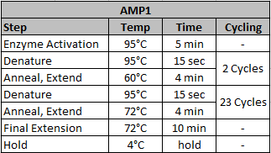

* + 1. The cycle will run for approximately 2 hours and 15 minutes.
    2. This is a **safe stopping point:** the plate can be left on the thermal cycler at 4°C or in a 4°C refrigerator for up to three days. If it will be longer than 3 days before you begin again, store the plate at -20°C.
       1. **Note:** If you will be continuing on to “Box 3” the same day, you can leave the 2X Index Master Mix from “Box 2” in the refrigerator to be used with “Box 3” to avoid an additional freeze-thaw cycle.
    3. **Process your worksheet: AMP Box 2 Gene Specific PCR**
       1. Open AMP Box 2 – Test Worksheet Processing by using the tile on the dashboard.
       2. Press **Find** and double-click on the correct worksheet.
       3. Use the dropdown under **Used Instrument** to select the correct instrument.
       4. Complete the AMP Box 2 Gene Specific PCR action by marking the **Completed** checkbox and selecting **Save**.
       5. Click on the **Build Next Worksheet** button.
       6. Mark the **To Build** checkbox for AMPBOX3. Verify the Transfer Controls is checked. Click on the **OK** button.
       7. The system will ask the user if they want to open the new worksheet. Click **No**.
       8. Select **Back** in AMP Box 2 – Test Worksheet Processing.
       9. Exit Soft Molecular application.
  1. Box 3 – Tagging/Index PCR:
     1. From the RICMBLAB$ shared drive, open the “Box 3 index codes log” Excel worksheet.
        1. Add each sample/control from the GS PCR to this list to assign indices appropriately.
        2. Each sample should receive a unique index code (AIL001-AIL192).
        3. Unless it is a new set of indices (i.e., A, B, C, or D), the indices that are used for this run should follow in sequence from the previous run (check the Index Codes Log on the RICMBLAB$ shared drive).
     2. **Process your worksheet: AMP Box 3 Tagging/Index PCR**
        1. Open AMP Box 3 – Test Worksheet Processing by using the tile on the dashboard.
        2. Press **Find** and double click the correct worksheet.
        3. Select indices for patients and controls based on what was recorded in the Box 3 Index Codes Log using the dropdown menu in the **Set ID** column.
        4. Use the dropdown menu under **Used Instrument** to select the correct instrument.
        5. Change the AMP3_INDEX if necessary, using the CODE dropdown menu in the Settings bar.
           1. **Note**: The Index is defaulted to AMP3_INDEX_A but can be changed to B, C, or D if necessary.
        6. Complete AMP Box 3 Tagging/Index PCR action by marking the **Completed** checkbox and selecting **Save**.
        7. Select **Print Worksheet**.
        8. Click the **printer icon**, verify the correct printer is selected and click **Print**.
        9. Close the Print Preview window.
        10. Select the **Print Plate View** button to open the Plate View preview window.
        11. Click the **printer** icon, verify the correct printer is selected and click **Print**.
        12. Close the Print Preview window.
        13. Click on the **Build Next Worksheet** button.
        14. Verify the AMPBOX5 To Build, and Transfer Controls is marked.
        15. Click **OK**.
        16. The system will ask the user if they want to open the new worksheet. Click **No**.
        17. Select **Back** in AMP Box 3 – Test Worksheet Processing window.
        18. Exit Soft Molecular application.
     3. Remove Box 3 (containing the indices) and the 2X Index Master Mix (see Box 2) from the refrigerator. The indices must thaw for a minimum of 15 minutes.
        1. **Note**: If the 2X Index Master Mix has been stored in the freezer (see Box 2 above), obtain the reagent and thaw for a minimum of 30 minutes prior to setup.
        2. Once the 2X Index Master Mix has thawed, mix by vortexing and pulse spin to collect contents.
        3. Once the rack of index codes has thawed, centrifuge for 1 minute at 2000 x g prior to each use.
     4. In a new 96-well plate (USA Scientific 1402-9300), aliquot 7.5ul of 2X Index Master Mix into separate wells.
     5. Aliquot 5.5ul of each index code (AIL###), unique to each well, as assigned by the AMP Box 3 Plate View.
        1. **IMPORTANT**: ensure the correct Index Code was added to the appropriate well according to the previously made assignments, and that each well received a different Index Code.
     6. Seal plate (USA Scientific 2921-7800).
        1. Label plate with worksheet code ex: 1.1.20-AMPBOX3-1
     7. Transport sealed plate containing both master mix and indices into post-PCR area hood. Transport sealed GS PCR plate from thermal cycler into post-PCR hood.
     8. Briefly centrifuge sealed GS PCR plate and Tag PCR plate.
     9. Transfer 2ul GS PCR product to corresponding wells of Tag PCR plate (according to plate layout on Worksheet). Once you have transferred the PCR product from the plate, re-seal the plate and store at 4°C until the samples pass final QC.
     10. Seal the Tag PCR plate (USA Scientific 2921-7800).
         1. Gently vortex the plate to mix.
         2. Briefly centrifuge the plate to collect the contents.
     11. Load Tag PCR plate onto a Veriti thermal cycler. The parameters should be as follows:

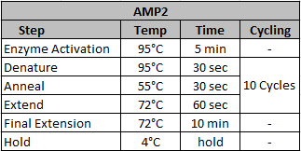

* + 1. The cycle will run for approximately 45 minutes.
    2. This is a **safe stopping point**: the plate can be left on the thermal cycler at 4°C or in a 4°C refrigerator for up to three days.
       1. If it will be longer than 3 days before you begin again, store the plate at -20°C.
  1. Box 4 – Library Purification:
     1. Remove Box 4 from the refrigerator.
        1. The reagents must thaw for a minimum of 15 minutes prior to set up.
     2. If this is the first use of the kit:
        1. Add 10 ml of 100% ethanol to Wash Buffer bottle, cap the bottle, and mix well by inverting the bottle multiple times.
        2. Remove and dispose of the kit supplied elution buffer.
     3. **Print your worksheets: AMP Box 4/5 Test Worksheet Processing** 
        1. Open AMP Box 4/5 – Test Worksheet Processing by using the tile on the dashboard.
        2. Press **Find** and double click the correct worksheet.
        3. Verify the RSB Buffer used in Box 4 appears in the list of PCR reagents under the General Settings tab.
           1. If the RSB Buffer must be added to the worksheet:

Click the dropdown arrow in the next available Code field.

In the dropdown menu that appears, select ILLUMINA_RSB_BUFFER.

Verify the Stock# reflects the correct lot number. If needed, select the dropdown arrow in the **Stock#** field to change the displayed lot number.

* + - 1. Verify the reagent lot numbers for Box 5 are correct.
         1. If a reagent lot needs to be changed, click on the dropdown arrow in the **Stock#** column and select the correct lot in the window that appears.
      2. Select the **Print Plate View** button to open the Plate View Preview window.
      3. Click the **printer** icon, verify the correct printer is selected and click **Print**.
      4. Close the Print Preview window.
      5. Click on the **Settings** button to open the Select Printer window. Verify the correct printer is populated in the dropdown field. Select **Print**.
         1. Select the **View** button to preview the Section Settings.
      6. Close the Print Preview window.
      7. Select **Back** in AMP Box 4/5 – Test Worksheet Processing window.
      8. Exit Soft Molecular application.
    1. Remove Tag PCR plate from the thermal cycler.
       1. Quick spin to collect all contents.
    2. Fully re-suspend Library Pure Prep Beads with gentle vortexing for 30-40 seconds.
       1. **NOTE:** **DO NOT CENTRIFUGE BEADS.**
       2. **IMPORTANT:** ensure reagents and consumables are readily available before starting the purification – it is important to **NOT LET THE BEADS DRY OUT** until the very end of the procedure.
    3. Aliquot 11ul Library Pure Prep Beads to each well in a clear, round-bottom, 96-well plate (Evergreen Scientific 290-8117-01R).
       1. Vortex Library Pure Prep Beads intermittently to prevent settling.
    4. Add 10ul Tag PCR products to the wells of beads.
       1. Mix by pipetting up and down 5 times.
       2. **Note**: 5ul of Tag PCR product will be left in Tag PCR plate. Once the PCR products have been transferred to the round-bottom plate, the Tag PCR plate can be discarded.
    5. Incubate the mixture for **4 minutes** at room temperature on the bench top.
    6. Place plate on magnetic stand (Ambion: AM10027) for **4 minutes** (or until solution clears).
    7. Leaving the plate on the magnetic stand, very carefully remove and discard the clear supernatant (20ul) from each well, taking care to avoid the bead pellet.
    8. Remove the 96 well plate from the magnetic stand.
       1. Add 100ul of Wash Buffer to each well and mix by pipetting up and down 5 times.
       2. Incubate at room temperature on bench top for **2 minutes.**
       3. Place the 96-well plate on the magnetic stand and let sit for **2 minutes (**or until solution clears).
    9. Leaving the plate on the magnetic stand, very carefully remove and discard the clear supernatant from each well, taking care to avoid the bead pellet.
    10. Repeat steps 10-12 once more for a total of two washes, removing as much buffer as possible after the final (second) wash.
    11. After removing all of the wash buffer, incubate the plate on the magnetic stand at room temperature for 2 minutes to dry out beads.
        1. **NOTE**: Avoid over-drying the beads.
    12. Remove plate from the magnetic stand.
    13. Add 20ul of RSB Buffer to each well and mix by pipetting up and down 5 times or until bead pellets are fully re-suspended and elution reaction appears homogenous.
        1. **Note:** Beads may appear granular in solution during this step. This is acceptable and does not affect the elution.
    14. Incubate for 2 minutes at room temperature (not on the magnetic stand) once all bead pellets are re-suspended.
    15. Place plate on magnetic stand to pellet beads out of solution. Let stand for 4 minutes (or until the solution has cleared).
    16. Transfer 18ul of the clear supernatant into a clean 96-well plate (Phenix Research Products MPS-3580), taking care to avoid beads. This resultant plate contains the purified libraries. Label plate using the format “Purified Libraries; ex. 1.1.20-AMPBOX4-1.” An aliquot of the purified libraries will be quantified prior to pooling.
    17. This is a **safe stopping point**: the plate can be left in a 4°C refrigerator for up to three days. If it will be longer than 3 days before you begin again, store the plate at -20°C.
  1. Box 5 – Library Quantification:
     1. Remove Box 5 from the freezer.
        1. The reagents must thaw for a minimum of 30 minutes prior to set up.
        2. Once the reagents have thawed, mix by vortexing and pulse spin to collect contents.
        3. ROX and LQ Diluent are stored in the refrigerator after initial thaw.
     2. Dilute an aliquot of purified library 10,000-fold:
        1. Transfer 198ul LQ Diluent to the appropriate wells in a 96-well plate.
        2. Add 2ul of purified library from final Box 4 product (Purified Library).
           1. Pipette up and down 5 times.
        3. Mix by pipetting 10 times with a pipet set to 150ul. The end product will be a 1:100 dilution of the purified library.
        4. Transfer 198ul LQ Diluent to the appropriate wells in a 96-well plate.
        5. Add 2ul of 1:100 diluted library.
           1. Pipette up and down 5 times.
        6. Mix by pipetting 10 times with a pipet set to 150ul. The end product will be a 1:10,000 dilution of the purified library.
     3. Prepare the LQ PCR master mix in a clean microcentrifuge tube according to the Box5 Worksheet. Add the reagents in the order listed; volumes are shown per reaction:



* + 1. Gently vortex to mix. Briefly centrifuge the master mix tube to collect all of the contents.
    2. Aliquot 8ul LQ PCR master mix into the appropriate wells in a 96-well optical plate (USA Scientific 1402-9300).
    3. Add 2ul of each qPCR Standard in duplicate in the appropriate wells of the 96-well plate (according to the Box5 Worksheet).
    4. Add 2ul of 10,000-fold diluted purified products to assigned wells according to the Worksheet.
    5. Seal plate.
       1. Briefly vortex and centrifuge the plate to collect all of the contents.
    6. Ensure that the QuantStudio is turned on.
    7. Load sample plate onto the QuantStudio instrument. To set-up QuantStudio run:
       1. Open the QuantStudio Real Time PCR Software icon located on the desktop of the connected computer.
       2. Under the **Set Up** panel, select **Template**.
       3. In the dialog window, open the RIH Templates folder.
       4. Open the AMP_Box5.edt file.
       5. In the **Experiment Name** field, input the run name by scanning the AMP Box 5 Plate View:
       6. In the **Experiment Name** field, change any dash or period to an underscore. (Ex. Change 12.16.19-AMPBOX5-1 to 12_16_19_AMPBOX5_1)
          1. QuantStudio 7 Flex System
          2. 96-well (0.2ml)
          3. Standard Curve
          4. TaqMan Reagents
          5. Standard
       7. Under the **Setup** panel on the far left of the screen, select **Define**.
       8. Under the **Samples** section located on the right side of the screen, select **New**.
          1. For each sample, insert the Soft Molecular **Order#** as the Sample Name. Repeat for all samples included in the run.
       9. Under the **Setup** panel on the far left of the screen, select **Assign**.
       10. In the Plate Layout tab on the right side of the screen, the standards and controls will be pre-filled.
           1. Click on a well in which a patient sample will be added (according to the Box 5 Worksheet Map).
           2. Select the appropriate sample name from the Sample section on the left side of the screen.
           3. The highlighted well should automatically fill-in the desired sample.
           4. Repeat for all samples included in the run.
       11. Highlight all patient samples added to the plate view and select **Target 1** from the **Targets** panel located on the left side of the screen. Ensure the **Task** assigned is **“U”** for Unknown.
       12. Under the **Setup** panel on the far left of the screen, select **Run Method**. The parameters should be as follows:
           1. Reaction volume per well = 10ul
           2. FAM detector applied to every well; no quenchers.
           3. ROX selected as passive reference.
           4. Collect data during the 60°C step.
           5. Auto baseline; manual threshold: 0.1
           6. Template setup:



* + - 1. On the far-left side of the screen, select **Run**. The Run panel should expand open once selected.
      2. Select the green **Start Run** button on top left corner of the screen.
      3. Select our QuantStudio instrument named **“LifespanRocks”.**
      4. Save and name the run by scanning the AMP Box 5 Plate View. The assay will run for 1 hour and 15 minutes. Once the run is complete, the plate can be discarded.
    1. **Process your worksheet: AMP Box 4 and 5**
       1. Open AMP Box 4/5 – Test Worksheet Processing by using the tile on the dashboard.
       2. Scan the barcode on the Box 5 Plate View into the Worksheet# field and select **Find**.
       3. Complete the AMP Box 4 Library Purification action by marking the **Completed** checkbox and selecting **Save**.
       4. Use the dropdown under **Quant Studio** to select the correct instrument.
       5. Complete the AMP Box 5 Library Quantification action by marking the **Completed** checkbox and selecting **Save**.
       6. Select **Back** in AMP Box 4/5 – Test Worksheet Processing window.
       7. Exit Soft Molecular application.
    2. Export *.eds file as *.txt file from the QuantStudio.
       1. Insert Flash Drive into the QuantStudio computer.
       2. On the far left-side of the screen, select **Export**.
       3. Select the blue **Browse** button located at the top of the screen.
       4. Select **Computer**.
       5. Select the appropriate **Flash Drive**.
       6. Select **Open**.
       7. Export the **Results** table only as a *.txt file. Ensure that both the “**Well**” column and the “**AMPNC**” column are unchecked.
       8. In the **Export File Name** field, scan the AMP Box 5 Plate View.
       9. Select **Start Export** button located at the bottom of the screen.
       10. Open the file on any Lifespan computer. In the run folder located on the CMB drive, move the exported *.txt file from the flash drive to the “**QuantStudio Files**” folder you created during Box 1 steps. Save.
    3. Open a new Asuragen LQ Analysis Module Excel Workbook from the AMP_MasterFiles folder on the RICMBLAB$ drive.
       1. This Workbook consists of several Worksheets used to import Box 5 results, analyze the data, and prepare samples for Box 6.
       2. At the top of the Workbook, click the yellow “enable editing” button.
       3. Then, a Security Warning box will pop-up asking if you want to make this a trusted document; select “yes”.
       4. Save the Workbook in the run folder by scanning the AMP Box 5 Plate View.
       5. On the **LQ Analysis** Worksheet, click on the blue “Import TXT/CSV Data File” button.
          1. Locate and select the Box5 *.txt file for this run.
          2. All fields in the worksheet should be automatically filled-in.
       6. Save the Workbook again.
       7. Criteria to assess overall quality of the run:
          1. LQ Analysis Worksheet:

Slope should ideally be around -3.32, but this number may change for each reagent lot. Discuss any significant variation with Director or Pathologist.

R2 should be greater than 0.98, and ideally = 1.00.

* + - * 1. Library Normalization Worksheet:

NTC will never be 0.0, but can be as high as 6nM.

Anything higher should be discussed with a Director/Pathologist.

Under the **Library Normalization** worksheet in the LQ Module Workbook, use the drop-down menu in the “Notes” column to select “NTC”. This will automatically change the **Library Volume to Pool (ul)** to 4 for the NTC.

**NOTE**: The original volume does not matter; always add 4ul of the NTC to your pooled library tube.

The Library Pooled Conc. should ideally be greater than 5 nM.

If the concentration is equal to or less than 5 nM, discuss with Director/Pathologist.

If this concentration is less than 2.5 nM, this step has failed. Discuss with Director/Pathologist.

* + - 1. In order for an individual sample to move on to pooling and Box 6, its Library Stock Concentration (on the **Library Normalization** worksheet) should:
         1. Be greater than or equal to 1.0 nM.
         2. Be greater than the stock concentration of the NTC.
         3. If a sample fails to meet these requirements, it should be omitted from the library pooling.

Under the **Library Normalization** worksheet in the LQ Module Workbook, use the drop-down menu in the “Notes” column to select “Exclude”.

This will automatically omit this sample from the pool, while retaining the information that the sample was tested by Box 5.

* + 1. **Process your worksheet: Box 5 Result Upload**
       1. Open AMP Box 4/5 – Test Worksheet Processing by using the tile on the dashboard.
       2. Scan the barcode of the Box 5 Plate View in the Worksheet # field and select **Find**.
       3. Verify Worksheet is selected in the Image Type field
       4. Select the **Images** button. On the window that opens, select the **Add File** tab then select the **add file (folder)** icon.
       5. Find and select the file to be added from the Windows Explorer window. Select **Open**.
          1. **Note:** Upload the Box 5 QuantStudio *.txt file only. The Asuragen LQ Analysis file cannot be uploaded.
       6. Choose **Instrument Documents** from the Template dropdown.
       7. Select the **green check** icon to add the file. Close the window.
       8. Enter values for LQ Slope, LQ Intercept, LQR2 into the fields in the header of the Worksheet Processing screen.
       9. Complete the AMP Box 5 Result Upload action by marking the **Completed** checkbox and selecting **Save**.
       10. Click on **Build Next Worksheet** button.
       11. Mark **To Build** checkbox for AMPBOX6. Verify Transfer Controls is selected. Click **OK** button.
       12. The system will ask the user if they want to open the new worksheet. Click **No**.
       13. Select Back in AMP Box 4/5 – Test Worksheet Processing window.
  1. Box 6 – Library Pooling/Normalization:
     1. **Print your worksheet: AMP Box 6 Test Worksheet Builder and Worksheet Processing**
        1. Open AMP Box 6 – Test Worksheet Builder by using the tile on the dashboard.
        2. Select **Find**.
        3. Open the vertical **Plate View tab**.
        4. Delete the standard controls by highlighting the well and clicking **Delete**. Repeat this process for all standards in the Plate View.
        5. **Bridge to Worksheet Processing**. Select **Yes** to save.
        6. Enter the Pooled Concentration into the Pooled Concentration (nM) field.
        7. Verify RSB Buffer appears in the list of PCR reagents under the General Settings tab.
        8. If the RSB buffer must be added to the worksheet:
           1. Click the dropdown arrow in the next available Code field.
           2. In the dropdown menu that appears, select ILLUMINA_RSB_BUFFER.
           3. Verify the Stock# reflects the correct lot number. If needed, select the dropdown arrow in the **Stock#** field to change the displayed lot number.
        9. Click on **Print Worksheet** button to open the Worksheet Preview window. Select **Yes** to save.
        10. Select the **printer** icon, verify the correct printer is selected and click **Print**.
        11. Close the Print Preview window.
        12. Select **Back** in AMP Box 6 – Test Worksheet Processing window.
        13. Exit Soft Molecular application.
     2. Remove MiSeq v2 Cartridge from freezer.
        1. Thaw the reagent cartridge
           1. Option 1 (preferred): Thaw overnight at 2° to 8°C.

**NOTE**: store at 2° to 8°C for up to 1 week.

* + - * 1. Option 2:

Place in dH2O water bath for 1 hour to thaw.

The water bath should contain enough room temperature deionized water to submerge the base of the reagent cartridge.

Do not allow the water to exceed the maximum water line printed on the reagent cartridge.

When completed, remove from the water bath.

* + 1. Remove Hyb Buffer from freezer.
       1. Place in refrigerator or on ice until ready to use.
    2. Remove Box 6 from the refrigerator.
       1. The reagents must thaw for a minimum of 15 minutes prior to set up.
          1. Once the reagents have thawed, mix by vortexing and pulse spin to collect contents.
    3. If this is the first use of the Box 6 kit:
       1. Remove and dispose of the kit supplied sequencing diluent.
    4. Remove PhiX from the freezer and defrost at room temperature for 15 minutes.
    5. Dilute PhiX control to 1nM in RSB Buffer.
       1. This should be a direct 1:10 dilution, so add 9ul of RSB buffer and 1ul of PhiX control.
       2. Vortex to mix and briefly centrifuge.
       3. Label this tube “X” for PhiX Control.
    6. Transfer the appropriate amount of each library from the purified library plate to a clean microcentrifuge tube according to the calculations from the LQ Analysis Module, Library Normalization Worksheet.
       1. Label this tube “PL” for pooled library.
       2. Vortex and briefly centrifuge.
       3. **Note:** For NTC, transfer only 4ul of purified product, regardless of the calculated concentration.
    7. Dilute the library pool (from PL tube) to 2.5nM using RSB Buffer in a clean microcentrifuge tube.
       1. This calculation can be found in AMP Workbook, “**Box 6**” Worksheet.
       2. Label this tube “DPL” for diluted pooled library.
    8. Transfer 15ul from the DPL tube (the 2.5nM pool) to a clean microcentrifuge tube.
       1. Add 3ul of 1nM PhiX control.
       2. Add 2ul of 1N NaOH.
       3. Label this tube “DL” for denatured library.
       4. Cap tube, vortex to mix, and briefly centrifuge.
       5. Incubate at room temperature for 5 minutes.
       6. Place tube on ice for 2 minutes, then immediately continue to step 14.
    9. Transfer 992ul of HT1-hyb buffer to clean microcentrifuge tube.
       1. Label this tube “S” for sample.
       2. Place on ice.
    10. In 3 separate microcentrifuge tubes, transfer 636ul of HT1-hyb buffer.
    11. Add 4ul of Read 1 Sequencing Primer to one of the 3 tubes.
        1. Label this tube “R1” for read 1.
        2. Vortex to mix.
        3. Briefly centrifuge.
        4. Place on ice until ready to load the MiSeq cartridge.
    12. Add 4ul of Index Read Sequencing Primer to one of the 3 tubes.
        1. Label this tube “IR” for index read.
        2. Vortex to mix.
        3. Briefly centrifuge.
        4. Place on ice until ready to load the MiSeq cartridge.
    13. Add 4ul of Read 2 Sequencing Primer to one of the 3 tubes.
        1. Label this tube “R2” for read 2.
        2. Vortex to mix.
        3. Briefly centrifuge.
        4. Place on ice until ready to load the MiSeq cartridge.
    14. Transfer 8ul of the denatured library to the pre-chilled 992ul aliquot of HT1-hyb buffer.
        1. Vortex to mix.
        2. Briefly centrifuge.
        3. Place back on ice until ready to load the MiSeq Cartridge.
        4. If necessary, complete any unfinished tasks from steps 9-13.
    15. This is a **safe stopping point**: the Purified Library plate and the “PL” (Pooled Library) tube can be stored at -20°C and run again if needed.
        1. If a run needs to be repeated and there is enough volume left in the PL tube, complete the setup beginning at step 7.
        2. If a run needs to be repeated and there is not enough volume in the PL tube, complete the setup beginning at step 6.
  1. Loading and set-up of the MiSeqDx (MiSeq) Instrument:
     1. Create an Illumina Instrument Sample Sheet:
        1. Create a Sample Plate:
           1. Select the **Illumina Experiment Manager** icon on the MiSeq Windows desktop.
           2. Select **Create Sample Plate**.
           3. Select **ASGN QuantideX® Pan Cancer DNA Panel**.
           4. Select **Next**.
           5. Insert run name into open field. Run name should match the AMP Box 6 Worksheet name.
           6. Select “**2**” for Index Reads.
           7. Select **Next**.
           8. Insert Sample IDs:

Sample IDs must have a combination of letters and numbers with no spaces. Dashes (“-“) are acceptable.

The patient Soft Molecular **Order#**: list in numerical order, as they should be listed in the AMP Box 6 Worksheet.

The three controls (in this order): MVCT, NTCAMP, and POSCTAMP.

**NOTE**: be sure to name the controls with all capital letters.

* + - * 1. Using the drop-down boxes, select the correct I7 and I5 Indices for each sample.
        2. Select **Finish**.
        3. It should prompt you to save using the run name you entered in step v.
        4. Select **Save**.
      1. Create a Sample Sheet:
         1. From the **Illumina Experiment Manager** screen, select **Create Sample Sheet**.
         2. Select **MiSeq**.
         3. Select **Next**.
         4. Under Select Category, select **Other**.
         5. Under Select Application, select **FASTQ Only**.
         6. Select **Next**.
         7. Insert the run name into the Reagent Cartridge Barcode field. Name the run by scanning the AMP Box 6 Worksheet.
         8. Select **ASGN Quantidex® Pan Cancer DNA Panel** from the dropdown box.
         9. Select “**2**” for number of Index Reads.
         10. Ensure the correct date is selected.
         11. Select **Paired End** for the Read Type.
         12. Ensure both Cycle Read 1 and 2 are set at **150**.
         13. On the right side of the screen, check the boxes for **custom primer** for Read 1, Index Read, and Read 2.
         14. Select **Next**.
         15. Uncheck the **Maximize** box on the top right corner of the screen.
         16. On the far left of the screen, select the **Select Plate** button.

Find the plate that you just created containing the correct run name.

Select **Open**.

* + - * 1. Select the **Select All** button.
        2. Select the **Add Selected Samples** button.
        3. Ensure all sample names are listed correctly.
        4. Ensure that the correct indices are chosen for each sample.
        5. Select **Finish**.
        6. It should prompt you to save using the run name that you entered in step vii.
        7. Select **Save**.
        8. A window will automatically pop up asking if you would like to “View in Excel”; select “**no**”.
    1. Load the MiSeq Cartridge:
       1. Thaw the reagent cartridge as described above.
          1. Once the cartridge is completely thawed, gently invert 10 times and then gently tap it on the bench to dislodge water from the base of the cartridge.
          2. Dry the base of the cartridge.
          3. The cartridge is now ready to be loaded.
       2. Pierce foil for positions 17-20.
       3. Add 600ul of tube “S” (the pooled, diluted, and denatured library) to position 17.
       4. Add 600ul of tube “R1” (diluted Read 1 Sequencing Primers) to position 18.
       5. Add 600ul of tube “IR” (diluted Index Read Sequencing Primers) to position 19.
       6. Add 600ul of tube “R2” (diluted Read 2 Sequencing Primers) to position 20.
    2. Load the MiSeqDx Instrument:
       1. From the home screen of the Illumina MiSeq Control Software, select the blue **Sequence** button.
       2. Clean the flow cell:
          1. Lightly rinse with laboratory-grade water until both the glass and plastic cartridge are thoroughly rinsed of excess salts.
          2. Thoroughly dry the flow cell and cartridge with a Kimwipe, followed by lint-free lens cleansing tissue.
          3. Make sure that the glass is free of streaks, fingerprints, and lint or tissue fibers.
       3. Load the flow cell:
          1. Raise the flow cell compartment door, and then press the release button to the right of the flow cell latch. The flow cell latch will then open.
          2. The stage should have the used flow cell from the previous run/wash. Remove this flow cell and store/discard appropriately (see MiSeqDx Instrument Procedure).
          3. Make sure the flow cell stage is free of lint. If there is any lint or debris, clean the stage using a damp Kimwipe (wet with deionized water).
          4. Holding the flow cell by the edges, place it on the flow cell stage.
          5. Gently press down the flow cell latch to close it over the flow cell.

As the flow cell latch closes, the alignment pins will properly position the flow cell.

An audible click indicates that the flow cell latch is secure.

* + - * 1. If the software does not identify the flow cell RFID, see the troubleshooting section of the MiSeqDx Instrument Procedure for instructions.
        2. Close the flow cell compartment door.
        3. Select **Next**.
      1. Load the reagents:
         1. Remove the bottle of PR2 from the 4°C storage.

Invert to mix and then remove the lid.

* + - * 1. Open the reagent compartment door.
        2. Raise the sipper handle until it locks into place.
        3. Remove the wash bottle and load the PR2 bottle.
        4. Dispose of the wash bottle contents appropriately.
        5. Empty the contents of the waste bottle into the appropriate waste container.
        6. Slowly lower the sipper handle.

Make sure the sippers lower into the PR2 and waste bottles.

* + - * 1. If the software does not identify the RFID of the PR2 bottle, see the troubleshooting section of the MiSeqDx Instrument Procedure for instructions.
        2. Select **Next**.
      1. Load the reagent cartridge:
         1. Open the reagent chiller door.
         2. Remove the wash cartridge and dispose of the contents into the appropriate waste container.
         3. Hold the reagent cartridge on the end with the Illumina label and slide it into the reagent chiller until the cartridge stops.
         4. Close the reagent chiller door.
         5. If the software does not identify the RFID of the reagent cartridge, see the troubleshooting section for instructions.
         6. Select **Next**.
      2. Starting the run:
         1. To upload the Sample Sheet, select the gray **Browse** button.
         2. Select the appropriate file.

The file should be named according to the Run Name (see the Sample Sheet creation step above).

Select **Open.**

Select **Restart Check**.

* + - * 1. Review the run parameters specified by the Sample Sheet.

These include the Sample Sheet Name, Analysis Workflow, Chemistry (Amplicon), and Read Length (i.e., generated through Experiment Manager).

Select **Next**.

* + - * 1. The system will then perform a check of all run components, disk space, and network connections.

If any items do not pass the pre-run check, a message will appear on the screen with instructions on how to correct the error.

When all items successfully pass the pre-run check, select **Start Run**.

* + 1. **Process your worksheet: AMP Box 6 Library Loading**
       1. Open AMP Box 6 – Test Worksheet Processing by using the tile on the dashboard.
       2. Select **Find**.
       3. Complete the AMP Box 6 Library Loading activity by marking the **Completed** checkbox and selecting **Save**.
       4. Select **Back** in AMP Box 6 – Test Worksheet Processing window.
    2. After the run is complete, perform the appropriate wash, according to the MiSeqDx Instrument Procedure.
  1. Collecting the MiSeqDx run metrics:
     1. **Process your worksheet: AMP Box 6 Data Transfer**
        1. On a Lifespan computer, open AMP Box 6 – Test Worksheet Processing by using the tile on the dashboard.
        2. Scan the barcode of the AMP Box 6 Worksheet in the Worksheet# field and select **Find**.
        3. Complete the AMP Box 6 Data Transfer action by marking the **Completed** checkbox.
        4. Click on the **Tasklist** button on the toolbar. Select **Yes** to save.
     2. Transferring files from the MiSeqDx to the desktop computer:
        1. Prepare files on the MiSeqDx:
           1. Select the shortcut on the desktop for the **SharedData** Folder.
           2. Alternatively, on the MiSeqDx Instrument, click on the **Windows start button** on the bottom left of the screen.

Select **Computer**.

Under the Networks heading, select **M-M70291R**.

Select the **SharedData** subfolder.

* + - * 1. Within the SharedData folder, create a new subfolder for your run. Name the folder by scanning the AMP Box 6 Worksheet.

Within this folder, create a subfolder labeled using the format FASTQ_[Worksheet Name]_AMP.

* + - * 1. Transfer FASTQ files:

FASTQ files are located on the **Data (D:)** drive.

Select the **Illumina** folder.

Select the **MiSeq Output** folder.

Select the run (i.e., based on the date – example: 20161221)

Select the **Data** folder.

Select the **Intensities** folder

Select the **BaseCalls** folder.

All FASTQ files will be in the GZ file type. Copy and paste all GZ files into the newly created FASTQ_[Worksheet Name]_AMP folder. **Note:** You do not need to transfer “Undetermined files.”

**NOTE: IF ANY DISCREPANCIES ARE SEEN IN FASTQ FILES OR THERE IS A PROBLEM WITH FASTQ FILE TRANSFER, CONTACT THE DIRECTOR OF CLINICAL BIOINFORMATICS OR BIOINFORMATICS ANALYST.**

* + - * 1. Transfer the archived (*.zip) SAV file.

Select the **Illumina Sequencing Analysis Viewer** icon located on the desktop of the MiSeqDx instrument.

Select **Browse** on the top left.

Select **Computer**.

Select the **Data (D:)** drive.

Select the **Illumina** folder.

Select the **MiSeq Output** folder.

Select the run (i.e., based on the date – example: 20161221).

Select **OK**.

Click on the **Summary** tab.

Select the **Zip my Run** button on the bottom of screen.

Save to the AMP run folder on the **SharedData** drive.

* + - * 1. Document SAV metrics in the AMP Tasklist.

On the Illumina Sequencing Analysis Viewer, leave the Summary tab for the run open.

In Soft Molecular, enter values for all SAV parameters into the fields on the Tasklist header.

There are 6 metrics to be documented from the Sequencing Analysis Viewer Summary tab. They are:

Under Run Summary:

% > Q30 – from Total

Aligned % (R1) – from Read 1

Under Read 1:

Cluster Density (Density (K/mm2))

Cluster PF (%)

Reads (M)

Reads PF (M)

Click **Select All**, then **Coll/Exp.** Button.

Complete SAV Parameters QC action by marking the **Completed** checkbox located on the patient sample line and select **Save**.

Select **Back** in the Tasklist Entry window.

Exit Soft Molecular application.

* + 1. Deliver worksheets to the Director/Pathologist assigned to AMP Interpretation.
    2. To transfer files from the MiSeqDx to the Lifespan desktop computer:
       1. On the Lifespan computer, click on **Windows start button** on the bottom left of the screen.
       2. Open **Computer**.
       3. Select **Map Network Drive** located on the toolbar at the top.
          1. Drive = Z:
          2. Folder = \\M-M70291R\SharedData (select from dropdown if available).
       4. Select **Connect using different credentials** box. Enter MiSeqDx username and password.
       5. Click **Finish**.
       6. Go to the **SharedData** folder.
          1. Locate the “_MiSeq” run folder you created.

This folder contains both the FASTQ folder and SAV zipped file (should remain zipped) created in the steps above.

* + - * 1. Move this folder into the appropriate CMB_Tests run folder on the RICMBLAB$ drive (see the folder created in “Box 1” steps above).
      1. Once you have moved the files, ensure they are deleted from the **SharedData** drive.
      2. When complete, right click on the SharedData drive and select **Disconnect**.
      3. **NOTE: IF ANY DISCREPANCIES ARE SEEN IN FASTQ FILES OR THERE IS A PROBLEM WITH FASTQ FILE TRANSFER, CONTACT THE DIRECTOR OF CLINICAL BIOINFORMATICS OR BIOINFORMATICS ANALYST.**
    1. According to the schedule on the MiSeq Maintenance form, transfer the raw run data for each run on the MiSeq (D:\Illumina\MiSeqAnalysis) to the \\LSFILE14\MGPGenomicData$ shared drive using the SharedData process above.
  1. Set-up of the QuantideX® NGS Reporter software:
     1. Open the **QuantideX® Reporter** icon located on the Asuragen Dell laptop computer connected to the MiSeqDx.
     2. Enter username and password.
     3. Select **Sign In**.
     4. Select the **New Project** button located on the top left of the screen.
     5. In the **Project Name field**, insert the Run name in the format 1.1.20-AMP-6250
     6. From the Analysis Type dropdown box, select **QuantideX® NGS HS21 Kit**.
        1. NOTE: At the discretion of the Bioinformatician, Director, or Pathologist, the **Pan-Cancer Panel** modules may also be used.
     7. Select **Save and Continue**.
     8. Select **Import FASTQ Files**.
     9. Select **Add FASTQ Files**.
     10. Locate the saved FASTQ files saved onto the RICMBLAB$ network drive outlined in the previous step.
         1. Highlight all FASTQ files that you want to import.
         2. Select **Open**.
     11. Select the **Import** button.
     12. Once all the samples have imported, select **Save and Continue**.
     13. Input the Functional Copy numbers listed on the Box 6 Worksheet for each imported sample.
         1. **NOTE: For samples that have been diluted, be sure to use the post-dilution Functional Copy number (which should be reflected in this Worksheet).**
     14. Select **Save and Continue**.
     15. Review all samples have the correct name and Functional Copy numbers. Select **Submit Analysis**.
     16. Once analysis has completed, highlight the current project.
         1. Select **Export Project**.
         2. Select **Ok**.
         3. Export to the Downloads folder in Windows.
     17. Once downloaded, go to Windows Explorer (**Computer**).
         1. Go to the **Downloads** folder.
         2. Locate the appropriate zip file and save it in the run directory under RICMBLAB$ network drive
     18. **For Directors or Designees Only**: Extract the *.zip file.
         1. Open the unzipped folder. Select the Summary subfolder.
         2. Create a copy of the **ReportSummary** Excel file and place it into the parent run folder. Rename this file using the format [Tasklist#]-HS21-QR_ ReportSummary.

1. **TEST PROCEDURE – Lifespan AMP Reporter:**
   1. PRINCIPLE:
      1. **NOTE**: These steps are performed by the Director of Clinical Bioinformatics or Bioinformatics Analyst.
      2. The Lifespan AMP Reporter (LAR) is a data analysis (bioinformatics) pipeline which combines multiple open source programs to analyze NGS data produced by the MiSeqDx instrument. The pipeline has been optimized to detect Single Nucleotide Variants (SNVs), as well as insertions and deletions (indels) in clinical samples.
      3. LAR includes 9 open source programs: FastQC, Burrows-Wheeler Aligner (BWA), Genome Analysis Toolkit 3 (GATK3), Samtools, Picard, Mutect2, VarScan, Amplicon Indel Hunter (aiHunter), and Annovar. In addition to these programs, the pipeline includes custom Perl scripts that create shell scripts in order to run the programs and perform upstream analysis. Please see **Figure 5** below for the pipeline flowchart.
         1. The Pipeline is performed on a desktop server running Red Hat Enterprise Linux 7.2 using Perl v5.16.3.
         2. FastQC is a program designed to perform quality control checks on raw sequencing data. It provides average quality scores for every base in each read. In addition, there are graphs indicating run metrics, including a tile graph that showing quality of the reads in the results. FASTQ files produced by the MiSeqDx are used as input.
            1. LAR includes FastQC version 0.11.5.
         3. BWA is a program which maps raw sequencing reads in FASTQ format produced by the MiSeqDx against human reference genome. BWA consists of three algorithms: BWA-trackback, BWA-SW and BWA-MEM. The first algorithm is for Illumina reads up to 100bp and the other two are for reads between 70bp to 1Mbp. In LAR, BWA-MEM is used since it is the latest and the read length in the libraries produced by the Actionable Mutation Panel is 150bp. BWA produces a BAM file with mapped reads.
            1. LAR includes BWA version 0.7.15 and human_g1k_v37.fasta as the human reference file.
         4. Picard is a set of command line tools used to format SAM/BAM or VCF files. In LAR, Picard is used to sort and format BAM files.
            1. LAR includes Picard version 2.6.0.
         5. Samtools is a program used to format SAM files produced by BWA-MEM. In LAR, Samtools is used to convert SAM files to BAM files.
            1. LAR includes Samtools version 1.3.1.
         6. GATK3 is a collection of command-line tools to format and analyze NGS data. GATK3 is used to format the BAM files and realign the indels.
            1. LAR includes GATK3 version 3.6.0 and 1000G_biallelic.indels.b37.vcf as a reference file for indels.
         7. Mutect2, which is part of GATK3, is a SNV and indel calling program. Mutect2 includes dbsnp_138.b37.vcf as a reference file for SNPs.
         8. VarScan is a program that detects SNVs and indels. VarScan has two separate modules to call SNV and indels independently. LAR uses the mpileup2snp and mpileup2indel modules.
            1. LAR includes VarScan version 2.3.9.
         9. aiHunter is a program to detect large indels in a paired-end amplicon based targeted sequencing data.
            1. LAR includes aiHunter version 1.1.0.
         10. Annovar is a program used to functionally annotate variants.
             1. LAR includes Annovar version 2015-12-14 as well as hg19_refGene, hg19_clinvar_20161128 and hg19_cosmic70 as Annovar databases.

**Figure 5:** Lifespan AMP Reporter pipeline flowchart.

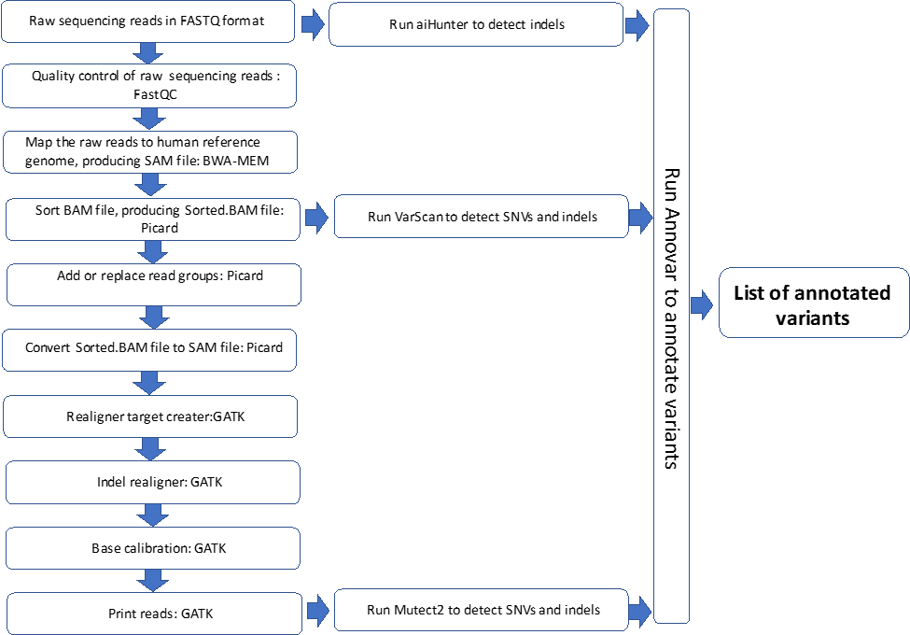

* + 1. LAR includes custom Perl and shell scripts to automatically run the pipeline. There are two main scripts in the pipeline:

1. Perl script “ListDetect_Main.pl” creates shell scripts for each sample to run BWA, Picard, Samtools, Mutect and Annovar.
2. Shell script “summary_command_line.sh” is a combination of sub-scripts to perform several analyses:
3. It performs comparisons between Mutect and VarScan results and creates text files including:
   1. Common variants detected by Mutect and Varscan
   2. Variants detected by only Mutect
   3. Variants detected by only VarScan
4. It creates a shell script to run all samples on aiHunter producing VCF files and those VCF files are automatically run on Annovar. It combines all annotated list of indels produced from each sample in a text file.
5. At the end of the analysis, it automatically removes all meta-files. It also moves FASTQ, BAM, and VCF from each sample and text files (including all annotated SNVs and indels) to the Run_Files folder. The user gets a warning on the command line window to transfer the Run_Files folder to the shared drive when the run is successfully completed.
6. Please refer to **Appendix A** for more details, including the source code for the pipeline.
   1. Data Processing:
      1. Open the RICMBLAB$ shared drive AMP Run folder. Open MiSeq subfolder and navigate to the FASTQ files.
      2. Transfer FASTQ files to /molpath/MiSeq/Analysis_Directory/Fastq_Files on Linux server using SAMBA, WinSCP, or similar secure method.
         1. **NOTE: Do not unzip these files, as they must be zipped to be run in LAR.**
      3. Start Putty on a Lifespan Windows-based computer to open a Terminal.
         1. Type the IP address for the Linux server, lsmplinux1 (10.229.9.24) on the “Host Name (or IP address)” window.
         2. The first time Putty is used, the IP address can be saved under “Saved Sessions”.
         3. If the IP address has been previously saved, click on the IP address under “Saved Sessions” window and press “Load”. Then, press “Open”.
         4. Enter your username/password.
         5. In the Terminal window:
            1. Type “cd /molpath/MiSeq/Analysis_Directory/sh_files”
            2. Type “perl ListDetect_Main.pl”

ListDetect_Main.pl is a perl script which outputs shell scripts to run the pipeline for each sample.

* + - * 1. Type “ls –lrt”.

This will list all shell scripts for each sample. Check if all samples were included.

* + - * 1. Type “cd ..”
        2. Type “sh ./sh_files/MVCT_S1.sh”.

This will run the shell script for the MVCT (positive control) sample.

**NOTE: Always run MVCT as the first sample since MVCT_S1.sh creates all run folders.**

* + 1. Start Putty again to open another Terminal. Repeat steps a-d. Then:
       1. Type “sh ./sh_files/<sample_sh_file_name>”.
       2. File names can be determined from step 3.e.iii.(a) above.
    2. Repeat step 4 for each sample.
    3. Lock the computer and leave at least 2 hours to run.
    4. When the program is done running, the last line should read: “[User_ID@lsmplinux1 Analysis_Directory]$”
    5. Close all Terminal windows except one.
    6. In the Terminal window, type “sh summary_command_line.sh”.
       1. This will run another script to create shell scripts that run aiHunter for each sample. It will run each shell script automatically and, therefore, this step should only be performed once.
       2. When aiHunter is done running all samples, meta files and FASTQ files will be removed. In addition, FastQC, BAM, Annovar, and summary files will be moved into /molpath/Miseq/Analysis_Directory/Run_Files.
    7. Lock the computer and leave it overnight as this step will take several hours (1-2 hours/sample).
    8. When the script is done running all samples, return to the Terminal window.
       1. If the analysis is completed without any errors, the last line should read “All done! Please transfer Run_Files folder to the shared drive.”
    9. Move the Run_Files folder to the RICMBLAB$ shared drive.
       1. Open the AMP run folder, and move the Run_Files folder into the parent folder.
       2. Rename the Run_Files folder using the format [YYYYMMDD]_ [Tasklist#]_AMP_Reporter (e.g., 20170508_AMPV8_AMP_Reporter).
    10. Go back to the Terminal and type “rm –r ./Run_Files”.
        1. This will remove the Run_Files folder from the Linux server.
  1. Data Analysis
     1. Review FastQC results under FastQC_files folder in AMP_Reporter folder, according to following steps:
        1. Open each result in HTML format.
        2. Check the first graph showing the average quality scores of all bases in each read.
        3. Open the AMP Workbook and go to the FastQC_Results worksheet.
           1. For each sample, indicate whether it has passed or failed quality control checks.
           2. “Pass” indicates all reads have quality scores >20.
           3. Note: If the scores drop towards the end of the reads, the sample should still be marked as “Pass”, since this is expected due to methodology of the assay.
           4. Mark samples “Fail” if the majority of the reads have average quality scores <20.
           5. The Negative Control (NTC) will have low quality scores due to no DNA in the samples. Mark the NTC as “Pass” if this is satisfied.
        4. Check the second graph (Per tile sequence quality).
           1. This graph shows the tiles in the Illumina flow cell. The colors are on a cold to hot scale, blue being positions where the quality is at or above the average for that base and hotter colors (red or orange) show worse qualities.
           2. Ensure that the overall quality of the runs is appropriate.
        5. In the FastQC_Results worksheet, enter initials and date to indicate completion of review.
     2. Review the variants according to the following steps:
        1. Open AMP_Reporter folder.
        2. Open Summary_Template Excel Workbook.
        3. In a text editor program, open the following files: Overlapping_Mutect_VarScan.txt, only_detected_by_Mutect.txt, only_detected_by_VarScan.txt, aiHunter_Summary.txt
           1. Copy and paste the information in these files into the corresponding Worksheets in Summary_Template Workbook.
        4. Save the file using the format [Tasklist#]_AMP_LAR_Summary (e.g., 20170508_ 1234LAR_Summary).
        5. In Overlapping_Mutect_VarScan worksheet, filter synonymous variants, variants with Variant Allele Fraction (VAF) <3% and frequently seen artifacts.
           1. A list of frequently seen artifacts was prepared from the validation data.
        6. Repeat step e. for Overlapping_Mutect_VarScan, only_detected_by_Mutect, only_detected_by_VarScan, and aiHunter_Summary worksheets.
        7. For any potential variants with depth of coverage is <200, review the BAM files in IGV.
        8. For patient samples, manually review the *ERBB2* gene in IGV.
           1. If there is coverage discrepancy for a given sample, discuss with Director.
           2. If appropriate, perform Sanger sequencing to determine if an indel is present.
           3. Open a new Excel workbook. Take screenshots of coverage in IGV and paste in to the workbook. Save the Excel file in the AMP run folder on the RICMBLAB$ shared drive using the format [Tasklist#]_Screenshots.
        9. Add all potential variants to “Variants” worksheet.
        10. Add all positive MVCT and PostCT variants to “Controls” tab.

1. **TEST PROCEDURE – SurascanReview (Interpretation):**
   1. Principle: This software is a Perl- and shell-script based tool that is used review variants, review some of the QC info for the samples, and aid in the confirmation and reporting of the results.
      1. Note: All steps in this section should be performed by either a Lab Director, bioinformatician, pathologist, or other approved/designated personnel.
      2. Note: This tool is simply an aid in these processes; all processes may be performed manually without the software, as needed.
      3. The tool consists of 6 Perl scripts, with an additional shell script (review_tool1) that launches the Perl scripts.
      4. Please refer to **Appendix B** for more details, including the source code for the 1 shell script and 6 Perl scripts.
   2. Set-up (**to be performed by Bioinformatician**):
      1. Transfer a copy of the **ReportSummary** Excel file onto the iMac desktop computer.
      2. On the lsmplinux1 Linux server, place the copy of the ReportSummary Excel file into /molpath/MiSeq/Analysis_Directory..
      3. Open a terminal window.
      4. Run the review_tool_v3 (SurascanReview) shell script:
         1. Type “cd /molpath/MiSeq/Analysis_Directory”
            1. This is the directory of all analysis.
         2. Type “sh ./Surascan_Reviewer/review_tool_v3/”
            1. This will create four files:

Variant_Summary Excel file: This is the summary file of variants.

Failed_Amplicons Excel file: This is the list of failed amplicons.

QC_Summary Excel file: This file contains mean coverage and functional copies.

IGV_batch_script.sh: This script is used to visualize BAM files.

* + - 1. Transfer Variant_Summary.xlsx, Failed_Amplicons.xlsx, QC_Summary.xlsx, and IGV_batch_script.sh to the run folder on the RICMBLAB$ shared drive using WinSCP.
         1. Change the name of the files using the following format: [Tasklist#]_HS21_ Variant_Summary.xlsx, [YYYYMMDD]_HS21_ Failed_Amplicons.xlsx, [Tasklist#]_HS21_ QC_Summary.xlsx and [Tasklist#]_HS21_IGV_batch_script.sh

1. **AMP BIOINFORMATICS- TASKLIST**
   1. **NOTE**: These steps should be performed by a bioinformatician or other approved/designated personnel.
   2. In Soft Molecular, open My Orders by using the icon on the dashboard.
   3. Click on the **Bioinformatician** tab.
      1. Click two times on tasklist number.
      2. Click on **No** button.
   4. In the tasklist, review the SAV Parameters for the run.
   5. Import SurascanReview Files.
   6. In the tasklist, click the ‘**…**’ button to the right of the Import button.
   7. Click **OK**.
   8. Select the Excel radial button, choose the file path (directory and file name) for the SurascanReview Variant_Summary file, and click **Import**.
   9. Repeat steps 6-8 for the Failed_Amplicons and QC_Summary files.
   10. **NOTE**: remember to import all 3 files.
   11. Review variant calls.
       1. In the tasklist, verify the Subtemplate is set to “Variants”.
       2. Review all variant calls for patient samples and controls by clicking the ‘+’ button to expand the child level results.
       3. For each variant, mark the checkboxes to indicate the pipelines which detected that variant.
   12. Review QC Summary data for patient samples and controls by reviewing the “Functional Copies” and “MeanCoverage” fields at the parent level.
   13. Review Failed Amplicons.
       1. In the tasklist, change the Subtemplate to “Failed Amplicons”.
       2. Review failed amplicons for all patient samples and controls.
       3. For patient samples, make sure that the ‘Print on Report’ box is checked for all failed amplicons.
   14. Upload the Excel screenshots file.
       1. Select **Analysis Images** button on the right side of the window.
       2. On the window that opens, select the **Add File** tab on the left side. Then, select the **add file (folder)** icon.
       3. Find and select the file to be added from the Windows Explorer window. Select **Open**.
       4. Choose **Instrument Documents** from the Template dropdown.
       5. Select the **green check** icon to add the files.
       6. Close the window.
   15. Verify that the Tasklist is set to the “FastQC” subtemplate.
       1. For each patient sample and control, enter the following information at the parent-level:
          1. FastQC R1: pass or fail
          2. FastQC R2: pass or fail
          3. Enter any relevant notes for FastQC R1 and R2 in the note columns.
   16. If any additional mutations were identified by secondary analysis:
       1. Create a new Variant_Summary file and save with the name. “Variant_Summary_Additional”.
       2. Open the file in Excel. Keep the header row, but delete all other existing data. Add data from the new variant call. Save the file and close.
   17. Import SurascanReview Variant_Summary_Additional File.
       1. In the tasklist, click the ‘**…**’ button to the right of the Import button.
       2. Click **OK**.
          1. Select the Excel radial button, choose the file path (directory and file name) for the SurascanReview Variant_Summary_Additional file, and click **Import**.
       3. In the Comment box at the top of the tasklist, enter a comment indicating your findings.
       4. For the Tasklist, change the subtemplate to “Variants”.
       5. For all samples, review the variants again.
       6. For each variant, mark the checkboxes to indicate the pipelines which detected that variant.
   18. Once reviews are complete: for each patient sample, complete the AMP Bioinformatics action by marking the 'Completed' checkbox.
   19. When all patient samples are complete, select **Save**.
   20. Select **Back** in the AMP Tasklist Entry window.
   21. Exit Soft Molecular application.
2. **AMP FIRST REVIEW-TASKLIST:**
   1. **NOTE**: These steps should be performed by a pathologist or director.
   2. In Soft Molecular, open My Orders by using the icon on the dashboard.
      1. Click on the **Molecular Pathologist** tab.
      2. Click two times on tasklist number.
      3. Click on **No** button.
   3. In the tasklist, review the SAV Parameters (QC information) for the run.
      1. Runs should ideally meet the following metrics. Those that do not meet the following metrics should be interpreted appropriately by the Director:
         1. Q30 > 80% (percent of bases with at least Q30)
         2. % Clusters PF (Passing Filter) > 80%
      2. Additional metrics to review
         1. % aligned (ideally 4-10%, but may vary with run)
         2. Cluster density (ideally 950-1,200K/mm2 per Illumina, but may vary with run)
            1. **NOTE**: Historically, the AMP runs show much lower cluster density with other criteria and results being appropriate. Therefore, this should be monitored, but is typically not used to determine whether the run passes or fails. See Lab Director for troubleshooting.
      3. If the runs fails any of these criteria, the Director/Pathologist may choose to repeat testing of all samples.
   4. Review variant calls.
      1. In the tasklist, verify the subtemplate is set to “Variants”.
      2. Review all variant calls for patient samples and controls by clicking the ‘+’ button to expand the child level results.
         1. Variants are filtered out by the SurascanReview program if they meet the following criteria:
            1. Depth of coverage < 200
            2. VAF < 3%
            3. Synonymous variants
            4. Intronic variants
         2. In addition, SurascanReview provides the primary variant information, such as the genomic coordinates, VAF, etc.
         3. Any variants with VAF between 3-5% should be reviewed for determination of inclusion in further steps (at the discretion of the Director/Pathologist).
         4. Review the information provided for the variant to aid in annotation.
      3. For each variant, to request reflex/confirmation testing by a different methodology:
         1. Go the child-level variant entry.
         2. Select a test from the 'Confirmation Test' field using the dropdown arrow.
         3. To reflex to Sanger sequencing, be sure to also mark the 'Sanger Confirmation Required' checkbox.
      4. **NOTE: For each patient sample with a Sanger confirmation, create an Internal note and enter the target gene and expected mutation for confirmation.**
   5. Review QC Summary data for patient samples and controls by reviewing the “Functional Copies” and “MeanCoverage” fields at the parent level.
   6. Review Failed Amplicons.
      1. In the tasklist, change the subtemplate to “Failed Amplicons”.
      2. Review failed amplicons for all patient samples and controls. For any given sample, amplicons with <200x depth of coverage will be listed.
      3. For patient samples, make sure that the ‘Print on Report’ box is checked for all failed amplicons.
      4. For the NTC, all 46 amplicons should appear on this list. If there are less than 46 entries, open the HS21 Report Summary Excel file and review all amplicons in detail to determine the failed amplicon(s).
   7. Review Controls, as follows:
      1. Box 1 Functional Copy Sensitivity Control (SENSCT, DNA Process Control)
         1. This control is used to determine if the Box 1 assay works appropriately.
         2. Target metrics should be 75 to 300 copies/ul in the FAM channel, or 300-1,200 Functional Copies.
         3. If these metrics are not achieved, samples may be repeated at the discretion of the Director/Pathologist.
      2. Asuragen Multivariant Positive Control should be positive for variants indicated by the vendor.
         1. If no variants are identified or if additional variants are identified, determine if all clinical samples should be re-tested.
      3. Cell lines with specific variants are used as Positive Controls and they should be positive for those variants.
         1. If no mutations are identified or if additional variants are identified, determine if all clinical samples should be re-tested.
      4. Negative Control (No Template Control, NTC): no variants should be identified.
         1. If any true variants are identified, determine if all clinical samples should be re-tested.
         2. In addition, potential contamination of the NTC should be evaluated by looking for the presence of the following parameters:
            1. Box 1: Functional Copies >200
            2. Box 5: Library Concentration >6nM
            3. QuantideX Reporter: mean coverage >200x
            4. FastQC: low error bars of high quality
         3. At the Director’s/Pathologist’s discretion, clinical samples may be re-tested if any of these criteria are identified.
   8. Sample Quality Control checks
      1. For each patient sample, review all failed amplicons, as described above.
         1. In the original HS21 ReportSummary Excel file, the coverage for all amplicons in each sample may also be reviewed. This file is available in the RICMBLAB$ shared drive AMP run folder.
      2. For each patient sample, review sample metrics. These metrics correspond to “QC_Status” states, as indicated on the original HS21 ReportSummary Excel file in the “QC_Summary” tab.
         * 1. Criteria for Pass state (Indicates a library result where the variant analysis will confidently report variants down to LOD):

Functional Copies > 200 AND

coverage for all amplicons > 200x

absolute Functional Copies < 200 OR

minimum coverage of one or more amplicons at < 200x

* + - * 1. Criteria for Failed state (Libraries in which the QuantideX NGS Reporter may not be able to detect even germline variants):

less than or equal to 20 absolute Functional Copies OR

greater than 20% of the targeted bases have less than 100x coverage

* + - 1. For each sample, the Functional Copies should be > 200, unless otherwise approved at the discretion of the Director/Pathologist.
      2. The “MeanCoverage” is optimally >1000x for any given sample.
      3. In the original HS21 ReportSummary Excel file, additional QC metrics may be reviewed, as appropriate.
    1. Any samples that fail QC parameters should either have testing repeated or should receive the appropriate annotation in the Final Report.
  1. Review all results.
     1. Select the **Analysis Images** button on right hand side of the screen. This will open the window with attached documents. The window can be floated by clicking the **Dual view** button at the top left of the window.
        1. In the Documents tab, review the Excel file with the screenshots of coverage in IGV.
     2. Change the Tasklist subtemplate to “FastQC” and review the FastQC results for all samples.
        1. Any sample that does not pass QC should be reviewed and reported as insufficient, repeated, or interpreted with caution at the pathologist’s discretion.
     3. Review the Box 1 results.
        1. In Soft Molecular, click on the AMP Box 1 – Test Worksheet Processing tile on the dashboard. Find and open the worksheet for this run.
        2. For each sample, review the Target 1 and Target 2 data at the child level.
        3. Review the Functional Copies for each sample (At the parent level, this is in the “Quantity x 4” column). This number, representing the library complexity (as determined by quantitative real-time PCR) should be ≥200.
           1. Any samples with a score of <200 may be dropped from further processing at the Director’s discretion. Any such samples that continue with processing should be interpreted with caution.
        4. Review the Inhibitor Assay (Target 2) results.
           1. The Target 2 Avg is the average Ct of the Target 2 assay for each standard control (calibrator).
           2. Any sample with a Target 2 Ct > 2 cycles above this number may exhibit signs of PCR inhibition. Review the sample accordingly and repeat testing under appropriate conditions, if necessary.
           3. In the Box 1 Worksheet, there is a column called “Target 2 Avg”. The value in this column = 2 + (Average Ct of standards), so the 2 is already added in this value.
           4. For each sample, compare the Target 2 “CT” and “Target 2 Avg” values. If CT > Target 2 Avg, an inhibitor may be present. See PCR Interfering Substances: BSA Method Procedure and the Interfering Substances section at the end of this document.
        5. Review the SENSCT results, as described above.
     4. Change the subtemplate to “Confirmations”.
     5. For each patient sample, review the variant calls:
        1. At the parent level, review the confirmation test results in the appropriate column and compare to the AMP variant calls.
        2. For all variants:
           1. To display the variant on the report, mark the ‘Print on Report’ checkbox.
           2. Click the dropdown arrow in the “Report?” field.

To display the variant on the report, Select a Tier level of I-IV.

For variants that will not be reported, select “No” or “Artifact”, if appropriate.

Tier designation is determined during the clinical interpretation review above. The following Variant Tiering system shall be used:

Tier I Variants (Strong Clinical Significance)

Tier II Variants (Potential Clinical Significance)

Tier III Variants (Uncertain Clinical Significance)

Tier IV Variants (Benign or Likely Benign)

If possible, ensure that variant nomenclature is consistent with Human Genome Variation Society (HGVS) guidelines and HUGO Gene Nomenclature Committee gene name. Reference transcript information should be included, as appropriate.

For indels, review of the sequencing data in IGV may help in determination of correct variant syntax.

* + - * 1. For both indels and base substitutions (single and multi-nucleotide variants), the variant call thresholds are:

Total depth of coverage ≥200x

Variant allele fraction ≥5%

* + - 1. Review Failed Amplicons.
         1. In the tasklist, change the subtemplate to “Failed Amplicons”.
         2. Review failed amplicons for all patient samples and controls.
         3. For patient samples, make sure that the ‘Print on Report’ box is checked for all failed amplicons.
      2. At the parent level, use the drop-down menu to select the AMP Final Result.
  1. Once reviews are complete: for each patient sample, complete the AMP First Review action by marking the 'Completed' checkbox.
  2. When all patient samples are complete, select **Save**.
  3. Click **Edit**, then repeat step J for the AMP Bioinformatics Second Review and AMP Second Review actions.
  4. Select **Back** in the AMP Tasklist Entry window.
  5. Exit Soft Molecular application.

1. **AMP CLINICAL INTERPRETATION AND VARIANT ANNOTATION:**
   1. Pathologist/Director: Review clinical and pathology information for the specimen and enter the appropriate information into the AMP Clinical Sample Log on the RICMBLAB$ shared drive.
   2. In Soft Molecular, open My Orders by using the icon on the dashboard.
      1. For each clinical sample:
         1. Enter the Order # and press **Enter** on the keyboard.
         2. Click on the Specimens tab at the bottom of the window.
         3. At the parent level, review the specimen attributes (specimen type, tumor %, etc.). Enter the Diagnosis in the “Diagnosis” field (as determined in the AP LIS).
         4. Click **Back** to return to prior screen.
         5. Click **Back** to exit back to Dashboard.
   3. Pathologist: For clinical samples, determine the clinical significance of variants (Guideline for review of sequence variants in samples)
      1. For each clinical sample, the associated clinical report should include interpretation of the variants with clinical implications, as appropriate.
         1. Interpretation (such as determination of pathogenicity or therapeutic targetability) may be based on a variety of factors, including visualization of the sequencing data and review of public databases, the literature, and historical laboratory data.
         2. Examples of relevant data include: frequency of the mutation in the tumor type (e.g., as reported in the COSMIC database), gene-specific functional data, the availability of targeted therapy, patient-specific clinical/pathological factors, literature/references, and information from publically available databases and other bioinformatics resources.
         3. Public databases include, but are not limited to: COSMIC (for determination of significance and frequency of variants in cancer), dbSNP (for determination of population frequencies of variants), MyCancerGenome, ClinVar, cBioPortal, clinicaltrials.gov, as well as the Genome Browsers from NCBI, Ensembl, and UCSC.
         4. Variants should be classified according to clinical significance, in accordance with professional organization guidelines.
         5. SurascanReview is a decision-support tool that can aid in this process.
         6. Variants should be classified with each clinical run. However, for variants that have been identified in samples previously, a variant database may be used. See the NGS Quality Management Program policy for more details.
      2. To visualize sequencing data for any given variant, open the Integrative Genomics Viewer (IGV) program.
         * 1. This first method will automatically create snapshots that can be reviewed and saved and should only be performed by a bioinformatician or designated personnel.
           2. Place all BAM and BAI files for the run into the shared drive folder \\lsfile03\RICMBLAB$\BAMfiles\.
           3. When IGV opens, go to the menu bar. Under Tool, click on “Run Batch Script” and select IGV_batch_script.sh (located within the AMP Run folder).

This will load the RefSeq Genes track, Asuragen HS21 Bed file track indicating the positions of the AMP assay amplicons (to aid in review of variants) and the BAM file for each variant in the Summary tab (this automatic list is added to the shell script by the SurascanReview tool).

It will automatically take snapshots of each variant on IGV and save them in a new subfolder \\lsfile03\RICMBLAB$\BAMfiles\[Sample].

If you want to save the snapshots, return to the run folder and create a new subfolder called “IGV”.

Transfer all snapshot folders from the BAMfiles folder to the IGV folder.

Review the snapshots for all variants.

* + - 1. Alternatively, IGV can be run manually. This method can be performed by any lab personnel.
         1. Open IGV.
         2. Load the Asuragen PanCancer Bed file under \\lsfile03\RICMBLAB$\BAMfiles\PanCancerDNA_BED_File and the BAM file for the sample of interest.
         3. Close IGV when complete.
    1. For clinically significant variants, an attempt may be made to confirm the variant by orthogonal testing, such as one of the following techniques (refer to the appropriate Procedure for additional information):
       1. Sanger sequencing
       2. *EGFR* real-time PCR assay
       3. *BRAF* real-time PCR assay
       4. *KRAS* real-time PCR assay
    2. **Note**: Based on an extensive validation study and numerous variants in clinical samples that were confirmed as per prior protocol, most variants that meet quality control standards can be reported without confirmation. However, at the discretion of the Pathologist/Director, variants may be confirmed by alternative testing (for example: low VAF, uncommon variant, etc.) if appropriate.

1. **SIGN OUT ENTRY**
   1. Open My Orders by using the icon on the dashboard.
   2. Verify the **Molecular Pathologist** tab is displayed.
   3. Click two times on order.
   4. Click on **No** button.
   5. Verify whether RBS rules are triggered correctly (Result, Interpretation sections are filled appropriately).
   6. Overwrite Interpretation window may display.
      1. The pop-up window will display original text.
      2. Click **Skip** unless a new result was manually generated.
   7. In the Test Result tab, review the assay results.
      1. Make changes, as needed.
      2. To switch subtemplates (Failed Amplicons, etc.), use the Subtemplates dropdown menu at the bottom of the tab.
         1. Verify that the ‘Print on Report’ box is checked for all Failed Amplicons.
      3. At the parent level, review the AMP Final Result. If necessary, use the drop-down to change the result.
      4. **Note**: If the Final Result was changed, click on **Generate** button to fire reporting rules which populate interpretation sections with correct/updated data.
      5. Review and update the “Print on Report” and “Report?” field, as appropriate.
      6. In the ‘Final Test Interpretation’ area:
         1. Update the Final Report comments.
         2. For each Tier I-IV that has a variant call, enter an interpretive comment indicating the clinical significance of each variant.
            1. To aid in the interpretation, review sample information (specimen type, diagnosis, tumor percentage in the sample, etc.)
         3. NOTE: If there are any Tiers that do not have a variant call, leave it blank. The Report will automatically indicate “NONE.”
   8. Mark Completed checkbox.
   9. Select **Sign Out** button.
   10. Select **Sign Out** in the window that appears.
   11. Make sure that information on the report is correct or edit as needed.
   12. Complete sign out by selecting **Complete Sign Out** button.
   13. Select **Back** in Sign Out Entry.
   14. Exit Soft Molecular application.
2. **LIMITATIONS:**
   1. False positive or negative results may occur if there is low tumor content or genetic heterogeneity in the tumor.
   2. This is a targeted NGS assay. Therefore, the results do not exclude the possibility of other variants that are not targeted by this assay.
   3. The Limit of Detection of the assay is 5% variant allele fraction for base substitutions (single and multi-nucleotide variants) and indels.
   4. Paired germline sequencing is not routinely performed; therefore, this assay is not designed to distinguish somatic from germline variants.
   5. During the original validation, a small percentage of indels in the *ERBB2* gene were not identified by the AMP assay.
      1. To ensure accurate variant calling, the following shall be performed on clinical samples:
         1. Load the sample’s BAM file in the Integrative Genomics Viewer software.
         2. Manually review the *ERBB2* gene for discrepancies in coverage across the gene.
         3. Any sample with discrepant coverage should undergo Sanger sequencing of the appropriate genomic coordinates and any variants identified in doing so should be reported, as appropriate.
   6. Deviations from procedure:
      1. For any assay runs that deviate from this Procedure or any samples that do not meet the acceptability criteria, indicate appropriately in the AMP Workbook.
      2. Add this information, as well as any associated issue and/or corrective actions, to the NGS_ExceptionLog.xlsx file on the RICMBLAB$ network drive. This information should be reviewed by a Director or designee, as appropriate.
3. **INTERFERING SUBSTANCES:**
   1. Hemoglobin and melanin are known to inhibit PCR amplification and may be present in clinical samples submitted for testing.
   2. If you suspect a PCR inhibitor is present in Formalin-fixed paraffin-embedded and other tissues (e.g., based on Box 1 inhibitor assay), the following options may be attempted upon discussion with the Director:
      1. If the concentration and volume are high, use the Genomic DNA Clean and Concentrate procedure. Then, repeat testing.
      2. Re-extract the sample using the organic extraction protocol found in the TNA Extraction Procedure. Then, repeat testing.
      3. The sample can be diluted with water and testing can be repeated.
      4. The sample can be diluted with BSA and testing can be repeated. See the PCR Interfering Substances: BSA Method Procedure for additional details.
   3. For Blood/Bone Marrow/Body Fluids, the following may be attempted:
      * 1. Re-extract the sample and run an extra AW2 wash before eluting off the column. The final wash before the elution step should be clear. Refer to the appropriate DNA Isolation Procedure for additional details. Then, repeat testing.
      1. The sample can be diluted with water and testing can be repeated.
   4. Discuss with Director/Pathologist for other options, as appropriate for the potential inhibitor in a sample.
4. **REFERENCE RANGE:**
   1. The reference range for samples is wild type/negative for pathogenic variants. Benign polymorphisms may be identified and will be indicated as such on the clinical report.
5. **REPORTABLE RANGE:**
   1. All variants otherwise identified may be reported, as clinically relevant and according to the Tier designation indicated on the clinical report.
6. **QUALITY MANAGEMENT PROGRAM**
   1. Refer to the NGS Quality Management Program document (Next-Generation Sequencing Infrastructure Policies) for the following policies and procedures:
      1. Monitoring, implementing, and recording upgrades to components of the assay (including wet bench and bioinformatics)
      2. Revalidation of the assay upon any changes made
      3. NGS wet bench processes
      4. NGS bioinformatics processes
      5. Variant database, reassessment, and reclassification
      6. Reporting of incidental findings
      7. Logging of positive results
   2. For the AMP assay, the controls, metrics, and quality control parameters used to monitor and assess each analytical run are described in the appropriate sections above.
   3. Refer to the Bioinformatics Policy document (NGS Infrastructure Policies) for information regarding:
      1. Management of NGS bioinformatics pipelines
      2. Versioning of pipelines
      3. Reference sequence utilized in the Lifespan AMP Reporter
   4. Refer to the Data Management Policy document (NGS Infrastructure) for policies and procedures related to storage and transfer of electronic data relevant to this assay.
   5. Version Traceability
      1. For historical AMP assay runs, the AMP Workbook Summary Worksheet indicates version number of various components, including MiSeq software and bioinformatics pipeline subparts.
      2. For AMP assay runs in Soft Molecular, the Tasklist contains version number for software used.
7. **TROUBLESHOOTING:**
   1. For issues with networking (of the MiSeqDx and/or Lifespan computer), see Director or Bioinformatician.
   2. For issues related to bioinformatics, see Bioinformatician.
   3. Performing a System Check on the MiSeq.
      1. Refer to the MiSeqDx Instrument Procedure.
   4. Pausing a run:
      1. Refer to the MiSeqDx Instrument Procedure.
   5. Stopping a run:
      1. Refer to the MiSeqDx Instrument Procedure.
   6. Resolving RFID Read failures:
      1. Refer to the MiSeqDx Instrument Procedure.
   7. Regenerating FASTQ files:
      1. Refer to the MiSeqDx Instrument Procedure.
   8. For other Instrument troubleshooting concerns, refer to Appendix A of the MiSeq System Guide or contact technical support.
   9. For troubleshooting related to the HS21 kit, contact Asuragen technical support.
8. **REPEAT TESTING**
   1. During the testing process, testing for some samples must be repeated for a variety of technical or analytical reasons. The specimen can be sent back to one of multiple prior steps in the workflow.
   2. In Soft Molecular, repeating a sample to a prior action can be accomplished from a variety of steps in the test workflow and places in the system. Please see the Soft Molecular Rerun Procedure for the specific steps to perform when requesting rerun testing.
9. **TECHNICAL SUPPORT CONTACT INFORMATION:**
   1. Illumina Technical Support
      1. Phone: 800-809-4566
      2. Fax: 858-202-4766
      3. Email: [techsupport@illumina.com](mailto:techsupport@illumina.com)
   2. Asuragen:
      1. Phone: 1-877-777-1874
      2. Technical Support: [support@asuragen.com](mailto:support@asuragen.com)
10. **REFERENCES:**
    1. Asuragen® QuantideX® NGS DNA Hotspot 21 Kit Protocol, # 49612v1 (Effective Date: 10-2016)
    2. Asuragen® QuantideX® NGS Reporter v2.0 User Guide, # PC-0249v1 (Effective Date: 10-21-2016)
    3. MiSeq® System Guide. Material # 20000262. Document # 15027617 v01. Effective Date: September 2015.
    4. MiSeqDx System Guide Document # 15027617 v01 (September 2015).
    5. MiSeqDx Instrument Reference Guide Part # 15070067 Rev. 02 (March 2017).
    6. Aziz N, et al. College of American Pathologists’ Laboratory Standards for Next-Generation Sequencing Clinical Tests. Arch Pathol Lab Med. 2015 Apr;139(4):481-93.
    7. Rehm H, et al. ACMG clinical laboratory standards for next-generation sequencing. Genet Med. 2013 Sep;15(9):733-47.
    8. Gargis AS, et al. Assuring the Quality of Next-Generation Sequencing in Clinical Laboratory Practice. Nat Biotechnol. 2012 Nov;30(11):1033-6.
    9. Jennings LJ, et al. Guidelines for Validation of Next-Generation Sequencing-Based Oncology Panels: A Joint Consensus Recommendation of the Association for Molecular Pathology and College of American Pathologists. J Mol Diagn. 2017 May;19(3):341-365.
    10. Li MM, Standards and Guidelines for the Interpretation and Reporting of Sequence Variants in Cancer: A Joint Consensus Recommendation of the Association for Molecular Pathology, American Society of Clinical Oncology, and College of American Pathologists. J Mol Diagn. 2017 Jan;19(1):4-23.
11. **ATTACHMENTS:**
    1. AMP HS21 Procedure Appendix A: Perl and Shell Scripts in LAR
    2. AMP HS21 Procedure Appendix B: Perl and Shell Scripts in SurascanReview
12. **REVISIONS:**
    1. 1/2/2018: Additional information for cleaning the flow cell stage, making fresh NaOH every six months, inverting the cartridge before loading and file naming formats were updated.
    2. 11/23/2018: Updated to reflect new HS21 kit**.**
    3. 1/17/2020: Updated with steps for Soft Molecular and updated footer with new laboratory name.
    4. 2/3/2020: Clarified Box 1 steps for Soft Molecular
    5. 5/1/2020: Added new way to thaw cartridge, library normalization step formula change and referral to MiSeq procedure for regeneration of FASTQ files.
    6. 10/5/2020: Updated instruction for 1N NaOH preparation and use, updated LQ Analysis worksheet steps for Box 4-5, and added instructions on the transfer of raw data from MiSeq.
    7. 3/6/2022: Updated several steps for Soft Molecular upgrade, changed the buffer used in Box 4 and Box 6, and updated analysis section to reflect new workflow.